Waves and the Sandy Seashore
—An Exploration
Written by Mike Vollmert, Hueneme High School,
Oxnard, California.
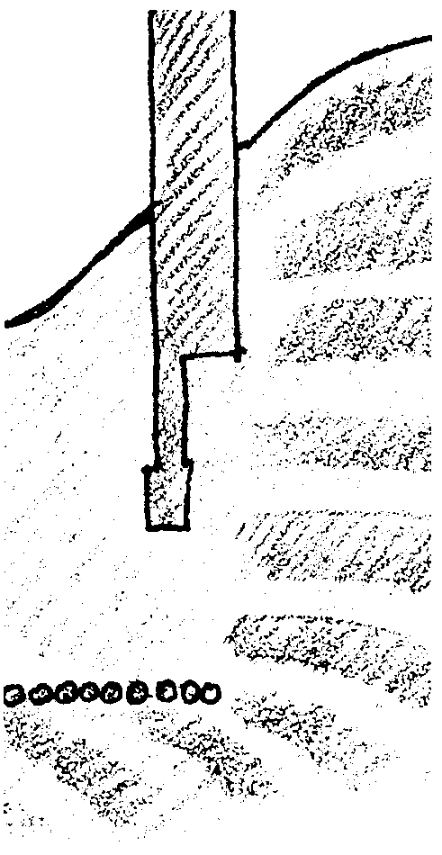

Key Concepts
1. Seasonal changes in wave action cause movement of sand up and down beach slopes.
2. Waves breaking on shore erode points and headlands and deposit sand in coves and bays.
3. Human-made structures, such as breakwalls and groins, have a dramatic effect on the shape of coastlines and the distribution of sand along beaches.

Background
Sandy beaches are not permanent features of a shoreline. They are fluid; the profile of a beach changes on a regular basis, depending on the nature of the waves hitting the beach. The most dramatic changes occur between summer and winter. Summer waves, typically smaller and of a shorter period, tend to push sand up the beach. Winter waves, bigger and of a longer period, tend to remove sand from the beach and deposit it just past the breaker zone, creating a berm, or hump, on the bottom.

As humans increasingly encroach on beaches, using them for recreation and housing or reshaping them to create harbors, humans attempt to prevent the movement of sand to create a more permanent sandy shore. Virtually all these attempts have proven to be futile. Breakwalls, groins and jetties interrupt the movement of sand down the beach, resulting in a build up of sand at one point and erosion at the point where sand normally would have been deposited.

Materials
For each pair of students:
• 1 plastic tub, approximately 18" x 10" x 6" deep
• 1 wavemaker (made from paint stirring sticks, cut about 6" long)
• 4-6 dominoes
For each class:
• 1 5-gallon bucket of fine sand (see teaching hints below)
• 1 large margarine tub

Teaching Hints
“Waves and the Sandy Seashore - An Exploration” is designed to show students the effects of waves on beaches and what happens when walls and jetties are constructed. Because of the limitations of the materials used, these effects are shown only in the most generalized manner, but it should be sufficient for the students to understand the basic nature of sandy beaches.
This activity can be used alone or as a follow-up to reading “The Lifecycle of Ocean Waves.” It is an exploration, a chance for students to “fiddle around” with the nature of waves and beaches. You may choose, either before or after the structured activities, to encourage students to explore on their own, adjusting beach shapes, groin and breakwall configurations, wave angles, and whatever other variables they come up with. Encourage the students to write down and diagram what they did, what they observed, and what conclusions they drew from these experiments. You may choose to omit the lab instructions altogether and, instead, model some experiments and let students design their own.
Divide the students into pairs for this activity. Have a tub, wavemaker and 4 (or so) dominoes ready for each team. Before class begins, use the margerine tub as a scoop to put 2 or 3 tubs of sand into each of the plastic tubs. Fine-grained silica sand works best. Scientific and school supply catalogs sell it for erosion stream tables. It is likely you can get a bucketful for free from a local construction materials supplier who sells the sand for use in sand blasting equipment. If you use beach sand, be sure to get fine-grained material. The larger the grains, the less they tend to be moved by waves. (This, by the way, was discovered by a 16 year old high school student as a science fair project!) Finally, be sure to wash the sand well before turning it over to the students.
Before beginning the exercise, students should practice making big and small waves. Everyone will want to make giant waves, but this should be discouraged because it causes changes that happen too quickly to be carefully observed. Students also will need to practice creating waves of a specified period. One way to do this is to have one student watch the second-hand on a clock or watch and tap out the appropriate rhythm with a pencil while another student generates waves in time. Once they get the wave rhythm and size right, both should concentrate on the changes taking place in the tub.

Key Words
breakwall - a free standing barrier that breaks the force of waves
cove - a small indentation or recess in the shoreline
groin - a small jetty extending from a shore to prevent beach erosion
jetty - a pier or structure of stones projecting into the sea usually to protect a harbor
longshore current - a current, running roughly parallel to the shoreline, produced in the surf zone by waves breaking at an angle with the shore
period - in this case, the time for two successive wave crests or troughs to pass a fixed point; also called wave period
tsunami - unusually large, long period sea wave produced by a submarine earthquake or undersea volcanic eruption; also called a seismic sea wave; erroneously called a tidal wave.

Extensions
1. Have students construct a harbor in their tub by creating a small channel in the beach, leading to a hollowed out area inshore. The channel and hollowed out area need to be deep enough to allow water to enter! Create waves at an angle and observe what happens to the sand moving down the beach. Then, using dominoes, try various schemes to prevent sand from silting up the harbor.
2. Take a field trip to a sandy beach with a pier extending well past the surf zone. Before going, have students devise various methods for determining wave height, length, and period. Take along some stopwatches, lengths of rope, meter sticks, etc., and have students try out their methods. Along the beach, cut some apples in half and have students toss them into the surf at various points, observing their movement down the beach. Have them diagram the movement, which will illustrate the longshore current along the beach.
3. Invite a local lifeguard to talk to the students about the beach, rip currents and dangers of swimming or boating in the surf. Have students develop safety posters for use around their school, elementary schools or at the beach.

Answer Key
Part One
1. While answers may vary, students should observe sand being pushed up the beach, increasing the amount of sand above the surf zone.
2. While answers may vary, students should observe the beach being “cut”, with the slope sharply increasing as sand gets moved down the beach and deposited just outside the surf zone.
3 a. Again, answers may vary, but the sand that was pulled off the beach by the big waves should now get pushed back up the beach, resulting in a beach similar to the one in step 1.
b. An observer should notice that, in the wintertime, sand disappears from the beach and, in the summer time, it reappears. In some places, the change is so dramatic that there is a sandy beach in the summer and a rocky beach in the winter.

Part Two
1. While answers may vary, students should observe that the point gets slowly eroded away.
2. Students should observe that the cove is slowly being filled in with sand from up the beach.
3. Waves tend to straighten shorelines. Wave energy tends to be concentrated on points, resulting in erosion, and dissipated in coves, resulting in deposition of sand.

Waves “feel bottom” when the water depth equals about one-third the wavelength of the wave. If a wave feels bottom at an angle, then it will tend to bend around to parallel the bottom, since the part of the wave that feels bottom will move slower than the part in deeper water. On a point, this will tend to concentrate the energy of the wave on the point farthest out. All of this energy concentrated on a small area will tend to cause erosion. In a cove or bay, the same tendency to “feel” bottom will tend to dissipate the energy of the wave, resulting in the slowing of the longshore current. As the energy is dissipated, any sand being moved by the wave will drop out, resulting in deposition of sand in the cove.

Part Three

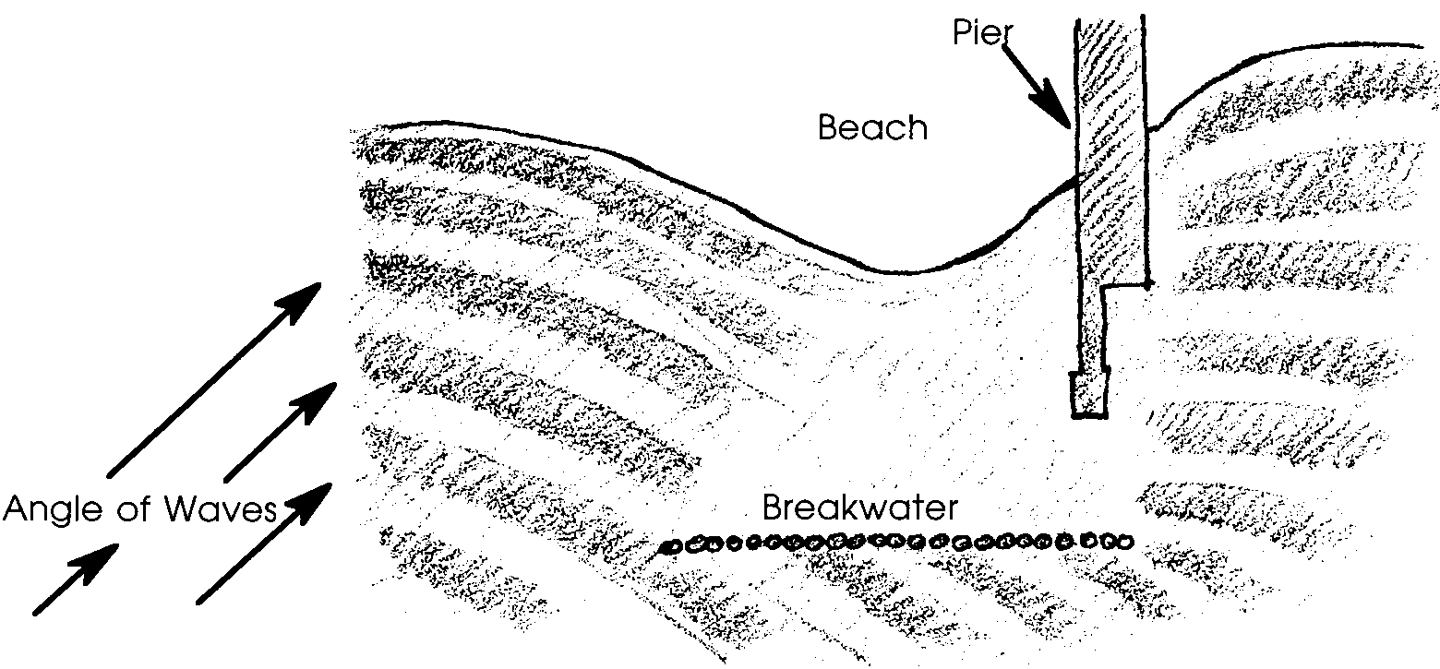
1. While answer depends on experimental results, the detached breakwall should cause the beach behind it to swell somewhat:

2. Answers will vary. Alterations in erosion and deposition patterns change habitats, reducing spawning and nursery grounds for fish and removing sandy areas where clams and other sandy shore animals burrow. The changing deposition patterns may fill in areas where people anchor or dock boats. The area of erosion may continue to recede, threatening property. Breakwalls, bulkheads and other structures often intensify problems people are trying to mitigate

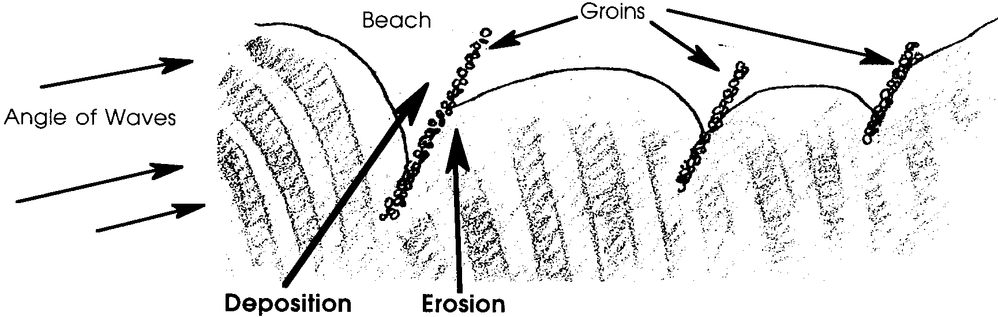
3. While answers may vary, the groin should cause erosion of sand from the side of the groin away from the prevailing currents and deposition on the side of the groin nearest the prevailing currents.

4. Answers will vary, but, in general, the neighbor’s beachfront will get eroded away by the construction of the property owner’s groin.
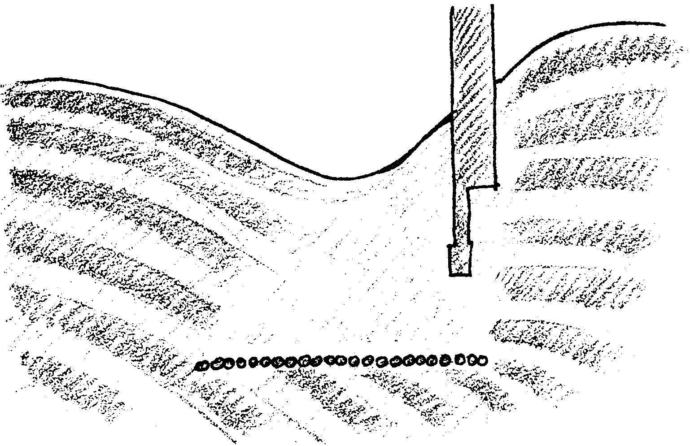
Waves and the Sandy Seashore
—An Exploration

The following activity is designed to explore the nature of waves as they interact with the seashore. There are three parts to the exercise. First, you will examine the effect different size waves have on a beach. Then you will examine how waves behave when they strike a point or a cove on a beach. Finally, you will examine how beaches are affected by the construction of breakwalls and jetties.

Follow the instructions carefully! You will get a tub, some sand, and a small paddle to be used as a wave maker. You will be asked to construct different sorts of beaches and shorelines and to make different sized waves. Remember, in order to see the effects of the waves, you must be patient and observant.

When you are asked to make “big” waves and “small” waves, remember that those terms are relative to the scale of the beach you are constructing -- “big” means about 1/2 to 3/4 of an inch tall, and small means about half that --we are NOT studying tsunamis in this exercise!. Waves that are too big will destroy the shoreline before you have a chance to observe what’s happening. It will take some practice to make consistent waves.
Part One
1. In one end of your tub, construct a beach extending out about 6-8 inches and sloping fairly gently to the bottom of the tub. At the high end of the beach, sand should go no further than halfway up the tub. Carefully add water to the tub until about half of your beach slope is under water.
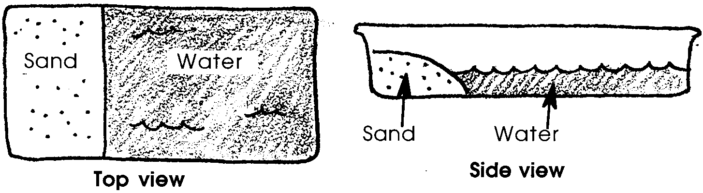
Your beach setup should look similar to the drawing below:
Using your wavemaker, gently make small waves, about 1/2 to 1 second apart. This will simulate the smaller, short-period waves that typically occur in summer. Make the waves for three or four minutes and carefully observe the changes that take place. Use words and sketches to describe those changes.

2. Reconstruct the beach you made in Step 1 as closely as possible. Now, make big waves, about 1-1/2 to 2 seconds apart. This will simulate the larger, long-period waves of winter. Make these waves for about three or four minutes, and carefully observe the changes that take place. Use words and sketches to describe those changes.

3 a. Without changing the configuration of the beach after finishing Step 2, now make small waves, about 1/2 to 1 second apart. Make the waves for about five minutes. Describe the changes you see take place.
b. Without changing the configuration of the beach, now make big waves again, about 1-1/2 to 2 seconds apart, for about 5 minutes. Describe the movement of sand, from winter to summer, based on your observations.

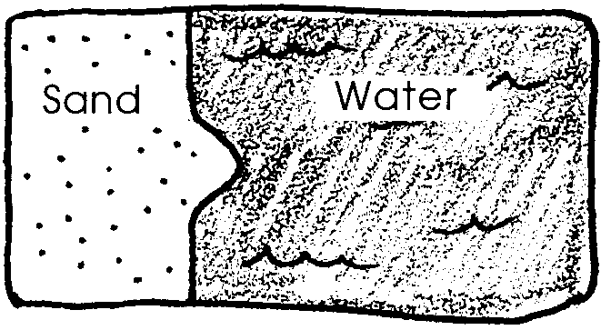
Part Two
1. Construct a beach in one end of your tub, much like you did in Part I, except this time create a point in the center of your beach:

Use your “wavemaker” to make small waves, about 1 second apart, for about eight to ten minutes, and carefully observe the changes that take place. Describe those changes, using words and sketches.

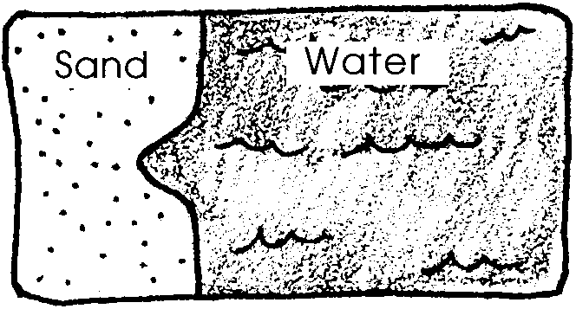
2. Next, construct a beach, much like in step 1, but this time create a cove instead of a point:

Using your wavemaker, make small waves, about 1 second apart, for about eight to ten minutes, and carefully observe the changes that take place. Use words and sketches to describe the changes.
3. In general, how do waves change the contour of a beach?

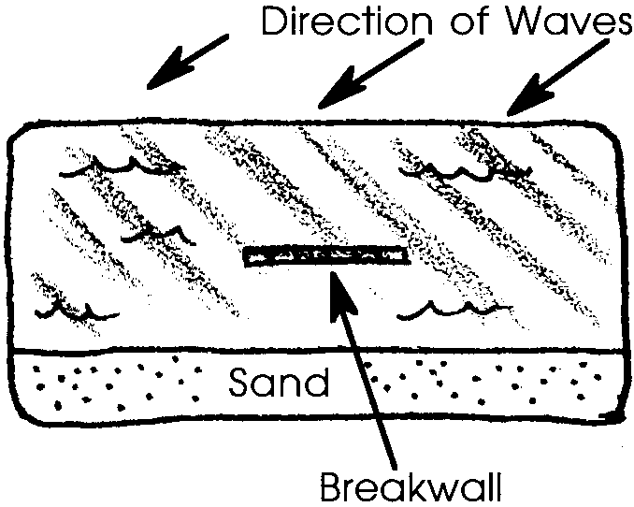

Part Three
1. Along one side of your tub, construct a gently sloping, straight beach. A little over half-way down the beach, construct a detached breakwall, using three or four dominoes. The breakwall should be about 4 inches from the shore line:

Using your wavemaker, make small waves, about 1/2 to 1 second apart. Make the waves at an angle to the beach, to create a “longshore current”, for about five minutes. Carefully observe the effects these waves have on your beach. Pay close attention to any differences that may occur because of the detached breakwall. Describe those changes.

2. How do you think the breakwall would affect marine life and humans?
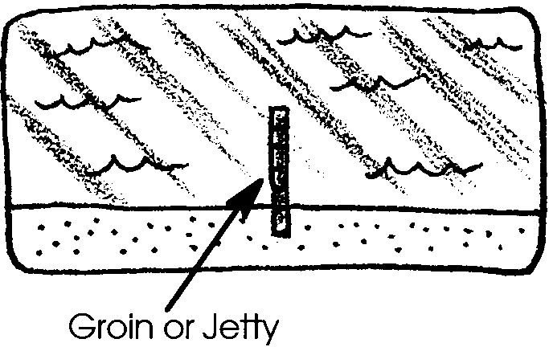
3. Along one side of your tub, construct a gently sloping, straight beach. A little over halfway down the beach, construct a groin, using two or three dominoes. (A groin is also called a jetty.) The groin should extend from above where the waves break, out into the water past where the waves break:

Using your wavemaker, make small waves, about 1/2 to 1 second apart. Make the waves at an angle to the beach, to create a “longshore current”, for about five minutes. Carefully observe the effects these waves have on your beach. Pay close attention to any differences that may occur because of the groin. Describe those changes, using words and sketches.

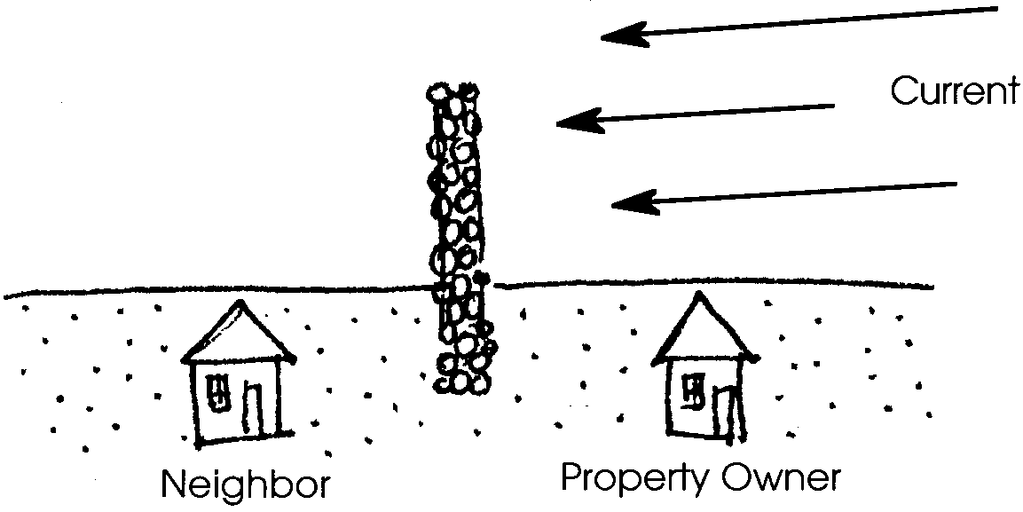
4. A waterfront property owner decides to build a groin, a small jetty, to keep the sand on his beach from moving down the beach in longshore currents. What effects will the groin likely have on his neighbor’s beach?

