The Lifecycle of Ocean Waves
Written by Mike Vollmert, Hueneme High School, Oxnard, California

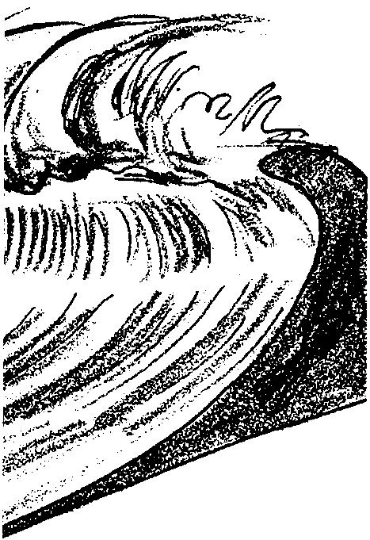
Key Concepts
1. Ocean waves are generated by three natural causes: wind, seismic disturbances, and gravitational attraction of the sun and moon.
2. Waves can be thought to experience a lifecycle not unlike living things, with stages of birth, growth, maturity, and death.
3. The behavior of waves changes radically when they change from deep-water to shallow-water.
4. The characteristics of shoreline determine the nature of breaking waves.

Background
Waves are an endless source of fascination for everyone, from scientist to surfer to beachcomber. Even the most casual visitor to the beach notices the endless cycle of surge and rush of waves on the shore, and experienced sailors are intimately aware of the wide variety of waves that exist in open water. Drew Kampion’s book, The Book of Waves: Form and Beauty on the Ocean, explains the phenomena of waves, from their birth in the open ocean, to their demise on the shore, and is recommended background reading for this activity.
Ocean waves are generated by three natural causes: wind, seismic disturbances, and gravitational attraction of the sun and moon. While a wave may move past a point, the water making up the wave will show no net movement. The water particles in a wave actually tend to move in circles.
The size of wind generated waves is dependent upon wind speed, the length of time the wind blows, and the distance over which the wind blows. As waves move from deep water to shallow water, their behavior changes radically. Waves “break” at the beach when a wave moves into water shallower than one half of the wave length and the particles of water in the crest have no room to complete their circular movement.
Physically powerful and interesting in their own right, waves are also ecologically important. Waves change habitats, batter organisms, and subject organisms to conditions of exposure and wetting.
Materials
For each student:
• “The Lifecycle of Ocean Waves” article
• “The Lifecycle of Ocean Waves—A Picture’s Worth” student pages
• “The Lifecycle of Ocean Waves” Three-Level Guide

Teaching Hints
“The Lifecycle of Ocean Waves”, excerpted with permission from Drew Kampion’s book, The Book of Waves: Form and Beauty on the Ocean, introduces many new terms and ideas. To assist your students in learning the vocabulary of the study of waves, have them interpret first the illustrations in the reading using the questions on the student pages, “A Picture’s Worth”. Then have students complete the Three-Level Guide as they read the text.
If your students have not used a Three-Level Guide before, explain to them that guide will take them through three levels of questioning, from a literal level, to inference, and then to analysis and synthesis. The idea is not to “get the answer right” per se, but more importantly, to use the questions as a guide to the major ideas in the article, and to try to incorporate those ideas into one’s own knowledge base. It is important to emphasize to the students that their reasoning is much more important than their answer. In fact, in levels two and three, there may be no “right” or “wrong” answer!
Traditionally, Three-Level Guides have been intended for individual work. Suggest that the students read the statements in the three-level guide before they read the article. (Some students may prefer to read the article first, then go back over it a second time with the three-level guide). The guide is intended to be a vehicle for helping students look for certain concepts in the article.
When students have finished, discuss the guide, referring to the article. You may wish to have students work in collaborative groups to compare their answers. The process of resolving differences of opinion can be very instructive.
It is sometimes helpful to have students note the page number and paragraph where they found evidence to support their answer. You may require the students to provide sound, complete explanations for the answers they chose!
For additional information about Three-Level Guides, see Teacher Background for the activity, “Meanwhile, in the Pacific...”, unit 2.

Key Words
amplitude - in this case, the height of a wave
fetch - the area over which the wind blows to raise up waves
frequency - number of completed cycles or alterations per unit time of a wave
tides - periodic rise and fall of the waters of the ocean and its inlets, produced by the attraction of the moon and sun and occurring about every 12 hours
tsunami - unusually large, long period sea wave produced by a submarine earthquake or undersea volcanic eruption; also called a seismic sea wave; erroneously called a tidal wave.
wavelength - distance measured in direction of propagation of a wave between successive points in the wave that are characterized by the same phase of oscillation

Answer Key
A Picture’s Worth
1. The amplitude of a wave is the vertical distance from the trough to the crest.
2. The frequency (or wavelength) is the distance from crest to crest.
3. “Sea” is a rippled, choppy sea surface where several separate wave patterns from several directions meet.
4. The circles in Figure 4 and “The Lifecycle of Ocean Waves” drawing represent the path that individual water particles take as the wave moves forward. Individual particles make little or no net movement as the wave travels across the ocean.
5. The chart of frequencies of given wave heights shows that only 10% of all ocean waves are over 20 feet tall. Storms with waves 50 feet or more must be very, very rare.
6. The graph in Figure 5 shows that as waves become longer, their speed increases.
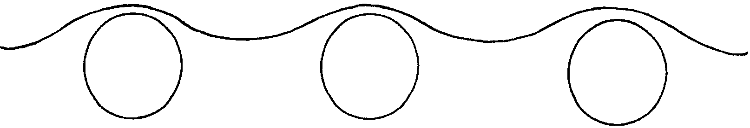
7. The graph in Figure 6 shows that swell has the greatest amount of relative energy. Swell waves are rounded and even.

8. Student responses will vary. Students may identify as dangerous the areas where water is moving under the waves back out to sea. This question is designed to get students looking at and talking about the drawings.
9. Figures 8 and 9 show what happens when shallow water waves pass over an underwater ridge or trough. When waves pass over a ridge, they tend to bend around the ridge, focusing their energy in a smaller area, over the top of the ridge. When they pass over a trough, they tend to bend away, spreading their energy over a wider area.
10. Surging breakers never truly break, they just wash up on the shore. Spilling breakers occur when waves break on gently sloping beaches, such that their crests slowly tumble down the faces of the waves. Plunging breakers occur on steeply sloping beaches, when the crest “falls” over the face of the wave, often creating a tube or cavity along the wave front.

The Lifecycle of Ocean Waves—Three-Level Guide
Level One
Directions: Read the statements carefully. Then, as you read the article, refer back to the statements and check those that you believe say or paraphrase what the author said. Be ready to support the statements you checked, and explain what is inaccurate about the statements you have not checked.

X 1. Waves are a fundamental way in which energy is transported in the world.
X 2. Ideal laboratory waves share the same features as ocean waves, but do not exist in the open ocean.
X 3. While a wave moves across thousands of miles of open ocean, the water making up the wave stays in basically the same place.
4. Tides are very different from waves.
X 5. Tsunamis are very difficult to detect in the open ocean, because they are small and move very fast.
X 6. The largest wave ever reliably reported was 112 feet high.
7. Most ocean waves are between 7 and 12 feet high.
X 8. The differences between sea and swell have to do with their shape and period.
9. When a wave moves into water shallower than one-half the wave height, it becomes a shallow-water wave.
X 10. Rogue waves result from the interaction of two or more wave trains.
X 11. When a wave moves into shallow water, it slows down, steepens, and becomes higher.
X 12. Deep water waves and shallow water waves both break when their height is greater than 1/7 of their wavelength.
X 13. Plunging waves are the ideal waves for surfing.
X 14. Plunging waves occur over steeper sloping bottoms than spilling waves.
X 15. Points on the shore will typically be gravelly or rocky, while the bay into which the point leads will generally have beaches of fine sand.
Level Two
Directions: Read each statement. Then, using the article as reference, decide whether you agree or disagree with each statement. Check those statements which you feel can be supported by the article. Be ready to support your opinions.
1. The contour of the sea bottom affects the shape of the waves travelling above.
X 2. Natural disasters can have an influence on waves.
3. Tsunami Park in Hawaii was created to increase public awareness of “tidal waves”.
X 4. Force, duration, and fetch of wind all influence the size of waves at sea.
X 5. Nearly half of all ocean waves are under 4 feet high.
X 6. As sea matures into swell, the wavelength tends to increase, and the height tends to decrease.
7. Individual waves move half as fast as the group to which they belong.
X 8. Waves break when there isn’t enough water ahead of the wave to fill in the front of it.
Level Three
Directions: Read each statement, relating the details and interpretations drawn from the article to ideas and experiences you’ve had in reference to the topic. Check the statements you agree with, and be ready to support your opinions.

X 1. All waves are basically similar.
X 2. Ocean waves have a lifecycle similar to living things.
3. While ocean waves may be fascinating in and of themselves, there is little practical value in studying them.

Text from: The Life Cycle of Ocean Waves, from The Book of Waves: Form and Beauty on the Ocean, by Drew Kampion, used with permission.
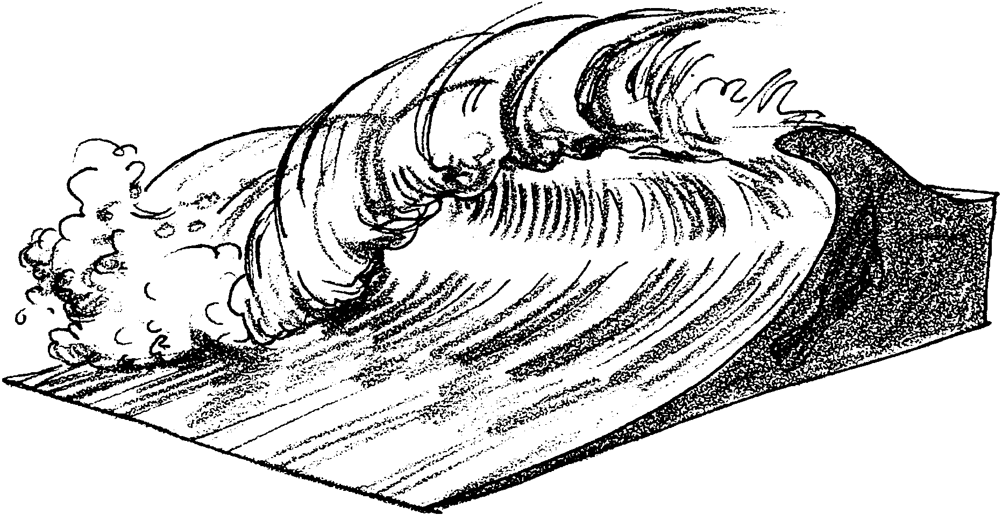
The Lifecycle of Ocean Waves
—A Picture’s Worth

The article, “The Lifecycle of Ocean Waves”, includes several charts and diagrams. These are designed to help the reader to better understand the information presented in the text. Use the charts and diagrams in “The Lifecycle of Ocean Waves” to answer the following questions.

1. Take a look at Figure 1.What is the amplitude of a wave?

2. What is the frequency (or wavelength) of a wave?

3. Study Figure 3. What does “sea” mean in this illustration?
4. What do the circles in Figure 4 and in the drawing “The Lifecycle of
Ocean Waves” represent?

5. One often reads stories of sailors who encounter terrible storms with huge waves, 50 or more feet tall. What does the chart in the text on page 41 say about those stories?

6. Based on Figure 5, state the relationship between speed and wavelength using words.

7. Based on Figure 6, what kind of ocean waves has the greatest amount of relative energy? Draw a sketch of what that kind of wave looks like.

8. Take a look at the drawings on page 42, “Beach Break Wave,” page 44, “Reef Break Wave,” and page 47, “Reef Pass Wave.” Which portions of the beach scenes in these drawings look like they would be most dangerous for a person?
9. Using Figures 8 and 9, discuss the differences between how waves behave over a ridge and how they behave over a canyon.

10. Use Figure 10 to help explain the characteristics of surging, spilling, and plunging waves.
The Lifecycle of Ocean Waves
Three-Level Guide
Level One
Directions: Read the statements carefully. Then, as you read the article, refer back to the statements and check those that you believe say or paraphrase what the author said. Be ready to support the statements you checked, and explain what is inaccurate about the statements you have not checked.
1. Waves are a fundamental way in which energy is transported in the world.
2. Ideal laboratory waves share the same features as ocean waves, but do not exist in the open ocean.
3. While a wave moves across thousands of miles of open ocean, the water making up the wave stays in basically the same place.
4. Tides are very different from waves.
5. Tsunamis are very difficult to detect in the open ocean, because they are small and move very fast.
6. The largest wave ever reliably reported was 112 feet high.
7. Most ocean waves are between 7 and 12 feet high.
8. The differences between sea and swell have to do with their shape and period.
9. When a wave moves into water shallower than one-half the wave height, it becomes a shallow-water wave.
10. Rogue waves result from the interaction of two or more wave trains.
11. When a wave moves into shallow water, it slows down, steepens, and becomes higher.
12. Deep water waves and shallow water waves both break when their height is greater than 1/7 of their wavelength.
13. Plunging waves are the ideal waves for surfing.
14. Plunging waves occur over steeper sloping bottoms than spilling waves.
15. Points on the shore will typically be gravelly or rocky, while the bay into which the point leads will generally have beaches of fine sand.
Level Two
Directions: Read each statement. Then, using the article as reference, decide whether you agree or disagree with each statement. Check those statements which you feel can be supported by the article. Be ready to support your opinions.
1. The contour of the sea bottom affects the shape of the waves travelling above.
2. Natural disasters can have an influence on waves.
3. Tsunami Park in Hawaii was created to increase public awareness of "tidal waves".
4. Force, duration, and fetch of wind all influence the size of waves at sea.
5. Nearly half of all ocean waves are under 4 feet high.
6. As sea matures into swell, the wavelength tends to increase, and the height tends to decrease.
7. Individual waves move half as fast as the group to which they belong.
8. Waves break when there isn't enough water ahead of the wave to fill in the front of it.

Level Three
Directions: Read each statement, relating the details and interpretations drawn from the article to ideas and experiences you've had in reference to the topic. Check the statements you agree with, and be ready to support your opinions.
1. All waves are basically similar.
2. Ocean waves have a lifecycle similar to living things.
3. While ocean waves may be fascinating in and of themselves, there is little practical value in studying them.

