Farming Four Feet Under
—Three Level Guide
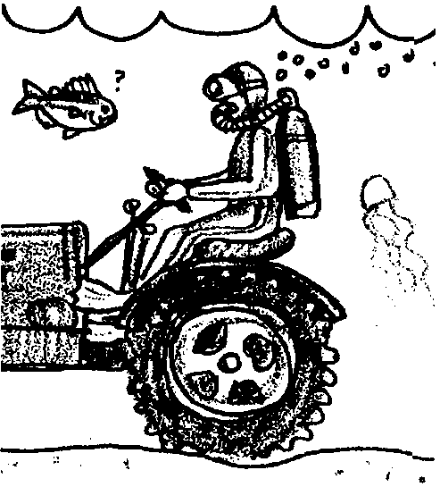

Key Concepts
1. Researchers are developing techniques to raise and harvest seaweeds.

Background
As the human population increases, demands upon the resources of the sea also increase. In a large number of places, research is underway aimed at increasing human use of the sea through the culture and harvest of seaweed.

Materials
For each student
• 1 copy of article: “Farming Four Feet Under” (Romeo, Judie, editor, Pacific Northwest Sea. 1977 Vol. 9, No. 3: 11-14.)
• 1 copy of “Farming Four Feet Under—Three-Level Guide”

Teaching Hints
In “Farming Four Feet Under”, students read and review a largely non-technical summary of research, conducted in the Puget Sound, which presents some of the concerns of and methods used by research scientists. Be aware that this article tends to minimize the unknown and possible deleterious side affects of algae culture. The increasing use of algae derivatives makes seaweed culture especially attractive. Additional background information may be found in the activity “Sea Forest”.
If your students are not familiar with the Three-Level Guide, explain to them that the guide will take them through three levels of questioning, from a literal level, to inference, and then to analysis and synthesis. The idea is not to “get the answer right” per se, but more importantly, to use the questions as a guide to the major ideas in the article, and to try to incorporate those ideas into one’s own knowledge base. It is important to emphasize to the students that their reasoning is much more important than their answer. In fact, in levels two and three, there may be no “right” or “wrong” answer!
Traditionally, Three-Level Guides have been intended for individual work. Suggest that the students read the statements in the three-level guide before they read the article. (Some students may prefer to read the article first, then go back over it a second time with the three-level guide). The guide is intended to be a vehicle for helping students look for certain concepts in the article.
When students have finished, discuss the guide, referring to the article. You may wish to have students work in collaborative groups to compare their answers. The process of resolving differences of opinion can be very instructive.
It is sometimes helpful to have students note the page number and paragraph where they found evidence to support their answer. You may require the students to provide sound, complete explanations for the answers they chose!
For additional information about Three-Level Guides, see Teacher Background for the activity “Meanwhile, in the Pacific...” (unit 2).

Key Words
carrageenan - commercially valuable gel derived from red algae
culture - cultivation of organisms; also the product resulting from such cultivation
extract - something (juice, ingredient, etc.) separated from a mixture by pressure, distillation, treatment with solvents or the like
relationships - connections, associations between individual organisms or groups of organisms
seaweed - marine algae visible to the naked eye

Extension
1. “One Step Further...” provides your students with an opportunity to further their graph reading skills by utilizing two graphs from a technical paper written by Tom Mumford, the biologist mentioned in the article “Farming - Four Feet Under” read by your students.

Answer Key
“Farming Four Feet Under” - Three Level Guide
Level I:
Directions: Read the statements carefully. Then as you read the selection, refer back to the statements in the guide and check those that you believe say what the author actually said or paraphrased in the selection. Indicate the page, paragraph and sentence on the statements checked for later reference. Also, be ready to explain what is inaccurate about the statements that you do not check.

x Research is being conducted aimed at growing seaweed as a crop for the production of carrageenan.
x Harvesting wild stocks of seaweeds is often dangerous and unproductive.
The Department of Natural Resources (DNR) cannot encourage the establishment of marine industries.
x To culture seaweeds, nylon nets (stretched over plastic pipes) are placed in wild seaweed beds.
The seaweed harvester used currently separates the seaweed blades from the nets and draws the blades to the surface to a waiting barge.
x Net cultured plant yield is less than tank cultured but is catching up.
x U.S. demand for seaweed extracts is currently being met by foreign countries.
Directions: Now compare your answers with those of others in your group. If there are many differences, find the page and paragraph that support your answer and write them next to the statement in question. When you finish your discussion, go on to the next level.

Level II:
Directions: The statements below may or may not be true. Check each statement you believe is a generalization the author himself draws based on the information he gives in the selection. Indicate the page, paragraph and sentence on the statements checked for later reference.

x Seaweed culture could become an important new industry in the Puget Sound.
x Different researchers have different theories regarding how to make seaweed culture a reality.
Seaweed culture may be possible in areas in which we do not now find seaweed growth.
x The next thrust of research will involve economic and technical considerations.
Directions: Now compare your answers with your group. As before, where there are differences, try to resolve them by reference to the selection. When you finish your discussion, go on to next level.

Level III:
Directions: Read each statement below, relating the details and author’s interpretations drawn from the selection to ideas and experiences you’ve had in reference to this topic. In column A, check the statements with which Mumford would have agreed. In column B, check the statements with which you agree.

A B

We currently know enough about the relationships that exist between plants and animals in the sea to accurately predict the changes that will occur due to widespread algae culture.
x Algae culture is an important means for reducing our dependence upon other nations for an adequate supply of the algae derivatives used in many industries.
x More research is needed before net culture should be implemented on a large scale.
x In the future, humans will need to more fully utilize the resources of the seas.
x There’s big money in algae!
Directions: Again, compare your answers with your group. Where there are differences, try to resolve them.

One Step Further
Figure 1

1. Net 2A was harvested about June 10 and October 15 (the dates must be extrapolated from the graph so some variation is permitted). Net 2B was harvested about July 20 and again on October 15.

2. The net had a three inch mesh.

3. The highest wet weight found on Net 2B occurred about July 10. (The weight was about 5.5 kg/0.25m²).

4. The rapid decreases seen June 10 and July 20 are a result of harvesting.

5. According to Figure 1, the period of most rapid growth for Iridaea cordata occurs from April to the first part of July.

6. For Net 2B the optimal harvest time in 1976 was about July 10. After this date the wet weight per 0.25m² began to decrease.

Figure 2

7. June and July had the highest average growth rate (from June 15 to July 15)

8. During the first half of October, the average growth rate was about minus 15 grams of salt-free dry matter per day per meter square. The plants actually lost weight.

9. The growth rate from August 15 to November 15 was negative. This kind of growth rate might be explained by overharvesting - more material was being removed than was being produced. The harvesting might have been by marine herbivores or by man, we can’t really tell from the data. Storms or disease could also cause the results observed.

10 a. According to figure 2, the optimal time for harvest would have been about July 12.

b. The date on figure 2 should agree closely with the answer for number 6 above.
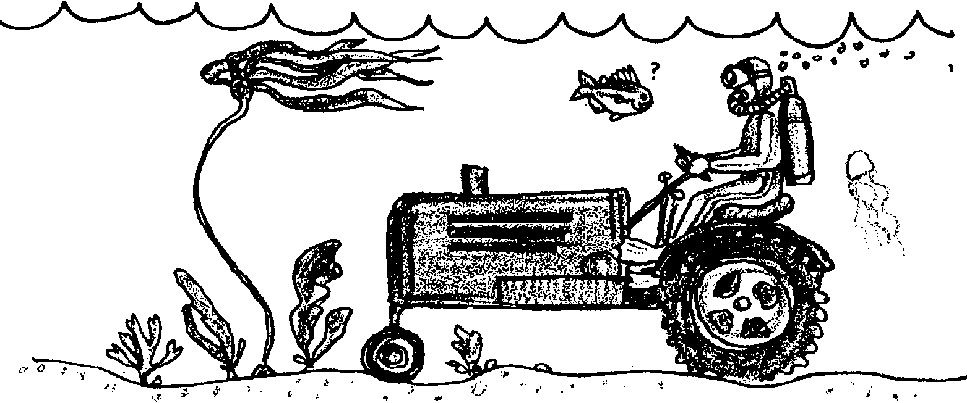
Farming Four Feet Under
—Three Level Guide

Level I:

Directions: Read the statements carefully. Then as you read the selection, refer back to the statements in the guide and check those that you believe say what the author actually said or paraphrased in the selection. Indicate the page, paragraph and sentence on the statements checked for later reference. Also, be ready to explain what is inaccurate about the statements that you do not check.

Research is being conducted aimed at growing seaweed as a crop for the production of carrageenan.
Harvesting wild stocks of seaweeds is often dangerous and unproductive.
The Department of Natural Resources (DNR) cannot encourage the establishment of marine industries.
To culture seaweeds, nylon nets (stretched over plastic pipes) are placed in wild seaweed beds.
The seaweed harvester used currently separates the seaweed blades from the nets and draws the blades to the surface to a waiting barge.
Net cultured plant yield is less than tank cultured but is catching up.
U.S. demand for seaweed extracts is currently being met by foreign countries.
Directions: Now compare your answers with those of others in your group. If there are many differences, find the page and paragraph that support your answer and write them next to the statement in question. When you finish your discussion, go on to the next level.
Level II:

Directions: The statements below may or may not be true. Check each statement you believe is a generalization the author himself draws based on the information he gives in the selection. Indicate the page, paragraph and sentence on the statements checked for later reference.

Seaweed culture could become an important new industry in the Puget Sound.
Different researchers have different theories regarding how to make seaweed culture a reality.
Seaweed culture may be possible in areas in which we do not now find seaweed growth.
The next thrust of research will involve economic and technical considerations.
Directions: Now compare your answers with your group. As before, where there are differences, try to resolve them by reference to the selection. When you finish your discussion, go on to next level.

Level III:

Directions: Read each statement below, relating the details and author’s interpretations drawn from the selection to ideas and experiences you’ve had in reference to this topic. In column A, check the statements with which Mumford would have agreed. In column B, check the statements with which you agree.
A B
We currently know enough about the relationships that exist between plants and animals in the sea to accurately predict the changes that will occur due to widespread algae culture.
Algae culture is an important means for reducing our dependence upon other nations for an adequate supply of the algae derivatives used in many industries.
More research is needed before net culture should be implemented on a large scale.
In the future, humans will need to more fully utilize the resources of the seas.
There’s big money in algae!

Directions: Again, compare your answers with your group. Where there are differences, try to resolve them.
One Step Further

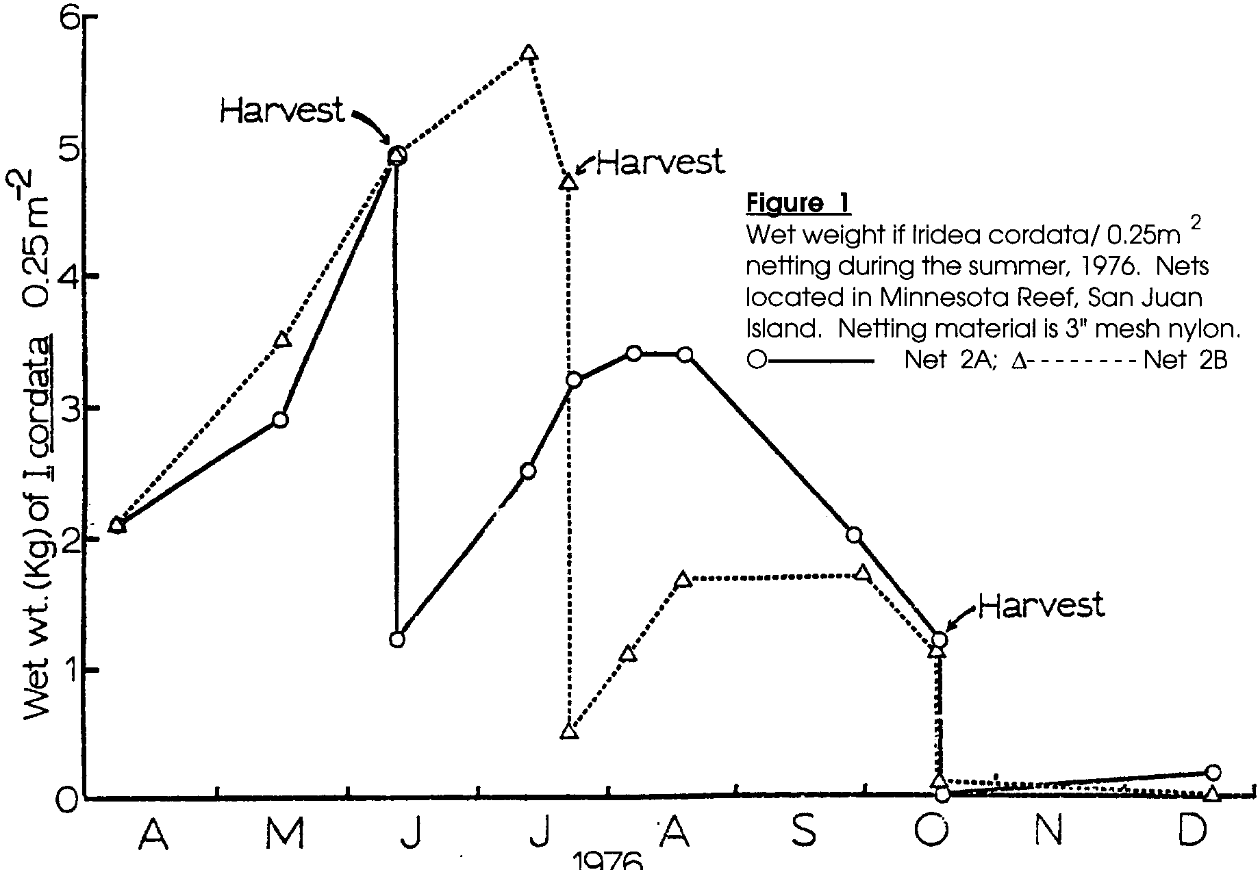
The two graphs which follow were prepared by Tom Mumford and describe some of the results of his studies. Use the two graphs to answer the following questions.

1. When was net 2A harvested? Net 2B?

2. How large was the net mesh?

3. When was the highest wet weight found on Net 2B?

4. What accounts for the rapid decreases seen at June 10 and July 20?
5. According to figure 1, when does the period of most active growth occur for Iridaea cordata?

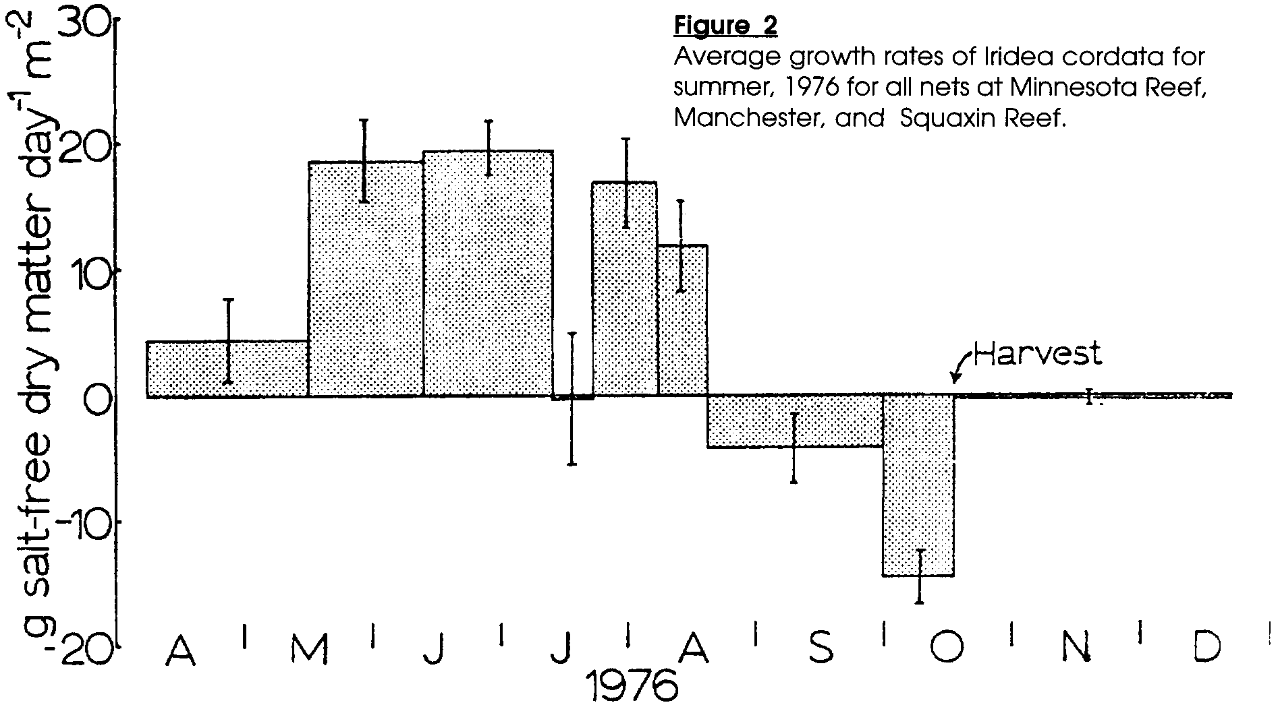
6. For Net 2B when did the optimal (best) time for harvest occur in 1976?

7. Which month(s) had the highest average growth rate?

8. What was the average growth rate during the first half of October?

9. How can you explain growth rates like those seen from August 15 to November 15?

10 a. When did the optimal time for harvest occur in 1976 according to
figure 2?

b. How does this date agree with your answer for number 6 above?

