Sea Forest
Edited by Holly Shewbridge, Monterey Peninsula School District, Monterey, California.
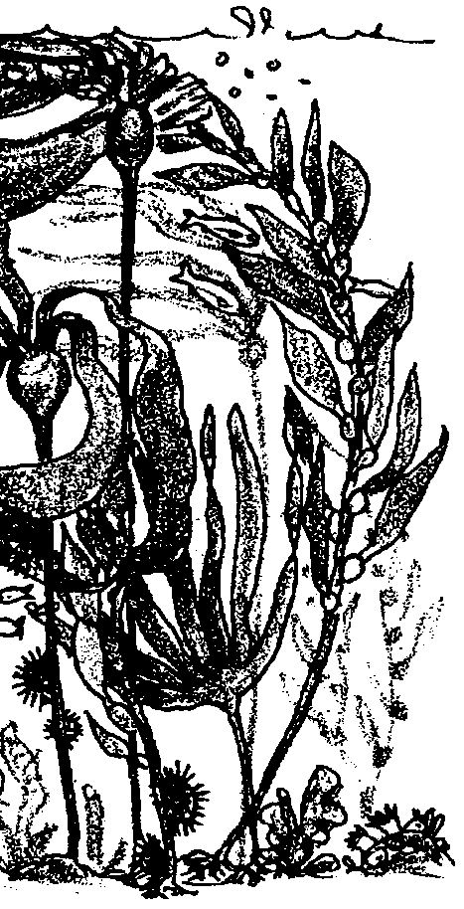

Key Concepts
1. Algae come in a variety of shapes, colors, and sizes.
2. Marine algae play significant roles in ocean ecology. They are primary producers, provide habitat for other marine life and buffer coastlines from wave action.
3. Seaweeds are significant economic and commercial resources.

Background
In temperate, cold water regions, the tumultuous rocky and sandy shores are home to the magnificent and highly productive kelp forests. The giant kelp, members of the Division Phaeophyceae or brown algae, usually require a rocky substrate to which they can attach. Some kelp forests grow attached to tube worm casings or other shells in sandy habitats. They depend on the high oxygen levels and continuous flow of nutrients present in coastal areas with high wave action.
Giant kelp form a canopy, not unlike the canopy of a terrestrial forest. Other algae grow under or even on the kelp, sheltered from the heaviest wave action and utilizing light filtering through the canopy. This community of algae is extremely productive, with a net primary productivity rivaling that of mangroves and estuaries.
Kelp forests shelter a dense population of invertebrates and fish. The young of many species hide and feed in the kelp forests. Perhaps the most intriguing inhabitants are the sea otters. They find shelter in the kelp, even wrapping themselves in the foliage to keep from drifting. They feed heavily on sea urchins, abalone, and other kelp eating herbivores and thus help maintain a lush kelp canopy.

Materials
For each student:

• a copy of “Sea Forest”
Teaching Hints

“Sea Forest” introduces students to the kelp forest, outlining the kelp forest’s important ecological roles and presenting major groups of algae and their physical characteristics. “Sea Forest” also provides an overveiw of the myriad human uses of kelp and other seaweeds.
Duplicate the text materials. One set is recommended per student. To save costs on copying, class sets can be made and have students write answers on binder paper. This activity lends itself well to individual completion as an in-class assignment or as homework. You might elect to have your students meet in small groups to discuss their answers before you conduct a general discussion. Use the technique that best suits the needs and abilities of your particular class.
A crossword puzzle has been included to reinforce the new vocabulary introduced in this section. Recognize the new terminology introduced and use it whenever possible in your discussion with your classes. While the scientific names of the plants illustrated are given, there is no real attempt to deal with the systematics of seaweed classification. Identification and systematics are best left to be tackled with seaweed samples in hand.

Key Words
agar - commercially valuable gel derived from kelp and red algae
algae - one-celled or many celled aquatic plants that have no root, stem, or leaf systems
algin - commercially valuable gel derived from kelp
blade - broad, leaf-like portion of algae
carrageenan - commercially valuable gel derived from red algae
chlorophyll - pigment essential for photosynthesis
Chlorophyta - division of algae that includes green seaweed
holdfast - the rootlike portion of the algae that holds it to a rock or surface. Unlike a true root, it doesn’t gather water and nutrients from the soil.
kelp - any large brown, cold water algae of the family Laminariaceae, used as food and in various manufacturing processes
mariculture - commercial growth of products from the ocean; also called ocean farming
Phaeophyta - division of algae that includes brown algae
photosynthesis - a process which occurs in the presence of sunlight in which six carbon dioxide molecules (CO2) and six water molecules (H20) are combined to yield one molecule of a simple sugar (C6H1206) and six molecules of oxygen (02)
phytoplankton - plant plankton; the primary producers of the sea
plankton - the mostly microscopic plants and animals that drift in water; singular = plankter
Rhodophyta - division of algae including red seaweed
seaweed - marine algae visible to the naked eye
spores - reproductive cells
stipe - the stalk arising from the holdfast and to which the blades attach
zonation - bands of an environment where particular plants and animals are found

Extensions
1. Eating seaweeds can create great interest in the study of algae. Have students bring in products that contain seaweed. Create a seaweed store and/or have a seaweed feast (make sushi!).

2. Mix up this pudding for a seaweed taste treat:

CREAMY TYPE COLD SET MILK PUDDING

5 teaspoons LACTARIN MV 406

7 tablespoons + 1 teaspoon non-fat milk solids*

3/4 cup sugar

6 cups milk

1-1/2 teaspoons vanilla

Makes 12 one-half cup servings.

a. Blend dry ingredients and place in large, electric mixer bowl.

b. Blend in 3 cups cold milk. Whip at high speed for 3 minutes.

c. Fold in an additional 3 cups cold milk and vanilla at low speed for approximately 1 minute.

d. Pour into mold or custard cups; refrigerate. Pudding may be consumed 5-10 minutes after preparation, but requires approximately 1 hour before it may be unmolded.

*To make milk chocolate flavor, substitute Carnation Hot Cocoa Mix Milk Chocolate flavor and eliminate the vanilla.

To acquire LACTARIN MV406, write to:
FMC Marine Colloids Division
2000 Market Street
Philadelphia, PA 19903
Telephone: 1-800-526-3649

Answer Key
1. The answer to this question is not to be found directly in the text, but relies on previous knowledge gained by the student.
Land and marine plants face rather different stresses. Land plants are limited by water availability and by nutrient availability. They also face problems in transporting water and nutrients to all parts of the plant. Marine plants, on the other hand, are surrounded by water and the water usually contains the nutrients. As a result, few marine plants have evolved elaborate transport systems. In addition, marine plants are largely free from the problems of gravity. The water supports the plant so they seldom have woody tissues like those used by land plants for support.

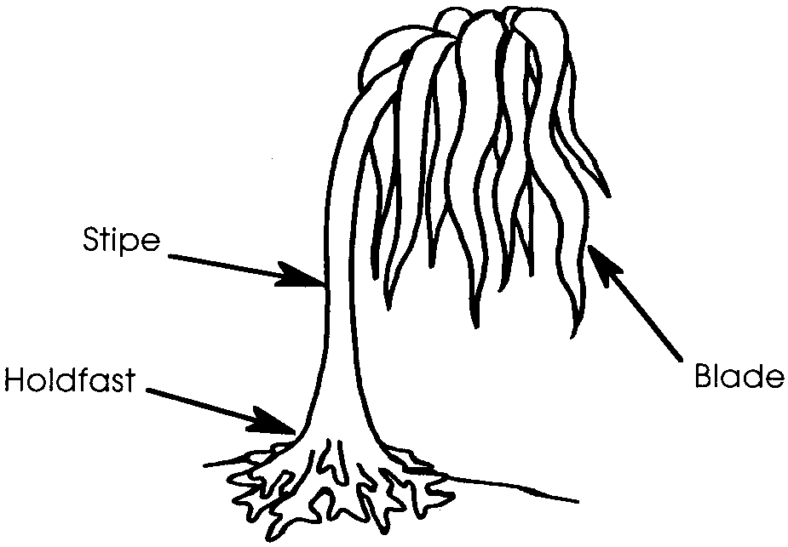
2.

3. The advantage to sexual reproduction is that it increases genetic variation in the population. Lack of variation means that if the environmental conditions are such that they will kill one individual, they will kill all of the individuals. Variation is a benefit to the species, not to the individual per se.

4. At this stage, most students will probably say “no”, they have not eaten seaweed. This question is rhetorical and is used primarily as an introduction to a subsequent section on algae derivatives.

5. Four historical uses for seaweed mentioned in the text are: a) food, b) soda ash, c) potash (fertilizer), and d) iodine.

6-9. The answers will vary, but should come from the lists included in the text.

Answer Key continued on next page.
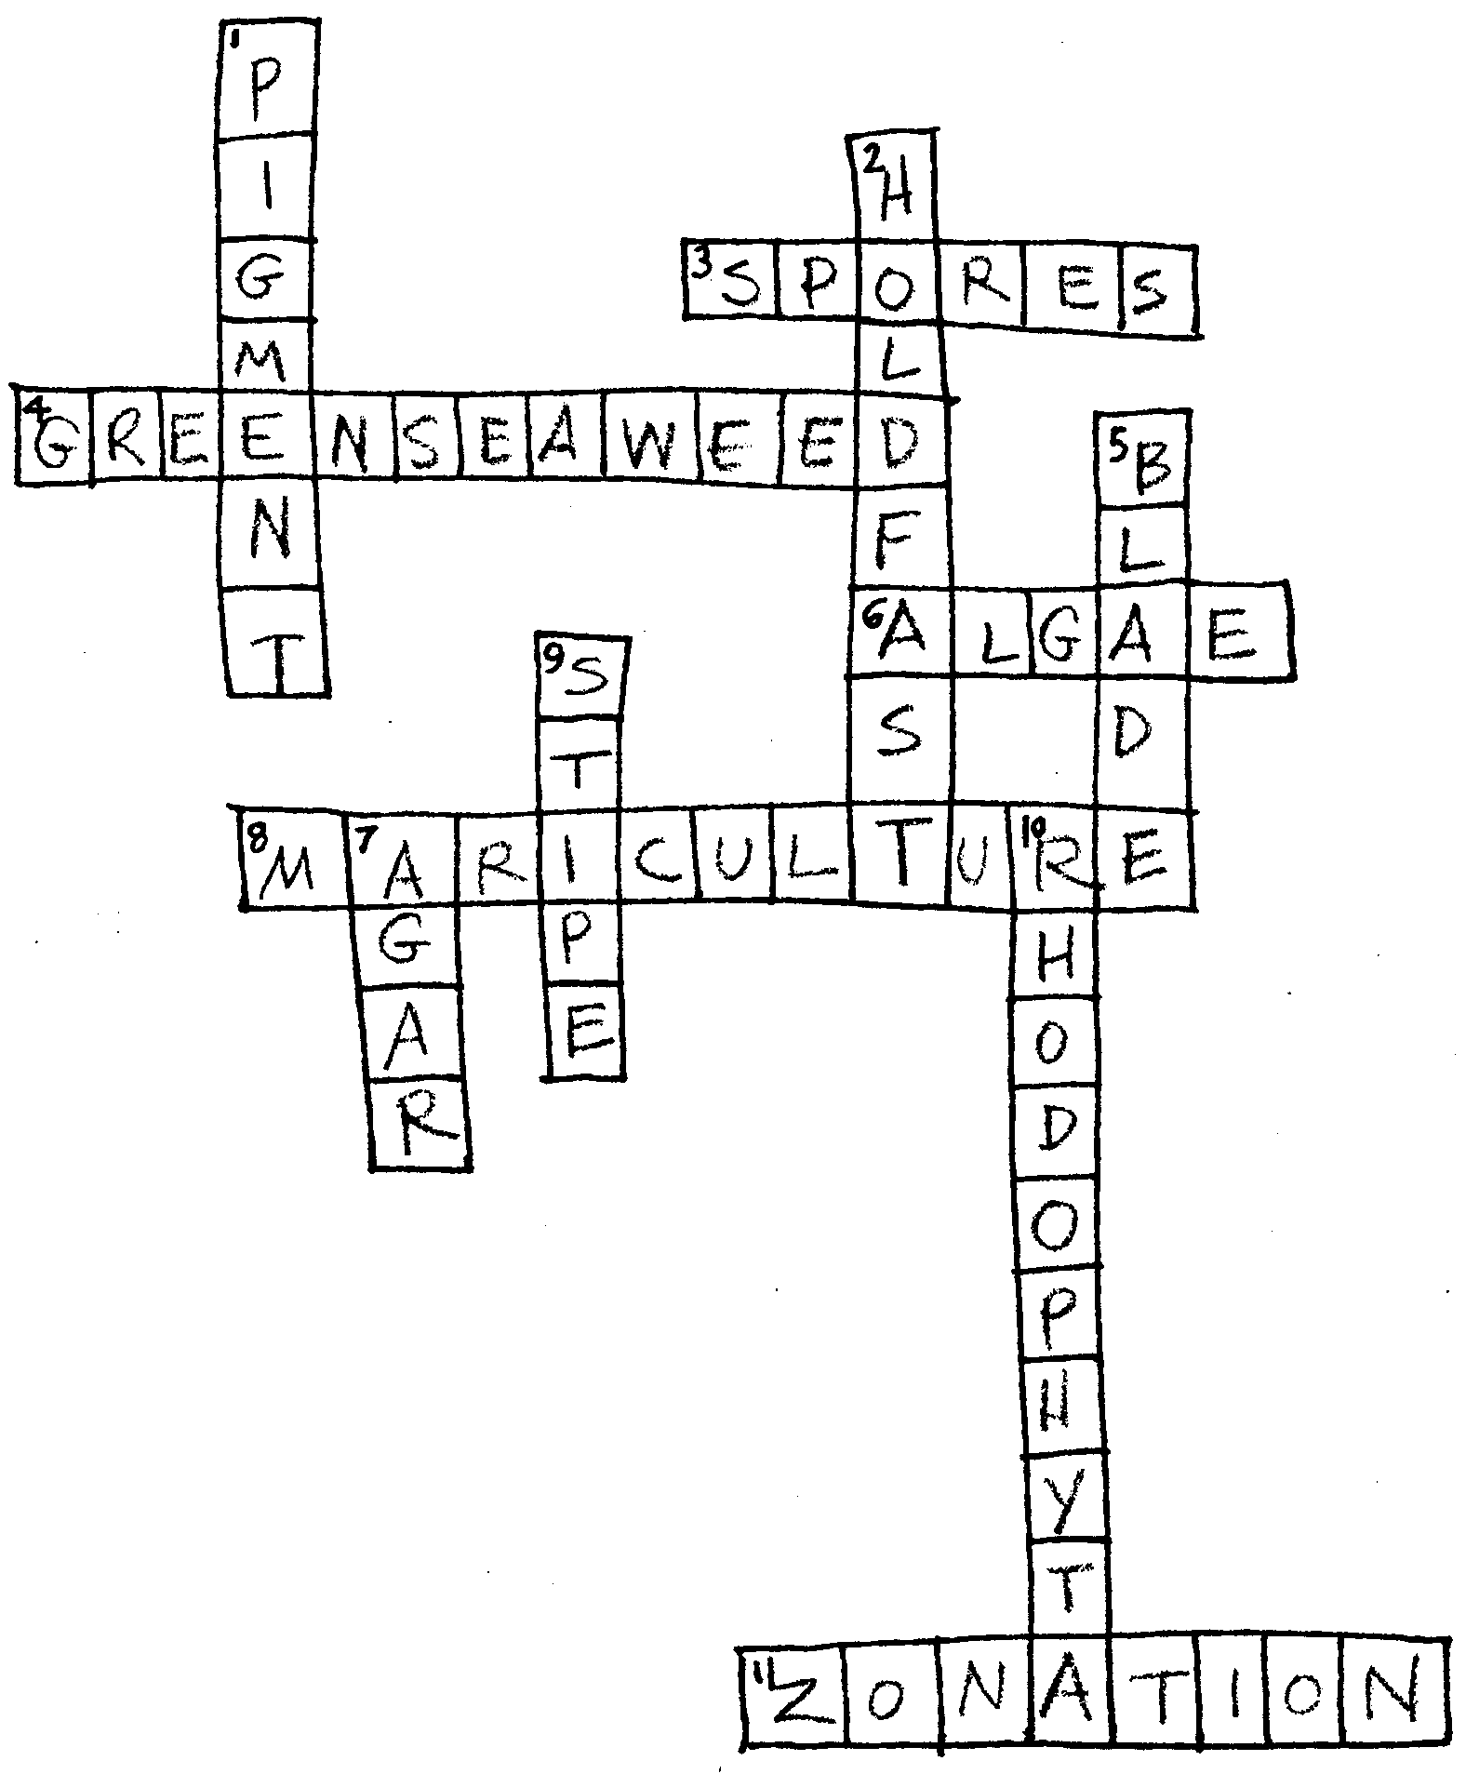
(Answer Key continued)

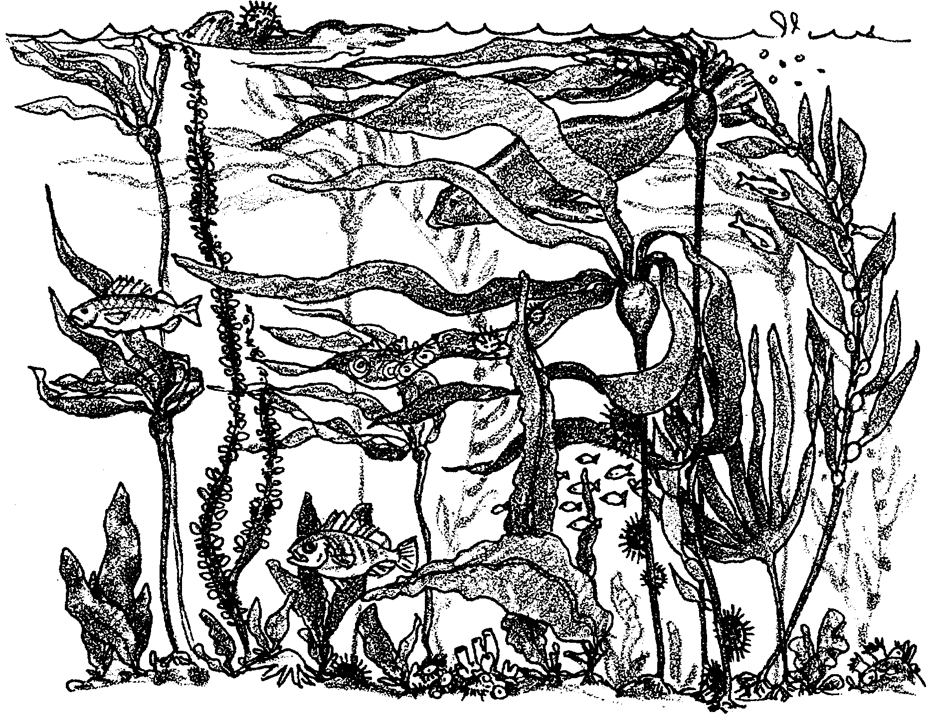
Sea Forest

Imagine trying to survive where the surf crashes into the beach. Surely very little could survive the tremendous energy released in the pounding of the waves!
It is in the crashing waves of exposed shorelines, however, that kelp forests thrive. Kelp, a type of algae, or seaweed, is flexible and bends in the surf instead of breaking. The beds of resilient kelp, in turn, shelter whole communities of sea otters, fish and other marine life. These are the forests of the sea.
Plants in the sea, just like plants on land, are often the first links in food webs. In most ocean food webs, marine algae are the primary producers. They capture energy from the sun, and then, through the process of photosynthesis, use the energy to make the sugars and starches necessary for life. This highly complicated process requires the green pigment chlorophyll. Algae, like land plants, also contain the green pigment chlorophyll and other yellow and red pigments.
Kelp and other seaweeds, however, are also quite different from land plants.
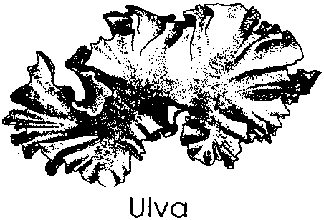
1. Land plants and marine plants face different environmental conditions. What are two factors that often limit where land plants can grow that usually are not a problem for marine plants?

Algae are relatively simple plants that do not form true root, stem or leaf systems. One group of algae, the green algae, grow in sheets that may look like lettuce or in filaments that look something like green noodles or shredded green cellophane. They usually grow in intertidal areas or in very shallow water, so very little green algae is found in the always submerged kelp forests. Because of the similarities found among the green algaes, scientists place them in a group they call "Chlorophyta". "Chlorophyta" comes from the Greek words "chloro = green" + "phyta = plant".
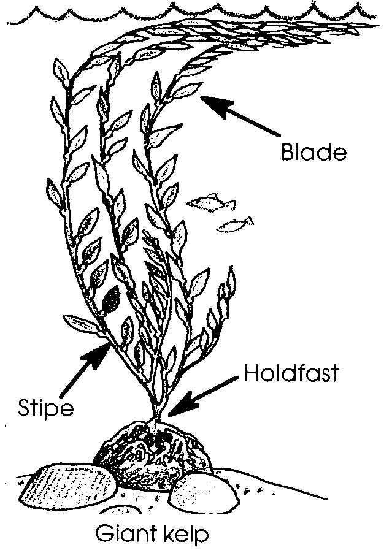
The giant kelp, the “trees” of the undersea forest, are in a group of algae known as the brown algae. The brown algae have parts that look like roots, stems and leaves, but, since they do not function like true roots, stems and leaves, they are given different names: holdfast, stipe and blades. Scientists place brown algae in a group they call "Phaeophyta". "Phaeophyta" comes from the Greek words "phaeo" = "brown" + "phyta = plant".
A land plant must pick up water and nutrients from the soil with its roots and then transport those materials through the stem and to the leaves. Marine algae, on the other hand, are surrounded by water which contains the necessary nutrients. The marine algae simply absorb them through all parts of the plant body. The holdfast in brown algae, then, only serves to anchor the algae. The holdfast literally holds the algae in place. The stipe reaches up to the lighted surface water. The holdfast of a giant bull kelp may be attached 30 meters or about 100 feet deep, so its stipe must reach about 30 meters or 100 feet up to the water surface. The blades at the top of the stipe have a large surface area for capturing the sun’s energy.

2. Label the sea palm shown below:
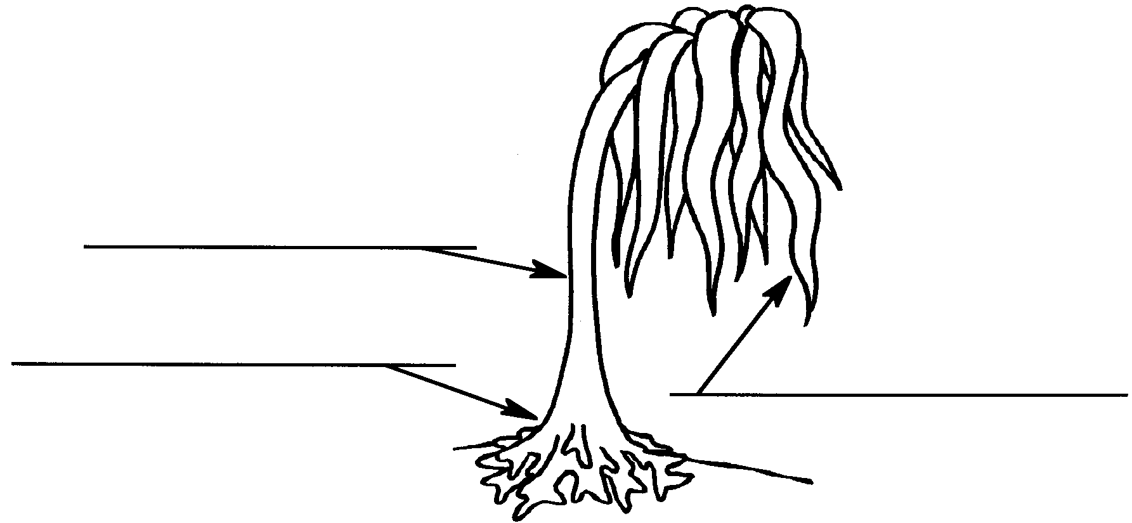

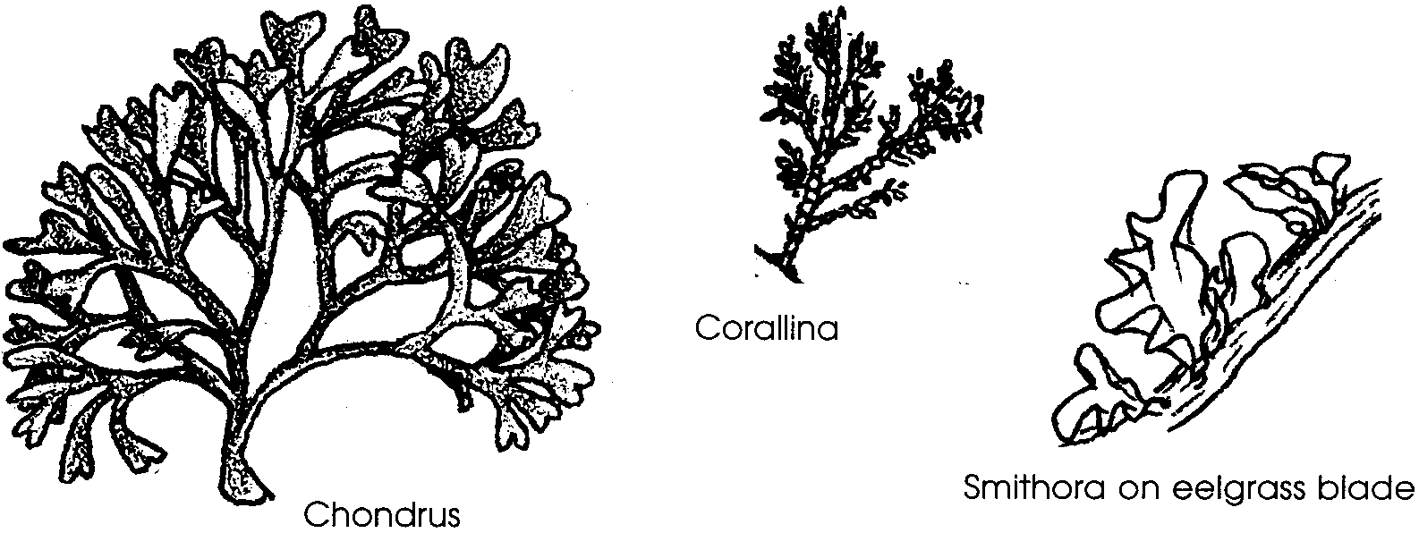
A third group of algae, the red algae, are much smaller than the brown kelps. They come in an incredible variety of shapes and textures and can appear reddish-orange, purple or even black. They live at many depths from high up on the beach in intertidal areas to the maximum depth of light penetration. In the kelp forest, the red algae tend to grow in red carpets below the bull kelp or actually on the blades of other seaweeds. Scientists place red algaes in a group they call "Rhodophyta". You guessed it. "Rhodophyta" comes from the Greek words "rhodo = red" + "phyta = plant".

Algae also differ from many land plants in that they never form flowers or seeds. The most common form of reproduction involves the formation of tiny spores. The spores either float or swim away and form a new plant. Some of the red and brown algae reproduce by breaking apart. Each section of the plant body may become a new individual. In this case, the new plants are carbon copies of the original.

3. Algae can also reproduce sexually. Sexual reproduction results in offspring that are not exact copies of the original and allows for variation among the individual members. What is the advantage of sexual reproduction in algae?

Seaweeds play an important role in coastal areas. They produce food and oxygen, and provide protection for many small animals and other algae species. Close examination of seaweed will reveal small crabs, fish and snails with shapes and colors that allow them to blend in with the seaweed. The seaweeds also assist in reducing the full force of storm waves. Seaweeds, including kelp, also are an important economic resource for humans. They are harvested for food and an incredible variety of other uses.

A Little History of Human Use of Algae
The earliest use of seaweed was as a food. For centuries the peoples of the Far East have harvested and cultivated seaweeds as a food source. Today, certain species of seaweed bring very high prices as relished specialty foods in Japan and other Asian nations. Some seaweeds, such as red nori and brown kombu are eaten whole. Because the seaweeds concentrate minerals and vitamins, they are a valuable food resource. Seaweeds are also eaten in South America and to a limited extent in some of the European countries. Although the oldest use for seaweed is as food, it is no longer the only or even the largest use.

4. Have you ever eaten seaweed? If so, when and where?

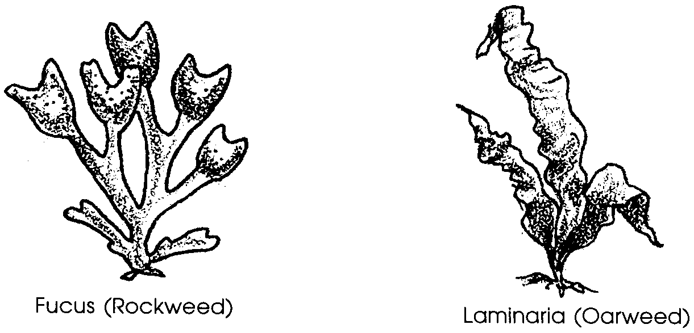
During the seventeenth century, French peasants began to manufacture soda ash from brown seaweed known as rockweeds and oarweeds.

The manufacturing process was simple and yielded substantial quantities of soda ash needed by glass makers and pottery glazers. The algae were collected by hand at low tide or after storms. As in most cottage industries, the whole family was involved. The young men were in charge of collecting the seaweed while the women, children and older men burned the seaweed in kilns. The burned seaweed was discovered to be a source of potash, an important fertilizer. Iodine was also discovered to be present in seaweed and techniques were developed to remove the iodine before the soda and potash were extracted. The iodine played a very important role in medicine. It wasn’t long before people began to take a closer look at the burning process. People also noticed the dense clouds of smoke coming from the kilns. As early as 1769, in France, complaints from neighbors stated that the fumes from the kilns damaged the fisheries and adjacent orchards.
Other sources and processes such fermentation yield a greater variety of products and replace the process of burning seaweed. The Soviet Union is now the only major producer of iodine from seaweeds. As land-based supplies of the materials once provided by seaweeds decrease, in the future seaweeds may once again play an important role in the economy of many maritime nations.

5. What were four historical uses for seaweeds?

The importance of seaweed in today’s economy comes from the yield of products which were once discarded in the extraction of iodine, soda, and potash. Today, boats mounted with “kelp mowers” harvest kelp from the surface down to a depth of about four or five feet. The kelp moves onto a conveyor belt and into a chopper where whirling knives cut it into six inch lengths. The kelp is loaded into a barge and taken to shoreside factories. Using these boats, crews of from six to nine men can harvest up to 50 tons per hour.
Gels (jelly-like substances) are extracted from kelp and other brown and red algae, and are used in foods, dental products, medicines, cosmetics, and industry. These gels are algin, agar, and carrageenan.
What are the extracted products? The group of large brown algae known as kelp is an important source of the gel algin. Algin powder has the interesting property of absorbing large quantities of water. One teaspoonful of algin dissolved in a quart of water will make the water so thick that it can hardly be poured. This is handy for lots of things. A teaspoonful of algin added to a gallon of ice cream prevents the water from forming coarse ice crystals in the ice cream. It also helps prevent the cupcake icing from sticking to the cellophane wrapper of your favorite sweet treat. Algin suspends penicillin and other antibiotics in solution so that they may be uniformly administered. It suspends the abrasives in auto polish and the pigment in paints. As can be seen from the list which follows, the uses of algin are incredible.

6. What are three ways you have used algin?
a.

b.

c.

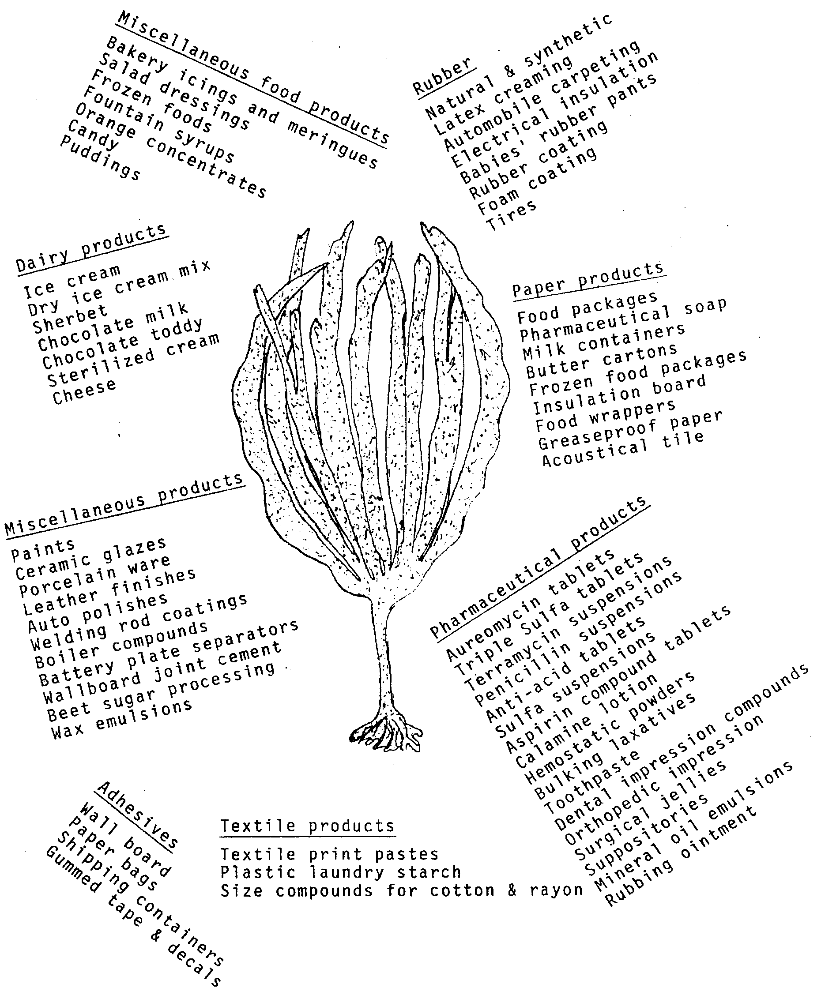
Agar gel is usually extracted from brown kelps and the red algae Gelidium by boiling. Agar is very important in microbiological laboratory studies where it provides a “medium” for the growth of microorganisms. Agar is nontoxic and is widely used in the canning of meat and fish. It is found in some other canned foods and cereals as well. Agar is also used in many of the same ways as algin and carrageenan.

7. Look at the list of “Major Algal Gum Applications in the Food Industry”. What are three ways you have used agar?

a.

b.

c.

Carrageenan is extracted from the red algae Chondrus . It is used extensively in the production of many items. Because of its non-toxic properties, it is used in many of the same branches of industry as algin. The list, “Major Algal Gum Applications in the Food Industry”, shows how widespread the use of carrageenan is today. It is safe to say that everyone in this country has either eaten seaweed or used products manufactured with seaweed derivatives. These “weeds” are important contributors to the quality of life.

8. What are three ways you have used carrageenan?

a.

b.

c.

9. What are three products you have used that contain all three gels: agar, algin, and carrageenan?

a.

b.

c
.
Most algaes harvested today are "wild" algaes, algaes growing on their own in the ocean. Increasingly, humans are planting and tending seaweeds in our coastal waters. This farming of seaweed for food and other uses is called "mariculture". In the years ahead, watch and listen for this word.
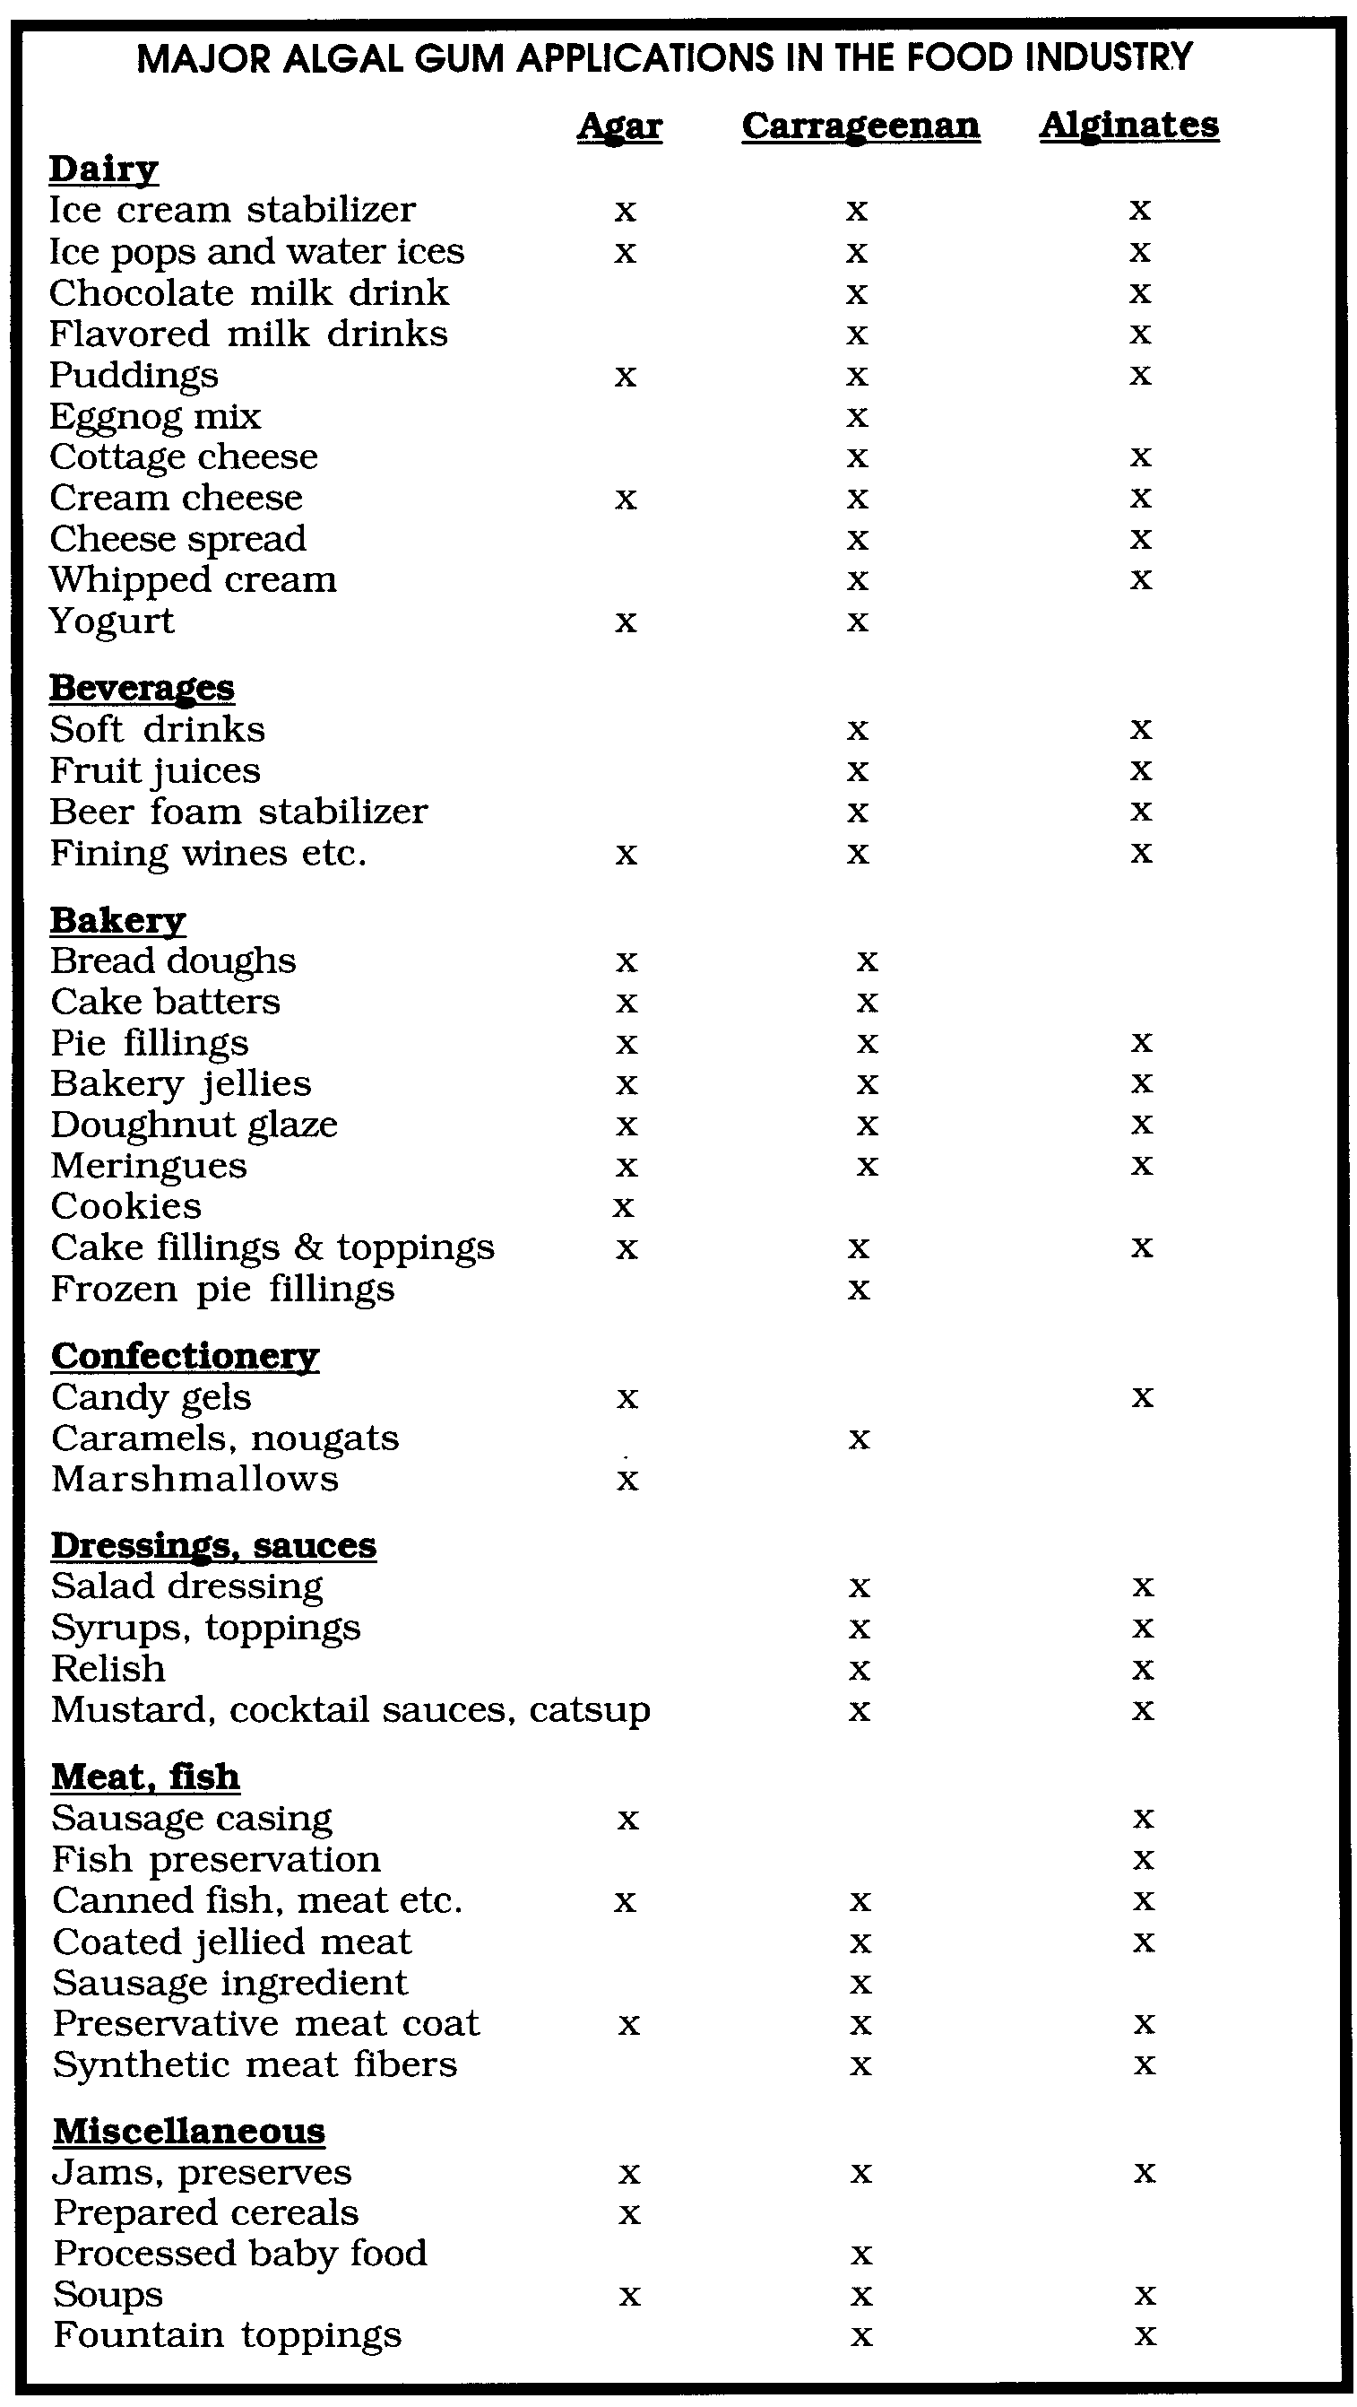
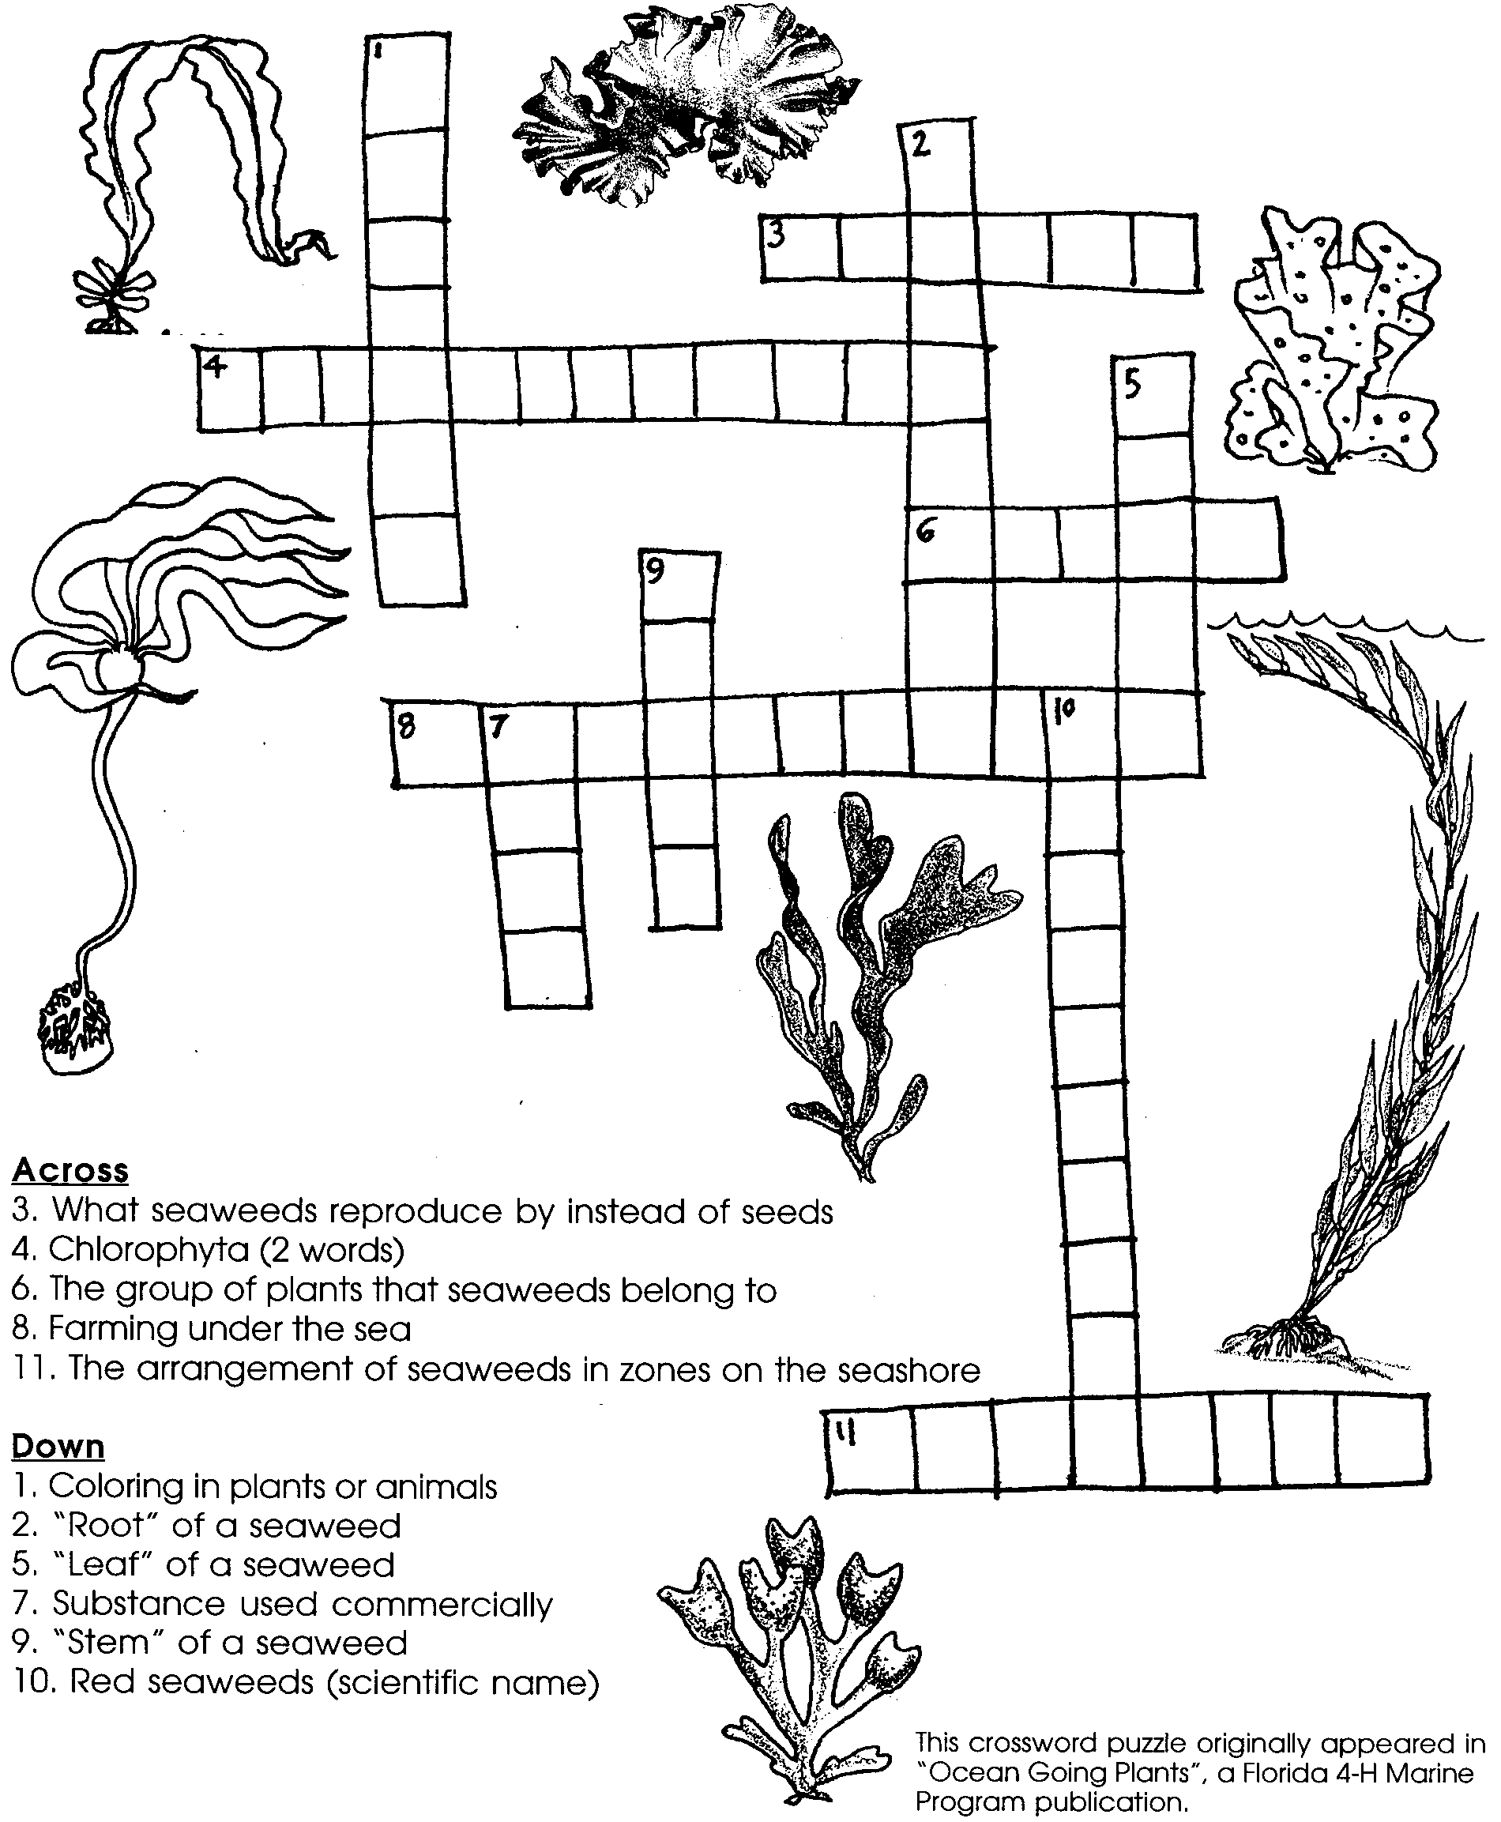
The giant bull kelp and other algae of the kelp forest are extremely valuable to humans as a food source and as an industrial resource. In their natural environment, algae are the foundation of complex food webs. They serve as wave breakers and provide habitat for a rich diversity of marine life. The sea forest are colorful and important jewels of the wave swept coast.

