Pressing Algae
Edited by Holly Shewbridge, Monterey Peninsula
School District, Monterey, California.

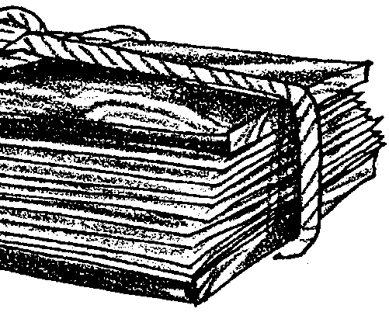
Key Concepts
1. Pressing algae is an effective way to become familiar with the variety and beauty of local algae.
2. Algae pressings can be used for reference and decoration.

Background
Algologists, botanists who specialize in the study of algae, have traditionally preserved specimens for study and reference by pressing, drying, and mounting. The specimens provide a long-lasting reference “library” of materials and can be quite beautiful. Additional background information may be found in the activities “Marine Ecology and Kelp Forests”, “Observing Algae”, “Key to the Identification of Some Common Marine Plants of the West Coast”, and “Sea Forest”.

Materials
For class of 32:
• several shallow pans (cafeteria trays, cookie sheets, dishpans)
• lots of newspaper
• two pieces of plywood
• two belts, a length of rope, or heavy objects (telephone books, rocks, bricks)

For each specimen to be prepared supply a piece of:
• mounting paper (art, drawing, or herbarium paper)
• waxed paper
• blotter paper (if available)
• corrugated cardboard

Teaching Hints
“Pressing Algae” provides an opportunity to make seaweeds interesting to your students. The techniques are simple but somewhat time consuming. This can be a fun and creative activity with products ranging from long-lasting reference specimens to works of art.
If you are able to collect fresh specimens of drift marine plants, be sure to check state and local restrictions. When collecting algae in the field, place all specimens from a particular habitat in a plastic bag. Include a label with pertinent information including date, location, collector, and habitat along with identification if known at this point.
Plants can be kept in plastic bags overnight in a refrigerator. You may want to put specimens in separate plastic bags before refrigeration. Also, be sure to keep fresh specimens of Desmarestia (see key) separated from other specimens. This alga is very acidic and may bleach other specimens. Do not add it to an aquarium because the acid it produces may kill the other organisms in the tank. Fresh specimens may become very slimy, so rinsing them with fresh water before use in lab may be desirable.
You may want to press the best specimens each year and use these to build up a school phycology (algae) collection. When preparing a collection, consider which labels to include. For example, when preparing specimens to use with the “Key to Identification of Common Marine Plants,” you may want to leave off the scientific name. Herbarium paper is the standard used, but typing paper or 3 x 5 cards will work if you select only parts of the algae. Thin specimens can also be laminated for protection.
The procedures do not differ greatly from those used in pressing land plants. However, algae need more pressure applied than standard botanical mounts. The general sequence is mounting paper, waxed paper, blotter paper, newspaper, cardboard. If blotter paper is not available, this step can be skipped. If the newspaper and waxed paper are not changed on a regular basis, the algae will begin to adhere to the wax paper. Have the students exercise care in choosing the portion of algae for mounting. The best portions should be utilized. The same procedures may be used for freshwater algae.
Either model how to press algae or duplicate the “Pressing Algae” instructions for each student team. Display a plant press and its component parts. Demonstrate how to prepare one plant for pressing and place with the proper waxed paper, etc.
Provide ample resource books and keys so that students may identify and learn more about their plants.

Key Words
algae - one-celled or many celled aquatic plants that have no root, stem, or leaf systems
blotter paper - soft, absorbent paper such as that found in desk blotters
frond - the blade(s) and stipe of an algae
herbarium - a collection of dried plants used for botanical study
holdfast - the rootlike portion of the algae that holds it to a rock or surface. Unlike a true root, it doesn’t gather water and nutrients from the soil.
intertidal zone - the region of a beach that is above the low water mark and below the high water mark
specimen - an individual organism used a representative of a group

Extensions
1. Students can create works of art such as bookmarks, greeting cards, etc.

2. Display the pressed and labeled algae on a classroom bulletin board.

3. Make seaweed prints on paper or tee-shirts. Lay rinsed and dried seaweed on newspaper. Apply poster or cloth paint with a roll or brush to one side of the specimen. Lift up the seaweed and place it on the paper or cloth with the paint side down. Cover with clean paper towel, and press or rub lightly to create the print. Gently lift off the seaweed. The seaweed can be rinsed and reused.
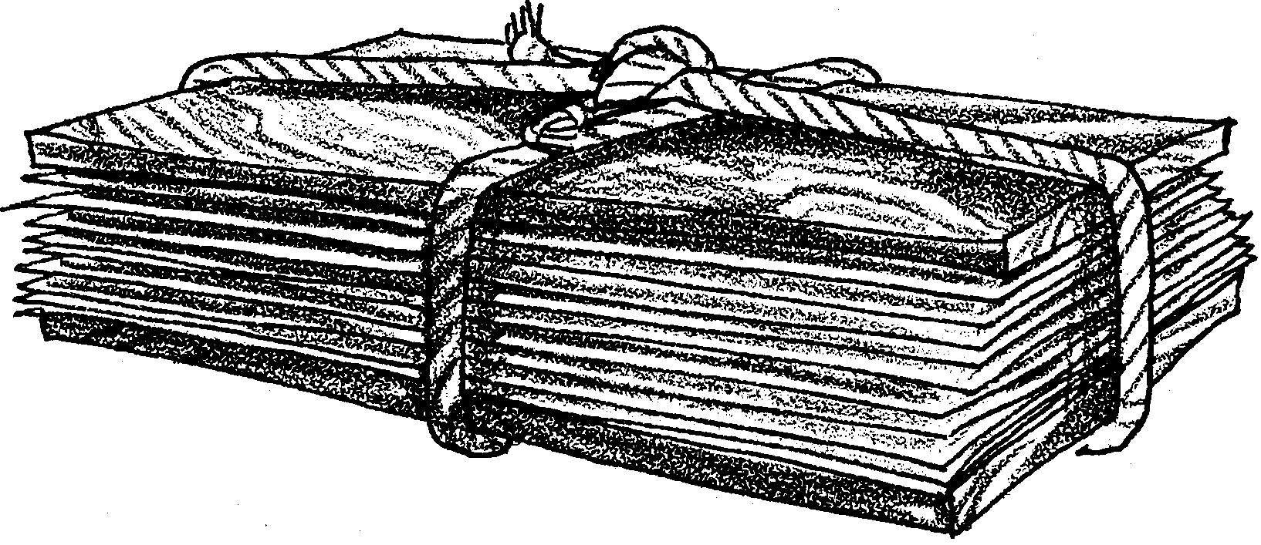
Pressing Algae

Many kinds of algae can be found along the seashore. Marine algae grow in a variety of shapes, colors, and textures. Pressing and mounting algae will help you learn more about these plants that are essential to marine ecosystems. The drift algae collected at a beach can be pressed and mounted for decoration as well as scientific study. In this lab you will arrange seaweed as flat as possible on a firm piece of paper. As the plants dry, pressure will be applied to produce a print-like appearance. Use local algae keys and reference books to help you identify the algae you collect.

Collecting dead and/or live organisms, including plants, from the intertidal zone is regulated by state and federal agencies. Check local regulations carefully before collecting any organisms from the seashore.

Materials:
• shallow pan (cafeteria trays, cookie sheets, dishpans)
• mounting paper (art, drawing, or herbarium paper)
• waxed paper
• blotter paper (if available)
• newspaper
• corrugated cardboard
• two pieces of plywood
• two belts, a length of rope, or heavy objects (telephone books, rocks, bricks)
Procedure:
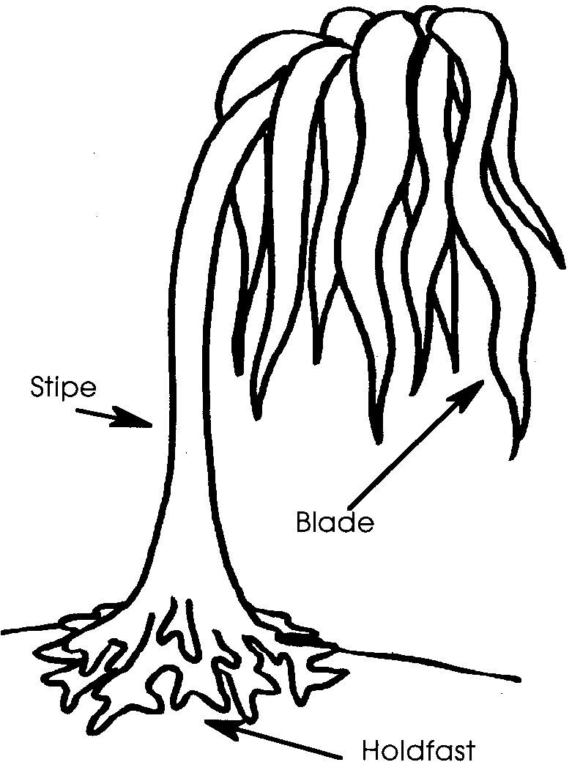
1. Collect drift algae specimens. If local laws allow, live algae specimens which are attached should be collected with the holdfasts intact. Be careful not to collect any animals that may be living in the algae. Live or drift algae should be kept wet until it is to be mounted. If it is necessary to sort algae the following day, keep it in a large plastic bag and refrigerated.

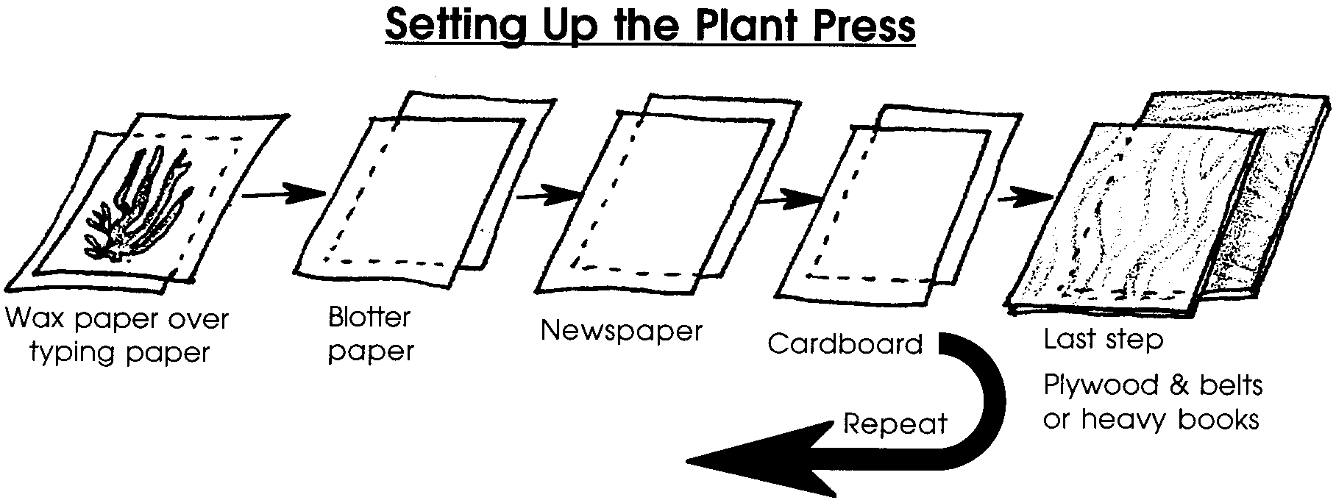
2. Select a specimen of algae to press. When possible choose a specimen that is complete with the blades, stipes, and holdfast. Avoid pressing algae that is too thick and bumpy. (Smaller pieces can be arranged for artwork, but be sure to use specimens of the same thickness so they will dry evenly). Rinse the specimen with sea water or fresh water in order to wash off any salt, fungus, sand, shells, etc.

3. Put a thin layer of water in a shallow pan. Float the piece of mounting paper in the pan, and then float the algae on top of the paper. Try to arrange the fronds so the algae is spread out and forms a thin layer. Carefully lift the paper and arranged specimen out of the pan and gently tilt the paper to drain off the water. If this process is too messy, spread the algae on dry mounting paper.

4. Put a piece of waxed paper on top of the algae. This will help to keep it from sticking to other layers. To keep track of your specimen, write your name on a small piece of scratch paper and place it on top of the waxed paper.

5. Next, place a layer of blotter paper (if available) on top of the wax paper, and then a few pages of newspaper on top of that.

6. Put a piece of cardboard on the newspaper.

7. Repeat these steps for each specimen you want to press. The basic unit is mounting paper with specimen, waxed paper, blotter paper, newspaper, and cardboard.

8. After all specimens have been prepared, stack them sandwich-style for drying. Start with a piece of plywood on the bottom, then a layer of cardboard and newspaper, then add the individual stacks of prepared specimens on top of each other, ending with plywood. Secure the stacks with belts, ropes, or weigh them down with heavy objects (e.g., telephone books, bricks, etc.).

9. Set the plant press near a heater or in any warm place where there is circulating air.

10. Change the layers of blotter paper and newspaper daily until plants are dry. Dry blotters can be reused. Up to five days may be required for plants to dry.

11. Some algae have natural adhesives which keep them attached to the paper. If the sample doesn’t stick, use a small amount of white glue on the paper to help attach the algae. If pressing algae for reference, use pencil or permanent marker to write the name of the plant, the place of collection, the date, a description of the habitat in which the specimen was collected, name of the collector, and any special remarks about the specimen.

