Identification of Common Marine Plants of the West Coast

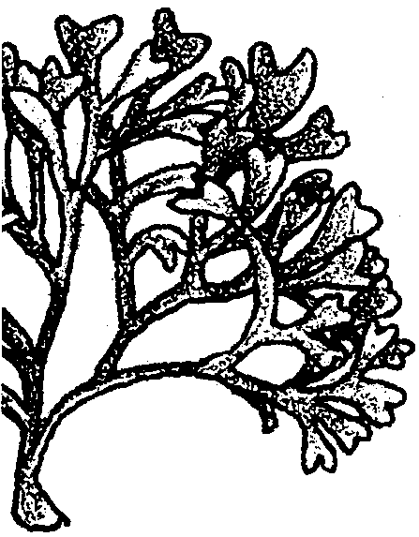
Key Concepts
1. Macroscopic marine plants of the West Coast can be divided into four basic groups: flowering plants, green algae, brown algae, and red algae.
2. External features can be used for identification of macroscopic marine plants.

Background
Many species of plants are found living in the marine environment. Marine plants are usually placed into one of four different divisions including seagrasses, green algae, brown algae, and red algae. Marine algae can be classified accurately based on pigmentation and reproductive life cycles, but these features require the use of microscopes and prepared cross-sections. Because the visible color of algae can sometimes be misleading, additional external features are often included in keys to identification.
The following key may be used as an aid to the identification of common visible marine plants, including the flowering seagrasses and algae found in Puget Sound and Monterey Bay. Most, but not all, of the plants included in this key can be found in both geographic areas. Many are found all along the west coast of the United States.
A glossary of terms to be used with the key is included.
Additional background information is found in the activities “Marine Ecology and Kelp Forests”, “Observing Algae”, and “Sea Forest”.

Materials
For each class:
• available specimens of marine plants (fresh or pressed, or pictures of algae labeled with common names only)
For each student or pair of students:
• copy of the Key to Identification
• copy of the glossary
• copy of the student worksheet
Teaching Hints

“Key to the Identification of Some Common Marine Plants of the West Coast” provides students with direct experience in the use of a dichotomous key. The key included can be used to identify common marine plants of the west coast. It is not required, and in fact may be difficult, to have all of specimens included in this key. If you are able to collect fresh specimens of drift marine plants, be sure to check state and local restrictions. You will need to collect a sufficient portion of a plant to allow identification.
Plants can be kept in plastic bags overnight in a refrigerator. You may want to put specimens in separate plastic bags before refrigeration. Also, be sure to keep fresh specimens of Desmarestia separated from other specimens. This alga is very acidic and may bleach other specimens. Do not add Desmarestia to an aquarium because the acid it produces will kill any animals in the tank. Fresh specimens may become very slimy, so rinsing them with fresh water before use in lab is desirable.
Since it is not always possible or convenient to obtain fresh algae specimens, you may want to consider making a class set of pressed algae herbarium specimens following the suggestions given in the activity “Pressing Algae”. Some biological supply companies sell pressed specimens common to both the east and west coasts of the United States.
Provide trays of drift algae, pressed specimens, or pictures for identification. Each specimen needs to be placed at a separate station around the classroom. Each specimen needs to have its own station number (#1-34). Remind the students that the station number has nothing to do with the key, it is just a station marker. If you find specimens not listed in the key, they can be given their own station number (#35 and above as needed) and ask students to find the closest relative based on the key. If you can’t tell whether a collected specimen is a red or brown seaweed, as a rule, it is probably a red algae (remember, color alone can be deceiving!).
This key is designed to separate the genera listed in the key (with the exception of the coralline algae). This key is not dichotomous because there are several options for each number. The key starts with steps 1A or 1B where you decide if the plant is a flowering plant or a seaweed. From that point there may be several letter choices for each numbered step, so be sure to remind students to choose from among all of the letters for a particular number. The process of choosing from among several choices can be clarified by identifying a specimen or two as a class. For example, have the class follow the sequence for sea lettuce, or Ulva, that is completed as an example on the student worksheet.
Since colors of specimens can be misleading, you can alleviate some frustration by letting students know if an alga is from the green, red, or brown division. Also note that within the key, step 8B can be a confusing. In the division Rhodophyta, order Cryptonemiales contains red algae with a range in morphology from calcareous crusts and filaments, to filamentous tufts, to plants with blades. When students reach step 8, remind them to choose from among all of the letter choices in step 8 to narrow down the possibilities. Students can identify specimens in any order. Students who are stuck can also be given the scientific name of the plant and work backward through the key.

Key Words
axial - rowing along the length of the plant rather than at the end.
blade - broad, leaf-like portion of algae.
calcareous - containing calcium carbonate (CaCO3)
dichotomous - division by branching in two.
differentiation - tissues specialized to perform different functions.
encrusting - covering in a crust-like fashion forming a low profile over a substrate.
estuary - coastal marine bay with freshwater sources.
filamentous - thread-like or fibrous strands.
holdfast - structure that attaches algae to substrate.
infralittoral - low intertidal area exposed only during low spring tides.
littoral - narrow vertical band of coastline affected by the range of tides.
lobed - rounded projections from the algal blade.
macroscopic - large enough to be seen without magnification.
midrib - central line of tissue that may strengthen the blade.
midlittoral - band of coastline between that range of the tides.
pinnate - blade projections arranged on either side of a common axis.
pneumatocyst - air-filled bladder allowing for positive buoyancy.
receptacle - fertile area where reproductive cells are produced.
stipe - stalk springing from holdfast and attachment place for blades.
substrate - surface layer of material on which an organism can grow and multiply.
sublittoral - depth below the range of the tides.
succulent - fleshy plant material that may retain water.
supralittoral - elevation above the range of the tides.
thalli - plant bodies lacking differentiation into roots, stems, and leaves. Singular = thallus.
Answer Key

LIST OF SPECIMENS INCLUDED IN THE MARINE PLANTS KEY
Key to Zonation: Supralittoral:Sp., Midlittoral: M, Infralittoral: I, Sublittoral :Sb
Division Common names Scientific names Zonation

Anthophyta Pickle weed Salicornia Sp.
Vascular plants Eelgrass Zostera I
Surfgrass Phyllospadix I

Chlorophyta Sea lettuce Ulva M
Green Algae Tiny sea lettuce Prasiola Sp.
Moss weed Cladophora Sp.
Dead man’s fingers Codium M
Tube algae Enteromorpha Sp.

Phaeophyta Acidic weed Desmarestia I
Brown AlgaePointed weed PunctariaI
Whip tube weed Scytosiphon M
Rockweed Fucus M
Thin rockweed Pelvetia
Drifting weed Sargassum I
Bladder chain weed Cystoseira Sb
Blade kelp Laminaria I
Wing kelp Alaria I
Ribbed kelp Costaria I
Feather boa kelp Egregia I
Bull kelp Nereocystis Sb
Giant kelp Macrocystis Sb

Rhodophyta Nori Porphyra Sp.
Red Algae Cluster algae Smithora I
Coralline algae Family Corallinaceae I
Tuft algae Endocladia Sp.
Beauty leaf algae Callophyllis I
Iodine algae Prionitis I, Sb
Slender algae Gracilaria M
Tapered algae Neoagardhiella Sb
Turkish towel Gigartina I
Tiny Turkish towel Mastocarpus Sp.
Rainbow algae Iridea M
Sea grapes Botryocladia I
Red membrane algae Rhodymenia I
Sea sacks Halosaccion M
Tiny branched algae Micorcladia I
Grape tongue algae Botroglossum I
Many-veined algae Polyneura I, Sb

Answer Key—Key to Identification of Common Marine Plants of the West Coast

Station # Common Name Sequence of Key Scientific names

Division Chlorohpyta
1 Sea lettuce 1 B, 4 A ulva

Division Phaeophyta
2 Rockweed 1 B, 2 B, 5 A, 6 A fucus

Division Rhodophyta
3 Turkish towel 1 B, 2 C, 8 C, 11C order Gigartinales
Gigartina

Division Phaeophyta
4 Bladder chain 1 B, 2 B, 5 A, 6 C Order Fucales
weed Cystoseira

Division Rhodophyta
5 Slender algae 1 B, 2 C, 8 C, 11 A Order Gigartinales
Gracilaria

Division Anthophyta
6 Surfgrass 1 A, 3 B phyllospadix

Division Rhodophyta
7 Nori 1 B, 2 C, 8 A, 9 A Order Bangiales
Porphyra

Division Phaeophyta
8 Whip tube 1 B, 2 B, 5 Escytosiphon
weed

Division Phaeophyta
9 Wing kelp 1 B, 2 B, 5 B, 7 B Order Laminariales
Alaria

Division Rhodophyta
10 Rainbow 1 B, 2 C, 8 C, 11 E Order Gigartinales
algae Iridea

Division Phaeophyta
11 Pointed weed 1 B, 2 B, 5 D punctaria

Division Chlorophyta
12 Dead man’s fingers 1 B, 2 A, 4 C codium

Division Rhodophyta
13 Iodine algae 1 B, 2 C, 8 B, 10D Order Cryptonemiales
Prionitis

Division Phaeophyta
14 Feather boa kelp 1 B, 2 B, 5 B, 7 D Order Laminariales
Egregia

Division Phaeophyta
15 Thin rockweed 1 B, 2 B, 5 A, 6 B Order Fucales
Pelvetia

Division Phaeophyta
16 Giant kelp 1 B, 2 B, 5 B, 7 F Order Laminariales
Macrocystis

Division Rhodophyta
17 Tuft algae 1 B, 2 C, 8 B, 10 B Order Cryptonemiales
Endocladia

Division Rhodophyta
18 Coralline algae 1 B, 2 C, 8 B, 10 A Order Cryptonemiales
Family Corallinaceae

Division Rhodophyta
19 Tiny Turkish towel 1 B, 2 C, 8 C, 11 D Order Gigartinales
Mastocarpus

Division Chlorophyta
20 Tiny sea lettuce 1 B, 2 A, 4 B Prasiola

Division Rhodophyta
21 Sea grapes 1 B, 2 C, 8 D, 12 A Order Rhodymeniales
Botryocladia

Division Chlorophyta
22 Tube algae 1 B, 2 A, 4 Denteromorpha

Division Phaeophyta
23 Blade kelp 1 B, 2 B, 5 B, 7 A Order Laminariales
Laminaria

Division Rhodophyta
24 Sea Sacks 1 B, 2 C, 8 D, 12 C Order Rhodymeniales
Halosaccion

Division Anthophyta
25 Eelgrass 1 A, 3 C zostera

Division Phaeophyta
26 Acidic weed 1 B, 2 B, 5 C desmarestia

Division Rhodophyta
27 Beauty leaf 1 B, 2 C, 8 B, 10 C Order Cryptonemiales
algae Callophyllis

Division Phaeophyta
28 Drifting weed 1 B, 2 B, 5 A, 6 C Order Fucales
Sargassum

Division Chlorophyta
29 Moss weed 1 A, 4 B cladophora

Division Rhodophyta
30 Tiny branched 1 B, 2 C, 8 E, 13 A Order Ceramiales
algae Microcladia

Division Phaeophyta
31 Bull kelp 1 B, 2 B, 5 B, 7 E Order Laminariales
Nereocystis

Division Anthophyta
32 Pickleweed 1 A, 3 A salicornia

Division Rhodophyta
33 Cluster algae 1 B, 2 C, 8 A, 9 B Order Bangiales
Smithora

Division Rhodophyta
34 Grape tongue 1 B, 2 C, 8 E, 13 B Order Ceramiales
algae Botryoglossum

Division Phaeophyta
35 Ribbed kelp 1 B, 2 B, 5 B, 7 C Order Laminariales
Costaria

Division Rhodophyta
36 Many-veined algae 1 B, 2 C, 8 E, 13 C Order Ceramiales
Polyneura

Division Rhodophyta
37 Tapered algae 1 B, 2 C, 8 C, 11 B Order Gigartinales
Neoagardhiella

Division Rhodophyta
38 Red membrane 1 B, 2 C, 8 D, 12 B Order Rhodymeniales
algae Rhodymenia

Adapted from the “Key to The Major Taxonomy of Macroscopic Marine Plants of Monterey Bay” by Mike Guardino and Holly Shewbridge.

Identification of Common Marine Plants of the West Coast

Directions: Use the key to identification and the glossary to identify the scientific name of the specimen at each station. Write down the common name, the sequence of the key, and the scientific names including the division, order (when possible) and genus for each specimen (see example). You can identify specimens in any order.

Station Common Name Sequence of Key Scientific names
#

Division Chlorophyta
1 Sea lettuce 1 B, 2 A, 4 A Ulva

2

3

4

5

6

7

8

9

10

11

Station Common name Sequence of Key Scientific names
#

12

13

14

15

16

17

18

19

20

21

22

23

Station Common Name Sequence of Key Scientific names
#

24

25

26

27

28

29

30

31

32

33

34

35

36

37

38
Key to the Identification of Common
Macroscopic Marine Plants of the West Coast

Choice Description Taxonomic Group Go to

1A Green plant with long grass-like blades
or fleshy leaves with parallel veins.
Includes seagrasses found in littoral
zone, with roots, stems, leaves, seeds
and flowers (in season). Division Anthophyta 3

1B Algae, plants not like 1A. 2

2A Bright or dark green algae that lack
visible differentiation. Division Chlorophyta 4

2B Brown or golden brown algae that feature
holdfasts, stipes, blades, receptacles, and
pneumatocysts. Length up to 20 m. Division Phaeophyta 5

2C Red algae that may range in colors
including yellow, greenish, pink, red,
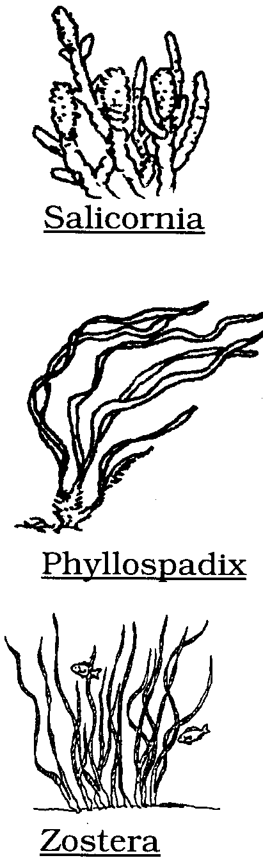
purple, black. Division Rhodophyta 8

3A Dense plant, not submerged, with green
and/or red succulent leaves. Lives in
tidal mud flats and estuaries. Tastes salty.

3B Long, narrow (< 0.5 cm) bright green
blades with dense root clump attached
to rocks in littoral zone. Marker for
"zero" tidal level.

3C Broad (> 0.5 cm) long blades with
parallel veins. Grows in sandy substrate
in subtidal zone of beaches or estuaries
having reduced wave force.

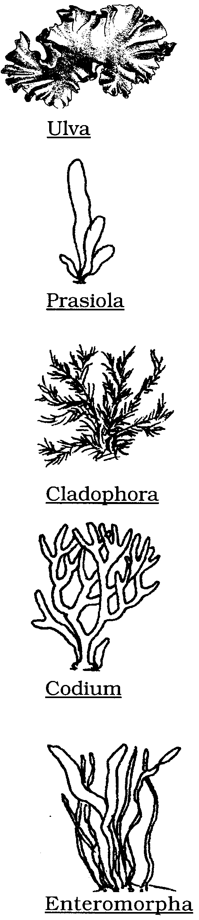
4A Thin, flat, translucent sheets of green
algae with small holdfasts and sometimes
wavy margins. May be narrow (to 4 cm)
or wide (to 1 m) sheets.

4B Plant with minute blade (< 1 cm tall)
attached to hard surfaces in littoral zone.
Near bird dropping areas.

4C Short, dense tufts of filamentous green
algae, 3 - 5 cm tall. Grows on rocks of
supralittoral zone.

4D Clumps of dark green spongy "fingers"
in infralittoral zone. "Fingers" up to
30 cm length, 0.5 cm wide.

4E Tubes or "intestine" shaped green
strands. Tube may be up to 1 m in
length, 0.5 - 5 cm wide. Common near
areas of freshwater seepage. Large
masses may float and collect on shore.

5A Small, dichotomously branched
intertidal rockweeds and larger
sublittoral algae. Tips thick and bumpy
when sexually mature. Order Fucales 6

5B Kelp plants differentiated into one or
many blades, stipes, and root-like
holdfasts. Order Laminariales 7
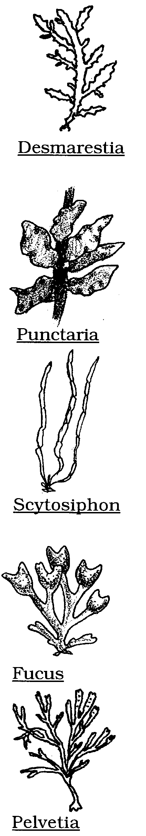

5C Thin, flat, strap-like blades that contain
sulfuric acid. May have strong odor, taste.
To 2 m long by 1-2 cm wide.

5D Plant found growing on eelgrass 1.5 -
2.5 cm wide. Light brown. Short stipe
and disc-like holdfast.

5E Plant olive-brown. Looks like sausage
links that taper to a point at the top.

6A Wide, dichotomously branched rockweed
(to 3 cm wide, 20 cm long). With bumpy,
swollen receptacles at tips. Many stipes
rise from small holdfast.

6B Slender, tough rockweed. Long
(to 15 cm) and narrow branching stipes
ending in reduced blades that lack
midribs. Small receptacles.

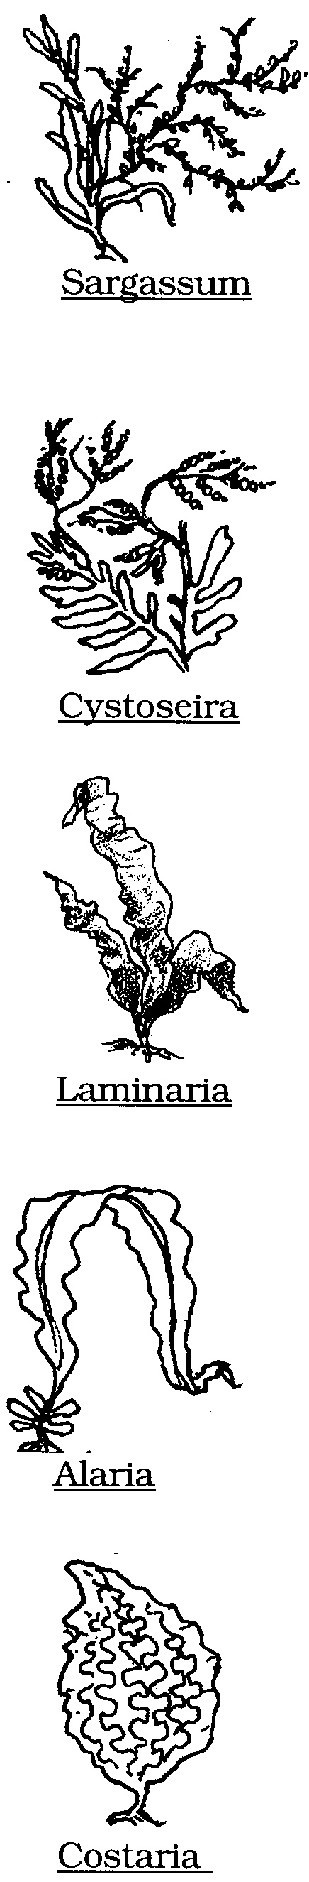
6C Plant has multiple branching. Flattened
lateral blades, not on main stipe, with
midrib and serrated margins. Tiny air
bladders attached between blades.

6D Cluster of flat, pinnate blades 1-2 cm
wide at base. Blades taper into a long,
thin stipe, up to 7 m, with string of
small "beads" (3-5mm) at tips.

7A Single, smooth, leathery blade shaped
like an oar arising from a tough,
cylindrical stipe. Up to 2 meters tall.

7B Large, single flexible blade (1m to 2 m)
with prominent midrib and smaller
wing-like blades where stipe meets
large blade. To 3 meters tall.

7C Large, single ruffled blade with five
long parallel ribs from top to bottom.
From 1.5 to 2 m long.

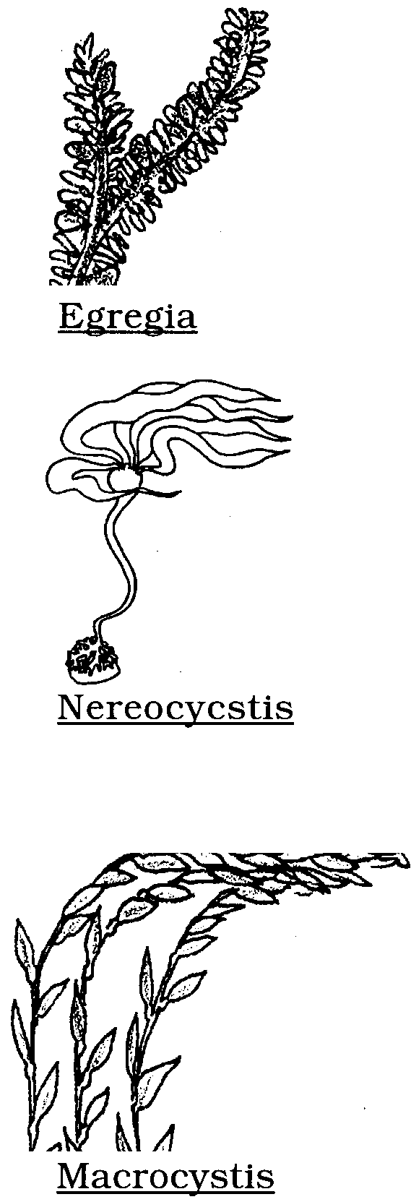
7D Long, thick, strap-like stipe with many
small, alternating blades and axial
pneumatocysts.

7E Long, thin stipe (up to 10 m) arising
from a small holdfast. The stipe flares
out and terminates in a single, fist-sized
pneumatocyst with 6 to 8 flat blades.

7F Long, round stipes arising from a
large holdfast. Fronds consist of large,
alternating blades with pneumatocysts
at their bases.

8A Blades are flexible sheets that are
reddish-green in color. Shiny when wet,
crispy when dry. Order Bangiales 9

8B Calcareous (encrusting or branching)
plant or filamentous plant or with
blades. Order Cryptonemiales 10

8C Plants red to dark red to black. Tough,
elastic, small to large, smooth or bumpy.
Blades with reduced holdfasts. Order Gigartinales 11

8D Flattened blades or small fluid-filled
sacs or bladders. Order Rhodymeniales 12

8E Small, delicate filaments or blades
with lobed margins. Order Ceramiales 13

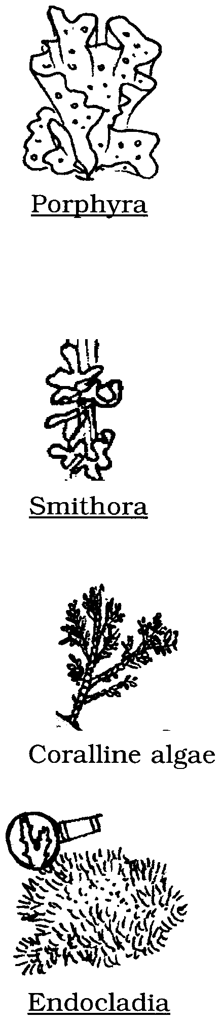
9A Thin, smooth, flexible blades. Variable
in color including brown, olive, red to
black blades (to 20 cm). Plant is
supralittoral, becomes brittle when dry.
Known as nori or sushi seaweed.

9B Purplish-red blades 3-6 cm long,
1-2 cm wide. Grows on blades of
eelgrass and surfgrass.

10A Hard crust, or erect plant with hard
shell-like segments and flexible joints.
Pinkish color or white when dead.

10B Dense, dark brown tufts of coarse
filaments.

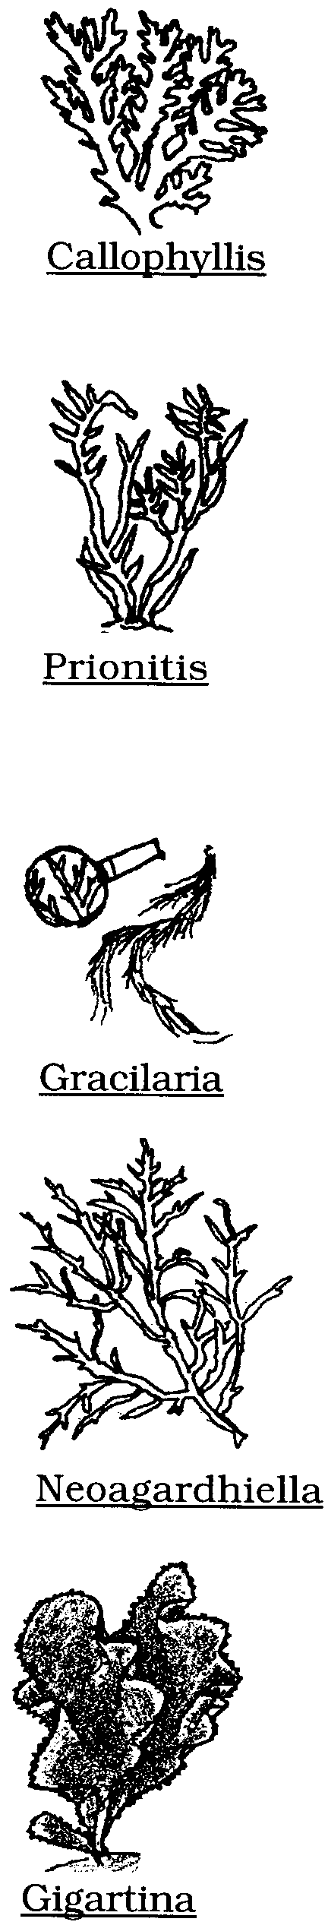

10C Irregular branches, flat, fan-like. Dark
red. Disk-like holdfast.

10D Plant brown to red to purple. Main axis
is long, broad, and flat tapering to the
end. With many smaller lateral blades,
10 - 35 cm tall.

11A Long (5 - 30 cm), round, highly
branched slippery slender strands.

11B Round stipe and round branches.
Thalli very branched with cylindrical
axes. Up to 0.5 m long.

11C Large "Turkish towel" with thick
rubbery blades and bumpy texture.
Gigartina

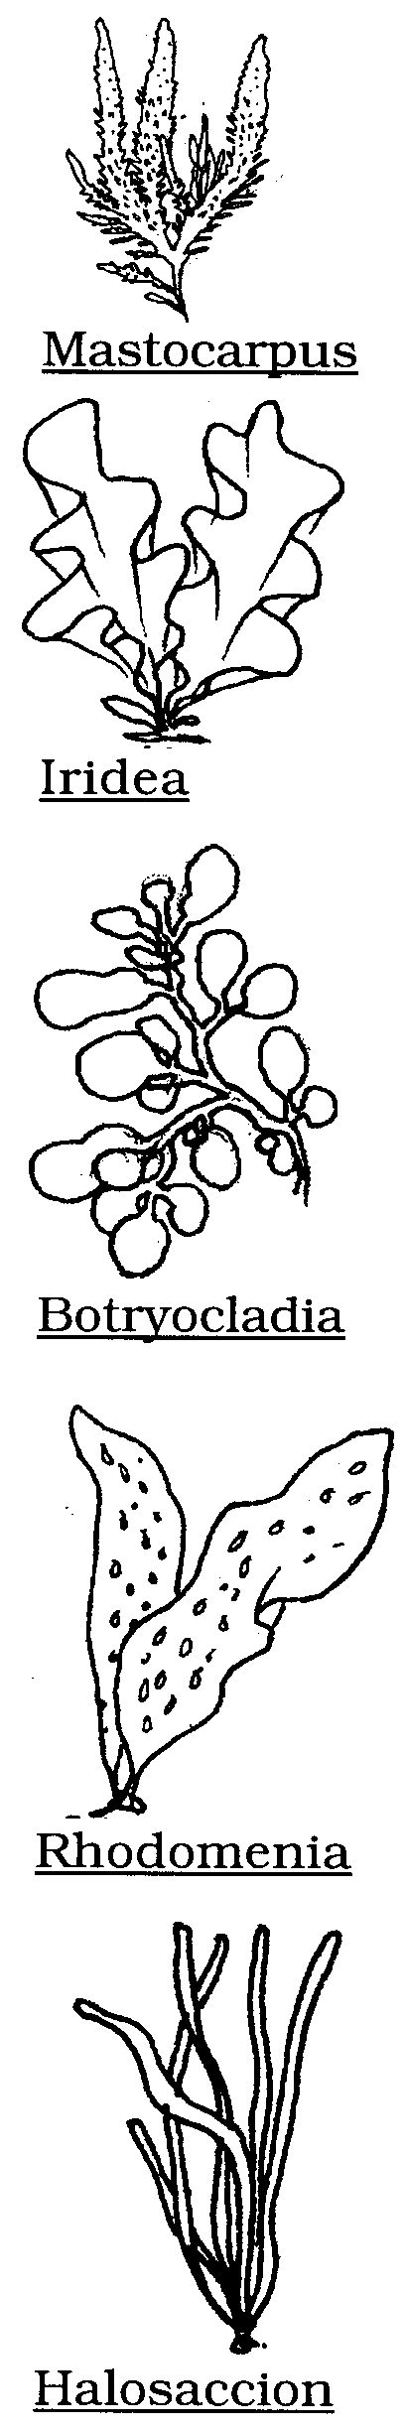
11D Small (to 10 cm), dense clumps of
rectangular blades with fine bumps.
Found in supralittoral zones. Males
smooth, yellowish-green.

11E Large, flat elastic blades with iridescent
appearance, color varies from olive
green to deep red.

12A Bright red "grape-like" sacs filled with
gelatinous liquid.

12B Thin, flat, dichotomously branched
blades with smooth margins.

12C Firm, olive colored clusters of long,
hollow, liquid-filled sacs.

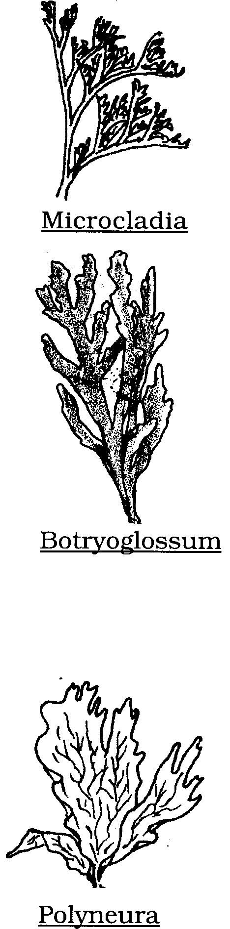

13A Delicate, filamentous plant found
growing on kelp.

13B Thin, flattened blades with ruffled,
wavy margins.

13C Broad, flat, fan-like blades, irregularly
branched, with vein-like lines
throughout. Blades 1-20 cm tall.

Glossary of Terms for Key to Identification of Common Marine Plants

axial: Growing along the length of the plant rather than at the end.
blade: Broad, leaf-like portion of algae.
calcareous: Containing calcium carbonate (CaCO₃)
dichotomous: Division by branching in two.
differentiation: Tissues specialized to perform different functions.
encrusting: Covering in a crust-like fashion forming a low profile over a substrate.
estuary: Coastal marine bay with freshwater sources.
filamentous: Thread-like or fibrous strands.
holdfast: Structure that attaches algae to substrate.
infralittoral: Low intertidal area exposed only during low spring tides.
littoral: Narrow vertical band of coastline affected by the range of tides.
lobed: Rounded projections from the algal blade.
macroscopic: Large enough to be seen without magnification.
midrib: Central line of tissue that may strengthen the blade.
midlittoral: Band of coastline between that range of the tides.
pinnate: Blade projections arranged on either side of a common axis.
pneumatocyst: Air-filled bladder allowing for positive buoyancy.
receptacle: Fertile area where reproductive cells are produced.
stipe: Stalk springing from holdfast and attachment place for blades.
substrate: A surface layer of material on which an organism can grow and multiply.
sublittoral: Depth below the range of the tides.
succulent: Fleshy plant material that may retain water.
supralittoral: Elevation above the range of the tides.
thalli: Plant bodies lacking differentiation into roots, stems, and leaves. Singular = thallus.

