Who’s Living Here?
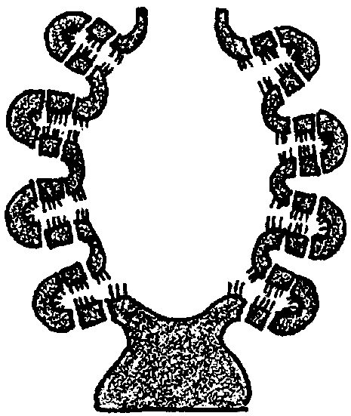

Key Conepts
1. Sponges play an important role in providing shelter for many creatures.
2. Over-harvesting of sponges can disrupt the ecological balance in a rocky shore habitat.

Background
Sponges provide habitat for a host of other organisms. Some of these organisms simply use the sponge as a home while others exist in sophisticated mutualistic relationships. Although sponges are relatively simple in structure and form, they play an important ecological role in marine communities.
Additional background information for “Who’s Living Here?” is found in the preceding activities, “Sponges” and “One From Many”.

Materials
For each group of 3–4 students:
• dissecting kits
• sorting jars
• dissecting microscopes
• balance
• ruler
• identification keys
• sponges

Teaching Hints
In “Who’s Living Here?” students dissect living sponge to find the commensal animals that inhabit the cavities within the sponge. Though some sponges under the right conditions can re-form colonies after being torn apart, the sponges you dissect are unlikely to survive after being removed from water and dissected. You will have to determine whether it is appropriate for your students to conduct this activity.
Large sponges work best. Specimens may be collected one day, enclosed in strong plastic bags, stored in a refrigerator overnight and used the next day. Sponges decompose rapidly, so it is important to use them promptly. Living sponges may also be purchased from biological supply houses.
Large sponges tend to have correspondingly large symbionts. Small sponges may be assigned to individual students or groups. Large sponges should be divided among several groups or the entire class. Provide any reference materials you may have which will aid in the identification of the resident creatures.
Wet weights of organisms are somewhat difficult to standardize. It is suggested that the organism be placed briefly on blotter paper or toweling before it is weighed. Be sure the balances are cleaned after use, as saltwater is very corrosive.
Duplicate the activity pages. One set is recommended per student. This exercise is best done in small groups, although if the materials and equipment allow, it may be performed by individual students. Some students may need a hand with the slicing. Watch for those that do. Plan to allot time for a discussion of the role of the sponge as an apartment house of the sea when you review the experimental results and provide answers for the questions in the “Analysis and Interpretation” section.

Key Words
ascon - a type of sponge having an oval shape and a thin body wall with pores leading directly to the body cavity
biological classification - assignment of organisms to group with a system of categories distinguished by structure, origin, etc. The usual series of categories is phylum, class, order, family, genus, and species.
commensalism - a symbiotic relationship between two organisms in which one benefits by living in or on the other, but not as a parasite, thus leaving the other unaffected
leucon - a type of sponge having a thick body wall with a highly branched canal system leading directly to the body cavity
mutualism - a symbiotic relationship between two organisms in which both benefit
over-harvesting - excessive hunting of an animal resulting in a decline in average size and an increase in effort necessary to catch the same amounts harvested in previous years; over exploitation
sycon - a type of sponge having a thick body wall folded to form many short canals leading directly to the body cavity
symbiosis - a general term for special relationships between organisms of different species; it includes parasitism, commensalism, mutualism, and others

Answer Key
1., 2., 3., 4. Answers depend upon the experimental results. Be aware that percentage calculations tend to be difficult for many students. The examples provided may not be sufficient. Be prepared to offer any assistance necessary.
5. If sponges were over-harvested, most likely the populations of the organisms that live within the sponges would decrease since their habitat was removed. The populations of the organisms that depend upon the organisms that live within the sponges would also decrease since their food supply would be reduced.
6. While answers will vary depending upon experimental observations, most results will tend to support the interconnectedness of life in the sea. As on land, whatever affects one species affects all species to a greater or lesser degree. This interconnectedness is an important concept to emphasize at a time when human actions tend to simplify ecosystems and reduce species diversely, often with dramatic, negative impacts upon marine life.
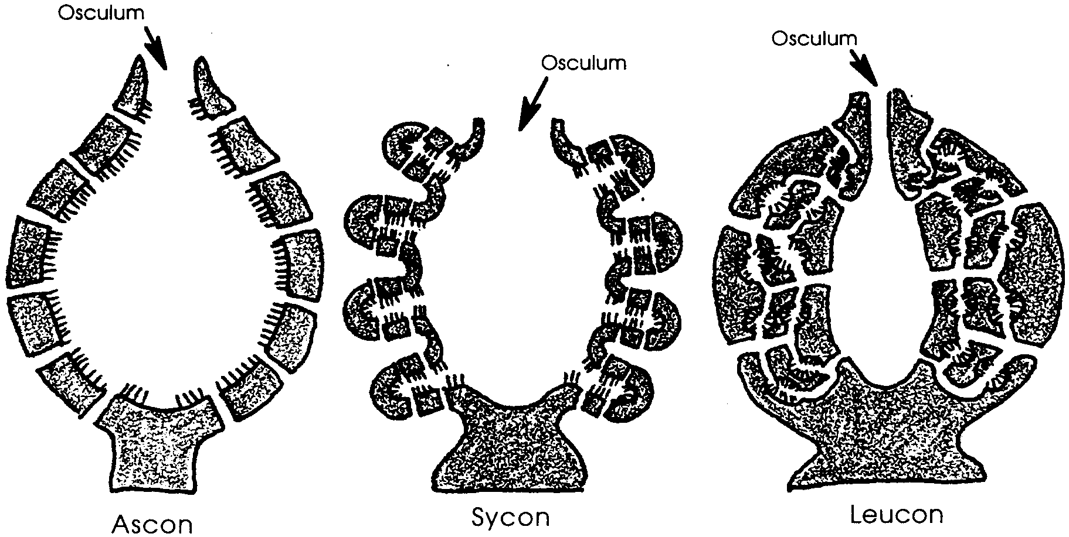
Who’s Living Here?

When you examine a sponge, you probably are observing more than just the sponge. Sponges actually create a mini-environment within rocky shore habitats.
Sponges enclose a great deal of space. They are primarily a bag with a system of holes, chambers and compartments. In their 500 million year history, sponges have evolved three basic canal systems which biologists call: ascon, sycon and leucon. The three body types are shown in the three sponge cross sections shown above.
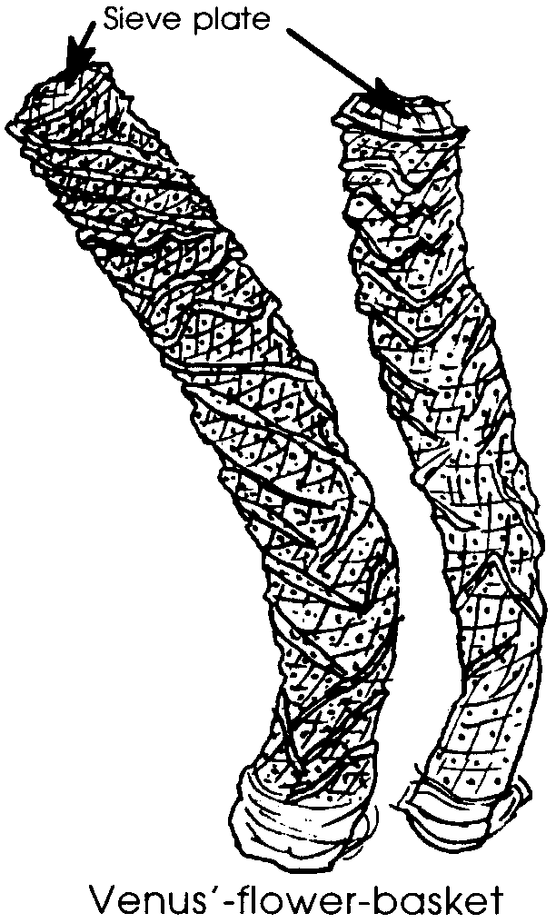
The enclosed space within the sponge offers a large number of hiding and living places for smaller animals. The relationships that exist between the sponge and the organisms within are of many different types. Some of the residents are commensal, meaning they benefit and the sponge is not harmed. Other residents exist in a mutualistic relationship, where both the resident and the sponge are benefitted by the association.
Symbiotic relationships, the long-term living together of different species, can be very interesting indeed. One particular glass sponge of the class Hexactinellida, Venus’-flower-basket, displays an interesting commensal relationship with certain species of shrimp.
A young male and a young female shrimp enter the cavity of the sponge and, after growth, are unable to escape through the sieve plate covering the osculum. Their entire life is spent in the sponge prison, where they feed on plankton brought in by the sponge’s water currents. The sponge with its imprisoned shrimp formerly was used in Japan as a wedding present, symbolizing the idea “till death us do part”.
Sponges are the apartment houses of the sea. In the following activity you will have an opportunity to discover which types of organisms are residents of sponges.

Materials
• dissecting kits
• sorting jars
• dissecting microscope
• balance
• ruler
• identification keys
• sponges

Procedure:
1. Obtain a sponge or a piece of a sponge.

2. Using the balance, weigh the sponge. Record the weight.
Sponge weight

3. Carefully slice off a thin section of sponge tissue. Examine the slice for animal life.

4. Sort out the creatures, grouping them into groups of like animals. Try classifying them as scientists would, according to phyla. Use “A Summary of Marine Animal Phyla” from Unit I as a guide. Use additional references to further classify the animals. Keep the sorted specimens. Record your results.

Phylum Number found
5. Repeat steps 3 and 4 until the entire sponge has been dissected and all of the inhabitants removed and sorted.

6. Use the balance to weigh each group of sorted animals. Record your results.

Phylum Weight

Analysis and Interpretation
1. What was the total number of individuals found within your sponge?

2. Compute the percent of total population for each species by numbers.
(Hint: This is easy -
The percent contributed by species A = number of species A x 100)
total number of individuals

3. Compute the percent of total population for each species by weight.
(Use the same technique you used for numbers in problem 2 above. )

4. Compute the percent of total weight contributed by the residents .
(This is easy, too -
% weight contributed by residents = total weight of residents x 100)
total weight of sponge
5. If the sponges were over-harvested, what would happen to the populations of the organisms that depend upon the organisms that live within the sponges?

6. In discussing the oceans, scientists sometimes say that all of the life of the sea is interconnected. Do your results from this activity tend to support this statement? Please explain your answer.

