One From Many
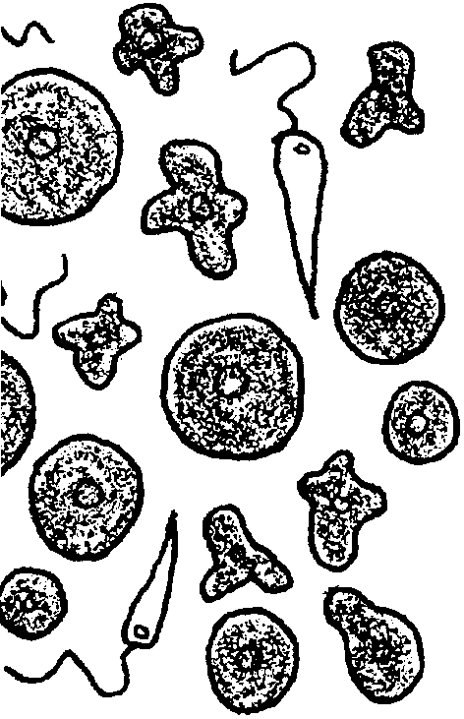

Key Concepts
1. Sponges are multicellular animals that have relatively simple cellular organization.
2.Sponge cells are specialized in most situations.
3. Sponge cells can re-associate after separation.

Background
“One From Many” duplicates the classic experiment of H. V. Wilson which demonstrated the power of re-association in sponges. The cell layers of the sponge function in loose concert. Different cells have become specialized for different functions, yet tend to act somewhat independently of each other. The paradox of multicellular animals has a slightly different twist within the sponges. The paradox notes that mitotic cell division produces two identical daughter cells yet multicellular organisms are not simple masses of identical cells. How does differentiation occur? In the sponges, the cells retain many of their original properties and can function more or less independently of the organism. The cells are not highly differentiated. The sponge seems to be a group of animals that bridges the gap between single celled organisms and multi-celled organisms.

Materials
For each class:
• refrigerator
• balances

For each student team:
• Microciona sps. Sponge
• seawater (4°C)
• 1 Griffin beaker, 250 ml
• 3 Griffin beakers, 150 ml
• 1 graduated cylinder, 100 ml
• 4 fingerbowls, 6 inch, and covers
• 4 Syracuse watch glasses
• 8 microscope slides
• glass marking pens or labels
• Pasteur pipette
• thermometer
• compound microscope
• “One From Many” student pages

Teaching Hints
Microciona sps. may be collected at the beach or ordered from biological supply houses. A single 1 gram fragment will provide enough suspension for a whole class, so great quantities are not required. The common pectin sponges, Mycale adhaerens and Myxilla incrustans, are also suitable specimens for this investigation. These incrusting sponges are almost invariably found growing on the upper valve of pectin scallops.
Caution your students to add the sponge suspension to the slide by gently placing the tip of the Pasteur pipette on or slightly above the slide. The suspension is slightly more dense and will tend to form a drop on the slide if the water is not agitated. Care is also required in the transport of the finished finger bowl preparations.
If you have no refrigeration facilities, you may elect to omit the finger bowls stored at 4°C. (Better, however, is to solicit a donation of a used refrigerator from your community. It is surprising how many working refrigerators are available for the polite asking.) You may elect to have some groups set-up and examine the room temperature preparations while others do the refrigerated set-up. The data can then be pooled and the questions answered. It is also possible for different groups to do the different dilutions and then pool their data upon completion. Good technique is required for good results. Anticipate any potential problems which might be encountered with your class and plan accordingly.

Key Words
aggregation - in the case of sponges, a collection of similar cells
association - the relationship between different systems or cells
suspension - state in which the particles of a substance are mixed with a fluid but do not dissolve or settle out

Answer Key
1, 2, 3. Answers depend upon experimental results. In general, more clumps are found at the higher dilutions and temperatures.
4, 5. The answers depend upon the experimental results. In general, larger clumps are found at the higher dilutions and temperatures. Commercial sponge growers might use the technique to increase the number of sponges they have to grow. Artificial propagation might also be useful in “seeding” sponges into new areas.

7. The answer to this question is not simple: a case can be made for either theory. The disassociated cells certainly behave like independent individuals, a fact that supports the theory that sponges are a group of single celled animals living in one place at one time. The individual cells do, however, reaggregate and form new sponge animals, a fact that seems to support the idea that the cells require the presence of others in a division of labor scheme. While the experimental observations do not answer the debate, they do show the tremendous re-associative powers of the sponge.
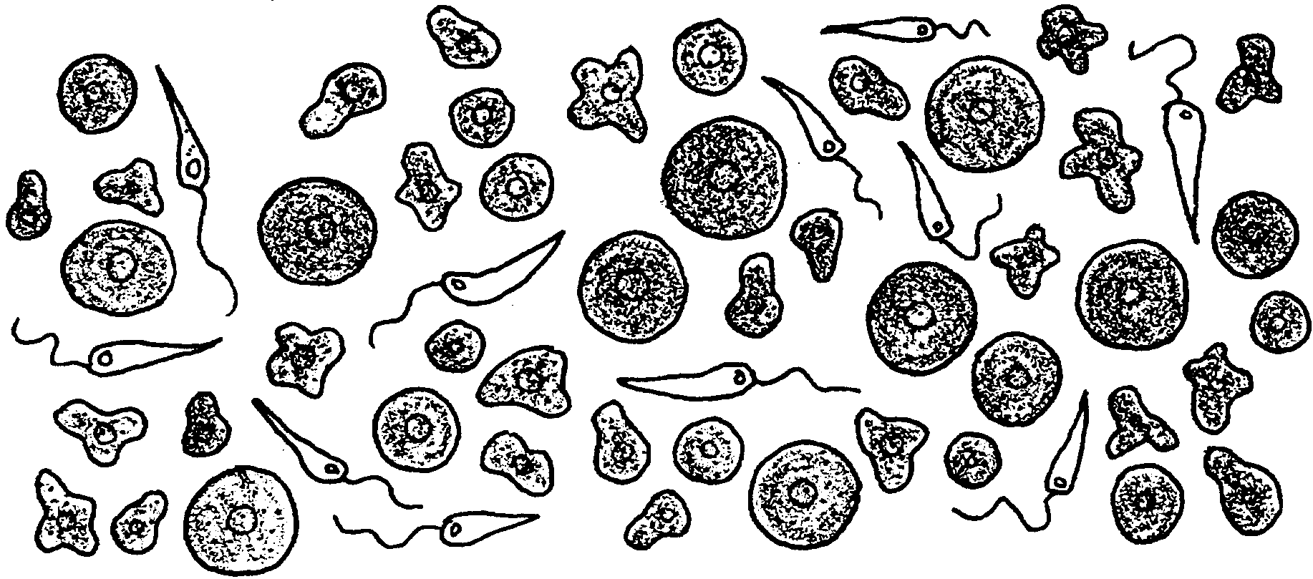
One From Many

Sponges are the simplest of multicellular organisms, exhibiting little coordination between cells. In fact, some biologists view sponges more as an association of individual single celled organisms rather than as a single, entire animal. In the following exercise you will have an opportunity to look into the question yourself. Are sponges single animals or a group of single celled animals living in the same place at the same time?

Materials
• Microciona sps. sponge
• Number 21 silk bolting cloth
• sea water (4°)
• 1 Griffin beaker, 250 ml
• 3 Griffin beakers, 150 ml
• 1 graduated cylinder, 100 ml
• 4 finger bowls, 6 inch, and covers
• 4 Syracuse watch glass
• 8 slides
• glass marking pen or labels
• Pasteur pipette
• thermometer
• refrigerator
• compound microscope
• balance
Procedure:
1. Obtain 1 gram of fragments of fresh Microcionia sponge.

2. Place 100 ml of cold (approximately 4°C) seawater in a 250 ml beaker.

3. Press the sponge fragments through number 21 standard quality silk bolting cloth into the 100 ml of cold seawater. (Rub sponge against cloth, then rinse through. Repeat until sponge is gone).

4. Use the 100 ml sponge preparation to prepare the following dilutions of sponge suspension and place them in labeled 150 ml Griffin beakers:

a. 25 ml sponge suspension + 25 ml sea water (4°C) = 50% dilution

b. 10 ml sponge suspension + 30 ml sea water (4°C) = 25% dilution

c. 10 ml sponge suspension + 90 ml sea water (4°C) = 10% dilution

5. Fill four small (6 inch) finger bowls two thirds full with the cool sea water.

6. Place a Syracuse watch glass on the bottom of each finger bowl.

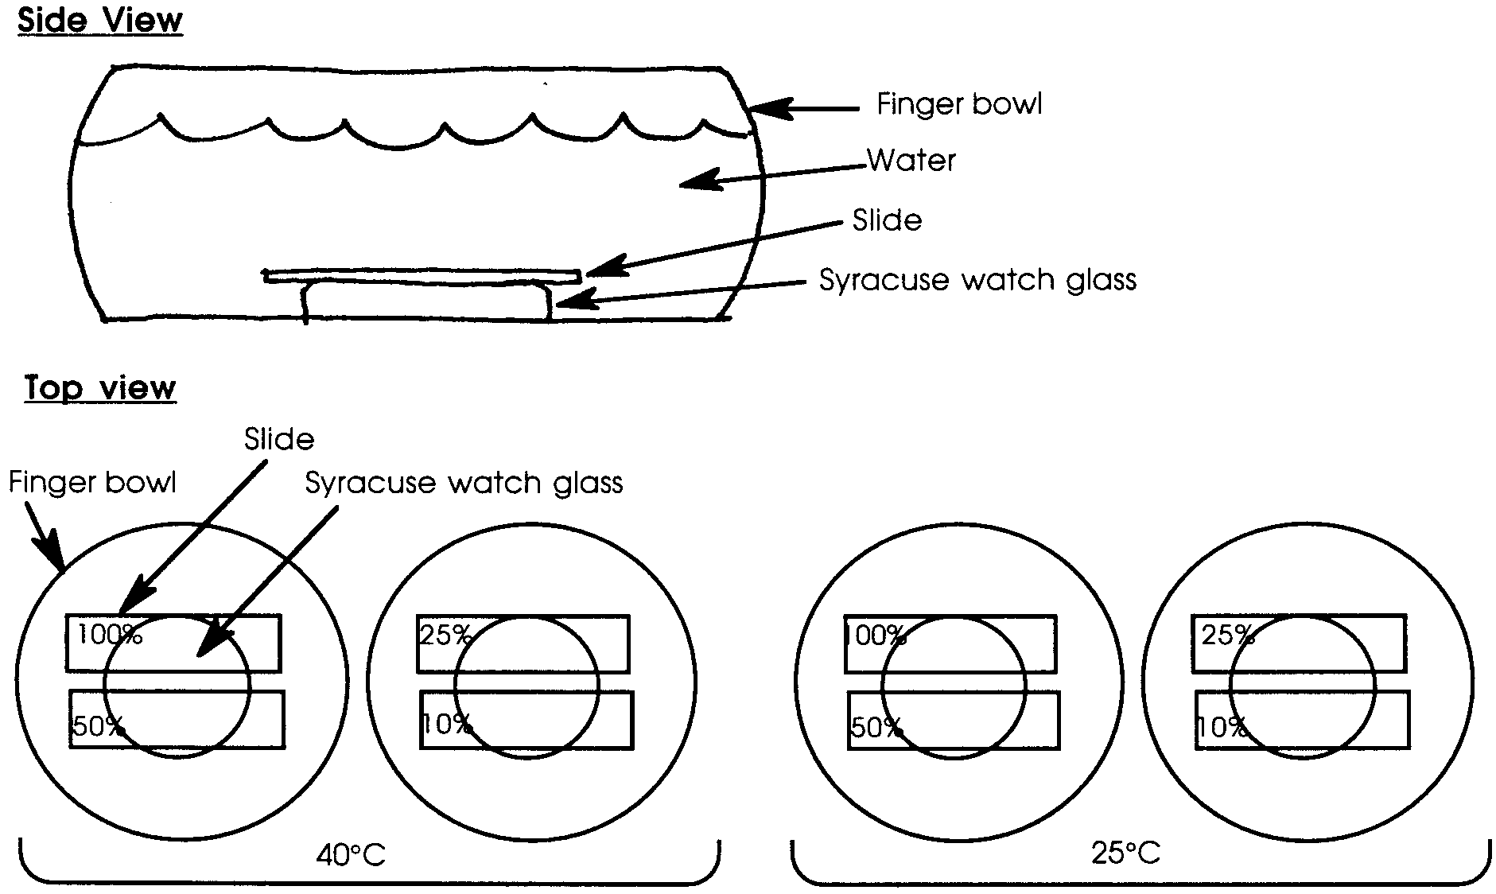
7. Obtain eight microscope slides. Label two for each of the four dilutions: 100%, 50%, 25% and 10%.

8. Place two slides on each Syracuse watch glass.

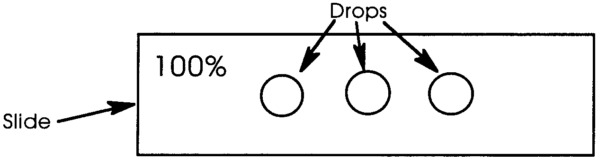
9. Use a Pasteur pipette to gently dispense one or two drops of the original suspension onto the center of the slide labeled 100%. Place equal sized drops to the right and left of the center drop. This will give you three samples to watch.

10. Repeat step 9 for each of the three dilutions remaining. Be sure to put the dilution on the proper slide.

11. Cover the finger bowls and allow one group to stand undisturbed for 24 hours at 4°C (refrigerator) and another at room temperature (about 25°C).

12. After 24 hours, gently remove the slides, cover the drops with a coverslip and examine under the microscope. You can prevent the slides from drying out by adding water or not removing them all at once.

13. In the space below, draw and label a sample of each of the eight slide preparations. To make your drawing and counting easier, choose the drop with the largest clumps from the three drops on each slide.

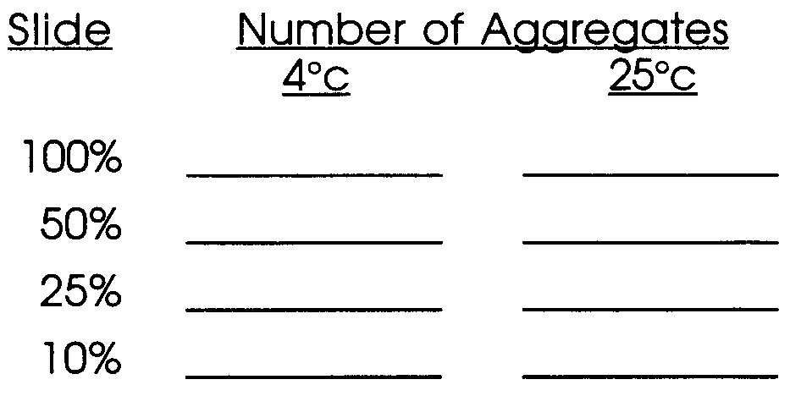
14. Count the aggregates in one field on each slide. Record these figures:

15. Estimate the size (in microns) of the largest aggregate found on each slide.
Record these estimates:

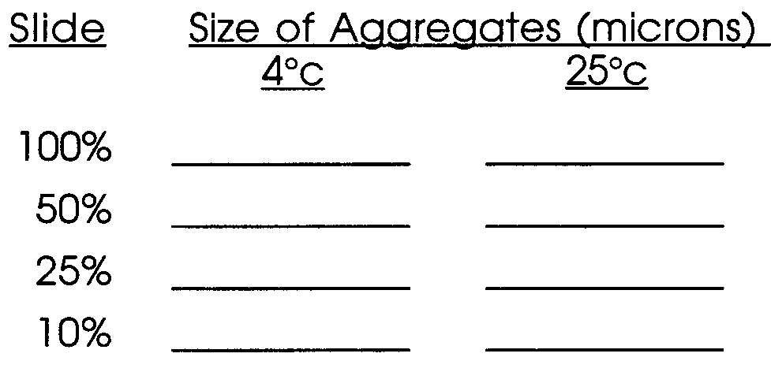

Analysis and Interpretation:
1. What was the largest aggregation of sponge cells that you found?

2. a. Which slide (dilution) had the largest number of aggregates?

b. What is the relationship between dilution and number of aggregates?

3. a. Which temperature had the largest number of aggregates?

b. What is the relationship between temperature and number of aggregates?

4. a. Which slide had the largest aggregates?

b. What is the relationship between dilution and size of aggregates?
5. a. Which temperature had the largest aggregates?

b. What is the relationship between temperature and size of aggregates?

6. Each aggregate has the potential for developing into a new sponge. How might a commercial sponge grower use this information to her advantage?

7. Does the ability of sponges to re-associate after being broken up support the theory that sponges are single animals or the theory that sponges are a group of single celled animals living in the same place at the same time? Explain your choice.

