Sponges
Edited by Holly Anne Foley and Karen Mattick
Marine Science Center, Poulsbo, Washington

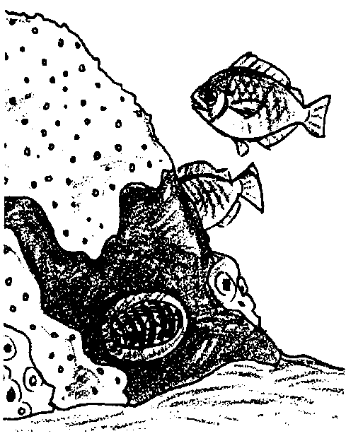
Key Concepts
1. Sponges are sessile animals of the rocky shore.
2. Sponges have organized pores and special flagellated cells to filter seawater.
3. Spicules in the body wall of the sponge help keep the sponge rigid and protect the sponge from predators.

Background
Rocky shore habitats provide the nooks and crannies and hard surfaces that encrusting and attached organisms need. One of the most colorful and yet often overlooked sessile organisms is the sponge.
The sponges, classified in the phylum Porifera, are the simplest of multicellular organisms. The body of a typical sponge consists of loosely aggregated cells organized into poorly defined tissues without organs. There is no mouth or digestive tract in sponges. Instead, the body is covered with small pores (ostia) through which seawater enters and fewer large holes (oscula) through which the water leaves the animal. As the water passes through the sponge, it travels through a system of canals of varying complexity which are lined with peculiar flagellated cells called collar cells (choanocytes).
The choanocytes, which strongly resemble a group of one-celled animals and thus suggest that sponges may have evolved from them, keep the water moving and extract the food from the water. Amoeba-like cells (amoebocytes) travel about in the sponge’s body wall carrying food, producing spicules (tiny needle-like structures which support the animal’s body) and carrying out sexual reproduction.
Reproduction in sponges occurs commonly by both asexual and sexual means. A small fragment of sponge will often grow a new individual, and some sponges, when completely torn apart (as for example, when forced through fine meshed silk so that the cells are separated), will re-form themselves into complete individuals.
Many sponges also reproduce by budding. In sexual reproduction, certain of the amoebocytes form eggs and sperm - usually at different times within the same individual. These eggs and sperm are broadcast into the water and ova are fertilized by sperm from another sponge.
Sessile animals such as sponges must have special adaptations to protect themselves from predators. They cannot swim away. Instead, the calcium carbonate or silica spicules make the sponge a sharp, uncomfortable mouthful for most predators. (A few sea stars and nudibranchs do prey on sponges.) The spicules, in combination with fibrous spongin tissue, also give the sponge body some rigidity.
Classification of sponges is difficult. The shape of a given sponge is so variable that no system of classification based upon appearance has been very satisfactory. Today, sponges are classified largely by the kinds of spicules present in the body wall. These structures are constant in form in a given species but vary from one species to another.

Materials
For each student or pair of students:
• various sponge animals- living or dried
• bleach solution (50% commercial bleach/ 50% water)
• dilute acetic acid (5-10%)
• depression slide
• Pasteur pipette or medicine dropper
• forceps
• compound microscope

Teaching Hints
The “Sponges” student pages give students a view of the whole sponge animal and a view of the structures inside the sponge’s pores. The laboratory portion invites students to take an actual piece of sponge body wall, dissolve away any tissues, and view the spicules that support and protect the sponge. “Sponges” includes an optional extension in which students attempt to identify their sponge by classifying sponge spicules.

Before students arrive:
You will need to collect or purchase living or dried sponge for this activity. This lab works particularly well if you have some living specimens for students to observe whole and a dried sponge students can use for observing spicules. It is slightly easier to observe the spicules in the dried sponge because most of the tissue material is already gone. In addition, you may want to foster care for living marine life by using the dried specimens instead. The sponge spicule activity is most interesting if students can compare spicules from more than one type of sponge.
If a subtidal sponge taken from underwater is to be kept alive, you must be certain not to expose the animal to the air since chambers of the sponge’s body fill with air and soon kill the specimen. The best collecting procedure is first to place the container under water and then gently introduce the sponge, keeping it immersed at all times. Intertidal sponges need not be so carefully handled since they are adapted to long periods of exposure. Sponges of various types may also be obtained from biological supply houses.

When students arrive:
1. If you have living sponge specimens or photographs, you may wish to introduce this activity by asking the students to observe and describe these inhabitants of the rocky shore. Are these animals or plants or something else? How do they think this organism makes a living in the ocean? How does it obtain nourishment and protect itself? Caution students to keep any living subtidal specimens you have underwater at all times.
2. Explain that these organisms are sponges, not the synthetic sponges you might purchase at the supermarket, but living marine animals. Explain that students will take a close look at this rocky shore inhabitant, looking first at the whole animal, then at its surface, and then inside the sponge. Explain that they will take an piece of sponge body wall and dissolve away some of the tissues and observe some of the structures inside the sponge body wall.
3. Distribute the student pages. You may want to model for the students how to take a sponge sample and dissolve the body wall tissues. Bleach and acetic acid are materials which can damage skin and clothing. Caution your students to use extra care and to wipe up any spills immediately.
4. Circulate through the lab as the experiment is being performed to be certain that your students are having success in viewing the spicules. Since sponge spicules are transparent, it is sometimes helpful to reduce the illumination on the microscope for better viewing.

Key Words
adaptation - hereditary characteristic of an organism in a population that improves its chances for survival
amoebocytes - small amoeba-like cells which secrete spicules and also distribute digested food and oxygen to other cells as they wander through the jelly-like layer of a sponge
choanocytes - cells that line the inside of a sponge's body and which move water through the sponge by beating whip-like structures (flagella). These cells are shaped somewhat like a goblet and are also called collar cells.
collar cells - choanocytes
megascleres - the larger of two types of spicules produced by sponges
microscleres - the smaller of two types of spicules produced by sponges
osculum - small, mouth-like opening of a sponge
Porifera - a group of animals (phylum) consisting of the sponges; the term means "pore bearing"
sessile - referring to an organism what is permanently attached to a substrate, not freely moving
spicules - noncellular skeletal structures that help support a sponge's body
spongin - a tough, fibrous protein, material that also helps to support a sponge
substrate - the base on which a sessile (nonmotile) organism lives or grows

Answer Key
Text Questions
1. The sponges in the drawings are irregular ball, crust or vase shapes. They appear to have a rough or bumpy texture. Their bodies are covered with holes or pores.
2. The circulation of water through the sponge allows the sponge to obtain oxygen and food from the water and to expel waste products.
3. Water is moved through the incurrent pores and out the osculum by the action of the whip-like flagella of the collar cells.
4. From the outside in, the structures that comprise the body wall of the sponge are:
epidermis → jelly-like layer with spicules → the collar cells

Procedure Questions:
7. Answers will vary depending upon student observations.
8. The sponge can lead a sessile existence because it moves its environment through itself. By moving water through its body the sponge obtains the food and oxygen it needs for survival. The adaptations include the collar cells and the coordinated beating action of the flagella. Its spicules and spongin protect it from predators by rendering the sponge nearly indigestible.

Analysis and Interpretation Questions
1. The answer depends upon experimental results.
2. Single species of sponge do not produce both lime and glass spicules. If both were found, it is possible that the sample was contaminated or that portions of two sponges were mixed. These results may also reflect an error in observation. Capillary action by the acetic acid sometimes sweeps the spicules out of the field of vision. To the untrained observer, the spicules may seem to have “dissolved.”
3. To tell if two sponges were the same or different species, you could prepare spicule suspensions from each of the two sponges and examine them microscopically. If the spicules are the same, the sponges belong to the same species.
4. Spicules form the supporting structure of the sponge.
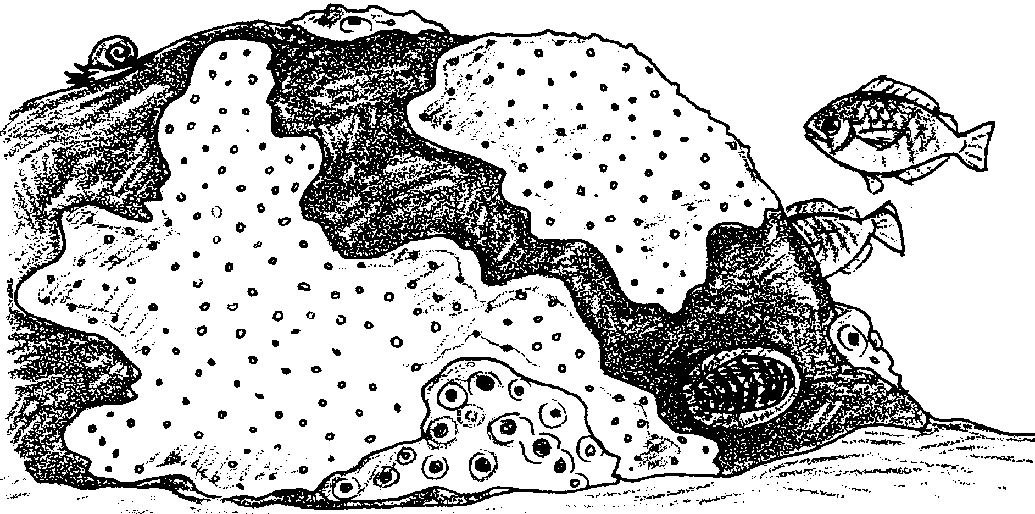
Sponges

As you first comb the rocky shore tidepools looking for crabs, barnacles, sea urchins and sea stars, you probably won’t notice the sponges. They don’t swim or crawl. They don’t have any obvious body parts to catch your attention. In fact, many look something like a crust on the rocks or like protruding fingers of plant material. But sponges are, indeed, animals.
Sponges are strange creatures and not at all like most of the animals with which we are familiar. They can be almost any color, from white and gray to any shade of red or yellow to purple and black. They have no head, body, arms, legs, or any other obvious structures that we generally associate with animals. Some sponges live singly. Others live in crowded colonies that form a crustlike layer over rock surfaces. Individual sponges can be as small as a centimeter or as large as two meters across.
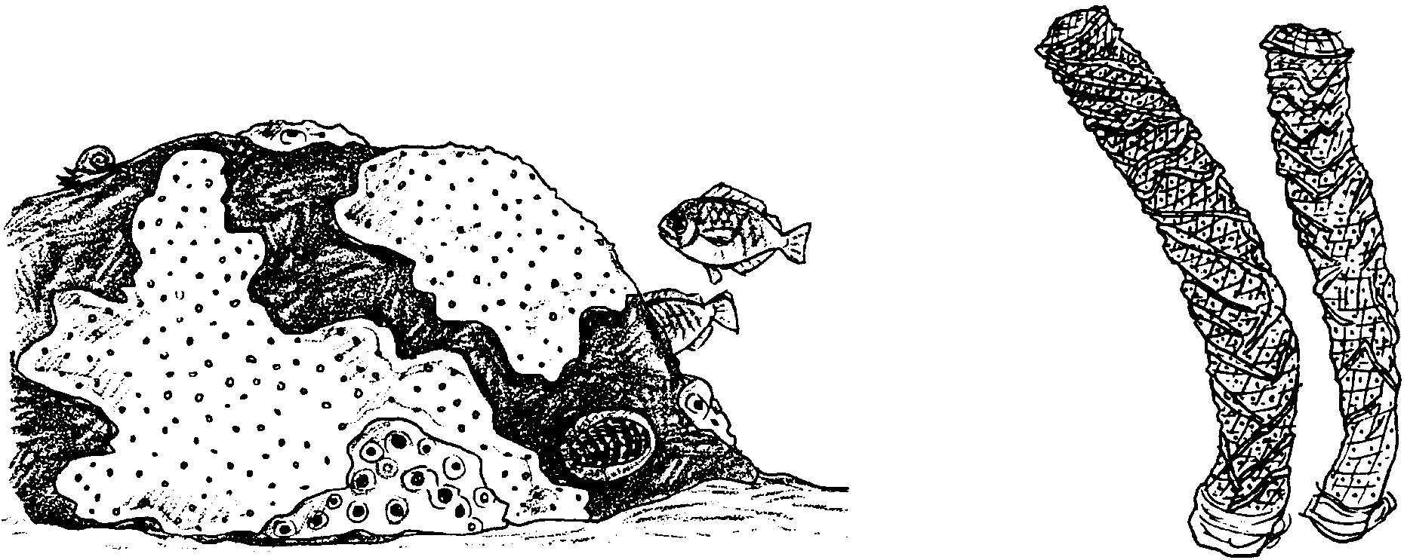
The body plan of a sponge is simple. Scientists consider sponges to have the simplest multicellular organization of all the animals.

1. Take a look at these drawings of sponges. What shapes, textures and body parts do all these sponges have in common?

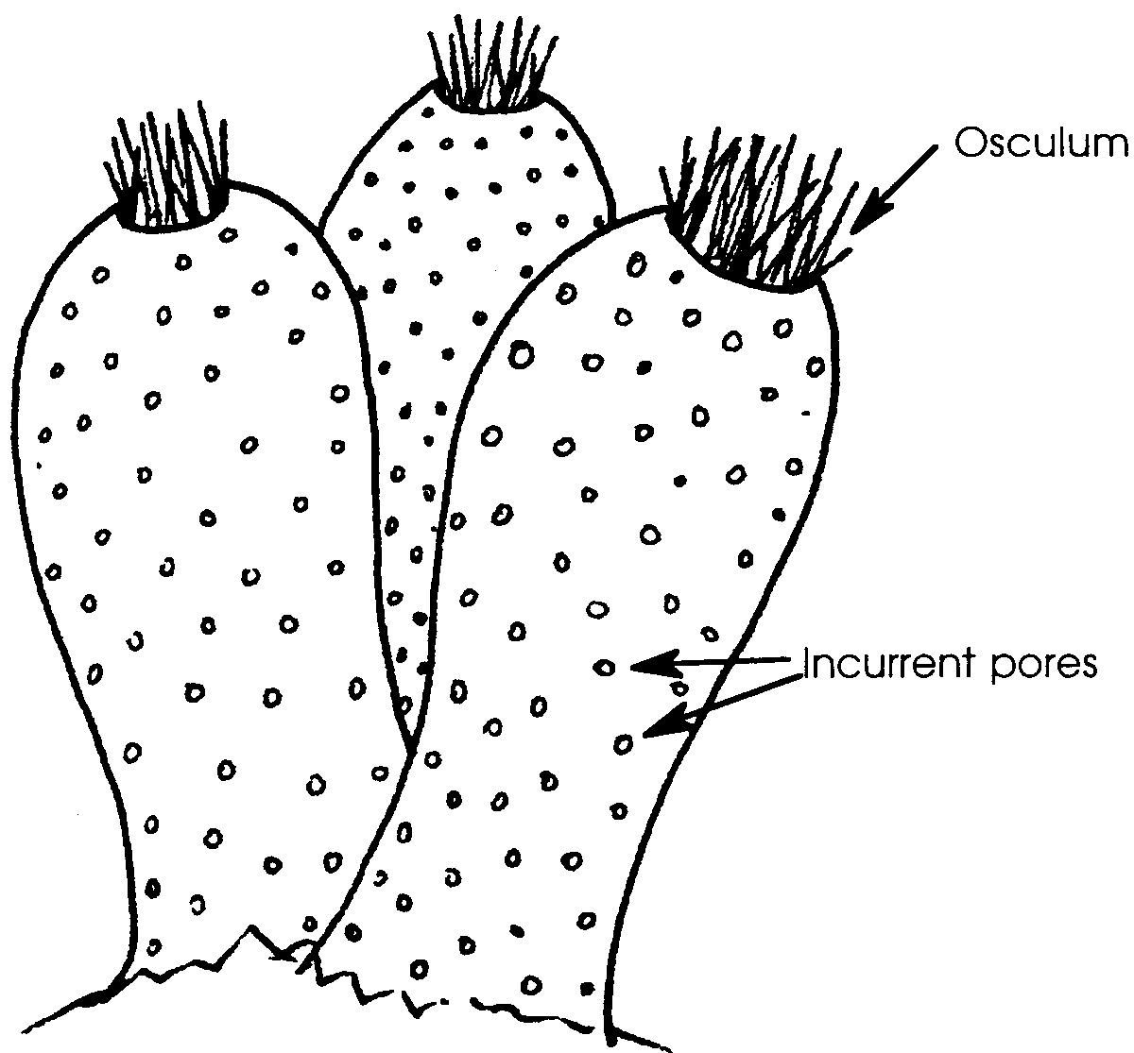
These sponges, living in the waters of rocky shores, must meet the same needs as the crabs, sea stars, barnacles, snails, sea urchins and other animals of the rocky shore. They must eat, obtain oxygen from the water, expel waste products, reproduce and protect themselves. How can they do this when they sit in one place, attached to rocks, not moving, and looking much more like a rock or vase or barrel than like a functioning animal?
Let’s take a closer look and examine the surface of the sponge.

A close look reveals that the sponge is covered with many small holes or incurrent pores. The pores explain the name scientists have chosen for the phylum, or group, in which they have placed sponges. Sponges are in the phylum Porifera, which means “pore bearing.”
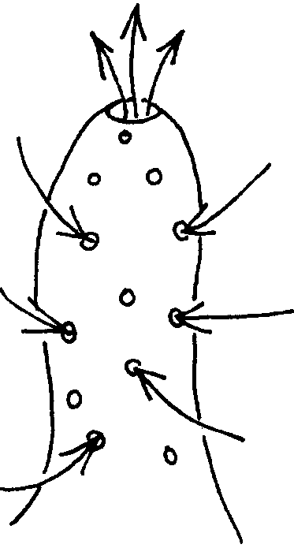

We also see a larger opening called the osculum (from the Latin for “little mouth”). If we were to place a drop of food coloring near the sponge we would be able to follow the dye as it moved into the incurrent pores and out the osculum.
2. What might this circulation of water through the sponge, shown by the path of the dye, do for the sponge?

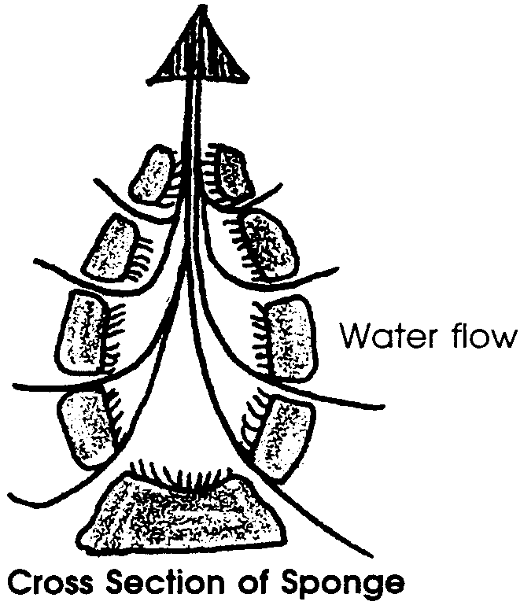
Let’s take an even closer look and examine the structures inside the sponge pores.

The colored water is moved through the sponge by the movement of whip-like structures (flagella) found on the cells that line the inside of the sponge’s body. These cells are shaped somewhat like a goblet and are called collar cells or choanocytes.

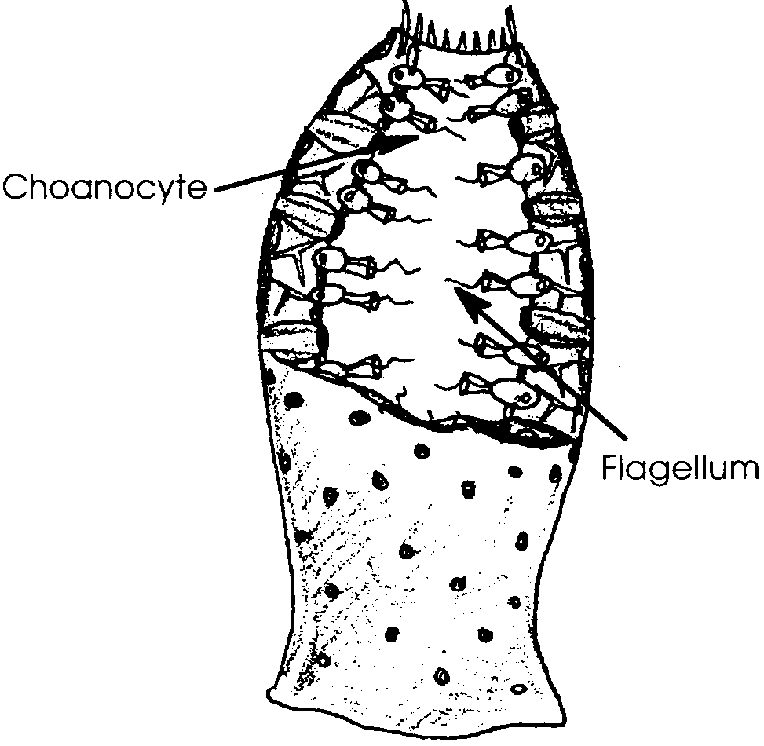
The current caused by these collar cells moves not only water but also plankton and other small bits of organic matter the sponges use for food. The current also helps supply oxygen to the living cells. Through water movement the sponge draws its food and oxygen to itself. Moving the environment through the sponge keeps the sponge from having to move through the environment. The adult sponge, therefore, can and does spend its life permanently attached by its base to a rock or shell or some similar substrate. The sponge is sessile, or relatively non-moving.

3. Show on the illustration at right the path the sea water takes as it is moved through the sponge. Describe how the sponge accomplishes this task.
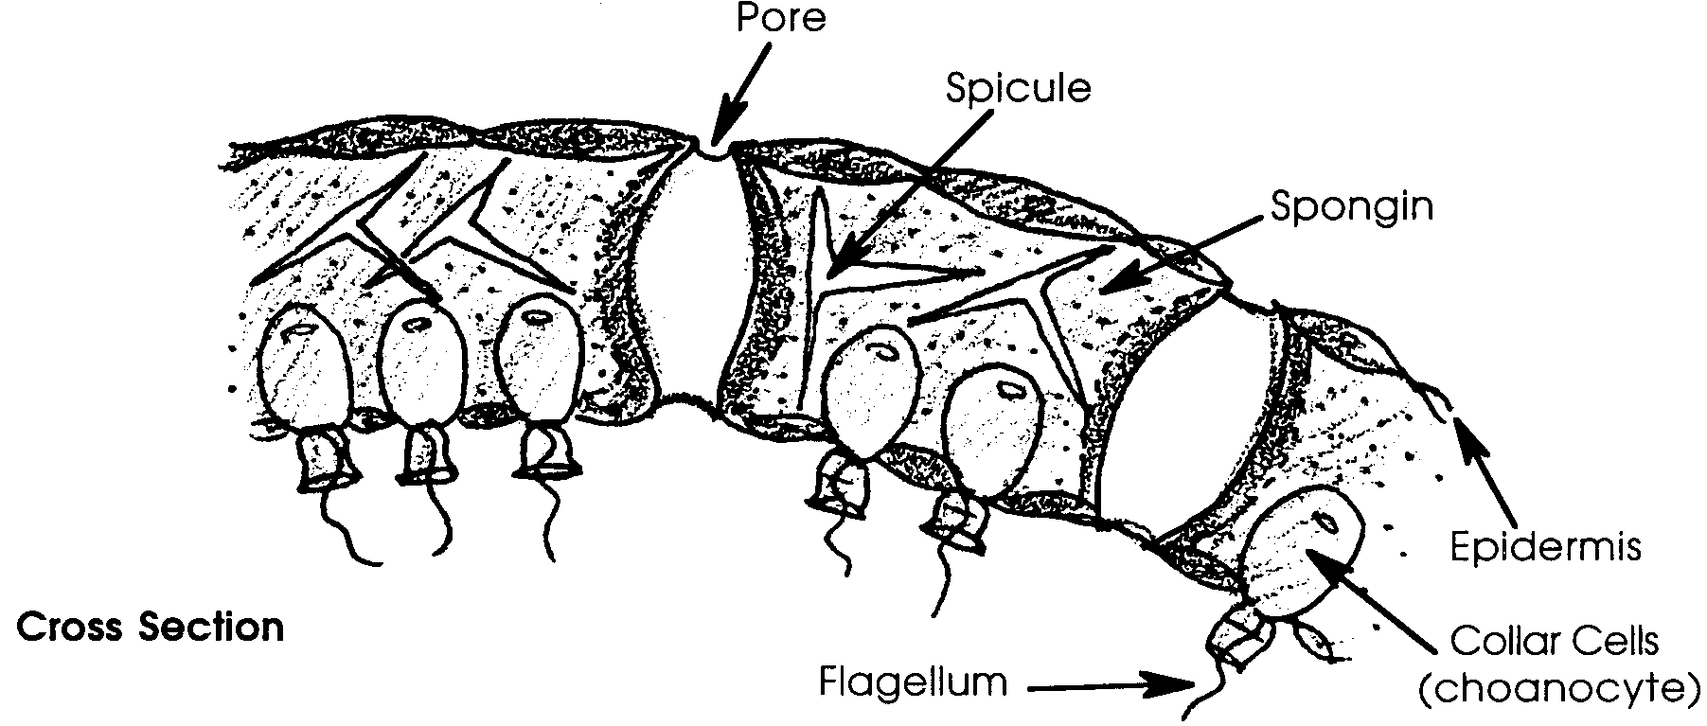
Let’s go one step further, and examine the actual body wall of the sponge. A simple sponge has a hollow body as shown in the figure above. The body wall is formed of two layers of cells separated by a layer of jelly-like material. The outer layer or epidermis protects the sponge. The inner layer contains the collar cells. The jelly layer is a mixture of loose cells, spicules and/or spongin. The spicules are noncellular skeletal structures that help support the sponge’s body. Spongin is a tough, fibrous protein, material that also helps to support the sponge.

4. Beginning at the outside and moving in, what structures comprise the body wall of the sponge?

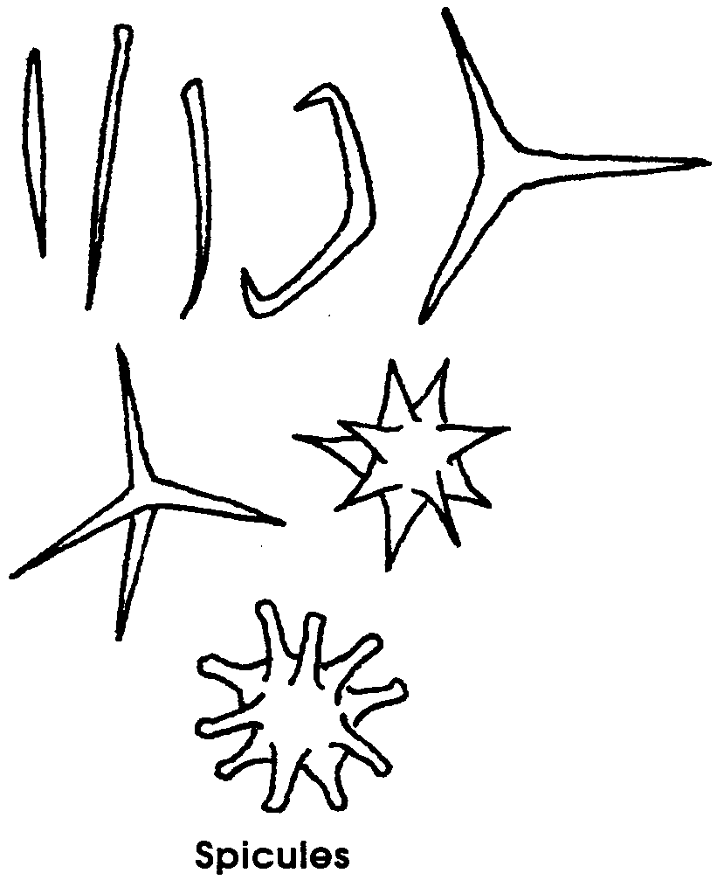
Spicules are secreted by living cells. They are small rods composed of either lime (calcium carbonate) or glass (silica). The spicules come in a variety of shapes and sizes. The spicules make the sponge a very difficult mouthful for a predator to swallow.
Spicules are secreted in the sponge by small amoeba-like cells called amoebocytes. These amoebocytes also distribute digested food and oxygen to other cells as the amoebocytes wander through the jelly-like layer.
In the following activity you will have an opportunity to take a piece of sponge body wall, dissolve away any soft tissue and examine the spicules.
Materials
• various sponge animals- living or dried
• bleach solution (50% commercial bleach/50% water)
• dilute acetic acid (5 - 10%)
• depression slide
• Pasteur pipette or medicine dropper
• forceps
• compound microscope

Procedure:
1. Use your forceps to obtain a very small piece of sponge, about 1 mm long and as wide as the tip of your forceps. If you take a larger piece of sponge, it will be difficult to separate out the spicules enough to get a clear view.
Place the sponge in the well in your depression slide.

2. Cover the section of sponge with 1 or 2 drops of bleach solution to dissolve away the sponge tissue.

3. Allow the tissue to dissolve completely, about two minutes.

4. Use the Pasteur pipette or medicine dropper or forceps to spread out the dissolved mixture so you’ll be able to see individual spicules.

5. Examine the preparation under the compound microscope. You should not require magnification greater than lOOx. DO NOT use the high power objective since bleach is corrosive. The best view will be at the outer edges of the solution where the spicules are most spread apart.
In the space below, make a drawing of the spicules you observe from this sponge.
Some sponges have spicules made of calcium carbonate, the same material that makes up lime, chalk and shells. Others have spicules made of silica, or glass. Try the following to discover which type of spicule is in your sample.

6. Carefully add a drop of dilute acetic acid to the edge of your sponge and bleach mixture.

7. Use the microscope to observe the spicules for any evidence of bubbling. Dilute acid will dissolve spicules composed of calcium carbonate, evidenced by bubbling, but will not dissolve spicules composed of silica.

What appears to be the composition of your spicules?

8. Now that you’ve examined sponge on the outside, inside the pores and even in the body wall itself, describe the adaptations (special structures or behaviors) that allow sponges to lead a sessile existence and yet get all they need from their environment and avoid predators?

Extension - Identification of Sponges
Each species of sponge has its own special combination of spicules. Like a fingerprint, those combinations may be used to identify the species of sponge.
Often sponges produce two types of spicules. The large spicules are called megascleres and the smaller spicules of a different design are called microscleres.
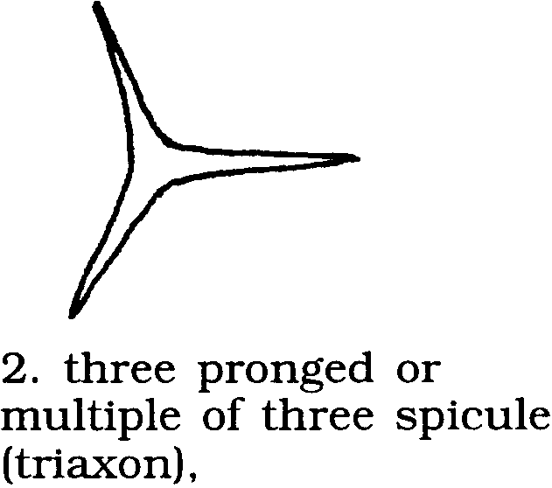
Biologists have divided spicules into four basic shapes:

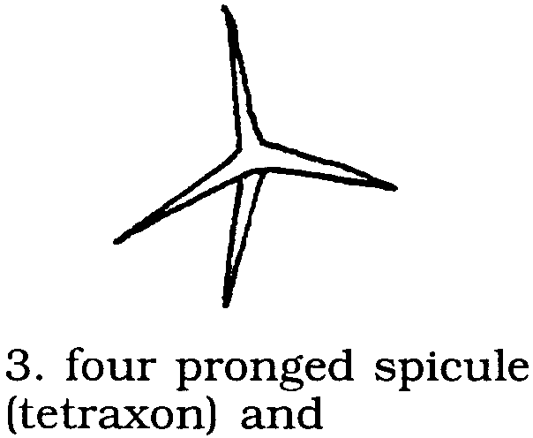
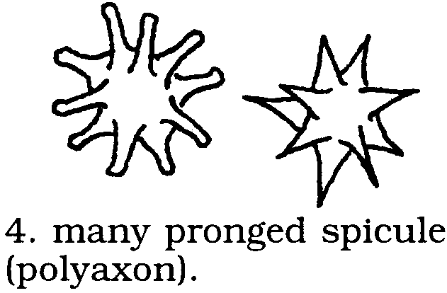

Use the “Types of Sponge Spicules” to find names for the spicules you observed. Record your data:
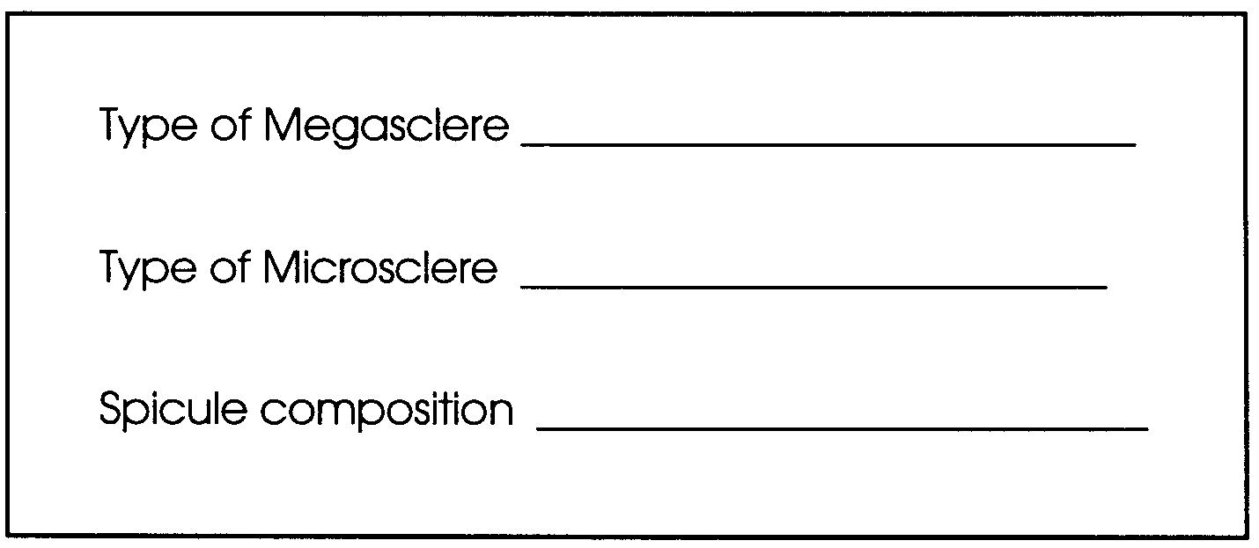
Sponges are usually grouped according to the type of spicules into three classes:

Class 1: Calcarea (Calcispongiae) Spicules composed principally of calcium, are monoaxon or three or four branched,

Class 2: Hexactinellida (Hyalospongiae) Spicules composed principally of silica, are 6-rayed,

Class 3: Demospongiae (Siliceous) Spicules or horny fibers or both are present. If spicules of silica are present in an intertidal form, the sponge probably belongs to this class. Spicules, if present, are never six-rayed.

Use this information to determine the class of the sponge from which you obtained spicules .

The sponge belongs to Class
because

Repeat the above steps for as many sponges as you can in the time provided.

Analysis and Interpretation
1. Which type of spicule (monoaxon; etc.) was most common?

2. Did any of your spicule suspensions contain both lime and glass spicules? If so, how might you account for this observation?

3. How could you determine if the two different sponges belonged to the same species?

4. While spicules are useful to biologists as an aid to identification, what is their role in the life of the sponge?

