Using the 24 Hour Clock
Lesson by Gene Williamson
Whitford Intermdiate School, Beaverton, Oregon\

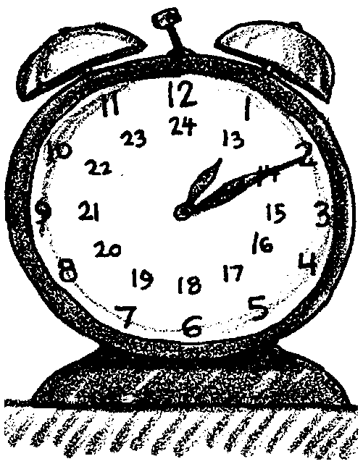
Key Concepts
1. There are several time systems in use worldwide.
2. The 24 hour, or military clock, is widely used among scientists to avoid the confusion of the standard AM-PM system.
3. Mathematical manipulations are easier when using the 24 hour system.

Background
We tend to take time and our A.M.-P.M. system of marking time for granted. A look at any dictionary quickly dispels the notion that time is a simple concept. While our commonly used system of time is based on the 24 hour solar day, astronomers use a sidereal time system based on the rotation of the earth in relation to any star; a sidereal day is about 4 minutes shorter than a solar day.
The division of the 24 hour day into A.M. (ante meridiem - before noon) and P.M. (post meridiem - after noon) is sometimes confusing (just when is 12 P.M.?); did you mean 8:00 at night or 8:00 in the morning?). To avoid this confusion, scientists often record time using a 24 hour clock. This system has obvious advantages under the surface of the ocean or in space away from the surface of the earth where the concept of morning has little meaning.

Materials
For the class:
• a large clock with 24 hour designations is helpful, but not required

For each student:
• “Using the 24 Hour Clock” student pages

Teaching Hints
It is especially important that students be thoroughly trained and practiced in the use of military time or the 24-hour time system before instruction in the use of the Tide Tables is given. Just as the metric system should be employed in the classroom laboratory and in the field, so should the 24 hour clock.
Less than one laboratory period (50 min.) is required for this exercise. Discussion should be encouraged.
The exercises given here lend themselves to many variations. Answers given are for convenience. Keep in mind that standard time based upon time meridians is used, almost without exception, in published tables and reports. Therefore, local variations such as “summer time” or “daylight saving time” must be acknowledged.
The classroom clock can be converted by numbering the extra hours, 13 through 24, either to the clock face or around its outer edge. If finances permit, a bona fide 24-hour wall clock can be purchased.
Try breaking this activity down into a series of short lessons, making sure each has been mastered before moving ahead. Typically the progression is (1) convert to 24 hr from standard; (2) convert from 24 hr to standard; (3) add in 24 hr designation; (4) subtract in 24 hr designation.
Break the addition and subtraction problems into two parts. Subtract the minutes, borrowing an hour if you need it, then subtract the hours, borrowing a full day (24 hrs) if you need it.

Key Words
Greenwich Mean Time - the time as measured at the prime meridian (0° longitude) running through Greenwich, England and used as a standard of calculation which avoids time zone confusion.
hundred hours - term used in the 24 hour clock time system to designate no minutes past the hour i.e. 0400 is read oh-four-hundred hours, whereas 0401 is read oh-four-oh-one hours.

Answer Key
Exercise A Exercise B
1. 0752 hrs. 1. 3:15 AM
2. 1952 hrs. 2. 11:00 PM
3. 1000 hrs. 3. 11:21 AM
4. 2200 hrs. 4. 1:21 AM
5. 1530 hrs. 5. 5:00 PM
6. 1715 hrs.
7. 1200 hrs.
8. 2400 hrs. or 0000 hrs. (next day)
9. 0004 hrs.

Exercise C
1. Addition 2. Subtraction
(a) 0400 hrs. (a) 1308
(b) 0308 hrs. (next day) (b) 0752
(c) 0010 hrs. (next day) (c) 0144
(d) 1330 hrs. (d) 2220 (day before)

Problem: 128 hours 38 minutes
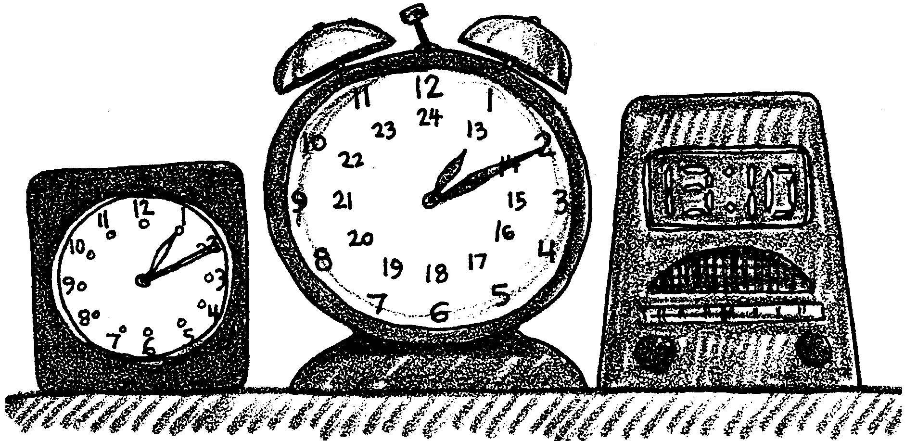
Using the 24–Hour Clock

Time is defined as a measurable period during which an action exists. The manner in which time is expressed must then suit the purpose for which it is intended. There are many reasons for a 24-hour clock. Accuracy, not only in recording, but also in communicating, is a primary argument for the 24-hour clock. The terms “A.M.” and “P.M.” are not required. For instance, 2400 hours of June 10 is the same as 0000 hour June 11. Daytime and nighttime are not significant factors. There are many places on the earth that are without the sun’s light for weeks at a time. At other times there are no nights. Time in a “Sea Lab” or other underwater stations has little use for the “A.M.” and “P.M.” designations. The day begins at midnight and runs for 24 hours.
The 24-hour clock can be adapted to Greenwich Mean Time (GMT) or Universal Time (UT) for world-wide usage. The U.S. Department of Commerce Tide Tables uses the 24-hour clock exclusively, as do many navigational tables and charts.
Use the 24-hour clock when asked, “What time is it?” In written work, at least in the field of marine science, record all times in 24-hour designations.
In this exercise you will learn how to express time and how to compute time differences using the 24 hour clock.

Materials
• wall clock. (modifications optional)
• pencil (with eraser)
Procedure:

A. Conversion to 24-hour Time

Orally, 24-hour time is expressed in “hundreds”: for instance, 8:00 A.M. would be spoken “eight hundred hours”; 2:30 P.M. would be spoken “fourteen-thirty hours”.
The written time uses four digits. Convert the following to the 24 hour clock.

AM-PM CLOCK 24-HOUR CLOCK

1. 7:52 A.M.
2. 7:52 P.M.
3. 10:00 A.M.
4. 10:00 P.M.
5. 3:30 P.M.
6. 5:15 P.M.
7. 12:00 noon
8. 12:00 midnight
9. 12:04 A.M.

B. Conversion to A.M.-P.M. Clock

Convert the following to A.M.-P.M. clock.

A.M.-P.M. Clock 24 Hour Clock
1. 0315
2. 2300
3. 112
4. 0121
5. 1700

C. Computing Time Difference

Keep in mind that the first two digits, reading from left to right, of a time expression represent hour, and that the last two digits refer to minutes. Minutes amounting to 60 or more must be converted to hours. If subtracting minutes, and “borrowing” becomes necessary, remember that when you “borrow” from the hour digit you are borrowing sixty minutes not one hundred minutes!
1. ADDITION
(a) 0240 hrs. +0120 hrs.

(b) 1708 hrs. +1000 hrs.

(c) 2250 hrs. +0120 hrs.

(d) 1100 hrs. +0230 hrs.

2. SUBTRACTION

(a) 1358 hrs. -0050 hrs.

(b) 0911 hrs. -0119 hrs.

(c) 0234 hrs. -0050 hrs.

(d) 0120 hrs. -0300 hrs.

Problem:
Sal Inometer, world famous physical oceanographer, wishes to collect data on the movement of deep currents off the coast of Washington State. She directs the crew of R/V Huskies-R-#1 to deploy current meters at a depth of 1000 meters. The current meters are deployed at 0915 hrs on June 27 and then recovered on July 2 at 1753 hrs. How long, in hours and minutes, were the current meters in place? (Hint: June has 30 days)

