Tanker Spill
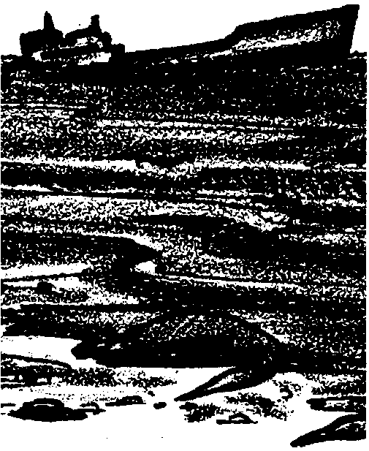

Key Concept
1. Wind and water conditions affect how an oil spill spreads.

Background
Humans are important agents of change of the natural environment. Through mining of natural resources, disposal of wastes, water and air pollution, and overuse of land, humans have radically changed the balance of nature. Coastal waters of the United States are heavily traveled. Major oil refineries are situated along our shorelines and oil tanker traffic is common. In spite of great efforts made to prevent oil spills, oil spills do occasionally occur. The spills which have occurred have demonstrated the disastrous effects of oil on wildlife and aquatic plant life. Since the oil from spills usually washes ashore, shorebirds and other shore animals and plants are especially likely to suffer. The impact of an oil spill will depend upon many factors: the size of the spill, the type of oil, winds and tides during the spill, and the concentrations of organisms in the area affected.

Materials
For each class:
• popcorn slinger made from 25 meters of cord and a pillowcase or cloth bag
• tennis ball-sized rock or other weight for the popcorn slinger
• 25 meters of twine
• 20 liters of popcorn
• question cards

Teaching Hints
“Tanker Spill” gives your students an opportunity to create an “oil spill” and to estimate the impact of the “oil” on the shoreline ecosystem. Popped popcorn serves as the “oil”. The advantages of popcorn include the fact that it is easily dispersed by wind and waves and that the remnants of the “spill” are eaten (gladly) by shorebirds.
This activity requires access to moving water. A sea or lake beach or stream is ideal. Sites with strong currents, wind, and/or tidal action will show the most dramatic distribution of the oil spill.
The student pages for “Tanker Spill” consist of question cards carried to the site. The question cards require your students to make certain observations. The observations form the basis for the group discussion which follows the activity. Directions for Pre-Trip Activities, On-Site Activities and Post-Trip Activities are found on the next pages. Anticipate any special requirements your class is likely to have. Duplicate the question cards and distribute one set to each student. This activity works well with small groups. Also take a few minutes to review the general precautions for field tripping which you will find elsewhere in this volume.

Pre-Trip Activities
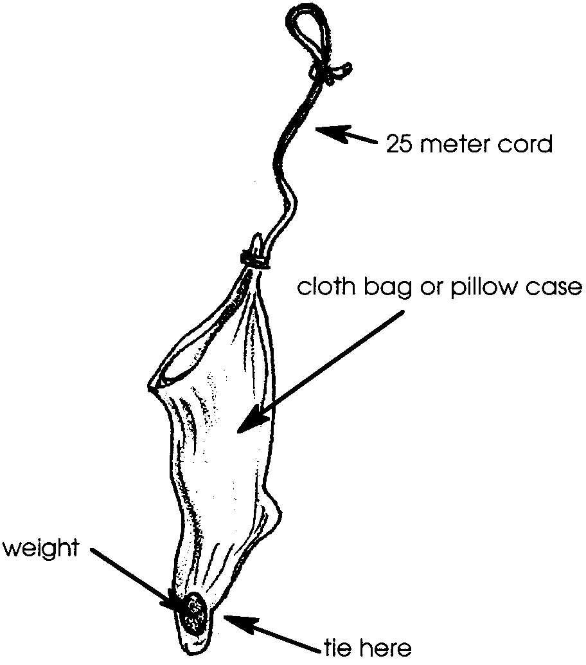
1. Introduce the topic of oil spills and the possible effects of oil spills on the environment.

2. Make a “Popcorn Slinger” after OBIS:
a. Tie a 25 meter cord firmly to one corner of the open end of a cloth bag or pillow case. Tie a loop at the other end of the rope.
b. Place a weight (for example, a tennis ball sized rock) in the bottom of the bag and tie it off in one corner to hold it in place.

3. Practice tossing the empty device.

4. Pop about 20 liters of popcorn and fill the bag. (When the bag is tossed into the water, the weight will cause it to sink.) The buoyant popcorn will then float out causing our “oil spill”.

On-Site Activities
1. Introduce the activity. The students will be responsible for estimating the impact of the oil spill on the landscape, the plant and animal life, and on human activities.

2. Provide a set of question cards to each student or group to aid them in their investigations.
3. Ask students to predict where the “oil” will end up and how long it will take to get there.

4. Toss out the popcorn and let the class begin to track it down. You may wish to have your class record their findings on their question cards.

5. At the end of the allocated time, gather all of the students together to discuss their findings. Discussion can be directed by using the questions from the question cards. You may want to summarize the findings by discussing the following impact questions.
a.How quickly did the spill reach the shore?
b.What agents dispersed the spill? (wind, tide, etc.)
c.How might different wind or water conditions affect the spill?
d.How could an oil spill be prevented from spreading?
e.Who should be responsible for cleaning up the spill?

Post-Trip Activities
1. Please note that item 5 above could be completed in the classroom, however, the field site lends itself well to this type of discussion.

2. If the discussion is to occur in the classroom, make sure that each student obtains a copy of the data from all of the groups. This can be accomplished by having the teams pool their data on a single sheet.

3. Provide opportunities for the students who have, by now, gained confidence in their abilities to engage in open ended investigation and relevant problem solving.

“Tanker Spill” is adapted from “Oil Spill” an activity developed by OBIS (Outdoor Biology Instructional Strategy) from the Lawrence Hall of Science, University of California, Berkeley.

QUESTION CARD
Landscape

Follow the spill and estimate its impact on the landscape. Use a 25-meter length of twine to measure the area the spill covered.

Estimates: Water sq. meters (length times width)
Land sq. meters (length times width)

Where did most of the popcorn end up? Why?

How might the underwater landscape be affected?

How did the spill change the general appearance of the landscape?

QUESTION CARD
Plant Life

Follow the spill and estimate its impact on plant life. How many different types of plants were affected?
Which plants were hardest hit by the spill? Why?

How might an oil spill affect land plants?

How would animals that eat aquatic plants be affected?

QUESTION CARD
Animal Life

Follow the spill and estimate the impact of the spill on the animal life. How many different types of animals were covered with oil?

Which animals were hardest hit by the spill? Why?

Which animals do you thing would be capable of escaping from a spill?

Which animals might not be able to escape?

How might an oil spill affect animals that live under rocks in the water?

QUESTION CARD
Human Activities

Follow the spill and estimate its impact on human activities. How might an oil spill affect fishing and other recreation activities such as swimming, water skiing, surfing, diving, etc.?

How might boats, docks, breakwaters, and other water structures be affected?

How might drinking water or food be affected by an oil spill?

