Create a Rocky Shore
Lesson by Holly Anne Foley
Marine Science Center, Poulsbo, Washington
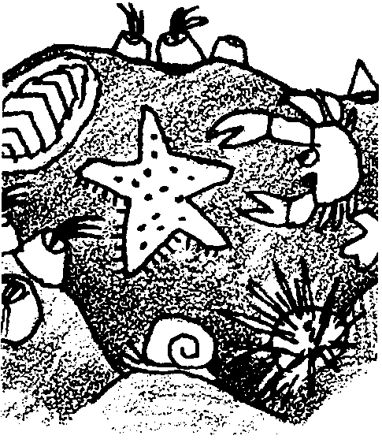

Key Concepts
1. Rocky shore organisms are adapted to live in specific tidal zones.
2. Each tidal zone is characterized by a typical community of organisms.

Background
Background information for “Create a Rocky Shore” is found in the preceding activities, “The Ecological Niche” and “Wharf Rat”.

Materials
For each class:
• craft materials such as
butcher paper
tissue paper
construction paper
glue, tape, staplers
scissors
markers, crayons, pastels, paints
• copies of “Create a Rocky Shore” student pages (optional)
• intertidal animal reference books

Teaching Hints
“Create a Rocky Shore” helps students integrate the basic ecological principles and concept of intertidal zonation developed in “The Ecological Niche” and “Wharf Rat”. In this activity, students create a paper model of a rocky shore or of a piling. Next, they mark tide heights on their model, create representative piling animals, and place their animals in the correct zones. Students use a tide calendar to determine the number of hours each animal typically is exposed at extreme low tides. Finally, they add interpretive notes describing how the animals are adapted to survive low tide.
Consider displaying these creations in your school, at an elementary school, at a local science fair or elsewhere in the community so that students know they will have a real audience and must make attractive and accurate creations.
The student pages include a list of animals and tide ranges typical of intertidal areas along the Pacific Northwest coast. You may wish to alter the list to fit your area.
Divide the students into teams of 3 or 4. Group students with different skills together. If some members have researching and writing strengths, some have artistic ability, and some enjoy doing and making, the groups will have greater success.
Students may choose to do a two dimensional or three dimensional model of a beach or piling. Produce boxes from the grocery store work well as a setting for a beach scene. Students can wrap butcher paper around a weighted coffee can to make a three dimensional piling. Very often, the students come up with the best ideas.
Students will need access to reference books and may want pictures of the animals they will be creating. If you can provide access to computers and a word processing program, ask students to create their interpretive signs on computer. The labels will be more polished.

Key Words
community - a group of organisms living together; any group of interacting organisms
habitat - the natural environment of an organism
intertidal - living or located between the high-water mark and the low-water mark
intertidal zonation - the observation that organisms are distributed in more or less distinct bands or tidal zones in the intertidal zone
intertidal zone - the region of a beach that is above the low water mark and below the high water mark
tidal zone - a region or band of an intertidal beach characterized by a certain exposure to wave action and drying ranging from spray to nearly perpetual submergence
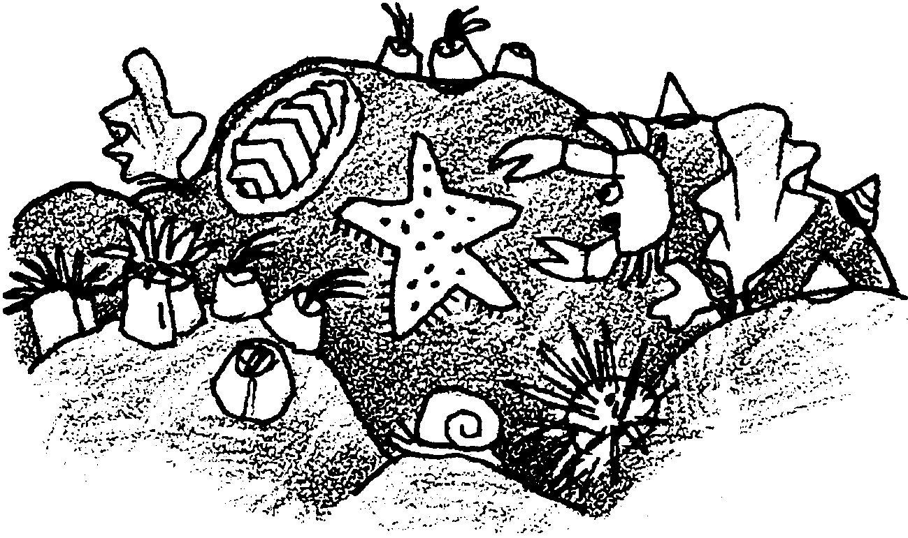
Create a Rocky Shore

Your task is to create a representation of a rocky beach or a wharf piling which will be used to teach others about marine animals and how they stay alive as the tides go in and out.

Here is what you will do:
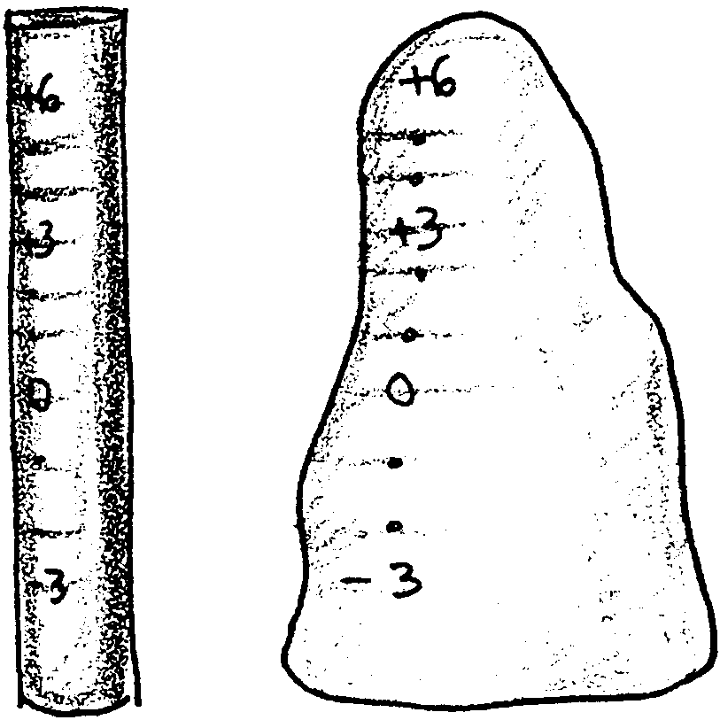
1. Create a representation of the physical structure of the habitat, either rocks or pilings.

2. Mark the tide heights from -3 feet to +6 feet on the model.

3. Create realistic models of the animals that typically inhabit the type of rock or piling you have made.

4. Place the animals in the tidal zones that correspond to those where the real animals live.

5. Finally, make a label for each type of animal that includes: name of animal, the time that the animal would be exposed to the air at most extreme low tides, structures or behaviors the animal has to survive low tide, any other interesting stories you can find.

6. Display your rocky shore to teach others and for others to enjoy.
Now that you know the procedure, assign each person in your team one of the following tasks. Every team member will assist with all aspects of the project, but each member also has a portion to direct.

Habitat Creation Director

Animal Creation Director

Animal Placement Specialist

Interpretive Note Writer

Your habitat should include at least the following animals in the following approximate tidal ranges:

Barnacles 0 to +5
Limpets 0 to +5
Snails -2 to +3
sea anemones subtidal to -1
chitons -3 to 0
sea stars -3 to 0
sponge subtidal to -3
mussels -2 to +2
sea urchins subtidal to -2

