The Ecological Niche

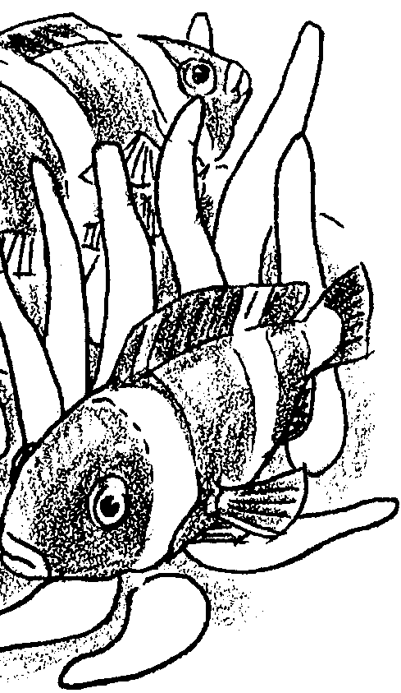
Key Concepts
1. Each marine plant or animal has specific requirements for space, water conditions and food source.
2. Organisms have adapted to utilize the resources of space, water conditions and food found in a wide variety of marine habitats.
3. Those conditions and relationships with which an organism can survive form its ecological niche; the organism's role in the community.

Background
Ecology is the study of relationships among organisms and their environment. Fundamental to the science of ecology are the concepts of community, ecosystem, ecological niche and succession. A group of organisms living and interacting together is termed a “community”. An ecosystem is the basic functional unit of nature and describes the relationships between the organisms and between the organisms and their non-living environment. The living and non-living components of an ecosystem are intimately linked by a variety of biological, chemical and physical processes.
The place and function, or “role”, of an organism within an ecosystem is termed its niche. Organisms have evolved special adaptations that allow them to survive in specific areas. These organisms, in turn, require certain things from their environment for survival. In other words, plants and animals live where they do because they find their essential needs met within the confines of that area. Communities and ecosystems change over time. The gradual replacement of one type of community or ecosystem by another is termed succession. Succession occurs in a definite sequence reflecting changes in environmental conditions.

Materials
For each class:
• as many books, journals and other resources that describe marine animals as possible
For each student:
• “The Ecological Niche” student pages

Teaching Hints
In “The Ecological Niche” each student will have the opportunity to explore the environment and adaptations of a marine animal of his/her choosing. Each student will research the food, substrate and water condition needs of the animal and the ways in which its particular habitat meets those needs.
Before you assign this activity, decide whether you will allow students to choose any marine animal or if you would like them to choose from rocky shore intertidal animals or from some other predetermined list.
Provide ample reference books and magazines to aid students in their selection of an animal and to help provide answers to the activity questions. A trip to the library might be in order here. It is possible to assign this activity as homework, but most classes need at least some initial guidance in attacking the questions.
Upon completion, you might find it profitable to have your students exchange papers and provide written comments on the papers they receive. You may want to create some other forum for sharing student findings. Two possible extensions that might serve as effective summary activities are described below.

Key Words
commensalism - a symbiotic relationship between two organisms in which one benefits by living in or on the other, but not as a parasite, thus leaving the other unaffected
ecological niche - the place and function of an organism within an ecosystem
food chain - outline of who eats whom showing path of energy transfer in an ecological community
intertidal zone - the region of a beach that is above the low water mark and below the high water mark
mutualism - a symbiotic relationship between two organisms in which both benefit
plankton - the mostly microscopic plants and animals that drift in water; singular = plankter
salinity - a measure of the salt concentration in a solution
substrate - the base on which a sessile (nonmotile) organism lives or grows

Extensions
1. Have students create a giant food web that includes all the animals students studied. Emphasize that in any food web, there is no one food source for all the animals. There is a diversity of prey preferences so no one food source is over-exploited and all animals have food to eat.

2. Have the class create a poster or display of the community that includes pictures or drawings of all the animals the students studied glued in their correct location on a drawing of the physical environment. Emphasize that in any habitat, there is no one place that all the animals live in. Some prefer low tide zones while others live in high tide zones. Some attach to rocks in areas of high wave action while others hide in crevices or sheltered tide pools. This diversity of living place preferences reduces competition and overcrowding enabling more animals to have a place to live.
Urchins

No animal fills the bill of “spiny-skinned” better than the sea urchin. Sea urchins have been used for food since at least the days of ancient Greece. Sea urchin eggs are considered a delicacy in many parts of the world. Ancient Romans used sea urchins as medicine. The urchin, spines and all, was ground, mixed with a cup of wine or vinegar, and swallowed. In some cases, urchins were burned with snake skins and frogs and the ashes mixed with vinegar. Drinking one cup a day was said to improve eyesight.

In the following exercise, you will examine the external anatomy of the sea urchin and observe the fertilization and development of the sea urchin egg.

Materials
• live sea urchin
• sea water
• filtered sea water
• finger bowl
• dissecting microscope
• 250 ml. Flask
• 10 ml. Pipette
• sea urchin egg suspension
• sea urchin sperm suspension
• compound microscope
Part I - External Anatomy of a Living Sea Urchin

1. Obtain a living sea urchin and place it in a finger bowl of sea water. What color is your sea urchin?

2. Measure the diameter of your sea urchin and RECORD the diameter in centimeters.

cm.

3. The sea urchin body can be divided into oral (mouth) and aboral (away from the mouth) hemispheres which display the radial symmetry typical of echinoderms. Observe the aboral surface of the live specimen.

a. Are the spines of equal length?

b. If the spines are not of equal lengths, are the spines in one region longer than the spines of another region?

If so, where are they the longest?

4. Observe the oral surface of the live sea urchin. The mouth of the sea urchin contains a toothed structure called Aristotle’s Lantern. The tips of the teeth are just visible through the open mouth. The sea urchin uses these teeth to scrape off and crunch encrusting growths like barnacles, hydroids, tube worms, sponges and algae. These teeth wear away with constant use. The worn area is replaced from above by the downward shifting of the entire tooth as the tooth grows at the upper end.

a. How many teeth (points) make up Aristotle’s Lantern?

b. How do these teeth aid the sea urchin in feeding?

5. Gently touch the spines of the urchin with your finger or eraser. Describe their movement.

The purple urchin, Strongylocentrotus purpuratus, of the Pacific coast burrows into rocks. These urchins use a combination of spine rotation and chewing to wear away the rocks on which they live. Eventually, they excavate a cup shaped depression into the rock.

b. What is one possible benefit of this burrowing behavior?

6. Observe the tube feet or podia. The podia are long, tube shaped structures with a flattened tip forming a sucker. Podia are part of the water-vascular system. When the podia come into contact with a hard surface, the center of the sucker is withdrawn producing a vacuum and adhesion.

What are two ways in which the podia might help the sea urchin survive?

1.

2.

7. Observe your specimen with the aid of a dissecting microscope. Structures know as pedicellariae are found between the spines. Each pedicellaria bears a jaw-like apparatus used for protection and to capture small animals. In some sea urchins the pedicellariae contain poison glands.

a. How many opposing “teeth” form the jaws?

b. How might the food captured by the pedicellariae be transported to the mouth?

8. Gently turn over your sea urchin. (If possible, place the sea urchin on a sandy substrate.) Describe the action of the spines and tube feet as the animal rights itself.

Return your sea urchin.

Part II - Reproduction and Development

Sea urchins normally discharge gametes (eggs and sperm) into the sea and there fertilization occurs. This process called external fertilization, is very common among aquatic organisms. With luck, the fertilized eggs develop into free floating, pelagic (open sea) larvae. These larvae drift with currents and thus distribute the sea urchins population and extend the range (area in which the urchin species is found) of the species.

There are great risks inherent in this free-floating lifestyle. Many larvae may be carried to locations where the substrate is unsuitable for sea urchin growth. Many more larvae are eaten by larger animals. To compensate for these high mortality rates, millions of eggs are shed by each female and even more sperm is shed by each male.

1. How many sea urchin eggs must reach maturity to replace each pair of sea urchins and maintain a constant population size?

2. Are the odds very good that any given fertilized egg will reach maturity? What makes you think so?

Procedure:

1. Obtain a drop of unfertilized sea urchin egg suspension. (Your teacher will provide the suspensions or instructions regarding how to obtain them). Place the drop on a depression slide, cover and observe using a compound microscope. The eggs are spherical and surrounded by a jelly coat. Mature eggs will show a small clear nucleus and uniformly distributed pale yolk granules.

a. In the space to the right, sketch an unfertilized egg. Label the nucleus and jelly coat, if visible.

2. Obtain a drop of sperm suspension and place it on a depression slide. Cover with a coverslip and observe using a compound microscope. The sperm swims by agitating its whip-like flagellum. You may be able to see the flagellum if you decrease the amount of light transmitted through your microscope.

a. In the space below sketch a sperm cell. Label the nucleus and flagellum, if visible.

b. How does the size of the sperm cell compare with that of the egg cell?

3. Using separate pipettes (Caution: do not mix the pipettes) add one drop of the sperm suspension to one ml. of the egg suspension in a 250 ml. flask filled with filtered sea water. Mix well by swirling.

RECORD the time: Time ___________________

4. Pipette a drop of the egg-sperm mixture onto a depression slide. Seal a coverslip over the mixture using petroleum jelly (Vaseline) around the edges of the coverslip. Immediately examine the eggs under a microscope using low power (lOx). After locating eggs, switch to high power. Under the high power, sperm will be seen clustering around the egg. Sperm penetration can be seen very soon after the eggs and sperm are mixed. Normally, only one sperm cell will penetrate the egg. A fertilization membrane will form over the egg.

a. RECORD the time at which the membrane first appears.

b. How long a time elapsed between the mixing of the gametes and the formation of the fertilization membrane?

c. In the space below, sketch the fertilized egg. Label the fertilization membrane.

5. By placing the suspension in a refrigerator, you may save your fertilized egg-sperm suspension for observation of more advanced stages of development tomorrow and the following day.

6. Observe and sketch eggs fertilized earlier in the day by other classes or by your teacher. Label each sketch to show the number of cells present.

7. The next day and the day following that observe and sketch your fertilized egg. By about 10 hours following fertilization, the fertilized egg has become a hollow ball of cells called the blastula. The blastula becomes flagellated and free-swimming within twelve hours.

At about 32 hours the blastula becomes folded in upon itself to become the gastrula.
The gastrula undergoes continued cell division to become the planktonic-feeding pluteus larvae at about two days.
Development from the pluteus stage to the adult may take several months. The young urchin, now about 1 mm in diameter, sinks to the bottom as the skeleton forms and assumes the lifestyle of the adult.

SKETCHES
24 hours
48 hours

8. Place the sea urchin larvae in the container provided by your teacher.

9. Clean the glassware and equipment you have used.

Analysis and Interpretation

1. What is one advantage of external fertilization? What is one disadvantage of external fertilization.

2. Developing sea urchin larvae are highly susceptible to predation. Lots of animals would like to eat them. It would seem advantageous for them to hide, rather than to drift in open water. What is a primary advantage to the drifting phase of development?

3. Kelp harvesters view sea urchins as a threat to the kelp beds. Some harvesters would like to eliminate the sea urchin. In view of the fact that the kelp beds and the sea urchin have coexisted for thousands of years, how would you reply to these harvesters?

4. What is one possible reason scientists have used sea urchin eggs to study the effects of pollutants on embryological development?

