The Nature of Oceanic Life –
Three Level Guide

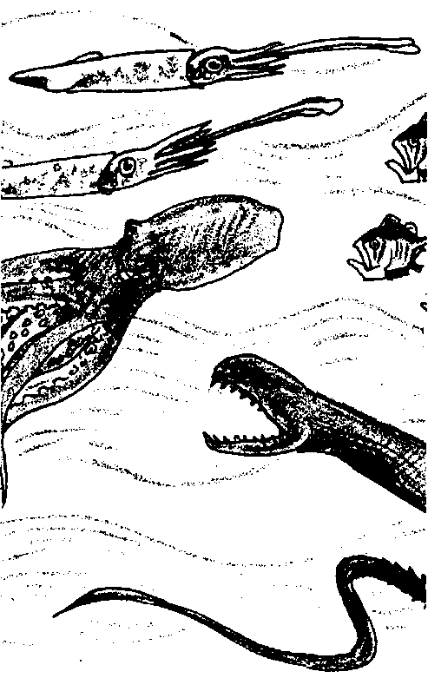
Key Concepts
1. An astounding variety of marine organisms live in several different ocean habitats, but all in the same interconnected medium of the moving oceans.
2. The sun fuels most lifecycles in the sea and microscopic, drifting phytoplankton are the dominant primary producers which harness solar energy.
3. Ocean currents move nutrients to areas of upwelling where marine life thrives.

Background
The sea abounds with life connected by ocean currents. “The Nature of Oceanic Life” provides a tour of life in regions of the ocean, from surface waters to the deep sea.
The article, “The Nature of Oceanic Life”, examines the dominant food chains in the ocean in which nutrients and energy pass from phytoplankton to zooplankton to fish and invertebrates and to the detritus, or decaying matter, that sinks into the deep sea. Unlike terrestrial ecosystems in which the producers are macroscopic grasses, trees and shrubs, in the marine environment the dominant primary production of organic matter is carried out by microscopic plants. These minute organisms trap the sunlight and use it to provide the energy necessary to sustain all of the life of the sea.

Materials
For each student:
• one copy of article: “The Nature of Oceanic Life” by John D. Isaacs (“Scientific American”, Sept. 1959, Vol. 221, No.3, pp.146-162.) “Scientific American” articles are not available for inclusion in this CD ROM version of the FOR SEA Guide. Please look for them in your library.

• one copy of “The Nature of Oceanic Life—Three-Level Guide”
Teaching Hints

While earlier activities in this Ocean Currents unit explored global current patterns, this reading introduces global distributions of marine organisms. It also introduces some of the marine habitats that appear later in the curriculum.
If your students have not used a Three-Level Guide before, explain to them that the guide will take them through three levels of questioning, from a literal level, to inference, and then to analysis and synthesis. The idea is not to “get the answer right” per se, but more importantly, to use the questions as a guide to the major ideas in the article, and to try to incorporate those ideas into one’s own knowledge base. It is important to emphasize to the students that their reasoning is much more important than their answer. In fact, in levels two and three, there may be no “right” or “wrong” answer!
Traditionally, Three-Level Guides have been intended for individual work. Suggest that the students read the statements in the three-level guide before they read the article. (Some students may prefer to read the article first, then go back over it a second time with the three-level guide). The guide is intended to be a vehicle for helping students look for certain concepts in the article.
When students have finished, discuss the guide, referring to the article. You may wish to have students work in collaborative groups to compare their answers. The process of resolving differences of opinion can be very instructive.
It is sometimes helpful to have students note the page number and paragraph where they found evidence to support their answer. You may require the students to provide sound, complete explanations for the answers they chose!
For additional information about Three-Level Guides, see Teacher Background, for the activity “Meanwhile, in the Pacific...”, Unit 2.

Key Words
mesopelagic - of, pertaining to, or living in the ocean at a depth of between 180m and 900m
nutrients - in this case, minerals and other substances needed for phytoplankton growth
pelagic - of, pertaining to, or living in the open ocean
photosynthesis - a process which occurs in the presence of sunlight in which six carbon dioxide molecules (CO2) and six water molecules (H20) are combined to yield one molecule of a simple sugar (C6H1206) and six molecules of oxygen (02)
phytoplankton - plant plankton; the primary producers of the sea
productivity - the rate at which energy is stored by producer organisms
synthesize - to combine constituent elements into a single unified entity
upwelling - the process by which warm, less-dense surface water is drawn away from a shore by offshore currents and replaced by cold, denser water brought up from subsurface

Answer Key
The Nature of Oceanic Life - Three Level Guide

Level I: Directions: Read the statements carefully. Then as you read the selection, refer back to the statements in the guide and check those statements that are actually stated or paraphrased in the selection. Be ready to explain what is inaccurate about the statements that you do not check.

X 1. The majority of the basic organic material that fuels and builds the life in the sea is synthesized within the lighted surface layers of open water by the many varieties of phytoplankton. (page 27, paragraph 5)
2. The porpoise and the seal live in the mesopelagic zone, the dimly lighted midlayer of the sea. (page 29 drawing)
X 3. The ocean’s deep bottom organisms feed on the depleted remnants of the constant “rain” of small debris and the occasional fall of a carcass. (page 27, paragraph 7)
X 4. Marine organisms have all evolved a similar mechanism for dealing with the fact that the phytoplankton they eat is in very dilute concentrations. (page 30, paragraph 3)
5. “Pelagic trees” have not evolved because the necessary nutrients for “pelagic tree” growth are not on the ocean floor. (page 31, paragraph 1,2)
X 6. Coral reefs are amazing organic structures. Some coral reefs have a mass that approaches the total of all human building that now exists. (page 39, paragraph 3)

Level II: Directions: The following statements may or may not be true, based on what the author implies. Check those statements that you feel can be supported by the selection. Be ready to support your opinion.

X 1. The fate of all phytoplankton cells is to sink to the ocean bottom.
X 2. If all phytoplankton cells sank to the bottom, life in the ocean would cease.
3. Since the nutrients stored in the bodies of plankton end up below the zone with a level of light adequate for photosynthesis, the amount of life (#’s and weight) is constantly decreasing in the oceans.
Level III: Directions: Read each statement below, relating the details and your interpretations drawn from the selection to ideas and experiences you’ve had in reference to this topic. Check the statements with which you agree.

1. Upwellings of bottom waters such as those found off the coast of Peru may positively affect the productivity of the coastal waters .
2. The ocean is a vast and rich storehouse of life waiting to be tapped by humans.
3. The most important thing for humans to learn from the sea is how to immediately get more food.

Note: Answers may vary in this section.
The Nature of Oceanic Life –
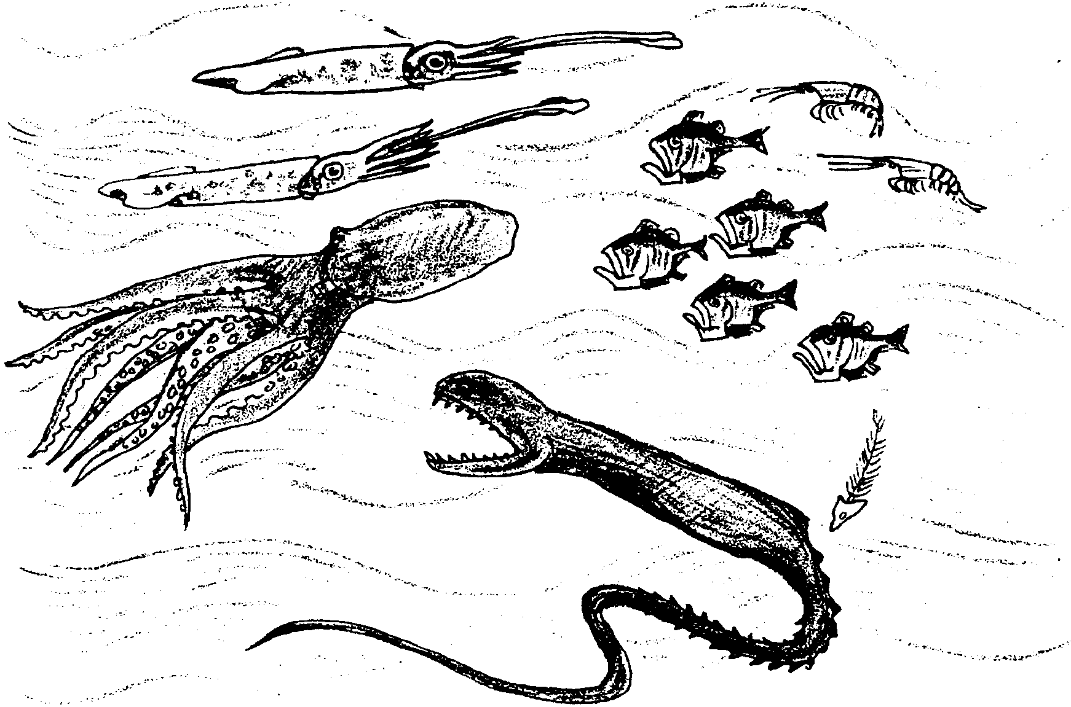
Three Level Guide
Level I: Directions: Read the statements carefully. Then as you read the selection, refer back to the statements in the guide and check those statements that are actually stated or paraphrased in the selection. Be ready to explain what is inaccurate about the statements that you do not check.

1. The majority of the basic organic material that fuels and builds the life in the sea is synthesized within the lighted surface layers of open water by the many varieties of phytoplankton.

2. The porpoise and the seal live in the mesopelagic zone, the dimly lighted midlayer of the sea.

3. The ocean’s deep bottom organisms feed on the depleted remnants of the constant “rain” of small debris and the occasional fall of a carcass.

4. Marine organisms have all evolved a similar mechanism for dealing with the fact that the phytoplankton they eat is in very dilute concentrations.

5. “Pelagic trees” have not evolved because the necessary nutrients for “pelagic tree” growth are not on the ocean floor.

6. Coral reefs are amazing organic structures. Some coral reefs have a mass that approaches the total of all human building that now exists.

Level II: Directions: The following statements may or may not be true, based on what the author implies. Check those statements that you feel can be supported by the selection. Be ready to support your opinion.

1. The fate of all phytoplankton cells is to sink to the ocean bottom.

2. If all phytoplankton cells sank to the bottom, life in the ocean would cease.

3. Since the nutrients stored in the bodies of plankton end up below the zone with a level of light adequate for photosynthesis, the amount of life (#’s and weight) is constantly decreasing in the oceans.

Level III: Directions: Read each statement below, relating the details and your interpretations drawn from the selection to ideas and experiences you’ve had in reference to this topic. Check the statements with which you agree.

1. Upwellings of bottom waters such as those found off the coast of Peru may positively affect the productivity of the coastal waters.

2. The ocean is a vast and rich storehouse of life waiting to be tapped by humans.

3. The most important thing for humans to learn from the sea is how to immediately get more food.

