Satellite Images

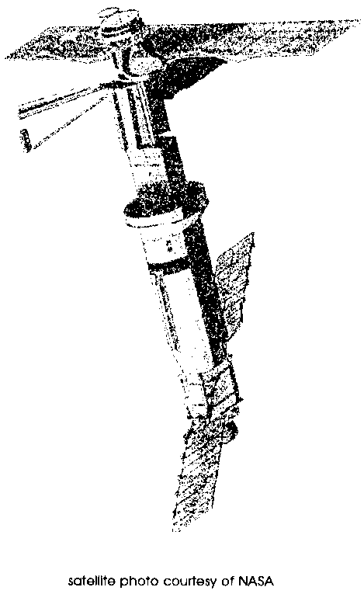
Key Concepts
1. Scientists use data collected through satellite images of the ocean to map current patterns and areas of high plankton productivity.
2. Areas of cold water and particularly areas of upwelling have high phytoplankton levels.
3. Phytoplankton are most abundant during the summer months when the hours of sunlight per day are greatest.

Background
Scientists at NASA and Woods Hole Oceanographic Institution have developed sophisticated new computer systems for processing ocean data retrieved from sensors launched in satellites. Altimeters, scatterometers and radiometers which sense infrared and visible light scan the ocean surface and transmit data to earth. Scientists compile the data into color images showing, among other things, phytoplankton productivity, variations in sea level, sea surface temperature changes during El Nino currents, and fluctuations in eddies in major ocean currents. The images are not only informative, but also beautiful.

Materials
For each student or student team:
• satellite images from FOR SEA “Marine Explorations CD-ROM” or from “Oceanography from Space” or “Ocean Color from Space” packets of satellite images, available free from:
NASA
National Aeronautics and Space Administration
Washington, D.C. 20546.
• copy of “Satellite Images” student pages
• colored pencils, pastels, markers, or crayons
Teaching Hints

“Satellite Images” gives your students a chance to use color satellite pictures to see current patterns and how they correlate with phytoplankton blooms.
Before students arrive, look through the packets of satellite images and set aside any you believe are not pertinent to what you are studying or are too difficult for the students to interpret. By far the most pertinent images for the Currents unit are the images of phytoplankton pigment concentrations. The images copy well on color photocopy machines.
The lesson asks students to review the needs of phytoplankton before interpreting a satellite image. Be prepared to help students fill in the table in the student pages with the needs of phytoplankton. For example, students may need to review the ingredients and products of photosynthesis. The table will be easier to complete if students have completed the preceding activity entitled “Ocean Currents”. It may be helpful to review the sections in that lesson about upwelling. A completed chart is provided in the answer key.

Key Words
nutrients - in this case, minerals and other substances needed for phytoplankton growth
photosynthesis - a process which occurs in the presence of sunlight in which six carbon dioxide molecules (CO2) and six water molecules (H20) are combined to yield one molecule of a simple sugar (C6H1206) and six molecules of oxygen (02)
phytoplankton - plant plankton; the primary producers of the sea
plankton - the mostly microscopic plants and animals that drift in water; singular = plankter
sensor - mechanical device, sensitive to light, temperature, radiation level or the like, that transmits a signal to a measuring or control instrument
upwelling - the process by which warm, less-dense surface water is drawn away from a shore by offshore currents and replaced by cold, denser water brought up from subsurface

Extensions
1. Give students satellite images showing sea surface temperature or other ocean features. Ask them to write brief explanations of the patterns the images depict.

2. Have students share the images they studied with the class. They might do oral presentations or circulate the images and the students’ interpretations around the room.
Answer Key

1. Day length is longest in June in the northern hemisphere near the north pole. Day length is longest in December in the southern hemisphere near the south pole.
2 a. Freshwater runoff and upwelling add nutrients to salt water.

b. Nutrients will be most abundant near shore where rivers, creeks, rain and snowmelt wash minerals eroded from land and decaying organic matter into the salt water.

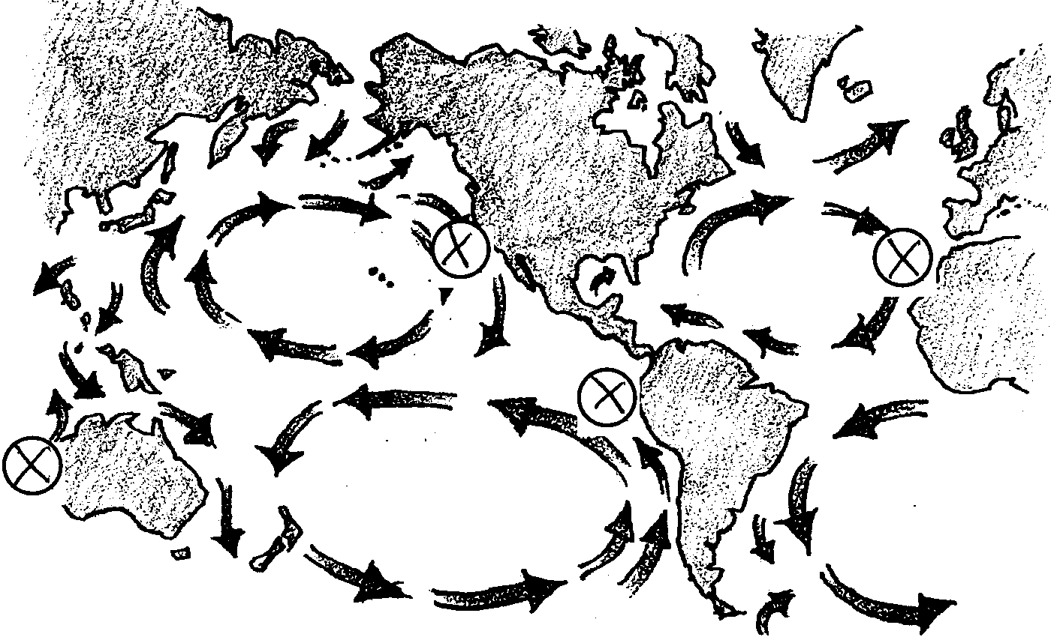
c. The drawing below shows the areas of major upwelling. Since students are inferring the areas from the information given in the text (i.e. “When water moving from the poles toward the equator runs into a continent, the continent forces the current upward.”), their answers may be expected to vary somewhat.

3. Phytoplankton need:
Where and/or when most abundant:
1. water abundant anywhere in the sea, of course

2. carbon dioxide & generally abundant; do not play a major
oxygen role in limiting phytoplankton populations

3. sunlight sunlight is abundant year-round near the
equator; day length is especially long near the
north pole from May to August and near the
south pole from November to February.

4. nutrients most abundant near land and in areas of
upwelling where polar water is surfacing.
4. Student maps will vary. Most students will color much wider areas of high phytoplankton abundance than appear in real satellite images. Student maps are effective if red and orange colors appear in the far north and along coastlines and especially in the areas of upwelling noted on the map in 2c.

5, 6, 7, 8. Responses will vary depending on the images students have selected.
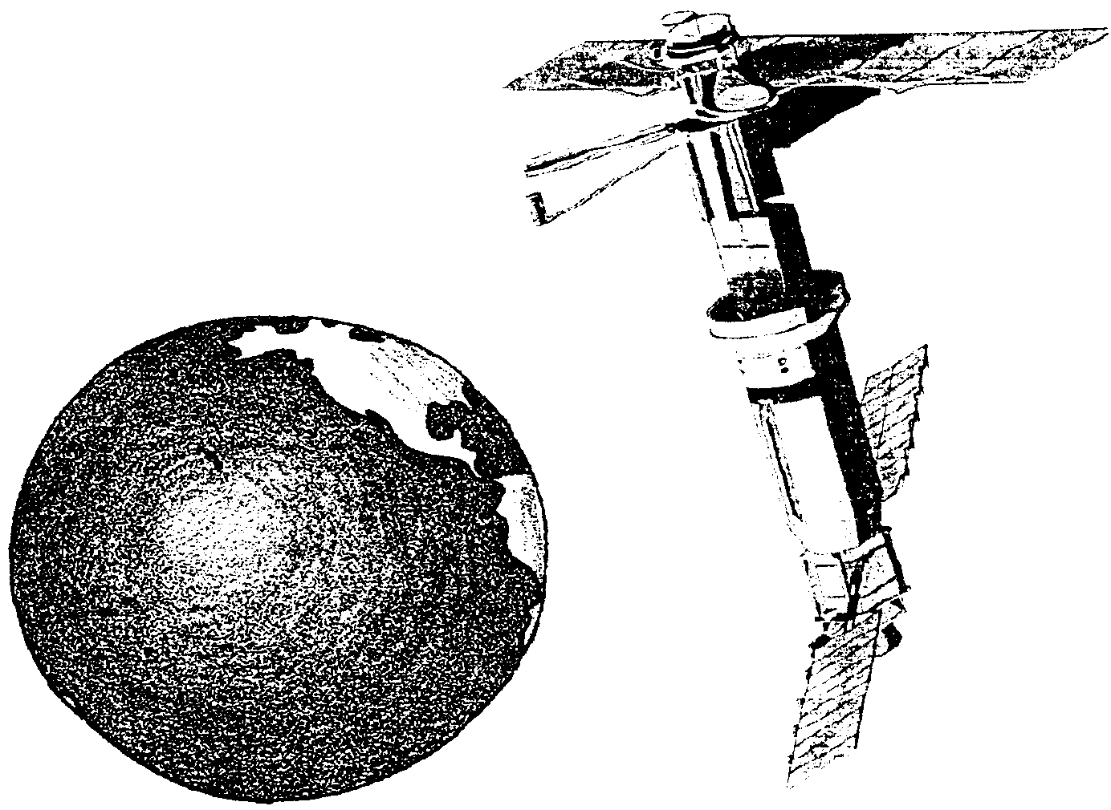
Satellite Images

Ocean currents were first mapped by sailors caught at the mercy of drifting waters. More recently, scientists have collected drift bottle data. These kinds of information work best to map local conditions. It takes an enormous amount of this kind of data to begin to build a good picture of global current patterns. Now, however, scientists are creating pictures of global patterns using data from sensors carried into orbit around the earth on board satellites.
How can a sensor in space collect information about the oceans? The sensors send light waves and other types of energy to earth and then receive reflected wavelengths back. The energy waves change depending on what they encounter when they reach the earth. These energy changes are recorded and then the data is relayed from the satellite to receiving centers on earth where they are processed by computer to create the color images. This is a much more sophisticated way of mapping ocean currents than setting bottles adrift.
It also is possible to use sensors to map populations of phytoplankton. Though most plankton is microscopic, plankton populations reach such high densities in some areas that satellites orbiting the earth can detect the plankton “blooms”. They measure the concentrations of plant pigments in the water. Pigments are what give plants their distinctive colors. If pigment concentrations are high, phytoplankton populations are high. Many of the images show a correlation between ocean current patterns and the populations of phytoplankton. You will have the opportunity to choose a satellite image and examine it in detail. You will be looking for these patterns in plankton populations.
Begin by thinking about what phytoplankton need to grow.

We know plants need sunlight to photosynthesize.

1. Where on the earth would there be the most hours of sunlight per day in June? in December?

Plants also need water. Phytoplankton, of course, are bathed in water, so their distribution is not limited by water supply.
Phytoplankton use carbon dioxide and produce oxygen as they photosynthesize. During respiration, when they breakdown glucose to get energy, they produce carbon dioxide and use oxygen. Both these gases are present in sea water especially near the surface where the water can absorb gases from the atmosphere. Phytoplankton produce both of the gases they need and they are bathed in water containing these gases.
Finally, phytoplankton need nutrients. Decaying organic material and minerals that wash off land in rain and snowmelt add nutrients. Upwelling currents also add nutrients. When water moving from the poles toward the equator runs into a continent, the continent forces the current upward. Winds and the gradual warming of the water as it moves toward the equator also pull the cool water to the surface. This water, laden with decaying material, fertilizes the phytoplankton.

2. a. Describe two processes that add nutrients to salt water.

b. Where would you expect to find higher nutrient levels, near shore or out in the open ocean? Why?

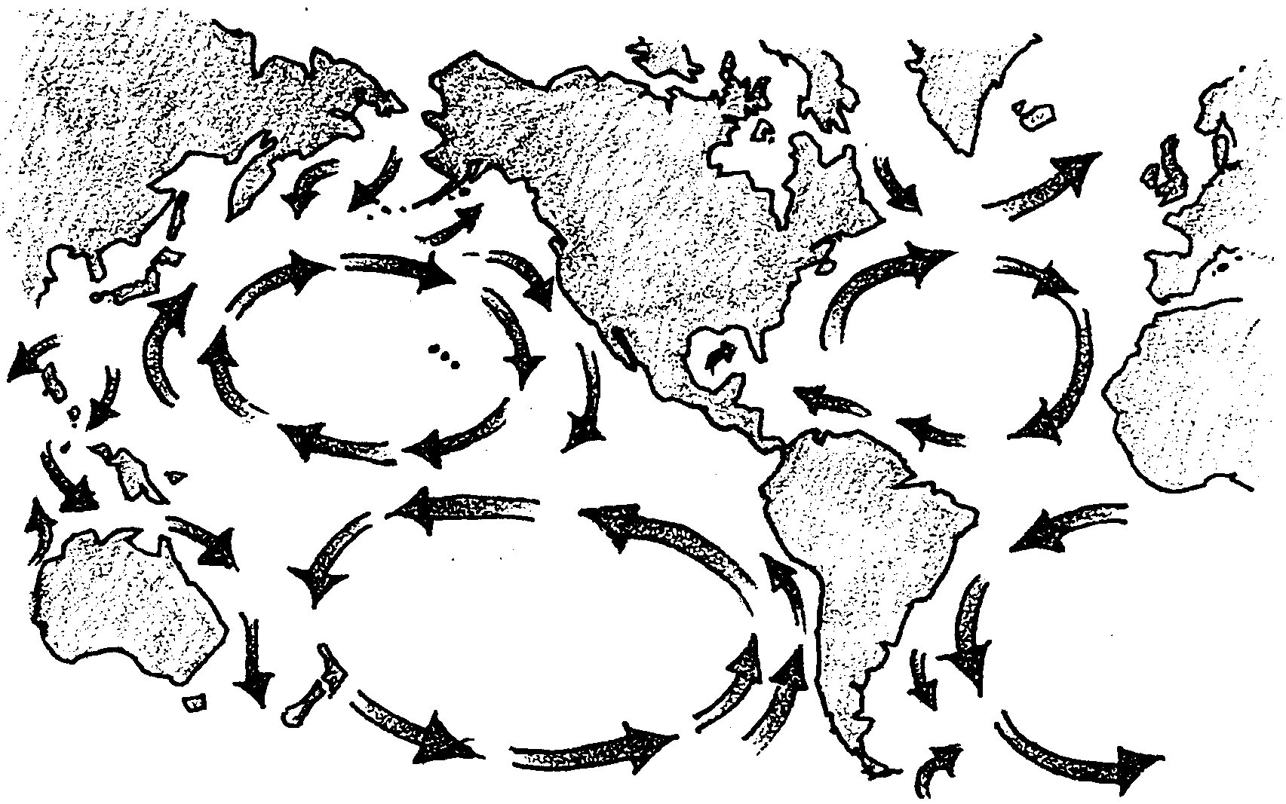
c. Find the places on the map of ocean currents that would have upwelling.

3. Review the needs of phytoplankton by filling in the following chart with the places in the oceans or the times of the year when the things the plants need will be most abundant.

Phytoplankton need: Where and/or when most abundant:
1. water
2. carbon dioxide & oxygen
3. sunlight
4. nutrients

Now try your hand at creating your own map to show where you think phytoplankton populations would be most abundant in the month of June.
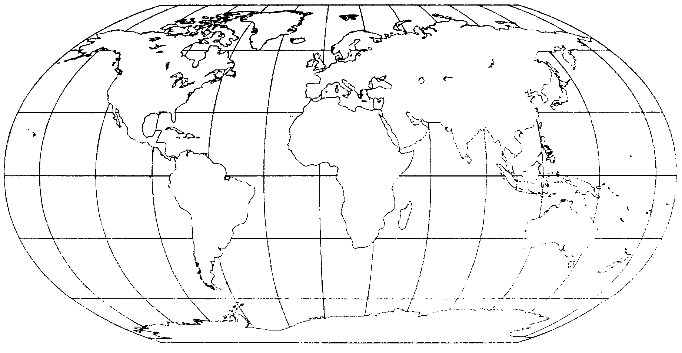
Scientists have chosen to use a color code to represent phytoplankton concentrations in the images they make from satellite data. Purple and blue colors indicate low phytoplankton pigment concentrations. Green and yellow indicate moderate concentrations and orange and red colors indicate high concentrations. Use colored pencils or pastels or other art materials to color in your map. Color the areas you think will have very little phytoplankton in June purple or blue. Color the areas you think will have some phytoplankton green or yellow. Color the areas you think will have high concentrations orange or red. Your map probably will not be a replica of actual satellite data; it is not meant to be. The goal is for you to predict general patterns in the oceans.

It’s time now to examine a satellite image. Choose the image which you would like to interpret from those your teacher has provided. Examine the picture and read the text describing the image. Then, answer the following questions:

4. What is the title of your image?

5. What part of the world does it show?

6. Describe how the phytoplankton is distributed in the image. Where are pigment concentrations highest?

7. Describe specific similarities between your map and the satellite image. Where are the color patterns the same?

8. Why are the colors patterned as they are in the satellite image? What is happening physically or biologically down in the ocean to create the color patterns?

