Out of Sight
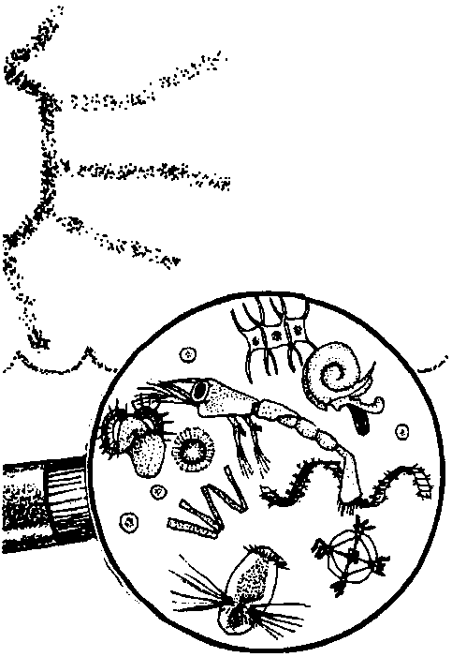

Key Concepts
1. Plankton are the beginning links in most food chains in the ocean.
2. Human activities can affect plankton growth.

Background
Phytoplankton, the usually microscopic wandering plants of the sea, capture the energy in sunlight and pass it on to all the other members of marine food webs. Without this food source, the life we know in the oceans would not exist. The phytoplankton also produce much of the oxygen available to both aquatic and terrestrial animals. The importance of these minute organisms cannot be over estimated.

Materials
For each student:

• One copy of “Out of Sight” student pages

Teaching Hints
“Out of Sight” continues the introduction to plankton begun in the activity “Observations of Living Plankton” and includes a crossword puzzle designed to reinforce the teaching of the new vocabulary. The puzzle originated with Mrs. Carolee Parmer, a marine consultant for the Florida 4-H Marine Program.
This activity lends itself to individual completion in class or as a homework assignment. Be aware of the new vocabulary and especially of the familiar vocabulary that is used in a new and specific manner (for example, “producer”, “consumer”). The crossword puzzle helps to review the new vocabulary terms. Upon completion of the puzzle, allow time for a discussion of the concepts covered and to provide answers to the questions in the text and in the crossword puzzle.

Key Words
consumer - organism that cannot produce its own food, but eats other organisms to obtain the energy necessary to sustain life
first order consumer - organism that eats producers
food chain - outline of who eats whom showing path of energy transfer in an ecological community
food pyramid - a food web diagram showing feeding relationships including the relative numbers of organisms at each energy level
food web - interlocking food chains existing because most consumers eat more than one type of food and are themselves eaten by more than one consumer
photosynthesis - a process which occurs in the presence of sunlight in which six carbon dioxide molecules (CO2) and six water molecules (H20) are combined to yield one molecule of a simple sugar (C6H1206) and six molecules of oxygen (02)
phytoplankton - plant plankton; the primary producers of the sea
plankton - the mostly microscopic plants and animals that drift in water; singular = plankter
producer - organism that can make its own food, using inorganic nutrients and energy from the sun
second order consumer - organism that eats first order consumers
third order consumer - organism that eats second order consumers
zooplankton - animal plankton

Answer Key
1. The primary difference between phytoplankton and zooplankton is that phytoplankton are plants that produce their own food while zooplankton are animals that must obtain their food from other sources. Your students may not recognize this important distinction at this point. They may instead refer to the pictures above in search of differences. This latter approach is acceptable but you need to point out the primary difference during your discussion of this material.

2. This problem may be set up as follows:

40 liters x 4,500,000 phytoplankton = 180,000,000 phytoplankton
aquarium liter in the aquarium

This calculation is designed to show the abundance of planktonic organisms. Unfortunately, a number like 180 million is hard to appreciate. You might try this analogy: If your students started spending money at the rate of one dollar per second, it would take 3 million minutes or 50,000 hours or 2,083 days or 5.7 years of continuous round the clock spending to spend 180,000,000 dollars!
3. Animals that live below the lighted zone depend upon: (1) the constant rain of small detritus that falls from the lighted layers; (2) the occasional large carcass that falls from above; (3) preying on animals that feed in the lighted zone and then swim into the lower depths and/or (4) trips into the lighted zone to feed.

4. Six molecules of oxygen are released for each sugar molecule produced by the phytoplankton. This question is designed to let you see if your students have a grasp of what the equation for photosynthesis is saying.

5. The answers depend upon the experience of your students. This question is designed to help relate the new concept to familiar situations. If your students have difficulty with the concept of food chains, you might have them practice with land based food chains including the standard:

grass → cow → human

6. Since the small fish is a second order consumer, we would call a medium sized fish that ate the small fish a third order consumer.

7. The answers will depend upon previous experience. Any reasonable answer is acceptable. The level of the consumer added will vary with the animals chosen.

8. Answers will vary. Accept any answer. The object of this question is to get your students thinking about the magnitude of food moved along the links of a food chain.

9. The problem may be set up as follows:

6.5 oz x 24 cans = 1560 oz. x 1 lb. = 9.75 lbs. tuna x 10,000 lbs. of phytoplankton = 97,500 lbs. of
can case 1 16 oz. case pound of tuna phytoplankton!

10. Strictly speaking, to maximize the amount of marine food available to people, we should harvest the producers (phytoplankton) directly. This is not always possible for many reasons both economic (cost of harvesting a diffuse organism) and sociological (people often will not eat new and strange tasting items). The farther down the food chain we feed, the greater the amount of food available.

11. Humans would be affected in many ways by the death of all of the ocean’s plankton just as we are diminished by the death of any species. In specific, however, we would find ourselves without most of the food we harvest from the ocean and without oxygen to breathe. Fairly considerable negative impacts!
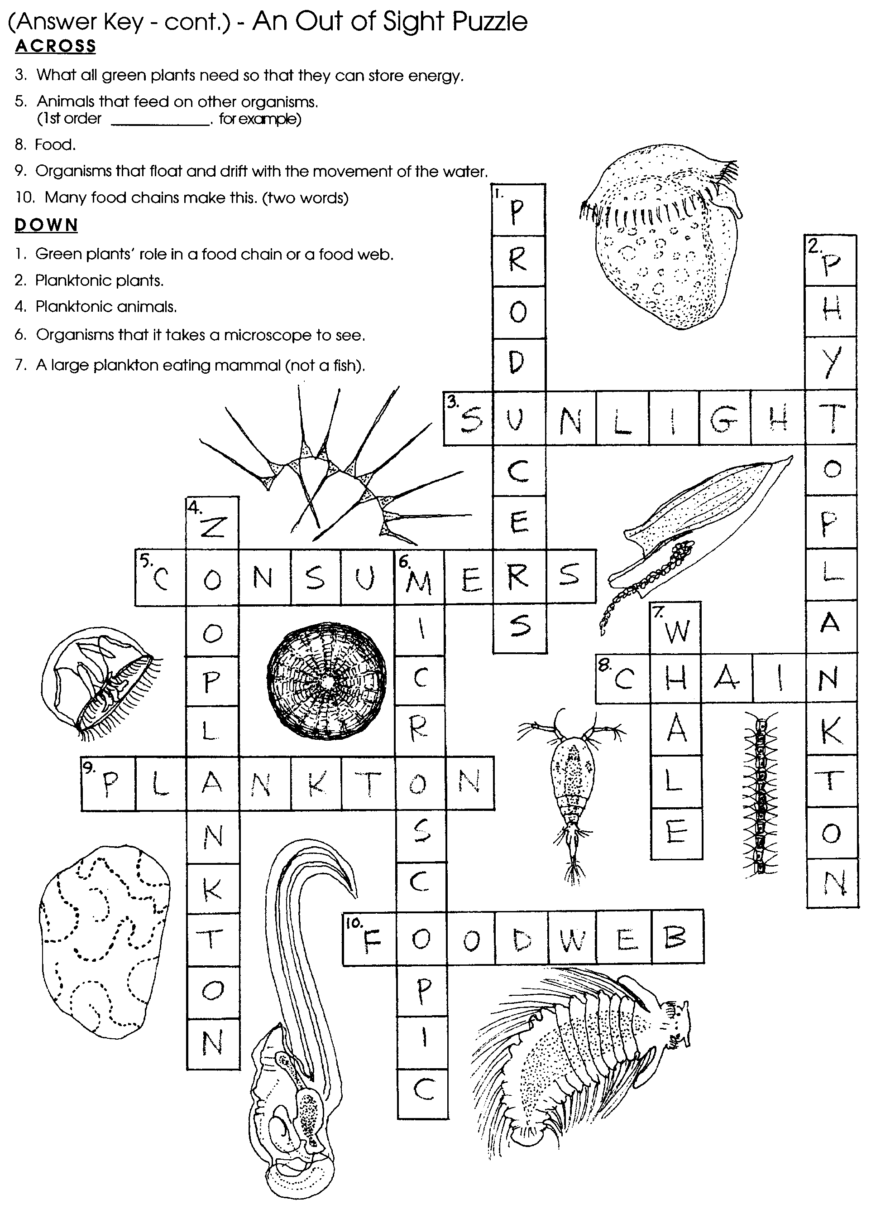
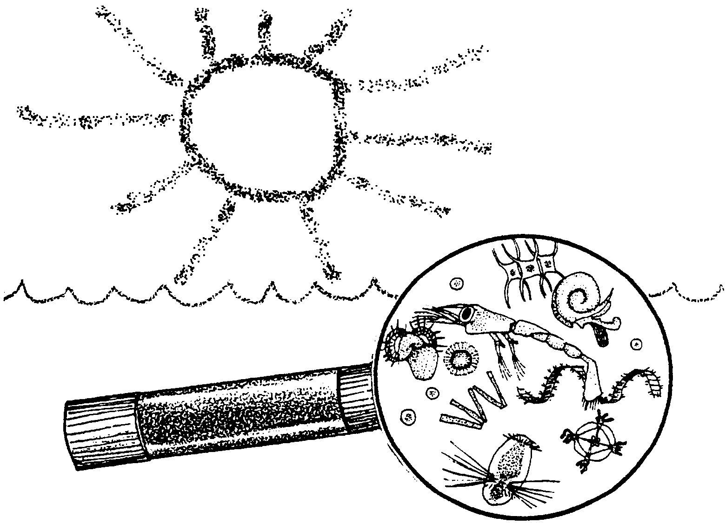
Out of Sight

Hold a drop of sea water. Clear, colorless, and uninteresting. Place that same drop of water under a microscope and a new world appears. Within a single drop we can find a population of minute plants and animals. What are these creatures? How are they important to animals living in the oceans? How are they important to humans?

These tiny plants and animals are members of a group of organisms that we call plankton. “Plankton” comes from a Greek word “planktos” which means wandering. Plankton are wanderers in the sense that they just float along with the water. These organisms have a limited ability to swim, in a real sense they are at the mercy of the tides and currents. Not all plankton are microscopic but, for the most part, as we discuss plankton, we will limit ourselves to those that are microscopic. Be aware, however, that some planktonic animals may be two or three feet across.

Since planktonic plants play a different ecological role than planktonic animals, oceanologists have given the two groups different names. Plant plankton is called phytoplankton (“phyto” is Greek for plant) while animal plankton is called zooplankton (“zoo” is Greek for animal). The term “plankton”, then refers to all of the floating plants and animals, both the phytoplankton and the zooplankton.

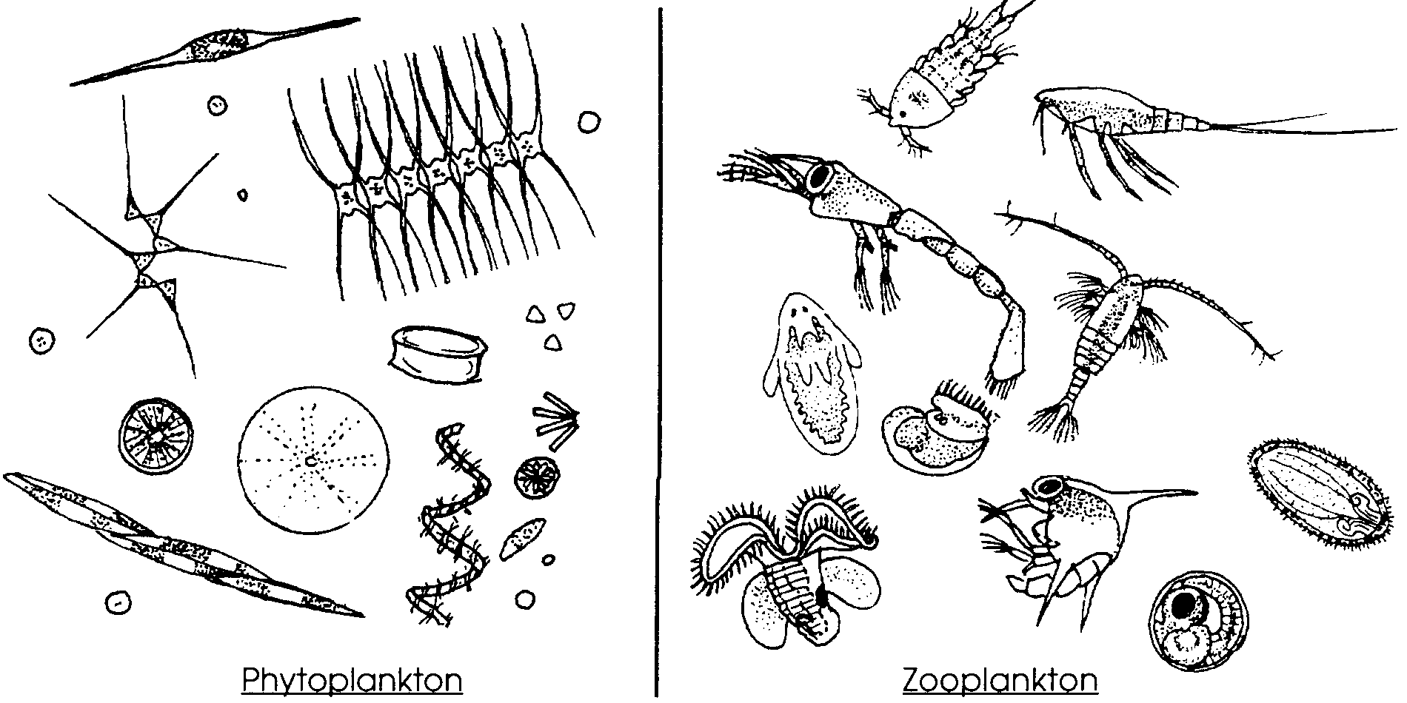
1. What is a major difference between phytoplankton and zooplankton?

Just how important are plankton to marine life? Perhaps, we might get an idea by looking at the numbers of plankton in sea water. Careful studies by biologists at the marine laboratory at Plymouth, England found that the ocean water they were examining contained, at the very least, four and a half million(4,500,000) phytoplankton in each liter of water! It is clear that by sheer numbers alone phytoplankton must play an important role in the oceans. What exactly is that role?

2. A science teacher living near the ocean decided it was time to set up an aquarium in his classroom. He went to the local beach and filled his forty liter aquarium with clear, colorless salt water planning to add some “sea life” later. In reality, how many sea creatures did he already have in his aquarium? (Assume that his sea water was like that examined in the lab at Plymouth, England). Please show your calculations.
Phytoplankton support most of the herbivores (plant eaters) of the sea. Because of this, phytoplankton may be accurately called the “grass of the sea”. As the sea’s primary producers, phytoplankton trap and store the energy contained in sunlight. In the process of photosynthesis, the phytoplankton use carbon dioxide (CO2) and water to produce more organic matter (food) than any other group of plants.
Since phytoplankton need sunlight, they are found only near the surface of the water where the sunlight can reach them. An interesting aside, phytoplankton produce oxygen in proportion to the amount of carbon dioxide they use. Some scientists calculate that without this oxygen production, life as we know exists on the earth would not be possible. This fact alone should make us very cautious in our treatment of the oceans. Without the food production by phytoplankton there would be no food for the microscopic grazing zooplankton. There would also be no fish since they feed directly or indirectly on the smaller grazers.

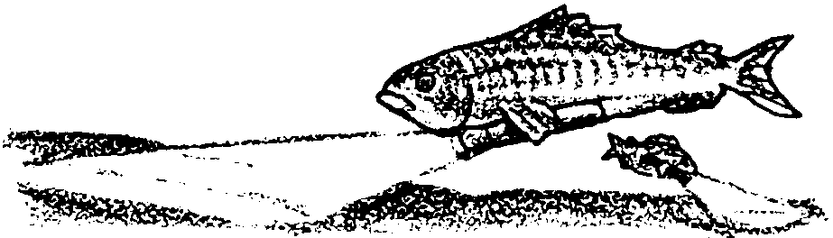
3. Phytoplankton are limited in vertical distribution by how far sunlight penetrates seawater. While blue light can penetrate to a depth of over 500 meters, the light that the phytoplankton can use is largely limited to the upper 70 meters of the ocean. Yet, we know that life exists below the 70 meter depth. What are two possible sources of food for animals living below the lighted zone?

4. The equation:

(in sunlight)
6 CO2 + 6 H20 - C6H12 06 + 6 02

describes photosynthesis. It tells us that through a long process which occurs in the presence of sunlight, six carbon dioxide molecules (CO2) and six water molecules (H20) are combined to give us one molecule of a simple sugar (C6H1206) and six molecules of oxygen (02). How many oxygen molecules are available to animals including humans from the production of each sugar molecule by phytoplankton?
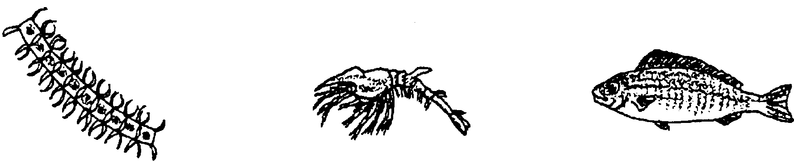
Nearly all of the phytoplankton species are used as food by small invertebrate (no backbone) animals that feed by filtering the water. Zooplankton such as the copepods and euphausiids and crab larvae and attached organisms, such as oysters, mussels and clams, feed in this way. These filter feeders are fed upon, in turn, by larger invertebrates and fish. All of these animals either consume directly or indirectly the food that the producers have stored. As a result, we call these animals consumers. We might draw a food chain to help see the relationships:
phytoplankton zooplankton small fish
(producer) (consumer) (consumer)

This simple food chain shows us that the small fish ate the zooplankton that ate the phytoplankton. The arrows show which way the energy and matter stored by the plants are moving.

5. Use your knowledge of marine plants and animals to draw another food chain with at least three members. Label the producer and the consumers.

Sometimes it is helpful for us to know whether the consumer we are talking about was the one who ate the producer, or one who was another consumer. To accomplish this, we call a consumer who eats green plants a first order consumer. A consumer who eats a first order consumer is called a second order consumer and so on. At each energy transfer (for example, a second order consumer eating a first order consumer) about 80 to 90% of the energy is “lost”, only 10 to 20% of the energy is available to the higher order consumer. Because of this energy loss food chains are seldom over four or five links long.
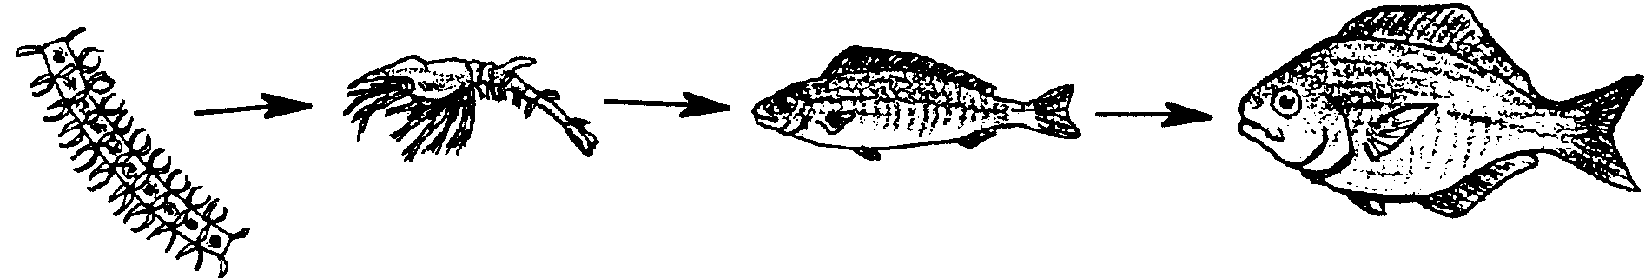
6. In the food chain shown below, what would we call a medium sized fish that ate the small fish?

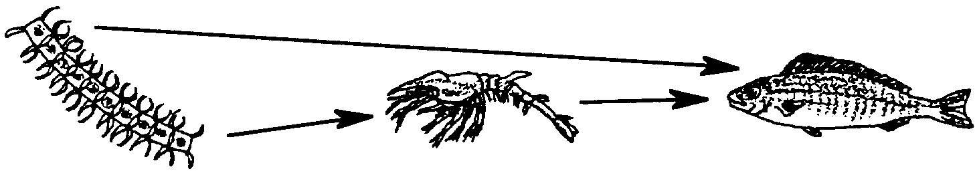
What about the Pacific Herring that eats both zooplankton and phytoplankton? When the herring eats the phytoplankton it is a first order consumer and when it eats the zooplankton it is a second order consumer. We can draw the food chain like this:

Phytoplankton zooplankton small fish
(producer) (first order (second order
consumer) consumer and
first order consumer)

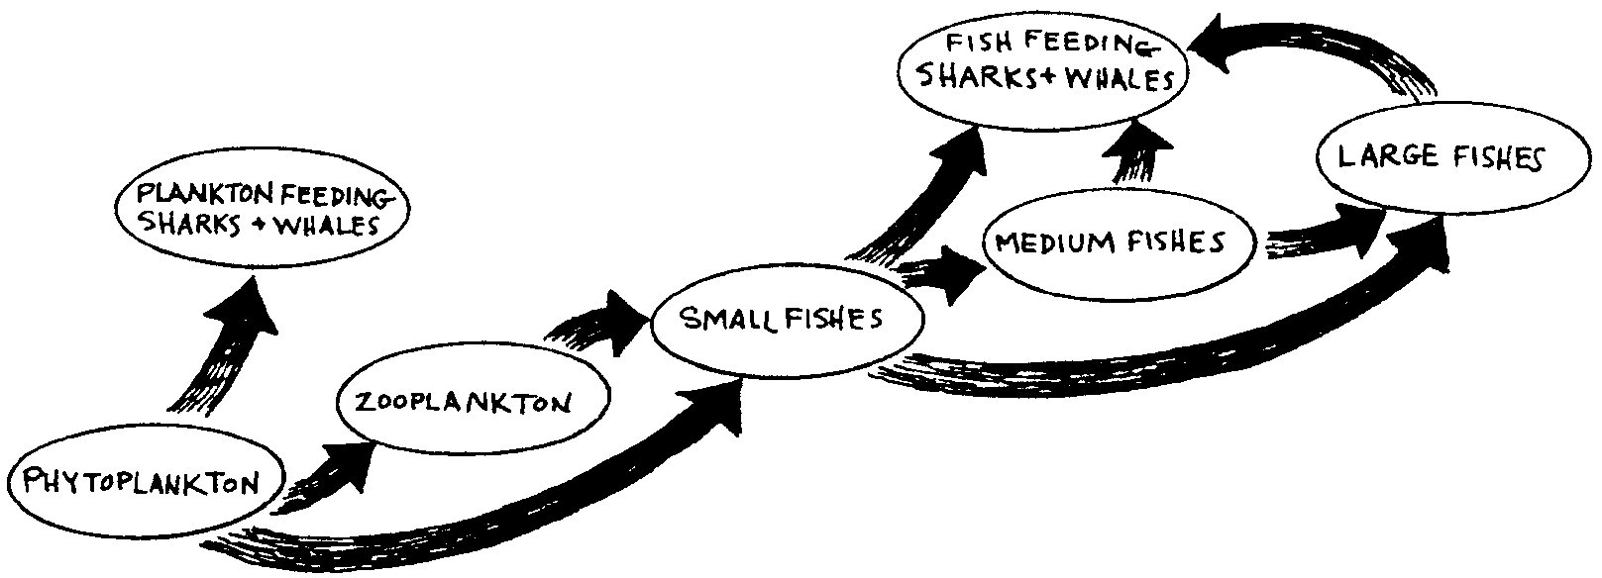
Now our food chain has become a food web. A food web is made of several food chains. We can find many such food chains and food webs, both on land and in the sea. Sometimes they can become very complicated.

We could continue to add members to this web until it became very much more complicated.
7. Add one more member to the food chain shown above. What level consumer is your addition?

Let’s look at our food chain again. It is obvious that a plankton feeding shark would have to eat a great deal of plankton to stay alive. Let’s isolate one food chain out of our web and see how much phytoplankton it takes to feed a fourth order consumer, a large Coho salmon.

8. Before you start, make a guess by filling in the blank in the following sentence. I think it takes about pounds of phytoplankton to make one pound of fourth order consumer.

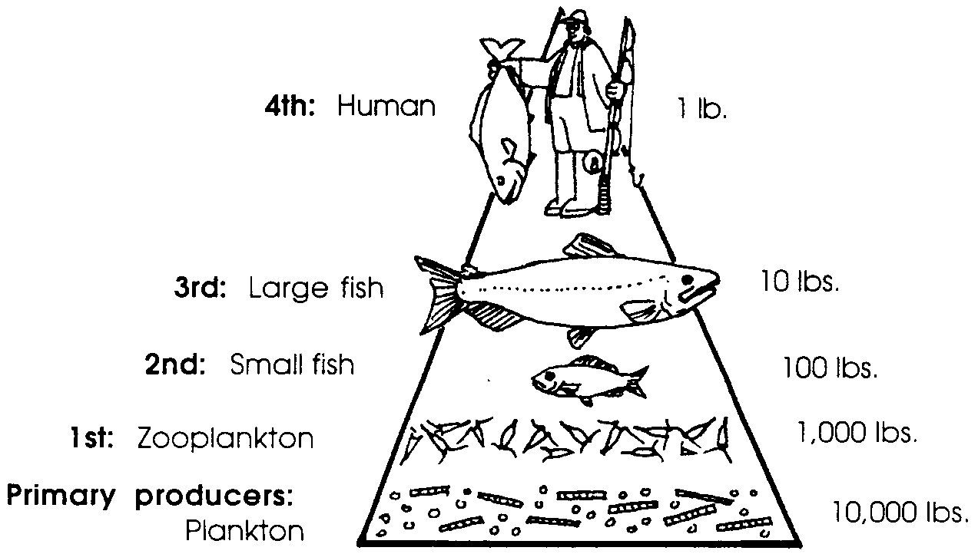
We have a clue. We’ve seen that processes like respiration (breathing) and natural mortality (death) cause the loss of 90% of the energy at each step in the food chain. Let’s see how much phytoplankton it would take to produce one pound of our salmon: it takes 10 pounds of medium fish which needed to eat 100 pounds of small fish which needed to eat 1,000 pounds of zooplankton which needed to eat 10,000 pounds of phytoplankton!

Wow! To produce one pound of our Coho salmon, we had to start with 10,000 pounds or 5 tons of phytoplankton. Without phytoplankton, we would have no fish to eat.

9. An example of a large, fourth order consumer fish is the Albacore tuna. Tuna comes to our supermarkets usually packed in 6 1/2 ounce cans. There are 24 of these cans in a case. How many pounds of phytoplankton were required to produce each case of tuna? (Hint: How many pounds of tuna are there in a case?)
Many people regard the oceans as unlimited sources of food which we have not yet begun to tap. From the above discussion it should be obvious that the total production of marine food animals depends upon the annual rate of production of phytoplankton. We must also consider the fact that marine food for human consumption must be both economical to harvest and edible. The amount of marine food available to humans also depends upon the consumer level of the food organisms we choose.

10. To maximize the amount of marine food available to people, what level consumer should we harvest?

According to some marine biologists, the maximum sustainable yield (the production which can be sustained year after year without the yield decreasing) of fish of the kinds we presently eat can be increased to perhaps double the present harvest. Even the present yield is imperiled by overfishing and by pollution from pesticides, herbicides, and oil. For example, DDT has a negative effect on photosynthesis of algae at a concentration of just one part in a billion parts of water, and an oil layer reduces the light available for photosynthesis. It is conceivable that over fishing and pollution could reduce our potential harvest from the sea.

11. What are two ways humans would be affected by the death of the ocean’s phytoplankton?

The importance of phytoplankton to the economy of the world cannot be overestimated. The health of these minute organisms has a direct impact on human welfare. Plankton, so seemingly insignificant, in reality are the basis for all fish life in the oceans.
An Out of Sight Puzzle
Across
3. What all green plants need so that they can store energy.
5. Animals that feed on other organisms.
8. Food.
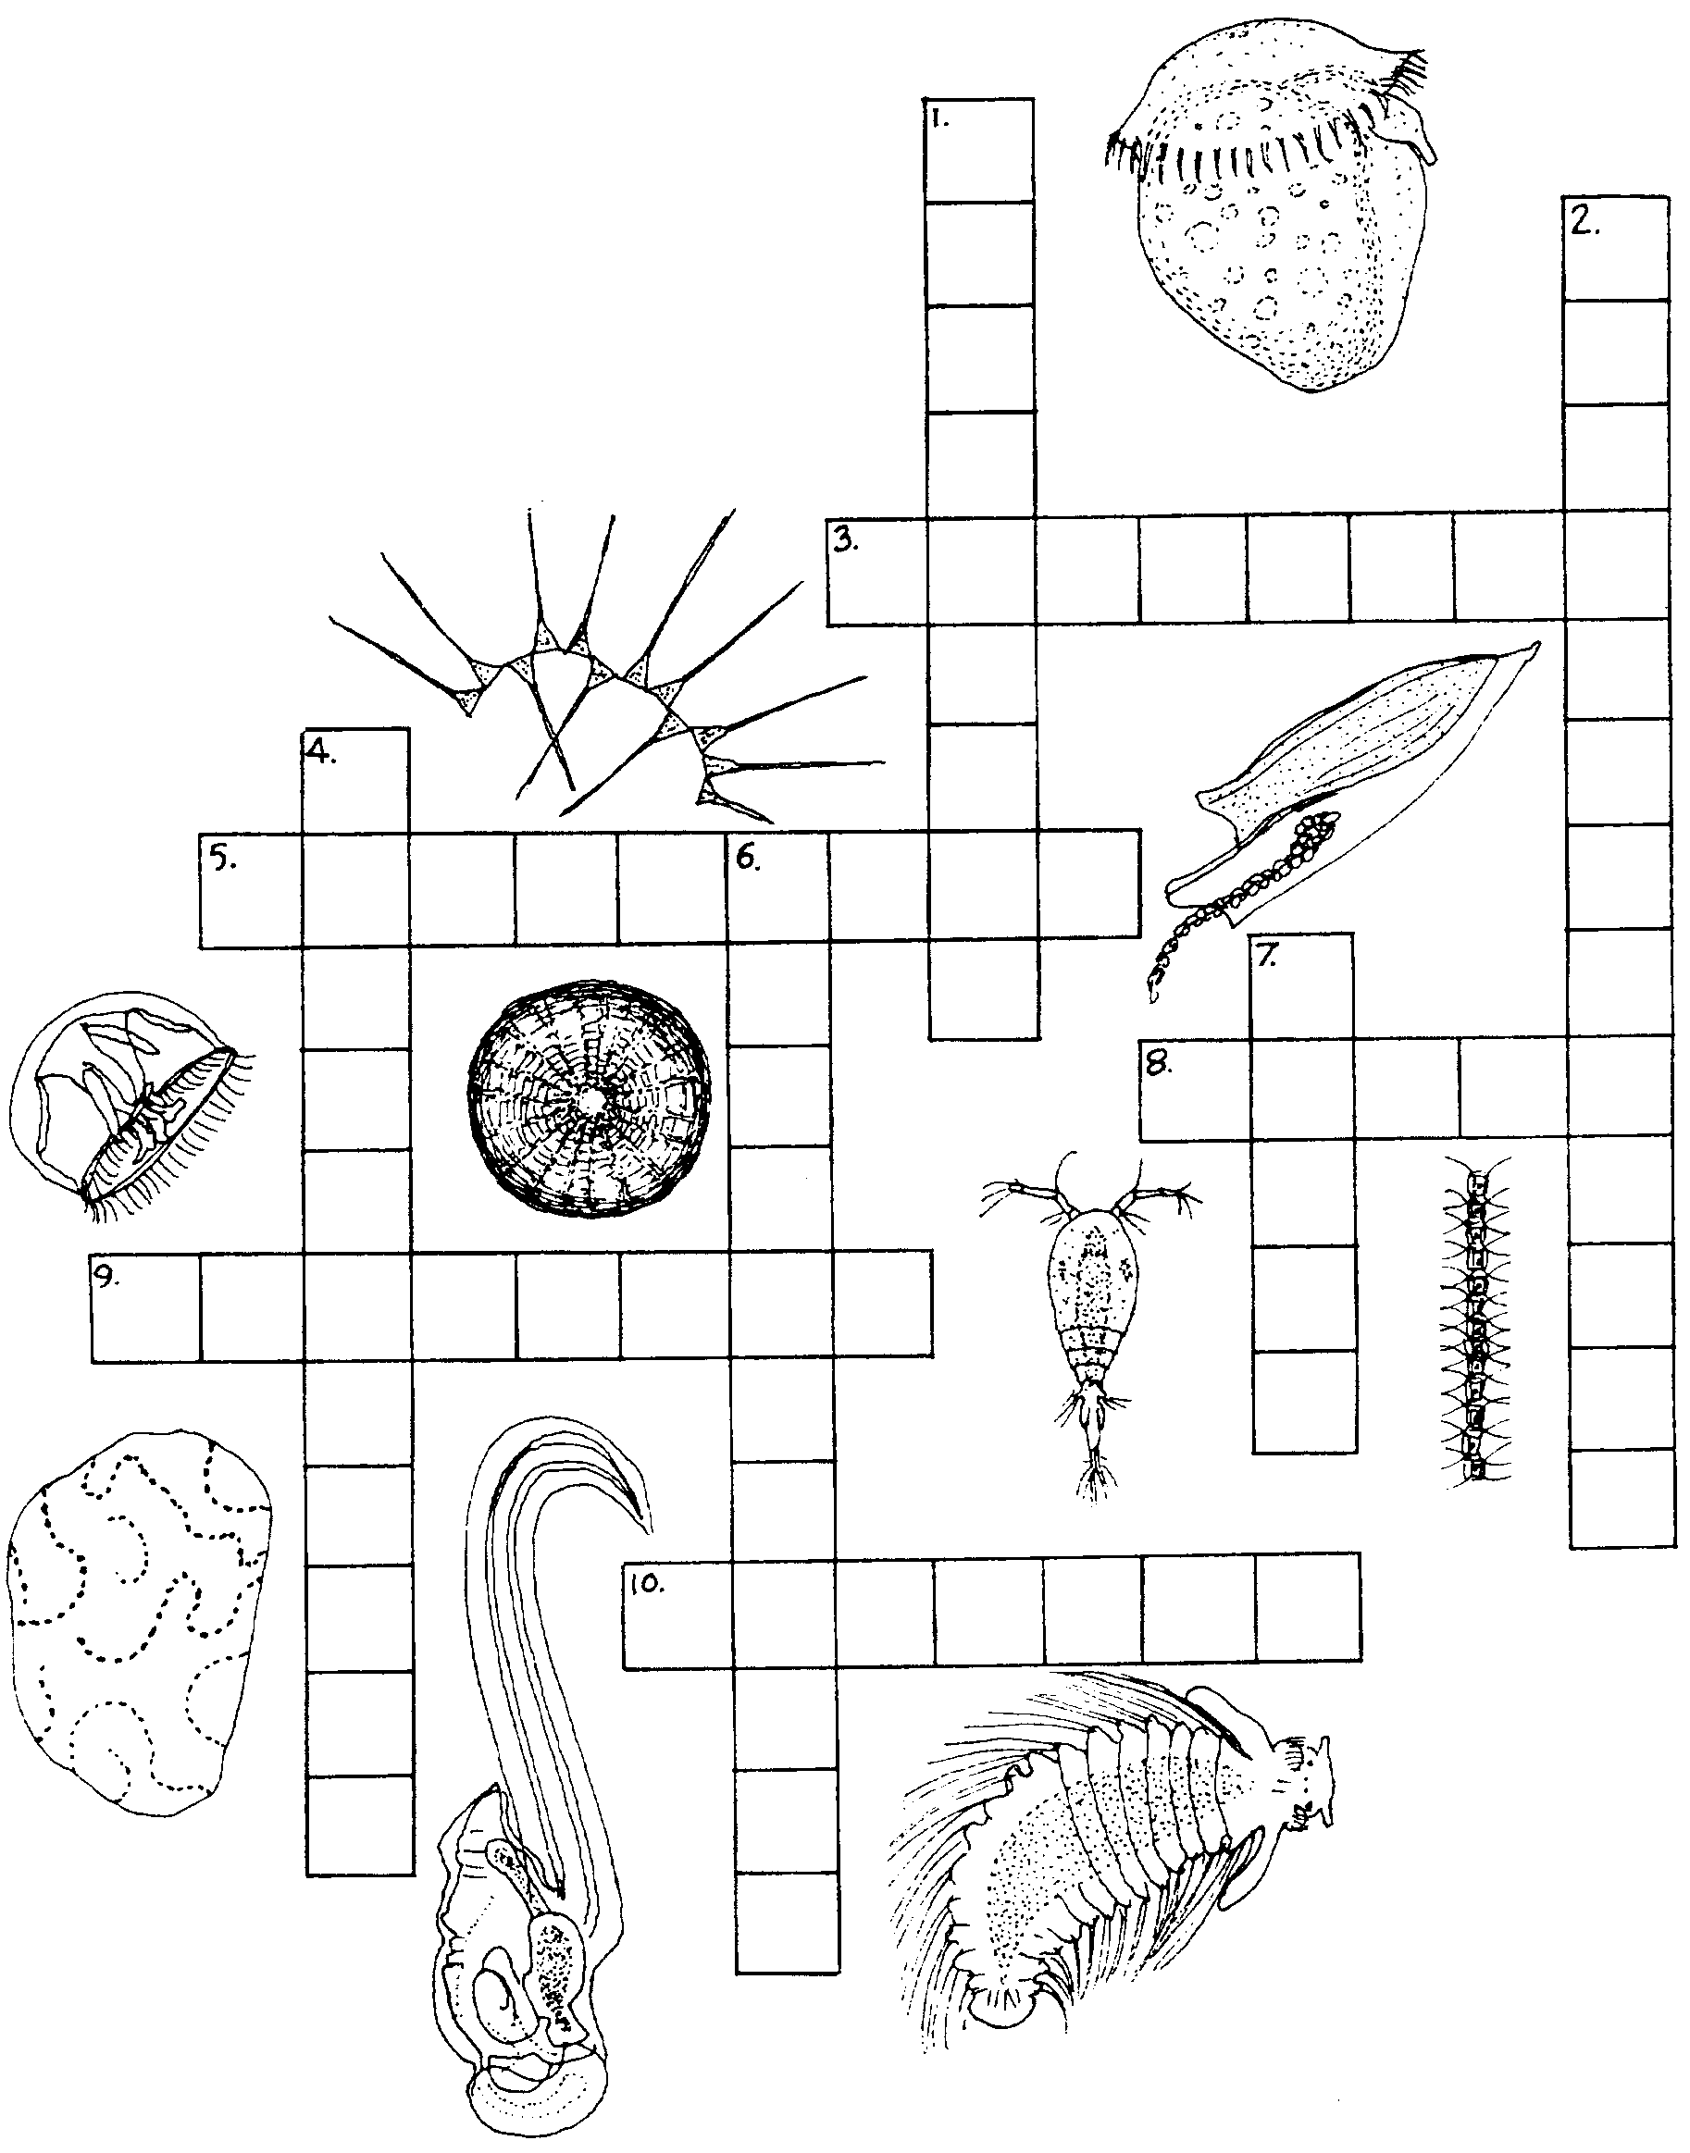
9. Organisms that float and drift with the movement of the water.
10. Many food chains make this. (two words)
Down
1. Green plants' role in a food chain or a food web.
2. Planktonic plants.
4. Planktonic animals.
6. Organisms that it takes a microscope to see.
7. A large plankton eating mammal. (not a fish)

