Observations of Living Plankton
Written by Karen Mattick, Marine Science Center, Poulsbo, Washington.
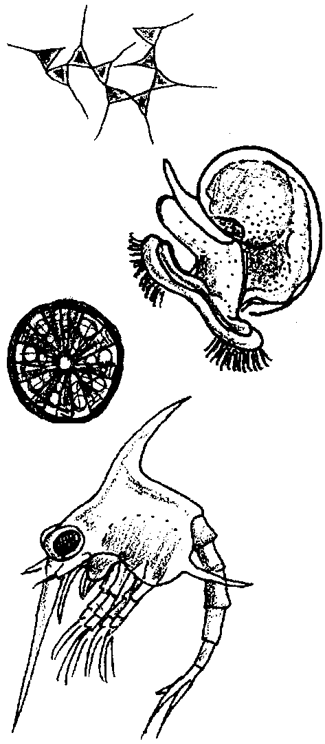

Key Concepts
1. Water teems with microscopic organisms known as plankton.
2. Plankton are wanderers, drifting in water currents.
3. By closely observing these organisms we can learn something about their structures and behaviors.
4. Scientists classify plankton into two major groups - phytoplankton (plants) and zooplankton (animals).

Background
Ocean currents play a vital role in moving heat, minerals, gases and organic material around the globe. At places where deep, cool, nutrient rich water rises to the surface in upwelling currents, plankton populations reach incredible densities. The word “plankton” means “wanderers”. These usually microscopic plants and animals drift wherever water currents take them and thrive where those same currents provide optimum conditions. The plankton are the crucial foundation of the ecosystem which supports a varied and rich food web.
The role of plankton as the basis for most oceanic life is well understood. Phytoplankton also produce a significant percentage of the earth’s oxygen. Other important roles of plankton are being investigated. For example, scientists studying global warming are examining the role of phytoplankton in absorbing the excess carbon dioxide that deforestation and burning of fossil fuels add to the atmosphere.
Adding excitement to the study of plankton are discoveries such as that reported in THE SCIENTIST, April 18,1994:
Researchers are performing flow-cytometric analyses of sea water to study phytoplankton. Similar to leukocytes swimming in blood, plankton easily lend themselves to the fluid nature of flow cytometry measurements...says Sallie Chisholm, a professor of civil and environmental engineering at Massachusetts Institute of Technology, Cambridge... She and other researchers are currently using these data to make deductions about surface ocean water mixing.
Chisholm, who directs MIT’s part of a joint educational program with Woods Hole Oceanographic Institution in Woods Hole, Mass., has been doing flow cytometry at sea for more than 10 years. In 1988, she and colleague Robert Olson, an associate scientist at Woods Hole, discovered a new species of phytoplankton using the technology.
“We had a flow cytometer on a ship, and we were actually studying the little orange-fluorescing cyanobacteria,” recalls Chisholm. ”We noticed some signals that were coming from things smaller than them, but had red fluorescence. At that time, there was no known organism that would have those qualities.”
They were living organisms, however, and were dubbed Prochlorococcus marinus . It turns out that Prochlorococcus marinus are more abundant than any other plankton known, and, in the equatorial region, the species accounts for 40 percent to 50 percent of total chlorophyll in the sea. “They’re just so small that people couldn’t see them with a microscope,” says Chisholm.

Materials
For each pair of students:
• plankton sample in a small, clear container (beakers, jars, cups, or bowls that hold 100 ml or more work well)
• 2 microscope slides or petri dishes
• eye droppers
• microscope
• 2 copies of “Observation of Living Plankton” student pages (optional- you may choose another way for students to record observations)

Teaching Hints
“Observations of Living Plankton” takes advantage of the beauty and intrigue of living plankton to capture student interest and stimulate questions about plankton. It is meant to give students concrete experience with plankton so that the content they learn later will connect with what they have observed. For example, “Earth As a Greenhouse” and subsequent lessons examine the causes, effects and control of global warming and the roles ocean currents and phytoplankton play in moderating the global climate.
1. Collect plankton. You may collect plankton for your students, but it would be even better, if logistics permit, for you to engage them in constructing their own plankton nets and collecting their own plankton.
Directions for constructing a plankton net and collecting plankton follow this lesson.
Both saltwater and freshwater plankton will work well for this activity, so if you have access to a pier, breakwater, bank, or shoreline, in salt water, a river or stream, pond or lake, a marsh or any other fairly natural body of water, you will be able to collect living plankton. The plankton identification guide in the student pages is for west coast saltwater plankton. If your plankton is from elsewhere, you may want to provide other references.
For best results, you will need about 50-100 ml of plankton sample per pair of students so they can watch the plankton sample in a container as described in the introductory section of the lesson. Acquiring a sufficiently large stock sample may require several plankton tows.

2. Introduce to the students the context for the plankton observation lesson. Explain that, now that they have some experience with the patterns and causes of ocean currents, they will have an opportunity to learn about the marine life that lives in those vast currents. Today they will look at a kind of marine life, called plankton, that is generally so tiny it is difficult to see with the naked eye. The plankton are drifters, traveling wherever the currents take them.
Let the students know that the goals of the lesson will be:

A. to notice patterns in the behavior and distribution of the plankton in a sample of water;

B. to draw and describe from microscopic observation the shapes, structures and behaviors of specific plankton; and

C. to identify phytoplankton (plants) and zooplankton (animals).

3. Distribute the student worksheet, “Plankton Observations”, to each student or prepare another means for the students to record their observations. You may prefer that students use their own paper, create group posters, or write on overheads or the chalkboard.

4. Provide each pair of students with a small, clear container holding a plankton sample. A beaker, jar or bowl with 50-100 ml of a plankton sample will work well. You may wish to give the students a moment or two to move and handle their sample. Then ask them to leave their sample undisturbed and complete the observations on the “Plankton Observation” worksheet.
You may wish to model for the students how to siphon some plankton into an eye dropper and either drop it onto a microscope slide or make small drops in a petri dish. Review microscope skills as needed.
For a more detailed plankton identification guide and techniques for quantifying plankton densities, see “Plankton I, II, III” in Unit VI: Our Home: The Estuaries.

Key Words
phytoplankton - plant plankton; the primary producers of the sea
plankton - the mostly microscopic plants and animals that drift in water; singular = plankter
upwelling - the process by which warm, less-dense surface water is drawn away from a shore by offshore currents and replaced by cold, denser water brought up from subsurface
zooplankton - animal plankton

Extensions
Experiments based on student observations
1. Review observations
Ask the students to share as small groups or as a whole class the behaviors, body parts, types of plankton and any other observations they noted as they looked at plankton. This discussion may bring up questions the students have that you can use to guide your next lessons. What types of plankton do they want identified? Which ones do they want to know more about? What did they notice that they would like explained?
2. Theorizing
Now ask the students, what do they think the plankton were doing? Why were they behaving as they did? What might the body parts the students noticed be for? How might a particular body shape help a plankter?
3. Selecting a variable to test
Explain that one way to learn more and to test a theory is to experiment. Have the students brainstorm things they can change in their plankton sample. For example, the students might suggest warming or cooling the sample, decreasing or increasing the salinity, or shining a light on the plankton or shading them.
As a class, go over the ideas and eliminate for the time being any that are too impractical or harmful to do at this time. Have each pair of students choose one variable from the remaining list to test.
4. Testing and interpreting test results
Ask the students to:
a. predict how they think the plankton will respond to the change they have chosen; their prediction will be based on whatever they theorize the behaviors and structures of the plankton are for;
b. set up a control with a plankton sample that they will not change;
c. conduct the test by changing the variable selected
d. record what happens in their test;
e. write a potential explanation for their results;
f. list questions they now have and what they would try next if they had time.
The students may be fascinated by what they learn or they may find the process frustrating. In any case, they have had the opportunity to practice both the creative and organizational skills of doing science. They will have thought for themselves and the more they practice, the better they will get at doing science.

Construction of a Simple Plankton Net
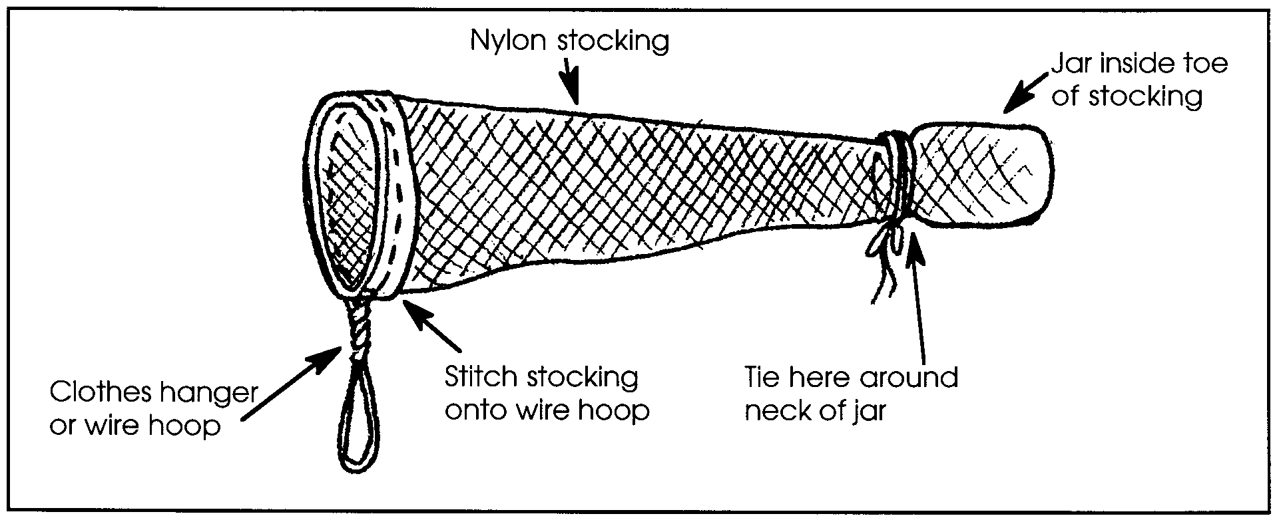
Phytoplankton — Plankton Identification Sheet
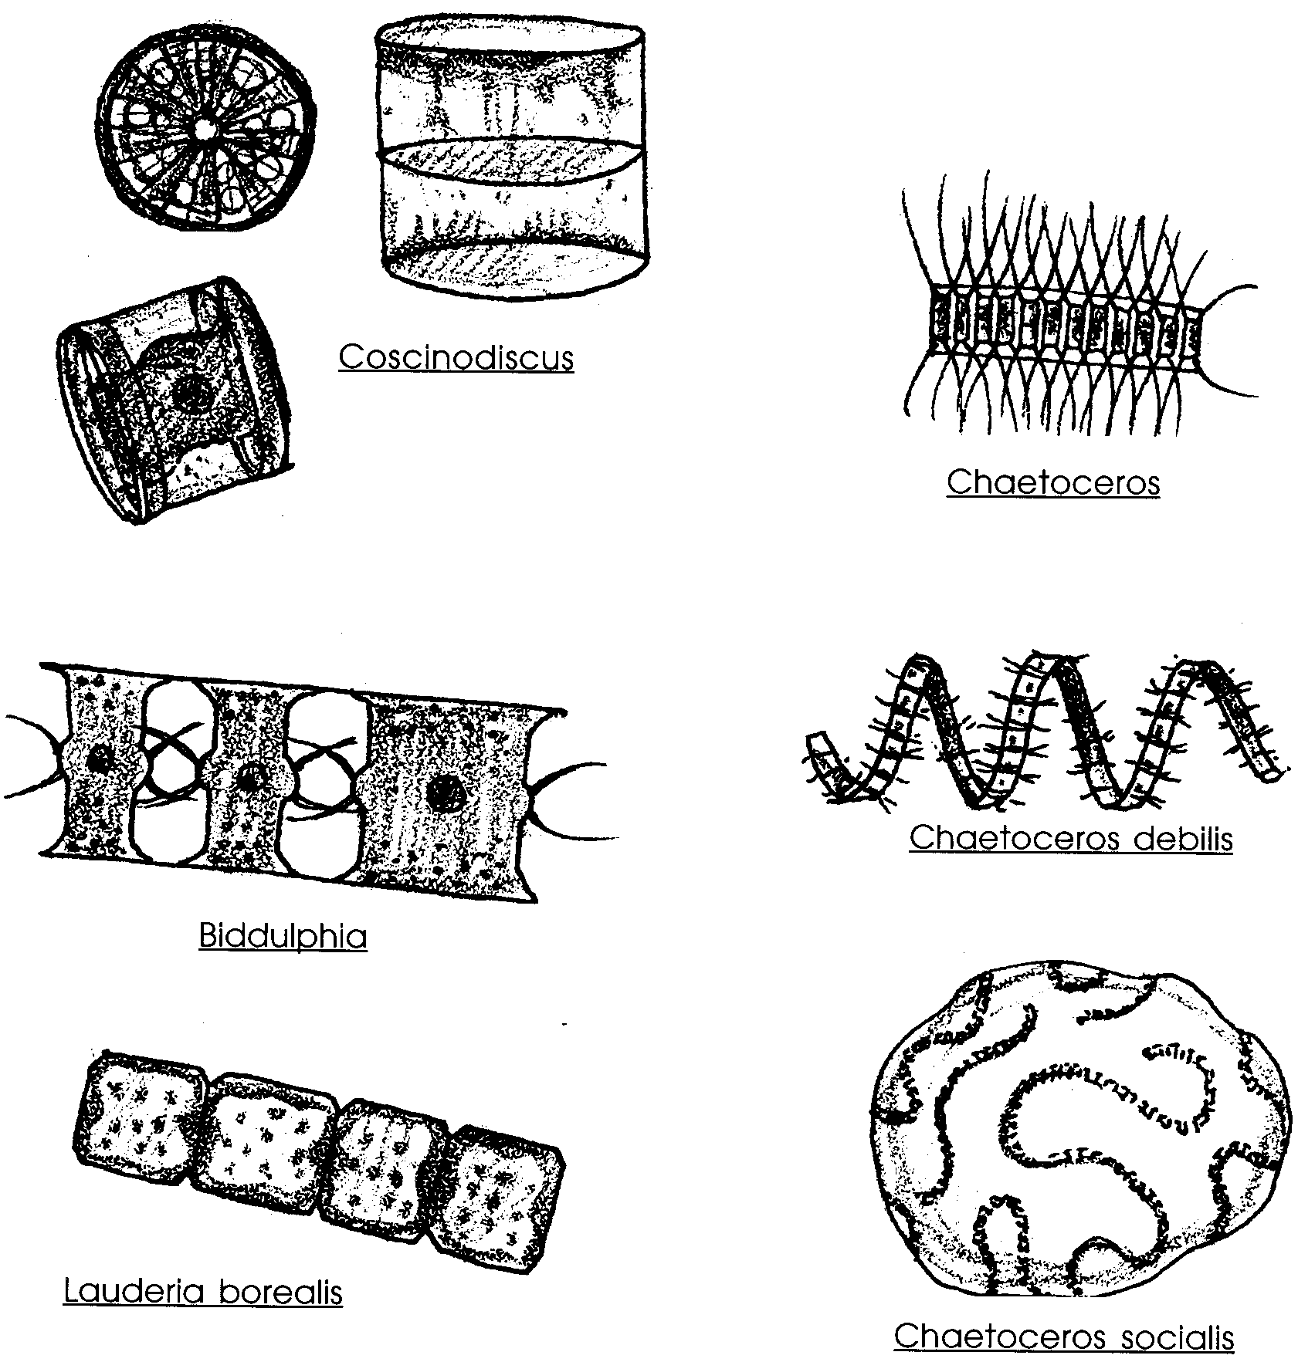
Phytoplankton, or plant plankton, contain the same pigments as land plants so they will appear green or gold. They use the energy in sunlight to power photosynthesis, the creation of sugars from water and CO2.
All the phytoplankton shown on this page are diatoms. Diatoms are microscopic, floating, golden-brown algae.
Diatoms have a silica case with two parts that fit together like a pill box or capsule. Some are single cells, such as Coscinodiscus, while others grow in chains or colonies, such as Chaetoceros.

Zooplankton — Plankton Identification Sheet
Zooplankton, or animal plankton, are transparent. They eat phytoplankton or each other. Most are active, moving legs, antennae, cilia, or tails.
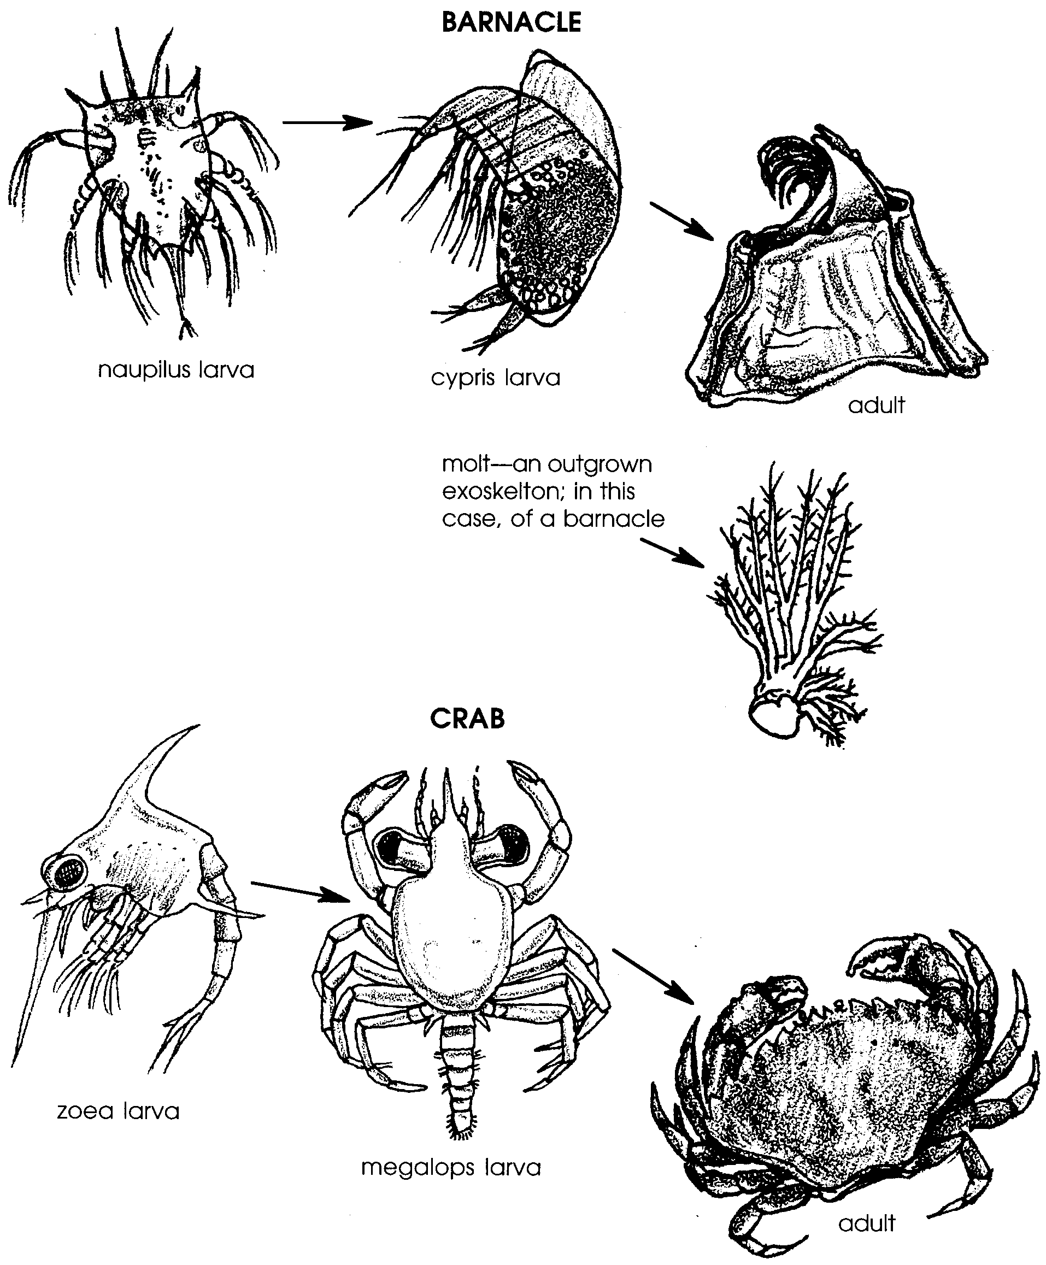
Zooplankton — Plankton Identification Sheet

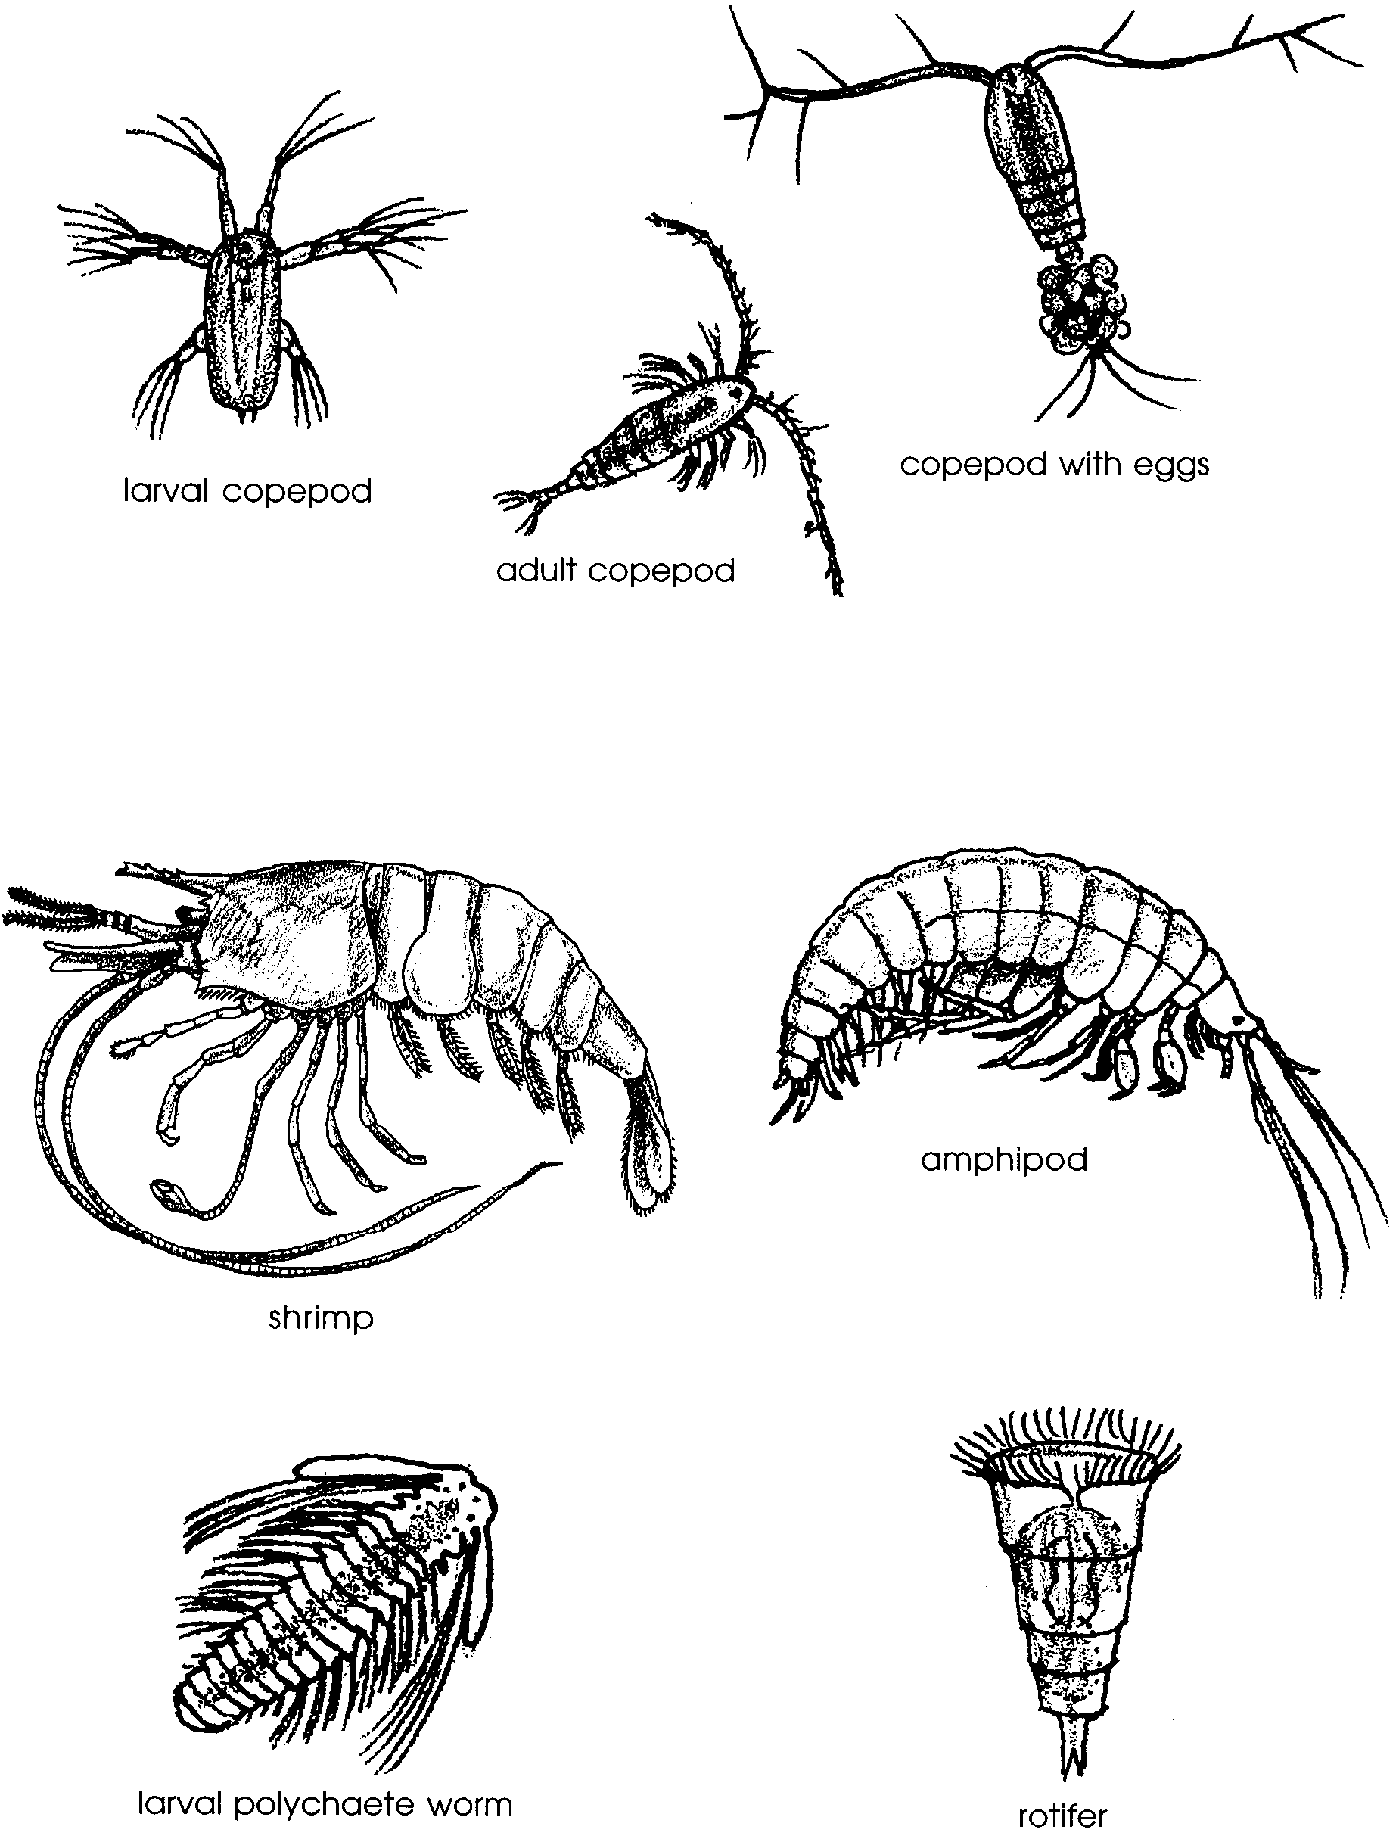
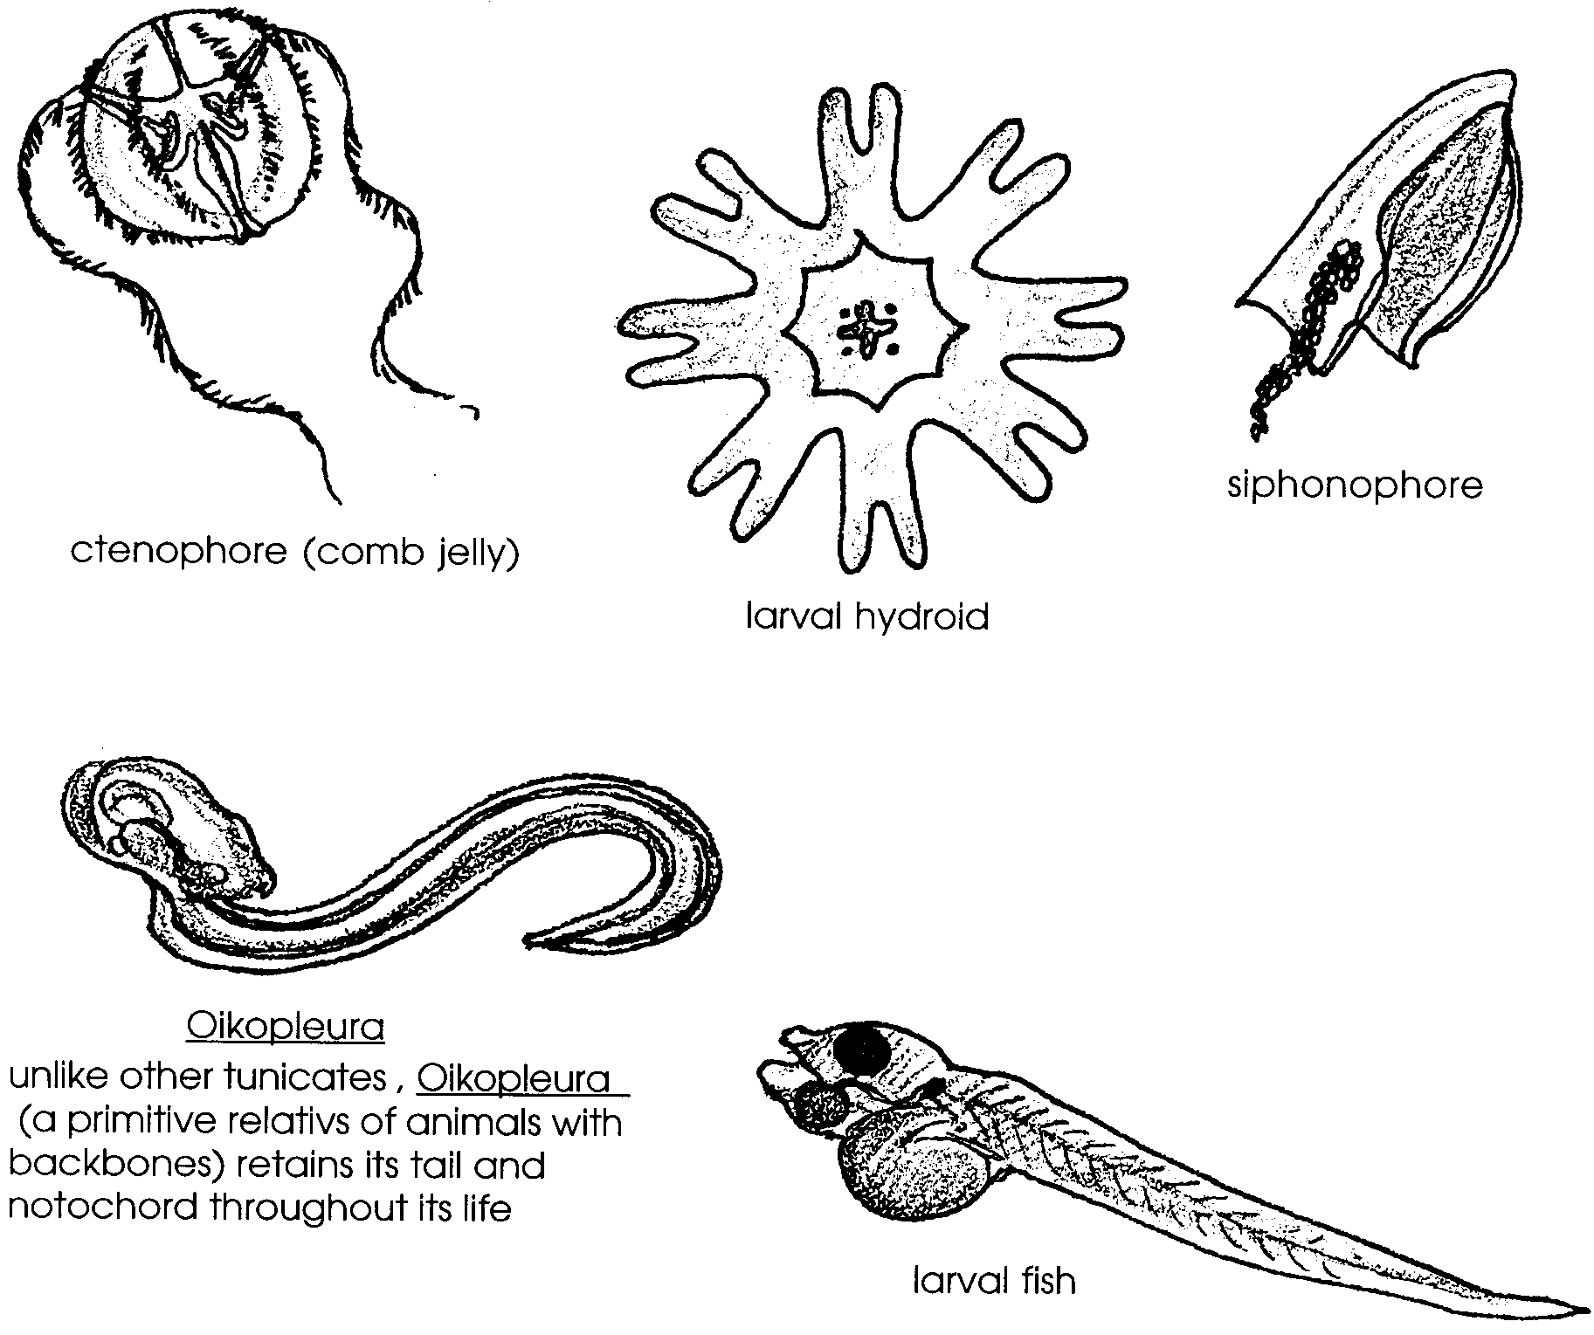
Zooplankton — Plankton Identification Sheet

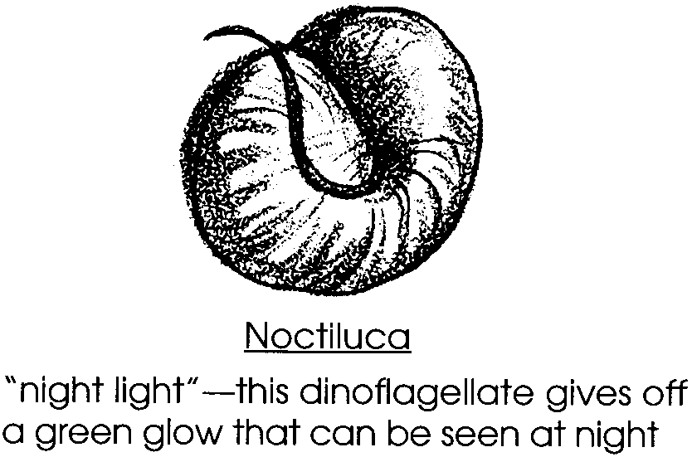

Dinoflagellates
Dinoflagellates have characteristics of both plants and animals. They can photosynthesize, but many can also absorb nutrients or consume other organisms. They move, using their tails or flagella.
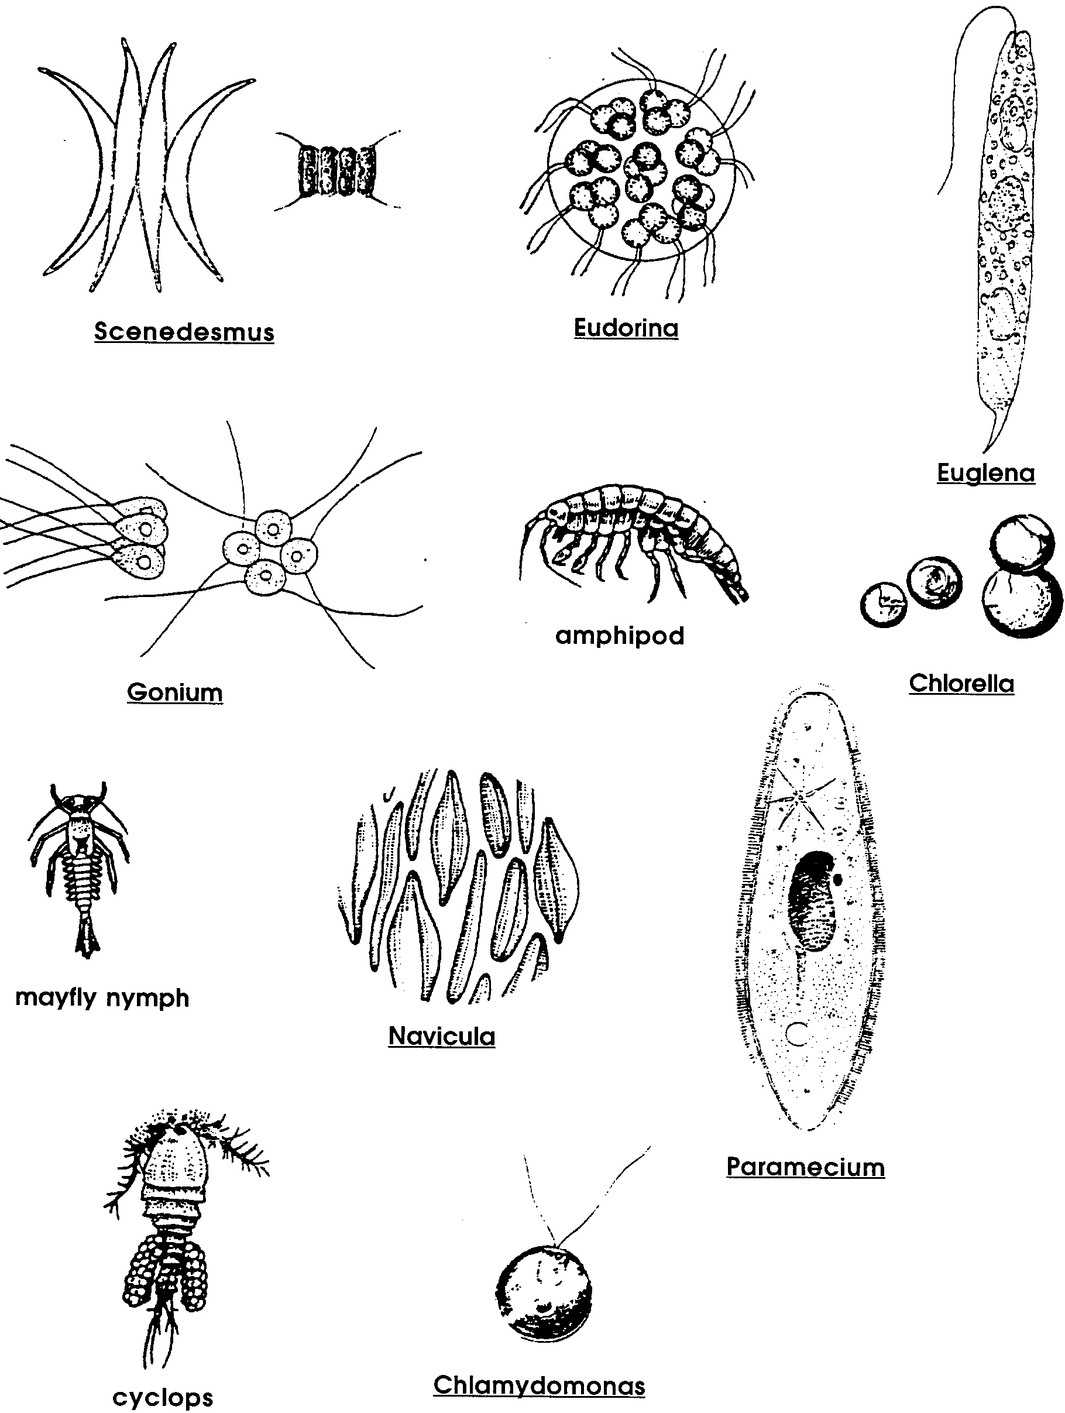
Freshwater Plankton - Identification Sheet
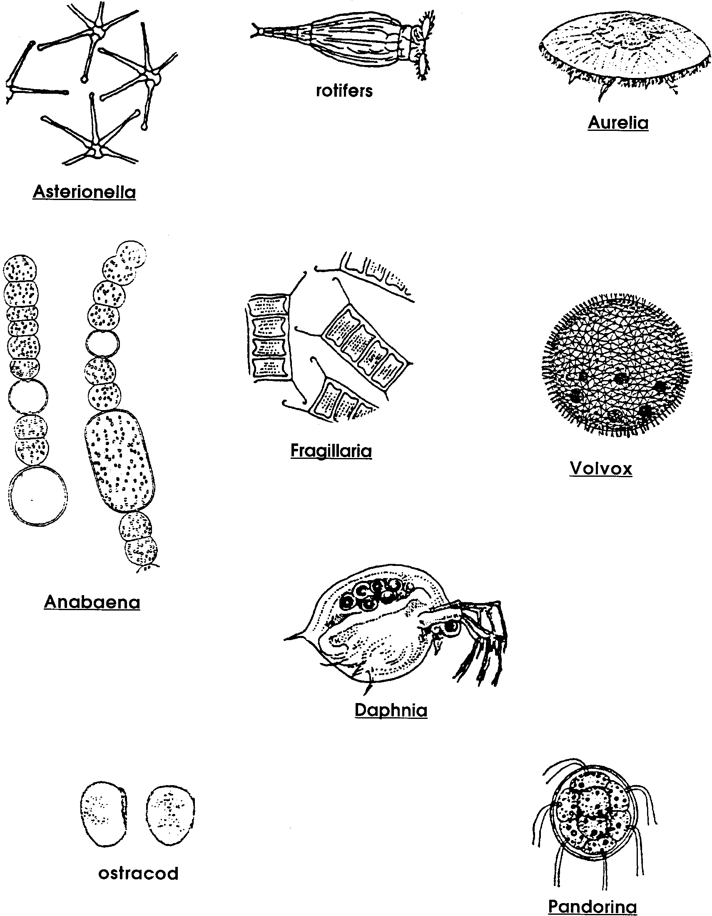
Freshwater Plankton - Identification Sheet
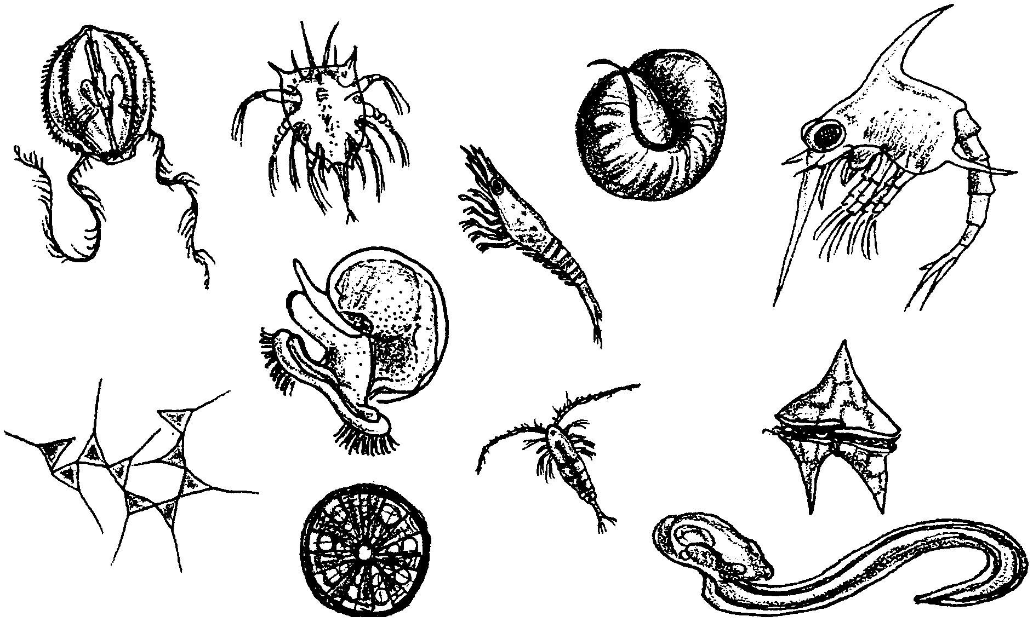
Observations of Living Plankton

Hold a cup of salt water and it will appear empty and lifeless. Look more closely, however, and you will see the tiny plants and animals we call plankton. The name “plankton” means “wanderers”. The plankton drift with ocean currents, going wherever the water carries them. They are especially abundant along coastlines where cold, deep, nutrient-rich waters rise to the surface of the ocean in upwelling currents. Many plankton will grow to be familiar marine animals such as crabs, snails or sea stars. All are a vital food source for other marine life, from tiny clams to giant blue whales.
This activity gives you the opportunity to observe living plankton. You will:
1. look for patterns in the behavior and distribution of the plankton in a sample of water;

2. draw and describe from microscopic observation the shapes, structures and behaviors of specific plankton; and

3. identify phytoplankton (plants) and zooplankton (animals).

To do this activity, you and your partner will need:
• a plankton sample in a small, clear container
• 2 microscope slides or petri dishes, 1 for each of you
• an eye dropper
• 2 microscopes, 1 for each of you (if there are not enough microscopes for all, you and your partner work together with one scope)
1. In the space below, draw what you see in your plankton sample when you first allow it to sit undisturbed. Then watch the plankton sample carefully for five minutes. Draw and describe how it changes in five minutes.

Check to see that you have added the following to your drawing:
Draw any specific, individual organisms you can see.
Make sure your drawing shows any distribution patterns in the container. Draw in the plankton to show where they are in the container.
Make sure the second drawing shows any changes in the container after five minutes.
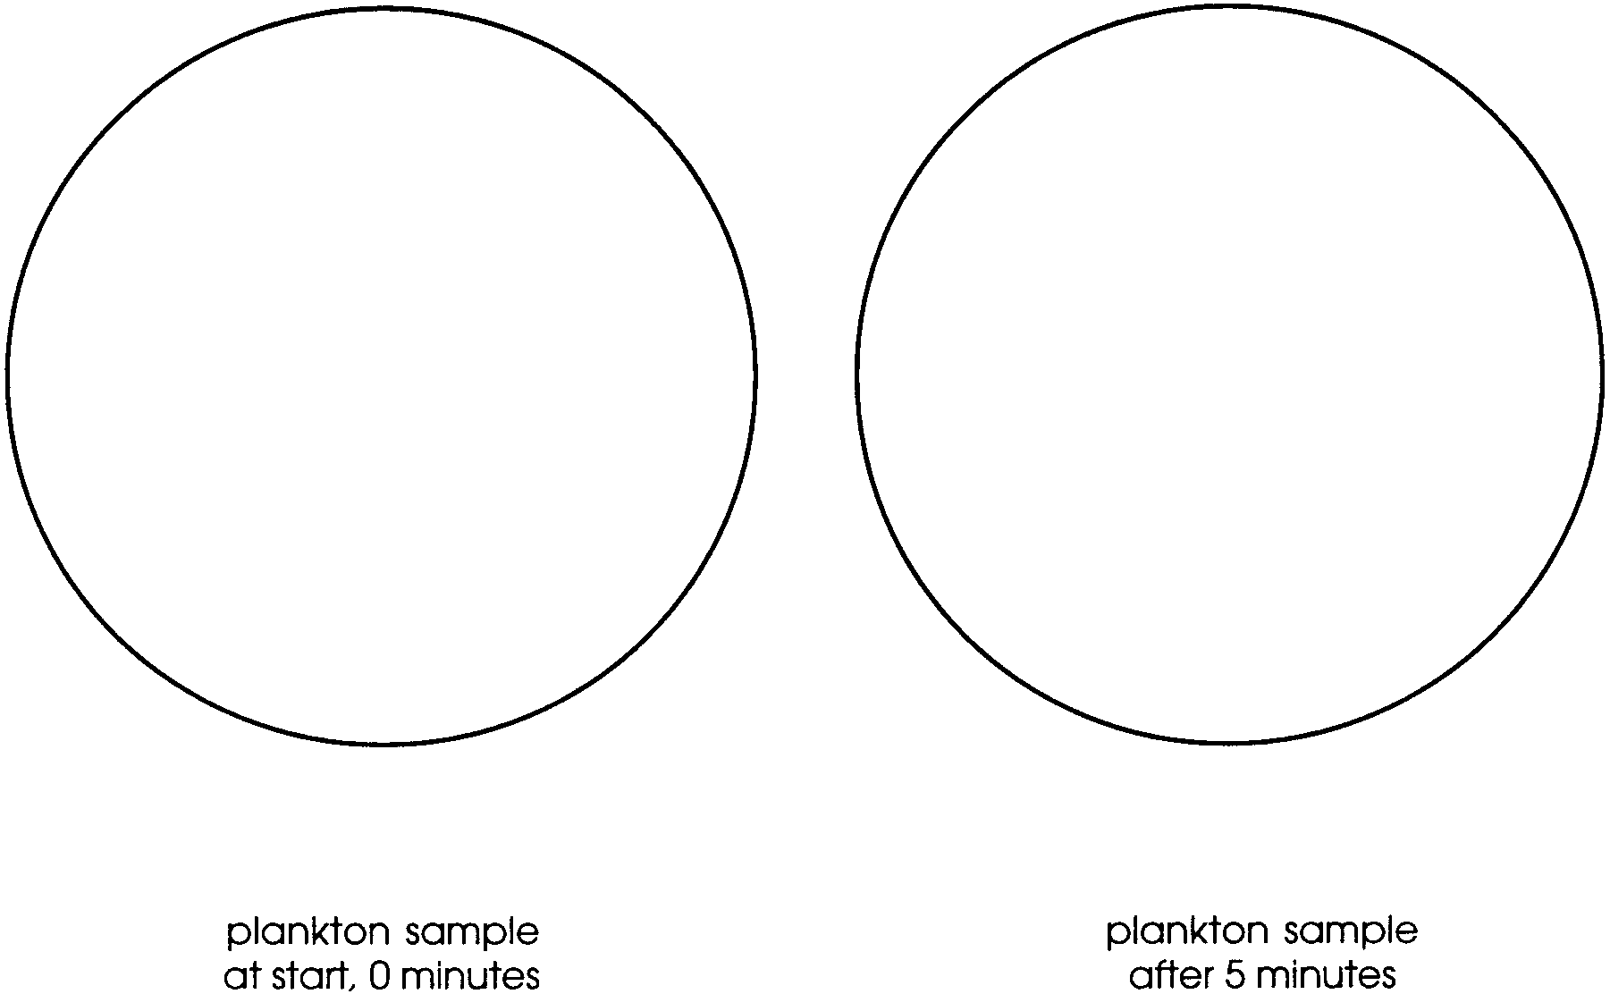

Summarize the changes you saw in your plankton sample:
2. Now view some of the plankton under the microscope. Obtain an eye dropper and slide or petri dish. Use the eye dropper to catch plankton you want to observe from your container. Place the plankton in small drops on your slide or petri dish. (Small drops help trap the plankton in a small area so the active ones cannot swim out of your view.) Observe under the microscope.

3. Draw in detail selected plankton you see under the microscope. Be sure to create large drawings that fill the spaces below. Draw detailed body shapes and structures such as legs, antennae, eye spots and tails.


Add notes to your drawings describing behaviors you saw. How did each plankter move? What did you see it do?
4. Return the plankton to their container and rinse, dry and return your materials.

5. Obtain a plankton identification guide. Use the guide to help you label each plankter drawing as a phytoplankter or a zooplankter.

