Drifting With the R/V Wecoma
Edited by Eugene Williamson, Whitford Intermediate School, Beaverton, Oregon.
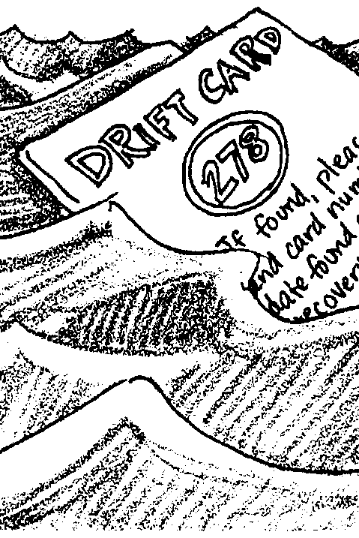

Key Concepts
1. Currents impact human activities.
2. There are a variety of ways to measure currents.
3. Analyzing data can give one an understanding of current behavior.
4. As with all measurements, there are inaccuracies inherent in the measurement of currents.

Background
The accurate measurement of currents has long been one of the goals of ocean science. Measurement techniques vary with the type and accuracy of the data required. An instrument may be anchored if the researcher wants to know how currents behave at a given location, as at the mouth of a bay, or at a specific depth. The instrument may be free-floating if the path of the current is under investigation. Drift bottles, drift cards, Swallow floats, and radio buoys are used in this way. More sophisticated is the use of satellites and towed electrodes, the latter of which senses an electric potential when there is a flow of water perpendicular to the ship's course.

Over time, scientists have noted that water temperature, salinity, and other properties, collectively called "tracers", are conserved below the surface as water is carried along by currents. Measuring these and knowing their values in possible source regions allows oceanographers to estimate the proportion of water from each source and often to trace the path of a given current, even without direct velocity observations. Other, non-conservative tracers such as oxygen (consumed by animals) or radioactive isotopes (e.g. tritium) act as clocks which allow oceanographers to estimate the age of the water since it left its source(s). For the harder to measure deep and bottom currents, this information when combined with the distance to the source gives an average velocity.

Today, current measurement is done with radar, satellites, and other sophisticated systems. It is now illegal to throw drift bottles into the sea. Nevertheless, scientists used drift devices for decades to gather data on the movement of surface currents. When a container vessel recently lost a load of athletic shoes in a storm, scientists used reports of shoes washing up on beaches to track currents in the area.

Materials
For each student:
• copy of “Drifting with R/V Wecoma” student pages
• ruler
• calculator (optional)

Teaching Hints
“Drifting with R/V Wecoma” gives your students a chance to work with the kind of data collected from drift bottles or cards. In this case the vessel is the R/V Wecoma out of Oregon State University.
This activity will take two to three class periods.
The directions for this activity are complex. Considerable explanation and modeling may be necessary. In fact, you may want to model the procedures instead of passing out the instructions.
Depending on the nature of your class, it may be desirable to have students work in small groups.
Plan to review the difference between latitude and longitude, and between land miles and nautical miles. Note that the latitude lines in the map projection used for this activity keep getting farther apart. Students will need to use the mileage scale at the bottom of the map to measure the distance traveled by each bottle.
This lesson is an opportunity for students to use critical thinking skills to decide what valid conclusions may be drawn from minimal and scattered data. There is more than one correct interpretation of the data. The fun in teaching this lesson is in encouraging students to really think and discuss alternative explanations.

Extensions
1. Have your students research modern methods of measuring ocean surface currents. Research could be presented in the form of a simple report or as a bulletin board display.
2. Have students research methods used to determine the motion of currents deep within the ocean.
Answer Key
1. Bottle # 7 traveled the farthest.

2 a. Bottle #3 traveled the fastest.

b. The factor which has the greatest bearing on the calculated speed of the bottle will be when the bottle is found. If the bottle washes up on a deserted beach, it may not be found for weeks, or in some cases, years.

c. Given conflicting data, it would be better to believe the faster speed. This would set some sort of upward limit for the speed of the current. Any lower speeds could be explained by the time required to find the bottle.

3. The data does not support the generalization. Bottle #3 was dropped much nearer the shore than bottle #12, but it went much further to the north.

4 a. It is not reasonable to assume that the bottles moved in a straight line. Ocean currents change speed and direction, often forming eddies which would carry the bottle in a tortuous path.

b. If bottles 5 and 6 move in straight lines, the surface currents at the drop point must be diverging at a 90 degree angle; not a very likely scenario.

5. A radio beacon would allow the scientist to stay in constant contact with the bottle. This would show the actual path followed by the bottle, and since the bottle would cease to move once it had reached the shore, would allow a more accurate determination of speed. Further, it would be possible to determine the speed of any part of the current in which the bottle was located.

6 a. All of the bottles out to 125-00 W moved to the north.

b. In November, the near-shore currents have a northward set.

c. See attached map.

7. To the west of 125-00 W, the bottles begin to move both north and south, more or less unpredictably. There must be a southward setting current to explain why some bottles are recovered south of the drop point.

8. Any bottle which ends up south of the drop point must have traveled farther to the south and then been brought back to the north by the Davidson since it is impossible to come ashore without contacting the Davidson. Some of these bottles found more rapid portions of the Davidson, or stayed in it longer, to eventually come to land north of the drop point.

9. Bottles dropped at 124-32 W would most likely be found north of Newport, perhaps near the mouth of the Columbia, though exact location is not predictable.

10. It is difficult to predict where bottles dropped at 126-10 W would be found. The data seems to indicate that some would be found north and some south of Newport. The fact that both bottles #11 and #12 are found north must be pure chance, as any bottle dropped that far out should stand about equal chance of coming in north or south of Newport.

11. It is easier to have confidence in answer 9, because all of the bottles there go north, whereas, of the bottles dropped farther out, 50% end up north and 50% end up south.

12. Changes in winds, temperature, rainfall, and other physical factors should combine to change the current patterns at other times of the year. It is to be expected that the data would yield different conclusions.

Note: In summer months the Davidson Current becomes a countercurrent below the California. Bottles dropped in May and June are found almost exclusively to the south, some as far as San Francisco Bay.
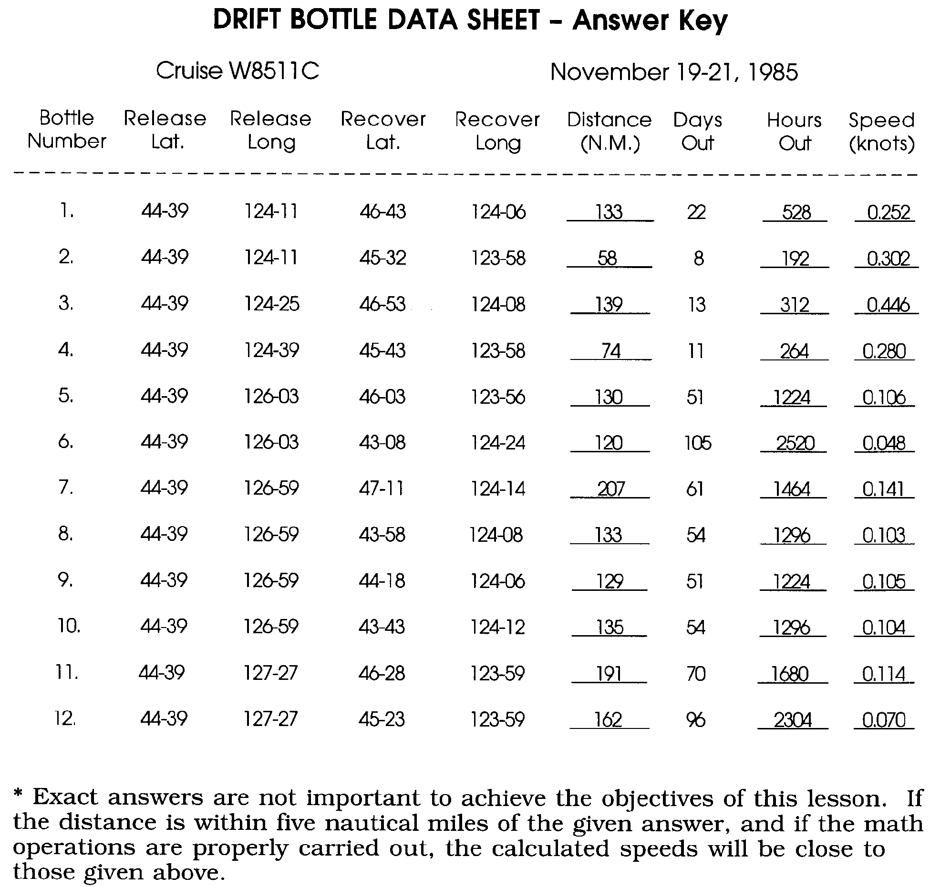
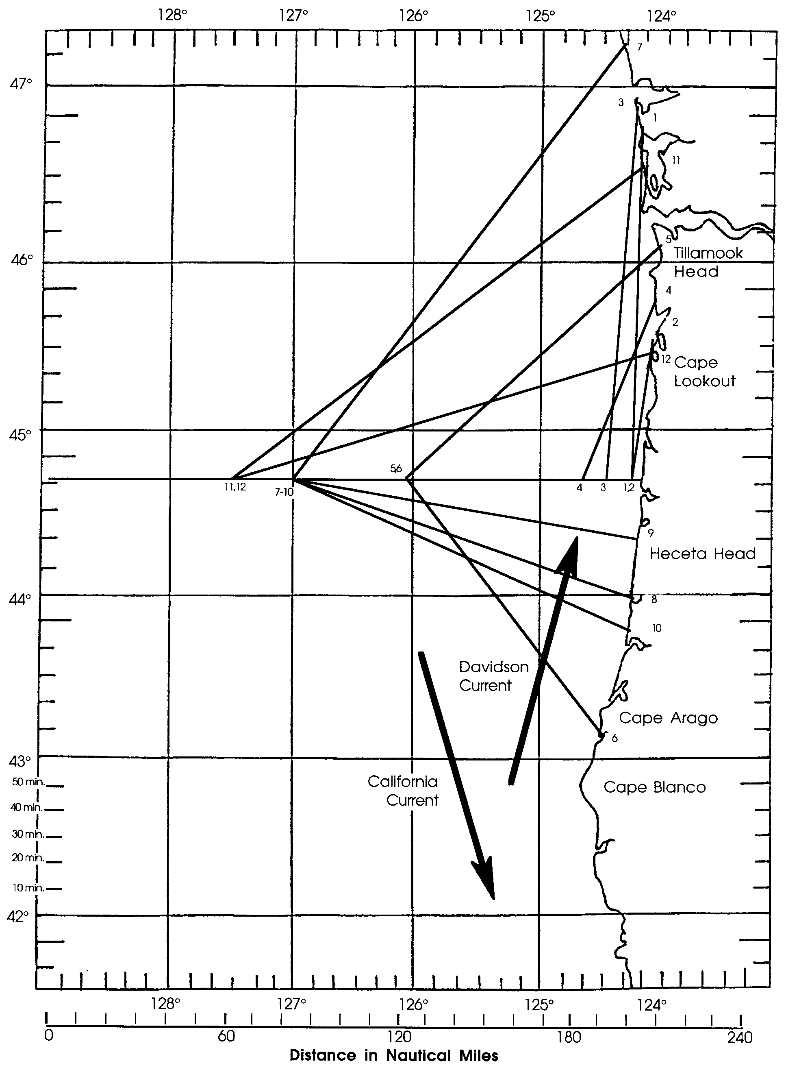

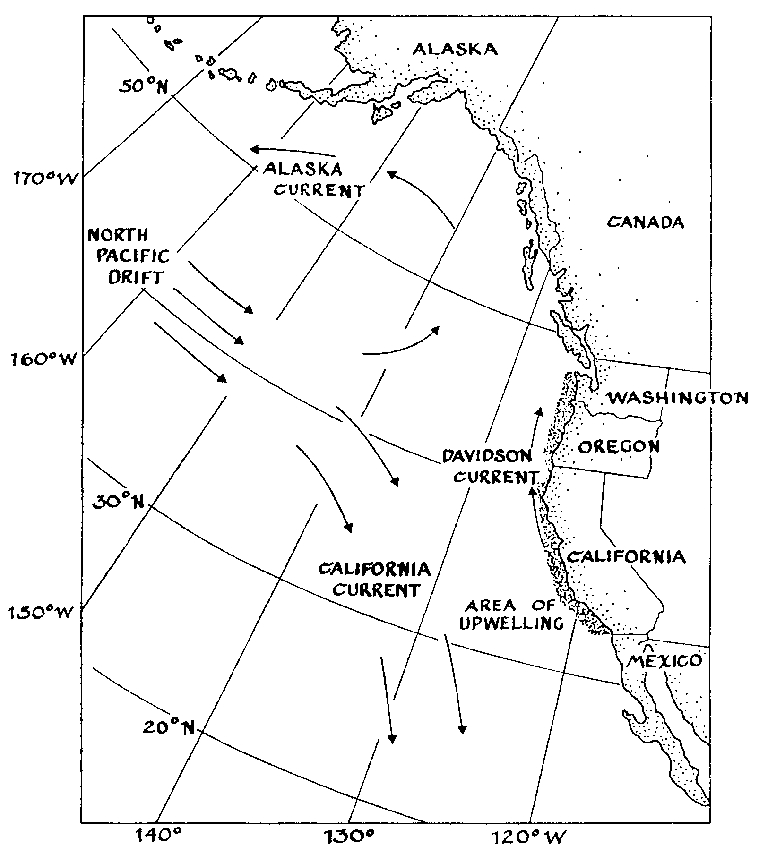

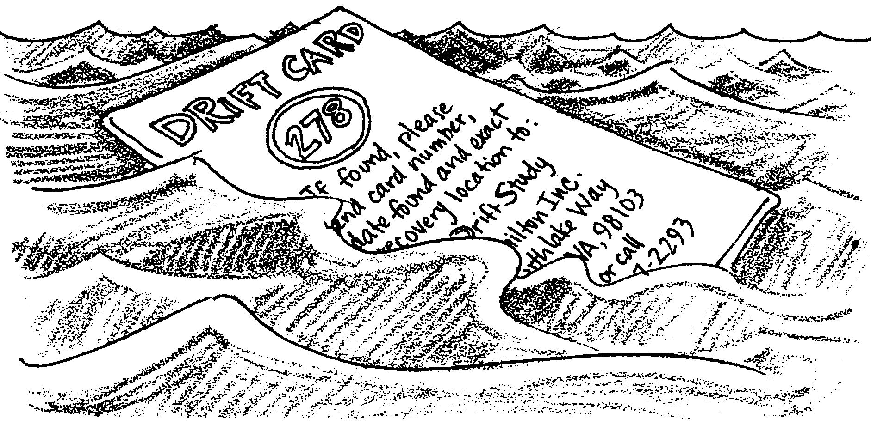
Drifting With the RV/Wecoma

Ocean currents affect us in many ways. Currents influence climate, oceanic transport, and the distribution and migration of marine organisms. Currents have been studied since human beings first attempted to navigate the oceans. How do we discover the behavior of ocean currents?

Scientists have many ways of detecting the movement of ocean waters. Modern methods use complicated equipment and rely on computers to interpret the data. Historically, one of the most popular original methods involved the use of some floating object, like a bottle, a plastic disk, or a zip-lock bag. A return card was generally included, and the device was simply thrown into the ocean and carried away by prevailing currents. Not all of these devices were recovered, so to be sure that enough data was retrieved, the scientist usually released a large number of drift devices. In this activity you will use actual drift bottle data collected by Oregon State University to learn more about the behavior of ocean currents along the North American west coast. You will use the data to compute the direction and speed of each bottle. Then you will map the path of the bottles to determine current patterns.

Since it is not possible to mark an "X" on the surface of the ocean to locate the starting position of the bottles, scientists use an electronic communication system called LORAN to find the latitude and longitude at which the bottles are dropped.

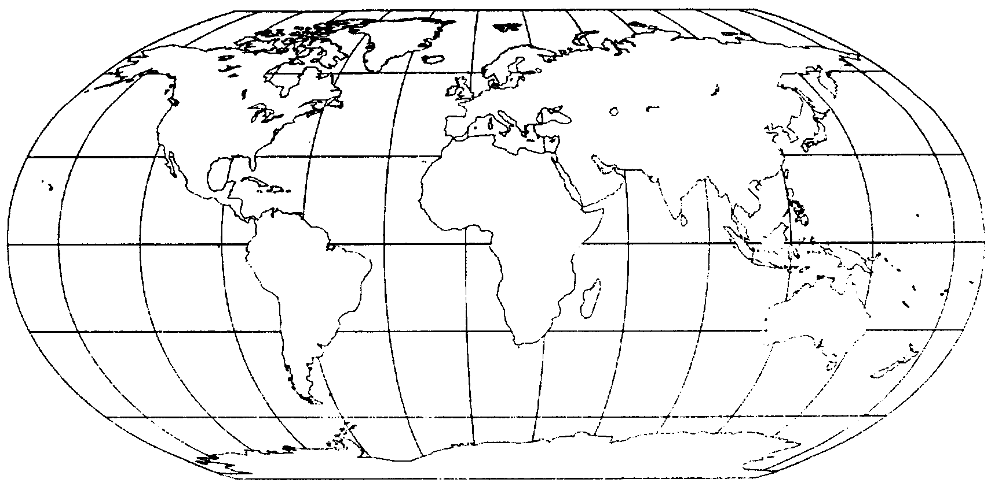
Latitude lines tell us how far north or south of the earth's equator the bottle was dropped. Longitude measures the distance east or west of an imaginary line which runs through Greenwich, England. Notice that while lines of latitude are parallel to each other, lines of longitude converge (come together) at the poles. Lines of latitude are always the same distance apart, but the distance between lines of longitude depends on where one is on the surface of the earth.

Materials

• Ruler
• Pencil
• calculator (optional)

Procedures

1. Use the attached map of the Oregon coast and the Drift Bottle Data Sheet.

2. Plot the apparent course of each of the bottles released by the crew of Wecoma. To do this you will need to locate two points for each bottle: the release point and the point at which the bottle was recovered. Each of these points is found by using the latitude and longitude figures given on the data sheet.

3. Since it is not possible to visually check the course of each bottle, it is not possible to map the exact course it follows. For this activity, we will have to assume that the bottle travels in a straight line from the drop point to the point of recovery.
4. Notice that all of the bottles were dropped at the same latitude. Newport, Oregon is the home port of the Wecoma. Newport is located at 44 degrees, 39 minutes North Latitude. All of the bottles were dropped along this line as the ship steamed directly west from Newport. It will be helpful for you to draw a very light pencil line showing the course of the ship. With the help of the instructor, find 44 degrees, 39 minutes on both edges of the map, and connect these points with a pencil line. This is the course of the Wecoma.

5. Now we are ready to find the apparent path of each bottle. Bottle #1 was dropped at 124 degrees, 11 minutes West Longitude. The scientist uses a shorter method of writing this information. It is written, 124-11 W. Find 124-11 W at the top and at the bottom of your map. Lay your ruler across the map to join these two points. Where the ruler crosses the ship's track is where bottle #1 was dropped. Place a dot at that point. Notice that bottle #2 was dropped at the same spot. The dot you just drew will also represent the starting point for bottle #2.

6. Use the same method to locate the recovery position of bottle #1. Find latitude 46-43 N on both sides of the map, and longitude 124-06 W on the top and bottom. Where the imaginary lines cross is the recovery position. Put a dot at the recovery position and label it #1. Since these bottles are seldom, if ever, picked up from the water, it is likely that the recovery position will always be at the coast. Check your recovery position to see that it is on the beach. If it is, you are ready to proceed.

7. Draw a line from the drop point to the recovery point for bottle #1. This is the apparent path of the bottle. Remember that the bottle probably did not follow this exact path, but it was close. Now repeat this procedure for bottles #2-12. When you have drawn lines to represent the paths of each bottle, you are ready for the next step.

8. Take a piece of scratch paper and lay the edge of the paper along the path followed by bottle #1. Put a mark at the edge of the scratch paper at both the drop point and the recovery point for bottle #1. These two marks now represent the distance traveled by #1. If you have a compass, you can do the same thing by placing one point of the compass on the drop position and the other point on the recovery position. How can we use these marks to tell us how far the bottle traveled? Easy! We just have to remember one thing. Every degree of LATITUDE is exactly 60 nautical miles. Each degree of latitude is subdivided into 60 smaller pieces called minutes. This is not a time unit. It is a distance unit. One minute of latitude is equal to one nautical mile. Each minute can also be divided into 60 seconds. Seconds are also a distance unit, representing 1/60 of a nautical mile, or about 100 feet.

(You may be asking yourself, "Why are we using latitude? Couldn't we use longitude just as well?" The answer is NO! Do you understand why we cannot use lines of longitude to measure distance? If not, be sure to discuss this with your teacher before going ahead.)
9. Now take your compass, or the scratch paper, and place it along the mileage scale at the bottom of your map. Place one of the dots on a line representing zero. Each of the small marks represents 10 minutes of latitude, or 10 nautical miles. You can now simply count the number of miles that bottle #1 traveled. If the other dot falls between marks on the map (usually it will), just estimate the value. If it is half way between two marks, that is 5 more nautical miles. What did you get for the distance traveled by #1? You should have an answer of about 131 nautical miles. If your answer is between 128 and 134, you are doing fine. If your answer is outside those numbers, you should ask your teacher for help. Now go ahead and find the distance traveled for the rest of the bottles, and place your answers on the data sheet.

10. Now we are ready to compute the speed of each drift bottle in nautical miles per hour (knots). One knot is roughly equal to 1.15 mph. Remember that there are 24 hours in each day that the bottle was at sea, so the speed of the bottle is found by this formula:

Distance traveled in nautical miles = speed of bottle in knots/hr.
Days out X 24

For bottle #1, first multiply 24 hrs/day by 22 days out to get 528 hours out. Then divide the 131 nautical miles traveled by 528 hours to get the speed of 0.248 knots. If you are using a calculator, round off your answer to three decimal places. Enter the speeds for all 12 bottles on your data sheet.

Results and Interpretation:

1. Which bottle traveled the greatest distance?

2a. Which bottle had the greatest speed? (Remember: the computed speed of the bottle is at best an estimate of the actual speed.)

b. What factor, more than any other, will determine the calculated speed of the bottle?

c. If you had conflicting data about the speed of a current, would you tend to believe the faster or the slower speed? Why?
3. One might expect that the farther from shore one dropped the drift bottle, the farther north or south it would travel before reaching the beach. Does the data from the R/V Wecoma support this generalization? Give an example to support your answer.

4a. We have assumed that the drift bottles move in a straight line. Is this a reasonable assumption?

b. Consider bottles number 5 and 6. If the bottles move in a straight line, what must the currents be doing where these bottles were dropped?

5. It is possible, though a bit expensive, to place a small radio transmitter in each of our drift bottles. How might this help us in plotting the path of currents?

6a. How do bottles dropped out to 125-00 W all behave?

b. What does this tell you about the near-shore currents in November?

c. The observations are due to a seasonal current known as the Davidson Current which extends roughly from central California to Vancouver Island. Draw a large arrow showing the approximate location of the Davidson Current on your map.

7a. Outside of 125-00 W, how do the drift bottles behave?
7 b. The California Current flows year-round off the Oregon coast. Use a map of ocean currents to find the location of the California Current and enter it on your map.

8. Based on your completed map, explain how it might be possible for bottles dropped in the same location to end up both north and south of the drop point.

9. If R/V Wecoma had dropped some drift bottles at 124-32 W, where do you think those bottles would have been found?

10. If R/V Wecoma had dropped bottles at 126-10 W, where do you think those bottles would have been found?

11. Would you be more confident about your answer to question 9 or question
10? Why?

12. The data used was gathered in November. Do you think data gathered at other times of the year would show the same results? Explain your answer.

