The Circulation of the Oceans
Lesson by Karen Mattick, Marine Science Center, Poulsbo, WA.
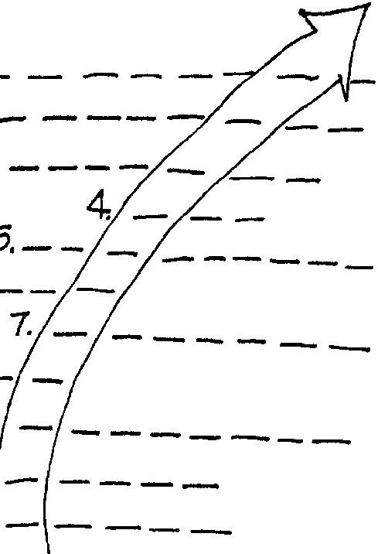

Key Concepts
1. Winds produce global current patterns.
2. Researchers are trying to understand the changing eddies and other water movements within the global currents.
3. Ocean currents shape the biology of the regions through which they move.

Background

Knowledge of the existence of ocean currents has been with us for some time. Ancient Polynesian sailors were adept at determining currents and adjusting their sailing course accordingly. Even so the circulation of the oceans is far from completely understood. Active research is being conducted to determine the immediate causes of the currents. Currents influence our climate as well as our shipping and commerce. The article “The Circulation of the Oceans” describes research on currents.

Materials
For each student
• One copy of the article: “Circulation of the Oceans” by Walter Munk (“Scientific American”, Sept. 1955, pp. 251-258). Please note: “Scientific American” articles are unavailable for inclusion in the CD ROM version of the FOR SEA Guide. Please look for this article at your library.
• One copy student text: “Circulation of the Oceans”

Teaching Hints
Duplicate the puzzlegram pages. One set is recommended per student. This activity may be performed individually or in small groups. Each approach has its advantages and disadvantages. Select the technique that best suits your particular needs. The puzzlegram is a modification of a reading game designed to teach vocabulary skills. This puzzlegram teaches vocabulary skills to a degree but the emphasis is on concepts. Completing the clues by filling in the blanks completes statements which are important concepts from the article. While the directions on the student sheets are designed to be self-explanatory, a few words about the format may be in order. Explain that when all of the blanks are correctly completed a term dealing with ocean circulation will appear. Each blank receives one letter. Plan to allow a few minutes for discussion of the concepts elucidated by the article and reviewed by the puzzlegram. Provide the correct answers during the course of your discussion.

Key Words
bathythermograph - an instrument that makes a record of the temperature at various depths in the ocean
climatic current maps - current maps which show average currents over a large area for a year or more
circulation - in this case, the flow of masses of water from one area to another and back
gradient - rate of change with respect to distance of a variable quantity such as temperature or pressure
gyre - a pattern made of four or five currents that dominate the circulation pattern of the ocean in each hemisphere, clockwise in the Northern Hemisphere, and counterclockwise in the Southern Hemisphere
model - a simplified representation of a system or phenomenon with any hypotheses required to describe the system or explain the phenomenon, often mathematically
pressure - exertion of force upon a surface by an object or fluid in contact with it; force per unit area
synoptic current maps - current maps which show currents over a restricted area for a short period of time; analogous to a daily or weekly
velocity - time rate of change of a body in a specified direction
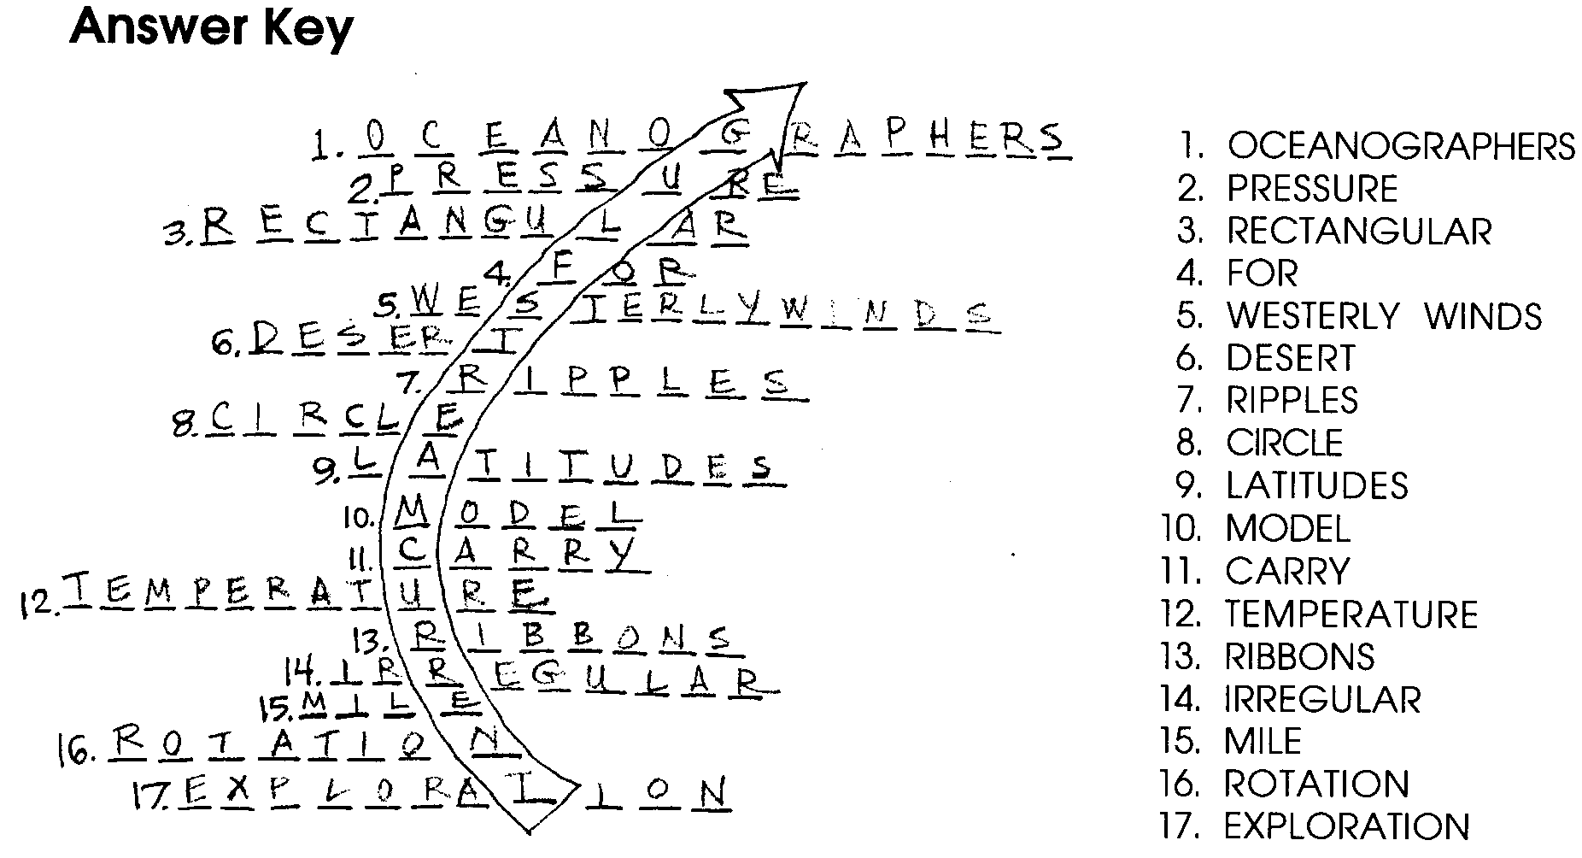

The Circulation of the Oceans

The Circulation of the Oceans Puzzlegram

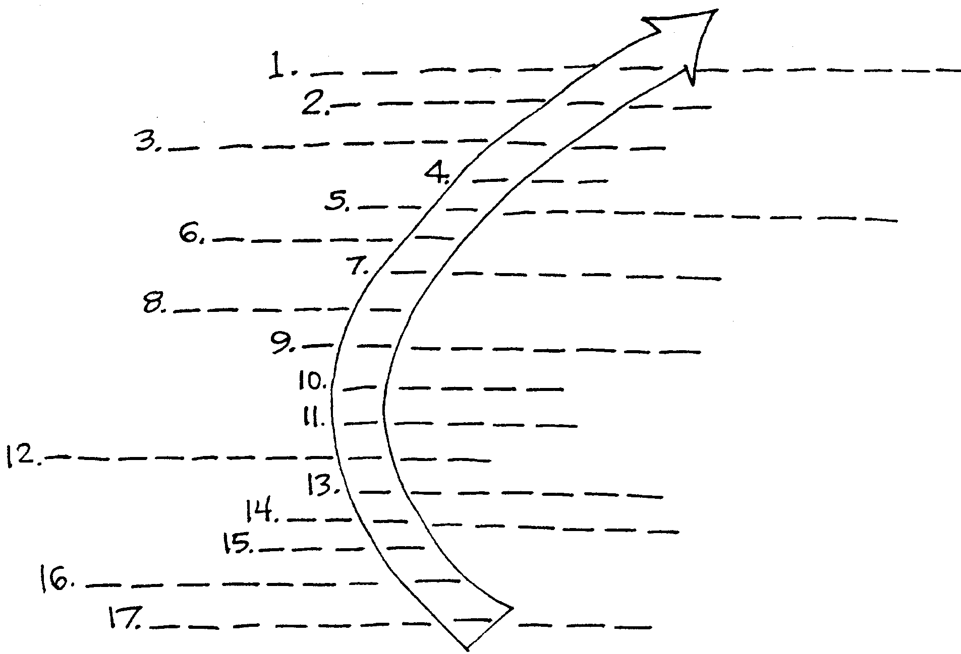
Fill in the blank space with the correct word in each of the sentences beneath the puzzlegram. The number of the sentence corresponds to a number in the puzzlegram. The correct answer will have the number of letters indicated by the number of blanks in the puzzlegram. When you have answered all of the sentences and filled in the blanks of the puzzlegram, a term dealing with ocean circulation will appear.

1. have now become interested in two kinds of current maps: climatic maps, which show average currents over a large area for a year; and synoptic maps, which are like a daily or weekly weather report.

2. Currents are deduced from fields in the sea.

3. The author, Walter Munk, uses a model to help explain ocean circulation patterns. In his model he uses an idealized ocean and known winds.
4. Gyre is another word ring.

5. From the chart “Idealized Ocean”, the idealized ocean would have
greatest velocity winds in the area labelled . (2 words)

6. Each subtropical gyre encloses a sea which is blue in color. Blue is the color of the sea.

7. It appears that an important element in the response of water to wind is not the large waves that rock boats and make people seasick, but the tiny bumps, the .

8. If there were no continents, the currents would flow in a great
around the earth.

9. If wind is stronger at some than at others, the stronger will overpower the weaker and the water will begin to circulate.

10. William Von Arx of the Woods Hole Oceanographic Institution constructed a that simulated ocean currents and seems to support the theories of the author of this article.

11. Ocean currents can be of considerable importance to the biology of the sea because they can a large number of living organisms.

12. Currents can be plotted by means of gradients measured with the bathythermograph.

13. Research suggests that the Gulf Stream, rather than being a wide river of moving water, may be made up of narrow, separate .

14. The motion of water in the open sea is highly and variable.

15. A drift buoy released in the ocean, could be expected to be carried something like 1/2 a in one hour.

16. The diagram labeled “Imaginary Small Ocean” shows that the earth’s
causes the circular pattern of water flow to be shifted into an egg shaped pattern.

17. Why the fine structure of the ocean circulates the way it does is a problem awaiting further .

