Mapping Ocean Currents
Lesson by Eugene Williamson, Whitford Intermediate School,
Beaverton, Oregon.

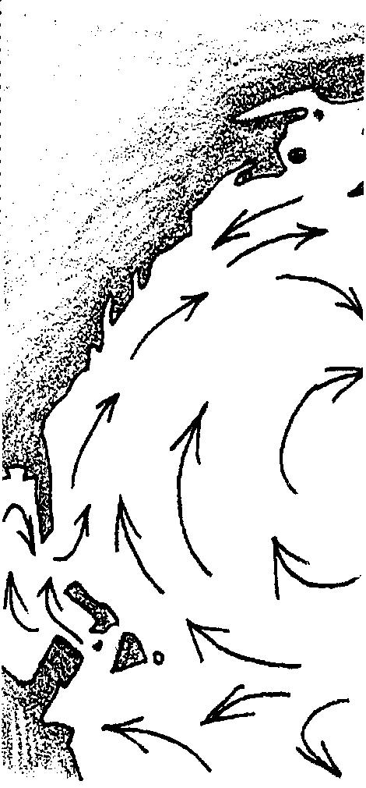
Key Concepts
1. Surface currents are a response to the uneven heating of the earth by the sun.
2. Temperature differences cause warmer water near the equator to swell and flow outward toward the poles.
3. Similar warming and expansion of the atmosphere causes winds which drag the water along.
4. The effects of temperature and the rotation of the earth on its axis and the positions of the continents lead to the complex patterns found on the sea surface.
5. Currents have considerable effect on human activities. From transportation to moderation of local climates, humans depend on ocean currents.

Background
Three concepts are strongly related to surface currents:
1. Water in the Northern Hemisphere tends to move to the right of the wind direction, creating a clockwise motion. Water in the Southern Hemisphere tends to move to the left of the wind direction, creating a counter-clockwise motion. In 1905, Eckmann determined a theoretical value for this phenomenon, known as the Ekman Spiral, that showed that the net transport of surface waters is at 45° to the right of the wind in the Northern Hemisphere and 45° to the left in the Southern Hemisphere.
2. This deflection of the water is the result of the Coriolis Effect. Objects, or ocean currents, moving through the Northern Hemisphere are deflected to the right because of changes in angular momentum that occur with changes in latitude. The opposite effect is seen in the Southern Hemisphere. This, in part, accounts for the clockwise rotation of the major current gyre north of the Equator and the counter-clockwise rotation south of the equator. The currents are further deflected by continents and by interaction with other surface currents.
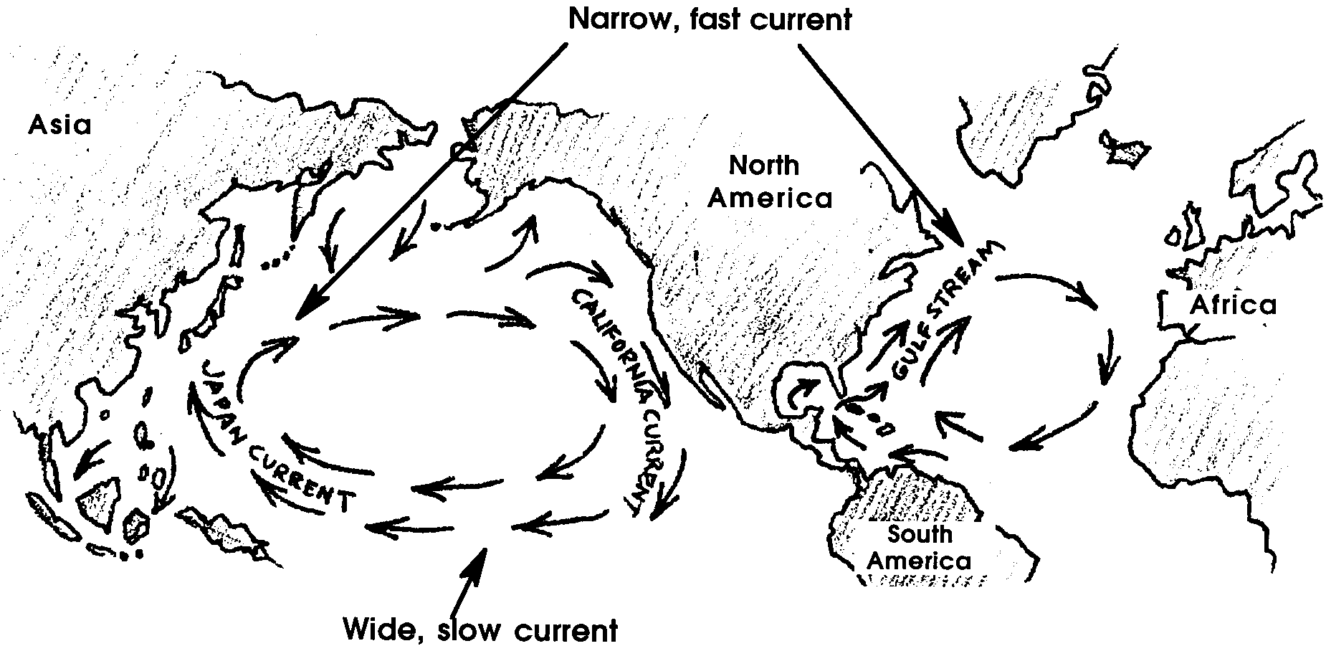
3. There are distinct differences between Eastern Boundary Currents and Western Boundary Currents. These differences are also a function of the earth’s rotation. Western Boundary Currents, like the Kuroshio and the Gulf Stream, are flowing toward the west and against a continent that has a shape that pushes the current back out toward the east. This causes the current to become narrow and deep, and to have relatively high velocities. This is somewhat analogous to putting your thumb over the end of a hose and constricting water flow. These currents also warm, but this is a function of their position, and not of the earth’s rotation.

Eastern Boundary Currents, like the Peru and the California flow eastward and against a continent that is angled away from the current. The result is broad, shallow currents that have low velocities. These currents are cold, again because they are the conduit for returning water from the polar regions to the equator.

Materials
For class of 32:
• Maps and other reference materials, such as oceanography texts, that show ocean currents
For each student:
• Copies of blank maps
• Colored pencils, one color for warm currents and one for cold currents

Teaching Hints
“Mapping Ocean Currents” involves students in mapping ocean currents and then interpreting those maps. The activity gives students a chance to discover circulation patterns for themselves, rather than having them presented in lecture format. The question set included may be expanded or reduced. The important thing is to get students to look at and interpret the evidence. Plan on at least part of one period to discuss the conclusions drawn by your students.
Mapping Currents will take two to three class periods.

1. Use a transparency to show students how you want the currents mapped. Western Boundary Currents should be represented by arrows that are wider than those used for Eastern Boundary Currents. Using just one arrow for each current simplifies the drawing and also makes the gyres more obvious.

2. Remind students that the names and positions of currents on reference maps are human constructs and that differences of opinion exist. They may need to use several references to establish a reasonable position for currents. Also, currents have no beginning or end in the real ocean. The whole of the ocean is in constant motion. There should not be big gaps left between the head of one arrow and the tail of the next.

3. Arrows with two heads are effective to show currents, like the North Atlantic Drift, that split when they come in contact with a land mass.

4. Modify the list of currents given to fit the reference materials available to you.

Key Words
boundary current - major currents which occupy the eastern and western edges of the oceanic gyres
Coriolis Effect - the apparent change in direction of objects moving across the earth’s surface, caused by the earth’s rotation, to the right in the Northern Hemisphere and to the left in the Southern Hemisphere.
drift - the speed at which a current moves
gyre - a pattern made of four or five currents that dominate the circulation pattern of the ocean in each hemisphere, clockwise in the Northern Hemisphere, and counterclockwise in the Southern Hemisphere
relative temperature - in this case, the temperature of a current compared to the temperature of the ocean surrounding it
set - the direction in which a current is moving, i.e. the set of the California current is generally to the south

Extensions
1. Have students research the work of Coriolis and report on its significance.

2. Have students research the disruption of normal current patterns that we call the El Niño. Report to the class on the effects that this phenomenon has on human activities.
3. Have students explain, using drawings, why early sailing ships delivering goods and mail to the United States from Europe would sail south and then along the Equator rather than following the much shorter route across the North Atlantic to New England. Find out where Columbus first made landfall in the Americas, and based on where he sailed from Europe, explain why this would be the expected result of his first voyage.

Answer Key
1. Current temperature is measured relative to the temperature of the ocean water that surrounds it. If the ocean surface temperature is 25° C, then a current that has water of 23° C is a cold current. The opposite is true for some very cold waters entering polar regions. They are considered warm because the surrounding ocean in even colder.

2. In the Northern Hemisphere, currents move in a clockwise direction. In the Southern Hemisphere, they move counterclockwise.

3. London is farther north than is New York. Base on this information, London would be expected to have very cold and bitter winters.

4. The North Atlantic Drift brings warmer waters from the Gulf Stream. The latent heat in these waters warms the atmosphere and keeps the climate relatively mild.

5. Global wind patterns match reasonably well with the movement of ocean currents. The patterns do not match exactly in part because continents present only a minor barrier to the movement of wind currents, whereas they block and deflect ocean currents.

6. Ocean currents transport heated waters from the equatorial regions into the colder polar regions, helping to balance the earth’s heat budget. At the same time waters that have lost their heat at the poles are being returned to the equator, thereby cooling that region.

7. The Trade Winds are responsible for the Equatorial Currents. The disruption of these normally steady and dependable currents can result in the formation of an El Niño.

8. The east sides of continents have warm currents flowing off shore. The west sides of continents have cold currents.

9. The four currents that make up the South Pacific gyre are the South Equatorial, the East Australia, the Antarctic Circumpolar, and the Humboldt.

10. Answers will vary.
Pacific Ocean

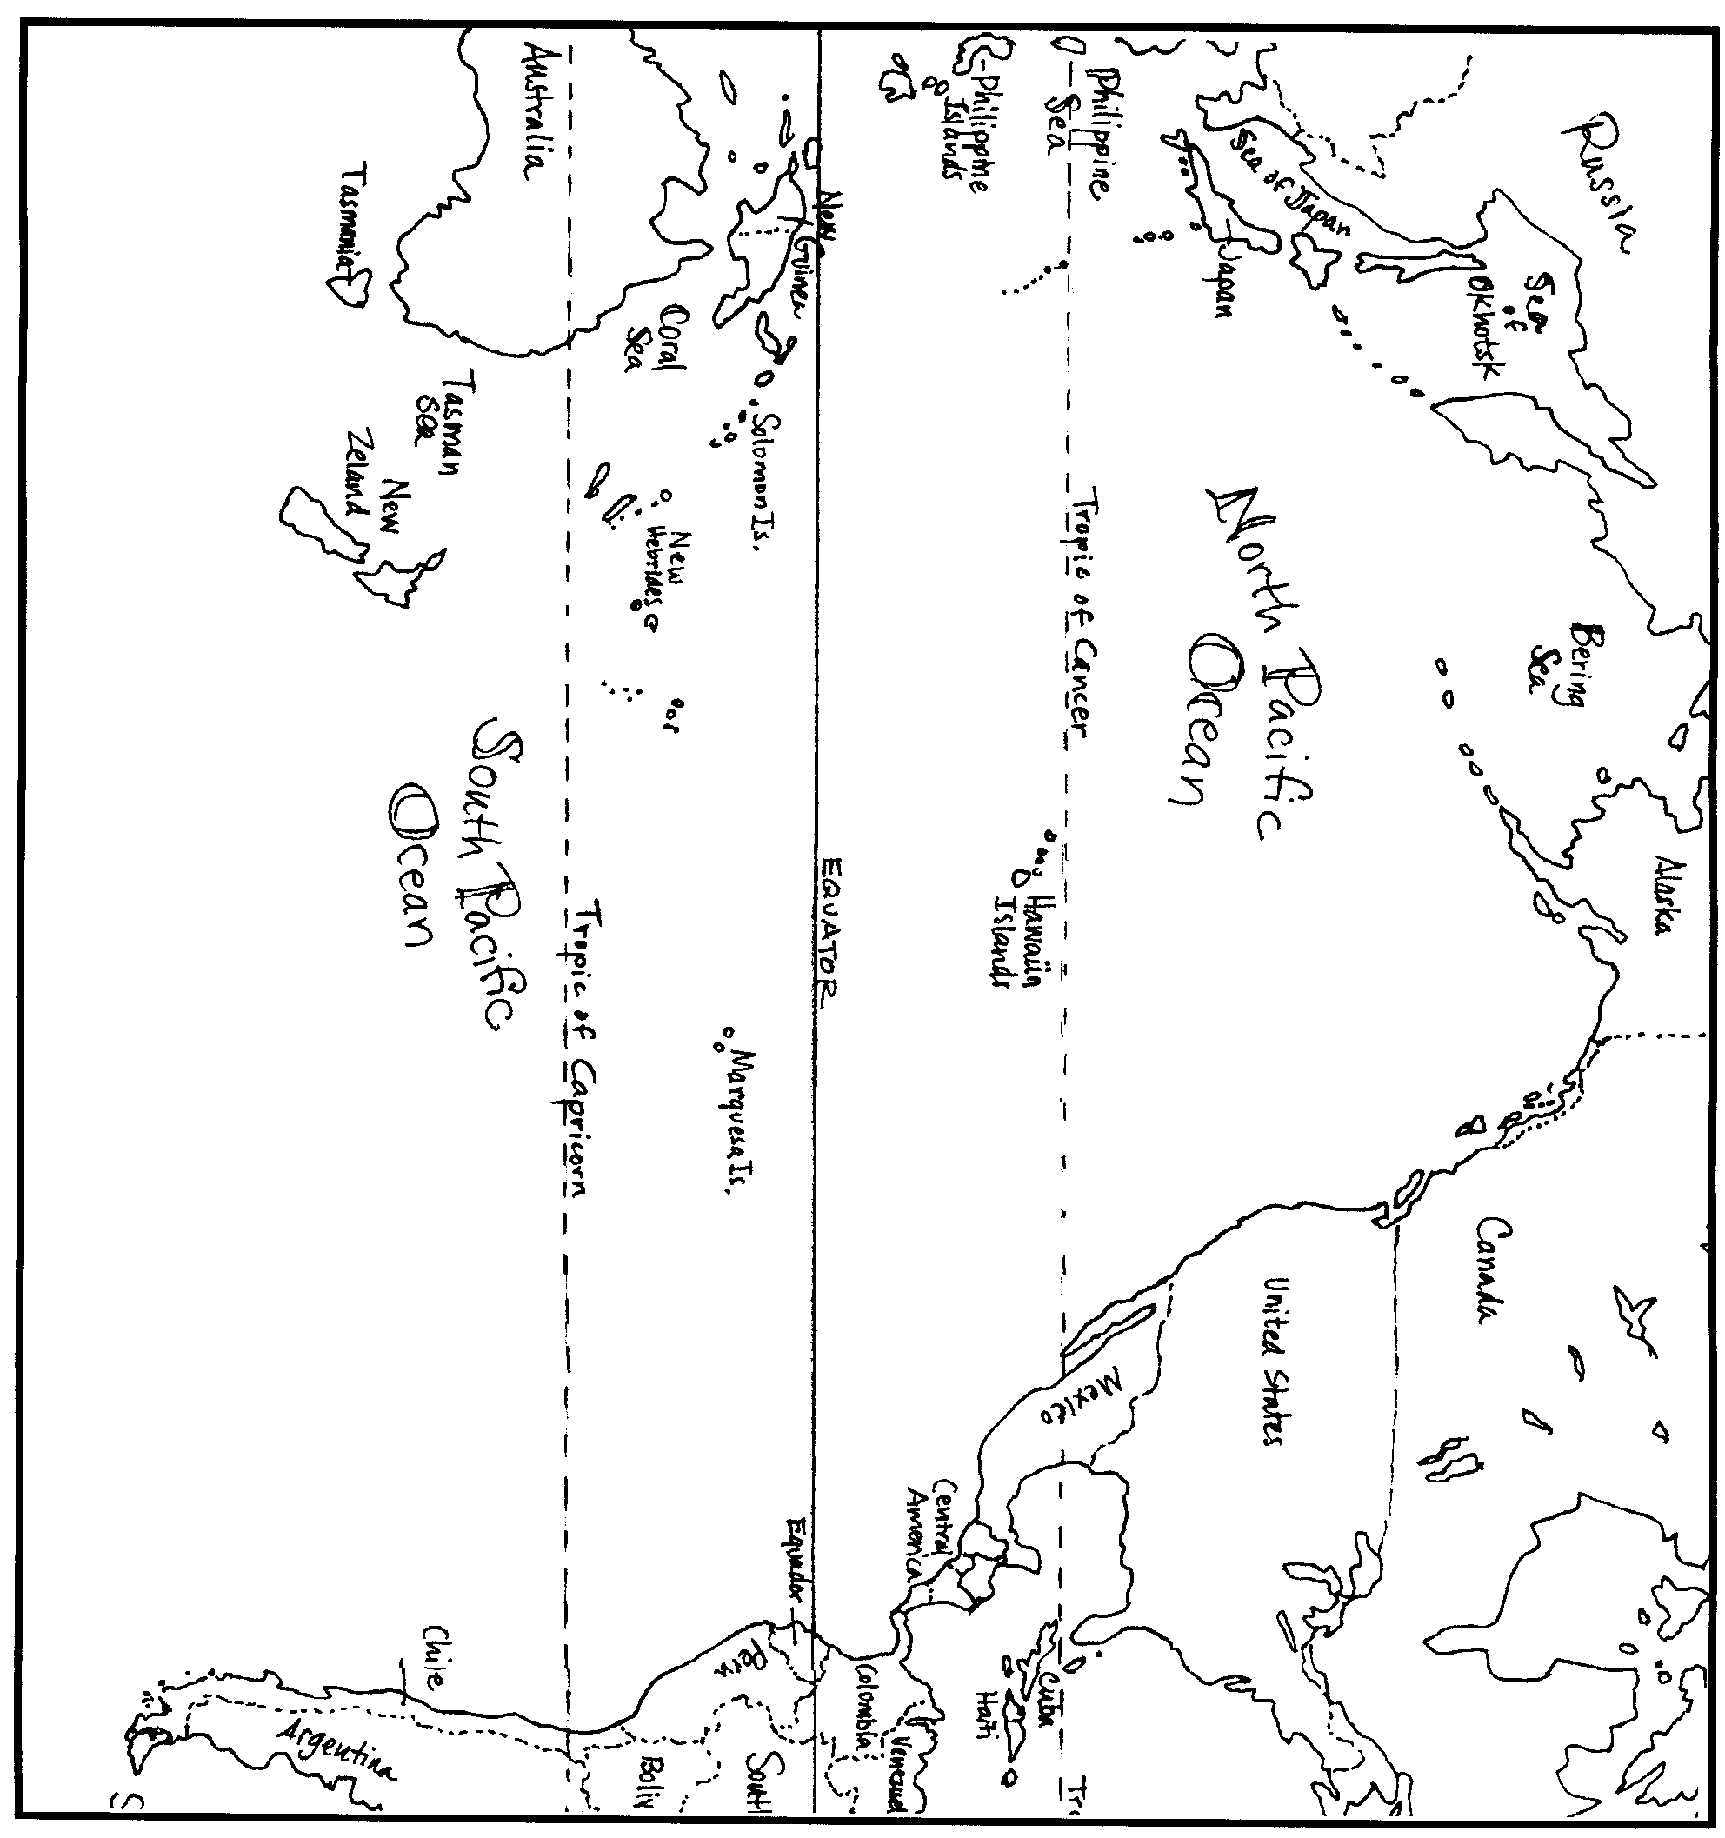
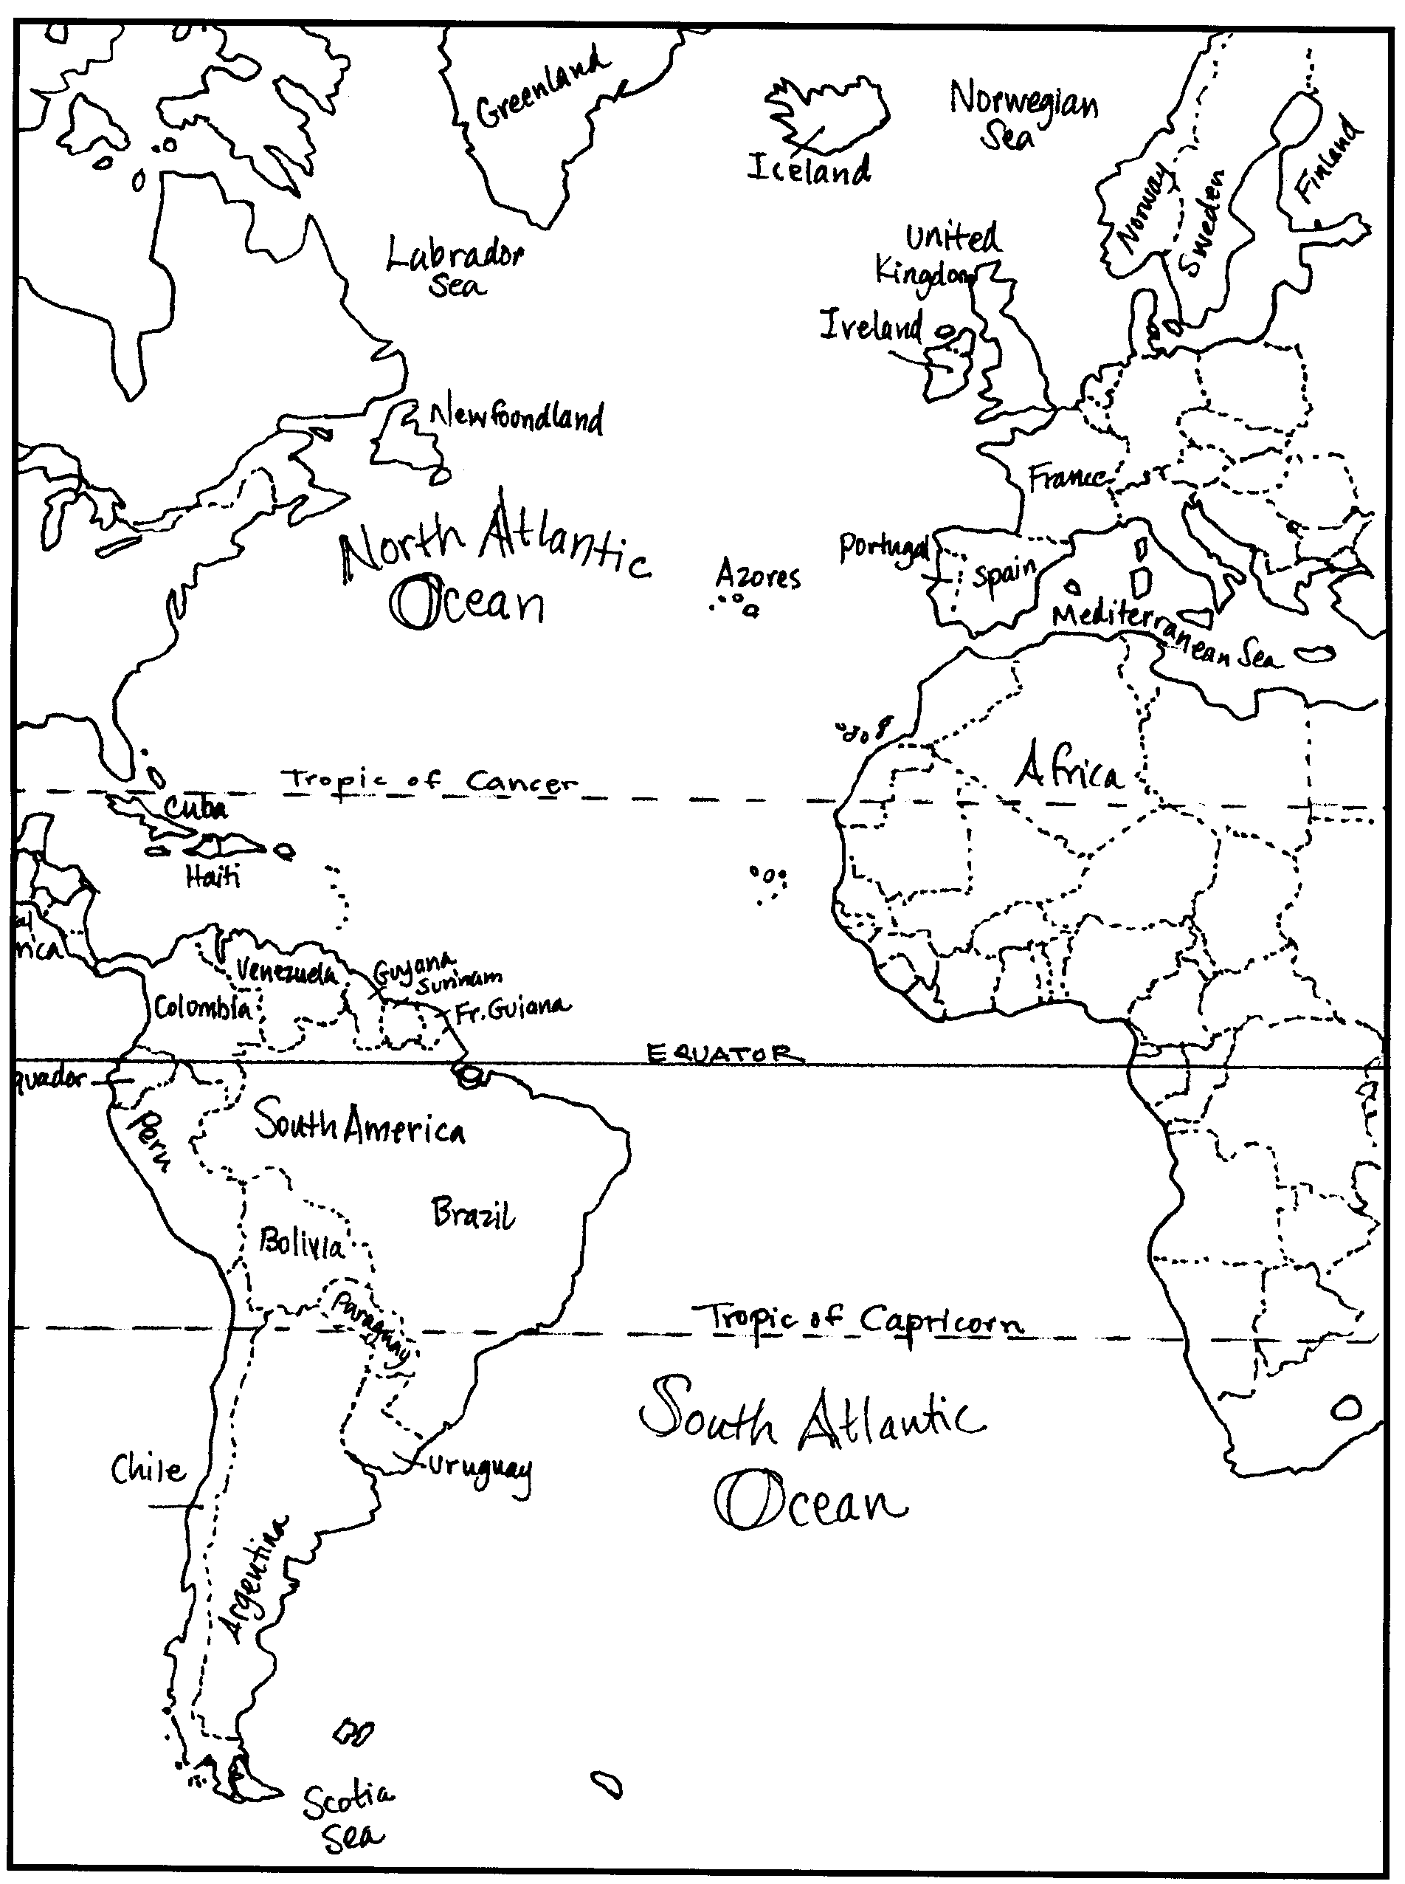
Atlantic Ocean
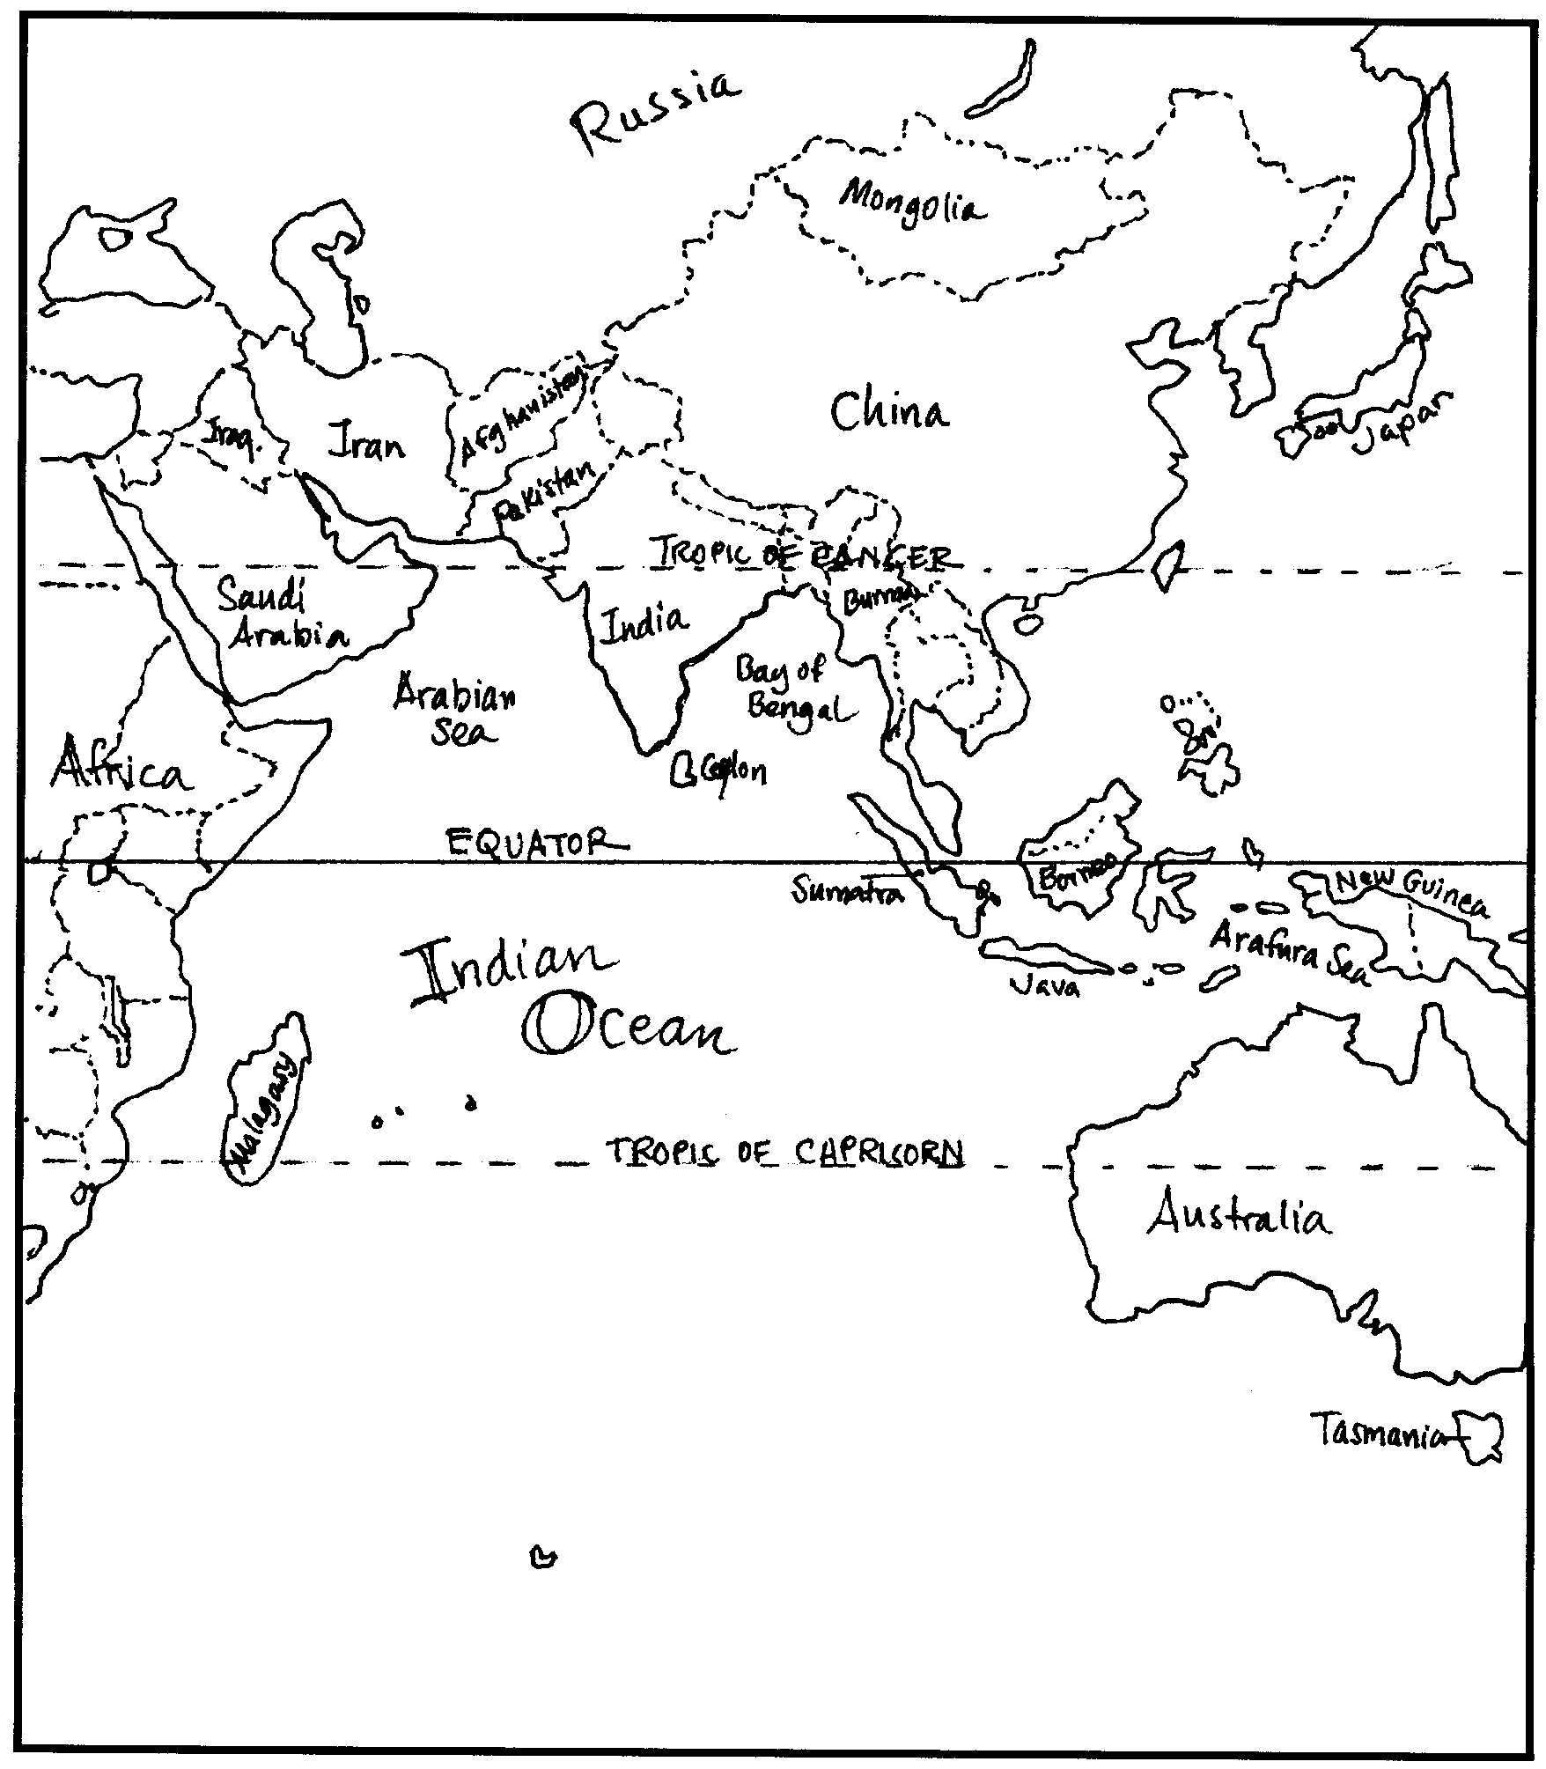
Indian Ocean
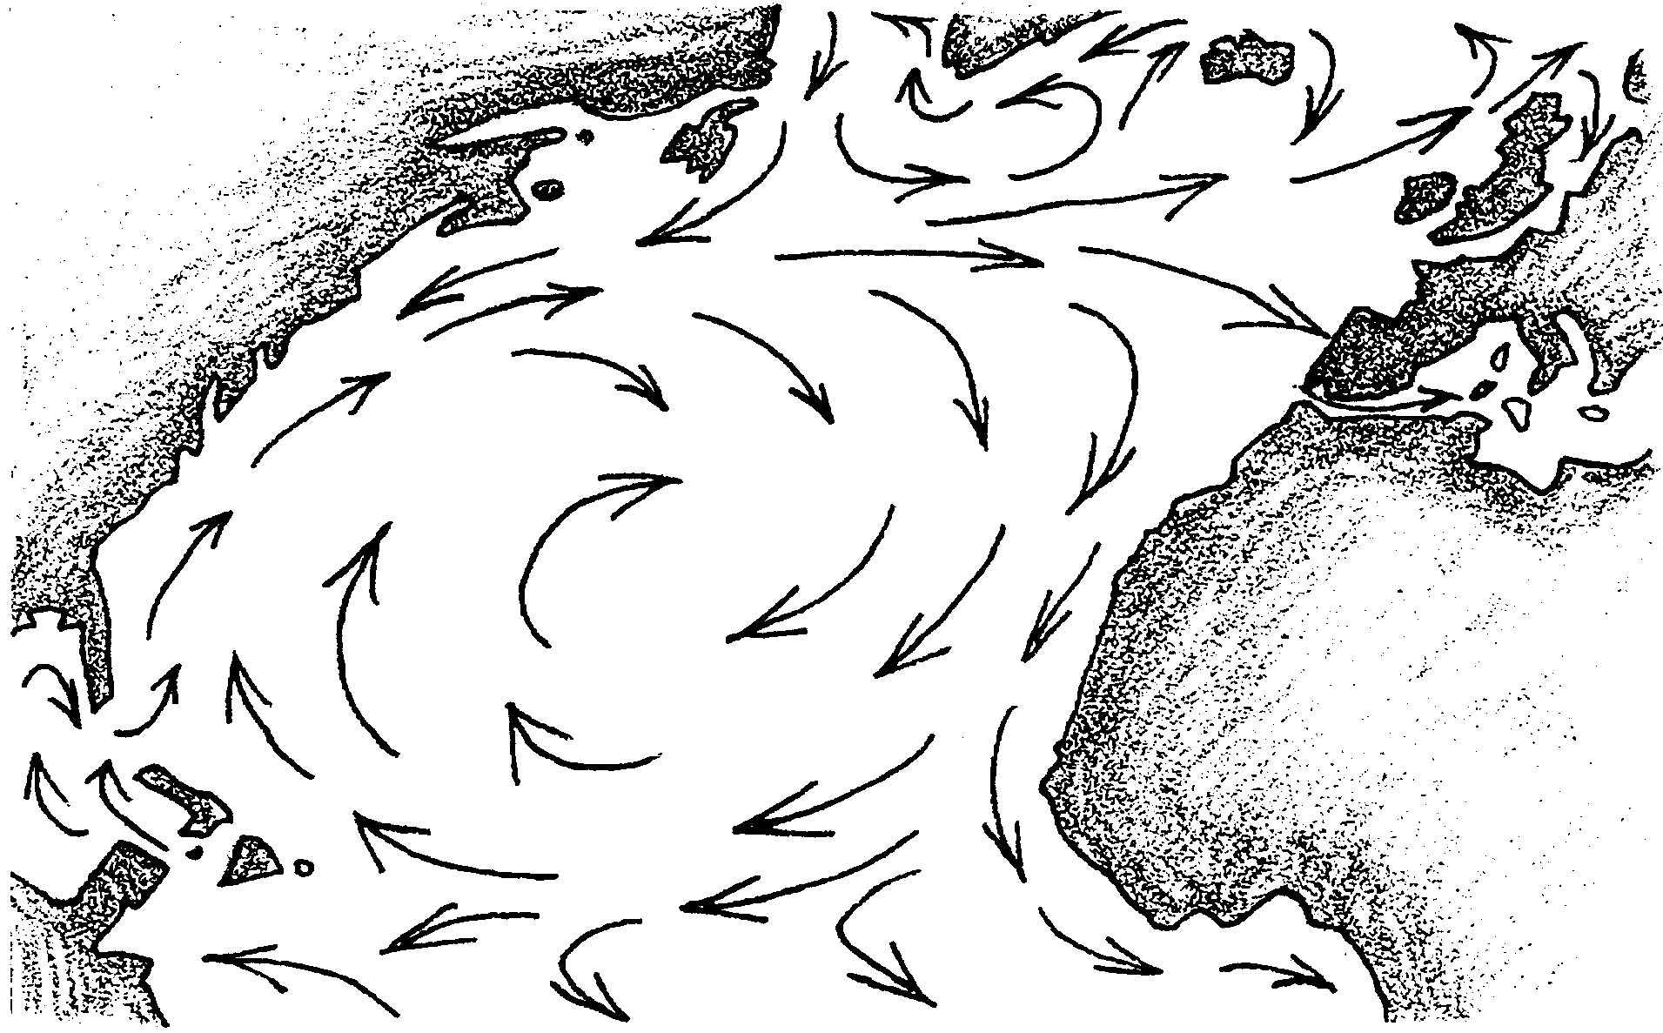
Mapping Ocean Currents

Ocean surface currents greatly influence all kinds of human activities, sometimes without our realizing it. The climate of every coastal region is absolutely dictated by the ocean currents that flow past it. Ships at sea use currents to help them make quicker and less expensive ocean crossings.
The location and direction of flow of ocean currents is determined by the uneven heating of the earth and by the rotation of the earth on its axis. A map of ocean currents reveals some of the patterns that develop as these currents move heat from the equator to the poles.
Currents are described in terms of their location, their speed of flow, or drift, and their direction of flow, or set. In this activity you will use several resources to map some major ocean surface currents. Then you will use the maps to help you understand how currents influence our lives.

To complete this activity you will need:
• maps of the world’s ocean
• two colored pencils, red for warm currents and blue for cold currents
• reference materials
Directions:

1.Use the reference materials to determine the location, set, and relative temperature (warm or cold) of each current.

2.Place one arrow on your map for each current. Use red for warm currents and blue for cold. Place an arrow head to indicate direction of flow.

3.If you find that two sources disagree on the location or temperature of a current, try to find a third source that will resolve the problem. Currents do change location and strength during the year, so maps will not necessarily agree.

4.Remember that the entire ocean is in motion. The head of one arrow should reach very close to the tail of the next arrow on your map. The currents that appear on any map are just the names given by humans to portions of the overall circulation patterns in the ocean.

5.Sometimes currents have more than one name. These are listed below with the preferred name first. You may use either name when labeling your map.

6.When you have completed the maps, use them and the reference materials to help you answer the interpretation questions that follow.

Map the following currents:

Atlantic Ocean:
Antarctic Circumpolar (West Wind Drift) C.
Antilles (Bahamas) C.
Benguela C.
Brazil C.
Canary C.
East Greenland C.
Equatorial Counter (Guinea) C.
Falkland
Florida C.
Gulf Stream
Irminger C.
North Atlantic Drift
North Equatorial C.
Norway C.
South Equatorial C.
West Greenland C.
Indian Ocean:
Aghulas C.
Antarctic Circumpolar (West Wind Drift) C,
Equatorial Counter C.
Monsoon Drifts
Mozambique C.
North Equatorial C.
South Equatorial C.
West Australia C.
Pacific Ocean:
Alaska C.
Antarctic Circumpolar (West Wind Drift) C.
California C.
Davidson C. (optional)
East Australia C.
Equatorial Counter C.
Humboldt (Peru) C.
Kuroshio (Japan) C.
North Equatorial C.
North Pacific C.
Oyashio C.
South Equatorial C.

Analysis Questions

1. Explain why a current found near the equator might be considered a cold current, while currents found far from the equator, like the North Atlantic Drift, are considered to be warm currents.

2. Notice that ocean waters move in large, circular patterns called gyres. How does the pattern of the gyre in the Northern Hemisphere compare to the pattern for the gyre in the Southern Hemisphere?

3. Compare the latitude of London to the latitude of New York. Which is farther north? What kind of winter weather might you expect that far north?

4. Given that London has generally mild winters with lots of fog, but not much ice and snow, how do you think the North Atlantic Drift affects the climate there?

5. How does the direction of surface currents compare to the direction of the global winds? Why don’t the currents follow the exact same paths that are followed by the winds?

6. After making careful observations of the location of both warm and cold currents, write one or two sentences explaining the affect that surface currents have on the temperatures of the poles and the equator.

7. What set of global winds is responsible for the strong and steady Equatorial Currents? What is the name given to the phenomenon that occurs when these currents are weakened and disrupted?
8. Make a generalization about current temperatures along: (a) the east sides of the continents, and (b) the west sides of continents.

9. What are the four currents that make up the South Pacific gyre?

10. In what ways do ocean surface currents influence your life?

