Creating Currents
Lesson by Eugene Williamson, Whitford Intermediate School, Beaverton, Oregon.
Adapted here from FOR-SEA Curriculum, Grades 7-8.
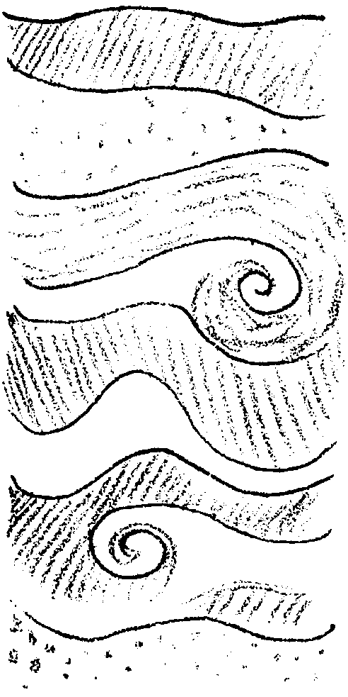

Key Concepts
1. Differences in densities due to variations in temperature and/or salinity create water currents.
2. Warm water tends to rise while cool water tends to sink, creating currents.
3. Fresh water tends to rise and salt water tends to sink, creating currents.
4. Wind helps drive ocean currents.
5. The rotation of the earth about its axis moves ocean currents in circular patterns.

Background
The oceans are constantly moving. The earliest sailors quickly discovered that their navigation had to compensate for the pull of currents on their vessels.

Recent oceanographic expeditions and measurements from satellites now give us a global picture of these great rivers of water, the ocean currents. But what might cause these global currents?

The three main causes of currents in the ocean are:
• wind
• earth’s rotation
• density differences in ocean waters

Large-scale water movements occur everywhere in the ocean. The surface currents are driven by winds, while deep subsurface currents are driven by density differences in the ocean water. Ocean currents transport heat from the equator toward the poles, thereby partially equalizing surface temperatures over the earth. Ocean currents, winds, and weather patterns are closely linked. Currents can affect the food chain by transporting nutrients and plankton from one area to another. Fish congregate in high plankton areas to feed, attracting larger predators such as tuna, birds and marine mammals (and humans!).

Wind Driven Currents

The ocean and atmosphere of the earth are heated unevenly by the sun. More heating takes place at the equator than at the poles. This difference in temperature at the equator and the poles causes warm air to rise along the equator, and cold air to sink at the poles. Rising and sinking air creates wind, as adjacent air masses move in response.
Wind blowing over long distances of ocean tends to drag surface water along with it. The rotation of the earth causes oceanic wind patterns to create large circular currents, or gyres. The “bending” caused by the earth’s rotation is called the Coriolis Effect. In the subtropical regions of the northern hemisphere the gyres flow clockwise, in the southern hemisphere subtropical gyres flow counterclockwise. Smaller subarctic gyres show a reversed pattern. In the subarctic regions of the northern hemisphere the gyres flow counterclockwise, in the southern hemisphere subarctic gyres flow clockwise. Washington State is located where the North Pacific Current splits with part flowing southward to form the eastward edge of a clockwise subtropical gyre and part flowing northward to form the eastward edge of a counterclockwise subarctic gyres. These large wind-driven currents are year-around, constant patterns.

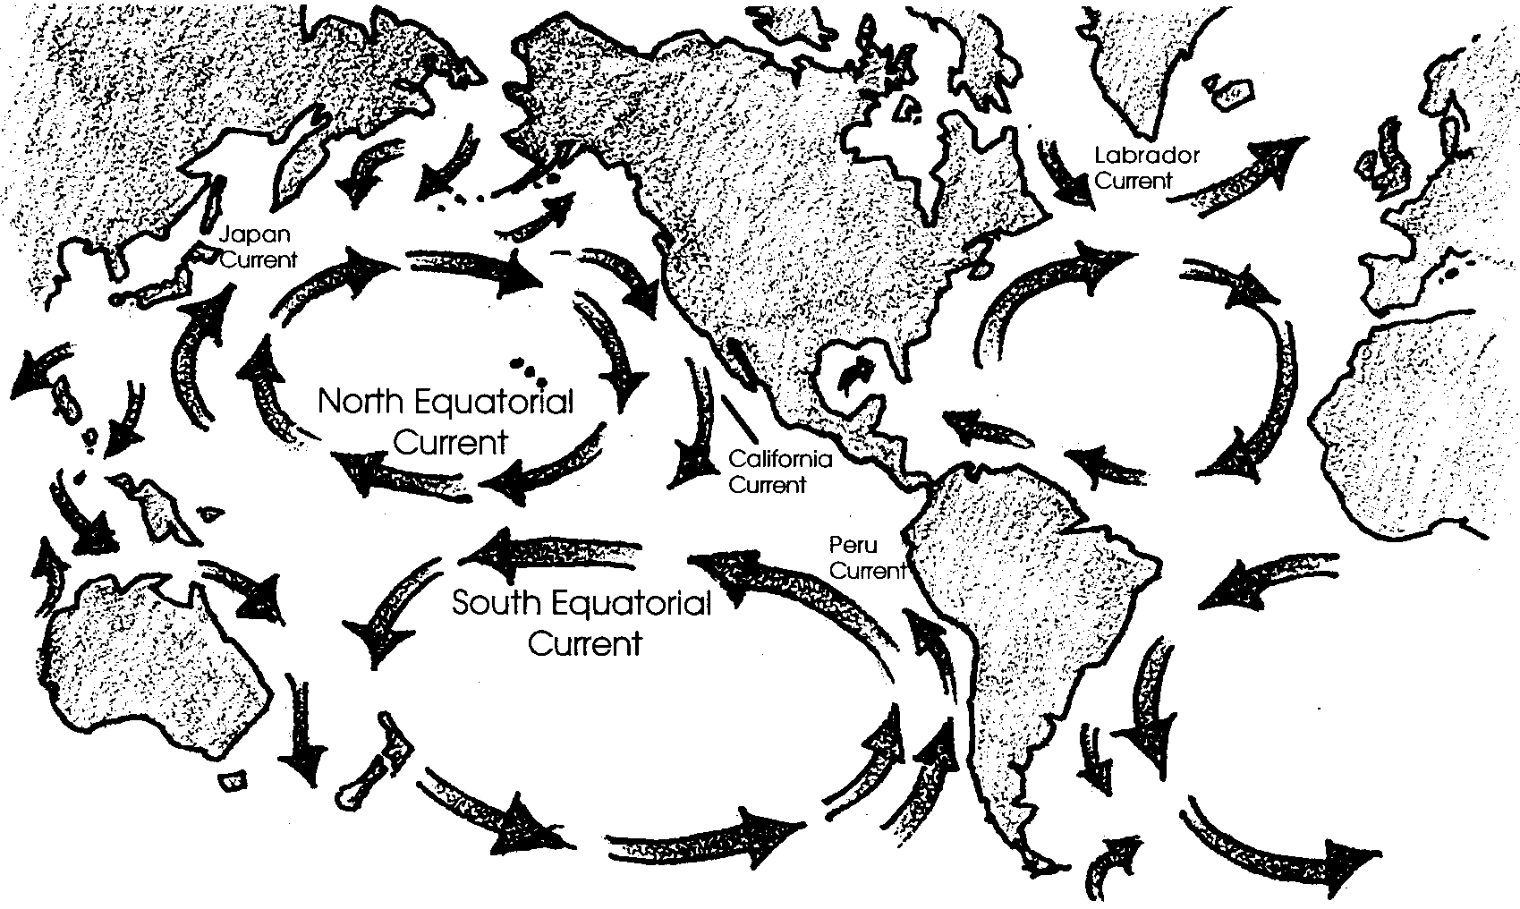
Density Currents

At the North and South Poles, ocean water is cooled by the polar ice caps and by the lack of sun. Very cold, dense water sinks and flows along the bottom of the ocean toward the equator. Antarctic bottom currents flow past the equator into the northern hemisphere. These polar bottom currents are very slow moving. It may take 600 years for Antarctic bottom water to reach into the northern hemisphere. This very cold water is full of oxygen and is the primary source of oxygen in the deep sea.
At the equator, waters warmed by the tropical sun rise, expand, and flow out away from the equator. Remember that the atmosphere is moving in much the same pattern, also due to unequal heating by the sun.
On a somewhat smaller scale, some important coastal currents are due to density differences between the less dense waters in the runoff from rivers and estuaries and the more dense ocean water. As a reminder that both density and wind play a role in the currents, these coastal currents are frequently steered by nearshore winds. For example, the plume from the Columbia River estuary flows northwestward in winter (mainly southerly winds) but toward the southwest in summer (northerly winds).

Materials
For class of 32:
Part I
• 1 aquarium filled almost full with room temperature tap water (the demonstration may be more easily seen if you tack a sheet of white paper across the back of the aquarium)
• 3 or so small spheres or other objects with densities near that of fresh water, available from scientific supply houses; it might add extra interest if 1 or 2 float in tap water and 1 rests on the bottom of the aquarium
• 750-1000 ml of cold (0-5° C) salt water colored blue
• 750-1000 ml of warm (35° C) fresh water colored red submersible heaters coil heaters (or 3 one-cup coffee heaters)
• 3 thermometers
Part II
• fan
• aquarium and water from above
Part III
• kitchen lazy Susan turntable
• pie plate or similar dish
• water
• food coloring
Teaching Hints

In “Creating Currents” students will see a model how waters of differing densities rise or sink, setting up patterns of water movement. Use of a kitchen turntable demonstrates how a spinning motion sets water moving in circular patterns.
These demonstrations are meant to capture the students’ interest and give them concrete experiences so that later studies of ocean currents make more sense. Students will develop an understanding of how density differences, wind, and the earth’s rotation cause currents.
It is not necessary to give the students a great deal of background information before performing the Creating Currents demonstrations. The demonstrations will puzzle the students and get them thinking about possible explanations for what they see. Accept student responses. If you give a “right” answer, students will stop exploring, asking questions, and being curious about what they see. After the students have developed explanations for the currents in the aquarium, have them use their ideas to predict and explain ocean currents.

Procedure
The following lesson plan requires that students discuss what they are observing and work in teams. It includes questions you ask the class orally as you do the demonstration. If you would prefer to have students complete a written list of questions, simply write the questions in the following text on an overhead or copy them on to a worksheet.

Part I - Density Currents

1. Begin with the aquarium nearly full of room temperature fresh water (about 20° C). Note: Even though the aquarium models the ocean, the demonstration calls for fresh water to make lab set up easier and to reduce hazards of using electric heaters near water. You may mix a salt solution if you wish. You will notice throughout these instructions that the temperatures and salinities are not realistic. They are very exaggerated to speed the process and assure visible results.
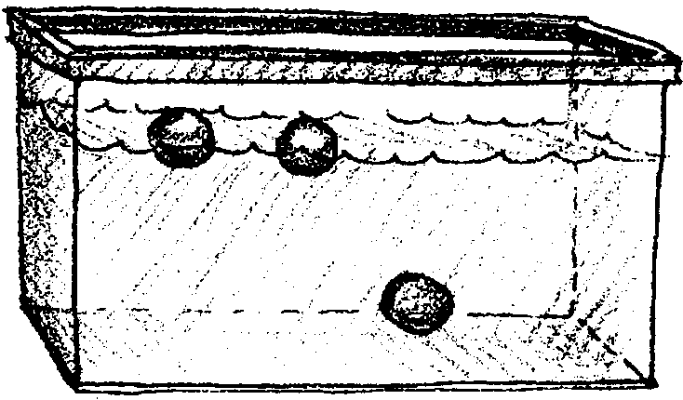
Place the two floating spheres and the one sinking sphere in the aquarium.

Ask the students, “Why do the spheres behave as they do?” Accept a wide variety of student responses. If they have studied density before, they may be able to explain that the floating spheres have a density less than that of the aquarium water and that the sphere at the bottom has a density greater than that of the aquarium water.

2. Ask the students to imagine that the aquarium of water represents the oceans (the students don’t need to know that the water came from the water faucet). Explain that you are going to model the sun heating the surface of the ocean by placing heaters in the upper layer of the aquarium.

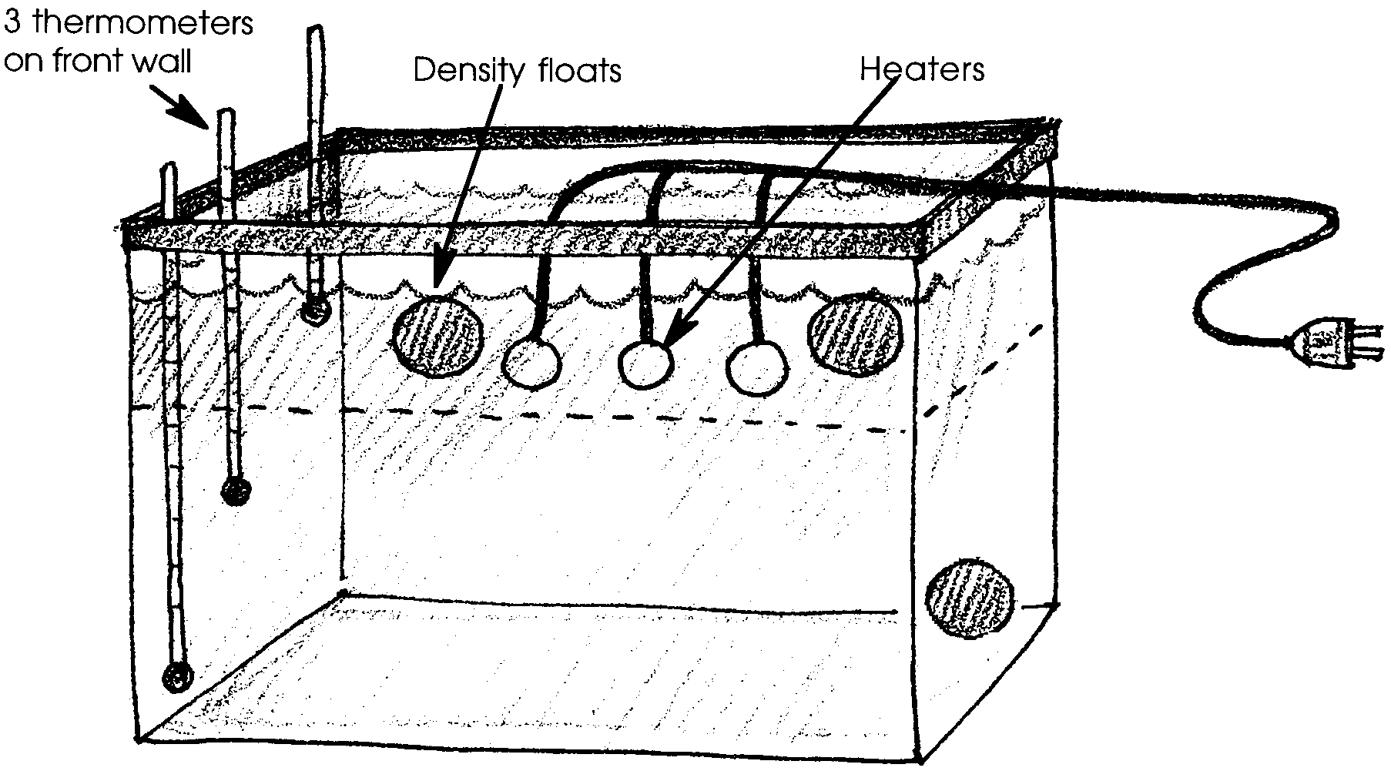
3. Place three thermometers in the aquarium so that students can monitor the water temperature at the bottom, mid depth, and at the surface.

4. Place the submersible heaters at a convenient depth of about 3 to 5 inches below the surface. Leave the heat on for 15-20 minutes or until the surface layer exceeds 40° C. This is much warmer than the ocean, but it assures a successful demonstration and can lead to later discussion of how much heat is enough to create currents.

5. While the water is heating, have the students work in teams of 2-4 to draw on the board, overheads, poster-sized paper, or their own papers what they predict the aquarium set up will look like after the upper layer has been heated for 20 minutes. You may want to randomly choose students to explain their predictions. If so, warn teams of the need to discuss their predictions so that all members understand their drawings of their predictions. Use any time remaining to ask selected students to explain their predictions.

6. Turn off and remove the heaters when the surface water is above 40° C. Unplug the heaters BEFORE removing them from the water. Ask the students where the spheres are now and what they think caused them to change position.

7. Show the students your container of blue-colored, cold, salty water. Ask them where on the earth cold, salty water would exist. (This water would form in ocean water, near the poles.) Ask them to predict how it will behave when you add it to the aquarium.
Pour the water in. You and your students may observe an internal wave and the movement of the bottom sphere. Ask the students to explain why the bottom sphere is no longer resting on the bottom of the aquarium. (The cold, salty water now at the bottom of the tank is more dense than the sphere. The sphere floats in that cold, salty water.)

8. While the aquarium settles, show the students the red-colored warm, fresh water. Ask them to imagine where warmer fresh water would form naturally on the earth and enter the oceans. (This water would come from tropical rivers.) Where do they predict the red water will go?
Pour the water in. Where does the red water go? How does it affect the floating spheres? (The red water ultimately will rise to the surface and decrease the surface water density causing the spheres to sink.)

9. Conclude the density current demonstration by asking students to draw or write a summary of what they learned about what determines the level of a certain type of water in the ocean.

Part II - Wind Driven Currents

10. It is possible to set the layers of water in motion by having several strong-winded students blow across the surface of the tank or by blowing across the surface with a fan. The surface water will begin to pile up away from the wind source and some may begin to sink. The deep water layer will begin to move along the bottom toward the wind source. This will not turn into an actual current gyre, but students will be able to see the beginning of a current and get some concrete sense that wind also creates water motion.

Part III - The Effects of the Earth’s Rotation on Ocean Currents

This demonstration is short and simple. It would be easy for students to do if you have enough materials. If you have only one or two turntables, this could be a station to try during another assignment.

11. Place a pie dish on the kitchen turntable and fill it nearly full with water. As an optional extension, form land forms in the dish with plasticine modeling clay.

12. Add a drop or two of food coloring to the water. Ask students to predict where the food coloring will go as the dish is rotated.

13. Now, gently rotate the turntable and observe the path the food coloring takes. It will travel in a circular pattern.
Conclude “Creating Currents” by asking students to draw or describe orally or in writing how temperature, salinity, wind, and the earth’s rotation move water.

a. When two bodies of water with different water temperatures meet, where do the two types of water move?

b. When two bodies of water with different salinities meet, how do they move relative to each other?

c. When wind blows across the ocean, how do the surface and deep ocean water move?

d. What kind of water patterns are caused by the spinning of the earth?

Key Words
Coriolis Effect - the apparent change in direction of objects moving across the earth’s surface, caused by the earth’s rotation , to the right in the Northern Hemisphere and to the left in the Southern Hemisphere
current - in this case, a body of water moving in a certain direction within a larger body of water
density - mass per unit volume
gyre - a pattern made of four or five currents that dominate the circulation pattern of the ocean in each hemisphere, clockwise in the Northern Hemisphere, and counterclockwise in the Southern Hemisphere

Extensions

1. Have students reproduce these demonstrations in their own quart jars. Consider having students who have experienced the demonstration present it to younger students or other classes.

2. Have students investigate how much difference in temperature or salinity is necessary to cause density flow.

3. Use a similar set up to try to produce a realistic thermocline. If the water is heated by sunlamps from above, the water does not develop a thermocline. Why not?

