World Conference on Global Warming

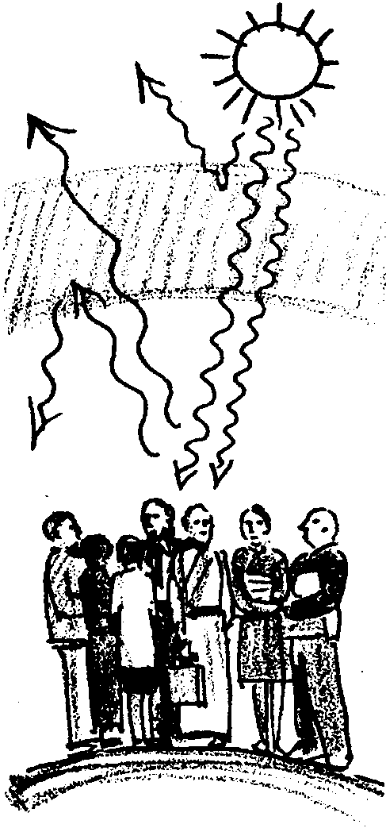
Key Concepts
1. Seemingly small changes such as the increase in world temperature by a few degrees can have wide ranging impacts, as primary effects bring about secondary changes which can bring about still further reaching consequences.
2. Global warming is an issue which will affect everyone on earth, but depending on their circumstances, people will differ in how they perceive the issue and how they will be impacted by its effects.
3. We can best adjust to changes caused by global warming if people who view the issue from different perspectives can work together to find mutually agreeable solutions.

Background
The World Conference on Global Warming provides students with an opportunity to synthesize what they have learned about the greenhouse effect with what they think and feel personally, and to consider how they should act as socially responsible citizens. It is presented here as a three-step lesson to take place over a three-day period.

Materials
Effects Wheel Activity
For each student:
• “Possible Effects of Global Warming” sheets (1 or 2 homework articles)
c
For each group of 4–6 students:
• 5-7 “Descriptions of Special Interest Groups” sheets
• 4 “Effects Wheel” sheets
• 1 pad Post-it notes
• red and green marking pens, one each
• set “Flash! Messages for . . .” sheets
For the class:
• 1 sheet butcher paper and marking pen (optional)

World Conference
For each group of 4–6 students:
• 5 sentence strips
• 1 or more marking pens

Teaching Hints
Day One
1. Tell students that as the final part of this unit they will conduct an imaginary world conference to discuss how people might cooperate to decrease the greenhouse effect, or cope with the changes it causes. In the conference, groups of students will represent people from various countries and other interests.

2. Divide the class into five groups (or allow the students to choose the group they will represent) as follows:
Automobile Manufacturers
Island Nations
Agriculturists
Conservationists
Wood and Paper Products

3. Organize tables or desks so students can meet in the five small groups. Give each student a copy of the description of her special interest group, and leave one extra copy within each group.

4. Briefly describe each of the interest groups for the entire class.
Explain that the World Conference has been called to allow each of the groups to present their point of view, and to look for possible solutions that are acceptable to some or all of the other groups.
Emphasize that it will not be a debate--everyone is affected by global warming, so no one is really “for” it. Instead, the task is to find out who is affected and how, and work out ways of doing something about it.

5. Tell groups to appoint a reader, who will read the description and questions aloud to the group, and a recorder to write down questions on the page. Then allow the groups 10-20 minutes to read the handouts and to discuss and record their ideas.
6. Five minutes before the end of the session, ask if there are any questions about the conference. (Tell the class that they will have some more time in the next session to plan exactly what they are going to say at the conference.)

7. Collect the writing from each of the groups so you can provide feedback during the next conference planning period.

8.Hand out the reading assignment, articles on “Possible Effects of Global Warming.” Instruct the class to read these before the next session, because they will find the information helpful in their planning for the World Conference.

Day Two
Getting Ready:

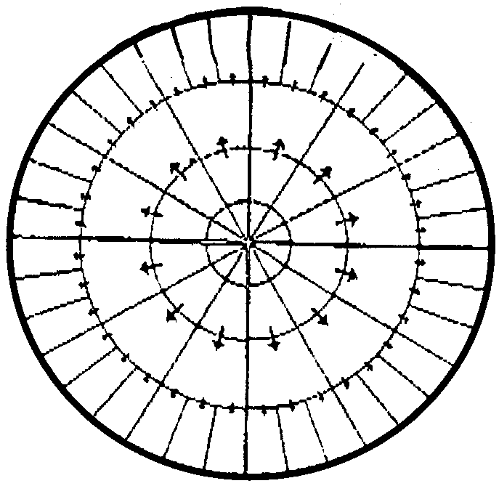
1. Photocopy the master sheet for the Effects Wheel. You will need four copies per group of four students. Cut the copies along the dotted lines so they are square, eliminating the extra paper outside the quarter circle on the long side of the paper. Join the four sheets to make one large Effects Wheel, or have students do this when they arrive.

2. Read through the students’ notes on their interest groups from the previous day and make comments and suggestions on what other ideas and issues they might consider in preparing their presentations.

3. Photocopy and cut apart one set of “Flash! Messages for . . ” , so you can give them to the appropriate groups near the end of the session.

Effects Wheel Activity:
1. Ask students to recall predictions made in the homework reading article about the effects global warming might have. As students respond, make a list on butcher paper or on the chalkboard. If some effects named by the students follow from other effects, show the relationship with an arrow. For example:

polar caps melt → sea level rises → coastal areas flooded

Point out that some of the effects listed occur as a result of other changes that happen before them--there is a “chain reaction” of effects. This can make it difficult to predict all of the effects of global warming.

Tell the class that most scientists investigating the greenhouse effect now agree that if we do not change our ways of using energy, the average global temperature will increase, although there is disagreement about how much. Estimates range from 2°F to 9°F by the middle of the next century.

Inform the class that one way of thinking about the long term effects of a change, like a 5°F rise in the world’s temperature, is to construct an Effects Wheel--and that is what they are going to do in the next 20 minutes.

Explain that they are going to work in the same groups they worked in during the previous session, so that they can look at those effects of global warming that are most important to their own interest group.

Show students the Effects Wheel, and explain that you want each group to write “+5°F” in the center of the center circle, to represent a 5°F rise in the average global temperature.

Explain that each group should then choose four primary effects of global warming from those listed on the board, and write each of these in the segments adjacent to the inner circle. (If necessary explain that a primary effect is one that occurs as a direct result of the increase in global temperature; e.g., “polar ice caps melt”.)

Point to one of the four segments of the second circle and explain that this is where they should write an effect which comes about as a result of one of their primary effects (e.g., “sea level rises by 3 feet”). Explain that the effects of this sea level rise should be written in the segments just outside this inner segment. Effects that would arise from those events would be written in the next outer circle, and so one.

Instruct students to write all the effects on individual “Post-it” notes which they will stick on the Effects Wheel, rather than writing directly on the wheel. This will allow them to easily change their ideas as they want. Demonstrate how to write an effect on a post-it and stick it to the wheel. (Note that post-it tablets can be pulled apart so that several students can write at the same time.)

Remind students that they will hold a “World Conference on Global Warming in the next session. In choosing which primary effects to put on their Effects Wheel, they might consider those which will be of greatest interest to the people they represent.

After the demonstration, organize the class into conference preparation groups. Distribute to each group one blank effects wheel, one pad of post-its, and pencils as needed.

While groups work, circulate among them and assist as the need arises. After about 15 minutes, give each group one red pen and one green pen. Ask them to look at the effects listed on the outer circle of the wheel and to circle in green those outcomes they think are positive. Have them circle in red those outcomes that are negative, and in black pencil those outcomes that are neutral. (Outcomes which are both positive and negative should be circled with both green and red.)

Sharing Completed Effects Wheels:
When all groups are finished, have each group report one of the primary effects they chose and one positive and one negative outcome of this primary effect. Also ask each group to report how many positive, negative and neutral outcomes resulted from their Effects Wheel. Make a table of these numbers as the groups report them. Ask the class to decide whether, on the basis of their predictions of the effects of a 5°F rise in global temperature, the outcomes would be mostly negative, mostly positive, or a combination of both.

Ask each group to post their Effects Wheel on the wall of the classroom, and invite students to look at each other’ Effects Wheels for ideas their group may not have considered. (Depending on the dynamics of your particular class and the time available, you may wish to have groups send only one representative to inspect the Effects Wheels while the others are preparing for the conference.)

Preparing for the World Conference:
Return each group’s notes from the previous session, along with your comments and suggestions. Tell them to look over these notes, adding any new ideas that may have occurred to them from class discussion or from their own Effects Wheels.

Tell students that each group needs to prepare itself to do the following things at the World Conference:

a. state the group’s position on dealing with global warming,

b. ask questions or make statements about other group’s positions,

c. suggest solutions that might be acceptable to most groups.

Remind students that the main purpose of the Conference is not to find someone to blame for global warming, but rather to find out who and what is affected, and what can be done by acting together.

Hand out “Flash! Messages for . . . ” slips to the appropriate groups. These are designed to add some excitement to the conference preparation session, and to suggest some new ideas. Tell the students that they do not need to use any of the ideas expressed in the messages if they do not want to do so.

During this group preparation period, circulate to offer suggestions. Some teachers have allowed groups to send representatives to lobby other groups to raise support for their own solutions.

Five minutes before the end of the session, remind students that they should have clear answers for all questions, and that they should decide on a strategy for letting all members of the group share in the presentation or in responding to other groups’ questioning. You may also want to designate an order in which the groups will present their ideas at the World Conference.

At the end of the period you may want to collect all groups’ preparation notes to read and add further suggestions.

Day 3, Conference Day

Getting Ready:
Organize a space on one wall of the room where interest groups can post their solution slips.

Organize the seating in the room into a conference style arrangement, such as a circle or semicircle.

You or the students may want to do some extra preparation for the conference such as a banner to hang in the classroom announcing the “World Conference on Global Warming,” and name cards for each of the groups.

When students arrive
Invite students to be seated in their interest groups for the conference. Hand out their notes from the previous session, if you have collected them.

Introduce the session along the following lines: “As you are aware, in the last two sessions, a number of interest groups have been working to prepare their points of view to present to the World Conference on Global Warming. Today we have invited these groups to this international event, to hear their concerns about global warming, and to see if we can find some common solutions to this worldwide problem. So let me go around to the groups in turn so you can tell us who you are.”

After each group has introduced itself, announce: “Now we will give each group five minutes to finalize their statements to the conference, and their proposed solutions to either cope with a warmer world or to reduce the amount of carbon dioxide in the atmosphere.

Instruct the groups to write each suggested solution on a separate sentence strip. Tell them to choose several people in their group to present their statements and suggestions.

Hand out five sentence strips and marking pens to each group. As the groups are preparing, circulate to answer questions and offer encouragement. After five minutes, call the students back together to make their presentations to the conference.
Interest Groups Make Presentations (25 minutes)

Explain the procedure by saying: “Each group will take no more than three minutes to make their statements and suggest solutions. Immediately following each group’s presentation, I will allow two additional minutes for questions and comments from other groups. I would ask that you state your points of view courteously, because one of the main purposes of this conference is to see how we can work together.“

As possible solutions are suggested, sentence strips should be posted in the area set aside for that purpose.

At the conclusion of each presentation, ask if there are any questions or comments. Try to limit the time for each presentation, including the discussion, to a total of 5 minutes.

After all groups have presented, thank each group. Point out that each group has a different approach to the issue of global warming (you may want to summarize these for the class) but that you are confident that the conference will be able to find some actions that all or some of the groups can agree to.

Discuss Possible Solutions
Ask the assembled delegates whether they think any of the solutions are acceptable to all of the interest groups, or at least most of them. Move these sentence strips to a central location for further discussion.

Lead a discussion about the relative merits of these solutions. (You may want to assist the class in arriving at a short list of three or four amended statements that are likely to be widely acceptable.)

Taking each solution in turn, give the groups 30 seconds to confer about whether or not the people they represent would vote “Yes,” “Maybe,” or “No.” Take one vote from each group, and record the results in a column next to the solution.

Announce the “winning solutions” as those that were agreed on by a substantial number of groups. Suggest that in a real World Conference, debate might go on for weeks or months to change ideas and modify proposals so they would be acceptable to everyone.

Inform the class that the conference is now at an end. Tell them, “What I want you to do now is to leave behind your point of view as a member of an interest group and look at the solutions before us as an individual. What do you personally think about the main solutions suggested? As a class, we are going to take a second vote on each of the solutions, to see how acceptable they might be to us.”

Tell students to vote on each solution as follows:
If you strongly agree--hold both hands up.
If it may be a good idea--hold one hand up.
If you’re not sure--fold your arms.
If it’s a bad idea--signal thumbs down.

Summarize the class response to each solution in a few words. Point out that a majority vote on issues of the environment may not necessarily be the best way, and is definitely not the only way, of making decisions. For example, in some cases, when a small group of people in a community, or a small nation in the world, is more adversely affected than others, steps other than a majority vote may be needed to prevent serious damage.
In other cases, standards already set by international or federal organizations or agencies may be violated, and the issue is taken directly to the courts, rather than the voters. In still other cases, the issue is first called to our attention, not by a vote or an official, but by a few individuals who start studying and raising the issue in the mass media and books, or through protests and demonstrations.
Remind students that regardless of what we might want to do in looking at issues such as global warming, our environment itself has the ultimate power of veto--it might not want to do what we vote it should!

Extensions
1. During the summer of 1992 an actual world conference on environmental issues, the “Earth Summit,” was held in Rio de Janeiro, Brazil. One of the leading stories from that conference concerned the role played by the United States government during prior negotiations on a “global warming” treaty and the U.S. refusal to sign a biodiversity agreement. There were numerous other issues that arose, both at the official conference and at an alternative gathering also held in Rio. Historically, the conference represents a growing world sense of urgency and seriousness surrounding the destruction of the environment. The importance of the conference topics was underscored by the fact that it included the largest number of world leaders assembled at any one time.

Have your students research and report on an aspect of this world conference, or debate the position taken, for example, on control of carbon dioxide emissions by the European community, as compared to that taken by U.S. officials.

The “World Conference on Global Warming” is modified and adapted from the Great Explorations in Math and Science (GEMS) teachers guide entitled Global Warming and the Greenhouse Effect, copyright by the Regents of the University of California and used here with permission. The GEMS series includes more than 40 guides and handbooks from preschool through tenth grade, available from LHS GEMS, Lawrence Hall of Science, University of California, Berkeley, CA 94720. (510) 642-7771.
Article:

The Potential Consequences of Global Warming

Climate change means much more than a simple rise in average global temperatures. Researchers predict that a simple change, such as the doubling of carbon dioxide concentrations in the atmosphere, will cause major changes in rainfall patterns, cloud cover, and seasonal temperatures across the globe. These changes in turn may result in a restructuring of the Earth’s entire biosphere. Since the Earth’s plants, animals, atmosphere and oceans are interdependent, changes in one part of the system will affect other parts of the system. These changes are not easily predicted for any given region, but experiments and computer simulations provide evidence that an increase in the average global temperature of only 5°F. would result in the following changes:

Ice Caps and Glaciers. Substantial melting of the Southern Polar ice cap and of the mountain glaciers around the world will raise sea levels. Melting at the North Polar ice cap will not raise sea levels, since the polar ice there floats in water. (To convince yourself of this result, experiment by putting an ice cube in water to represent the North Polar Ice Cap. Does the level of the water go up in the glass as the cube melts?) It is also predicted that reduction in the size of the white, highly reflective glaciers around the world will mean that more of the Sun’s energy is absorbed by the Earth, contributing to further warming.

The Oceans. Since water expends as it warms, a rise in average sea water temperatures would cause sea levels to rise even further. Over the past century, sea level has already risen 4 - 8 inches. The reason for this increase may be due to the 1°F. warming during this period, or to a variety of other causes. It is very difficult to estimate how much further the sea level will rise if the global temperature increases 5°F. Estimates range from 1 foot to 3 feet.

Coastal Areas. Images of the Statue of Liberty up to her neck in water are misleading. Sea levels will not rise that dramatically. However, an increase of two or three feet will be disastrous for low-lying coastal areas. For example, Louisiana has 40% of the nation’s ocean. Likewise, Florida will also lose much of its valuable coastline and much of the Everglades National Park. In California, farmland in the Sacramento River Delta region will be threatened by incursion of salt water, as will other low-lying coastal areas. Around the world, rising sea levels will have a major impact on ports, harbors, and low-lying residential, industrial, and farm lands. Among the hardest hit will be island nations that may be totally inundated by a sea level rise of just a few feet.

Plant Growth. Experiments with plants grown in atmospheres with increased carbon dioxide have shown that certain species grow faster, and utilize water more efficiently. In some cases this will help farmers. However, not all plants react the same way. Certain weeds and insects will thrive, and may threaten crops.

Agricultural Patterns. Changes in climate will result in changes in the worldwide pattern of rainfall and soil moisture. In some areas rainfall and snow are likely to increase, while in other areas precipitation will probably decrease. For example, according to some computer models, the central region of the United States, which now produces most of the nation’s wheat and corn, is likely to suffer increasing drought conditions in summer, while Canadian agriculture may benefit from increased rainfall and a longer growing season.

Clouds. Warmer temperatures will increase evaporation from the oceans. How this will affect further global warming is unclear. In one view, higher evaporation will cause more clouds to form which may decrease global warming by reflecting more solar energy back into space. However, water vapor is itself a greenhouse gas, as it readily absorbs infra-red radiation. At night, when the Earth cools by emitting infra-red photons from its surface, increased water vapor will prevent some of the heat from escaping by absorbing infra-red photons and emitting some of them back toward the Earth.

Water Resources. Overall precipitation is likely to increase because of increased evaporation and cloud cover. However, due to changes in the pattern of precipitation, some regions that currently enjoy abundant rainfall might experience droughts. Droughts have detrimental effects on agriculture, on river transportation systems, and on hydroelectric power. In addition to lower rainfall, if there are more hot days, soil evaporation will increase, exacerbating the effects of droughts. With generally warmer weather, some places will have rain instead of snow, increasing the chance of winter floods and reducing the amount of stored water for the spring and summer. In other areas, there might be an increased snow pack, resulting in spring flooding when the snow melts. People who live in coastal areas and on islands what depend on wells may find them contaminated, as salt water from rising sea levels seeps into the fresh groundwater.

Forests. The composition of forests is likely to change as trees that grow better in increased carbon dioxide atmospheres replace those that do not. With warmer temperatures, there are likely to be more hot days, drier conditions, and more extensive forest fires. The increased frequency of fires will also change vegetation patterns, as will changes in rainfall, cloud cover, and extremes in temperature.

Biological Diversity. The plant and animal species that now inhabit the Earth evolved in response to changing environmental conditions over millions of years. Fossil evidence shows that during the transitions between glacial and interglacial periods, which took thousands of years, many species migrated to new regions or evolved into new forms; many others became extinct, unable to adapt to the speed of climate change. However, global warming due to the greenhouse effect is expected to cause significant changes in less than a hundred years, about one human lifespan. As habitats change, the availability of food, shelter, and water will change. While some species may be able to migrate with the changes, or change their behaviors, many species will not be able to find new niches, or adapt to the rapidly changing conditions. Significant global warming is therefore likely to result in accelerating the already fast rate of species extinction (now estimated to be up to 30 species per day).

Human Health. In a warmer world, we are likely to experience a greater number of hot days. While hot days are welcome at the beach, they are periods of stress for many people, especially those with respiratory diseases and the elderly. Changing air circulation patterns may exacerbate problems due to pollution. Insect pests may increase in certain areas, along with diseases transmitted by them. In areas with higher summer temperatures, or more hot days, the demand for air conditioning is likely to increase, which in turn will increase the need for electricity. If this is generated by burning fossil fuels, more carbon dioxide will be added to the atmosphere.

Surprise Impacts. It is unlikely that forecasters will be able to anticipate all of the effects of global climate change. We really don’t know about the effects that increased cloud cover is likely to have, or the capacity of the oceans to absorb increased carbon dioxide. Some of the surprises could be positive, such as the discovery of crops that grow well in an atmosphere rich in carbon dioxide. Many surprises are likely to be detrimental, as people and other organisms struggle to adapt to the changes in climate.
Article:

What Can We Do?
It is unlikely that we will be able to avert global warming entirely, given our current energy habits and dependence on fossil fuels. However, we can slow down the rate of change, perhaps giving us several additional decades to figure out how to adapt to changing world conditions. Following is a list of what we can do.

Conserve Energy. By far the most cost-effective solution to the potential problems of global warming is to use less energy. This will mean that we will have to burn less fossil fuel, so less carbon dioxide is added to the atmosphere.
Recent history has shown that we can make major savings through energy conservation. From the beginning of the oil embargo in 1979, to 1984, oil consumption per capita fell by one-sixth in industrialized countries (although energy consumption increased overall because of population increase). The economies of these countries remained relatively strong, despite predictions by some economists that economic growth depended on maintaining high growth in energy use.
Domestic energy efficiency can be increased. Purchase of the most energy-efficient appliances, lighting fixtures, and cars can significantly reduce the nation’s energy use. Each of us makes many decisions daily involving energy usage. Every watt saved not only keeps money in our pockets, it also delays the development of global warming.

Recycle. A can of soda pop has a food energy value of 1 Kilocalorie of energy. Yet the energy required to produce the aluminum can that packages it requires the expenditure of 2200 Kilocalories! Because most of the energy that goes into making a can is expended in refining the aluminum metal from crude ore, we can recover a considerable portion of that energy by tossing the can into a recycling bin instead of into the garbage. Or, we could avoid the dilemma altogether by using fully recyclable containers, such as glass.
Communities across the nation are finding it increasingly difficult and expensive to dispose of their solid waste. Costs of incineration or burial are between $100 to $120 per ton. The cost for recycling a ton of material costs about $40 per ton. Much of our solid waste consists of plastic or paper containers that produce carbon dioxide when they burn or decompose. We have the choice of recycling these materials into entirely new plastic and paper products, or replacing them with more durable containers that can be reused many times.

Discourage Deforestation. The most effective means of removing excess carbon dioxide from the atmosphere is by promoting forest growth. This is because trees use carbon dioxide to construct new wood. Rain forests lock up huge amounts of carbon dioxide in the plants and animals of which they are composed. Unfortunately, the destruction of rain forests is reducing one of the world’s major carbon dioxide reservoirs at the disheartening rate of over 50 acres per minute.
Leaders of certain developing nations, who are under fire for converting their rain forests into timber and agricultural land, claim that the industrialized world has already destroyed most of its forests, and is now using wood from theirs. The historical record, which describes millions of square miles of forests that have been cleared in the U.S., for example, supports their accusations. In addition, the United States is the world’s second largest importer of tropical hardwoods, after Japan. From this perspective, the industrialized nations have a responsibility not only to preserve old growth forests within their own borders, but to contribute to solutions of the economic problems that have resulted in the destruction of rain forests in other countries.
Old growth (or climax) forests are the best reservoirs of carbon dioxide of any forest because they lock up the most carbon dioxide per unit land area in their diversity of living organisms. The preservation of these forests will not only reduce the problem of global warming; it will also help to preserve thousands of species of plants and animals. These have intrinsic value in themselves. They also provide a vast generic pool of diversity for breeding new types of crops and animals, and offering new chemical structures for medicines and other uses. For example, about one-quarter of all pharmaceuticals have an active ingredient that originally derived from a tropical forest plant or animal.

Encouraging Reforestation. Humankind has been eliminating forests for the last 10,000 years, but in some areas reforestation is underway. In some cases, as marginal agricultural land has been abandoned, forests have grown back. Local governments and non-profit groups have undertaken tree-planting programs. In other cases, private timber companies have undertaken tree farming operations. Spectacular improvement in wood production has been achieved through careful species selection, genetic screening, spacing, thinning, pruning, fire and pest control fertilization, and a harvesting cycle that encourages the growth of young, vigorous trees. These forest management practices help to reduce atmospheric carbon dioxide, as long as they do not replace old growth forests. Additionally, timber that is used for building also adds to the planet’s carbon storage capacity, as long as efforts are made to retard rot and prevent fire, and so long as the new buildings do not replace forests.
Name Date

Automobile Manufacturers

As representatives of automobile manufacturers around the world, you are concerned about profits for owners and investors, and jobs for workers. People who buy new cars seem to be mostly concerned about safety, engine power, and the cost of a new car. So these are the guidelines you use to design them. In the past ten years, many governments have required more effective pollution control equipment on cars and on the factories that produce them--all of which adds to the price of cars, making people think twice about buying a new one. Now, because of a predicted greenhouse effect, you are being asked to help reduce the amount of carbon dioxide by producing cars that are smaller, and car owners are being encouraged to use them only when necessary. You are worried about reduced profits. If this happens, investors won’t put their money into your companies, and you would have to close down some of your factories. That would put thousands of people out of work.

1.a. How would you describe the people you represent?

b. Why are they concerned about the possibility of global warming?

2. List some questions or comments that you might like to put to other groups at the conference.

3. List some ideas for what the people you represent can do to help cope with a warmer world.

4. List some ideas for what the people you represent can do to reduce the amount of carbon dioxide in the atmosphere.

Adapted with permission from LHS - Great Explorations in Math and Science:
Global Warming and the Greenhouse Effect © 1990 by the Regents of the University of California
Name Date

Island Nations

As representatives of the Island Nations, you are urgently concerned about rising sea levels, which are already spoiling the fresh water and vegetable gardens on many islands. You are also very worried about the possible increase in devastating hurricanes, and the death of the coral reefs and mangrove swamps that your people rely on for fishing. You are very frustrated, because in order to solve your problem, people in large countries around the world must decide to produce less carbon dioxide and other gases. Most people in these other countries do not seem very interested in helping you, possibly because you represent less than 1% of the worldÕs population. You are hopeful that people from large industrialized countries such as the United States will recognize that low coastal areas in their own countries also will be seriously affected by rising sea levels.

1. a. How would you describe the people you represent?

b. Why are they concerned about the possibility of global warming?

2. List some questions or comments that you might like to put to other groups at the conference.

3. List some ideas for what the people you represent can do to help cope with a warmer world.

4. List some ideas for what the people you represent can do to reduce the amount of carbon dioxide in the atmosphere.

Adapted with permission from LHS - Great Explorations in Math and Science: Global Warming and the Greenhouse Effect © 1990 by the Regents of the University of California

Name Date

Agriculturalists

As representatives of the world agricultural community, including small farmers, large landowners, and livestock companies, you are caught in a dilemma. Major changes in the earth's climate due to the greenhouse effect and global warming will affect which crops and animals are able to be raised in different regions. Thus, some farmers will be helped, and others will be devastated. You also know that animals like cows, sheep, and horses contribute significantly to the greenhouse effect, through the production of methane. (Like carbon dioxide, methane is a greenhouse gas and it is estimated that it may account for about 25% of the global warming that is predicted to occur in the next century.) In addition, cutting down forests to make room for crop and pastureland also increases the amount of carbon dioxide in the atmosphere. While you worry about the consequences of these activities, you know that you must increase food production to feed the world's growing population.

1. a. How would you describe the people you represent?

b. Why are they concerned about the possibility of global warming?

2. List some questions or comments that you might like to put to other groups at the conference.

3. List some ideas for what the people you represent can do to help cope with a warmer world.

4. List some ideas for what the people you represent can do to reduce the amount of carbon dioxide in the atmosphere.

Adapted with permission from LHS - Great Explorations in Math and Science: Global Warming and the Greenhouse Effect © 1990 by the Regents of the University of California

Name Date

Conservationists

As representatives of conservation groups around the world, you are very concerned about the major changes to the habitats of the world and to the unique plants and animals they contain, if the earth warms up. You are also very concerned about the destruction of forests, especially rain forests in tropical and temperate areas that contain so many species. As many as 300-400 species of plants and animals become extinct each year due to the removal of forests. This "extinction crisis" is likely to increase with global warming. You would like to find ways of convincing people that the things each individual person does, such as driving cars, using plastic and paper packaging, even using too much electricity (which is made by burning fossil fuels) can have a detrimental effect on our global environment. You want people to realize that it makes good economic sense to conserve natural resources, whether or not the predictions about global warming turn out to be accurate.

1. a. How would you describe the people you represent?

b. Why are they concerned about the possibility of global warming?

2. List some questions or comments that you might like to put to other groups at the conference.

3. List some ideas for what the people you represent can do to help cope with a warmer world.

4. List some ideas for what the people you represent can do to reduce the amount of carbon dioxide in the atmosphere.

Adapted with permission from LHS - Great Explorations in Math and Science: Global Warming and the Greenhouse Effect © 1990 by the Regents of the University of California
Name Date

Wood & Paper Producers

As representatives of the timber companies, wood mills, paper producers, and people who work in these industries around the world, you are proud that you provide people with useful products, such as wood to build houses and make furniture, and paper to write on, to publish books and newspapers, and to make containers. Unlike plastic products, containers made from wood are better for the environment because they decay and turn into useful soil. Yet some people blame you for destroying forests and contributing to the greenhouse effect. You already plant new trees when you cut down forests. You promote paper recycling programs, but not many people use these. Also, people seem to prefer to buy their goods in cartons rather than glass bottles that can be recycled. So why should it be your responsibility? You are aware that if the use of wood and paper products is reduced, thousands of people will lose their jobs.

1. a. How would you describe the people you represent?

b. Why are they concerned about the possibility of global warming?

2. List some questions or comments that you might like to put to other groups at the conference.

3. List some ideas for what the people you represent can do to help cope with a warmer world.

4. List some ideas for what the people you represent can do to reduce the amount of carbon dioxide in the atmosphere.

Adapted with permission from LHS - Great Explorations in Math and Science: Global Warming and the Greenhouse Effect © 1990 by the Regents of the University of California
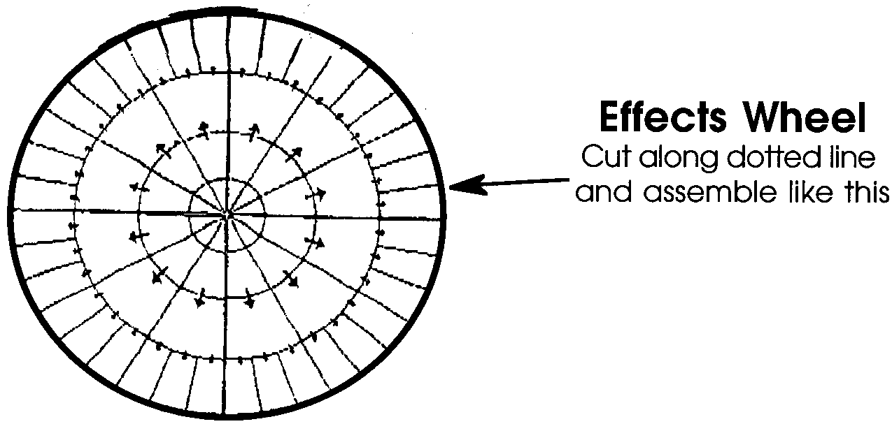
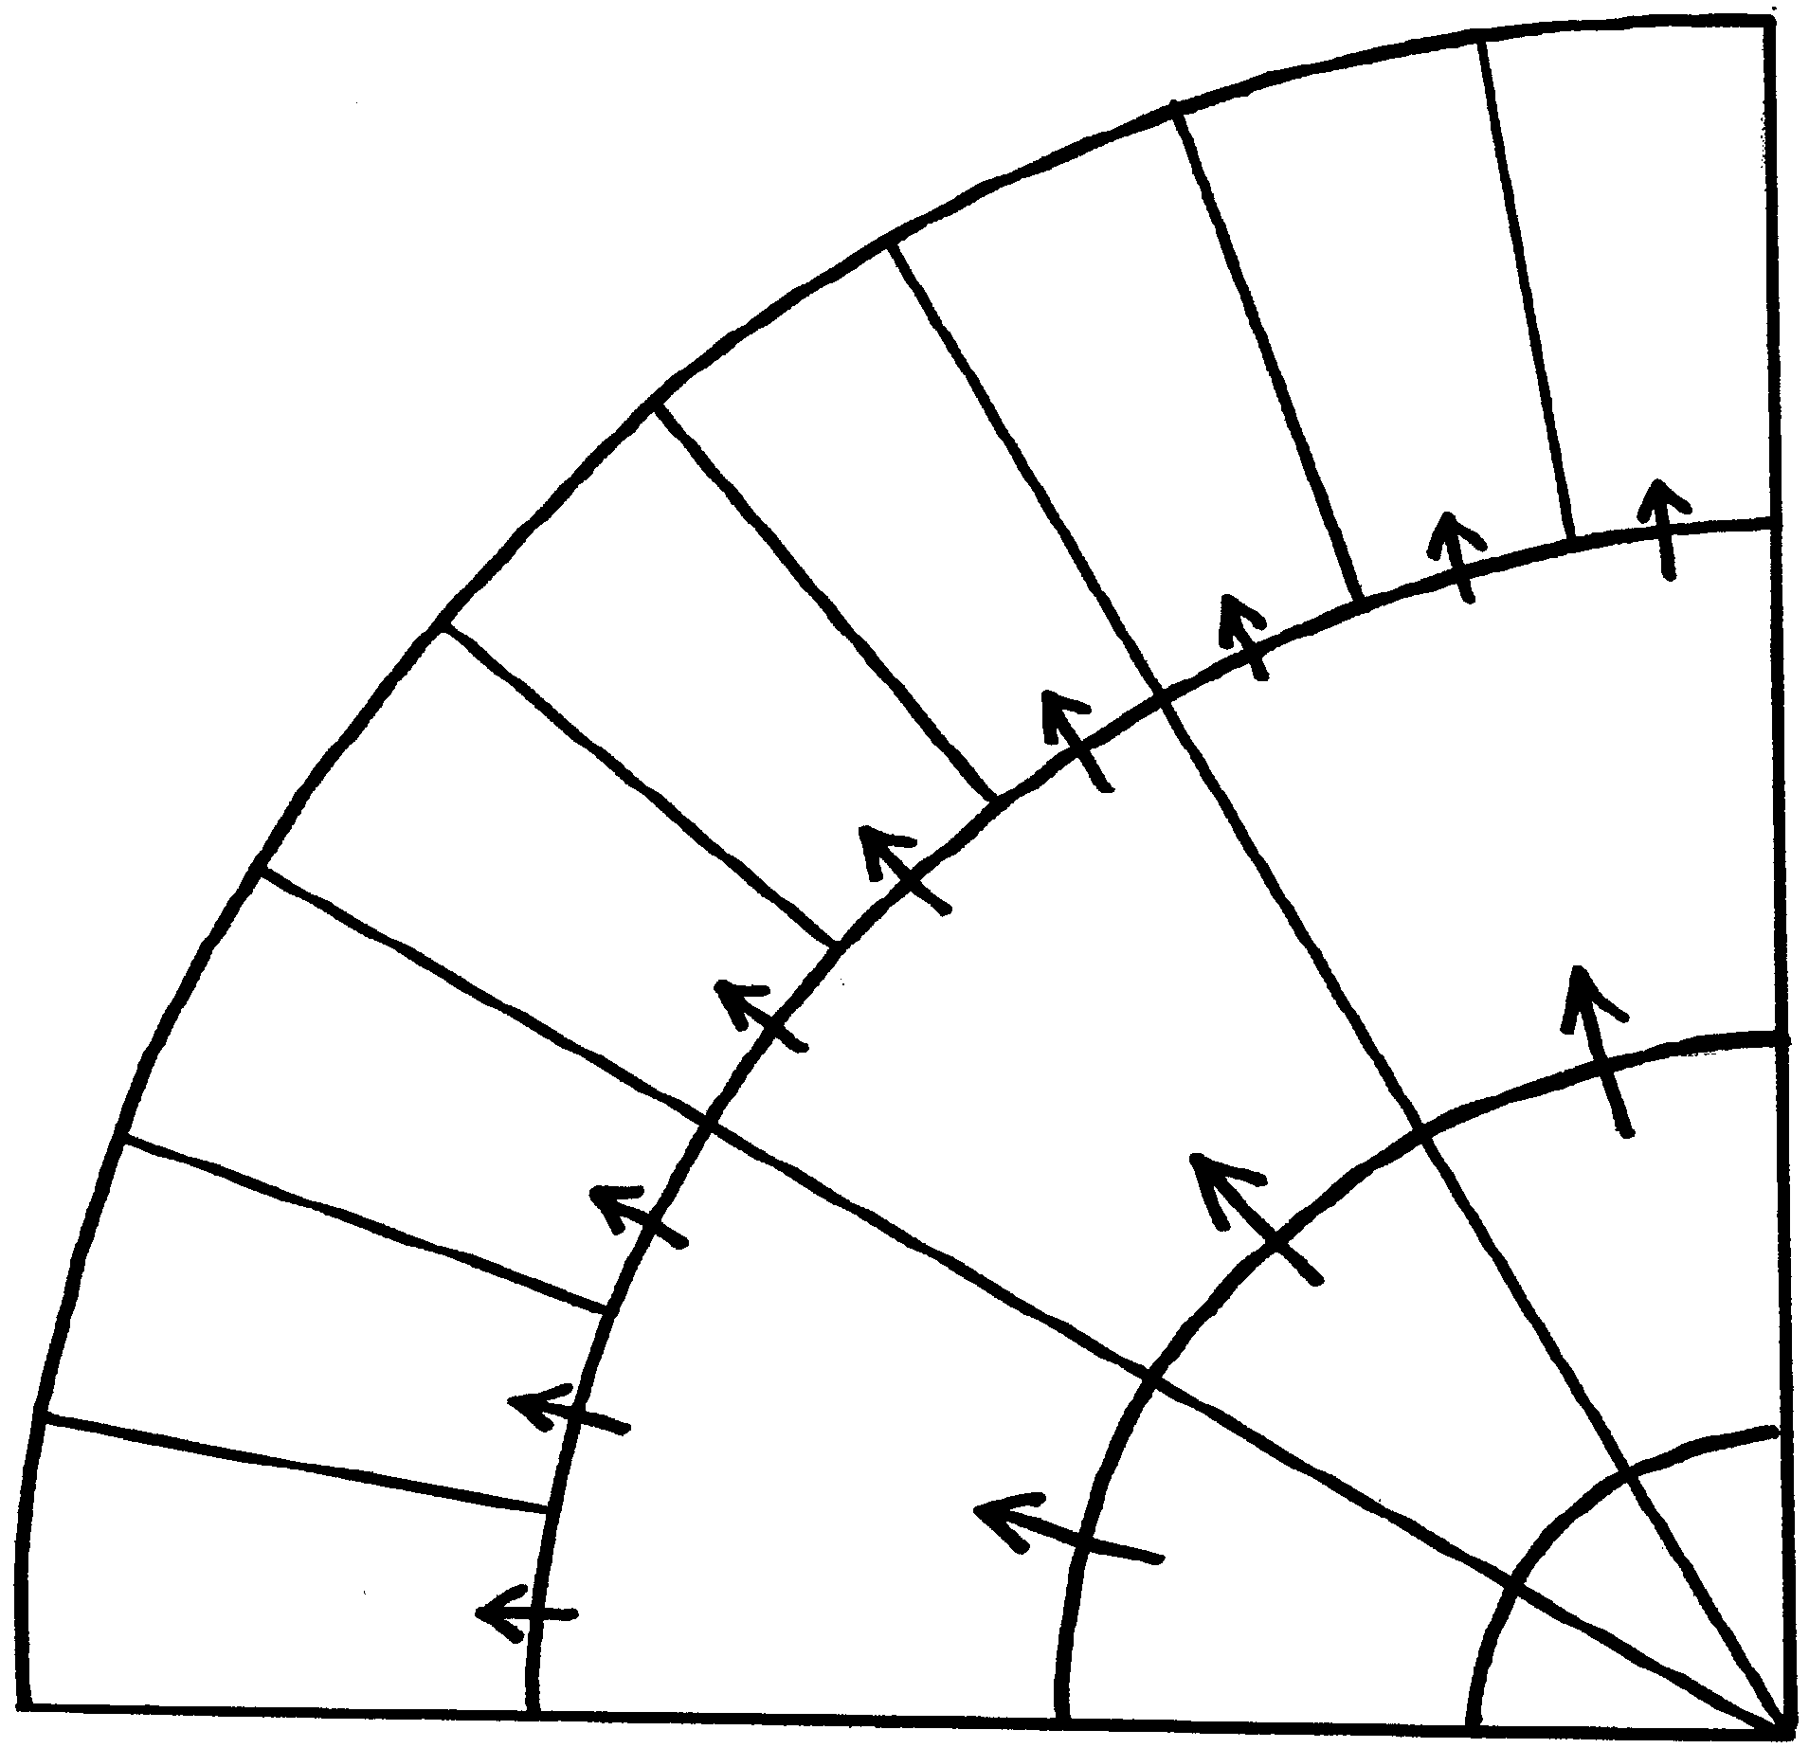

Flash! Messages for Automobile Manufacturers

• Your public relations office informs you that the companies you represent have already reduced emissions of carbon dioxide by 1) improving the fuel efficiency of cars worldwide; 2) installing energy-efficient lighting and heating in factories; and 3) encouraging employees to further conserve energy by turning off lights and machines when not in use. They want you to improve the image of auto manufacturers by telling people about these efforts.

• Your market researchers have discovered that there is a growing market for small cars. A creative engineer has proposed that factories now producing large cars be converted to making smaller, more fuel-efficient cars. To do this would require funds that would come mostly from the governments of industrialized nations.

• Your Advanced Research Division is already conducting research on alternative methods of transportation that greatly reduce the amount of carbon dioxide released in the atmosphere. One of these methods is Maglev trains, which are suspended above the tracks by magnetic fields. You would like more funds to greatly expand this line of research.

Flash! Messages for Wood and Paper Producers

• Your market analysts have found that the growing population of the world has increased the need for housing and paper products. This has increased the orders for timber and other wood-based products. Also, advances in literacy rates have increased the need and demand for books and newspapers. You may wish to ask for assistance from other groups at the conference to determine how some of these needs might be met without increasing the amount of logging.

• Your research division points out that durable homes built of wood actually reduce greenhouse gases because carbon is stored in the wood. Research should be focused on how to prevent fire and rot, both of which release the carbon stored in the wood.

• Your union representatives say that efforts to reduce logging will put thousands of people out of work. They suggest that some of these people might be put to work planting new forests, but they wonder where the money will come from, since these forests will not be harvested for at least 50 years. They want to find a solution to this problem at the World Conference.

Flash! Messages for Agriculturalists

• Biologists have discovered that certain plants grow rapidly with increased carbon dioxide. Unfortunately, weeds grow rapidly too. You would like the industrialized nations to provide funds for continuing research to find useful plants that will outgrow the weeds.

• Energy engineers have told you that farming produces methane, which is a significant greenhouse gas. However, this problem can be turned into an advantage if the gas is collected and burned, and the energy produced is used to replace existing fossil fuel power plants. This will require funding from the richer nations of the world.

• Farm economists tell you that if world climate patterns change drastically, some farmers will lose all they have from droughts and storms, while others will benefit from increased rainfall and warmer weather. The economists suggest setting up a worldwide insurance program that would help balance the risk. Such a program will cost money, but you think it is important not to raise the cost of food because that will hurt poor people the most.

Flash! Messages for Island Nations

• You are working hard to bring the problem of rising sea levels to the attention of other nations, especially those that produce most of the greenhouse gases. You would like more people to know about your problems, and more concern from other nations of the world so something will be done about them.

• You are requesting funds from the World Bank, to undertake projects that will reduce the effects of global warming. These projects include: alternative fresh water supplies and food sources, and programs to resettle people on higher islands, where this is possible. Since the World Bank receives its money mostly from the industrialized nations, you need their support.

• You have thought of approaching individual companies that contribute most to the global warming problem, such as car and wood products manufacturers, to help prevent global warming now, while there is still a chance to save the islands, by reducing their output of carbon dioxide, or by using their profits to plant trees and preserving untouched forests that absorb carbon dioxide.

