Global Climate Change – What Do the Scientists Say?
Lesson by Judy D’Amore, Marine Science Centers
Port Townsend and Poulsbo, Washington.

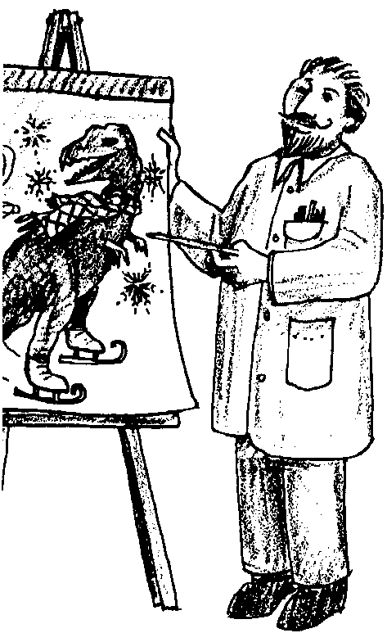
Key Concepts
1. The earth is currently warmer than it has been throughout most of the past million years.
2. Major climatic changes in the history of the earth, such as ice ages, have been accompanied by temperature changes of only a few degrees.
3. Climate changes in the past are correlated with changes in atmospheric concentration of carbon dioxide and methane.
4. Predictions based on scientific models include temperature changes equal to or greater than those which occurred between periods of continental glaciation (inter-glacial periods). They also include significant changes in rainfall distribution.

Background
Background for “Global Climate Change: What do the Scientists Say?” is found in the preceding activities entitled “The Earth As a Greenhouse”, “Looking for Carbon Dioxide”, and “Looking for Another Greenhouse Gas: Methane”.

Materials
For each student:

• Student activity guide: “Global Climate Change: What Do the Scientists Say?”

Teaching Hints
“Global Climate Change: What Do the Scientists Say” provides students with an introduction to change date and to current atmospheric and meteorological thoughts on global climate.
The content of this lesson has been prepared as a student text with questions. You may prefer to deliver the material via lecture/discussion, by preparing graphs and maps as overheads or handouts.
Whichever way you choose to present this material, allow plenty of time to discuss this information and its implications for the future.

Key Words
continental glaciation - ice age, expansion of polar ice into mid-latitudes

inter-glacial period - the warmer period between episodes of glaciation

Answer Key
1. The decade from 1980 to 1990 was the warmest.

2. Scientists know a trend this short in geologic time might be caused by factors other than the greenhouse effect. Most atmospheric scientists do believe that global warming will soon be detectable, however.

3. The last ice age began about 110,000 and ended about 15,000 years ago.

4. The inter-glacial period occurred about 130,000 years ago.

5. There are thought to have been 9 or 10 glaciations.

6. During most of the past 900,000 years it was cooler. During inter-glacial periods the earth reached temperatures as high or even slightly higher than it is now.

7. The earth became as warm as it is now 6 times, not counting the present.

8. The earth’s temperature variation between glacial periods and inter-glacial periods was 4-5°C. (Note: There is a discrepancy between units on graph #3 and graph #4 which students may notice. This figure is based on the information on graph #4.)

9. Both carbon dioxide and methane levels rise and fall with the earth’s temperature during this period. Whether their atmospheric concentration was brought on by the temperature changes or whether the gases themselves caused the temperature changes is not known.

10. No, carbon dioxide levels have never been as high as they are now.

11. The level of carbon dioxide was highest during the peak of the last inter-glacial warming period.

12. No, methane levels have never been as high as they are now.

13. The biggest increases in temperature will take place in the polar regions, the north pole in the winter and the south pole in the summer.

14. Predictions for global warming range from 0°C to 12°C above present temperatures, depending on the region of the earth, as compared to 4° to 5°C between ice ages and inter-glacial periods. Although it is not possible to make an exact comparison, students should recognize that this level of climate change will be significant indeed.

15. a. Regions wetter in winter: northwestern Canada, India, northern Australia, Argentina, northern Europe, East Africa, and parts of Siberia.
b. Regions dryer in winter: eastern United States, central and southwestern Asia, most of northern South America, and southern Europe.
c. Regions wetter in summer: northern Australia, India, West Africa, the Middle Eastern Countries, and isolated parts of Northern Europe and South America.
d. Regions which may experience summer droughts: most of the United States, most of south America, central and southern Africa, southern Europe, and most of Asia.

16. Answers will vary. Students should mention that never in the time period we have been able to study have concentrations of carbon dioxide and methane gas been as high as they are now, and there is much we don’t know about how this will affect our planet’s future climate. Past technologies did not permit deforestation and other similar activities on anything like the present scale. In the future, the fossil fuel resources and forest resources will not be available for such an “experiment”.

Reference:

Climate Change: The IPCC Scientific Assessment, edited by J.T. Houghton et al. The Intergovernmental Panel on Climate Change, Cambridge University Press, 1990.
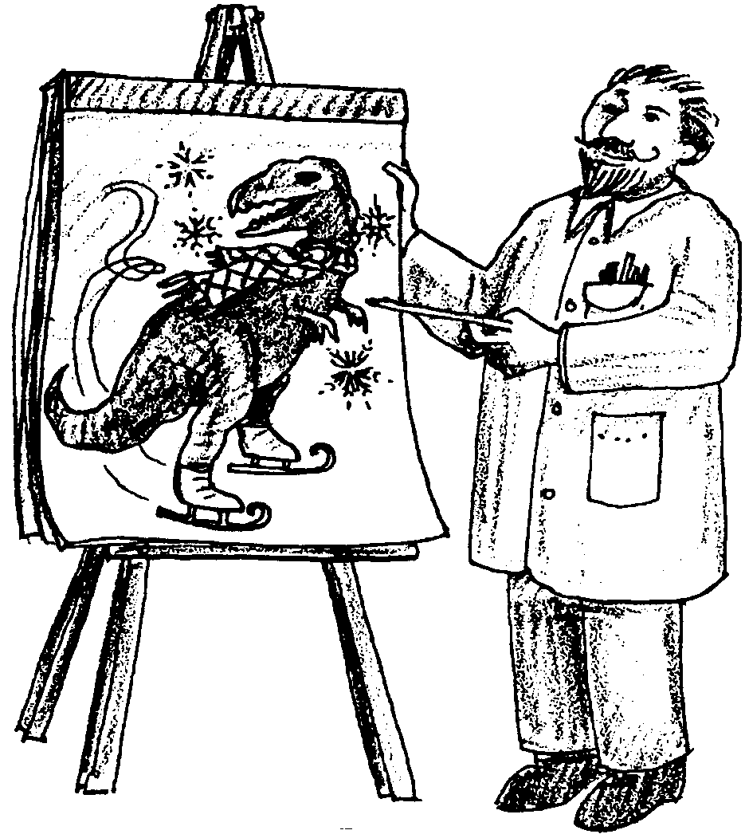
Global Climate Change: What Do the Scientists Say?

The Earth’s Paleoclimate

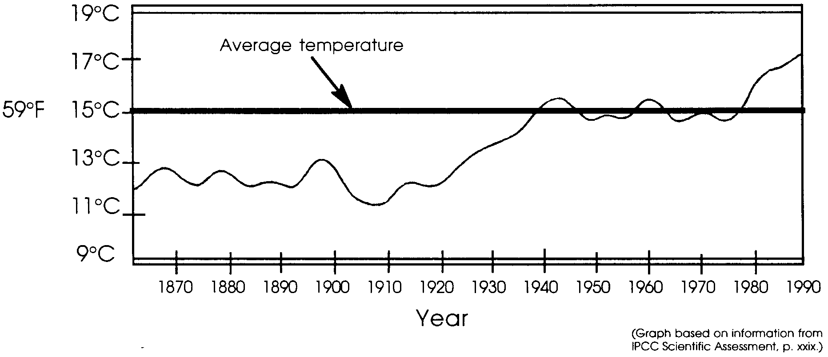
We know the atmosphere is changing, but is the earth getting warmer? To answer this question, scientists need a consistent record of temperatures taken from many different parts of the earth’s surface for long periods of time. Unfortunately, such records weren’t kept before the middle of the nineteenth century, but we do have good records from about 1860 to the present.
The graph below shows the picture that has emerged for a period of 130 years, made from a composite of land surface and sea surface temperatures.
1. During which decade were the warmest temperatures recorded?

2. Although this graph suggests a warming trend, why might scientists be cautious about making predictions based on this information alone?

Other research is looking into clues about the earth’s climate during much earlier periods. You might wonder where scientists look for this information. Some is derived by extracting cores from polar ice sheets which have formed over thousands of years. Substances trapped in the ice, as well as the water itself provide information about the climate when the ice was formed. Other scientists look at the composition of the shells of marine animals buried in ocean sediments to find clues about how much of the earth’s water was in the ocean and how much was bound up in glaciers. Still others deduce information on past climates from pollen grains trapped in mud deposits. By combining information from these studies, scientists have pieced together a picture of the earth’s climate extending much further back into the past.
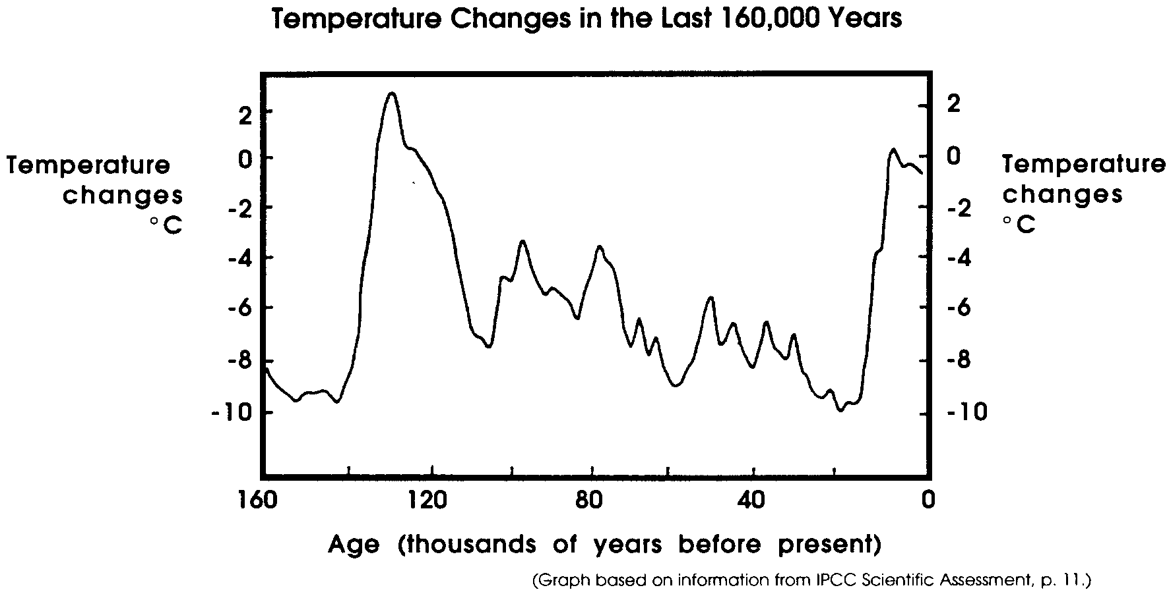
The following graph shows temperature changes that have occurred over the past 160,000 years.

3. During most of this period the earth was under the influence of the last ice age. Using the information on the graph, approximately when did the last ice age begin? When did it end?
4. Approximately when did the last inter-glacial period occur? (The inter-glacial period was the warm period between the last glaciation and the ice age which preceded it)

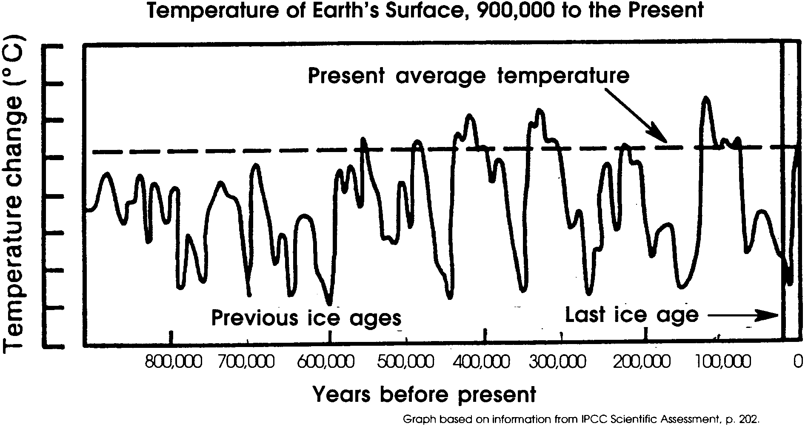
Remarkably, scientists have clues about the earth’s climate still further back in time. The graph below shows global temperatures reaching back 900,000 years before the present.

5. Find the last ice age on this graph. How many ice ages can you count, including the most recent one? (Hint: If you find it difficult to answer this question, you should know that scientists themselves do not agree on how many glacial periods there were!)

6. What could you say about the earth’s temperature in general over the past 900,000 years as compared to the present?

7. How many time during this period was the earth’s temperature as warm or warmer than at present?

8. About how much did the temperature of the earth change between the glacial periods (ice ages) and the inter-glacial periods?
The Earth’s Past Atmosphere

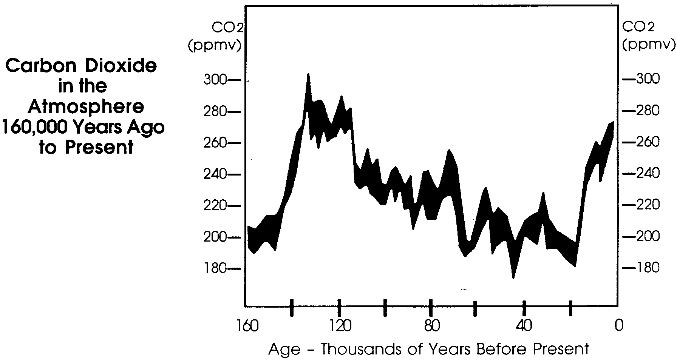
In trying to understand the role of the atmosphere in regulating the earth’s climate, scientists have also tried to learn whether the atmosphere was also changing during this period. They have been able to study the ancient atmosphere by analyzing air bubbles trapped in the Antarctic ice sheet. The graphs below show the concentration of carbon dioxide concentration and methane in the atmosphere over the past 160,000 years. Compare them to graph #2, the earth’s temperature over the same time period, reprinted below as well.
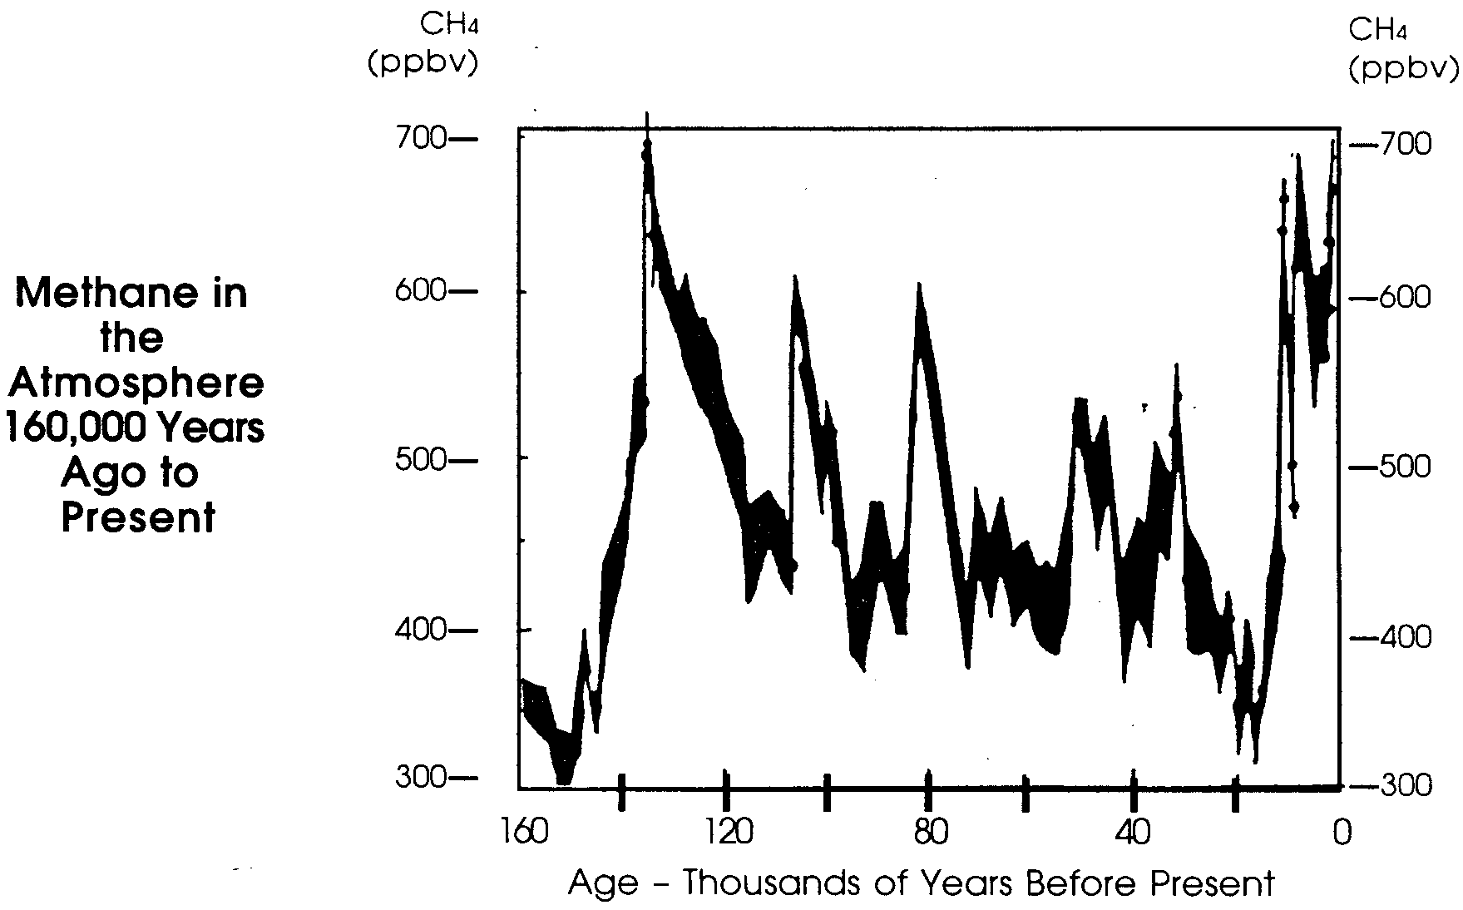
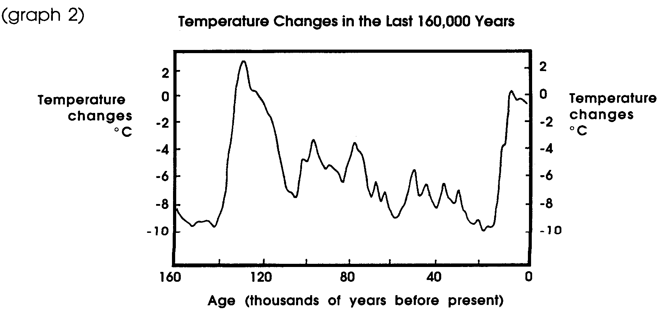
(Above graphs based on information from IPCC Scientific Assessment, p. 11 and 18.)

9. What seems to be the relationship between carbon dioxide and methane in the atmosphere and the temperature of the earth’s surface over the past 160,000 years?

10. The atmospheric concentration of carbon dioxide is currently about 350 ppm (parts per million). During the period of this graph, was it ever as high as its current level?

11. What event on the temperature graph corresponds to the period when carbon dioxide reached its highest concentration in the atmosphere (before the present)?

12. The concentration of methane in the atmosphere has risen from about 800 to about 1600 ppb (parts per billion) in the past 200 years. In the period of this study, has it ever been this high before?
The Earth’s Future Climate
With greenhouse gases on the rise, scientists have developed models to try to understand how the earth’s climate might be affected. Models of the earth’s processes are extremely complex, because they must predict the interaction of factors such as air movements, ocean currents, precipitation, cloud cover, glacial ice-and the human factor. In the model used to prepare the maps below, it is assumed that humans continue to produce carbon dioxide at the current rate, causing its concentration to double by the year 2020.
Maps #1 and #2 below show a projection of the temperature increases which would occur around the earth if carbon dioxide in the atmosphere doubled.
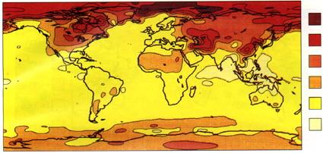
more
than 12°C

8 to 12°C

6 to 8°C

4 to 6°C

2 to 4°C

0 to 2°C

Map #1: Predicted Increase in Temperature during months of
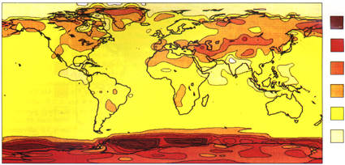
December, January, and February, with doubling of atmospheric CO₂
more
than 12°C

8 to 12°C

6 to 8°C

4 to 6°C

2 to 4°C

0 to 2°C

Map #2: Predicted Increase in Temperature during months of
June, July and August, with doubling of atmospheric CO₂
13. According to this model, where on the earth will the biggest temperature increases occur? At what seasons of the year?

14. How do these temperature changes compare with the temperature changes that have happened on the earth between the ice ages and the inter-glacial periods?
Patterns of precipitation and soil moisture may also change. Maps #3 and #4 below are also based on a doubling of carbon dioxide in the atmosphere.
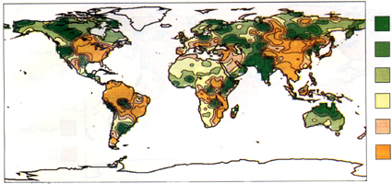
Map #3: Predicted Change in Soil Moisture during months of
more
than 2cm

1 to 2cm

0 to 1 cm

0 to -1cm

-1 to -2cm

less
than -2cm

December, January, and February, with doubling of atmospheric CO₂
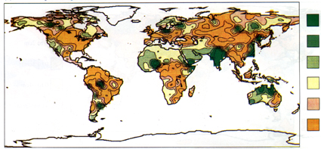
Map #4: Predicted Change in Soil Moisture during months of
more
than 2cm

1 to 2cm

0 to 1 cm

0 to -1cm

-1 to -2cm

less
than -2cm

June, July and August, with doubling of atmospheric CO₂

(Above maps based on information from IPCC Scientific Assessment, Fig 5-8 (a) and (d).)
15.a. Name at least four parts of the world that are likely to be much wetter in the winter than at present.

b. Name four places that will be dryer in winter.

c. Name four parts of the world that are likely to be wetter in summer.

d. Name four areas which may experience summer droughts.

16. The oceanographer, Dr. Roger Revelle of Scripps Institution has described the changes people are making in the atmosphere as “a large scale geophysical experiment of a kind that could not have happened in the past nor be reproduced in the future.” What does he mean by this statement? Do you agree with him?

