Looking For Carbon Dioxide
Written by Judy D’Amore, Marine Science Centers
Port Townsend and Poulsbo, Washington.

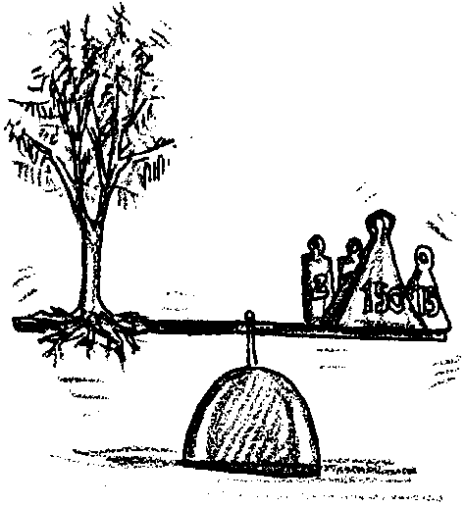
Key Concepts
1. Sources of carbon dioxide include respiration of animals and combustion products, including combustion of fossil fuels.
2. Car exhaust is a particularly concentrated source of carbon dioxide.

Background
Carbon dioxide is currently the most important greenhouse gas, due to its higher concentration in the atmosphere than other greenhouse gases and its long residency time there. Carbon dioxide is produced naturally by animals and plants, and it is generated by the weathering of carbonate rocks and by volcanic eruptions. Human activities, the burning of fossil fuels and the deforestation of temperate and tropical ecosystems, also produce carbon dioxide. While these human sources are much in the news today, the natural sources are one or two orders of magnitude greater than the human sources.

So, why all the concern? There is a significant difference between the two types of sources. Natural sources are “balanced” by natural sinks, or reservoirs; carbon dioxide flows from the ocean into the atmosphere and from the atmosphere into the ocean, for example. Carbon dioxide from human sources, on the other hand, is essentially “one way”; from the fossil fuels or deforestation into the atmosphere or other reservoirs where it accumulates. The following graph shows the reservoirs (where carbon dioxide is stored) and the fluxes (change in location). Carbon quantities/fluxes are shown in gigatons (billions of tons) of carbon per year.
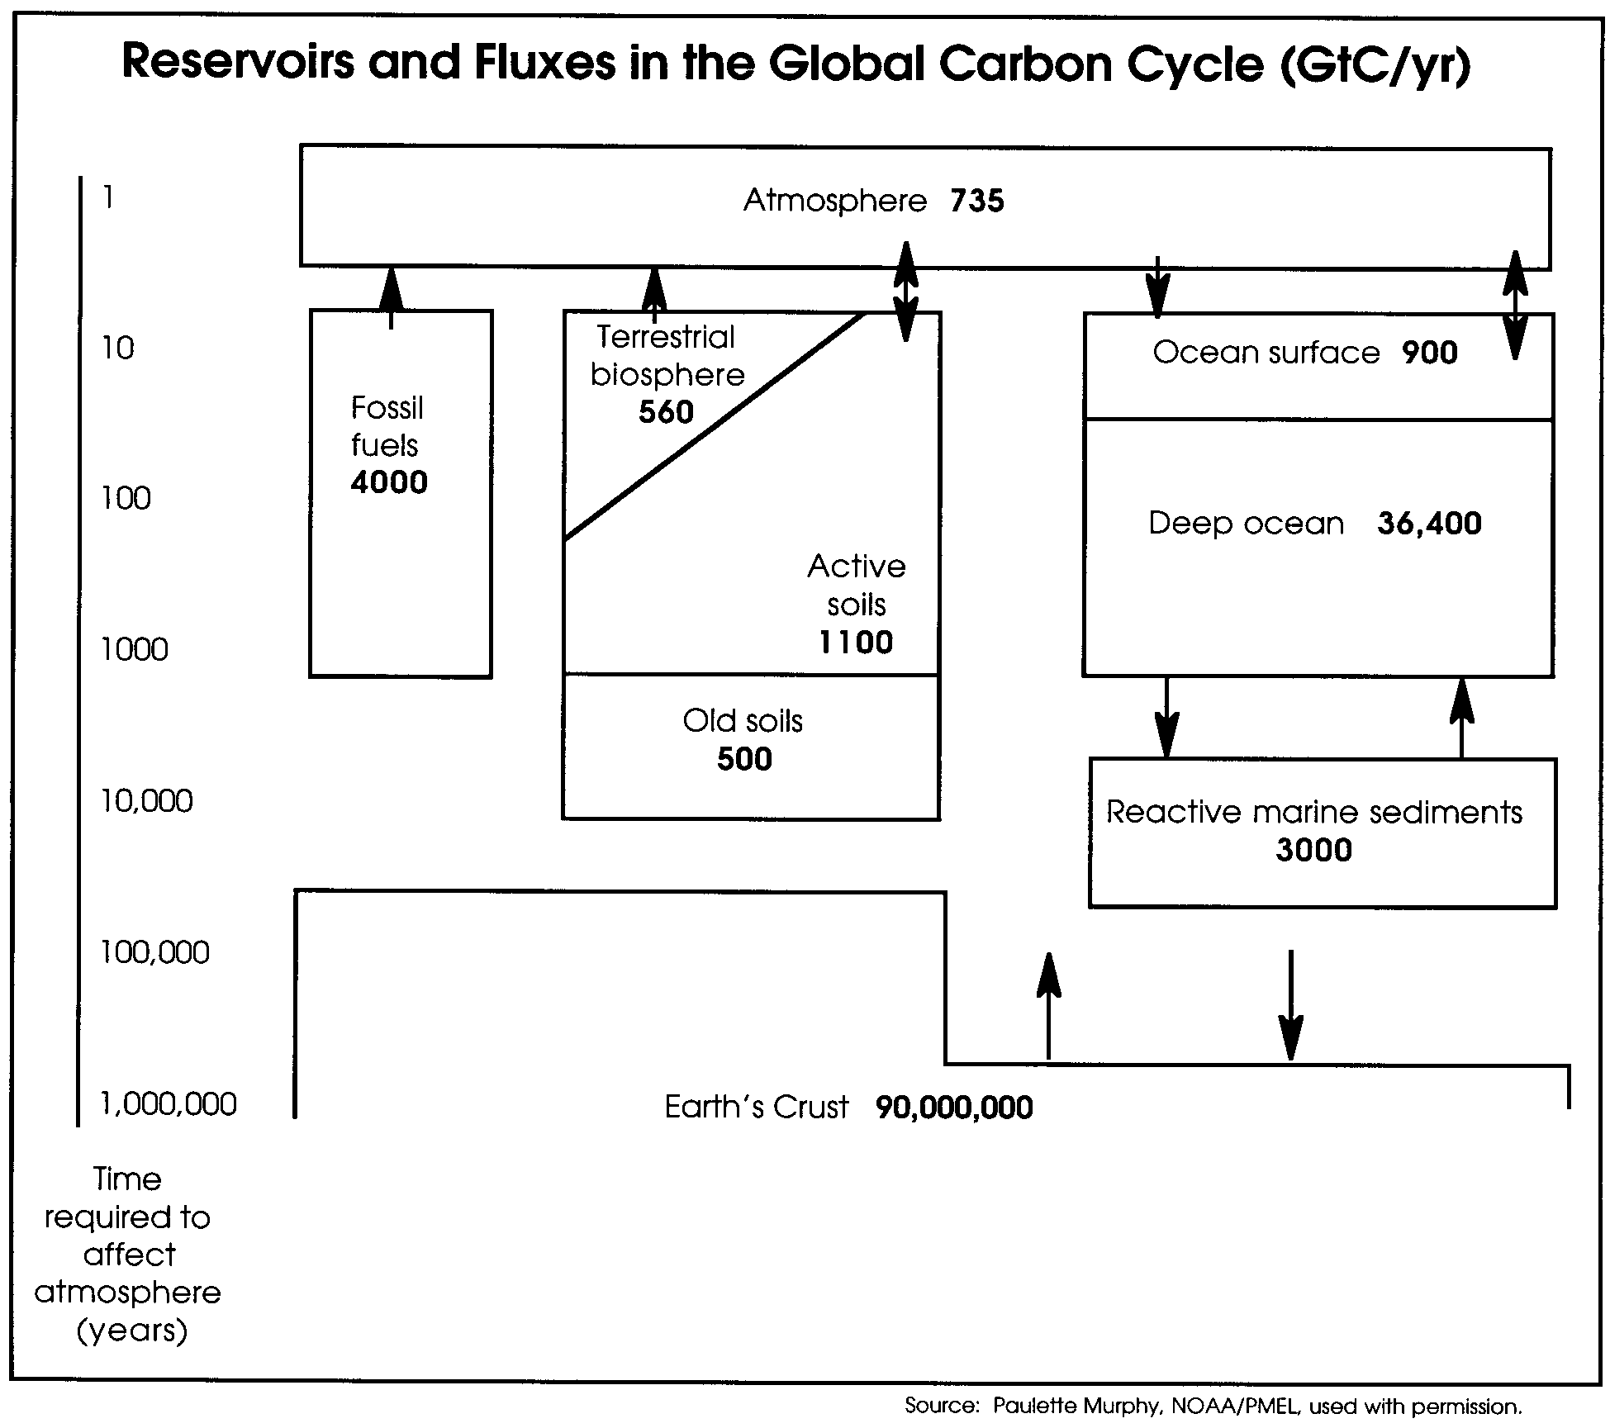

The problem, then, is not that human sources of carbon dioxide are greater than natural sources, it is that they are persistent in the atmosphere and other sinks. Using some rather clever detective work, scientists have been able to determine changes in atmospheric carbon dioxide concentrations over the past 18,000 years. The data to make the following graph was obtained from analyzing arctic ice cores.
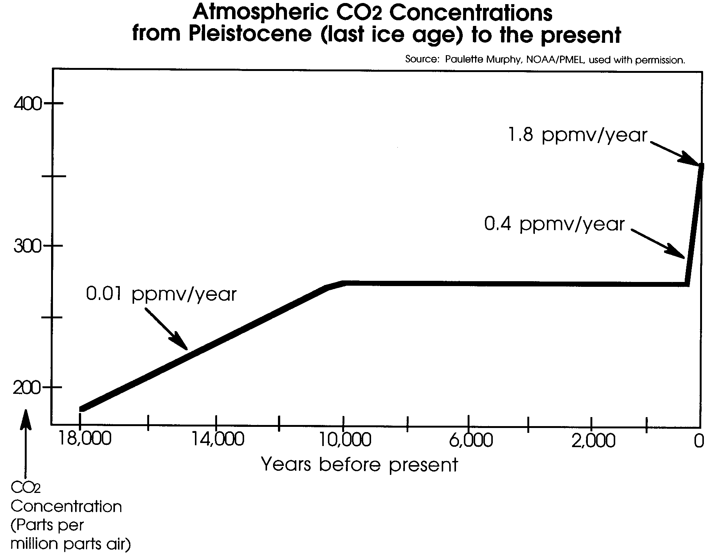

The graph shows some interesting findings. The period from about 18,000 years before present to about 10,000 years before present was the last ice age. During that 8,000 year period, there was a steady increase in atmospheric carbon dioxide (0.01 ppmv/year). The interglacial period in which we now find ourselves has been characterized by a stable level of atmospheric carbon dioxide, that is until recently. The dramatic rise in atmospheric carbon dioxide in the last 200 years has been due to human factors, principally the burning of fossil fuels and slash burning associated with deforestation. The atmospheric carbon dioxide reservoir has increased 25% to its present value of 735 gigatons of carbon per year. The rate of increase seen over the past two centuries is extraordinarily rapid on a geologic time scale.

The relative impact of fossil fuels and deforestation or forest cut back on the three primary carbon dioxide sinks is shown in the following figure.
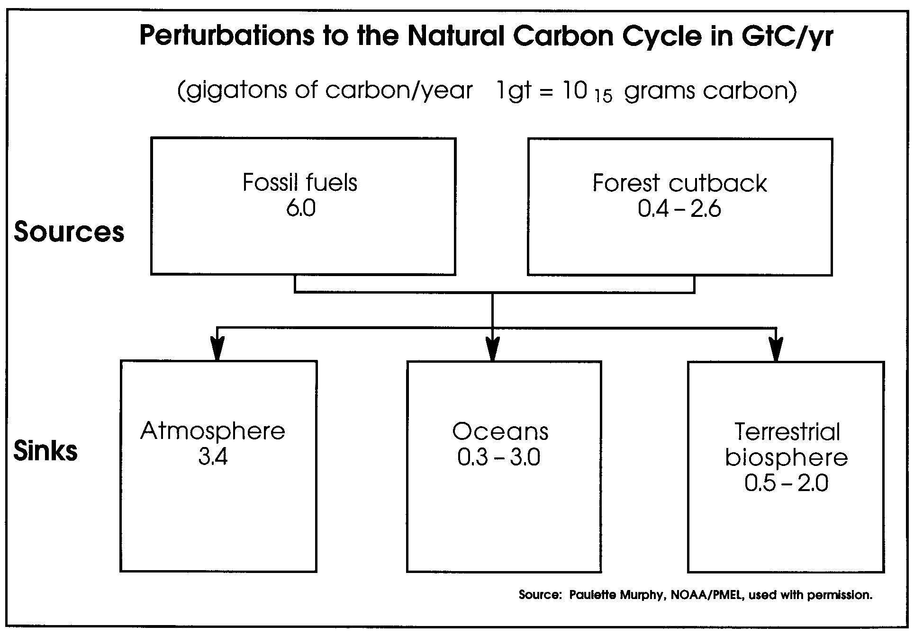
Notice that the contribution of carbon dioxide from the burning of fossil fuels is from about 2 to 15 times greater than the contribution from forest cutbacks (forest cutbacks vary widely from year to year). Notice also that while the most carbon dioxide is added to the atmosphere, a significant amount is added to the oceans and to the terrestrial biosphere as well.

The above observations have lead to widespread agreement among scientists that the composition of the atmosphere is changing. As noted in the background for “The Earth As A Greenhouse”, unfortunately the implication of these changes is beyond the reach of a simple experiment. How much excess carbon dioxide is absorbed by the ocean? Do higher concentrations of CO2 in the atmosphere stimulate faster plant growth, helping to offset the increase? Do some gases counteract the effects of others? How will changes in atmospheric composition affect the Earth’s cloud cover, altering the proportion of solar energy that is reflected before entry? Might higher temperatures in polar regions increase precipitation, expanding the snowpack and causing an earlier return to an Ice Age. What do recent studies which seem to indicate that carbon dioxide was 16 times present levels 440 million years ago while the Earth’s temperature was cooler mean for our predictions? These are some of the unanswered questions that keep scientists from making firm predictions. Yet few scientists are in doubt that humans are carrying out a large scale experiment on the Earth’s life support system.
Although absolute CO2 concentrations in the atmosphere are small (about 350 ppm), CO2 can be detected using the pH indicator bromthymol blue using methods outlined in this activity.

Materials
For class of 32:
• 1 5-lb bag of charcoal
• class set of thought problem, “The Mystery of van Helmont’s Tree”
• approximately 8 liters (about 2 gallons) prepared BTB stock solution (0.5 grams BTB in 500 ml. water)
• 1 or more air pumps (i.e. bicycle pumps)
• 3 or 4 narrow-mouth quart bottles, glass or plastic, for production of pure carbon dioxide gas
• 1 gallon vinegar
• 1 box baking soda
• 1 car, parked somewhere convenient to classroom and safe for class to stand around
• funnel or cone made from tagboard or manila folder, firmly taped
• class set of student reading, “Keeling’s Curve”

For each team of students:
• 5 small, identical bottles, or 5 test tubes on rack, containing prepared bromthymol blue (BTB) pH indicator solution
• blue, green and yellow colored pencils
• 4 small identical balloons (Plan to have extras handy for breakage and further experimentation.)
• 5-6 twist-ties or paperclips

Teaching Hints
In “Looking for Carbon Dioxide”, students use simple equipment to trap air samples and compare the levels of carbon dioxide present in the samples by bubbling them through containers of BTB solution.
“Looking For Carbon Dioxide” is intended to follow the lesson, “What Goes In? What Goes Out?” It is assumed that both you and the students are familiar with using the indicator, BTB from the lesson “What Goes In? What Goes Out?”, even if there is still some uncertainty about the interpretation of that lab. If you are not using these lessons sequentially, you should review “What Goes In? What Goes Out?” to familiarize yourself with the use of these materials.
Introduction:

Photosynthesis and Respiration

Before beginning the investigation, you should establish that students have some familiarity with the nature of carbon dioxide and its role in photosynthesis and respiration. The following sequence may be useful as introduction or review.
Give students copies of the thought problem, “The Mystery of van Helmont’s Tree”, either as a brainteaser prior to the lesson, or at the beginning of class.
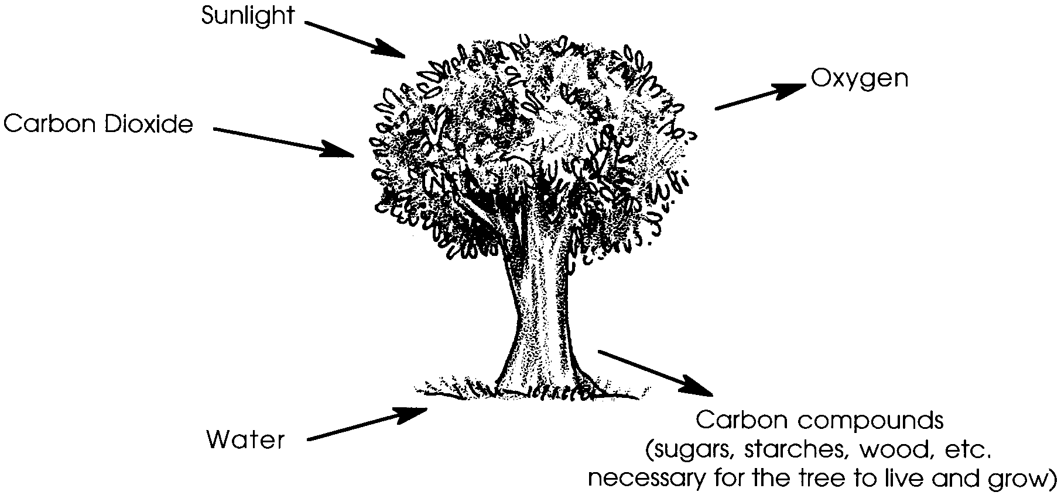
Most students will have difficulty picturing the gas, carbon dioxide as the source of the material that accumulated in the tree. Discussion of this problem can lead into a new perspective on what the tree did--captured carbon (in the form of carbon dioxide) from the air around it, enabling it to grow larger, as in the following simplified diagram:

You may, of course, prefer to teach the balanced formula for photosynthesis.
Ask students to consider what happens to the carbon in the tree if we burn it, or if we eat something produced by a plant:
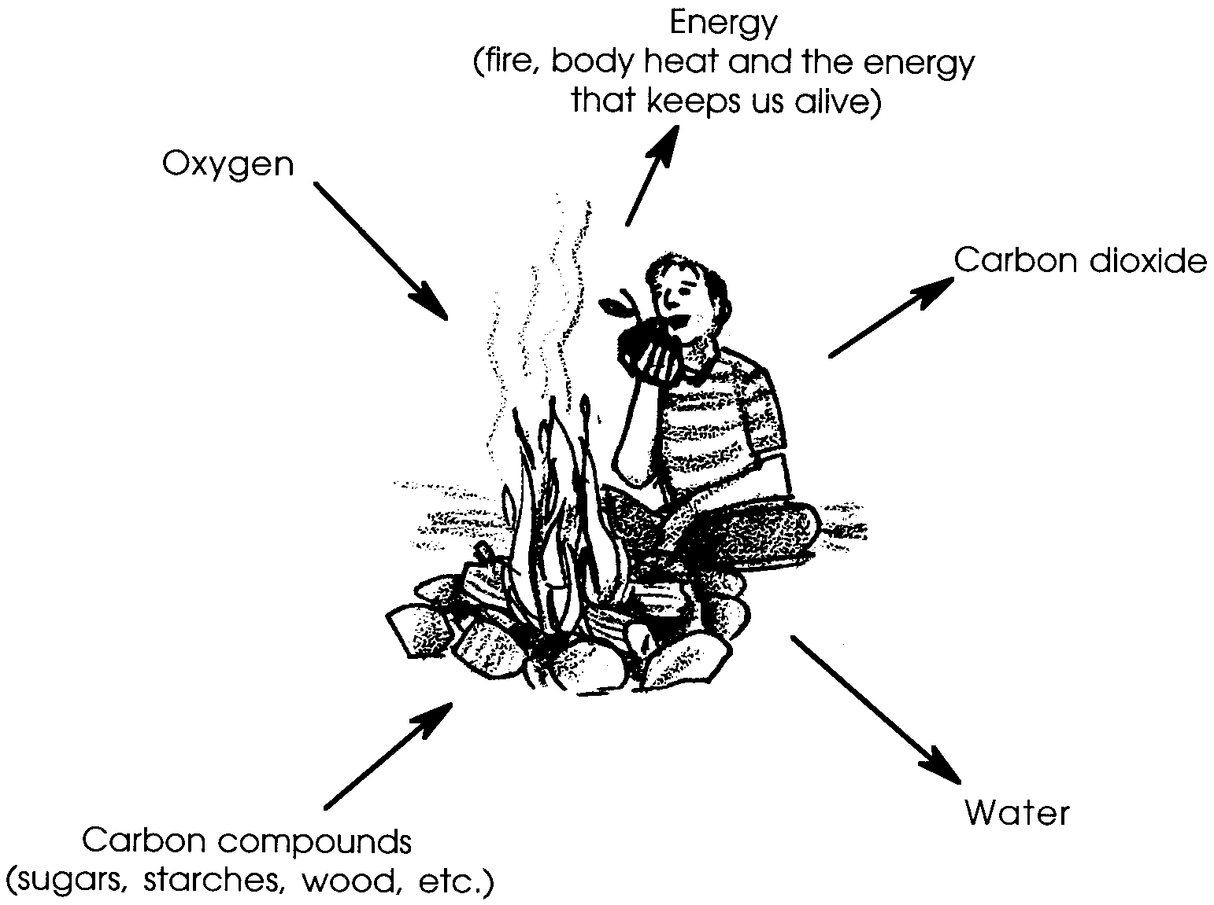
If students have limited experience with carbon as an ingredient in familiar substances (wood, paper, edible carbohydrates, petroleum, etc.), use charcoal, which is practically pure carbon, as a visual aid. Help them understand that the charcoal, when combined with oxygen, becomes the transparent, odorless gas, carbon dioxide.
You may want to demonstrate that carbon dioxide, a larger, heavier molecule than oxygen, is truly heavier than other gases in the atmosphere. For this you will need to generate some pure carbon dioxide gas by mixing vinegar and baking soda. You can use the same equipment as in step 3, below. Have a candle burning in a deep, wide-mouth jar, and as soon as the vinegar and baking soda begin reacting, pour the gas produced by the reaction over the candle. Then have students share observations and propose possible explanations for the event.

Activity: Catching Carbon Dioxide

1. Remind students that carbon dioxide is a trace gas in the atmosphere. Ask them where in our environment they might expect to find higher levels of carbon dioxide? (You might use any ideas they suggest for further investigations beyond the ideas presented here.)

2. Tell them that to look for carbon dioxide in the environment, they’ll need to make an instrument to catch some air samples. Then they can use the indicator, BTB, to compare the samples to determine how much carbon dioxide is present.
(If students have not previously worked with BTB, it is recommended that you begin with activities described in “What Goes In? What Goes Out?”.)
Demonstrate blowing up a balloon and clamping the neck firmly with a twist tie, then releasing the air through a straw. (It is advisable that you practice this technique before demonstrating it to students.)
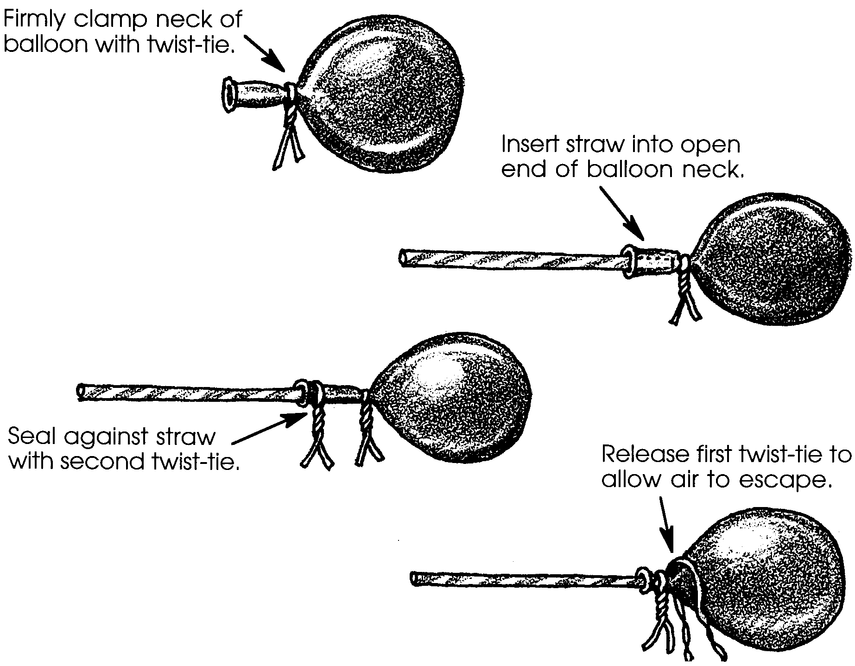
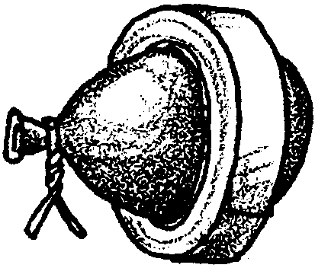
Explain that to make valid comparisons between several samples they will need a way of standardizing the size of their samples. You can give them this problem to solve themselves, or you can suggest using a template such as the circular space inside a masking tape roll to determine the diameter of the balloon-sample.

Ask students how differences in the carbon dioxide levels of their samples will show up when they bubble them through BTB. (They should observe the BTB turning different colors.) Suggest that they record the colors before and after the experiment on their data sheets using colored pencils. Note that they should always leave one container of BTB alone to serve as a control.
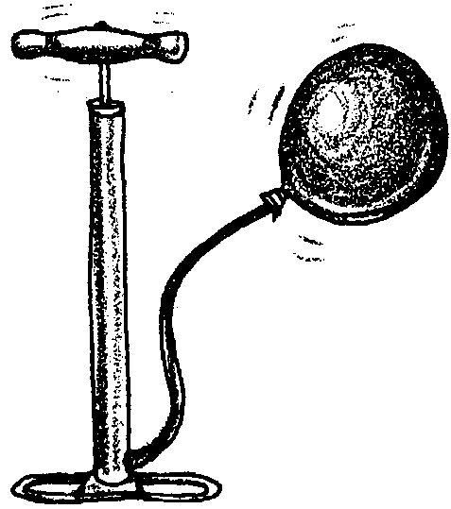
3. Tell them that the first two samples to test should be (1) plain air and (2) a sample of pure carbon dioxide. Those two samples will give students an idea of the total range of results possible using BTB.

Demonstrate how to fill a balloon using the air pump to get an air sample.

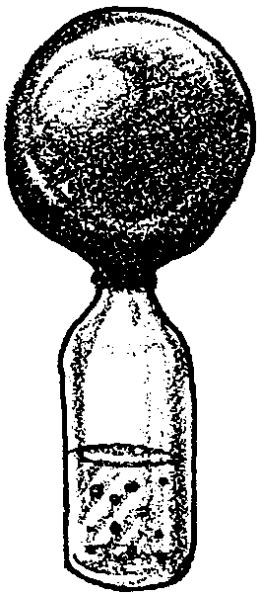
Demonstrate the procedure for making carbon dioxide using vinegar and soda.
Put 100 ml vinegar into narrow mouth bottle. Add 5 level tablespoons of baking soda, wait 1/2 minute for carbon dioxide generated to force air out of the bottle, then slip a balloon over the bottle opening and hold securely until it has expanded to the size needed. Quickly clamp shut. The same bottle can be used by successive teams of students by adding more vinegar and soda.

4. When instructions are clear, let student groups move around the room to get air samples and complete these two tests. Circulate, providing assistance as needed

5. After student groups have completed these tests, use the ideas generated by students in step #1 to introduce animal and human breath as a source of carbon dioxide. First have students predict the color change they expect in the BTB, then have them blow up a balloon and test the sample. (Students might also be interested in exploring the effect of vigorous exercise on their results. If so, have them repeat the experiment with notations on their data sheets of how they modified the conditions in which samples were taken.)
6. Ask students whether they would expect to find carbon dioxide in the combustion of fossil fuels, such as automobile exhaust.
Before sampling, be sure to chock the car wheels. For safety reasons, it is advised that you, the teacher, take the samples from the tailpipe of a car and hand them to the students. Keep in mind that automobile exhaust contains toxic gases including carbon monoxide. Avoid breathing the fumes and wash your hands carefully after obtaining the samples.
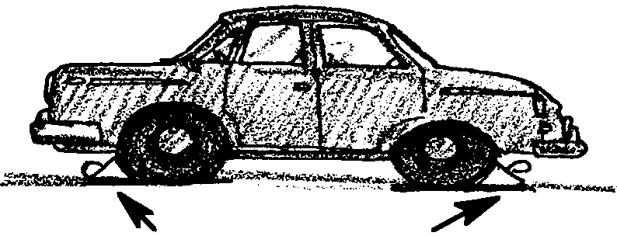
It is advisable that you practice taking an exhaust sample before the class activity. You will need a funnel or a tagboard cone to conduct the exhaust from the tailpipe of the car to the balloon. If using a metal funnel, wear potholder gloves, as the funnel may become hot. If using a manila cone, check that the small end fits inside a balloon and the large end fits snugly over the tailpipe. You may need to have an assistant step on the accelerator to increase pressure into the balloon. When a balloon is full, hand it to a student to tie and fill the next.
Chock both front and rear wheels.

When each student group has a sample, return to the classroom and have students test the exhaust samples as they did the others.

7. Discussion of results. Make a classroom chart of results by having each group record each test result on a scale of 1-10, where 1 is the BTB solution color prior to bubbling any gas and 10 is the BTB solution color after bubbling pure CO2 through it.. If you prefer, tests results for each gas sample could be averaged to yield a composite score.
Most classes discover that car exhaust has an extraordinarily high carbon dioxide content. This is because gasoline is very rich in carbon. You may want to emphasize this point by holding up the 5-lb bag of charcoal and sharing with students that every gallon of gas we put in our cars contains approximately as much carbon as this bag of charcoal. Ask students this question: Would people be more conscious of how much carbon dioxide their cars produced if their cars dropped an equivalent amount of charcoal on the roads instead of an invisible gas?
8. Distribute student reading, “Keeling’s Curve”, to use as homework or independent classroom assignment. Be aware that, because the summer and winter readings are so different, some students will be tempted to graph the data using two lines. Caution students that the graph will have only one line, but that it will be deeply zig-zagged. Discuss answers to questions when students are finished.

Key Words
bromthymol blue - a pH indicator solution

Keeling Curve - a graph showing the increasing levels of atmospheric carbon dioxide, named for Charles Keeling who pioneered studies of global atmospheric change

Extension
How much carbon dioxide does your family produce?
1. Have students estimate how many miles their families drive every month. How much gasoline is burned if their cars average 28 mpg? (If they know their gas mileage, have them use that figure.) Every gallon of gas puts 20 lbs. of carbon dioxide into the atmosphere. How much carbon dioxide is produced in a month?

2. Compare the carbon dioxide production of a car getting 28 mpg with a car that gets 35 mpg.

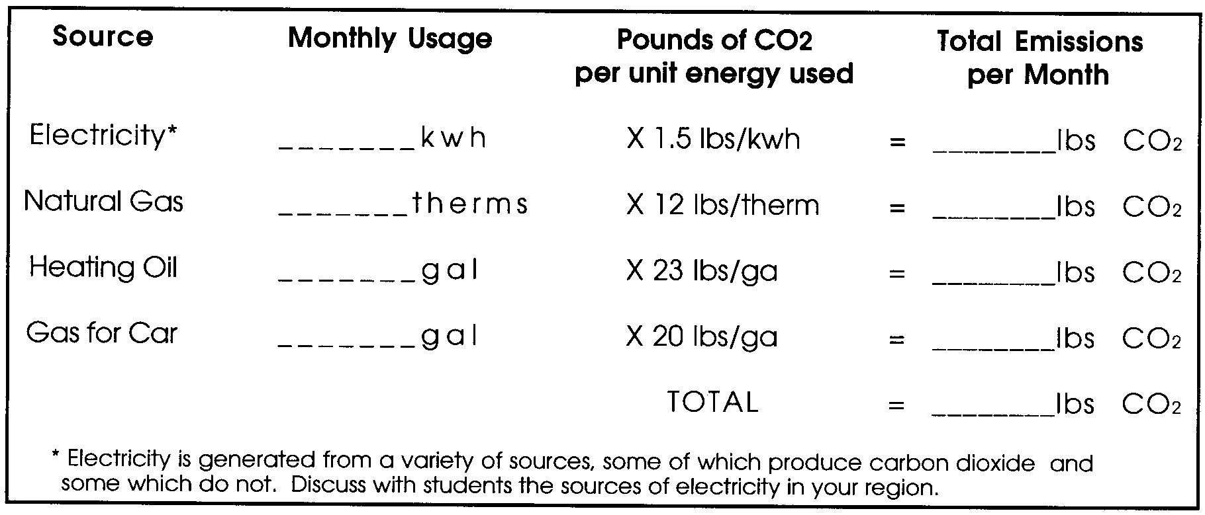
3. Have students create a fossil fuel usage table based on information from home utility bills and their car’s odometer. For example:

4. Ask students to suggest actions they and their families might take to consume less fossil fuel and thereby reduce carbon dioxide emissions.

Answer Key
The Mystery of van Helmont’s Tree
The tree removes large quantities of carbon dioxide from the atmosphere and combines the carbon dioxide with water to form the carbon compounds from which the tree is built. Oxygen is a waste product.
Keeling’s Curve
1. Scientists know that records by other scientists can be tremendous sources of information. Scientists generally start investigations by finding out what is already known about the topic.

2. During the day plants take in carbon dioxide and release oxygen as they perform photosynthesis. At night when the sun goes down they perform respiration, taking in oxygen and releasing carbon dioxide. These processes change the concentration of carbon dioxide in the atmosphere over a 24-hour period.

3. Photosynthetic activity takes place primarily in the spring and summer in the northern latitudes, causing plants to draw more carbon dioxide out of the atmosphere during those seasons.

Adapted with permission from the lesson “Where Does CO₂ Come From?” developed at the Lawrence Livermore National Laboratory, P.O. Box 808, Livermore, CA 94550
Extension activity adapted from Global Warming: Understanding the Forecast, teachers’ resource manual, by Carl M. Raab and Jane E. S. Sokolow. American Museum of Natural History and Environmental Defense Fund, 1992.
See also Global Warming and the Greenhouse Effect, by Colin Hocking, et al., Great Explorations in Math and Science, Lawrence Hall of Science, University of California at Berkeley, CA 94720
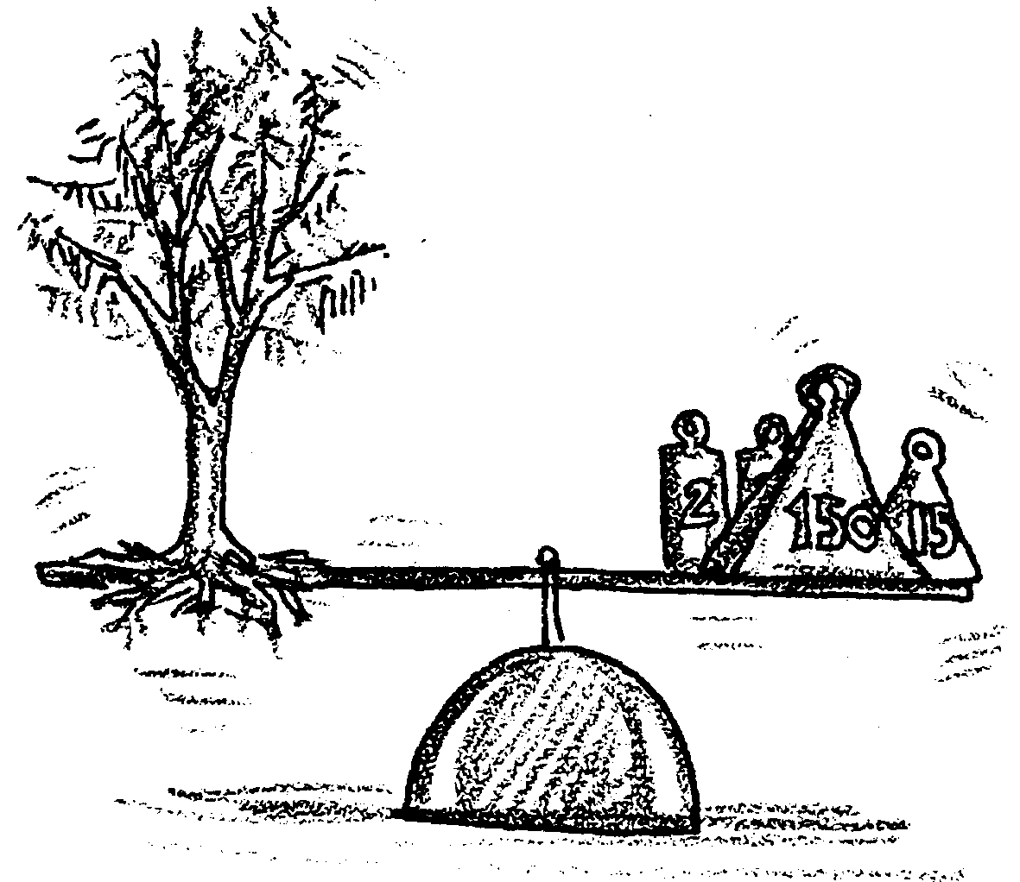
Looking For Carbon Dioxide

The Mystery of van Helmont’s Tree

Can you solve this mystery?

In the late 16th Century, Jan von Helmont, a Belgian chemist, planted a willow cutting. He weighed the cutting before placing it in the soil. It weighed exactly 5 lbs.
He placed it in a large pot and filled the pot with 200 lbs of soil. He then covered the pot so nothing could leave or enter, except when he watered the plant.
The plant was watered with rainwater.
Five years later, van Helmont dug up the tree and weighed it again. It had grown to 169 lbs. He weighed the soil and it weighed 199 lbs.

Question:
What material went into the tree to cause it to grow? Where did this material come from?
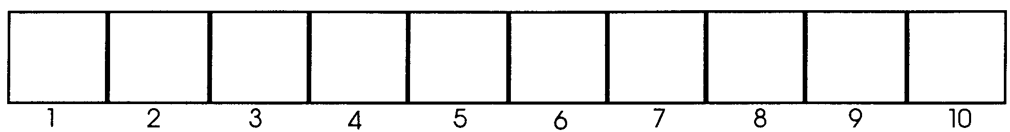
Looking for Carbon Dioxide

Preparing a color scale
The bromthymol blue test for carbon dioxide is different from many scientific tests because the results are a color change in the BTB solution. How can we record this information in a way which is meaningful to everyone? One way is to make a color scale.
The color scale should represent the total range of results possible in the air samples you test, from 0 to nearly 100%.

1. Color box #1 the color of the control BTB solution, into which no air is introduced.

2. Color box #10 the color of the gas produced by combining vinegar and baking soda. This sample should be nearly 100% carbon dioxide.

3. Color the 8 boxes between boxes #1 and #10 gradations of color between them.
Test Results
Sample Description: (Where was it taken from?)

Predicted results: (Which color box do you expect it to match

Results: Control color Sample color

Which color box does it most closely match?
How do you explain these results?

Test Results
Sample Description: (Where was it taken from?)

Predicted results: (Which color box do you expect it to match

Results: Control color Sample color

Which color box does it most closely match?
How do you explain these results?

Test Results
Sample Description: (Where was it taken from?)

Predicted results: (Which color box do you expect it to match

Results: Control color Sample color

Which color box does it most closely match?
How do you explain these results?

Test Results
Sample Description: (Where was it taken from?)

Predicted results: (Which color box do you expect it to match

Results: Control color Sample color

Which color box does it most closely match?
How do you explain these results?
Keeling’s Curve
How much carbon dioxide is there in the atmosphere? The first person who set about to answer that was Charles Keeling.
In 1953 Charles David Keeling was a young geochemist (a scientist who studies the chemistry of the earth) with a new position at California Institute of Technology. A casual remark by a fellow scientist caused Keeling to ask this question--and to begin a lifelong research project that awakened the world to global climate change.
Keeling, an avid outdoorsman, admits he had another motivation for his study—it could not possibly be done indoors!
Keeling discovered there was no instrument at that time for measuring carbon dioxide, so he would have to build one. He began by searching through old scientific papers for ideas. Eventually he invented a “manometer,” a tool so precise it could measure carbon dioxide to 5 hundredths parts per million. In the spring of 1955 he climbed out on the roof of his own laboratory and took his first sample of the earth’s atmosphere.
Keeling decided to test the atmosphere around the clock. That spring, Keeling’s wife gave birth to their first son. During the summer that followed, Keeling’s wife rose every 4 hours to feed the baby -- and Keeling rose every 4 hours to take air samples.
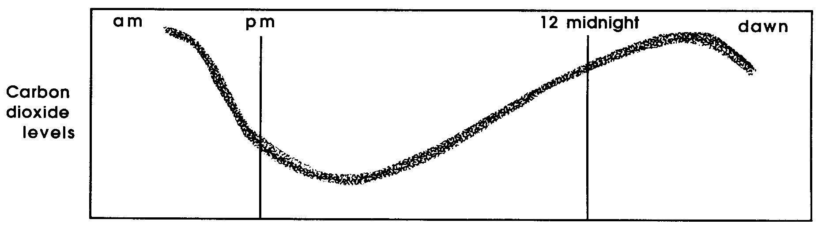
When Keeling analyzed his samples, he discovered an interesting pattern. The carbon dioxide levels in his samples rose and fell over the course of a day. Every morning as the sun came up, the carbon dioxide began to drop. It reached its lowest point in the late afternoon, but in the evening it began to rise again. All night it rose, only to fall again as the sun appeared.

1. What might explain this daily rise and fall of carbon dioxide in the atmosphere which Keeling discovered?
Keeling began taking samples from many other places. His samples soon revealed something else. Forests and cities might influence carbon dioxide levels locally. Weather patterns might affect them as well. But no matter where Keeling took his samples, they never showed less than 315 ppm (parts per million) carbon dioxide. Keeling wondered if 315 was the approximate level of carbon dioxide in the earth’s atmosphere.
Keeling soon had an opportunity to find out. He had developed a new instrument for taking carbon dioxide measurements. In 1958 he was invited to place one of these in a research station on Mauna Loa Hawaii, one of the most isolated places in the world.

2. Why do you think it was important to place this measuring instrument high on a mountain in the middle of the Pacific Ocean?

As data began coming in, Keeling discovered that his instrument was again showing a baseline level of carbon dioxide. The number was 314 ppm, very near his prediction. Keeling decided this must indeed be the amount of carbon dioxide in the atmosphere.
As more data came in, Keeling began to notice a second pattern, this one taking place on a yearly cycle.
See the pattern for yourself. Find the blank graph at the end of the chapter. (It is titled “Keeling’s Carbon Dioxide Data 1958-1970”.) Plot the following data points on the graph:

Year Carbon Dioxide in ppm
1958 318
313

1959 319
313

1960 320
314

The first measurement given for each year was taken in the winter, the second was taken in the summer.

3. What is a possible explanation for the changing carbon dioxide levels Keeling found in the atmosphere between winter and summer?
Keeling continued to monitor his station on Mauna Loa in the years that followed. The graph of his measurements has come to be known as “Keeling’s Curve.”
See for yourself the picture that has unfolded out of Keeling’s research. Add the remaining data points to your graph:

Year Carbon Dioxide in ppm
1961 320
315

1962 321
315

1963 322
316

1964 323
317

1965 323
318

1966 325
318

1967 325
319

1968 326
320

1969 327
321

1970 328
323
4. Describe the overall change in carbon dioxide concentration of the atmosphere which took place during the 12 years from 1958-1970.

5. What are some probable causes for this change?
Since the above measurements were taken, Keeling’s instruments have continued to record an ever increasing concentration of carbon dioxide in the atmosphere. By 1980, the yearly average was up to 338 ppm. In 1990, it had reached 352 ppm.
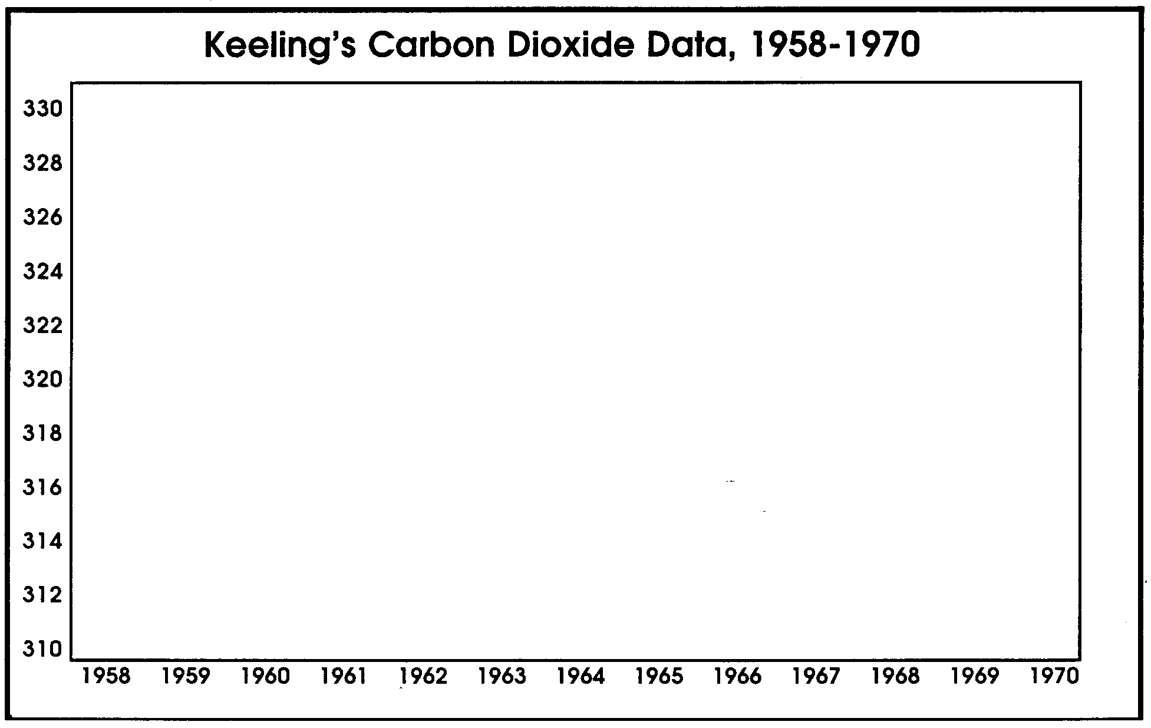
Will it continue to climb, or will it eventually level out? There are no clear answers, but the outcome will surely depend on human activities, and on choices we make in the years to come.

