What Comes In? What Goes Out?
An Investigation of Photosynthesis and Respiration in Water Plants
Lesson by Karen Mattick, Marine Science Center, Poulsbo, Washington.

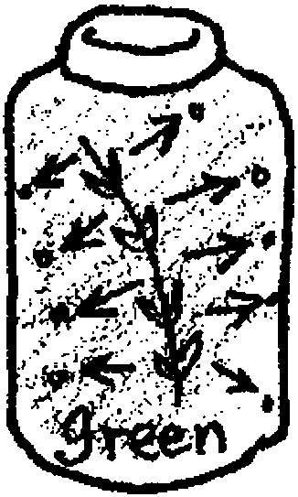
Key Concepts
1. Plants give off carbon dioxide when in the dark as a by-product of respiration.
2. Plants take in carbon dioxide when in the light as an ingredient for photosynthesis.
3. We can use a pH indicator as an experimental tool to test the activity of water plants in dark and light.

Background
Background information for this activity is found in the preceding lesson “The Earth As a Greenhouse”.

Materials
For each team of students:
For Day 1-
• 2 clear containers with lid or stopper (Size is not critical. Could be test tubes or flasks, for example.)
• enough bromthymol blue (BTB) pH indicator solution to fill both containers. Create BTB stock solution by mixing 0.5 grams BTB with 500 ml. water. This can be diluted with additional water. You will want the solution diluted enough so that it will change from blue to light green after blowing into it through a straw for one or two minutes.
• 1 or 2 healthy sprigs of aquarium plant such as Elodea or Anacharis
For Day 2-
• assorted marking pens
• scratch paper or poster paper
For Day 3-
• 1 beaker or flask containing 50-100 ml BTB solution
• one straw
• small piece of scratch paper or 3 x 5 index card
Teaching Hints
“What Comes In? What Goes Out?” is an activity in which students investigate the color changes a water plant makes in a pH solution as it respires and photosynthesizes. It is not important for students to understand pH nor to know details about respiration and photosynthesis before they try the lab. It is important for them to notice changes, to use their own experience to try to explain what they observe and to design their own experiments to test their explanations.
“What Comes In? What Goes Out?” is meant to puzzle students and interest them in figuring out just what those plants are doing in those containers to cause the color changes. After doing this activity, the students will be able to connect lectures and readings about photosynthesis, respiration and global warming to this concrete experience.
“What Comes In? What Goes Out?” will take at least 3 1/2 days to complete using the following suggested lesson plan:

Day 1 - “What Comes In? What Goes Out?”- Setting Up the Puzzle

This first portion of “What Comes In? What Goes Out?” will take about 15 or 20 minutes to complete.
1. Explain to the students that plants, especially the phytoplankton drifting in ocean currents, may play an important role in global warming. In order to understand global warming, scientists need to know a great deal about what ingredients plants take in order to stay alive and what waste products they give off. Tell the students that they will be setting up a lab to examine what plants take in and what they give off.
2. Ask each group to fill two clear containers with the blue solution. Explain that it is called bromthymol blue, or BTB, but that name is not very important to remember at this time. Caution them that BTB does stain clothing and skin.
Tell the students to add a sprig or two of water plant to one of their containers. They should seal both containers with the lids or stoppers and label them with their names or group identification.
3. Have the teams put their bottles in a dark cupboard somewhere in the classroom. If a dark cupboard isn’t available, the students may seal their containers with black plastic.

Day 2 - What Happened?
1. Have the student teams retrieve their containers and examine them. The blue liquid in the container with the plant should have turned green overnight. (The plant respired, giving off carbon dioxide (CO2). The CO2 lowered the pH in the container causing the pH indicator to change from blue to green.) The blue liquid in the container without a plant should still be blue.

2. Ask students in each team to talk with each other and write on an overhead transparency, chalkboard or poster paper a sentence or two explaining why they think the BTB turned green in one bottle and stayed blue in the other.
Accept all the groups’ explanations. Some students may write explanations that mention photosynthesis or respiration. Though some students may understand these processes well, many others may use those names as abstract explanations without understanding in any concrete way what has happened in the containers. Other students may suggest very concrete explanations that do not connect with photosynthesis and respiration at all. For example, they may write that the green color from the plant bled into the BTB and turned the liquid green. This wide variety of explanations is acceptable and, in fact, welcome. It will give you a lot of information about what the students already know.

3. Give each group a few marker pens and some paper. Tell the group to select one person as the scientific illustrator and to give that person the pens and paper.
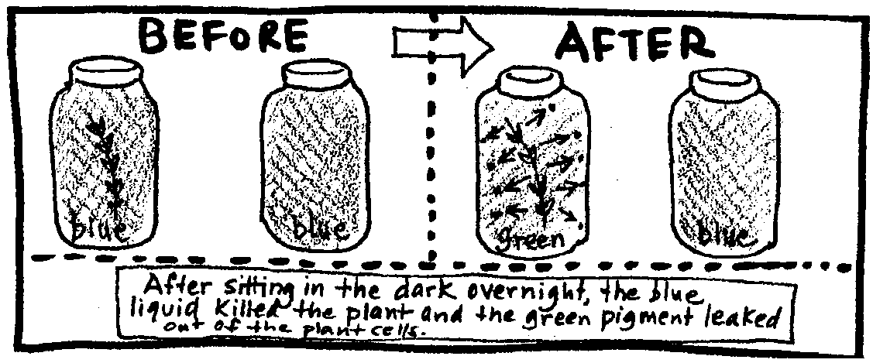
Display one team’s hypothesis about the BTB color change and ask all the teams to tell their scientific illustrators how to draw a picture that depicts this first hypothesis. You may want to suggest that they literally draw pictures of the bottles before and after they sat in the dark and then draw inside them what the hypothesis suggests happened overnight.

Explain that they should draw the hypothesis as it is written even if they think it is incorrect. You may sense some tension as some students desire to correct the hypothesis; from your point of view as the teacher, this is desirable because it means the students are thinking critically about what the explanation means. They will be more open to new hypotheses and to revising or defending their own.
Circulate around the room observing the groups’ drawings and helping them get started.

4. Now ask the teams to select new illustrators. The rest of the team members will now help those illustrators draw diagrams of a second hypothesis. Continue this process until the teams have illustrated all the various explanations the class created. Circulate around the room and listen to the students asking questions and critiquing the hypotheses, and, in essence, thinking in much more depth about what happened in their containers overnight. It is likely that they will start to make more precise definitions of words used in their explanations.

5. If you have time left, ask each team to write a new hypothesis or polish their original one and post it or turn it in.

6. Finally, have each team place their bottles in a sunny location or under bright light.

Day 3 - More Evidence
1. Have the students retrieve their containers from the lighted location. The BTB in all the bottles should be blue again. (The water plant, now in light, is photosynthesizing, taking in the CO2 it produces in respiration. This increases the pH, turning the BTB back to blue.)

2. Ask each team to use this new piece of information to revise or support their hypothesis from the day before. The goal is to explain what is happening in the containers in the dark and in the light. Why are the color changes happening?

3. Share with the students that you know of another way that BTB can change color. Give each team a straw and beaker or flask with 50 ml - 100 ml or so of BTB. Have someone at each team blow through the straw into the BTB. You may want to have the students make a shield so the BTB will not bubble over and stain their clothing. To make a simple shield, have them place a piece of scratch paper or a 3" x 5" card over the top of their beaker and punch the straw through the paper. Tell the students to keep blowing until the BTB stops changing color.
The BTB should turn green or yellow-green. (The C02 the students exhaled into the BTB will lower the pH, turning the indicator green.)

4. Ask the students what they added to turn the BTB green. Even at the high school level, the students may be confused about whether they exhale oxygen, carbon dioxide or something they vaguely call “air”. This may be a time for you to be quiet and allow the students around the room to decide amongst themselves what they exhaled into the BTB. After the discussion is complete, correct any misconceptions and proceed.

5. Tell the students they may now use the BTB, the water plants, the containers, the dark and light locations and the straws to create an experiment to test what is going in and out of the plants. Explain that you had them change just one variable- whether the plants were in the light or the dark. Ask them to think of another change they could make to test their ideas about the plants’ activity. Allow them time to set up their experiments.

Day 4 - Sharing Experimental Results
To finalize “What Comes In? What Goes Out?”, choose a format or variety of formats for your students to share the results of their experiments. You may want them to write papers describing their hypotheses, experimental set-ups, data and conclusions. Possible alternatives include creating posters or displays or giving oral presentations.
As the students move ahead into activities about global warming and learn more about photosynthesis and respiration, you may refer back to this lab. For example, if the students are learning the formula for respiration, you can explain that the symbols represent what they saw happening in their BTB. They will have mental images of the process to go with the symbolic formula.

Key Words
bromthymol blue - a pH indicator solution

pH - a symbol reflecting the hydrogen ion concentration of a solution; a measure of the acidity of a solution

photosynthesis - a process which occurs in the presence of sunlight in which six carbon dioxide molecules (CO2) and six water molecules (H20) are combined to yield one molecule of a simple sugar (C6H1206) and six molecules of oxygen (02)

respiration - the energy-producing process by which a living organism or cell obtains oxygen from the air or water, distributes it, uses it for oxidation of food materials, and gives off carbon dioxide

