The Earth as a Greenhouse
Written by Judy D’Amore, Marine Science Centers Port Townsend and Poulsbo, Washington.


Key Concepts
1. There is a natural greenhouse effect caused by gases in the atmosphere which keeps the Earth warmer than it would be otherwise.
2. Like the roof of a greenhouse, certain trace gases in the Earth's atmosphere trap heat energy and delay its escape from the planet, causing global warming.
3. Scientists are concerned because the concentrations of these " greenhouse" gases in the atmosphere have been increasing.

Background
Global Climate Change
In this unit, students have studied the patterns and the causes of the great ocean currents which join all the world’s oceans. They have observed the drifting plankton and examined the global role currents play in moving and nourishing plankton populations. They know something now about the importance of plankton as the first links in the food chains which nourish jellyfish, sharks, pelagic fish and marine mammals, the animals who traverse the open ocean. The Currents unit now closes with a last look at the oceans from this global perspective. This section explores global climate change.
There is no firm consensus on how the oceans may mitigate or exacerbate the increase in greenhouse gases in Earth’s atmosphere nor is there consensus on how the increase in greenhouse gases will affect the oceans. Many scientists, however, are concerned that changing weather patterns may alter ocean currents. Melting polar ice may create freshwater lenses near the poles which will slow or stop the great rivers of water that move polar water toward the equator. Altered weather patterns may prevent upwelling and thus threaten marine food webs. These changes could have far reaching impacts on marine life.

The Earth as a Greenhouse
An alien visitor arriving in our solar system might notice three similarly sized planets, all about the same age, all made of roughly the same chemical constituents, and all with similar orbits around the sun. Yet on closer inspection, one planet, Mars, would be found to have an average temperature of 10°F below zero, far too cold for life as we know it. The middle planet, Earth, averages a comfortable 59°F. Meanwhile, Venus, the third planet, is a scorching 900°F! Although Venus is the closest to the sun and Mars the farthest away, their distances alone do not explain such extreme differences in temperature. Scientists sometimes call this the Goldilocks problem: Why is Mars too cold, Venus too hot, and Earth just right? They believe the answer lies in the enormously different atmospheres of these three planets.
Mars is thought to have been more like Earth at one time. Scientists think it was once much warmer, it may have had liquid water on its surface, and it had a much thicker atmosphere. But for some reason (perhaps because of its smaller size and lower gravitational force) it has lost most of its atmosphere. There is little carbon dioxide in the atmosphere of Mars; most is locked up in the planet’s interior or frozen in the form of “dry ice”.
The atmosphere on Venus is extremely dense, with a pressure on the planet’s surface 100 times the air pressure on Earth. The thick cloud cover completely obscures the planet within. Under such a deep shadow, one would expect freezing temperatures on the planet’s surface, but clearly this is not the case. Venus’s atmosphere is composed largely of carbon dioxide and water vapor.
Earth’s atmosphere forms a relatively thin layer on the surface of our planet. Although it extends upwards 30 miles, over 90% of the atmosphere is under 10 miles from the Earth’s surface. Earth’s atmosphere is composed of nitrogen gas (78%) and oxygen (21%). Other gases, including carbon dioxide, account for less than 1%. This balance of gases keeps Earth at a temperature about 60°F (33°C) warmer than it would be otherwise.
How does the atmosphere regulate our planet’s temperature? Energy arrives from the sun in the form of short wave radiation, which includes visible light. It passes through the transparent atmosphere and strikes the Earth. Some may be reflected away again as visible light, some warms the Earth, and some is radiated as heat energy or infra-red radiation back through the atmosphere into space. If the Earth had no atmosphere, the energy would escape almost as quickly as it arrived, and the temperature on our planet would be similar to the temperature of Mars.
On a planet with an atmosphere like the Earth’s the energy does not escape so easily. Instead, the infra-red radiation is absorbed by certain gas molecules which delay its escape into space. The retention of heat energy in the atmosphere keeps the planet warmer than it would be otherwise. (See diagram #1, on the following page)
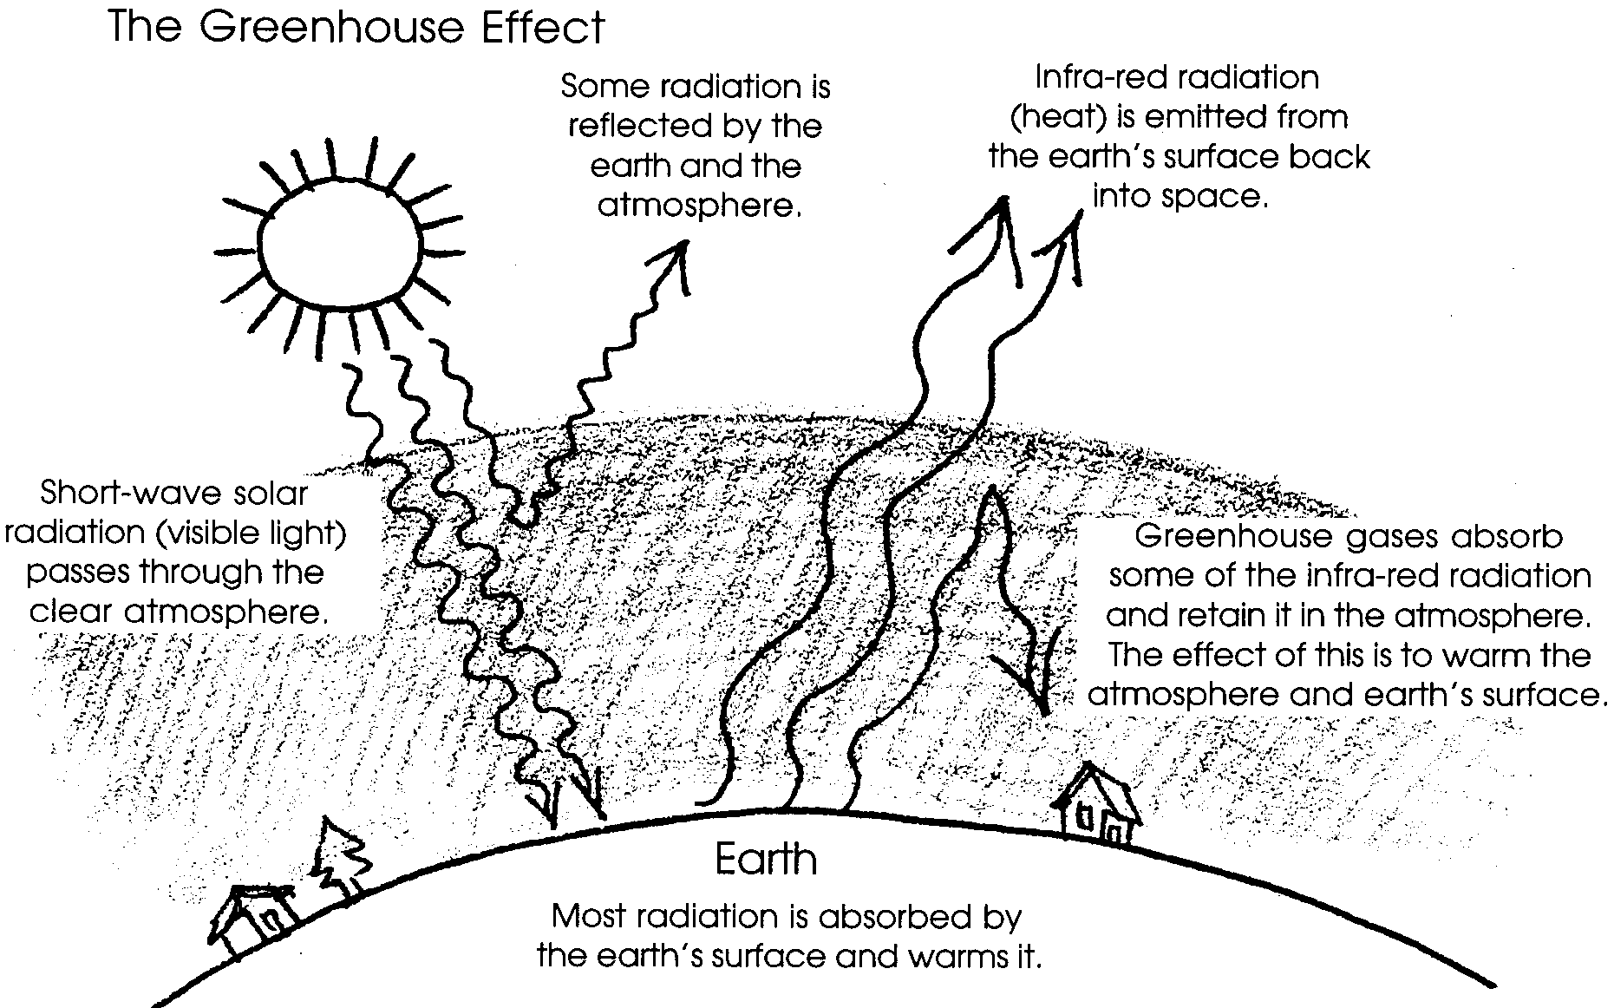

Not all gases produce the greenhouse effect. Gases which trap heat in the atmosphere are called greenhouse gases. They include carbon dioxide (CO2), methane (CH4), nitrous oxide (N2O), and chlorofluorocarbons (CFCs). The first three occur naturally in the atmosphere as trace gases, but their presence has increased sharply over the past half century. CFCs have been measurable in the atmosphere only since the 1930s. The higher concentrations of these gases are undoubtedly the result of human activity, i.e., the burning of fossil fuels, global deforestation, livestock and agricultural production, and chemical products of an increasingly industrial world. Water vapor is also a greenhouse gas, but we know little about the extent of our impact on its presence in the atmosphere.
There is little argument among scientists that the composition of the atmosphere is changing. Unfortunately the implication of these changes is beyond the reach of a simple experiment. How much excess carbon dioxide is absorbed by the ocean? Do higher concentrations of CO2 in the atmosphere stimulate faster plant growth, helping to offset the increase? Do some gases counteract the effects of others? How will changes in atmospheric composition affect the Earth’s cloud cover, altering the proportion of solar energy that is reflected before entry? Might higher temperatures in polar regions increase precipitation, expanding the snowpack and causing an earlier return to an Ice Age. These are some of the unanswered questions that keep scientists from making firm predictions. Yet few scientists are in doubt that humans are carrying out a large-scale experiment on the Earth’s life support system.

Materials
For class of 32:
• overhead transparency of “The Greenhouse Effect”
• 4 labels for players in Greenhouse Gases simulation, duplicated from masters included in lesson onto tagboard or stiff paper
Visible Light The Earth’s Surface
Infra-red Radiation Carbon Dioxide

For each group of 3–4 students:
• two clear plastic 2-liter soda bottles, tops cut off (You may decide to have students cut the tops off. If so, an exacto knife is needed to start the cut, although sharp scissors can finish the job.)
• soil for 2" layer on bottom of each soda bottle
• two thermometers, preferably 6" long, backed with plastic, metal, or cardboard
• tape to fasten thermometers to inside wall of bottles
• two pieces of thin cardboard or tagboard to shield thermometer bulbs from direct light
• one piece plastic wrap and rubberband for covering one of the bottles
• light bulb mounted on swivel clamp, firmly clamped to ring stand weighted with a heavy stack of books, or a block of wood, and accessible to a power outlet
• ruler
• 4-5 fine tipped marking pens of varied colors
• one data sheet
• graph paper for each student, or if you prefer, one piece of butcher paper about 3' long per group

Teaching Hints
This lesson and the following four lessons examine how the greenhouse effect works and how plants take in and produce the major greenhouse gas, carbon dioxide. Students look for and measure human sources of carbon dioxide. Finally, they analyze scientists’ current understanding of global climate change.

Part 1: Introducing Global Warming

1. Have groups of students work together to list as many facts as they can about global warming and the greenhouse effect.

2. Ask each group to share one idea their group generated. Accept all ideas, but watch for contradictory information. If some students ideas are in conflict with ideas of others, point out that scientists are not in complete agreement on global warming either. Hopefully some of these differences can be resolved in the activities which follow.

3. In their groups, have students brainstorm things they don’t know about global warming. Once again, have groups share ideas with the class, while you record questions they have raised. Post this list on the wall for future reference.

4. Encourage students to watch for news articles to share and discuss which relate to global warming and the greenhouse effect.

Part 2: Making a Model Greenhouse Activity

1. Tell students that when scientists study processes that take place on a global scale, such as the greenhouse effect, they often make use of models. Is the Earth really like a greenhouse? Let’s make a model of a greenhouse to find out how one works. Then we can decide how a greenhouse is similar-and different-from the Earth itself.
This experiment will look at what happens to the temperature of a greenhouse when light shines on it.

2. Direct students to tape the thermometers on the inside of the bottles, facing out. Have them put 2" of soil in the bottom of the bottles. Cut and tape the cardboard as needed to form a shade over thermometer bulbs. Cover one bottle with plastic wrap, secured with a rubber band. Leave the other bottle open.
Have students use the ruler to position bottles equidistant from the light source (1/2" to 1"), with thermometers facing away from the light.

(See the diagram on the following page.)

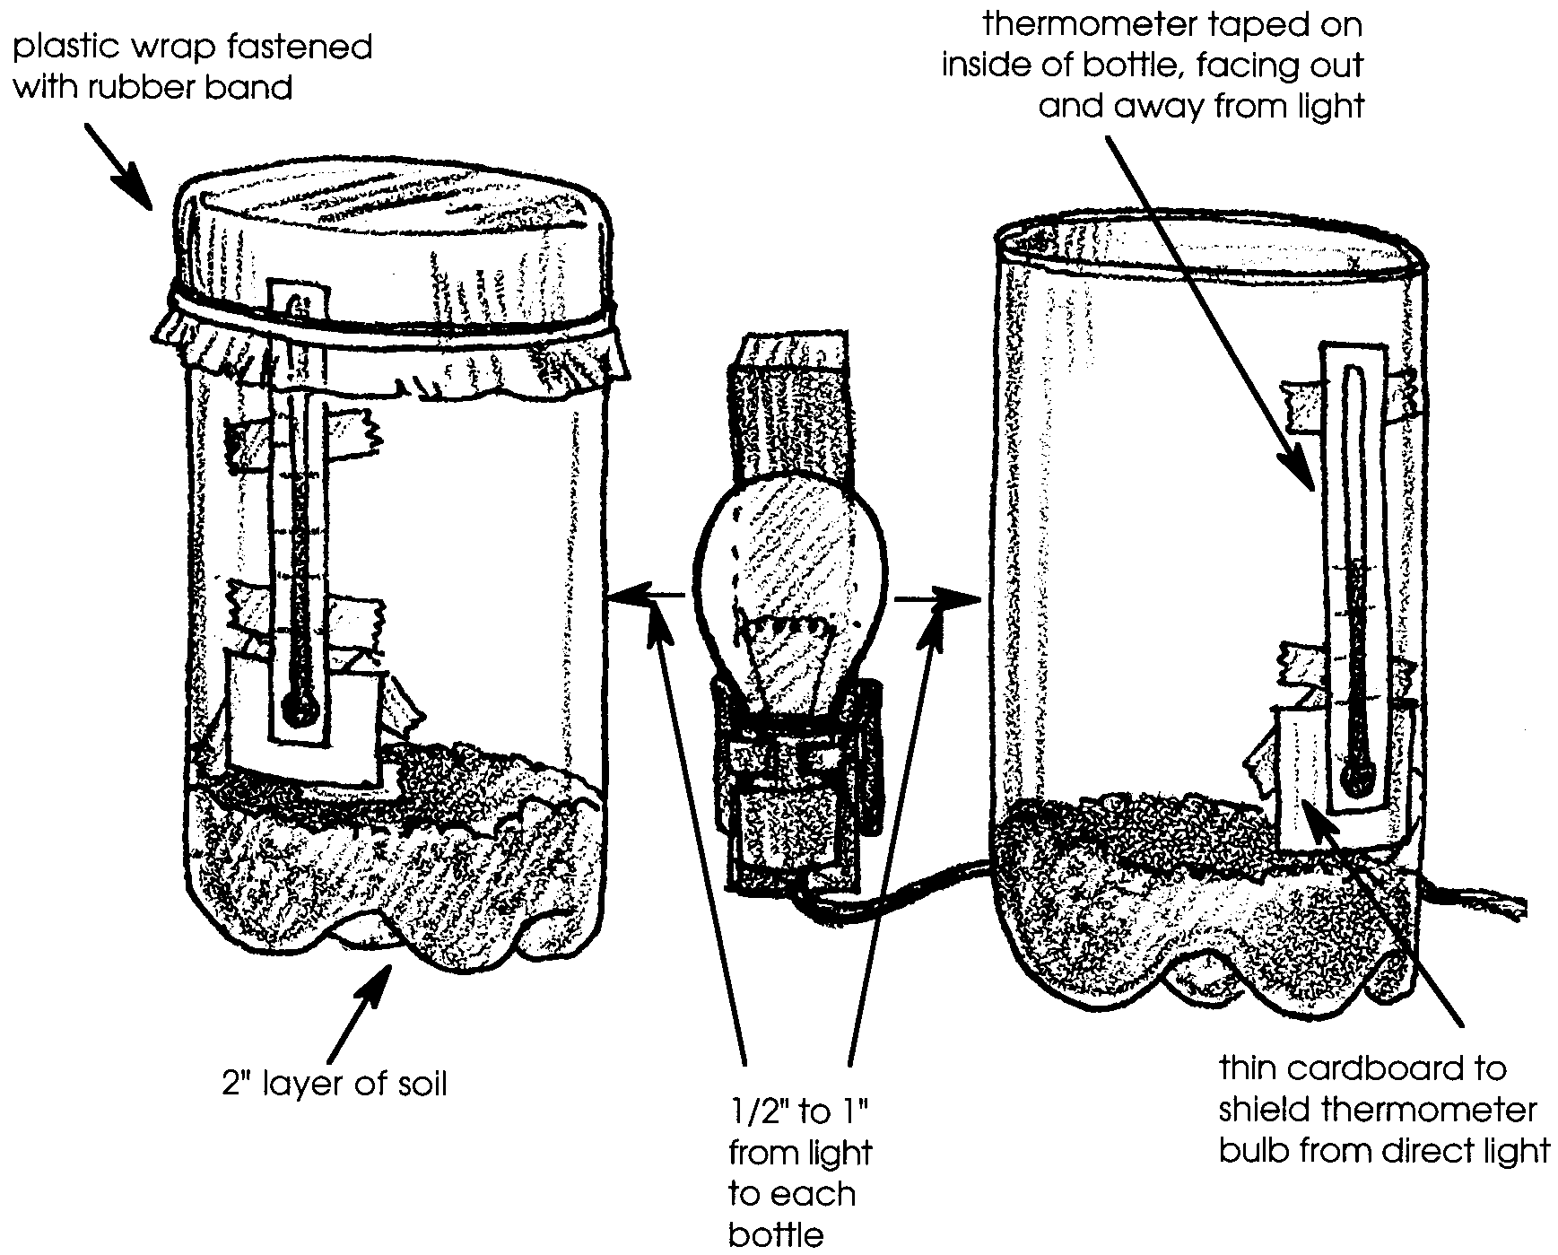
3. When the apparatus is ready, have students turn on the light and begin recording the temperatures inside the bottles. They should make records on their data sheets every minute for 20 minutes. To facilitate simultaneous recording, one student can be timekeeper, one can be recorder, and two students can read the two thermometers.

4. Have students develop graphs of their data. (For ease in viewing graphs you might have each group produce a large graph on butcher paper.) They should use pens of two different colors to indicate the temperature curves in the two different bottles.

5. Ask a representative of each group to report the results of that group’s experiment to the class. Groups may report slightly different results, but most should see the temperature in both bottles rise and then stabilize. The covered bottles, however, should rise to a higher temperature before stabilizing.
6. Give the students the following questions to discuss and answer in their groups. Have one person in the group write down the explanation of the group’s answer to each question:

A. Why did the temperatures rise in both the bottles? (Energy from the light bulb warmed the soil in the bottles.)

B. Why did the temperatures stop rising after a period of time? (Heat was also able to leave the bottles. Eventually the energy coming in and the energy escaping reach a balance or equilibrium.)

C. Why did the covered bottle reach a warmer temperature than the open bottle? (The covered bottle was able to absorb and retain more heat than the open bottle.)

7. Have one person in each group share that group’s responses to these questions, and discuss their interpretations as a class.

Part 3: The Earth as a Greenhouse

1. Ask students to tell you what the equipment in the greenhouse model corresponded to on the Earth and its real environment. (The light bulb was the sun, the soil and the air in the bottle was the Earth and its atmosphere.)
Ask students how the greenhouse model is different than the real Earth. (The atmosphere of the Earth isn’t covered with plastic. Air on Earth can move around, and so can heat.)

2. Tell them, “Let’s look at the real atmosphere to find out why it behaves like the air in a greenhouse even though it has no cover.”
Draw a cross section of the Earth on the chalkboard or overhead. Have students guess the thickness of the atmosphere in the scale of your diagram. (It will generally be less than the thickness of the line representing the surface of the Earth! The Earth’s diameter is about 8,000 miles, and 90% of the Earth’s atmosphere falls within the troposphere, extending just 10 miles above the Earth’s surface.)
Ask students if they know what gases make up the atmosphere. (The atmosphere is 78% nitrogen and 21% oxygen. All other gases make up the last 1%. These include the gases we call “greenhouse gases” because they contribute to global warming.)
Ask if students can name any of the greenhouse gases. (Greenhouse gases include water vapor, carbon dioxide, methane, nitrous oxide and chlorofluorocarbons.)

3. Tell students you’re going to take a look at how the Earth traps heat through the greenhouse effect. You may first want to provide students with more information on radiation, or you may simply explain that visible light and infra-red radiation are each forms of energy of different wavelengths. Use Diagram #1 The Greenhouse Effect to introduce the heat-trapping properties of our atmosphere. Or if you prefer, follow the sequence below for a simulation activity which models the greenhouse effect.

Simulation Activity
Give one student a card labeled Visible Light and have her stand at one side of the room, representing the sun’s energy. Give a second student a card labeled The Earth’s Surface, and have him stand at the other side of the room. Keep the other two cards handy.
Tell the class they first will consider what would happen if the Earth had no atmosphere. Have the student representing light from the sun walk toward the student representing the Earth and touch him. Explain that when visible light strikes the Earth the energy is transformed to heat. The heat excites the molecules on the Earth’s surface, causing them to move around more rapidly. (Have the student playing the Earth shake his body briefly.)
Now the energy is no longer in the form of visible light, but in the form of heat, or infrared radiation. Pull out the card labeled Infra-red Radiation, and trade it to the student representing energy in exchange for the Visible Light card. Explain that on a planet with little or no atmosphere such as the moon or Mars, infra-red radiation will soon radiate back into space. This planet is only slightly warmed by the sun’s rays.
If, however, it encounters one of the greenhouse gases in the atmosphere something very different happens. Have a third student come up and give her the Carbon Dioxide card. Have the student with the Infra-red Radiation card walk toward her and touch her. Explain that the chemical bonds in Carbon Dioxide readily absorb Infra-red Radiation, and when they do, their molecules are warmed. (The student may shake her body to dramatize this.) Eventually Carbon Dioxide will send Infra-red Radiation on its way again, but instead of leaving the Earth’s atmosphere, it might be reflected back to Earth--or it might get absorbed by yet another carbon dioxide molecule.
For assessment you might ask students to explain:

1 a. Why did the open bottle warm up when the sun’s rays hit it?

b. Why does a planet with no atmosphere warm up when the sun’s rays hit it?
(In striking the dirt in the bottle, or the planet’s surface, visible light rays are changed to heat, or infra-red radiation).
2 a. Why was the temperature higher in the covered bottle than in the open bottle?

b. Why is a planet with carbon dioxide in its atmosphere warmer than a planet without such an atmosphere?
(In both cases, the heat is trapped longer before it can escape.)

Key Words
chlorofluorocarbons (CFC’s) - synthetic chemicals made from carbon, fluorine and chlorine. They have been used in some foams and insulation, also in refrigerants and industrial solvents. CFC’s are thought to cause thinning of the ozone layer. They are also greenhouse gases.
equilibrium - state of balance or stability where two opposite processes are occurring simultaneously at an equal rate
fossil fuels - carbon compounds such as coal, oil, and natural gas which were produced by organisms that lived millions of years ago
greenhouse gases - gases that absorb heat in the earth’s atmosphere. The primary greenhouse gases are carbon dioxide, methane, nitrous oxide, water vapor, and chlorofluorocarbons (CFC’s).
infra-red radiation - invisible, long-wave electromagnetic radiation, felt as heat
visible light - short wave electromagnetic radiation, visible to the human eye

Extensions
1. What other variables affect the temperature inside a greenhouse? Would it make a difference if the soil inside were wet or dry? What if there were water inside instead of soil? What if part of the greenhouse were painted white? Black?
Have student groups choose a question to explore, propose a hypothesis, and then develop an experiment to test the hypothesis. Help students understand the importance of including a control in their experimental procedure.
2. How would the temperature inside a bottle greenhouse be affected if it were filled with carbon dioxide, a greenhouse gas?
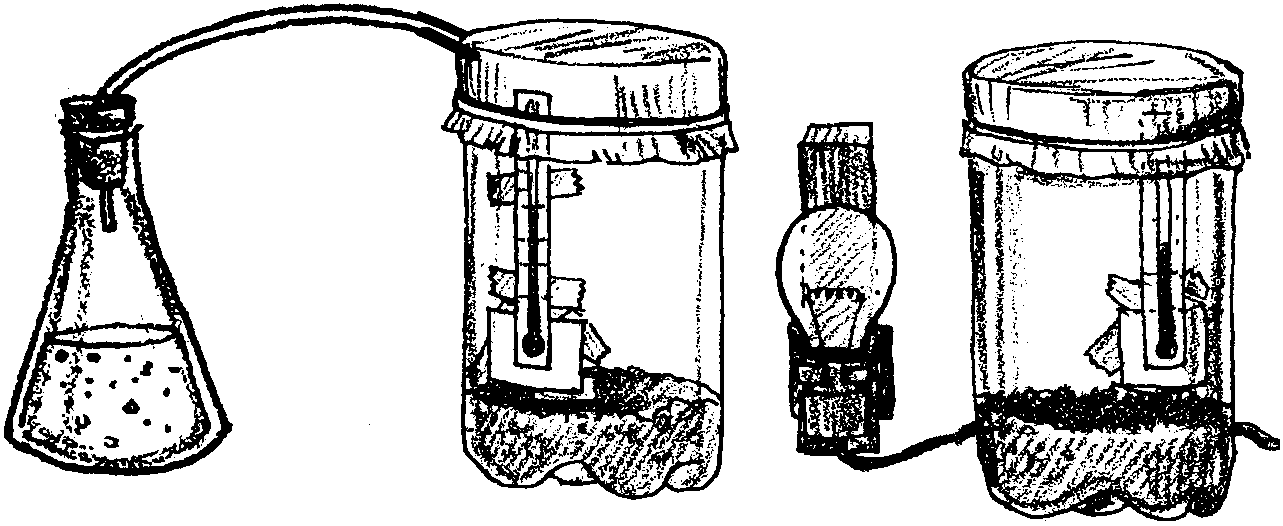
To explore this question, either as a demonstration or as a student project, set up an experiment using two closed greenhouse bottles, one containing ordinary air and the other filled with carbon dioxide. Carbon dioxide is the gas released when vinegar and soda are combined. Use the equipment diagramed below to capture it in one of the bottles. Keep in mind when handling carbon dioxide that it is heavier than the surrounding air.

Set up the two bottles as before and record the temperature change over a 20 minute period. Have students graph and interpret the results.
You may prefer to do Extension activity 2 after the lesson, “Methane and You.”

References:
Sandra Henderson, et. al., Global Climates--Past, Present and Future, 1993. U.S. Environmental Protection Agency, Office of Research and Development.
Colin Hocking et. al., Global Warming and the Greenhouse Effect, 1990. Great Explorations in Math and Science (GEMS), Lawrence Hall of Science, University of California at Berkeley, CA 94720.
Carl M. Raab and Jane E. S. Sokolow, Global Warming: Understanding the Forecast, teachers’ resource manual, 1992. American Museum of Natural History and Environmental Defense Fund.
Michael L. Roa, Environmental Science Activities Kit, 1993. The Center for Applied Research in Education, Professional Building, West Nyack, New York, 10995.
Pamela Wasserman and Andrea Doyle, Earth Matters, 1991. Zero Population Growth, Inc., 1400 16th Street NW, Suite 320, Washington D.C. 20036. 202/332-2200.
Jonathan Weiner, The Next One Hundred Years: Shaping the Fate of our Living Earth. New York: Bantam Books, 1990.

Visible Light

The Earth's Surface

Infra-red Radiation

Carbon Dioxide
The Earth as a Greenhouse - Data Sheet

Time Temperature in Open Temperature in Closed
Bottle Bottle

