Whale Research—Orca Whale Photo I.D.
Written by Ardi Kveven, Snohomish High School, Snohomish, Washington.
Orca whale illustrations graciously donated by Albert Shepard. Orca whale catalogue pictures used with permission from The Whale Museum, Friday Harbor, Washington.
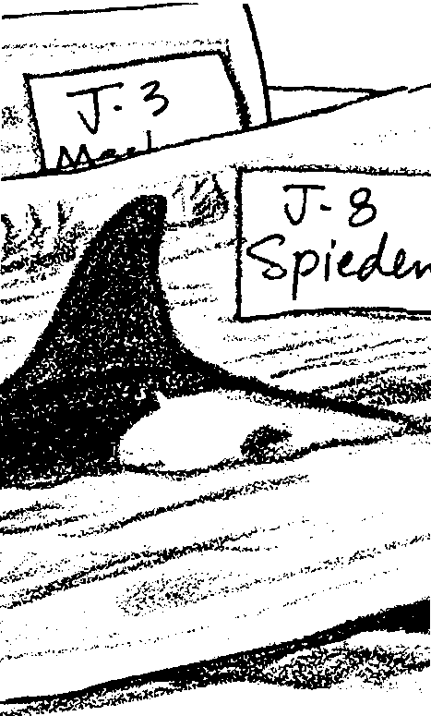

Key Concepts
1. Individual orca whales can be recognized by saddle patches and characteristic markings on their dorsal fins.
2. Population information can be derived once individuals are identified.
3. Orca societies are matriarchal; orca whales stay with their mother their entire lives.

Background
The study of the orca whales in the Pacific Northwest and Vancouver Island started in the early 1970’s when oceanariums were collecting live orca whales to display in captivity. After some 62 orca whales had been taken from local waters, residents started to worry about depletion of the population. Although government agencies monitoring the capture of the orca whales assumed the local population to be in the thousands (meaning that a decrease of 62 animals was relatively insignificant), they commissioned a population study to be conducted by Dr. Michael Bigg. Much to the officials’ surprise, there were less than 400 orca whales in waters off British Columbia and Washington. After these findings were reported in 1976, no more orca whale capture permits were issued for Washington or British Columbia waters. Most orcas now are captured in Iceland.
Dr. Bigg pioneered the photo identification of orca whales after discovering that nicks, scratches and marks on the dorsal fins and saddle patches of the animals did not heal and were as indicative of individuals as human finger prints. To test his theory, Dr. Bigg marked two notches in the dorsal fin of one male orca whale with his jackknife after it was captured by an oceanarium. The whale was later released. More than twenty years later, this male still can be seen in the San Juan Islands in the summer time and identified by his characteristic twin notches. He is known as K-1 or Taku.
Even though most government funding for orca photo-ID research has ended and other funding is very difficult to obtain, scientists continue their work. They have discovered three populations of killer whales in the waters around Washington State and British Columbia: transient orca whales, offshore orca whales, and resident orca whales.
Scientists have identified about 170 transient orca whales. These whales visit inshore waters only occasionally and are called “transient” whales because they do not stay in inshore waters for long before moving on. The transients primarily feed on seals and porpoises and tend to travel in small groups of perhaps two or three whales. Researchers can distinguish them easily from other populations of whales partly by the tall, pointy triangular shape of their dorsal fins.
Researchers discovered the offshore population of orcas only recently. They have identified about 200 offshore whales around Vancouver Island. Scientists believe that these whales spend much of their time along the continental shelf in the Pacific Ocean where rich populations of fish thrive. They travel in large groups of thirty to sixty whales. Scientists know little else about these whales, but suspect they are fish eaters.
The whales captured by aquariums and most often seen by whale watchers are resident whales, a population that now numbers around 300 whales. These orcas are called “resident” whales because they spend much of their time each year in the inshore waters along Vancouver Island and in Puget Sound hunting salmon. All of the resident whales have been identified through photo i.d. and, over time, researchers have begun to piece together an understanding of the social structure of the resident whale population.
There are two communities of resident whales which never mix. The northern community contains about 200 whales who live along the British Columbia coast. The southern community contains about 100 whales who live in the waters of southern British Columbia and Washington State. All of the whales included in this photo i.d. lesson are from the southern community.
The southern community consists of three pods, called J, K and L pods. Each pod spends most of its time traveling alone or breaking up into smaller groups called subpods. Scientists hypothesized at first that the male bulls, identified by their very tall dorsal fins (about six feet tall!), led the pods of whales. The bulls very often travel ahead or to the sides of the pods, apparently as sentinels looking for danger or for fish. It soon became clear, however, that the social structure of the pods was matrilinear. Each orca spends its entire life with its mother, so each pod is led by a few older female orcas who travel with their sons, daughters, and their daughters’ offspring. The relationships among the whales appear to be very close; family groups tend to surface to breathe at the same time, especially when resting, and each pod uses unique calls when communicating.
The life cycle of the orca whale is similar to that of humans. Females become reproductively mature at about fifteen years. They give birth to five or so young between age fifteen and age forty and then live to be about fifty years old, with some individuals living to be eighty or older.
Armed with information about how to distinguish whales, about orca society and about the life cycle of the whales, researchers have established a catalogue of resident orcas. They have assigned a letter and a number to each whale. The letter represents the whale’s pod and the number represents the individual whale. More recently, common names have been assigned.
The catalogue includes a photograph or drawing of each whale’s dorsal fin. Researchers compare new photos with the catalogue pictures to identify recently sighted whales.
Scientists also have established family trees which show the ages of the individual whales and the deduced identities of their mothers. They do not know the identities of the fathers. Researchers believe mating probably takes place between males and females of different pods during superpod aggregations when J, K and L pods mix.
The whale populations continue to change as does our understanding of their lives and our impact on their well-being. When your students finish the photo i.d., you may wish to share with them changes in the whale pods as whales die and calves are born. One of the whales in this lesson, J-3, Merlin, was seen in 1995 with a sunken blowhole, a sign of lack of food, and then disappeared. Researchers assume he has died. On a happier note, two new calves were born in J-pod in the spring of 1996. Interestingly, the white saddle patches on these calves were tinged with pink because, like many newborn humans, these calves were jaundiced. As the summer of 1996 progressed, the calves gradually lost the unusual pink color.
Studies currently are underway to assess impacts whale watching may be having on the orca whales. In the past ten years the whale watching industry in Puget Sound has grown from about a dozen boats to nearly 100 vessels. The number of pleasure boaters following the whales has increased tremendously as well. So far studies do not indicate any definitive changes in the whales’ behavior, but the commercial whale watching community has formed an alliance and is working to insure that their members observe the federal Marine Mammal Protection Act and do not approach the whales closer than 100 yards and do not harass them.
Scientists also are concerned about the impact dwindling salmon supplies may be having on the resident orca whales. Some whales are showing signs of lack of food, but this may be due to diseases as well as the possibility of salmon shortages.
If you would like to stay current on changes in the whale populations you can send for “Spirit of the Sound”, the quarterly newsletter of the Whale Museum, Post Office Box 945, Friday Harbor, WA 98250, 1-800-946-7227. The original researchers also publish a new catalog every five years or so. The current catalog is Killer Whales, by John K.B. Ford, Graeme M. Ellis, and Kenneth C. Balcomb and is available at the Whale Museum and bookstores.

Materials
For each pair of students:
Part 1:
• 1 set of 11 orca whale pictures
• “Part 1 Whale Catalogue”
Part 2:
• 1 set of 16 photos from one day of field work
• “Part 2 - Whale Catalogue”
• “Part 2: Genealogical Keys and Biographies”
Part 3:
• map of San Juan Islands
• “Part 3 Genealogical Key”

Teaching Hints
In “Orca Photo I.D.”, your students will practice comparing new orca photos with catalogue pictures. In Part 1, they will try to match 11 pictures taken in the field to a catalogue of orcas. In Part 2, they then try their hand at interpreting a sampling of one day’s worth of photographs. They will have to determine which orca whales have been photographed more than once and will have to identify some orca whales by analyzing what other whales they are associated with in the photos. Finally, in Part 3, students analyze orca whale hotline data, in which boaters and residents around Puget Sound have called in sightings of orca whales.
This activity is designed to simulate actual photo I.D. research. It is most successful after the previous activity, “The Challenges of Counting and Monitoring a Population of Whales”.
For higher quality reproduction, you may wish to have the photos copied at a professional copy center and made into sets of whale photos which you can laminate for use year after year.
Students will need feedback on how accurately they are matching orca whale photos to the catalogue. Carry the key around with you to check student answers quickly. Remind students to use both the saddle patch and notches in the dorsal fin to insure the correctness of their matches.

Key Words
genealogy - in this case, a record or account of the ancestry and descent of a group of orca whales
orca whale - the killer whale; Orcinus orca
pod - a small herd or school, especially of whales or seals

Extensions
1. Have students use the genealogy table to list the offspring of the orca whales they identified.
2. Your class can adopt an orca whale. The Whale Museum at Friday Harbor, Washington, has an adoption process that will send your class a certificate of the orca whale they choose, an information sheet and current research newsletter. The small fee goes to education and preservation. Your class may wish to adopt one orca whale for a year.
3. If you live near the Pacific Northwest coast, consider an orca whale watching trip. Contact the nearest aquarium or marine science center to locate whale watching charters.

Answer Key
Part 1:

1. Student responses will vary. Accept the students’ ideas. The upcoming text and questions will teach students the characteristics researchers use to identify whales.
2. There are six males pictured in the photos.
3. One can tell one orca from another by:
a. nicks and scratches on the dorsal fins
b. differences in the shapes and markings on saddle patches
c. tall dorsal fins which indicate adult males and small dorsal fins which indicate females and juveniles.
Analysis and Interpretation
1. Student answers will vary. Most students will be able to identify only some of the whales the first time through.
2. The southern residents pods J, K and L are represented in the photos.
3. Answers will vary. They will have different reasons for finding some whales easy to identify and other whales difficult to identify.
4. NOTE: The family trees in the student pages are partial family trees. There are additional whales in these pods. See the book Killer Whales if you would like the entire catalogue of whales. Answers continue on next page.

4. Whale Year born How old today? Who is its mother? Who are its offspring?

J-8 1933 1. J-4 (Mama)
(Spieden)
J-6 1956
(Ralph)
J-3 1953
(Merlin)
J-5 1938
(Saratoga)
K-1 1955 K-7 (Lummi)
(Taku)
K-3 1954 1. K-14 (Les)
(Sounder) 2. K-16 (Opus)

K-7 1910 1. K-1 (Taku)
2. K-11 (Georgia)
K-40 1963 K-18 (Kiska)
(Raggedy)
L-11. 1959 L-35

L-10 1959 L-12 (Alexis)
(Okum)
L-28 1949 1. L-38 (Dylan)
(Misky) 2. L-85 (Mystery)

L-38 1965 L-28 (Misky)
(Dylan)

Acknowledgments:
Whale illustrations graciously donated by Albert Shepard.
Whale catalogue pictures used with permission from The Whale Museum.

Part 2:
1. Photographs 1, 2 and 3 show male orcas. The rest of the photographs show females and juveniles. Even this step in identifying whales is difficult because the angle from which the photograph was taken can affect how tall the dorsal fin looks!
2. Give the students a few moments to try to identify the whales. Identification is very difficult without a lot of practice. Step 3 in the student pages gives the answers (i.e., The male in Photo #1 is J-6 Ralph. The male in Photo #2 is L-10 Okum. The male on the right in Photo #3 is J-3 Merlin.).
3. a. Photo #1 is of J-6, Ralph. Photo #2 is of L-10, Okum. Photo #3 shows J-1 Ruffles on the left and J-3 Merlin on the right. The students should enter the identities of these whales on the table on the next page of their hand-outs.
b. Students can calculate the age of the whales from the birthdays given in the family trees and biographies. J-6 Ralph was born in 1956. L-10 Okum was born in 1959. J-1 Ruffles is believed to be the oldest J-pod male and was in his thirties when the whale biographies were written, which was in the late 1980s. Students may estimate his birth as sometime in the late 1940s or early 1950s. (In fact, researchers estimate he was born in 1951.) J-3 Merlin was born in 1953 and was 42 years old at his death in 1995.
4. The whales swimming with Okum in the photo are either females or juveniles. If they are whales from his matrilinear group, then they could be L-12, Alexis (Okum's mother); L-11, Squirty (Okum's sister); L-42 Mozart or L-41, Mega (Okum's nephews); or L-77, Matia (Okum's niece). If students check the biographies, they will discover that Mega and Mozart now show the tall adult dorsal fin, which leaves Alexis, Squirty and Matia as the most likely possibilities.
5. Students should have grouped in one pile photos #4, 8 and 12. A second pile should contain photos #5, 9 and 11. A third pile should contain photos #6, 7, 10, 13 and 14. The final pile should contain photos #15 and 16.
1 J-6 Ralph
2 L-10 Okum
3 J-1 Ruffles J-3 Merlin
4 K-40 Raggedy
5 J-8 Spieden
6 K-7 Lummi
7 K-7 Lummi
8 K-40 Raggedy
9 J-8 Spieden
10 K-7 Lummi
11 J-8 Spieden
12 K-40 Raggedy
13 K-7 Lummi
14 K-7 Lummi
15 J-4 Mama
16 L-12 Alexis J-4 Mama

Students may decide that the photographs of Lummi and Spieden actually are of three or four other, different whales instead of those two. The different appearances are due to changes in camera angle. The tell-tale clues to the whales' identities are the two notches always apparent on Lummi's dorsal fin and the scratches on Spieden's saddle patch.
6. Your students should be able to identify 9 orcas in the photographs. There are a few additional unidentified whales in the photos.

7. The photographers saw whales from all three pods, J, K, and L.

8.a. The whale on the left is Alexis from L pod. The whale on the right is Mama from J pod.

b. These whales probably were photographed during a superpod formation in which different pods mingle.

9. It might be advantageous and even necessary for orca whales to meet in superpods for mating so that the orca whales do not interbreed within a pod and reduce genetic diversity. Males will fertilize females from other pods, passing their genetic material to another group of orca whales.

10. Students should use the genealogies and biographies to read about the whales and write down information of interest to them. This question is open-ended and is meant to generate interest in the whales. Orcas are intelligent, their life spans are very similar to ours, and their societies are complex; they are fascinating to study.
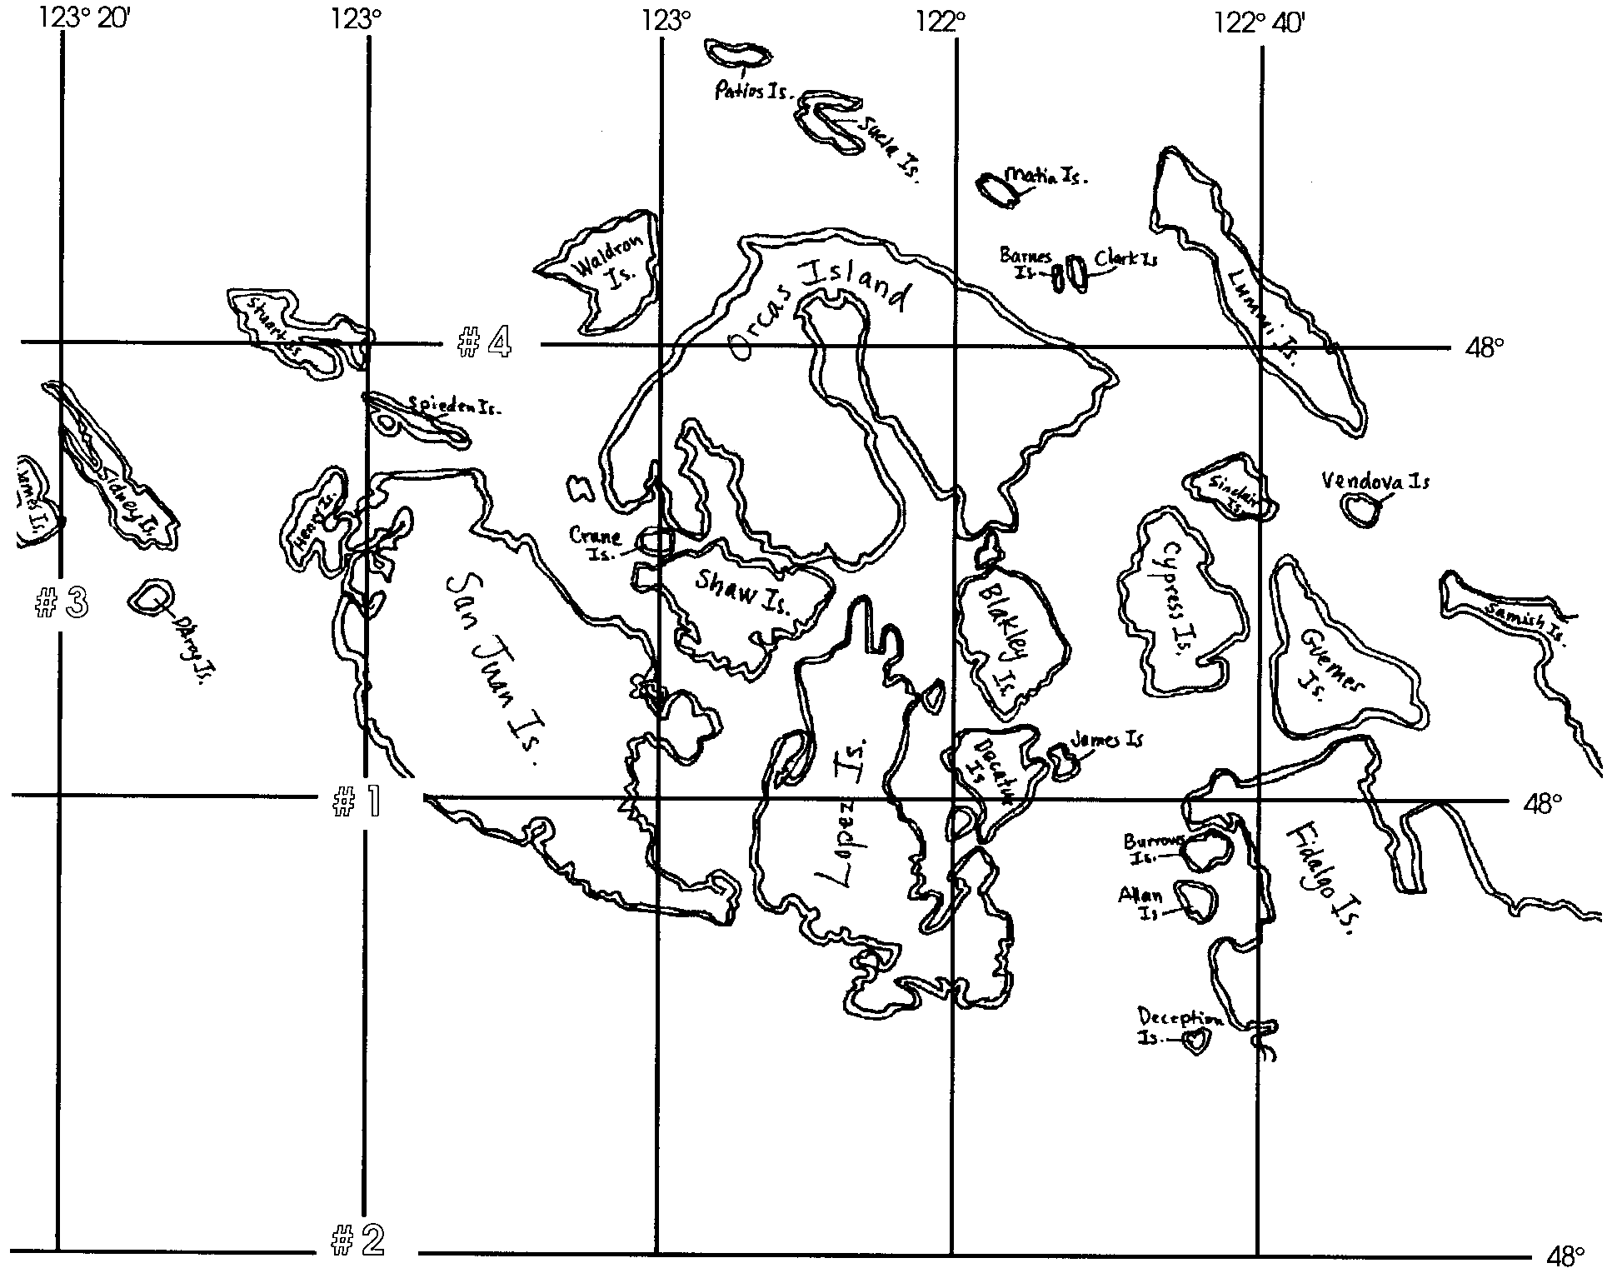
Part 3: Map with sightings:
2. a. 10:00 a.m. sighting is K-pod, Lummi’s sub-group.
10:06 a.m. sighting is K-pod, Kiska’s sub-group.
10:30 a.m. sighting is Lummi and Kiska’s sub-groups together.
11:00 a.m. sighting cannot be identified as orcas.

b. The whales spotted at 11:00 am probably were not orca calves. Orcas always travel with their mothers, so juvenile orcas should be accompanied by adult orca whales. These cetaceans most likely were Dall’s porpoises.

3. It would be best to send a photographer around the north side of the island to spot the orca whales since the whales seem to be moving northwest.

4. With over 50 orca whales present and mating activity suspected, this sighting probably was of a superpod formation in which several pods intermingled.
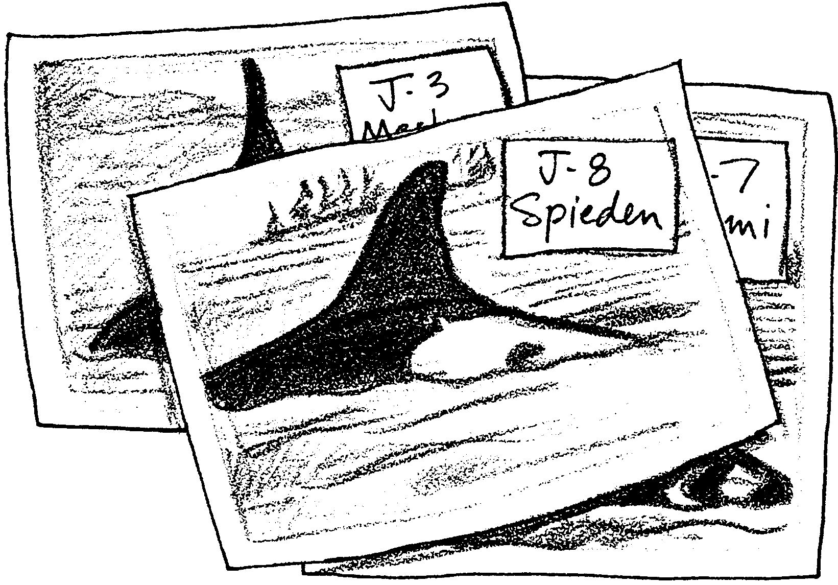
Whale Research: Orca Whale Photo I.D.

Orca whales (Orcinus orca), also known as killer whales, live in very social societies. Adult orca whales stay with their mothers their entire lives and have a development and life span very similar to our own. Wild orcas generally live to be about 70 years old.
Some orcas feed on fish while others feed on other marine mammals. In Puget Sound, in Washington state, where orca photo-ID research first began, resident orca whales travel in pods and hunt salmon. Transient orca whales enter Puget Sound from time to time, but travel as individuals or in very small groups. The transient orca whales feed on seals and other marine mammals.
You will be observing photographs of orca whales from the southern resident pods in Puget Sound and will attempt to identify each orca whale. Scientists identify each orca whale with a letter which represents its pod and a number unique to that orca whale. Many of the orca whales also have common names.
Part 1
Materials:
• set of 11 orca whale pictures
• “Part 1 - Whale Catalogue”
• Parts 1 and 2, “Orca Genealogy”
Work with a partner. Suppose that you and your partner are whale researchers and you have returned from a long day of photographing orca whales. You have developed your film and printed the best photographs. Now it is time to try to identify the whales in your pictures.

1.Carefully examine the photographs. Look for differences in the physical appearance of the whales. List three or more differences you see.

a.

b.

c.

Scientists have figured out that each orca whale has characteristics that they can use to recognize that whale. The dorsal fin may have scratches, nicks or tears. When orca whale research began in the 1970s, one scientist, Dr. Mike Bigg, decided to find out whether or not the nicks he saw in the whales’ dorsal fins persisted throughout the whales’ lives. He heard about a whale, K-1, that had been captured. (The K indicates that the whale lived with K pod, and the 1 indicates that particular whale, named 1 because it was the first whale from that pod named by scientists.) Dr. Bigg cut two large notches in K-1’s dorsal fin before the whale was let go. That whale still has those same two notches today. Look at your photographs and see if you can find a whale with two big cuts in its fin. That whale is known as K-1 or Taku.
In addition to looking at notches in the whales’ dorsal fins, you also can look at the white areas on their backs by their fins. This area is called a saddle patch. Different whales have different shaped saddle patches and some have scratches in their saddle patch that stay with them their whole lives much like a fingerprint on a person.
There is one more characteristic that will help you tell the whales apart. Male orca whales become sexually mature at about thirteen years old. As they reach adulthood, their dorsal fins grow much taller. A male’s dorsal fin can be about two meters tall (that’s about six feet)! Females and juvenile orca whales have smaller dorsal fins.

2. How many male orcas are shown in your photographs?

3. List here the three things you can look for to tell your whales apart:
a.

b.

c.
4. Now, try to match your photographs to the drawings in the catalogue. Check with your teacher after you have matched the whales to see how many you have correct and to get hints on which ones you need to try to identify again. It takes a great deal of practice to learn how to identify the whales.

Analysis and Interpretation
1. How many orca whales did you identify correctly the first time through?

2. Which pods are represented?

3. Which orca whales were easier to identify? Which orca whales were more difficult? Why?

There probably were other whales traveling with these whales you photographed. Since you know that orca whales spend all their lives swimming with their mothers in a family group, you can make some guesses about what other whales might have been swimming with the whales in the pictures.
Use the family tree to figure out who else is in the whales' families. You also can figure out the whales' ages.

4. Whale Year born How old today? Who is its mother? Who are its offspring?

J-8 1.

J-6

J-3

J-5

K-1

K-3 1.
2.

K-7 1.
2.

K-40

L-11.

L-10

L-28 1.
2.

L-38
Part 2

Materials:
• set of photos from one day of fieldwork
• ”Part 2 - Whale Catalogue”
• “Part 2: Genealogical Keys and Biographies”

On a typical day of field work, researchers may take numerous photographs and photograph the same orca whales many times. In order to get an accurate count of orca whales, they need to identify the orca whales in the photos so they know how many they photographed more than once.
They may also return to shore and find they have photos that are difficult to identify. If there are other orca whales in the pictures, however, they can deduce the names of unidentified orca whales by knowing what orca whales tend to spend time together. If one known orca is from J-pod, for example, it is very likely that whales nearby are also from J-pod and probably from that whale’s family. The one exception to this is when pods gather in superpod formations. Scientists believe these gatherings of several pods may be when males and females from different pods mate.
Obtain a set of photos taken in a day of field work, a “Part 2 - Whale Catalogue” and the “Part 2: Genealogical Keys and Biographies”. You will need this additional information to identify the orca whales in this new set of photos. Here’s what to do:

1. First, sort the photographs into two piles, one pile with all the male whales and one pile with all the female and juvenile whales.

2. You should wind up with three photographs that include male orcas: photos #1, #2, and #3. Use the “Part 2 - Whale Catalogue” to try to identify the male orca whales. (The male on the left in photo #3 is not in your catalogue; he is J-1 Ruffles, named for his very ruffled dorsal fin.)

3. Identifying whales in the field is challenging! How did you do in naming the whales? The male in photo #1 is J-6 Ralph. The male in photo #2 is L-10 Okum. The male on the right in photo #3 is J-3 Merlin.

a. Enter these whales in the table on the next page.

b. Look up these males in the genealogy and the biographies. How old are they now?

4. Take a look photo #2. Notice, there are two other whales swimming with L-10 Okum. Check the genealogy and biographies. Who might these two whales be? (There are several possibilities.)
5. Look through the photographs of females and juveniles and look for photos that seem to be of the same whale. Group these photos.

You now should have four stacks of photos. Use the catalogue to identify these whales and enter their names in the table below.
List the pod letter, number and common name of the orca whale in each photograph.

PhotoPod Letter-No. Common Name
1
2
3
4
5
6
7
8
9
10
11
12
13
14
15
16

Now, answer the following analysis questions:

6. How many individual orca whales did the scientists photograph in the field that day?

7. What pods did they see in these encounters with the orcas?

8. The two whales in photo #16 are from different pods.

a. Which pod is each whale from?

b. What might have been happening at that time to account for these whales being seen together?

9. Sometimes several pods mingle in superpods. Scientists hypothesize that the orca whales socialize and mate at these times. Why might it be important for mating to occur when several pods meet? (Remember, an orca whale spends all its life with its mother as long as its mother is alive.)

10. Look up each of these whales in the genealogy and biographies to learn more about them. Who are their relatives? How old are they? Have there been any recent deaths or births? What interesting stories have scientists learned about them?

Part 3
Materials:
• copy of map of San Juan Islands
• “Part 3 - Genealogical Key”

Because scientists cannot be on the water all the time and cannot always locate the orca whales, they have created an orca whale hotline. Anyone who spots an orca whale can call the hotline and report the sightings. The hotline welcomes reports of animal strandings and sightings of other marine mammals. It is important to note that whales and other marine mammals are protected under the Marine Mammal Protection Act of 1972. All marine mammals are protected from harassment of any kind. Boaters are required to stay 100 yards away from whales and seals and travel parallel with the slowest moving animal. Whale watchers interested in spotting orca whales for the orca whale hotline must maintain their distance from the animals to avoid disturbing them.
Because the information that comes off the hotline does not include photographs and often is provided by persons who are not trained in orca whale identification, scientists must analyze the data and try to infer what orca whales have been spotted. Try your hand at interpreting the following information from the orca whale hotline from the summer of 1993.

DATE REPORT

June 6 10:00 am Boater radioed in 6 orcas sighted at Long. 123° 10 min.
Lat. 48° 30 min. Large bull with two notches, one
young calf.

June 6 10:06 am 4 orcas, 1 bull with small notch, 1 female with tattered
edge of dorsal fin Long. 123° 10 min. Lat. 48° 20 min.

June 6 10:30 am 10 orcas, 2 large bulls, one with two notches, 1 young calf,
1 female whose dorsal fin looked torn on one edge.
Long. 123° 20 min. Lat. 48° 35 min.

June 6 11:00 am Boat radioed in pod of 6 orca whale calves bow riding on
boat. No adult whales. Long 123° 05 min. Lat. 48° 40 min.

1. Plot where all these sightings occurred on the map of the San Juans on the following page.

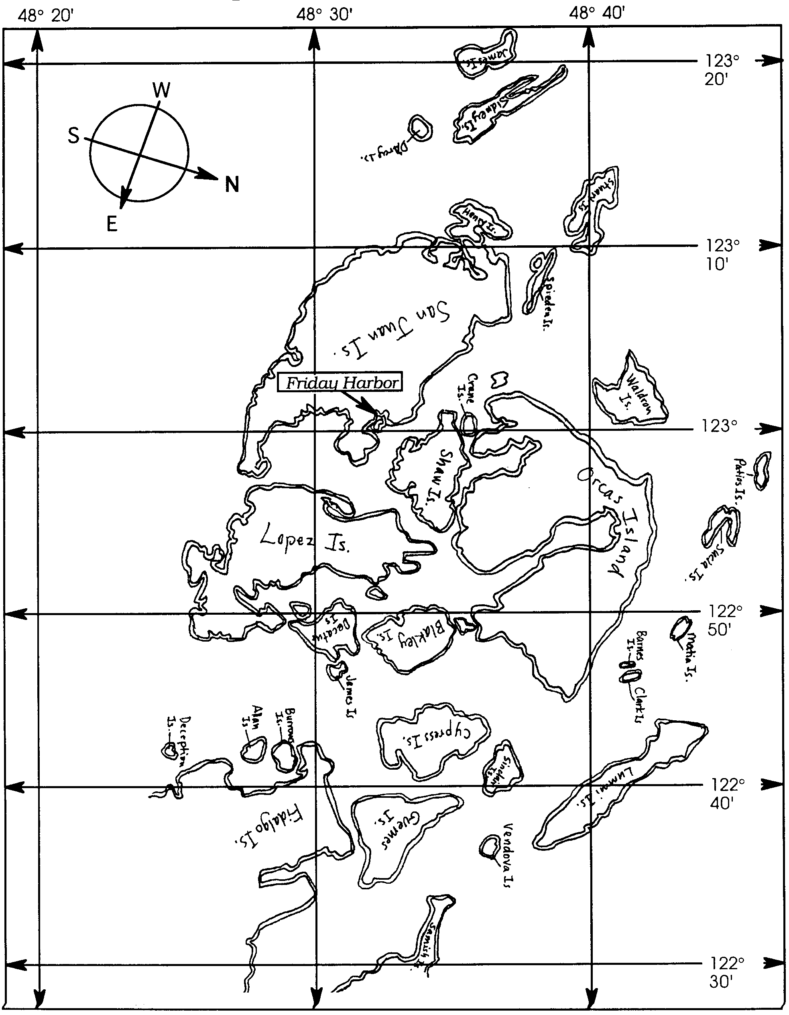
Map of the San Juan Islands, Washington
2. a. Identify the pod and subgroup of orca whales sighted in each report. You will need to use the genealogy key and any information the callers provided about the direction the orca whales were traveling.

Sighting 1 10:00 am Pod Subgroup
Sighting 2 10:06 am Pod Subgroup
Sighting 3 10:30 am Pod Subgroup
Sighting 4 11:00 am Pod Subgroup

b. Which sighting of orcas probably was not really orca whales? Explain your answer.

3. If you were to send a photographer in a zodiac from Friday Harbor on San Juan Island to confirm the identification of these subgroups, in which direction would you send her? Why?

4. Here is some more additional information:

June 26 Over 50 orca whales sited between Spieden Channel and southwest of Henry Island. Dispatch photographer to location. Lots of feeding and breaching activity. Most likely mating going on.

What kind of formation of orca whales might these whale watchers have observed?

