Whale Research – The Challenges of Counting and Monitoring a Population of Whales
Written by Ardi Kveven, Snohomish High School, Snohomish, Washington.
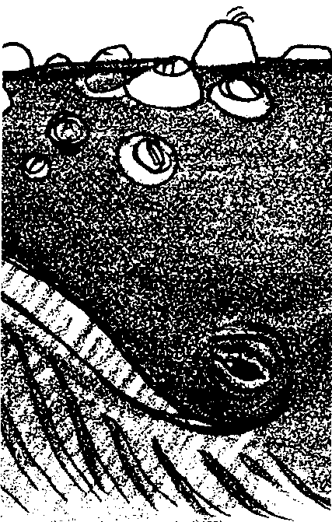

Key Concept
1. It is difficult, but possible, to identify individual whales by making detailed observations of flukes, fins or other body parts that are visible when a whale surfaces.

Background
Early information on cetaceans primarily came from whalers. Not much was known about live dolphins and whales until dolphins were captured for oceanariums and studied in captivity. Photo-ID observations of wild animals began in the 1970s and is today a widely accepted approach to scientific research.
Researchers need to be able to recognize individuals within a population so they can determine the total number of whales, typical associations, sex of individual whales and other information. The whales, however, are not always where researchers are and they do not always surface when the cameras are ready. Furthermore, typically only a small portion of the whale appears above water when the whale surfaces. Scientists have become skilled at differentiating individual whales by unique markings on the portions of their bodies that are visible above water.
Although effective, the logistics of such studies and the patterns of distribution of some cetacean species means that photo-ID studies for estimating abundance have only been practical to use on a relatively small number of species to date, primarily: orca whales, humpback whales, blue whales, and bottlenose dolphins. Abundance estimates for other cetaceans are derived from aerial or vessel surveys.

Materials
For the class:
• sheet of butcher paper, the width of one end of your classroom
For each student:
• copies of “Whale Research: The Challenges of Counting and Monitoring a Population of Whales” student pages
Teaching Hints

In “Whale Research: The Challenges of Counting and Monitoring a Population of Whales”, some students will play the role of orca whale researchers. The rest will play the role of wild orca whales. The orca whales will surface from time to time above a sheet of butcher paper. The researchers will try to determine the total number of orca whales in a simulated pod of orca whales. They will try to determine the sex of each orca whale and the orca whales’ typical associations.
Select five students to be orca whale scientists. The rest of the students will be orca whales.
Before students try the orca whale watching simulation, meet with each group of students. Tell the student orcas that they will surface from time to time. They should show only the backs of their heads above the sheet of paper representing the water. Explain that orcas travel in matriarchal groups. The students should form sub-groups and often, but not always, surface together. Ask the researchers to plan how they will record their observations of the orca whales. How will they make sure they haven’t counted a orca whale twice? How will they tell the sex of an orca whale when only the back of its head will show?
When you are ready to begin the simulation, choose a volunteer to help hold up the butcher paper at one end of the room. The five students playing the role of researchers will stand at the other end of the room. They cannot move any closer to the orca whales. Federal law requires that whale watchers not approach whales and that they maintain at least a 100 yard distance between themselves and the whales. Have the orca whales surface for 3-4 seconds at a time. They may move below the surface of the water in between surfacings.

Key Words
monitor - to observe, record, or detect with instruments that have no effect upon the object observed; to watch closely
orca whale - the killer whale; Orcinus orca

Extensions
1. Scientists also recognize orcas by their signature whistles and clicks. Have the students invent signature calls. Then have them close their eyes and try to recognize each other by listening to their greetings. Practice with one student at a time vocalizing and then simulate the noise of entire pod of orca whales calling by having most or all of the student orca whales vocalizing simultaneously.

Answer Key
1. Student answers will vary. We recognize our friends by their physical mannerisms, their physical features, their overall body build, the clothes they usually wear, and by their voices. We use contextual clues as well. We expect to see our friends in certain places.

2-7. Student responses will depend on their results.
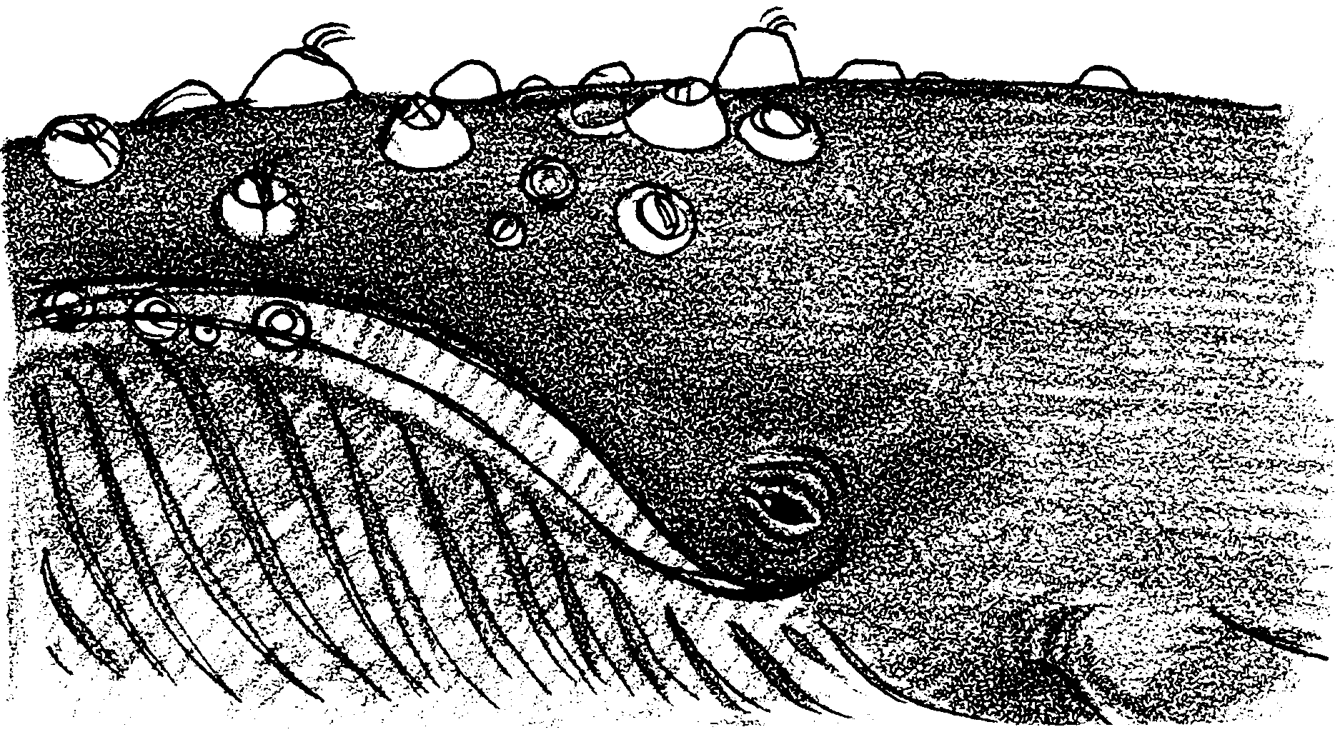
Whale Research: The Challenge of Counting and Monitoring a Population of Whales

In the 1960’s and 1970’s, oceanariums from around the world began collecting orca whales from waters around Washington state and British Columbia to use in orca exhibits and shows. Marine biologists became concerned that the wild population of orca whales might be too small to survive the loss of these orca whales. They set out to determine the total number of orcas in the region.
How do you get an accurate count of a population of animals that spend most of their time underwater? You need to do as thorough a count as possible and yet you must be careful not to count individual orca whales twice.
In this activity, you will model the data collecting process orca whale researchers use and experience the frustrations.

1. We usually recognize our friends quickly and easily. What specific information do we use to identify our friends?
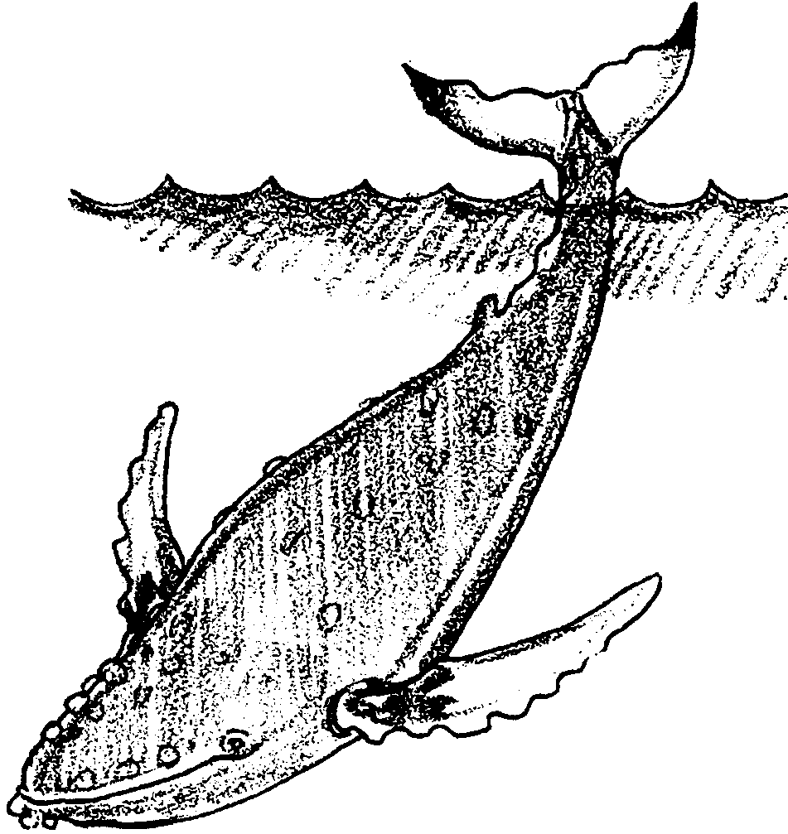
Whale researchers cannot count a whale until it surfaces. When it surfaces, they must be able to identify exactly which individual they are observing by recognizing just the part that surfaces. On a humpback whale, for example, the scientist must recognize the whale by unique patterns on its tail flukes.

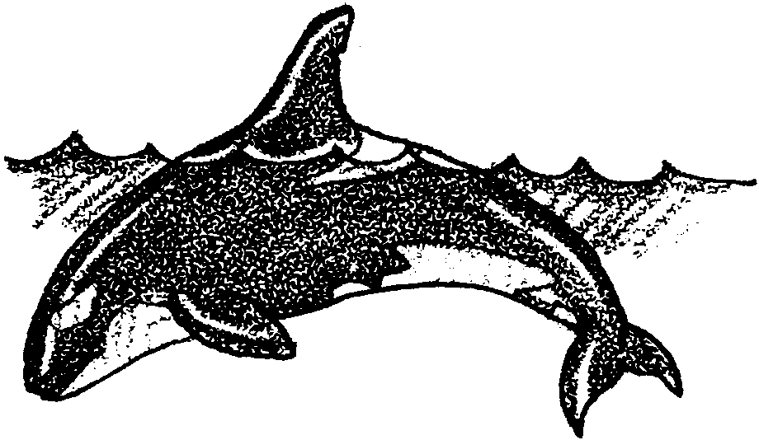

Orca whales are identified by nicks, scars and patches on their dorsal fins.

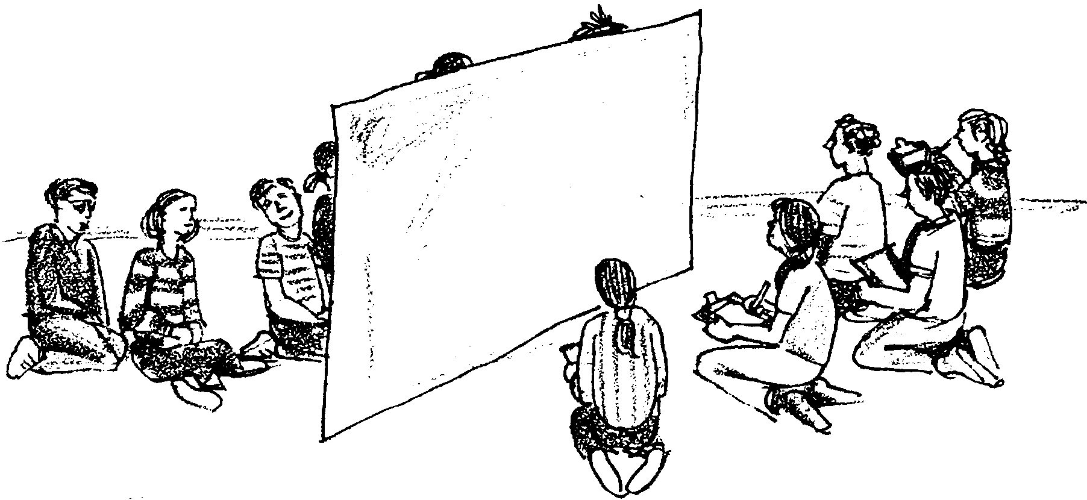
Most of the students in your class will play the role of orca whales hidden underwater by hiding behind a sheet of butcher paper. A few students will be researchers trying to count and identify model orcas.

From time to time student orcas will surface with just the BACK of their heads visible above the paper. The researchers will have only this view for the short time the orca is above water to identify the student orca.
You will have a turn being a researcher and will need to answer the following questions when you are done.

2. What characteristics did you use to tell the orca whales apart?

3. How many total orca whales did you count?

4. How many really were behind the butcher paper?

5 a. How many females did you count in the orca pod? How many males?

b. How many females and males were there really?

c. How could you tell females from males when all you saw were the backs of their heads?

6. What problems did you encounter in trying to get an accurate count of orca whales?

7. How are the problems you encountered similar or different from those experienced by whale researchers?

