The Scrimshander
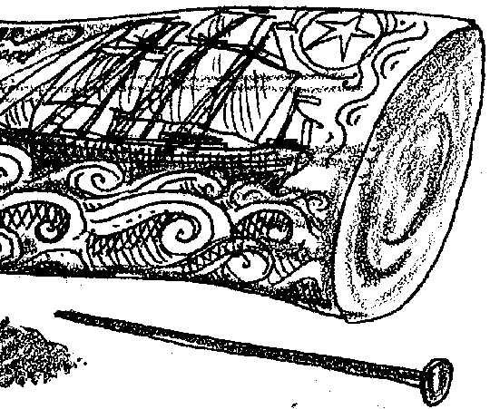

Key Concept
1. Scrimshaw is a folk art form originating on whaling vessels in which sailors carved whale teeth or bones.

Background
Whales and whaling conjure up mental images of sailing ships and days gone by. The year long whaling voyages provided ample opportunity to engage in hobbies. The range in artistic ability found in scrimshaw pieces runs from exquisite to primitive. On many whalers everyone from the captain to the lowest crewman would have a piece of scrimshaw in progress. The favored pieces to carve were teeth, baleen and walrus tusks. The baleen became elaborate corset stays, while the teeth sometimes retained their shape and other times became pastry wheels or other domestic articles. Walrus tusks were transformed into cribbage boards. The art form was so absorbing that lookouts would oftimes not report the sighting of a whale so as not to disturb their carving. Perhaps as a result, the word “scrimshander” or “scrimshanker” has also come to mean avoiding one’s obligation to work.

Materials
For each student:
• beef bone or old piano keys
• nail, compass, single edged razor blade or other carving tool
• sand paper, 2 fine papers and one coarse paper, each 4 inches square
• lamp black or charcoal, pastels chalks, crayons, etc.

Teaching Hints
“The Scrimshander” serves to introduce your students to a truly American folk art form.
In place of whale teeth and baleen, this activity uses beef bones. The activity is enjoyable and clearly reveals the patience possessed by the seamen. The techniques first appeared in the “Massachusetts Marine Educators’ Newsletter” and later in “Current, The Journal of Marine Education” (Volume 1, Number 1, Fall 1979).
Soup bones will provide the raw material for this activity. Most butchers are willing to cut the bones into 2-1/2 inch lengths for you if you explain how you are going to use them. If your butcher is very friendly, she may cut the pieces in half lengthwise so that they more nearly resemble whale teeth. For advanced scrimshanders, it is sometimes possible to find old piano keys in second hand shops. Have your students practice on soup bones before they work on piano keys.
There are two ways to prepare the beef bones:
1. Boil bones for 2-1/2 to 3 hours to remove meat and gristle. (Make soup with the broth!) Scrub bones and remove all excess meat and debris. Re-boil the bones for half an hour in a strong detergent solution to remove the grease. Pat bones dry and leave to air dry for 3 to 4 days. You may wish to speed up the process by putting them in the oven on racks to dry for a few hours.
2. Soak bones in sodium hydroxide (“lye”) for 5 days to 2 weeks to remove excess meat, gristle and marrow. Rinse in fresh water, pat dry and leave to dry for a day.
Provide sufficient sandpaper for your students to smooth the bone surfaces. One four-inch square of coarse and two four-inch squares of finer grit papers are required for each student. The choice of carving tools is limited only by your imagination. The traditional tool was the ubiquitous sailor’s pocket knife. The highlighting materials used by whalers ranged from soot from the fires used to render or “try” the oil from the blubber, to paint, to tar and India ink. Most often the pigments were black, but red, green and blue highlighting is also seen on some pieces. A variety of pigments may be used by your students. Lampblack may be found in some old, well-stocked hardware stores. Charcoal, pastels and crayons also work well. Felt tip pens tend to penetrate the bone and as a result do not work well. Let your students be as creative in their pigment choice as the original artisans. Disasters may be sanded away with a little effort!
Duplicate the activity pages. One set is recommended per student. Caution your students about the use of sharp carving tools and circulate through the room as the activity is performed to minimize the likelihood of accident. Plan to display the finished pieces (perhaps in the library or some other central location). You may provide extra bones for interested students to take home and carve. Provide resources and the incentive to follow up on the scrimshaw with reading and projects dealing with early whaling. This activity provides an excellent opportunity for favorable “P.R.” for your program and for the school. Make the most of the opportunity.

Key Words
scrimshander - one who engages in the art of scrimshaw
scrimshaw - a carved or engraved article, especially of whale ivory, whalebone or the like, made by whalers as a leisure occupation
whalebone - baleen
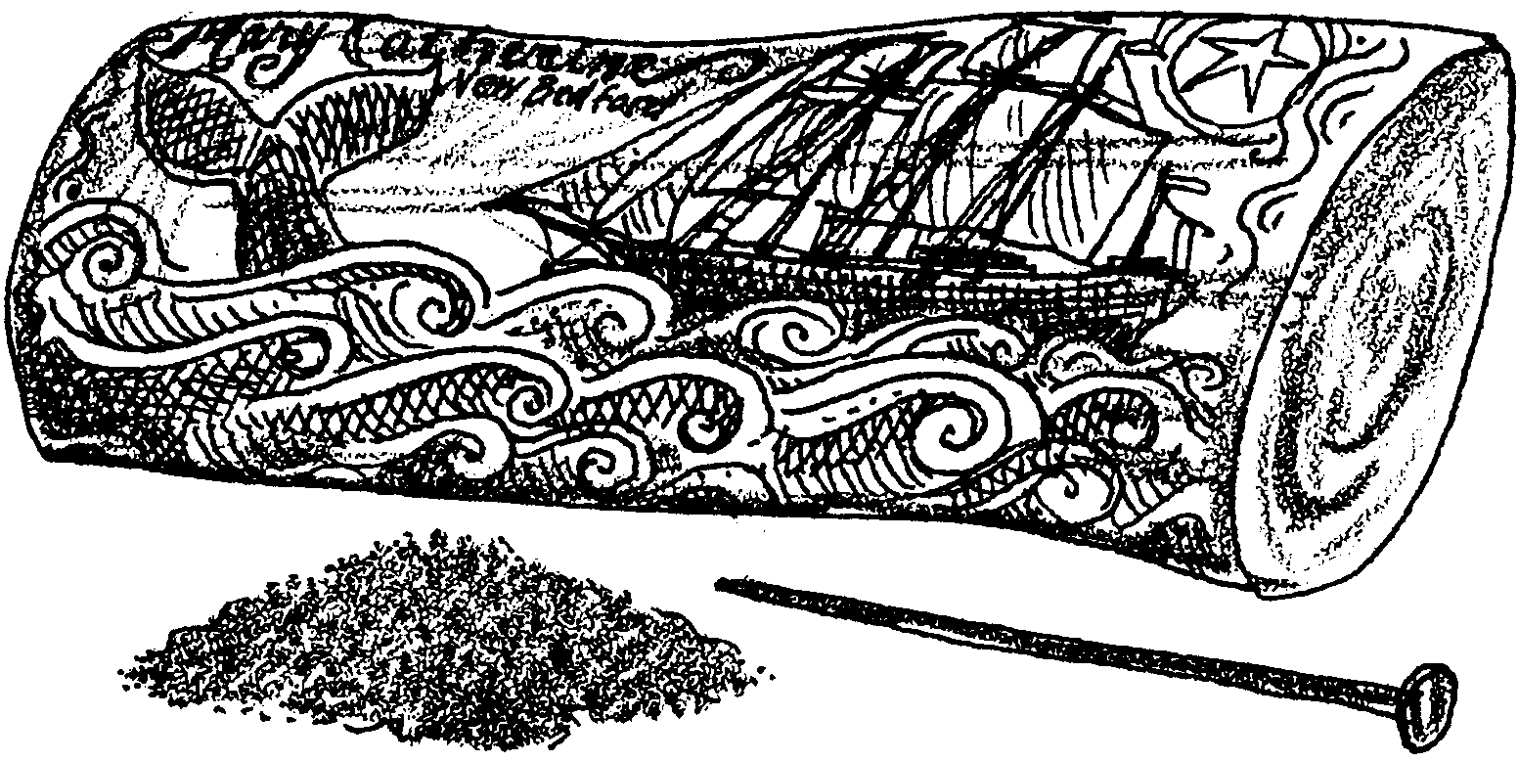
The Scrimshander

“Hail! What boat are you?”

“The Mary Catherine, one hundred and ninety days out from New Bedford bound for Greenland, in search of the whale.”

Seamen are condemned to spend a part of their lives in a very restricted place of work which they cannot leave for long periods at a time. For the sailing whalers on the Mary Catherine, the cruise had already lasted over half a year. It would probably be two, three or four years before the crew returned to their home port of New Bedford, Massachusetts. Sailing was hard work in bad weather and there was very little free time. In fine weather, the crew of a sailing ship had enough spare time to engage in various hobbies. Whalers passed the time of day carving sea scenes, initials, designs, their ship and the catch and other depictions of life at sea. The carving was done on the teeth of sperm whales or other toothed whales or on “whalebone,” the baleen of the non-toothed whales. In the following activity you will have an opportunity to try your hand as a “scrimshander”.

Materials
• beef bones
• old piano keys
• nails, compass, single edged razor blades or any type of carving tools
• sand paper (two fine papers and one coarse paper are needed; a 4-inch square of each)
• lamp black or charcoal, pastel chalks, crayons, etc.
Procedure:

1. Sandpaper the bone. Spend a good deal of time smoothing the bone. Experiment with all grades of paper for the best finish.

2. Draw a design lightly on the bone. The first time, keep it simple. It does not have to deal with whaling.

3. Carve out design with nail or other carving tool.

4. Fill in design with lamp black or other pigment. (Caution: A little lamp black goes a very long way.) Be sure to fill in all the crevices. If the design needs more carving, do it and refill with pigment.

5. Polish the bone with a soft rag for the final gleam.

6. Display your scrimshaw work of art.

