Exploiting Marine Mammals
Lesson by Barbara Baldwin, San Jose, CA

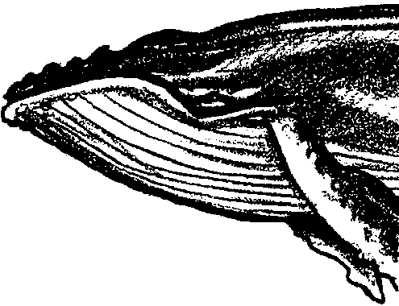
Key Concepts
1. When a resource is free for the taking, humans in modern economies tend to harvest as much of that resource as possible.
2. Issues surrounding protection of marine mammals are complex but important.

Background
The harvest of marine mammals is surrounded by controversy. Traditionally, human interaction with the mammals has caused the demise of the selected species.

Materials
For each student:

• one copy “Exploiting Marine Mammals” student pages

Teaching Hints
“Exploiting Marine Mammals” contains three major sections:
• The first section, a case study of whaling, deals with the doctrine of “freedom of the seas” and the resultant tendency for nations to over-exploit marine resources because of the “common goods problem”. The controversies surrounding whaling are a function of the common goods problem in the sense that since no one person or nation is guaranteed a return for wise management, there is no incentive to manage wisely. It is to the individual’s or nation’s best short-term interest to harvest as many whales as possible. The successes of the International Whaling Commission in regulating whaling is also examined in this section. The Commission has the mandate to manage and regulate whale harvest but little or no enforcement power.

• The second section is an historical case study of the Northern Fur Seal. The potential benefit from international cooperation in marine mammal management is examined and the fur seal situation is contrasted with management of whales.

• The third section examines the dolphin-tuna controversy. The nature of an ongoing controversy is that there are no hard and fast answers. This is likely to be frustrating for your students. The issues need to be discussed and developed. Unfortunately, the discussion does not provide the solution. “What Can You Do?” provides some concrete ways in which to approach this dilemma.
“Exploiting Marine Mammals” may be conveniently divided into three lessons. The first includes the text and questions through “Whales: A Case Study”. The second lesson includes “Northern Fur Seals: A Case Study” and “Exploiting Marine Mammals - Actions”. The third lesson includes: “The Dolphin-Tuna Controversy”. The lessons are best completed by individuals working at home or in class. After the text is read and the text questions are answered, encourage small groups or class discussion of the questions included below. These materials allow for flexibility. Use the approach that will provide the most positive experience for your students.
The following questions can provide material for group or class inquiry discussion sessions:
1. What do you feel is the future of the remaining whales?
2. What might have happened if the whaling nations had cooperated with one another more quickly and established realistic quotas and regulations? Could the decimation of populations of large whales been avoided?
3. Do you think that fixed proportions of whales could have been harvested each year? What benefits would have been guaranteed to the people of the world by doing that? Is it possible to have a sustainable harvest on a population of whales?
4. What powers could have been given to the International Whaling Commission to enforce its regulations?
5. How does the treatment of the seal differ from that of the whale?
6. Why can nations agree to protect one but not the other?
7. What had to take place before the nations would act to protect the seal?
8. Could the revenue sharing concept be adopted by the whalers?
Encourage your students to become involved in the efforts to reach an effective and sustainable management policy for marine mammals. “What Can You Do?” gives some suggestions for ways to become active. Provide encouragement for your students’ efforts but temper enthusiasm with a discussion of how we harvest meat in our country, recognizing that the way we view our slaughter of cattle, chickens, pigs, or turkeys might be similar to the way people of other countries view the killing of marine mammals. During the discussion pose the question: which group can claim the moral high ground on this issue? Is the answer, both? Or neither? Probably. The key to the problem of depleted marine mammal stocks likely lies in the proper management and controlled harvests which provide for a healthy population and an optimum sustainable yield.
In your discussions encourage students to recognize that the ethics or “humaneness” of harvesting whales or seals can (and one could argue, should) be separated from the issue of sustainability. As a nation, we have not done a good job of separating the two. On this issue, Dr. Doug DeMaster, Biologist at the National Oceanic and Atmospheric Administration National Marine Mammal Laboratory, in reviewing these lessons noted:
“For example, typically conservation among scientists refers to ‘wise and sustained’ use; whereas to most Americans or at least some environmentalists, it is equated with ‘protection’. Further, people, who believe for ethical reasons that whaling should be banned, typically believe whaling is inhumane. Therefore, for these people the issue of sustainability is irrelevant. Perhaps the class should discuss the standards used in this country for what is humane relative to the production of beef, veal, chicken, etc. As is my usual ‘beef’, the American public is entirely inconsistent in the way it approaches complex issues. Ethics and emotion have a valid place in policy and decision making, but it needs to be recognized when a decision has been made for these reasons, as opposed to reasons relating to more traditional issues of conservation, such as ‘is a particular practice sustainable’. Out of respect for non-U.S. cultures, I recommend incorporating the concept of sustainability separate from ethical issues in evaluating the merits of whaling.”
In a time of a developing “global village”, this seems like wise advice.

Preparation:
Duplicate the student pages. You may wish to acquire the 12-slide set entitled, “Economic and Political Exploitation of Marine Resources.” It includes pictures of whaling and sealing scenes which are quite controversial. The question could be raised, do the slides depict the inhumane treatment of helpless animals or simply the harvesting of a valuable crop? The slides are available from:
Project COAST, College of Education, University of Delaware, Newark, Delaware 19711

Key Words
exploitation - utilization, especially for profit
factory ship - whaling ship equipped to process killed whales and to transport the oil and by-products
International Whaling Commission (IWC) - multinational group responsible for whale management
over exploitation - excessive hunting of an animal resulting in a decline in average size and an increase in effort necessary to catch the same amounts harvested in previous years
quota - a share or proportional part that belongs, or is due, to a state, person, etc. of a fixed amount or quantity
Answer Key

1. The effect of modern technology has been to increase the total fish catch often to the point of destruction of the fish resource.

2. The two warning signs that indicate a marine mammal population is being over-exploited are: a decline in the average size of the marine mammal of a given species that is taken; and, an increased intensity of the effort necessary to catch the same amount as harvested in previous years. In other words, more effort to catch smaller (often immature) individuals.

Whaling: A Case Study

3. The right whales were slow and floated after being killed. These attributes led to their near extinction through overhunting. The current population estimate of the North Atlantic right whale is 350 animals, they are near biological extinction now. Often whalers refer to a population as being extinct, when they actually mean it is economically no longer feasible to continue exploitation. There is a big difference between “biologically extinct” (from which a species can never recover) and “economically extinct”.

4. The three technological breakthroughs which allowed whalers to hunt the large, fast swimming great whales were the steam powered ship, the cannon fired harpoon with an explosive head, and the pumping of compressed air into the carcass to keep it afloat.

5. The construction of the first “factory ship” was a breakthrough for whale hunters because it allowed them to pursue and kill whales on the open sea while eliminating the need for hauling these pelagic kills to a shore station for processing.

6. The two major shortcomings that prevented the International Whaling Commission from being effective in whale management are:

a. Any member nation, if it gives a 90 days notice, can refuse to obey a Commission decision

b. The Commission is powerless to regulate the number of factory ships or to allocate a quota to any of them.

Essentially the problem centered on the lack of enforcement powers possessed by the IWC. Since the 1970s, the situation has changed rather markedly. Because of the influence of the environmental community, a member nation that refuses to obey a decision of the IWC will likely face a strong economic reaction from world markets in the form of boycotts. The U.S. market is further used as a strong incentive via the Pelly amendment. Under this amendment, a nation that violates an IWC ruling can be embargoed for some or all of the products it exports into the U.S. For example, Japan is very nervous about reinitiating commercial whaling because of the importance of exporting fish products to the U.S. The IWC, while not regulating the number of ships, regulated whaling by setting stock, areal, and seasonal restrictions on whaling up until the 1984 moratorium, when all commercial whaling stopped.

7 a. The major increase in the number of Sei whales killed annually began in about 1958.

b. The catch of blue whales was decreasing during the years when the Sei whale catch was increasing.

c. It appears that whalers maintained a constant total annual whale catch by substituting plentiful species for the species that were destroyed. In this case, Sei whales were being substituted for blue whales.

d. From the end of the 1960’s to 1972, the annual catch of Sei whales took a drastic fall. Sei whales were over-exploited and the whalers were forced to find a new species. The Minke whale appeared next in line for commercial exploitation. In the late 1970s, the IWC enacted the New Management Plan and quotas were put into place with a total moratorium following in 1984, thereby breaking the cycle of overexploitation leading to increased hunting of a substitute species.

8. It was necessary to ban the killing of five species of whale in 1976 because the IWC had been unable to regulate whale harvest to provide for the guaranteed survival of the whales. The whale species had been seriously reduced (some by 90% or more) and a ban was deemed necessary for their survival.

9. A moratorium on all commercial whaling would allow the depleted stocks of whales to recover.

10. Since whale watching is a non-consumptive use of whales, they remain alive to reproduce and increase the chances for long term survival of their species.

Northern Fur Seals: A Case Study

1. Non-native hunters valued the fur seals for the seal’s fur coats which were made into fur coats for the hunters. Native hunters had used the seals for food and fuel as well as for clothing.

2 a. If you were certain that you would be given a second 20-year contract, it would be to your benefit to manage the seals for a sustained yield. You would want to be able to make a reasonable income each year for the duration of your lease period.

b. The picture changes if you are sure you are not going to have your contract renewed. The incentive and economically wise thing to do in the non-renewal situation is to kill as many fur seals as you can lay your hands on during your last season in business. This question really presents a microcosm of the common goods problem. The lease holder is equivalent to a private owner - the incentive is for wise management. The short term lease holder is in the same situation as any participant in a common goods fishery. If he lets the seals go to breed next year, there is no guarantee that he will get to kill the seals next year. Thus, the incentive is to harvest as many as possible now. The greed reflected in the “shrewd economic management” of this latter usually results in severe depletion of the resource.

3. Protecting the seals on the breeding ground proved to be an ineffective way to protect the species because of open sea sealing. Pelagic hunters killed the seals before they could reach the island refuges. Effective protection did not occur until killing females was prohibited on land and at sea, and only juvenile, non-reproductive males were harvested.

4. In return for their agreement not to hunt the seals on the open sea, Canada and Japan were each given 15% of the total revenue gained from the hides. In effect, these nations were paid not to hunt.

5. A similar situation might involve a cessation of whaling by all nations except for one (or perhaps one whaling company made up of individuals from all nations) regulated by the IWC. The total revenues would be divided among all of the current whaling nations in proportion to the intensity of their investment in whaling. This plan would allow all nations currently whaling to regain some of their investment in whaling equipment while eliminating their expenses and restricting the kill. Such a system would have obvious benefits for the whales.

6. Prior to 1984, a whaling nation’s income was determined by the intensity with which it hunted. In such a situation, the incentive is to take as many whales as you can today and worry about tomorrow, tomorrow. Taken to its illogical conclusion, the philosophy of maximizing profit through maximizing kill spells doom for marine mammals. The IWC was, and is, a countervailing force to this philosophy, setting quotas for whale harvests. By following IWC recommendations, doom will be averted.

7. Plastic marine debris is a threat now facing the Northern Fur Seals. Fortunately, the rate of entanglement has slowly declined since the mid-1980s. The decline in the entanglement rate is probably due to recent education programs informing fishers and the general public of the dangers associated with discarding debris in the oceans. The education programs are coupled with stiff fines for illegal dumping of fishing debris and other forms of plastic in the ocean. These laws are in effect for tour boats, tankers, freighters, etc., as well.

8. Two ways in which plastic marine debris affect wildlife are through:
a. entanglement
b. ingestion
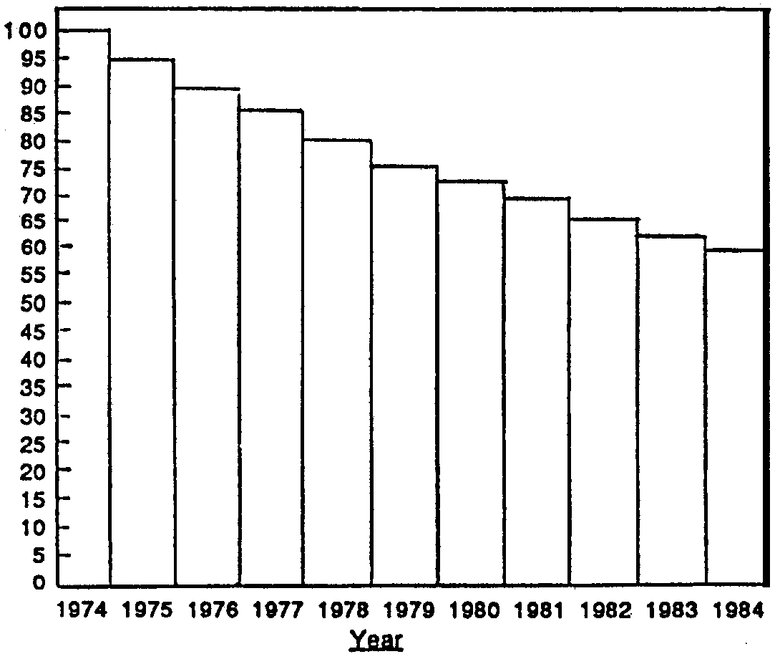
9. a-b. A correctly completed graph is drawn below:

c. Approximately 60% of the original population remains after ten years.

d. While the question asks for an opinion, such a prolonged rate of decline reflects a very serious problem, one which will hopefully be recognized by your students.

10. Plastic marine debris entanglement was one factor which contributed to the decline in the Northern Fur Seal population from 1975 to 1980. The fur seal population on the Pribilof Islands has been stable since 1981. Scientists do not know why the population has not grown, especially in view of the cessation of the commercial seal harvest after 1984.

The Dolphin-Tuna Controversy

1 a. Between 1971 and 1987, 1,995,371 dolphins died in tuna purse seine nets.

b. In 1971, 246,213 dolphins died in the nets of U.S. fishing vessels. In 1987, 13,992 dolphins died.

c. In 1971, 15,715 dolphins died in the nets of non-U.S. fishing vessels. In 1987, 97,941 dolphins died.

d. The number of dolphins killed each year by non-U.S. vessels has increased.

e. The number of dolphins killed each year by U.S. vessels has decreased (but is still far from zero).

2. Thailand has to provide evidence that:
a. it has adopted a program comparable to the U.S. dolphin protection program, and
b. the average rate of accidental dolphin deaths caused by its fleet is comparable to that of the U.S. fleet.

3. The 1984 changes were not effective largely because they were not implemented.

4. Answers will vary but should be supported by reason.

5. Answers will vary but should be supported by reason.

6. a. Zero dolphins died in the nets of U.S. fishing vessels in 1996.

b. Two thousand five hundred forty seven (2,547) dolphins died in the nets of non-U.S. fishing vessels in 1996.

c. Since 1989, what has happened to the number of dolphins killed each year by U.S. vessels has decreased.

d. Since 1989, the number of dolphins killed each year by non-U.S. vessels has also decreased.

7. Since the question calls for an opinion, answers will vary. A sustainable level of kill means that, even though individuals members of the population are killed, the size of the population does not change.

8. There are two ways for the dolphin population to maintain a constant size when a “new” mortality factor such as net kills is added: increase the birth rate, or decrease the mortality from some other factor. The dolphins have apparently been successful at one or the other or a combination of both since the population is now stable. In fact, the estimated population growth rates in 1997 are 2-4%, much higher than the 0.5% fishery mortality.

9. Two factors that have reduced the pressure on dolphins from tuna fishers include a reduction in the number of boats fishing for tuna, and individual quotas for the number of dolphins each boat may kill incidentally to the tuna fishing effort.

10. a. Answers will vary, but most students will think that “dolphin fishing” is most harmful to dolphins.

b. Again, answers will vary. Many students will think that “log fishing” is most harmful to the ecosystem.

11. a. This question is a re-asking of question 10. b. which asked for an opinion. Students now have the factual information to recognize that “log fishing” is most harmful to the marine ecosystem.

b. “Dolphin safe” policies might be a disaster for the eastern tropical Pacific ecosystem because of the annual removal of huge numbers of a variety of organisms as by-catch from school fishing and log fishing activities. The magnitude of the removal of organisms can be quickly calculated by knowing that 10,000 sets are made each year. If all 10,000 were made during school fishing, 50,000,000 pounds of by-catch would occur; if all were made during log fishing, 200,000,000 pounds of other marine organisms would be lost.

12. Since this question calls for an opinion, accept any reasoned answer. In the view of many scientists, the trade is not a good one. The long term effects on the eastern tropical Pacific ecosystem (including the dolphins which live there) could be extremely deleterious.

13. Answers will vary. Use this question as an opportunity to discuss the role of public involvement and the need for that involvement to be informed.
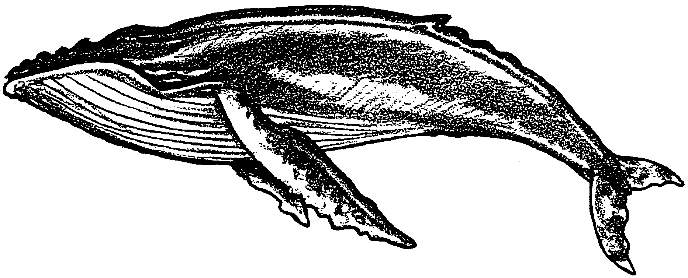
Exploiting Marine Mammals

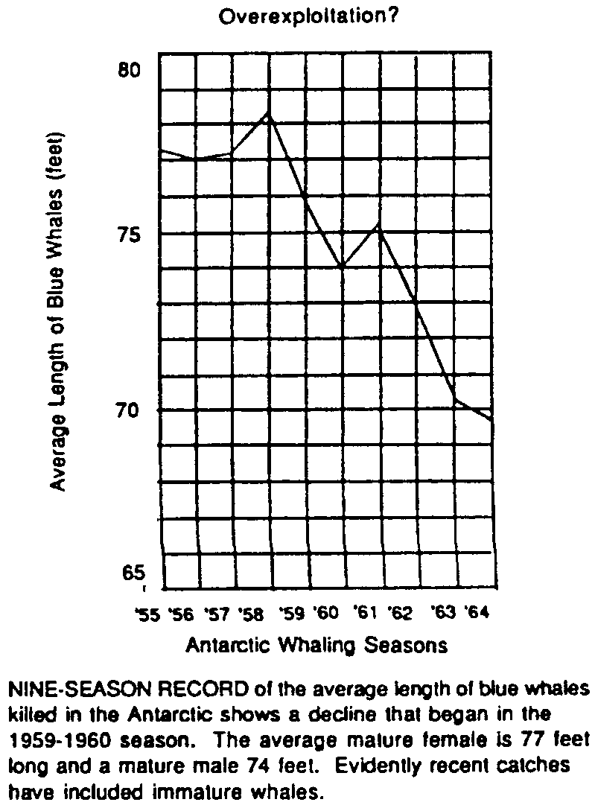
The nations of the world have for centuries refused to accept any restrictions or limitations on the quantity of fish that any one nation could catch. The international law of the seas provided for “complete freedom of the seas” outside accepted territorial waters. For most of previous history, this lack of catch restrictions is understandable. For example, both the size of the ships and the method used to catch marine mammals ensured the continuation of all the species. A ship would put to sea, catch as many as it could hold, and return to port to process and sell its catch. However, modern technology has provided whaling fleets complete with accompanying processing ships. Smaller ships catch their limits, transfer the whales to the processing ship, and return to chase the same school of whales, if possible.

1. What has been the effect of modern technology on the total fish catch ?

The extermination of a species occurs through what is technically called “over-exploitation”. The results of over-exploitation vary from a slow decline in the abundance and availability of a species to an abrupt and permanent elimination.
The usual signs of over-exploitation are a decline in the average size of the animal that is taken, and an increase in the effort necessary to catch the same amount as harvested in previous years.
The normal response to a declining marine species has been for the fleet to increase hunting time and energy, while making improvements in gear and methods.

2. What are the two warning signs that indicate a marine mammal population is being over-exploited?

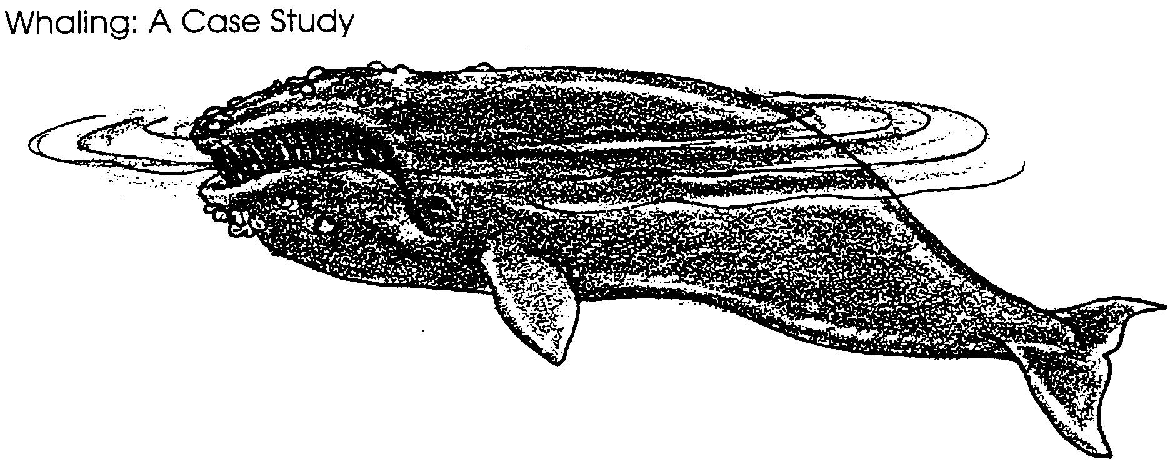
In most cases, an attempt to revive the species by halting or limiting the size of the catch is not initiated.

Commercial whaling in Europe began in the 12th century in the Bay of Biscay off northern Spain. Here a group of Spaniards, called the Basques, hunted the small, slow Biscayan Right Whale. It was named the “right” whale because it would float after it had been killed. Other species of whales would sink and were therefore called the “wrong” whales. By the 13th century, the Basques had established a precedent that would be continued for the next seven centuries - the Biscayan Right Whale had been hunted into near extinction.

3. Since the Basques hunted whales without the advantages of modern technology, what attributes of the whale allowed it to be hunted to near extinction?

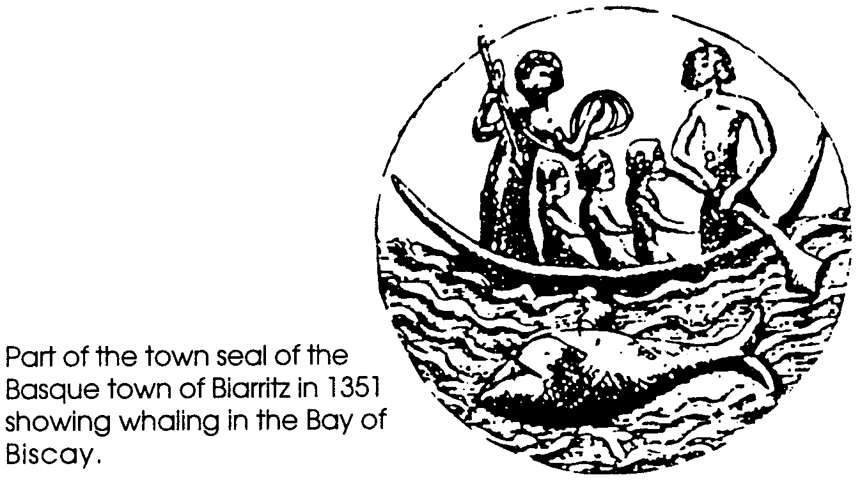
By the 16th century, the whalers of Europe had extended the hunt into the Atlantic, off the coast of Great Britain and France. They pursued the species known as the Atlantic Right Whale. It was black in color, very abundant, and rich in oil. By the 17th century, the Atlantic Right Whale was also nearly extinct.
The whaling fleets now moved further north into the waters around Iceland and Greenland. Here lived a species that was rich in the valuable whale products of baleen, oil, and meat. It was called the Greenland Right Whale and it, too, soon became nearly extinct.
Diagram showing the manner of cutting in the Bowhead and Right whale
By the beginning of the 19th century, the whalers of the North Atlantic were in serious trouble. The majority of easily caught whales were now reduced to population sizes near zero; only the large, fast swimming whales remained. Then, in 1862, a Norwegian whaler named Svend Foyn developed a new method for hunting the big whales. He adapted the steam engine to his whaling ship and invented a cannon-fired harpoon with an explosive head. With this device, he could now catch the faster whales. The problem of keeping these large whales afloat still remained. To solve this problem, Foyn pumped compressed air into the carcass.
4. What three technological breakthroughs allowed whalers to hunt the large, fast swimming, great whales?

a.

b.

c.

Armed with Foyn’s new techniques, the North Atlantic whalers now attacked the large blue whale. The technique was so effective that by 1903, the blue whale was no longer found in huntable numbers in the Northern Hemisphere.
Having destroyed their livelihood in the Northern Hemisphere, the whalers now turned to the great Antarctic summer feeding grounds. The first Norwegian fleets to sail in the Antarctic returned home with reports of whale herds of tremendous size.
The estimates of the first Norwegian fleet were accurate. The herds were so bountiful, it is estimated that 25% of the whales killed floated away before they could be skinned. The whalers refused to learn any lessons from their experience in the North Atlantic. They picked the slowest species in the Antarctic region, the humpback whale, and hunted it mercilessly. In 1911, 8,500 humpback whales were killed; by 1925, only 9 humpback whales could be found to kill.
As the whalers killed off the whales that bred near the Antarctic islands where their fleets anchored, they forced themselves to go out to sea to find whales. This would have been a very costly operation since it involved hauling the dead whales back to one of the islands to be processed. However, in 1925, a Norwegian captain constructed a large “factory ship” that could accompany the fleet into the Antarctic Ocean. The ship had a slipway by which the whale was hauled onto the deck to be processed. The factory ships were so successful that by 1930, 38 were in operation. These ships permitted the whaling nations to increase their catch from 10,500 in 1925 to 40,200 in 1931.

5. In what way was the construction of the first “factory ship” a break-through for the whale hunters?
In 1931, the first attempt to create international regulations for the whaling industry was initiated. This attempt was the Convention for the Regulation of Whaling. This agreement tried to protect the remaining “right” whales, immature whales, and females accompanied by a calf. Its effectiveness was doomed because two of the leading whaling nations, Germany and Japan, refused to sign it.
Following World War II, a second attempt was made to establish controls. Many marine scientists predicted that the whale would be annihilated if the pre-war slaughter continued. In 1946, in Washington, D.C., the International Whaling Commission was created. Most of the world’s whaling nations joined the Commission. The Commission had the duty to set minimum-length requirements, set the opening and closing dates for the whaling season, and set an annual Antarctic quota.
Despite its impressive responsibilities, the Commission was at first doomed to the role of a powerless administrator. Any member nation, if it gave 90 days notice, could refuse to obey any Commission decision. The Commission was also powerless to limit the number of factory ships or to allocate a quota to any of them. This would have violated the principle of the freedom of the high seas which grants to every nation the right to use the resources of the oceans as it decides. The result was an increasing number of whaling fleets hunting fewer and fewer whales!

6. What were two major shortcomings that prevented the International Whaling Commission from being effective in whale management?

a.

b.

From the years since the creation of the International Whaling Commission to the mid-1980’s, the estimated quantity of whales continued to decrease. The necessity to make decisions based on the opinions of the member nations resulted in protection for the various species of whales coming too little and too late.
While scientists and annual catch statistics continually predicted that the blue whale would be hunted into extinction, the Japanese, Russian, and Dutch members refused to agree to any regulation to protect it. In 1964, the number of blue whales killed dropped to 20 for the entire whaling industry. Compare this with 29,400 killed in 1931. Following the 1964 season, the member nations agreed to place the blue whale on the protected species list. In effect, the whaling industry had waited until the blue whale could no longer be hunted profitably before they would protect it!
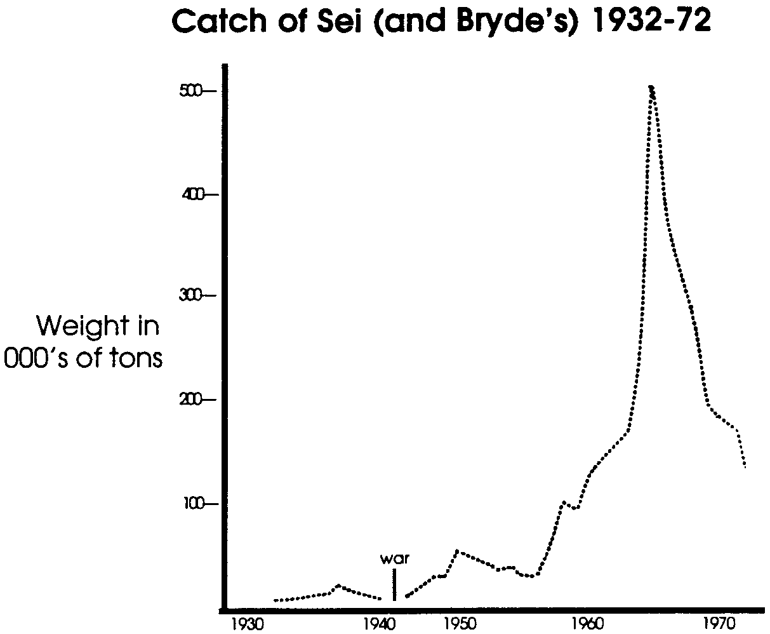
7. The graph below shows the catch of Sei whales from 1932 to 1972. Use this information to answer the questions that follow the graph.

a. In which year did the major increase in the annual catch of Sei whales begin?

b. What was happening to the catch of blue whales during the years when the Sei whale catch was increasing?

c. From this information, how does it appear that the whalers maintained a constant total whale catch?

d. What happened to the annual catch of Sei whales since the end of the 1960’s?

In 1964, the Commission set a quota of 16,000 whales that could be killed. Scientists predicted then that the figure was too high and the whale population would not be able to recover. By 1963, the Committee of Three, a team of three scientists hired by the Commission to advise on the proper quota limit, suggested a limit of 4,000 whales. The Japanese refused to accept a quota less than 10,000 whales. Since the Japanese could have refused to accept the Commission’s quota, the rest of the nations on the Commission agreed to the Japanese figure. The Japanese refusal underscores the Commission’s lack of enforcement power.
By 1976, 30 years after its creation, it was abundantly clear that the Commission had still not fulfilled its obligations. In that year, it was necessary to ban the killing of:
• all Fin Whales in the Southern Hemisphere and North Pacific;
• Sei Whales in the Nova Scotia region of the North Atlantic and in two regions of the Antarctic;
• Bryde’s Whales in the Southern Hemisphere;
• Minke Whales in the East and Central South Pacific; and
• Sperm Whales in areas of the Southern Hemisphere

8. Why was it necessary to ban the killing of five species of whales in 1976?

Since 1976, public opinion worldwide has helped the IWC more effectively manage whale populations. Individuals from dozens of countries have worked to see that IWC recommendations are followed. In 1984 the strengthened IWC instituted a moratorium (ban) on all commercial whaling. The IWC believed a moratorium would prevent the extinction of currently over-exploited whale species, allow the depleted stocks of whales to recover, and give scientists time in which to make proper and accurate assessment of whale populations and their ecology.

9. How did the IWC believe a moratorium on all commercial whaling could benefit the whales?

The moratorium protects all stocks of large whales from commercial whaling by member countries of the IWC. There is good evidence that most of the stocks of whales that have been monitored are recovering. If whaling is resumed, it is likely that the quotas will be very low. Further, only whales that have recovered will be considered for commercial whaling. As the IWC discusses these plans, other economic factors are assuming an important role. From the time whale watching began in Japan in 1988, the number of passengers on whale watching boats has almost doubled every year. The money the boat operators, marina operators, and hotels make from whale watchers has also almost doubled every year. In 1992, more than 19,000 people went whale watching in Japan raising a staggering 1,014,900,000 yen (about 9.5 million dollars). The Whale and Dolphin Conservation Society reported to the 1993 IWC conference in Japan that “IWC manages whales for the entire world, and it should now consider the importance and the value of whales alive. World-wide, whale watching, not whaling, is the most pervasive use of whales today.”

10. How might managing whale populations for whale watching hold promise for their long term survival?

What are current policies on whaling? You may be interested in contacting the IWC at:
The Red House; Station Road; Histon, Cambridge CB4 4NP; England

What is the current U.S. policy on whaling? You can find out from:

Secretary of State, Department of State; Washington, D.C. 20520

Administrator, National Oceanic and Atmospheric Administration U.S. Department of Commerce; Washington, D.C. 20230

If you have concerns about what you hear from these individuals, you may wish to write expressing your concerns. Each year a delegation from the U.S. goes to the International Whaling Commission meetings. Many times a year trade negotiations are transacted. If our elected and appointed officials are aware of public concern for whaling, they can continue to take the American point of view to these transactions.
Don’t think letters do any good? Candid government officials will tell you they read and count letters, and they feel if one person actually takes the time to sit down and write, a thousand people must have similar feelings. The single, most effective, direct action is letter writing.
You can find out about other countries’ views on whaling and the current status of conservation efforts by writing:

UN Mission: Japan, 866 UN Plaza, New York, NY 10016
Embassy of Japan, 2520 Massachusetts Ave. N.W., Washington, D.C. 20008
Embassy of Iceland, 2022 Connecticut Ave. N.W., Washington, D.C. 20008
UN Mission: Norway, 825 3rd Avenue, New York, NY 10022
Royal Norwegian Embassy, 2720 34th Street N.W., Washington, D.C. 20008
American Cetacean Society, P.O. Box 2698, San Pedro, CA 90731
Center for Action on Endangered Species, 175 W. Main, Ayer, MA 01432
Cousteau Society, 777 Third Avenue, New York, NY 10017
Defenders of Wildlife, 1244 19th St. N.W., Washington, D.C. 20036
Environmental Defense Fund, 1525 18th St. N.W., Washington, D.C. 20036
Friends of the Earth, 124 Spear St., San Francisco, CA 94105
Greenpeace USA, 1611 Connecticut Ave. N.W., Washington, D.C. 20009
National Audubon Society, 950 Third Avenue, New York, NY 10022
National Wildlife Federation, 1412 16th St. N.W., Washington, D.C.20036
Ocean Education Project, 245 2nd Street, N.E., Washington, D.C. 20002
Sea Shepherd Conservation Society, P.O. Box 7000 S., Redondo Beach, CA 90277
Sierra Club, 530 Bush Street, San Francisco, CA 94108
The Oceanic Society, 153616th St. N.W., Washington, D.C. 20036
Whale Protection Fund, Center for Environmental Education
2101 L St. N.W., Washington, D.C,. 20037
World Wildlife Fund, 1250 24th Street N.W., Washington, D.C. 20037

Northern Fur Seals: A Case Study

Off the coast of Alaska lies the chain of Pribilof Islands on which every year a mysterious chapter of nature repeats itself. Here the Northern Pacific fur seal herds arrive each summer to await the birth of the new members of their species.
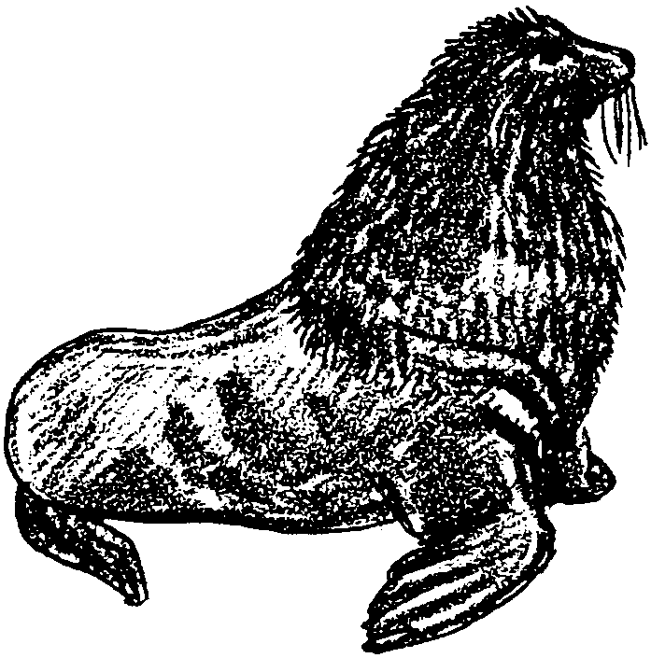
The fur seal is a mammal which spends most of its life swimming in the ocean in search of food. The bull fur seals arrive on the islands in May and defend territories of beach for themselves and up to 50-60 females. The females arrive in June. Soon the pups are born. By late August the pups are old enough to swim. By September, most adult males return to the ocean. By November the pups have stopped nursing and the females and pups leave the islands too. The seals migrate south to spend the winter in warmer latitudes. The following May they reappear on the Pribilof Islands to repeat the cycle.
The islands are named the Pribilofs after the Russian navigator who discovered and claimed them in 1783. Pribilof was searching for the breeding grounds of the fur seal.
Pribilof wanted to find the seals because of the value of their skins, which were made into expensive coats. The seals, however, had been of value to the Aleut people for centuries because they were a source of food, fuel, and clothing.

1. Why were the fur seals valued by non-native hunters?

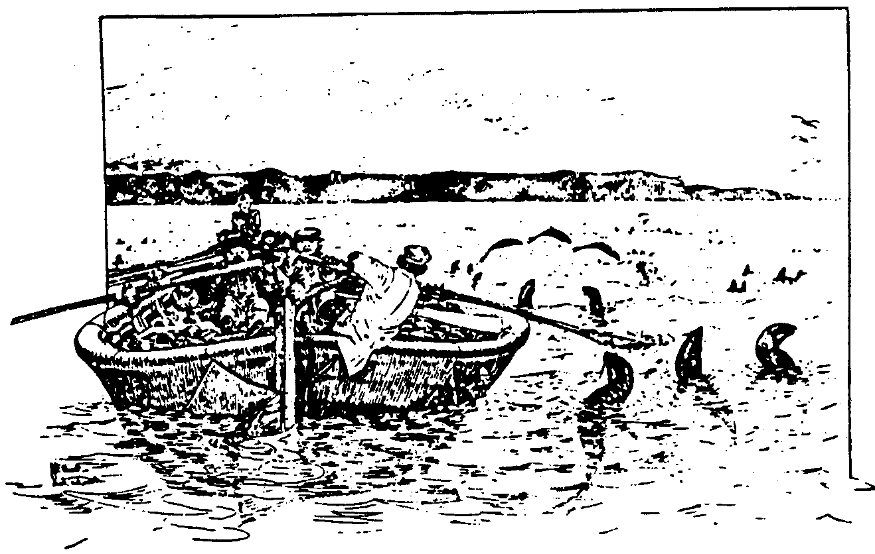
While the Pribilofs were under the control of Russia, the seals were taken in great numbers. From 1786 to 1828, 100,000 per year or over 4 million fur seals were harvested. Harvests were reduced and during the last 10 years about 30,000 seals were killed each year. In 1867, when the islands were bought along with Alaska by the United States, the seal population was thriving. Then an unfortunate thing happened. During the first two years of United States ownership, there were no regulations. In 1868 alone, 240,000 seals were taken on the islands. To make matters worse, seal hunters were also killing seals at sea. The United States granted a 20-year contract to a private company in 1870 which permitted the regulated harvesting of seals on the islands to continue.

"Fur seals around the baidar - Natives of Saint Paul lightering off the bundled sealskins to the ship from the Village Cove". This is a sketch by Henry W. Elliott, who visited the Pribilofs for the Treasury Department and the Smithsonian Institution in 1872, shortly after purchase of the islands from Russia. The baidar, or bidarrah, was made of sea lion skins. Canvas-covered bidarrah are still used in ship-to-shore ferrying.

2. Assume you are the president of Fur Seals Coats, Ltd. and are nearing the end of your 20-year lease period which gives you the right to kill fur seals in the Pribilofs.

a. How would you regulate the number of fur seals killed by your hunters if you were sure you would be given a second 20-year contract?

b. How would you regulate your fur seal hunters if you were sure you would not be given a second 20-year contract?

Harvesting seals at sea (pelagic sealing) had a very different impact on fur seals than harvesting on the islands. As early as 1847, the number of males harvested was controlled and the harvest of females was completely stopped. Pelagic sealers had a difficult time distinguishing between males and females. At the peak of pelagic whaling most of the 42,000 seals killed annually were lactating (milk producing) females. When these females were taken, the pups waiting ashore also died. It was during the end of the 1800’s that the American government became concerned with the impending annihilation of the fur seal. It attempted to control the harvest on the Pribilofs. The harvest, however, was not controlled offshore where American, Russian, Canadian, and Japanese fishing boats would spear the seals as they approached the islands.
In 1892, the United States asked Great Britain and Japan for help in protecting the seals. They would agree only to suppress hunting within a 60-mile radius of the Pribilof Islands.

3. Why did protecting the seals on the breeding grounds prove to be an ineffective way to protect the species?

By 1911, a herd that once numbered 2-3 million had been reduced to about 300,000 seals. The nations of the world at this point stepped in to protect what was left of the herd. On July 7, 1911, the North Pacific Sealing Convention was signed by the United States, Japan, Russia, and Great Britain. Under the agreement, all open-sea seal hunting was forbidden north of 30 degrees North latitude. Each nation owning breeding islands in the area regulated hunting on those islands. The United States and Russia, who owned the islands concerned, agreed to share the revenue gained from the hides and to give Canada and Japan 15% of the total amount.
4. Since Japan and Canada owned no seal breeding islands, regulations limiting on-shore hunting had little effect on them. What incentive was given to Canada and Japan to persuade them to stop open-sea sealing?

Under the international protection, the herd increased from 300,000 to 2,000,000 in half a century. From this two million, an annual harvest of 20,000-70,000 two, three, and four year old males continued until 1985 when the United States and other member nations failed to ratify a new fur seal treaty.
Today the killing of the seals on the Pribilof Islands is done by the natives of the islands under the supervision of the United States government but only for the purpose of subsistence. In 1992, 1676 seals were harvested.
In looking back, few can deny that the protection afforded through international cooperation has saved the fur seals from a fate similar to that of the whales. The Northern fur seal story shows that it is possible for nations to work together to protect valuable marine resources. Hopefully, the lessons learned in this case study will be applied to other marine mammals as well.

5. The Seal Convention works because all of the nations that were sealing receive some portion of the total income earned from the reduced hunting allowed by the treaty. How could you create a similar situation involving whales and whaling nations?

6. Prior to the moratorium in 1984, whaling regulations did not guarantee any nation a fixed percentage of the total income from whaling. How was a nation’s income determined?
Current Threats to the Northern Fur Seals

Having successfully recovered from the brink of extinction due to hunting, Northern Fur Seals now face another threat from plastic marine debris. Plastic marine debris includes: strapping bands, beverage container rings, nets, ropes, lines, and packaging materials. Plastic marine debris affects wildlife in one of two ways - animals become entangled in it or they ingest it. When an animal becomes entangled in plastic debris, the animal can strangle, suffocate, or exhaust itself. When an animal ingests plastic, the material can block intestinal tracts, causing death. Fortunately, small pieces of plastic usually pass harmlessly through an animal’s digestive tract.

7. What is a threat now facing the Northern Fur Seals?

8. What are two ways in which plastic marine debris affect wildlife?

Each year there are more reliable reports of animal entanglements for all types of marine mammals. The best documented research has been conducted on the Northern Fur Seal population on Alaska’s Pribilof Islands. Scientists noted that from 1975-1980, the fur seal population had been declining 4-8% per year.

9. The following will give you an idea of what it means for a population to decline 4-8% per year; for ten years:
a. In 1974, 100 Northern Fur Seals were observed on St. Paul Island. Show this number on the bar graph below.
b. A 5% decline each year was noted between 1974 and 1984. Calculate the number of seals alive each year. (Hint: to find the number living at the end of a year after a 5% decline, first find the size of the decrease during the year by multiplying the number at the start of the year by .05. Then subtract that number from the original number alive at the beginning of the year. A calculator makes this job easier.) Show these numbers on the bar graph below.
c. What percent of the original number of seals remains after ten years?
d. In real life, the fur seal population stabilized during the last part of the 1980s and early 1990s. Stellar sea lions, however, have been declining steadily since 1960. Scientists think there is a lack of food for the sea lions. How serious do you think such a long term decline would be for a marine mammal population?
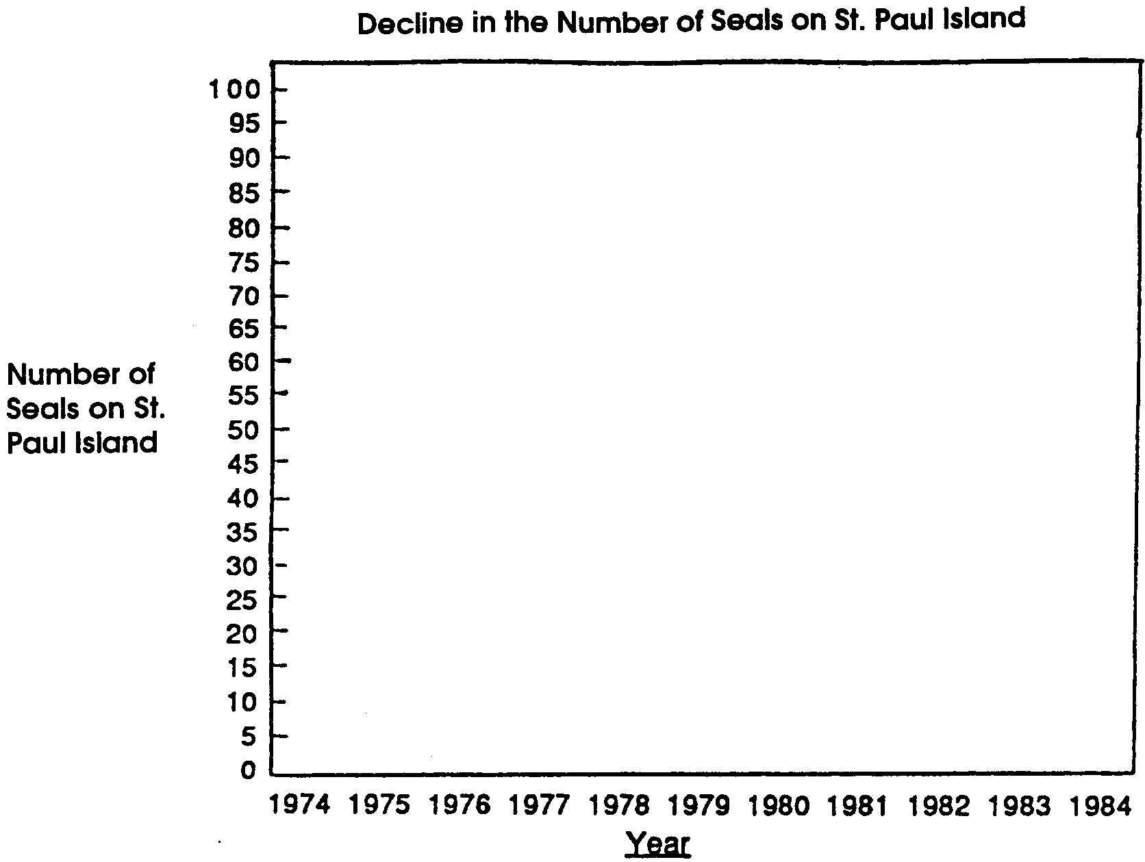
In an effort to find the causes for the decline, scientists closely monitored the annual fur seal harvest between 1981 and 1984. Examining harvested seals, they found seals entangled in plastic debris (most commonly fishing net fragments) and scars from past entanglements. Based on their research, the scientists theorized that such entanglements played a large role in the observed decline of the fur seal population from 1975 to 1980. Further, scientists pointed out that they could count only the seals that survived to reach land. They believe most entangled seals die before reaching their breeding grounds on the Pribilofs.

10. What seems to be one of the reasons for the 4-8% decline seen in Northern Fur Seal populations from 1975 to 1980?

The Dolphin-Tuna Controversy

For many years, people in the Eastern Tropical Pacific Ocean have observed that schools of yellowfin tuna commonly swim beneath schools of dolphins. Tuna fishermen were among the people who observed this phenomenon. In order to catch the tuna underneath, they set mile-long purse-seine nets around the dolphins. In so doing, tens of thousands of dolphins were caught and drowned in tuna nets each year.
Many people in the United States and elsewhere were alarmed by the numbers of dolphins killed in tuna fishing nets. As a result of this concern, the United States Marine Mammal Protection Act (MMPA) of 1972 was enacted. The Act calls for the reduction of marine mammal kills “to insignificant levels approaching zero mortality”. The table below shows the number of dolphins killed each year during this period.

Incidental Mortality of Dolphins in the
Eastern Tropical Pacific Yellowfin Tuna Purse-Seine Fishery
Year U.S. Vessels Non-U.S. Vessels Total
1971 246,213 15,715 261,928
1972 368,600 55,078 423,678
1973 206,697 58,278 264,975
1974 147,437 27,245 174,682
1975 166,645 27,812 194,457
1976 108,740 19,482 128,222
1977 25,452 25,901 51,353
1978 19,366 11,147 30,513
1979 17,938 6,837 24,775
1980 15,305 29,598 44,903
1981 17,890 17,146 35,036
1982 23,267 5,065 28,332
1983 8,513 (no estimate available)
1984 17,732 15,018 32,750
1985 19,205 36,032 55,237
1986 20,692 103,905 124,597
1987 13,992 97,941 111,933
TOTAL 1,443,684 552,200 1,987,371
From Table 10 (Estimated incidental kill of dolphins in the tuna purse
seine fishery in the eastern tropical Pacific Ocean, 1972-1996) of the
Marine Mammal Commission's 1996 Annual Report.

1. Use the table above to answer the following questions:
a. How many dolphins died in tuna purse seine nets between 1971 and 1987?

b. How many dolphins died in the nets of U.S. fishing vessels in 1971? in 1987?

c. How many dolphins died in the nets of non-U.S. fishing vessels in 1971? in 1987?

d. What has happened to the number of dolphins killed each year by U.S. vessels?

e. What has happened to the number of dolphins killed each year by non-U.S. vessels?
Recall that the United States Marine Mammal Protection Act (MMPA) of 1972 calls for the reduction of marine mammal kills “to insignificant levels approaching zero mortality”. The table above shows that a large number of dolphins continued to be killed each year.
In 1984, the U.S. Congress reviewed the Marine Mammal Protection Act. Congressional representatives recognized that the dolphins were still in danger. They also recognized that U.S. tuna fishing crews were at a competitive disadvantage. U.S. boats spent more money to fish in ways that did not capture dolphins. To provide help for the dolphins and the fishers, Congress amended the Marine Mammal Protection Act. The new Act required that each nation exporting tuna to the United States provide documentary evidence that it had adopted a program comparable to the U.S. dolphin protection program. Exporting nations also had to provide evidence that the average rate of accidental dolphin deaths caused by its fleet is comparable to that of the U.S. fleet.

2. In order to be allowed to export tuna to the United States, what two pieces of evidence does Thailand have to provide to the U.S. government?

a.

b.

Since much of the tuna caught worldwide was destined for U.S. markets, the 1984 plan seemed like a good one. However, during an MMPA reauthorization hearing in April, 1989, it was noted that NOAA Fisheries hadn’t yet completed regulations implementing the 1984 amendment. Foreign fleets were fishing and exporting tuna to the U.S. as they always had. It was also revealed that the U.S. tuna purse-seine fleet had declined by more than 60% in the last ten years but that the level of incidental dolphin take by the fleet had not gone down proportionately. The remaining boats were catching more, not fewer, dolphins. Finally, it was noted that the estimated numbers of dolphins killed by foreign fleets had increased dramatically in 1986 and 1987.

3. In terms of reducing the deaths of dolphins, how effective were the 1984 changes in the Marine Mammal Protection Act?

You might correctly guess that Congress was not pleased by these findings. In light of these developments, Congress enacted additional amendments that require the Secretary of Commerce (the person ultimately in charge of enforcing the MMPA) to find the regulatory programs of other nations unacceptable unless:
• They include, no later than the start of the 1990 fishing season, prohibitions against encircling pure (i.e., single species) schools of certain marine mammals, and conducting “sundown sets”. Sundown sets were prohibited because dolphins are harder to see and remove from nets during sunset hours. The nation’s program would also need to implement other dolphin-saving measures applicable to U.S. vessels.

• The nation’s program reduces the average rate of incidental dolphin kills by its vessels to no more than two times that of American vessels by the end of the 1989 fishing season. By the end of the 1990 fishing season and thereafter, the average rate could be no more than 1 1/4 times greater.

• The total number of eastern spinner dolphins, Stenella longirostris, taken incidentally during the 1989 and subsequent fishing seasons does not exceed 15% of the total number of all marine mammals taken incidentally by vessels of the harvesting nation.

• The total number of coastal spotted dolphins, Stenella attenuata, taken incidentally during the 1989 and subsequent fishing seasons does not exceed 2% of the total number of all marine mammals taken incidentally by vessels of the harvesting nation.

• The rate of incidental takes during the 1989 and subsequent fishing seasons is monitored by the Porpoise Mortality Observer Program of the Inter-American Tropical Tuna Commission or an equivalent international program in which the United States participates. The observer program must be based upon observer coverage equal to that of U.S. vessels during the same period.

• The harvesting nation complies with all reasonable requests by the Secretary for cooperation in carrying out the scientific research program required by the MMPA.

• The amendments also require that the government of any intermediary nation that exports yellowfin tuna or tuna products to the United States provide reasonable proof that these products didn’t originate from a country without an appropriate dolphin-protection program.
The message from the U.S. Congress to other nations was meant to be clear: “Play by these rules, or don’t sell tuna in this country”.

4. In your opinion, which of the requirements imposed by the Congress seems to be most important in reducing the number of dolphins killed? Why?
Congress also had a message for the U.S. tuna purse-seine fleet. The amendments to the Marine Mammal Protection Act which affect the U.S. fleet specified that:
• By January 1, 1989, the Secretary of Commerce issue regulations to ensure that purse-seine sets on marine mammals are completed no later than 30 minutes after sundown.

• By January 1, 1990, the Secretary establish performance standards encouraging U.S. fishermen to use the best marine mammal safety techniques and equipment that are economically and technologically practicable.

• The Secretary prescribe regulations, effective April 1, 1990, prohibiting the use of Class C explosive devices (i.e., large firecrackers) to herd dolphins during fishing operations unless a study shows that the use of the devices doesn’t harm or kill dolphins;

• Until at least the 1991 fishing season, each U.S. tuna purse-seiner carry an official observer to conduct research and observe fishing operations during each trip to the eastern tropical Pacific;

• The Secretary contract with the National Academy of Sciences to help identify possible alternatives to the practice of setting-on-dolphin to catch tuna and, by December 5, 1989, submit to Congress a plan for developing and implementing any promising techniques; and

• On or before April 1, 1992, the secretary submit to Congress a report describing efforts to reduce the incidental take of dolphin in the yellowfin tuna purse-seine fishery, and propose legislation or other measures to reduce or eliminate it.

5. In your opinion, which of the new requirements imposed on the U.S. tuna purse-seine fleet is most important in reducing the number of dolphins killed? Why?

How effective have the changes regulations and fishing techniques been in reducing the number of dolphins killed? The following table extends the dolphin mortality information presented earlier.

IIncidental Mortality of Dolphins in the
Eastern Tropical Pacific Yellowfin Tuna Purse-Seine Fishery
Year U.S. Vessels Non-U.S. Vessels Total
1971 246,213 15,715 261,928
1972 368,600 55,078 423,678
1973 206,697 58,278 264,975
1974 147,437 27,245 174,682
1975 166,645 27,812 194,457
1976 108,740 19,482 128,222
1977 25,452 25,901 51,353
1978 19,366 11,147 30,513
1979 17,938 6,837 24,775
1980 15,305 29,598 44,903
1981 17,890 17,146 35,036
1982 23,267 5,065 28,332
1983 8,513 (no estimate available)
1984 17,732 15,018 32,750
1985 19,205 36,032 55,237
1986 20,692 103,905 124,597
1987 13,992 97,941 111,933
1988 19,712 61,881 81,593
1989 12,643 84,403 97,046
1990 5,083 47,448 52,531
1991 1,002 26,290 27,292
1992 439 15,111 15,550
1993 115 3,601 3,716
1994 105 4,065 4,170
1995 0 3,274 3,274
1996 0 2,547 2,547
TOTAL 1,482,783 800,820 2,275,090
From Table 10 (Estimated incidental kill of dolphins in the tuna purse
seine fishery in the eastern tropical Pacific Ocean, 1972-1996) of the
Marine Mammal Commission's 1996 Annual Report.

6. Use the table above to answer the following questions:

a. How many dolphins died in the nets of U.S. fishing vessels in 1996?

b. How many dolphins died in the nets of non-U.S. fishing vessels in 1996?

c. The MMPA was reauthorized in 1989. Since then, what has happened to the number of dolphins killed each year by U.S. vessels?

d. Since 1989, what has happened to the number of dolphins killed each year by non-U.S. vessels?

Clearly, the U. S. Congress, responding to public outcry, wants to drastically reduce or eliminate dolphin kills. You should want that, too. But as with many complex issues, things are not always what they seem. Marine Mammal Biologist, Doug DeMaster at National Marine Mammal Laboratory has spent over ten years working on this problem. He notes that there are some important things to keep in mind:
• First, he notes that past levels of kill of spinner and spotted dolphins killed by tuna fisherman were not sustainable. The populations of these dolphins declined by 60 to 80%.

7. What do you think the term “sustainable” means in relation to kill levels of dolphins?

• Second, he and other scientists believe that the current kill level of less than 3,000 animals per year out of an estimated population of 10,000,000 is sustainable. A sustainable level of kill means that, even though individual members of the population are killed, the size of the population does not drop dramatically. A population being harvested at a sustainable kill level is not in jeopardy of extinction.

8. Dr. DeMaster notes that the current kill rate is less than 0.5% per year. This means that for the population as a whole less than one out of every 200 animals dies in tuna nets each year. How can the dolphin population keep from declining when there is a continuing dolphin net kill rate of 0.5%?
• Third, the U.S. tuna fleet in the eastern tropical Pacific, which included as many as 110 boats in the 1970s, now includes fewer than 10 vessels.

• Fourth, tuna boats now have individual quotas for the number of dolphins they can kill as part of their tuna fishing. Since these quotas have been established, the number of dolphins killed in tuna nets has decreased dramatically.

9. What are two factors that have reduced the pressure on dolphins from tuna fishers?

a.

b.

This all sounds as if the move toward “dolphin safe” tuna has been successful. True enough, but this success comes with a real threat to the ecosystem of which the dolphin is a part. Let’s see how by looking at Dr. DeMaster’s final point.
• Fifth, there are three ways to catch tuna in the eastern tropical Pacific. “Dolphin fishing” in which the nets encircle associations of dolphins and tuna is the way we've been focusing on. “School fishing” in which schools of tuna are encircled is a way which poses little danger to dolphins. The third way to catch tuna is called “log fishing” in which the net encircles associations of tuna, turtles, sharks, and other animals that gather around floating objects.

10. a. Which of the three tuna fishing techniques do you think is most harmful to dolphins? Please explain your choice.

b. Which of the three tuna fishing techniques do you think is most harmful to the marine ecosystem? Please explain your choice.

The “by-catch” (i.e., animals other than tuna) is vastly different depending on whether one dolphin fishes or not. The by-catch for dolphin fishing, for example, is 100 pounds of animals per net set. All 100 pounds are dolphin. The by-catch for school fishing, on the other hand, is 5,000 pounds per set and for log fishing is 20,000 pounds per set. The by-catch consists of shark, turtles, small tunas, etc.

11.a. Which of the three tuna fishing techniques is most harmful to the marine ecosystem?

b. Many U.S. canneries have announced policies to only buy “dolphin safe” tuna. How might these policies be a disaster for the eastern tropical Pacific ecosystem?

At this point, the dolphin safe policy has primarily affected the U.S. fleet. Most U.S. boats now fish elsewhere. The Earth Island Institute, a environmental group, has been successful in forcing changes in the way people fish for tuna. They are working to eliminate the practice of “dolphin fishing” for tuna in the eastern tropical Pacific. If they are successful, the result could be the loss of 50,000,000 to 200,000,000 pounds of marine animals from the marine ecosystem each year. The reduction in the sustainable yield of tuna in the area will be 30%. These would be exchanged for not killing approximately 3,000 dolphins per year.

12. Our actions have very real consequences. Sometimes the choices are hard. Do you think the trade of 50,000,000 to 200,000,000 pounds of other marine animals and 30% of the tuna for 3,000 dolphins is a good one? Please explain your choice.

After more than 10 years of study, Dr. DeMaster sums it up by saying: “This is a classic case of well meaning environmentalists creating a bigger problem than necessary because of the way we value charismatic vertebrates relative to non-charismatic vertebrates.”
By “charismatic vertebrates” Dr. DeMaster means that dolphins have a special charm or spiritual attraction. This attraction tends to make people value certain animals as “more important” or “more worthwhile”. If nothing else, our study of ecosystems shows us that each animal and plant has a special role to play in keeping a system functioning. We’ve come to learn that when we simplify an ecosystem (say, turn a forest into a cornfield), that ecosystem becomes more vulnerable to damaging change. We would do well to apply that knowledge to complex problems. From the tuna/dolphin controversy we can see simple solutions to complex problems sometimes become problems of their own.

13. What types of action could you take to let others know about this complex problem?

In the next section, you will find some concrete ways you can help solve this problem.

What Can You Do?
Here are some actions you can take immediately.
Write letters
Let the tuna companies know that you appreciate their efforts to reduce dolphin kills but that the problem needs further study, or why you won’t buy their “Dolphin Safe” products.

Starkist Foods, Inc., 180 E. Ocean Blvd., Long Beach, CA 90802
H.J. Heinz Co., P.O. Box 57, Pittsburgh, PA 15230
Van Camp Seafood Co., 901 Chouteau Avenue, St. Louis, MO 63164
Ralston Purina Co., Checkerboard Square, St. Louis, MO 63164

Let Congress and the U.S. Commerce Department know that the Marine Mammal Protection Act’s intent was to reduce dolphin mortality not to destroy the ecosystem of the eastern tropical Pacific. The U.S. should take a leadership role in avoiding ecosystem destruction in the name of dolphin protection

Chairman
House Subcommittee on Fisheries, Wildlife Conservation and the Environment
544 House Annex 11
Washington, D.C. 20515

National Ocean Policy Study
Senate Commerce Committee
527 Hart Senate Office Bldg.
Washington, D.C. 20510

U.S. Department of Commerce
National Marine Fisheries Service
Universal Bldg.
1825 Connecticut Avenue N.W.
Washington, D.C. 20235

Your Representative
U.S. House of Representatives
Washington, D.C. 20515

Your Senator
U.S. Senate
Washington, D.C. 20510

Write letters to the editor, opinion pieces or editorials in your local newspapers.

Let Others Know about the Issue
Write to Earth Island Institute, Dolphin Project, 300 Broadway, Suite #28, San Francisco, CA 94133. Thank them for their past efforts and ask them to redirect their efforts toward protection of the eastern tropical Pacific ecosystem.
Prepare a public service announcement for your local radio station and television.

But, Does It Work?
Just as public opinion helped cause the Soviet Union to stop whaling and public opinion caused the tuna purse-seine fleet to change their fishing techniques, so can public opinion work for a solution which protects the ecosystem as well as the dolphins. We can make our voices heard and have an effect. Let’s do it now!

