Marine Mammal Adaptations: Echolocation
Written by Ardi Kveven, Snohomish High School, Snohomish, Washington.

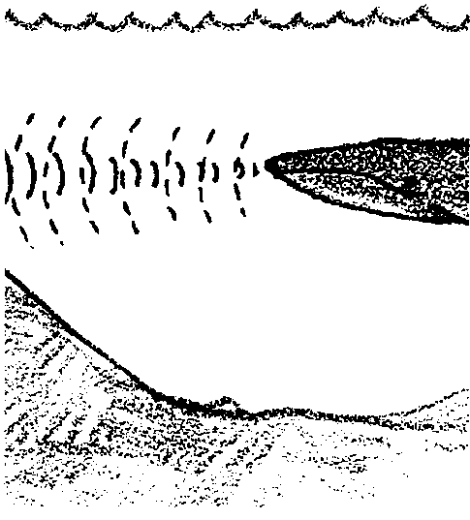
Key Concepts
1. Dolphins and toothed whales use echolocation as a primary tool to sense their environment.
2. In echolocation, the dolphins and whales emit sound waves, receive the reflected waves and determine from the changes in the sound waves locations and identities of objects.

Background
Dolphins and toothed whales generate sound waves in an organ in their heads called the melon. The sound waves bounce off objects and return to the animal where they are received by the lower jaw bone and transmitted to the inner ear. The whale’s brain interprets the signals with astounding accuracy and perception. In experiments with captive dolphins, the animals were able to use their echolocation to differentiate between spheres of the same size made of different materials.
Researchers believe the dolphins and toothed whales use echolocation to find prey, communicate and navigate. Humans can hear some of the low frequency sound waves and can feel some of the high frequency waves. Some scientists suspect that dolphins can produce sound waves powerful enough to stun prey. There are a number of anecdotal reports of this use of sound waves by cetaceans. One diver recounts a story of approaching two dolphins too closely. One of the dolphins turned, faced the diver, and directed a blast of sonar that sent the diver backwards in the water.

Materials
For each team of students:
• 1 slinky
• stop watch or clock or watch with a second hand
• 1 book
• 1 meter stick
• copies of “Marine Mammal Adaptations: Echolocation” student pages
Teaching Hints

In “Marine mammal Adaptations: Echolocation”, students will use slinky waves to model sound waves. They will try to determine how far away an object is by timing the speed of the slinky wave. The process is slow and laborious. Students will appreciate the incredible abilities of the whales to use echolocation.
Before students arrive, select a space in which to do the activity. Move tables and desks to the perimeter or center of the room or arrange to work in the hallway or gym.
Explain to students that whales and dolphins are experts at navigating and finding food using echolocation. In essence, the whales are analyzing the echoes from sound waves they send out in order to locate ocean features or other animals. Since humans lack this ability to generate, receive and analyze sound waves in this way, the students will practice echolocation by sending out slinky waves, measuring the return or echo of the wave, and then using that information to locate an object.
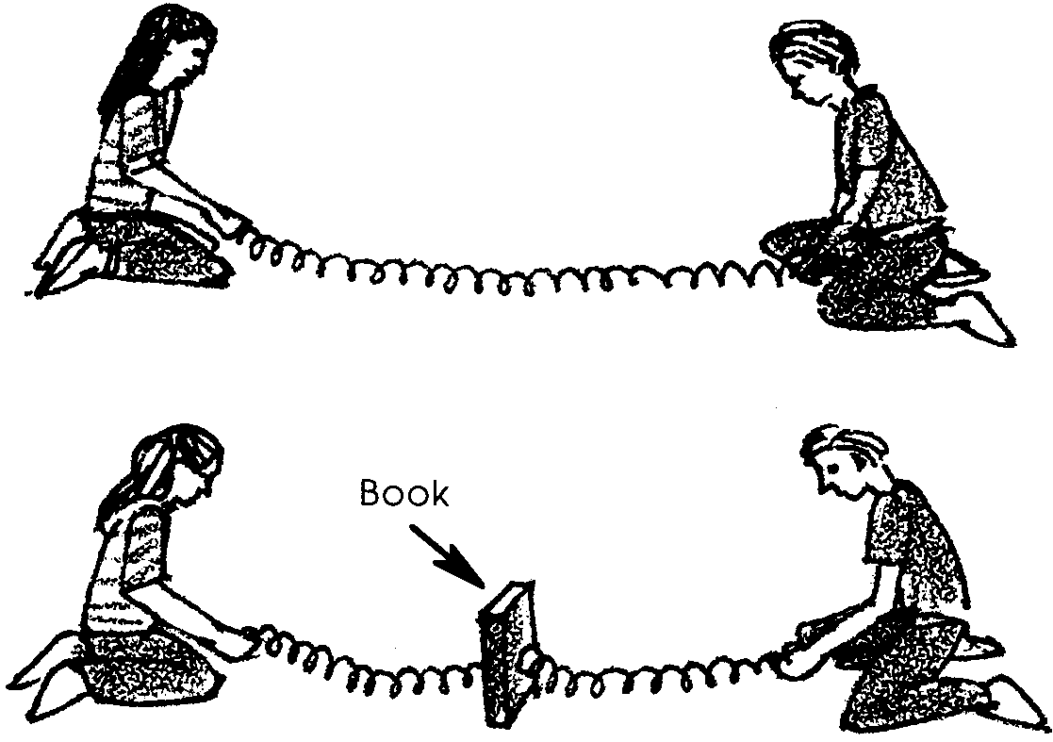
Choose a volunteer and demonstrate how to generate a slinky wave. You and the volunteer should sit on the floor several feet apart facing each other. Each of you should hold an end of the slinky and stretch it out between you. Warn students that if they let go of the slinky when it is extended it may snap and harm someone and it will become hopelessly tangled. One of you should generate a wave by moving your hand about two feet sideways in one pulse. The wave should travel down the slinky to your partner and then return back to you.

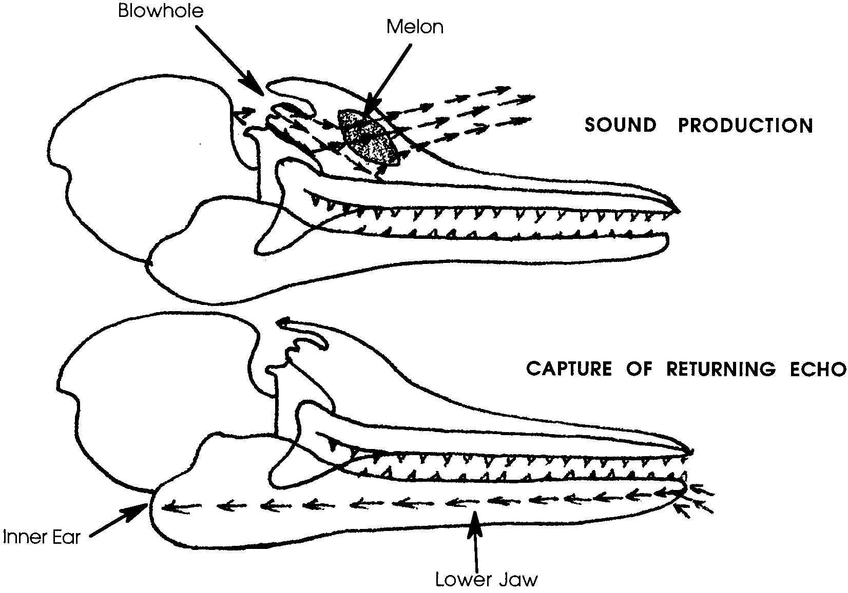
Key Words
echolocation - system of locating objects by determining the time for an echo to return and the direction from which it returns, used by dolphins, bats, and some other animals
wave - a progressive disturbance propagated from point to point in a medium or space without progress or advance by the points themselves

Extensions
1. Have students use a carpenter’s estimator, available at hardware stores, to find distance. The tool finds distances by reflecting waves off walls.
2. Invite a guest speaker involved in the use of radar or sonar to talk about and demonstrate applications of radar or sonar.

Answer Key
1. The slinky wave should move in the opposite direction when it reaches the wave generator’s partner.

2-3. Experimental results will vary.

4. Slinky wave measurement is similar to echolocation in that the data collector is producing waves and measuring their return in order to collect information about the location of objects.

5. Echolocation operates much faster than the slinky wave measurements of distance and the animal can process many incoming signals. In addition, whales can use echolocation to communicate and identify objects as well as to determine distance. Echolocation probably is much more accurate than slinky wave measurements!

6. Echolocation is important for marine mammals because it helps them to navigate, find prey, and communicate in formless, often dark waters of the open ocean.
Marine Mammal Adaptations:
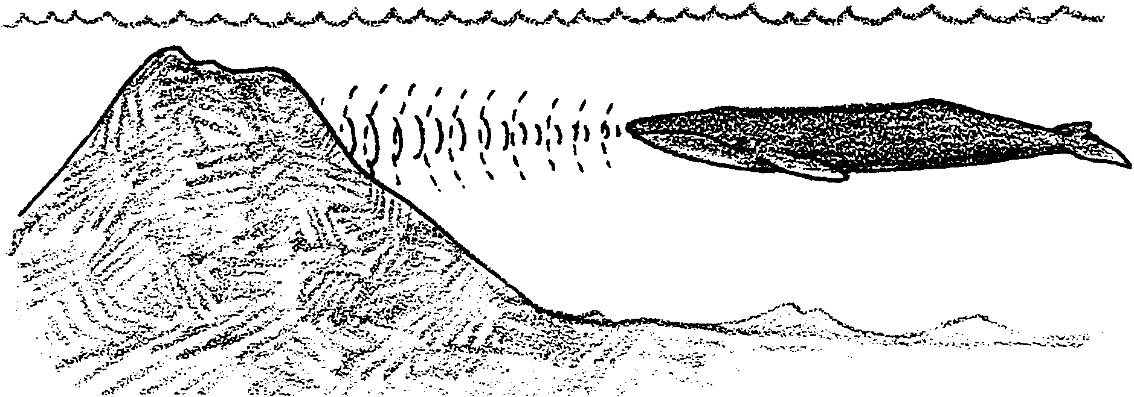
Echolocation

In the moving, formless, often dark waters of the open ocean, dolphins and toothed whales depend on sound to find their way. In a process called echolocation, using echoes to locate objects, the whales emit sound waves. When the sound waves hit an object, they reflect back to the whale at a different wavelength. The whale receives these echoes and processes the information. Their brains are so adept at processing the information that they can use echolocation to navigate, find prey and communicate with each other.

Echolocation is not quite the same as our sense of hearing. Whales can send sound waves at the same time they receive and interpret them. (Humans sometimes like to believe that we can speak and listen at the same time, but we cannot!) They can identify a species of fish or even the identity of an individual fellow whale using echolocation. They can locate prey so accurately that they can swim right to it to capture it and eat it.

In this activity, you will make slinky waves instead of sound waves. You will use the slinky wave to determine the distance from you to an object.

You will need:
• one slinky
• a stop watch or clock or watch with a second hand
• a book
• a meter stick

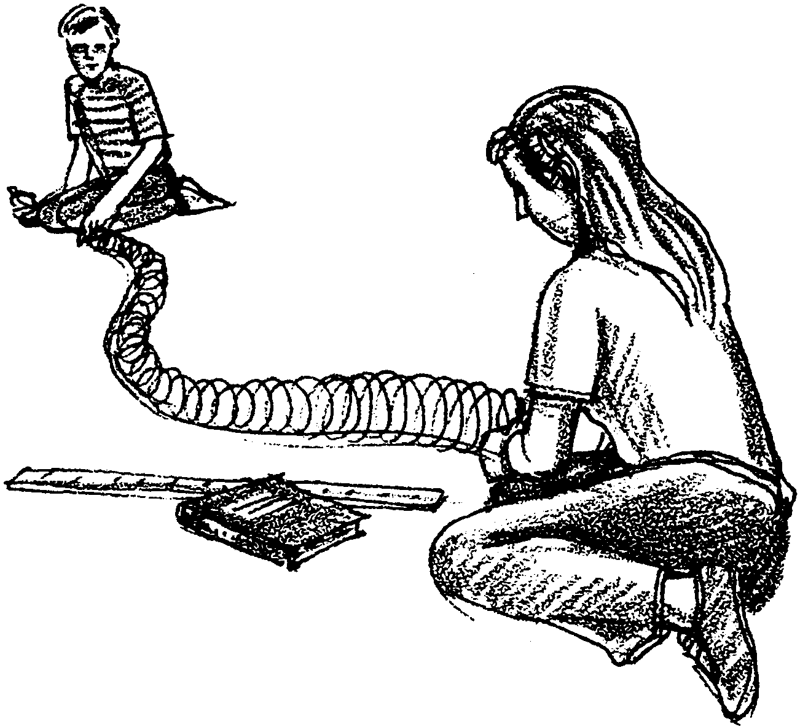
1. Sit on the floor opposite your partner, each of you holding an end of the slinky as demonstrated by your teacher. Generate a slinky wave by moving your end of the slinky once sideways about 2 feet. Take turns generating waves.

What happens when a slinky wave reaches your partner?

2a. How many seconds does it take a slinky wave to travel from you to your partner and back again?

b. How many meters apart are you and your partner?

c. If speed = distance x time, how fast are your slinky waves moving? Show your work.
3a. Place a book somewhere in your slinky, between the coils. Make a slinky pulse and measure how long it takes the pulse to move from you to the book and back. Record the time: seconds

b. If speed = distance x time, how far away is the book from you? Show your work.

c. Measure the distance from you to the book with a meter stick. Record the distance:

d. How close was your slinky wave measurement to the actual distance?

4. In what ways is slinky echolocation similar to the echolocation dolphins and whales use?

5. In what ways does whale echolocation differ from the slinky wave measurement method?

6. How is echolocation important for marine mammals?

