Marine Mammal Adaptations
Bradycardia—The Diving Response

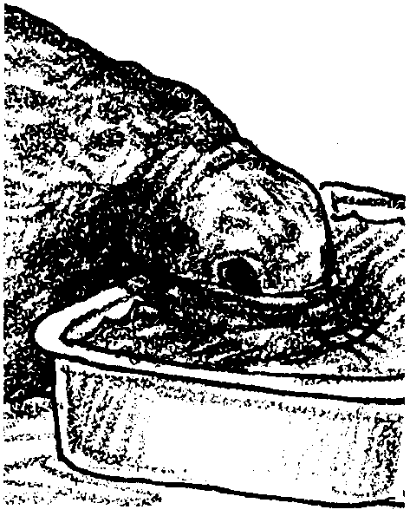
Key Concepts
1. Though they breathe air, marine mammals dive for long periods of time to great depths without harm.
2. One adaptation that enables marine mammals to stay submerged is bradycardia, or the diving response, in which the heart rate slows dramatically and blood circulates to the body core and not to the extremities.

Background
The ability of marine mammals to dive for very long periods of time has fascinated people for ages. Large lung capacity seemed to be the obvious answer. Examination of marine mammals, however, showed that marine mammals have lungs which are not significantly larger in proportion to body size than ours. By the turn of the century, physiologists were looking for better explanations. After many ingenious experiments, it appears that diving mammals have a sophisticated system for reducing the heartbeat (bradycardia) while simultaneously reducing circulation to the peripheral body parts. Circulation to the brain and heart is maintained during the dives. Additional energy is derived during diving through lactic acid production. The lactic acid production causes an “oxygen debt” that must be paid when oxygen becomes available. The oxygen debts were found to be less than anticipated and evidence seems to indicate that there is also a reduction in metabolic activity in the non-active tissues deprived of oxygen. An interesting overview of the research is found in the following article which is recommended to you and to your students:

Scholander, P.F. “The Master Switch of Life”, in Scientific American (Dec. 1963)

Materials
For each team of 2–3 students:
• dish pan filled with ice water
• towel
• stop watch or watch or clock with a second hand
Teaching Hints

In “The Diving Response - Bradycardia”, students investigate bradycardia in humans, using themselves as the test animal. Human divers appear to respond like other vertebrates when subjected to asphyxiation. Divers develop bradycardia within 20 to 30 seconds. There may be a difference between people and other vertebrates that merits mention: pathological arrhythmias, or irregularities of the heartbeat, are alarmingly common in people after only half a minute’s dive and such arrhythmias have so far not been observed in animals. While adverse reactions are unlikely to occur in your class, be certain to caution your students to stop if they feel faint or uncomfortable. Also be certain that your students follow the directions as written.
More students will participate in this lab if you warn them the day before so they can bring hair ties, a brush or fresh make-up.
Demonstrate the proper techniques for taking the pulse. The radial pulse may be taken by placing the first three fingers in the hollow on the thumb side of the ventral surface of the wrist. Since the thumb has a pulse of its own, its use to sense other pulses is not recommended. The pulse may also be taken by placing the first three fingers on the Adam’s apple and rolling them dorsally and anteriorly (back and up) into the depression of the neck where the carotid artery is located. While measuring the carotid pulse has some obvious disadvantages in this procedure, it is a stronger pulse and may be used where there is great difficulty in locating the radial pulse.
It is likely to take your students several trials before they are comfortable while immersing their face. Explain that though they may feel anxious at first, they will feel a marked sense of calm as they get accustomed to the water. Expect some general confusion during this period. Be aware of these potentialities and plan accordingly.

Key Words
asphyxia - extreme condition caused by lack of oxygen and excess carbon dioxide in the blood
bradycardia - slow heartbeat rate, usually less than 60 beats per minute, such as that occurring when diving animals are submerged
suffocation - impede respiration by preventing access of air to the blood through the lungs, may result in death
tachycardia - excessively rapid heartbeat
tourniquet - bandage, cord, or other device for arresting bleeding by forcibly constricting a blood vessel
Answer Key

Text Questions

l. Asphyxia is a condition in which too little oxygen is supplied to the living tissues.

2. The brain and heart tissues are most susceptible to damage from asphyxiation.

3 a., b., c. Student answers will vary.

4. Bradycardia is a slowing of the heart action when an animal is submerged in water.

5. Diving animals avoid brain and heart damage during diving by:
a. bradycardia
b. reducing peripheral circulation while maintaining circulation to the heart and brain.

Analysis and Interpretation
1. Most likely the students’ heartbeat rate will fall within the normal ranges shown. Averages are, however, just that and you will likely have students that fall beyond the normal ranges. Allay their fears and assure them that their rates are appropriate for them!

2, 3, 4, 5, 6. Answers depend upon experimental results. In general, the effects of bradycardia are less pronounced if a subject is merely told to hold his breath without submerging his face.

7. Your students are likely to devise ingenious ways to measure a reduction in peripheral circulation. One of the simplest involves placing a blood pressure cuff around the calf muscle and inflating the cuff to the point of constriction of the venous or arterial circulation. The pressure is then reduced to the point where the blood just begins to flow and the subject’s face is emerged. If there is a reduction in flow, it will manifest itself by a cessation in the fluctuations in the mercury column of the sphygmomanometer.

8. While the answer depends upon the experimental observations, it has been proven that people do exhibit bradycardia when faced with asphyxiation.
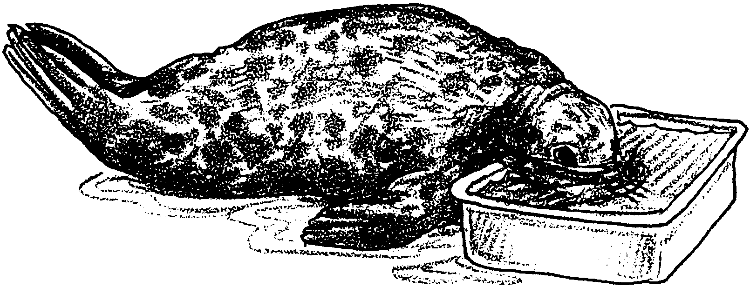
Marine Mammal Adaptations
Bradycardia—The Diving Response

Breathing and heartbeat mean life. These processes bring oxygen to our tissues and remove carbon dioxide. Any interruption of breathing or circulation threatens life. Interestingly enough, not all of the tissues of an animal need to be continuously supplied with fresh oxygen. Most parts of the human body display a considerable tolerance for asphyxia (too little oxygen). The tissues of an arm or leg can be isolated by a tight tourniquet for more than an hour without damage. The kidney can survive without circulation for a similar period. A transplanted cornea can survive for many hours. The heart and brain, however, are extremely sensitive to asphyxia. Suffocation or heart failure kills a human being within a few minutes, and the brain suffers irreversible damage if its circulation ceases for more than five minutes.

1. What is asphyxia?

2. Which tissues are most susceptible to damage from asphyxiation?

3a. How long do you think you could hold your breath?

b. Try it. How long did you hold your breath?

c. How deep do you think you could dive without harm (assume you may wear weights so it would be physically possible to get down)?
Most of us can hold our breath for about a minute. We can dive 10 or 20 feet before it becomes uncomfortable. There are some human divers, however, who have greatly extended both the time and depth at which they can dive. Consider these diving records from breath-hold diving competitions. In 1974, Enzo Maiorca dove 94 meters (308 feet). In 1983, competitive breath-hold diver Jacques Mayol exceeded this depth with a dive to 105 meters (344 feet)! These divers can stay underwater on a single breath for as much as four minutes! These divers do not take air tanks with them; they take one breath and dive!
Consider these even more amazing diving feats by seals and whales. The fur seal is known to dive at least as deep as 250 meters (820 feet). Some sea lions dive as deep as 480 meters (1575 feet). Scientists have recorded elephant seal dives as deep as 1500 meters (4,922 feet). Sperm whales hunt giant squid in the deep sea, exceeding depths of 1,610 meters (5,280 feet) and staying down for over an hour.
How do marine mammals avoid problems during their very long dives? The simplest explanation would be that the diving animals have a large capacity for storing oxygen. When we look, we find that their lungs are not unusually large. Scientists have found, however, that every diving animal studied exhibits bradycardia, a slowing of the heart action when the animal is submerged. In addition to slowing their heartbeat, diving animals also close down circulation to most body parts while maintaining circulation to the heart and brain when making a dive. Typically, the blood supply to the muscles, intestines, and lower parts of the body is greatly reduced during diving.

4. What is bradycardia?

5. What are two ways in which diving animals avoid brain and heart damage during diving?

Do we observe bradycardia in humans? In the following experiment you will have a chance to experience the same diving response marine animals use to dive for a long time.
Materials:
• dish pan
• towels
• cold tap water
• stopwatch or watch with a second hand

Procedure:
Work in pairs. Record all data as you collect it on the data chart.

Resting Heart Rate

1. Sit quietly for two minutes. During this time your partner can practice taking your pulse. (You will not be able to count your own pulse with your face in the water.) After the two minute rest, have your partner count your pulse for 15 seconds. RECORD this figure on your chart. Repeat the above twice more and determine the average for the three trials.

Name

Resting Heart Rate Heart Rate Heart Rate
Holding Breath Face in Water

1. 1. 1.

2. 2. 2.

3. 3. 3.

avg. avg. avg.

Name

Resting Heart Rate Heart Rate Heart Rate
Holding Breath Face in Water

1. 1 1.

2. 2. 2.

3. 3. 3.

avg. avg. avg.

Heart Rate While Holding Breath
2. When you submerge your face in the water, it will take 10-20 seconds or so for bradycardia to begin. In fact, your pulse rate may increase when you first put your face in the water. As a result, you will need to keep your face in the water for 20 seconds to get bradycardia started and then keep it in the water for another 15 seconds so your partner can count your pulse when you are experiencing bradycardia.

Practice this out of water. Hold your breath for a total of 35 seconds. Count your pulse for the last 15 seconds. Record your heart rate in the table. Repeat two more times and then average your counts.

Heart Rate With Face in Water

3. Practice holding your breath with your face in the pan of cold water for 35 seconds. Submerge your face up to your ears. Have towels ready. When you have your self-confidence established and can do it without excitement, you are ready for the next test.

4. With your face in the water up to your ears, have your pulse measured the last 15 seconds of the 35 second period. Repeat twice more and determine an average for the three times as before.

5. Empty and rinse the pan when finished. Assist your partner, repeat the experiment and collect the data.

6. Clean up the counters, floor, sinks, and spread the towels out to dry.

7. Complete the data chart by recording the average rates/minute. Use this information to complete the pulse rate bar graph on the next page.

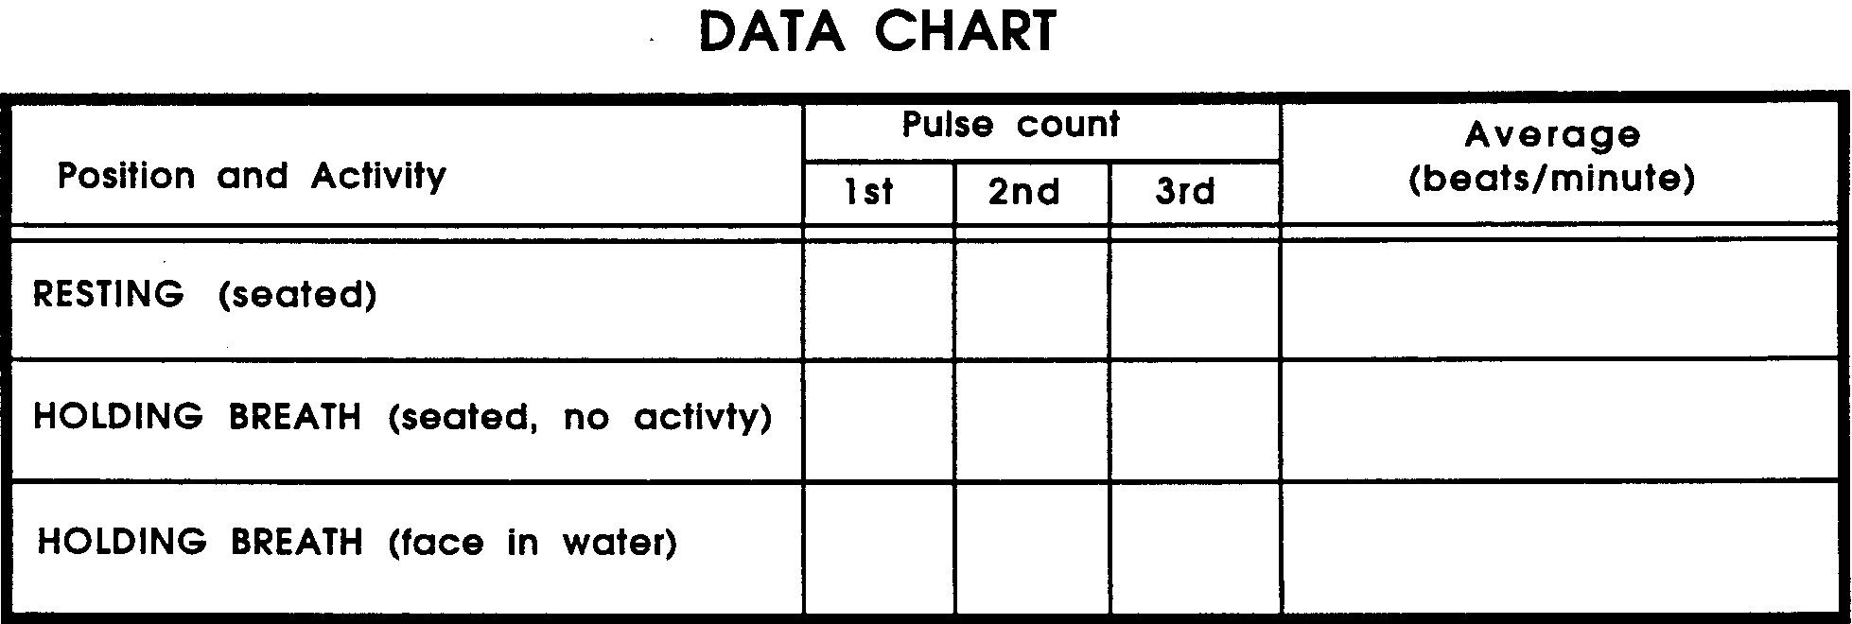

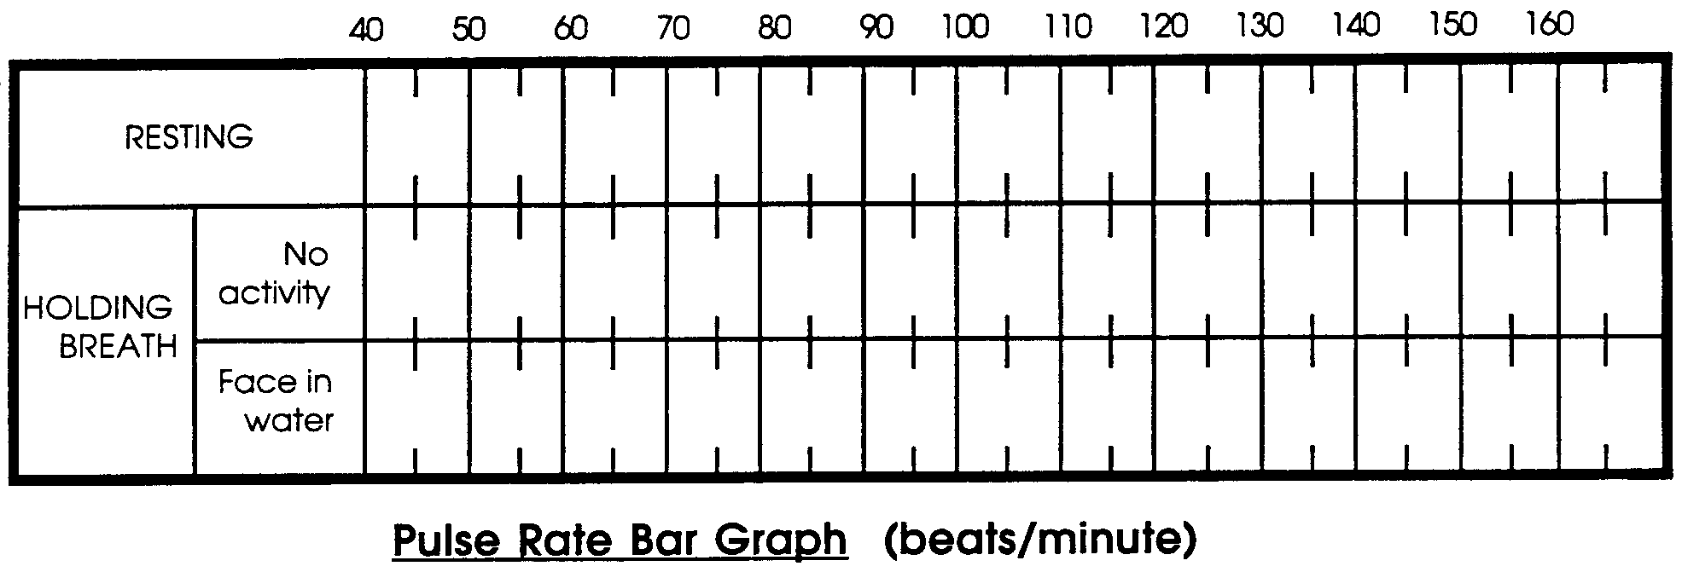

Analysis and Interpretation:

1. How does your resting pulse rate (seated) compare with the “Average Normal Variation in Heart Rate” shown below?

Average Normal Variation in Heart Rate

Children: 72 - 92

Adults: 65 - 80

Women: 70 - 80

Men: 65 - 70

From a normal of 70, the pulse of a person after a 100 meter dash might be about 120.

Less than 50 is said to be “bradycardia”. More than 110 is said to be “tachycardia”.

2. What was the effect of breath holding on your pulse rate?

3. How did placing your face in the water affect your pulse rate?

4. A reduction of pulse rate from the average range to 50 per minute is said to be bradycardia. Under which conditions did you show bradycardia?

5. Researchers have noticed that psychological factors tend to influence the physiological response to asphyxia. Under which condition did you worry most about suffocating?

6. Did the fear of suffocation affect your results? How?

7. In diving animals, bradycardia is usually associated with a reduction in circulation to peripheral body parts (parts other than the brain or heart). Design an experiment that would provide us with information to decide whether humans show a similar reduction in circulation.

8. From your observations, would you conclude that humans exhibit bradycardia when faced with asphyxiation? Support your answer with the data you collected.

