Marine Mammal Adaptations –
Diving Buoyancy Lab
Written by Ardi Kveven, Snohomish High School, Snohomish, Washington.
Adapted from the 1993 JASON Project Curriculum, National Science Teachers Association.
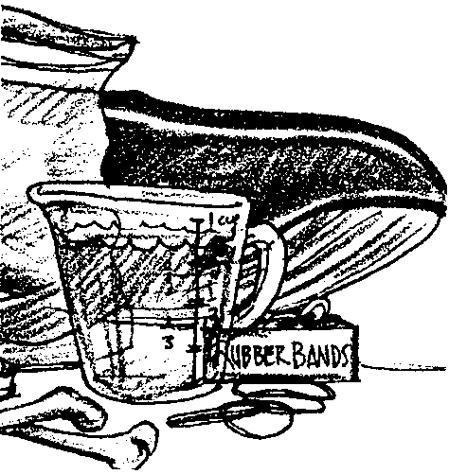

Key Concept
1. Pressure tends to compress air spaces in marine mammals as they dive.

Background
The blubber most marine mammals wear to keep warm is quite buoyant and would seem to prevent seals and whales from diving. Seals and whales, however, are extraordinary divers. Despite their buoyant blubber covering, their body composition makes them essentially neutrally buoyant. Through subtle control of their bodies, they can control their dives.

Materials
For each pair of students:
• resealable plastic sandwich bag
• a few ounces of vegetable shortening (consider using shortening leftover from the blubber mitt lab)
• chicken leg bones (cook the chicken to kill pathogens)
• gallon bucket with water

Teaching Hints
In this lab, students experiment with bone, air, fat, and water to find a combination that will be neutrally buoyant in a given tub of water. Then they submerge their model marine mammal and observe the compression of air spaces within the animal.

Key Words
blubber - fat layer between muscle and skin of whales and other cetaceans; whale oil was derived from blubber
buoyancy - the power of a fluid to push upward or keep afloat a body immersed in it
insulator - a material of such low conductivity that the flow of heat through it is greatly reduced or negligible
Extensions

1. Have your students test and modify their plastic bag whales in a different type of water (colder, warmer or more or less salty).

2. Provide a balance and graduated cylinders and ask students to measure the mass and volume of each part of their model animals and then the mass and volume of their assembled plastic bag whale. What ratio of mass to volume is necessary to make a neutrally buoyant whale in the water they are testing? ( Fresh water has a density of 1 gram per milliliter, so any object that weighs more than 1 gram for each milliliter of space it takes up will sink in fresh water. Any object that weighs less than 1 gram for each milliliter of space it takes up will float in fresh water. Salt water has a higher density and so objects must be somewhat more dense, they must weigh more for their size, in order to sink in salt water.)

3. There are many standard physics lab activities that explore density and which could extend this lesson. For example, your students could make Cartesian divers.

Answer Key
1. Student lists of materials that make up a whale’s body will vary. They probably will include muscle, bone, nerves and skin. Students may mention blood, water and air. Accept reasonable lists.

2 a. Student predictions will vary.

b. The baggie with shortening will float.

3 a. Student predictions will vary.

b. The baggie filled with air will float.

4 a. Student predictions will vary.

b. The baggie filled with water will be neutrally buoyant and will neither float nor sink.

5 a. Student predictions will vary.

b. The baggie with a chicken bone will sink.

6. Ratios of materials will vary depending on the kind of water in which students are testing their whales.

7. Neutral buoyancy enables whales to dive or surface without expending a lot of energy to overcome buoyancy.

8. Answers depend upon experimental observations. It would be expected that the plastic bag whales would compress as the students submerge their plastic bags.

9. As whales and seals dive, the air in their lungs would compress.
Marine Mammal Adaptations—
Diving Buoyancy Lab
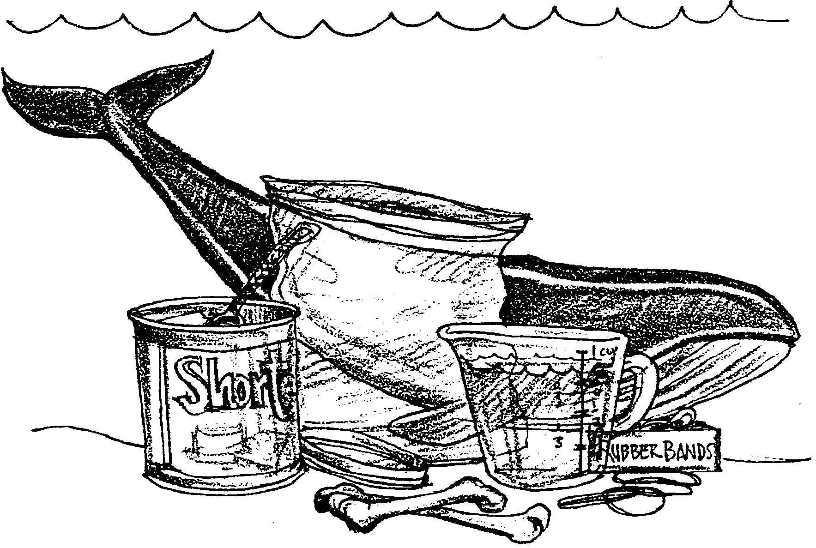

Whales and seals have blubber to help them stay warm. This blubber not only insulates, but also floats very well. Whales and seals do need to spend part of their time at the water’s surface to breathe, but they also depend on their ability to dive to evade predators, hunt food and travel. They are able to submerge despite their buoyant insulation.

1. What other materials, in addition to blubber, do you think make up a whale’s body?

In this lab, you will use models of the materials that make up a whale’s body and discover what ratio of materials enables your whale to rest in the water, neither floating too high nor sinking too deep. You also will get a chance to observe what happens inside your model whale’s body as it does dive deep.
A real whale is made of tissues including blubber, muscle, and skin. Its blood and its tissues are largely made of water. Its body also includes bone. Open cavities in the whale’s body are filled with air. We will use the following materials to model a whale’s body:
Blubber = shortening

Skin = plastic bag

Bone = chicken bones

Water = water, of course

Air = air, of course

Begin by testing the materials separately. Use a plastic bag as the skin to hold the other body parts of your whale.

2a. Do you think a bag with shortening and no air sealed inside will sink or float?

b. Try it. Place some shortening in a plastic bag, push all the air out, and seal the bag. Place the bag in your bucket or tub of water. What did the bag with shortening do?

3a. Do you think a bag filled with air and sealed will sink or float?

b. Try it. What did the bag filled with air do?

4a. What do you think a sealed bag filled with water will do in the bucket of water?

b. Try this, too. Did the bag sink or float?

5a. Finally, do you think a sealed bag with a chicken bone and no air will sink or float?

b. Try it. What did the bag with a chicken bone inside do?

Now assemble some combination of these materials to create a plastic bag whale that is neutrally buoyant. This means that the whale will neither float at the surface of the water nor sink to the bottom.

6. How much of each material did you use to make a neutrally buoyant plastic bag whale?

7. How might it be beneficial for a whale to be neutrally buoyant?
Make your plastic bag whale dive. Push it to the bottom of your bucket and watch how the bag and its ingredients change.

8. How did your model whale change as you made it dive?

9. Scientists once believed that marine mammals could stay submerged for so long without coming up for air because they took in huge gulps of air before they dove. If this were true, what would happen to those lungs full of air as the whale or seal dove?

