Marine Mammal Adaptations –
Blubber Mitt Lab & Staying Warm
Written by Ardi Kveven, Snohomish High School, Snohomish, Washington.
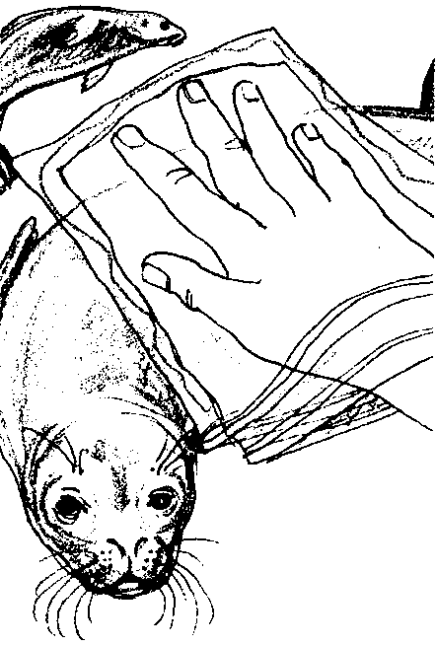

Key Concept
1. Blubber insulation is one adaptation that enables marine mammals to maintain a constant body temperature even in very cold water.

Background
Almost all marine mammals utilize the insulating properties of blubber to stay warm. Beluga whales, which live in frigid northern waters, have the thickest blubber with up to a foot of fat. Blubber is firmer and far thicker than the fatty tissue of land mammals and is laced with connective tissue.
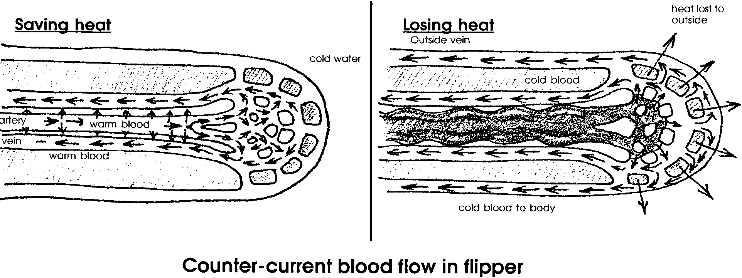
Blubber is such an effective insulator that marine mammals must guard against overheating. Whales and seals have blood vessels close to the skin surface in their appendages and they can regulate blood flow to these extremities to dissipate or conserve heat. In this counter-current circulation system, warmed blood moving to the extremities passes near vessels carrying cooled blood back to the heart. The warm blood loses its heat to the returning blood instead of losing it to the cool water that surrounds the extremities. The returning blood is now slightly warmer and, therefore, will require less reheating when it returns to the body core.

Marine mammals also use fur to stay warm. Walruses, seals and sea lions have fur but rely on blubber for warmth. Fur seals and sea otters depend on two layers of pelage: long, course guard hairs covering a thick fur layer. Fur seals and sea otters also depend on the insulating properties of air bubbles trapped in the layer of thick fur between the skin and the longer guard hairs. While in the water, otters and fur seals spend a significant amount of time grooming their fur to maintain the air layer near their skin.
All of the marine mammals also stay warm by consuming large quantities of food. While cold-blooded animals, animals whose body temperatures vary with the temperature of their environment, generally are less active and eat less as temperatures fall, homeothermic, or warm-blooded, animals must eat more as the external temperature falls so that they can maintain a constant internal temperature.

Materials
For each team of 3 students:
• 2 one-gallon or one-quart resealable freezer bags
• 36 oz. (3/4 of a large can) of vegetable shortening
• spatula
• ice
• 2 thermometers
• bucket or tub
• graph paper
• “Blubber Mitt Lab” student pages

Teaching Hints
In “Blubber Mitt Lab”, students experience for themselves the discomfort of cold water for a homeothermic (warm-blooded) mammal. Then they will experience the insulating properties of a blubber mitt.

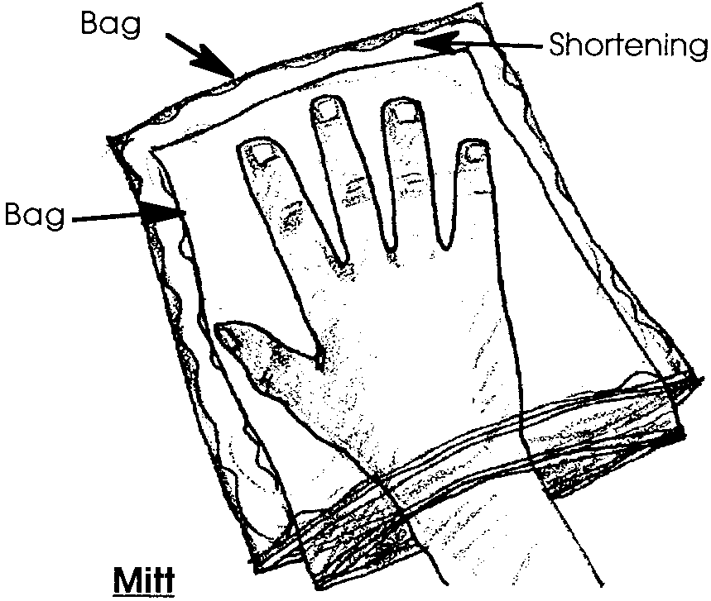
Either you or your students will need to make blubber mitts. If you can stand the mess, consider having your students make the mitts. Once a class set of mitts is constructed, you can use them year after year.
To construct a blubber mitt, scoop the shortening into one plastic bag. There should be enough shortening in the bag to form a cover around a student’s hand when the mitt is complete. Turn another bag inside out and place it inside the shortening-filled bag.
Start at one side seam and flatten the bag out and zip the two plastic bags together. If you keep the edges free of shortening, the seals will grip more securely. Use duct tape to seal any places where the bags do not seal.
Before students arrive, fill buckets or tubs with water and ice so the water has time to cool.
When students arrive, have them work in groups of three. Each student will have a turn rotating through each of the three roles in the lab, including testing the blubber mitt in the cold water.
Notice that students design their own graphs to depict their data. Encourage them to be creative, but also insist that they carefully label their graphs.

Key Words
blubber - fat layer between muscle and skin of whales and other cetaceans; whale oil was derived from blubber
insulator - a material of such low conductivity that the flow of heat through it is greatly reduced or negligible

Extension
1. Have students substitute other materials, such as Styrofoam packing peanuts, for the shortening, retry the experiment, and compare results.

Answer Key
6. Summary of results: While answers depend upon experimental results, the blubber mitt is usually effective in insulating the hand, slowing heat loss to the water and maintaining a higher hand temperature.
Marine Mammal Adaptations:
Blubber Mitt Lab
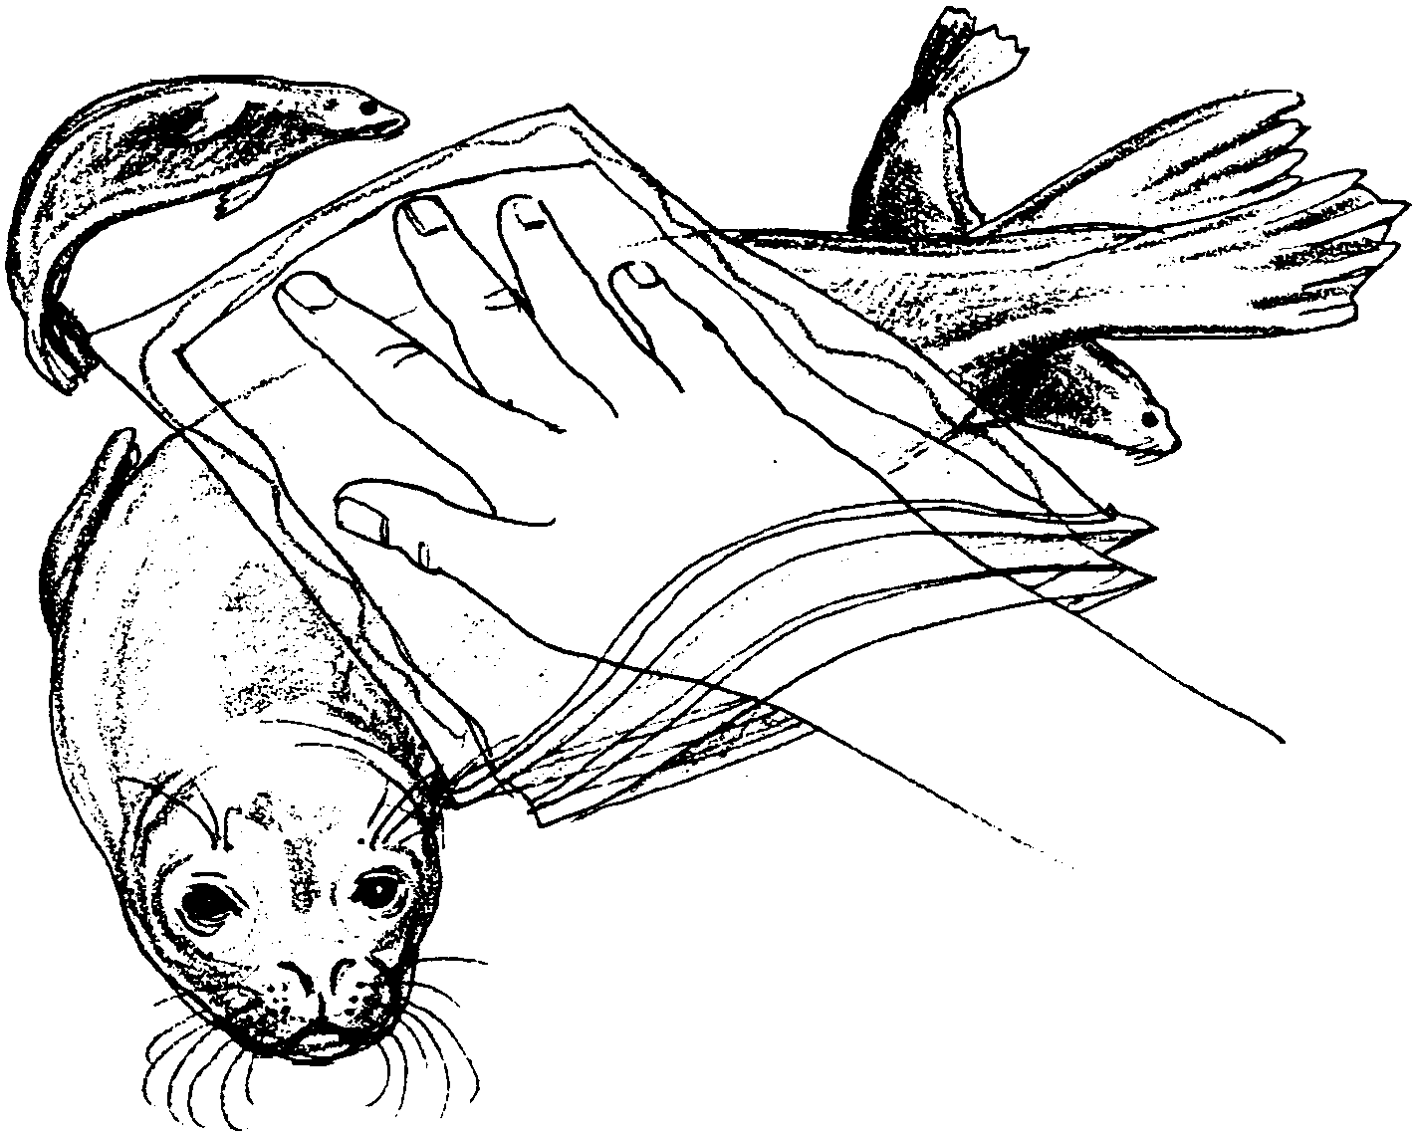
& Staying Warm

Marine mammals, just like all mammals, must maintain a constant internal body temperature. This is an incredible challenge for animals that spend most or all of their time immersed in water that may be as much as 30° Celsius cooler than their bodies. Most marine mammals use blubber or fur or a combination of both to stay warm. How well do these insulators work? In this lab, you will immerse your hand in cold water and test a model of blubber to see how effective it is at maintaining the temperature of your hand.
Your group will need:
• one blubber mitt
• 2 thermometers
• a bucket or tub filled with ice water
• graph paper
• clock or watch
1. Work in a team of three students. Select a beginning role for each team member. Each of you will rotate through all three roles as the lab progresses. Select one person to wear the blubber mitt and submerge his or her hand in the ice water. Select another person to time the submersion in water and a third person to read temperatures and record data.
2. The person wearing the blubber mitt should put the mitt on one hand and insert a thermometer inside the mitt. That student should hold the second thermometer in the other hand. (Hold the thermometers gently so they will not shatter.) Place both hands in the bucket of water at the same time. DO NOT IMMERSE THE BLUBBER MITT DEEPER THAN THE TOP OF THE MITT. YOU WON’T WANT WATER SPILLING INTO THE MITT.

The timer and recorder should take temperature readings every 30 seconds for two minutes.

3. Record the results in this table:

Team Member #1

Time Temperature in Temperature of hand
blubber mitt without mitt

30 sec.

60 sec.

90 sec.

120 sec.

Team Member #2

Time Temperature in Temperature of hand
blubber mitt without mitt

30 sec.

60 sec.

90 sec.

120 sec.

Team Member #3

Time Temperature in Temperature of hand
blubber mitt without mitt

30 sec.

60 sec.

90 sec.

120 sec.
4. Trade roles and repeat the procedure until all three team members have tested the mitt. Record all data in the charts above.

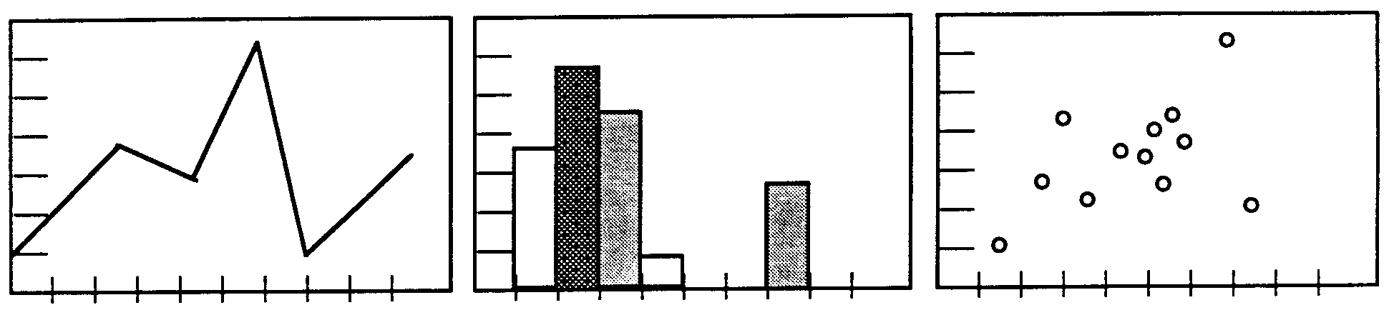
5. Devise a way to graph your results so that all the numbers are depicted visually. Below are some sample types of graphs. Select the style you think will most clearly picture your data. Be sure to label the graph so someone who did not do the experiment will be able to understand the graph.

6. Summarize your results: What effect did the blubber mitt have on the temperature of your hand?

