Marine Mammals

Key Concepts
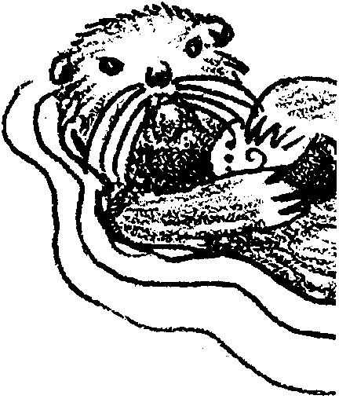
1. Marine mammals are air-breathing, warm-blooded animals that live in the sea. They give live birth and nourish their young with milk from mammary glands. All have hair at some point in their development.
2. Toothed whales, baleen whales, eared seals, true seals, and sea otters are some of the major groups of marine mammals.

Background
Next to sharks, marine mammals hold the greatest fascination for students. The sheer magnitude of the great whales is over-whelming. The streamlining of the seals is impressive. Their big eyes are “sympathetic”. All of these attributes and more tend to give marine mammals a special place with your students. Whether it be whaling issues or harp seal hunting, marine mammals are frequently in the news today.

Materials
For each student:

• copy of “Marine Mammals” student pages

Teaching Hints
This reading is designed to give a brief introduction to the more common marine mammals. Dugongs, manatees, and sirens have been omitted in favor of focusing on the more common groups. If time permits, encourage your students to prepare reports on these and other lesser known marine mammals.
Since most of your students will have had limited personal contact with marine mammals, supplement these materials with films, videos, charts, posters, and other available teaching aids. A list of sources for additional information follows.
Duplicate the activity pages. One set is recommended per student. This activity lends itself to completion by individuals as homework or as an in-class assignment. Whichever approach you elect, plan to provide your students with the correct answers to the text questions during a discussion of the concepts and materials presented in the reading.
Resources:
American Cetacean Society International Fund for Animal Welfare
“The Whalewatcher” P.O. Box 193
P. 0. Box 2639 Yarmouth Port, MA 02675
San Pedro, CA 90731 phone 781-362-4544
phone 323-548-6279
Whale Museum
Greenpeace Foundation 62 1st Street N.
1726 Commercial Drive P.O. Box 945
Vancouver, B. C. V5N 4A3 Friday Harbor, WA 98250
phone 604-253-7701 360-378-4710

Key Words
adaptation - hereditary characteristic of an organism in a population that improves its chances for survival
ambergris - an opaque, ash colored secretion of the sperm whale intestine, used in perfumery
baleen - an elastic, horny, fingernail-like material growing in place of teeth in the upper jaw of certain whales and forming a series of thin, parallel plates on each side of the palate
Cetacea - a group of animals (order) comprising aquatic, chiefly marine mammals including whales and dolphins
pinnipeds - a group of marine mammals including seals and walruses
plankton - the mostly microscopic plants and animals that drift in water; singular = plankter
spermaceti - a pearly white, waxy, translucent solid obtained from the oil in the head of the sperm whale; used in cosmetics, candles, and as an emollient
taxonomists - scientists who describe, identify, name, and classify organisms

Answer Key
1. The two characteristics that all mammals share are:
a. hair, and
b. feeding their young with milk from mammary glands.

2. Countless environmental factors impinge upon marine mammals. The most obvious for which we might expect to see special adaptations include: temperature, light, oxygen, food availability, salinity, dissolved materials, and predators. This question is designed to provide a springboard for discussion of the difficulties a mammal faces in the marine environment.
3. The two primary ways in which marine mammals deal with cold water temperatures are:
a. insulating hair, and
b. insulating fat layers.
There are also a myriad of more subtle ways in which marine mammals cope with water temperature. For example, these include sophisticated circulatory patterns that allow reduced circulation to certain areas resulting in a reduction in heat loss.

4. The ability to dive deep and stay down a long time enables the whale to feed at many different levels. It also may help whales escape danger from storms, hunters, etc. Your students may have additional ideas.

5. This question is likely to be frustrating for your students. Part of the frustration will stem from the fact that the “hypothesis” as stated is nearly impossible to prove or disprove.
We might be able to determine whether the sea chirps are warnings by subjecting one group of marine mammals to some stress, such as a pollutant, while observing a similar group not under stress. Recorded differences in sea chirps might be attributed to the stress. Whether we could consider them as “warnings” is difficult to say. The problem lies in the fact that we have attributed human attributes (the ability to perceive and reason and warn) to marine mammals. While the marine mammals may indeed have these capabilities, our scientific methods are ill equipped to determine whether what we hear are warnings. They could well be just that. The question can provide an opportunity to discuss the article and the problems with newspaper abbreviated articles or to discuss the problems of experimental design in this type of situation or to discuss communication in marine mammals. The article could also be used as a springboard for a discussion on human interaction with marine mammals. This latter discussion, however, might better occur later, after your students have gained a factual background about marine mammals.

6. As the whale swims into a mass of plankton, water containing plankton rushes into its mouth. The tongue is pressed toward the roof of the mouth forcing the water out through the baleen. The plankton is caught on the baleen “hairs” and the excess water squirts out the sides of the mouth. When a mouthful of food has built up on the baleen, the whale licks it off with its tongue. The text provides only limited help in answering this question. The answer comes from a careful look at the picture and the text statement that “Baleen whales feed on plankton, strained through the baleen...”. This question is a test of logical thinking. Be on the lookout for logical, albeit incorrect, answers.
7.
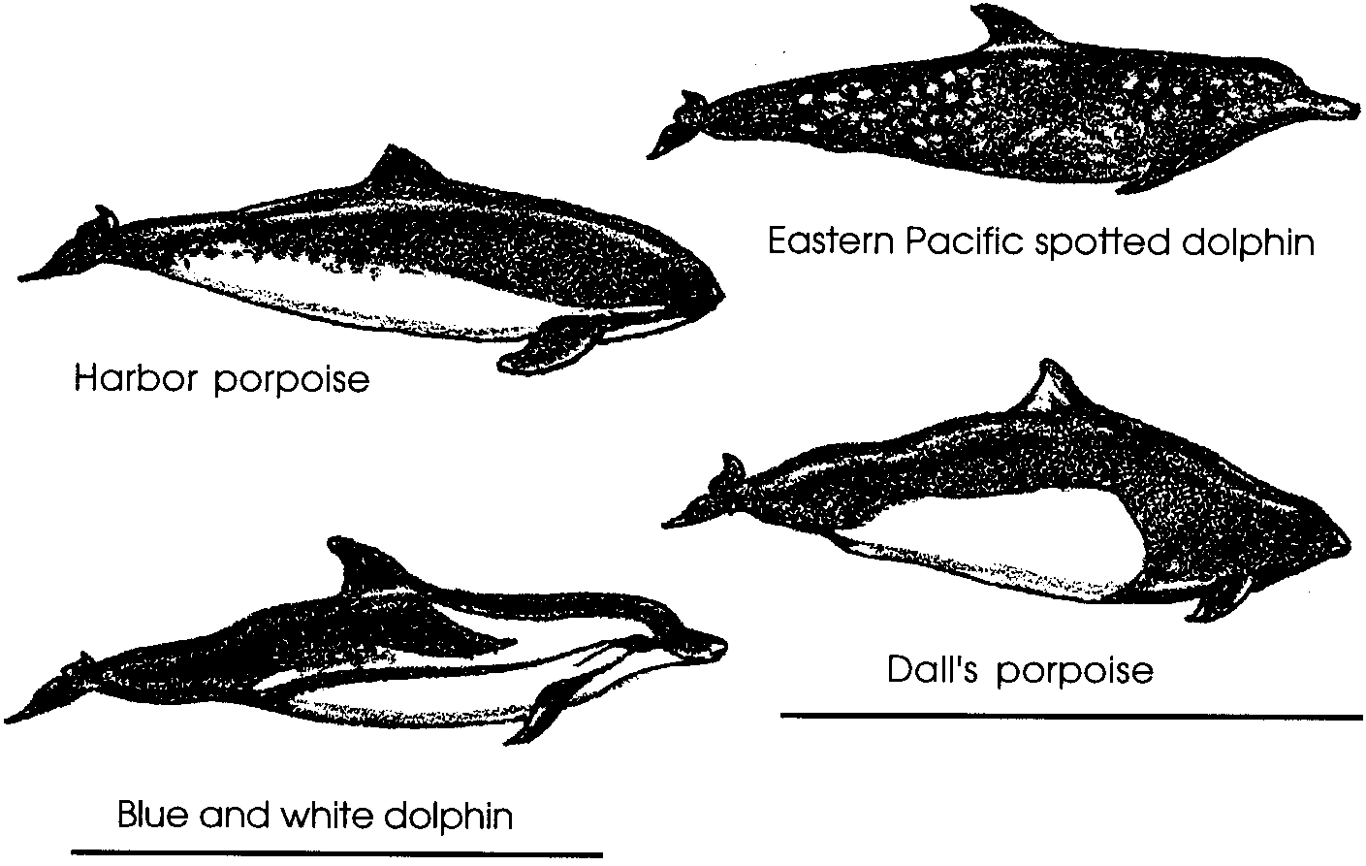

8. Since this is an opinion question, there are no right or wrong answers. Many believe that a major reason for past unrestricted whaling and for the present continuation of whaling efforts involves the “common goods” question which is discussed in some detail in subsequent activities dealing with salmon. The common goods dilemma may be summed up as: since no one owns the whale, there is no (or little) incentive to manage (or conserve) it (i.e., the whale I “conserve” may be taken by some other whaler and, hence, not benefit me at all). Currently, there exists international pressure and long term incentives to manage and practice conservation of whale stocks for those countries that wish to harvest whales.
A second important reason for continued whaling in the face of decreasing whale stocks stems from the fact that whaling nations and individual whalers have large capital investments in whaling equipment. While it would not make sense to invest in whaling as a new venture, the business “start-up” costs have already been paid and some return on the investment is better than the loss incurred by not operating. Economic incentives, then, are the major reason that whaling continues. The benefit is to the individual, in the cases where whales face extinction the cost is to society as a whole.

9. This question treats a touchy subject. When a fisher witnesses a marine mammal eating one of the animals the fisher is pursuing, the fisher is inclined to blame the marine mammal for the poor fishing. This line of reasoning is not hard to understand, the fisher can see the action and knows that a salmon or abalone eaten by a marine mammal is one less to catch. The results of pollution, overfishing, or mismanagement of the fisheries resource are not as clearly defined. Nonetheless, overfishing, pollution, habitat alteration, and poor management are more likely causes of reduced fish catches.

10. Eared seals can turn their hind flippers forward, enabling them to move rapidly on land; true seals have shortened fore limbs which make movement on land difficult and awkward in appearance.11. The current population size estimate for harp seals is only 13% of the historic figure.

12. The answers depend upon experimental observations. This question is designed to further your students’ appreciation for the diving abilities of marine mammals.

13. If the sea otter populations were reduced in number by hunting, the sea urchin populations would probably increase since the sea otter is a predator on sea urchins.

14. If the number of sea otters was reduced by hunting, the kelp beds would suffer increased grazing from the increased number of sea urchins.

15. Kelp harvesters would want to encourage sea otter population growth because sea otters are effective predators on sea urchins. Questions 13 - 15 point out some of the complex interdependencies that exist in the marine environment.

16. This question asks for an informed opinion. As such, answers will vary. Factors such as declining numbers of sea otters, pollution, changes in water conditions, changes in dietary preferences might be suggested as ones that could influence the health of kelp forests.
Some might argue that the observed results would have been a predictable outcome of widespread sea otter hunting because reduced sea otter numbers tend to allow the sea urchin numbers to increase which tends to decrease the extent of the kelp beds. Such an argument likely oversimplifies the situation.

17. This is an opinion question in which there are no right or wrong answers. The question should provide you with an opportunity to discuss the problem. One solution may lie in regulations such as the recent California laws which have established protected zones around sea otter habitat. Drift net fishing activity is excluded from the protected zones.
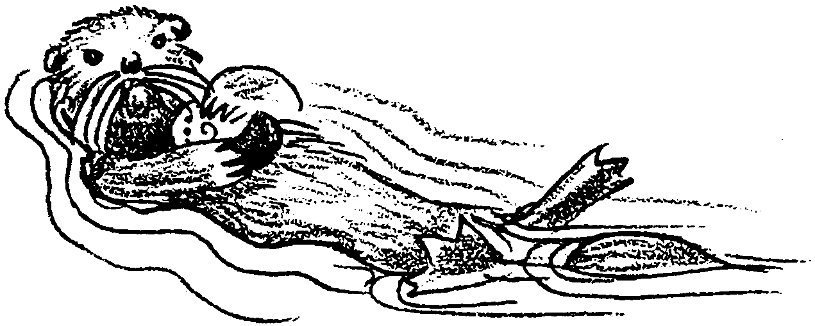
Marine Mammals

Mammals? What makes an animal a mammal? If we look at the scheme developed by taxonomists to classify animals we see that the phylum Chordata is at the top of the developmental list and that the subphylum Vertebrata is the most developed subphylum within the chordates. The most developed class is the class Mammalia. Hmmm... Could it be just coincidence that taxonomists have placed humans in the most developed class of the most developed subphylum of the most developed phylum? I don’t suppose it could have anything to do with the fact that humans made up the whole system. Interesting coincidence.
Back to the problem at hand. What are the characteristics that cause taxonomists to place an animal in the class Mammalia? All mammals share two characteristics. First, all mammals have hair, sometimes the hair is not very evident, and in some of the whales, the hair is completely absent after birth. Second, all species of mammals feed their young with milk, a fluid secreted from special glands in the skin. These glands are called mammary glands.
In addition to these two distinctive characteristics, taxonomists often use others to help them classify an animal as a mammal. The hearts of all adult mammals have two ventricles - muscular, thick-walled pumping chambers. Also mammals are usually “warm-blooded”, they are able to maintain their bodies at a specific temperature regardless of the temperature of their environment. Further, most mammals have a means of nourishing the young within the body of the mother during the early stages of development.

1. What are the two characteristics that all mammals share?
In spite of the many characteristics they have in common, mammals show great diversity. The modifications of form that account for the diversity enable an organism to live in a particular niche. These modifications are called structural adaptations. What are the special structural and behavioral adaptations possessed by those mammals that spend their life in the sea?

2. Pressure is an environmental factor with which animals living in the seas must deal. What is one other environmental factor for which we might expect to see special adaptations possessed by marine mammals?

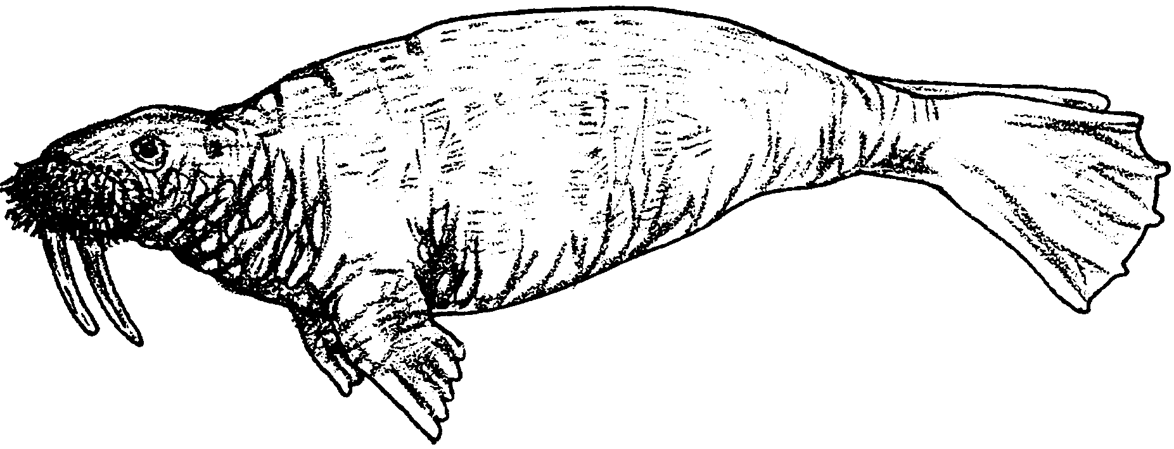
Marine mammals include whales, dolphins, porpoises, seals, sea lions, walruses, and sea otters. The bodies of marine mammals are well-adapted for life in the sea. Most are streamlined, making it easier for them to move through the water. Seals’ limbs are modified to form flippers, while sea otters have flipper-like hind feet. Instead of vertical tails like fishes, whales have horizontal tails - an adaptation that enables them to dive and surface easily. Whales combat cold ocean waters by insulating their bodies with a thick layer of fat (blubber), which also provides buoyancy, padding, and a source of energy when food is scarce. Fur seals and sea otters depend on long, fine coats of guard hair with thick fur beneath for warmth. True seals and sea lions also have a coat of hair but they rely on a layer of fat to keep them warm.

3. What are two ways in which marine mammals deal with the cold temperatures found in the seas?

a.

b.

Young marine mammals are born well developed and with their eyes open. The high protein and fat content of the milk of marine mammals provides the young with energy for their life functions and puts fat on them quickly, giving them needed insulation from the cold. The young grow fast and can take care of themselves early in life, adaptations essential to survival in the marine environment. Marine mammals are unique in many ways. Perhaps the most fascinating aspect of marine mammals, especially whales, is their ability to dive deep and stay down a long time. Although, proportionally, their lungs are not much larger in size than those of land mammals, sperm whales can dive to depths of 3,000 feet and stay down for as long as 90 minutes.

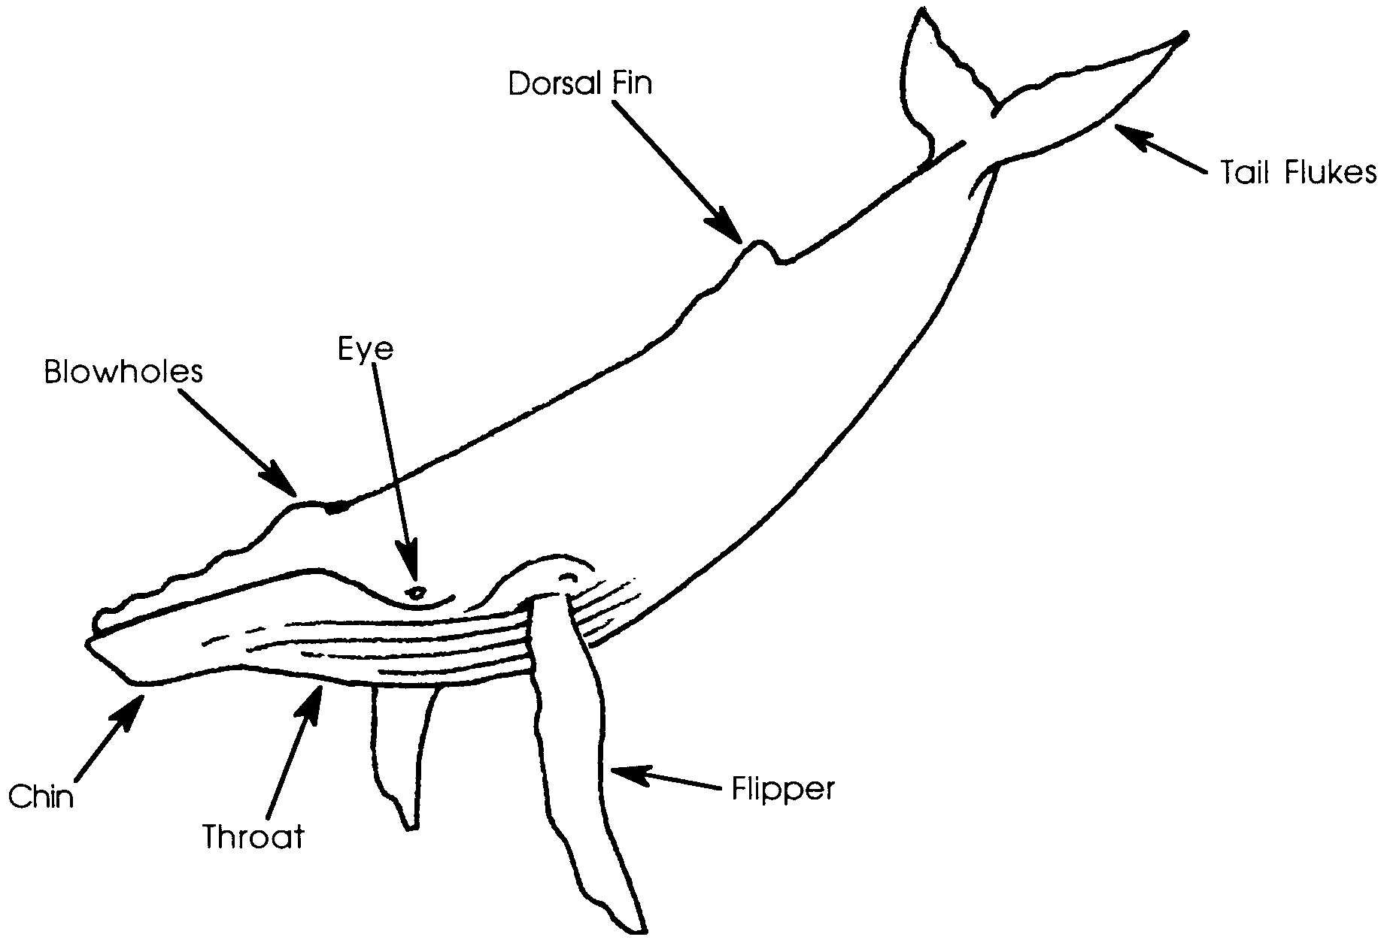
4. What is one way in which the whale’s ability to dive deep and stay down a long time help guarantee the survival of the whale?

Whales and Dolphins - The Cetaceans

Whales and dolphins have always caught the fancy of humans because of their size, beauty, and playfulness. They have been valuable to humans for centuries as a source of food and oil. The scientific name of the order, Cetacea, comes from “cetus”, the early Greek and Latin word for whale.
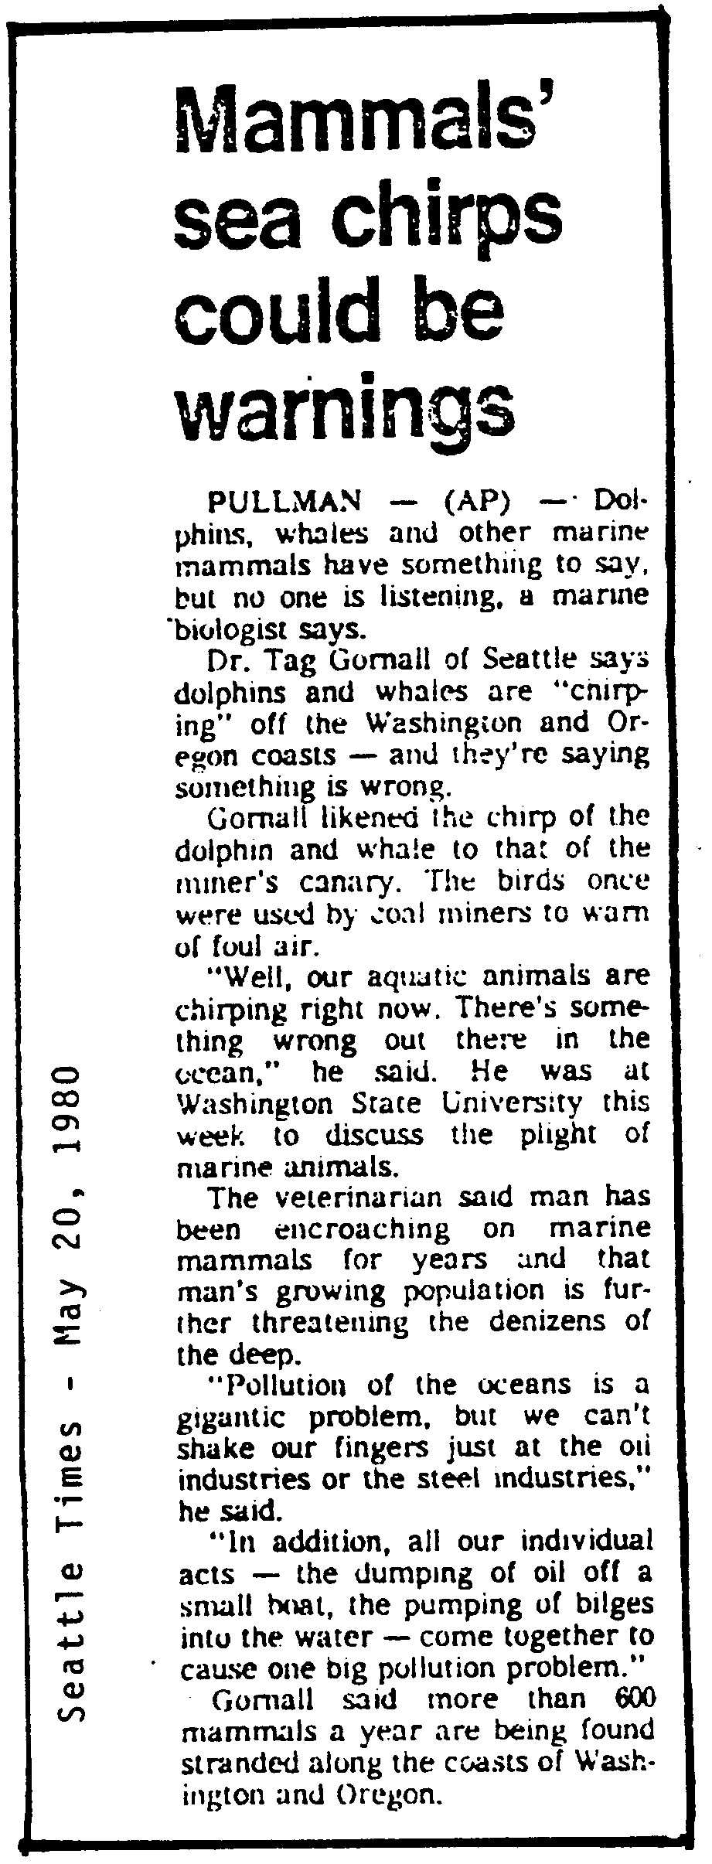
Cetaceans have poor senses of smell and of taste, but a good sense of vision and an excellent sense of hearing. Whales and dolphins are apparently very intelligent mammals that make a variety of sounds, both for “talking” with one another and, in some cases, for use as a sort of sonar to locate food and avoid underwater objects. Cetaceans breathe through nostrils (blowholes) on top of the head.

5. While most people would agree with Dr. Gornall’s statements about human’s encroaching on marine mammals, many would be skeptical about his saying that “the chirping of sea mammals is saying something is wrong”.

In the space below, design an experiment that would provide information to either prove or disprove Dr. Gornall’s hypothesis that the sea chirps are warnings.

Cetaceans usually give birth to only one offspring each year. The young are large at birth, usually one-fourth to one-third or more the length of the mother. For example, an 80-foot blue whale may give birth to a baby that is 25 feet long and weighs 2 tons or more. The young grow quickly, doubling their length within the first year. The cetaceans are divided into two groups:
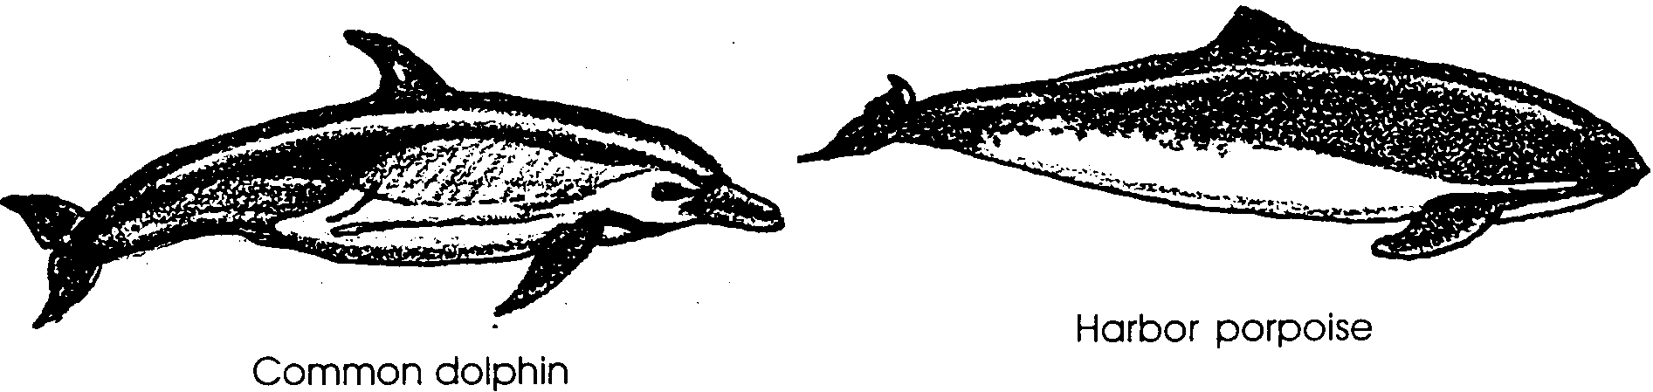
a. toothed whales - dolphins, porpoises, beaked whales, sperm whales and pygmy sperm whales;


b. baleen whales - blue whales, right whales, fin whales, and California gray whales.

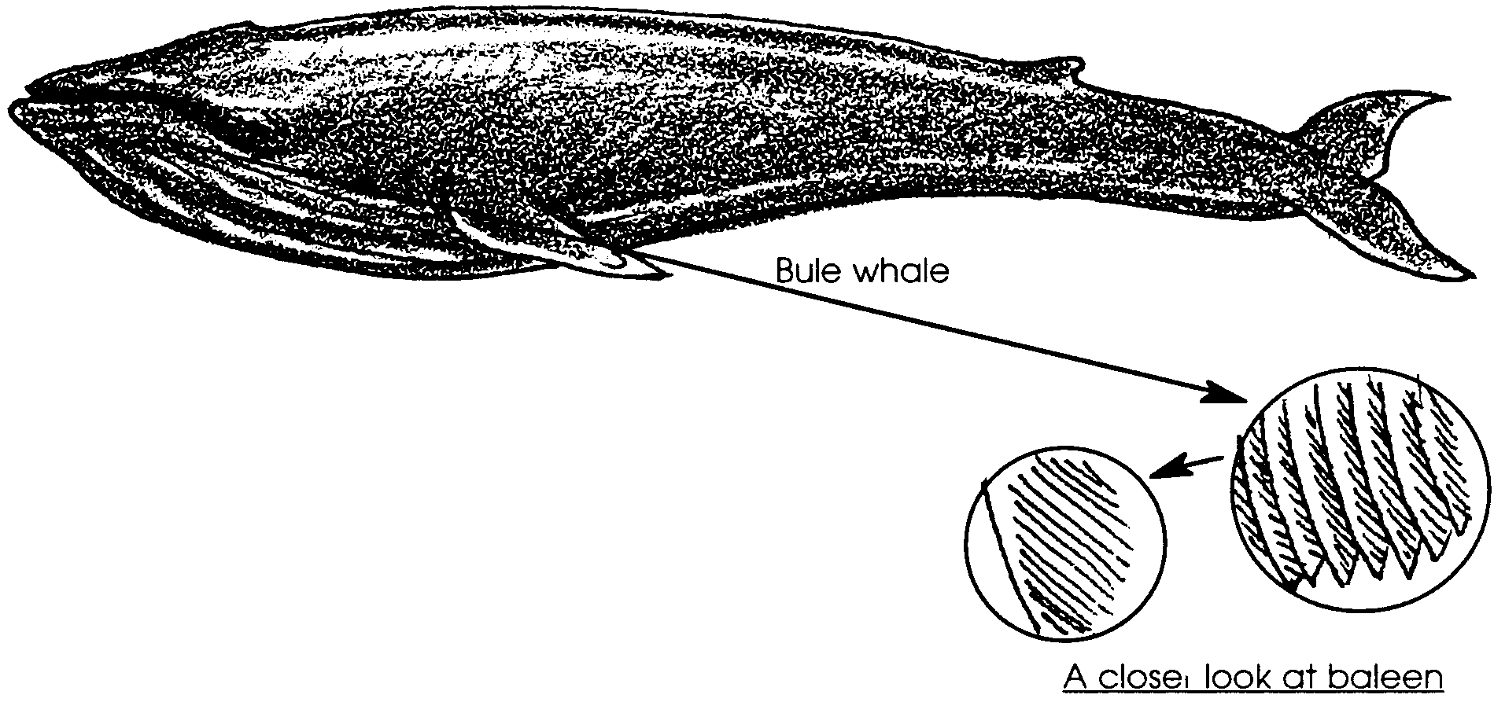

Toothed whales feed mostly on fishes, squids, octopuses, and occasionally on large mammals. Baleen whales have no teeth; instead, sheets of a fringed, fingernail-like material, called whalebone or baleen, hang from their upper jaws. Baleen whales feed on plankton, strained through the baleen, and also on small fishes and shrimp.
6. Use the drawing of the whale’s baleen to help you trace, in words, the path of plankton from free floating to swallowed!

Dolphin and porpoise are terms that often cause confusion. Strictly speaking, the long-beaked forms are called dolphins and the small, snubby-nosed forms are called porpoises. However, these words are commonly used interchangeably. The dolphin fish, also called mahi-mahi, is not a mammal.
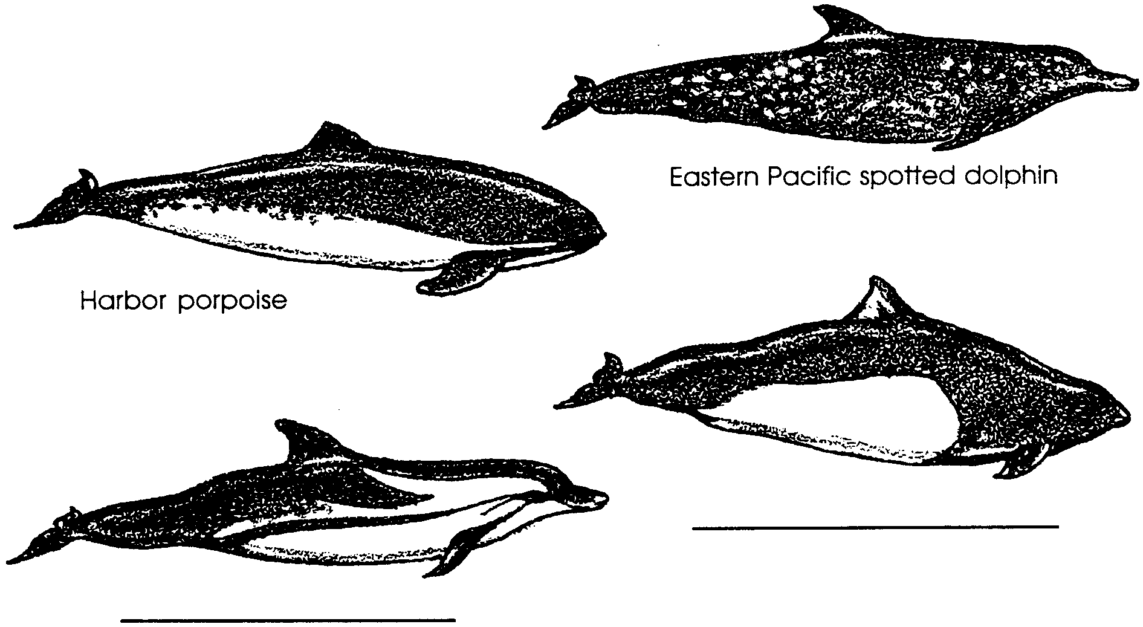
7. Label the dolphin and the porpoise shown above. Use the information in the text to help you distinguish the two marine mammals.

Dolphins are perhaps the most popular cetacean with mariners. One reason is the human-like interest they take in play. They can be seen running at the bow of a boat or riding waves in the surf. Dolphins also show concern for one another - when one member of a group is injured, the others will come to its aid.
Whales are the largest animals known. In fact, the blue whale, reaching a length of 100 feet and a weight of more than 100 tons, is the largest animal that has ever lived. Larger than the largest dinosaur, whales can grow so large because their body weight is supported by the water and, in the case of baleen whales, because of the abundance of the planktonic organisms on which they feed. Not all whales are large, however. Some, like the pygmy sperm whale, reach a length of only 13 feet.
Whale hunting by native cultures goes back many centuries before the appearance of western people. Non-native whaling, the commercial fishing of whales for food and by-products, has also been carried on for many centuries. Whaling began off the east coast of North America almost coincidentally with the first settlements. By 1640, there was a well established shore whale fishing on the east coast. By the 1800’s whalers from New Bedford and Nantucket, Massachusetts were plying the waters of the west coast in search of the whale. At that time, the main products taken were oil and spermaceti (a wax-like substance) used in lamps and for making candles; and whalebone, used in women’s garments. Today whale oil is used in the manufacture of soap, cosmetics, shortening, lubricants, and many other products. The meat and rest of the body are used for human or animal food and for fertilizer. Ambergris, a rare, soft, grayish material found in the digestive tract, is the most valuable product from whales, and is used in the finest perfumes.

8. There are now substitutes for all of the products derived from whales. In your opinion, what is one reason that whaling continues?

Human toll on whales has been so heavy that some species, including the blue whale, now are regarded as endangered. Whaling ended in the United States in 1971 when a law was passed protecting eight species of whales. International regulations have been set and, although enforcement has not been completely effective, many large whale populations are beginning to increase. As an encouraging sign, the California gray whale population has increased to a point that it qualified for removal from the endangered species list. Controversy continues to surround marine mammal harvesting. You will have a chance to explore some of the issues in subsequent activities.

Seals, Sea Lions, and Walruses - The Pinnipeds

Like the whales and other cetaceans, pinnipeds - true seals, sea lions, fur seals, and walruses - are well adapted for life in the sea. The name pinniped: which means feather feet, refers to the modification of the front and hind feet to form flippers. These flippers allow many of the pinnipeds to be excellent swimmers. Some pinnipeds, such as the harbor seal, may spend 6 to 8 months at sea, without ever touching land during that time. Others, such as the northern fur seal, spend considerable time on land. Pinnipeds have thick hides with heavy layers of fat underneath and, in some cases, fur to protect them from the cold. Pinnipeds may be separated into two groups:

a. the eared seals including fur seals and sea lions

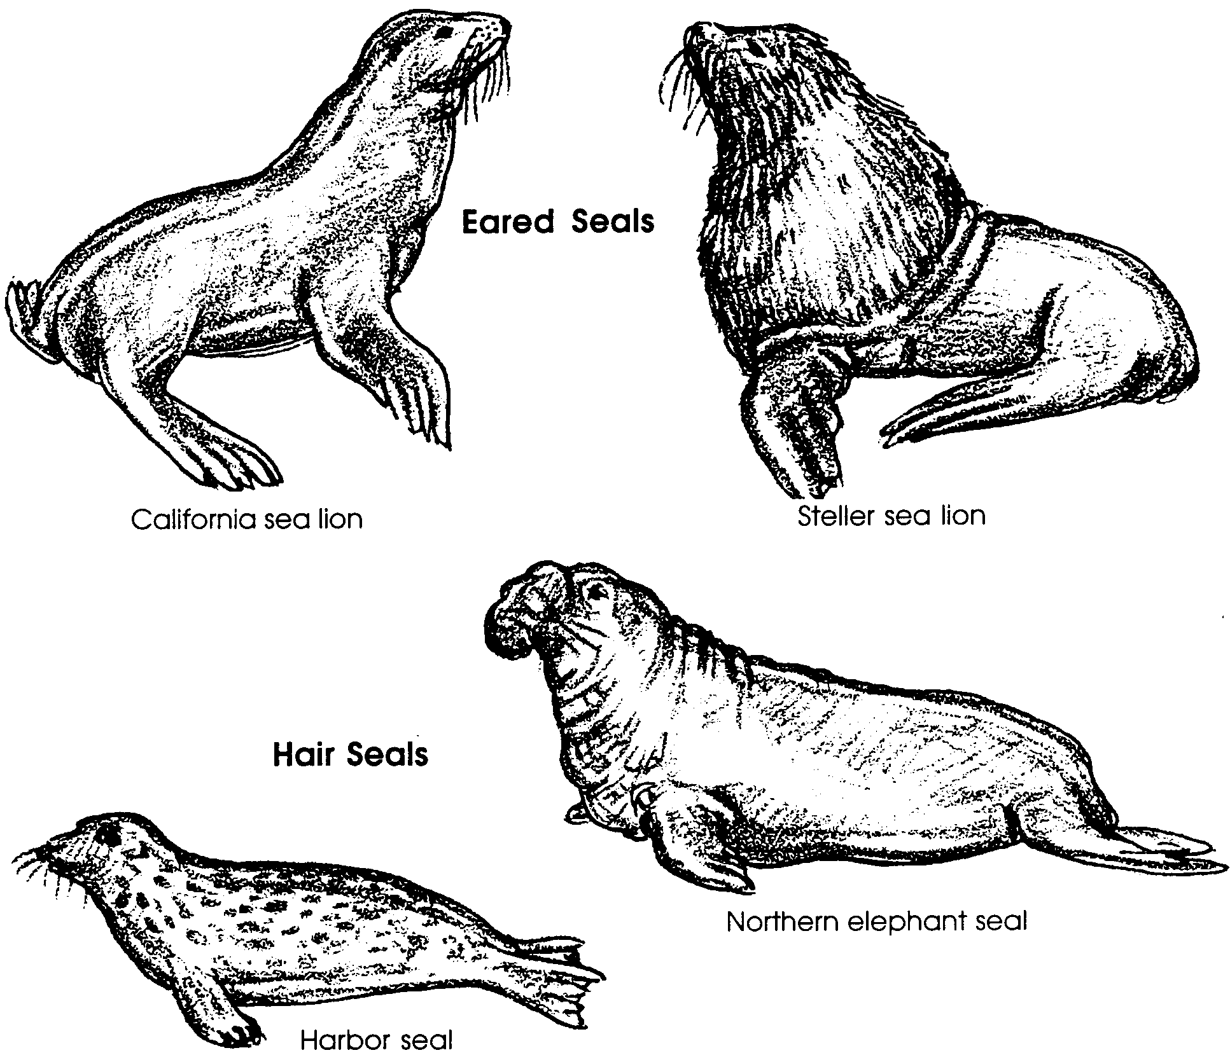
b. the true seals, or so-called hair seals, including harbor seals, ribbon seals and elephant seals.

Eared seals have small, external ear flaps. They can turn the hind flipper forward, enabling them to move rapidly on land, and they use large front flippers for swimming. Eared seals breed in special areas called rookeries, commonly on offshore islands, to which they may return year after year. During the breeding season, males fight for territories on these rookeries, and victorious males hold groups of 20 or more females, called harems. Males may go up to 2 months without feeding during breeding time.
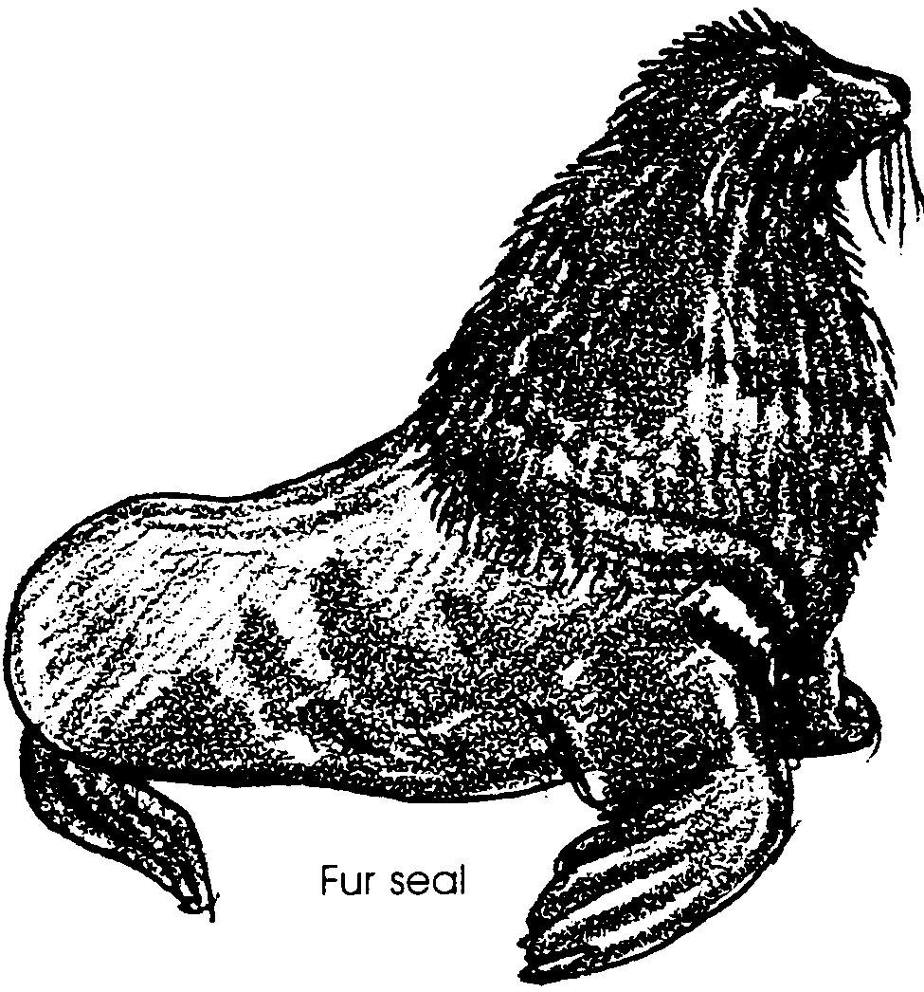
Sea lions are often seen along the coast. The trained seals commonly seen in circuses are California Sea Lions. Although the general public views them as interesting and appealing wild animals, commercial fishermen consider sea lions to be nuisances. Sea lions occasionally prey on commercially valuable fish, destroy expensive fishing gear, and interfere with fishing operations. As a result, quite a controversy exists over the value of sea lions.

9. Fishers commonly blame marine mammals for reduced fish catches. What are two other factors that might be more important causes of reduced fish catches?

a.

b.

True seals have no external ears. Unlike eared seals, they cannot turn their hind flippers forward or walk on their fore flippers. They are consequently clumsy on land, only able to worm their way along. Hair seals have smaller front flippers than do eared seals, and primarily use their hind, rather than front, flippers for swimming.

10. Eared seals and true seals differ in their ability to turn the hind flipper forward. Use these differences to decide which group of seals spends more time on land. Write your choice in the space below.

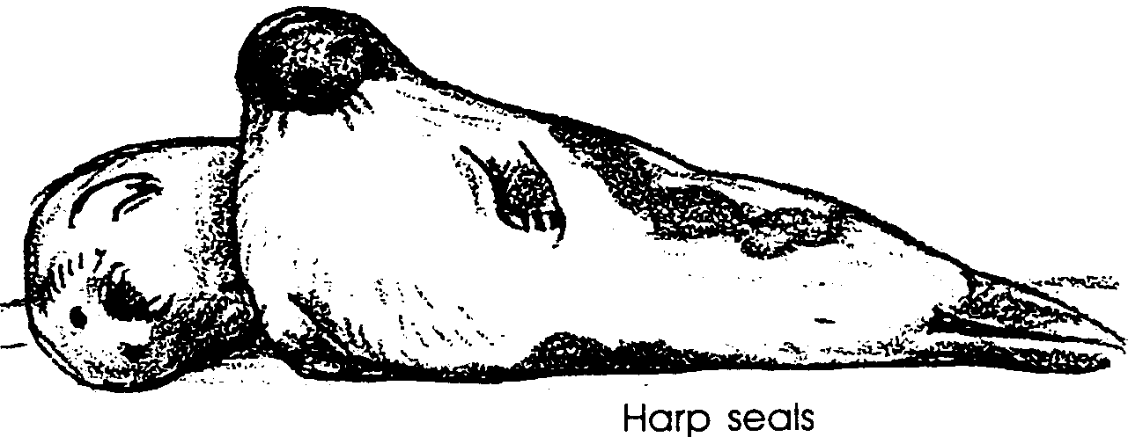
The Harp Seal is a “true seal” found in large numbers in the Arctic during the summer. Adult harp seals are sleek and silvery with a dark horseshoe shaped patch on their backs. During the first three weeks of life, baby harp seals have soft, pure white fur. Because of the beauty of their coats, baby harp seals have been hunted for over a century. Controversy now rages between the seal hunters and those opposed to seal hunting. Population estimates show drastic decreases in the numbers of harp seals from a historic figure of perhaps 15,000,000 to a current low of less than 2,000,000. As the debate over the causes of the decrease continues, the hunting goes on. You will have an opportunity to look at this issue in more detail later.

11. The current population size estimate for harp seals is only per cent of the historic figure.

(Hint: This is easy.

percent of historic figure = current population estimate
historic population estimate x 100 )

Sea Otter

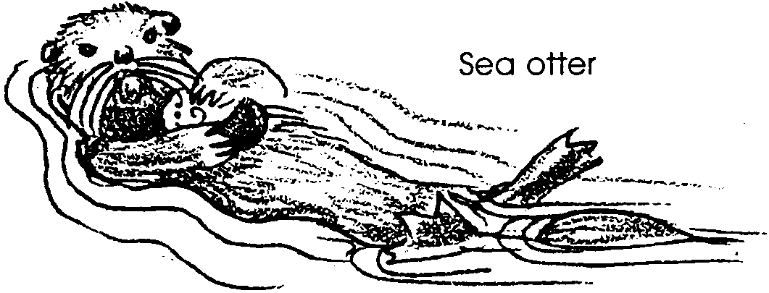
The sea otter is a member of the weasel family. Sea otters are closely related to river otters, but are considerably larger, often reaching lengths of 4 1/2 feet and weights of 70 to 80 pounds. Their front paws, used for holding food and other objects, are stubby and rounded. The hind feet are large and webbed and, along with the tail, are slightly flattened for use in swimming. When moving rapidly, sea otters swim on their bellies. Otherwise, they are normally seen swimming or resting on their backs. They can dive to 300 feet and remain underwater 4 to 5 minutes to hunt for food.
12. The sea otter for its body size has a lung capacity roughly proportional to ours. Use a watch with a second hand to determine how long you can hold your breath. Record the figure here: seconds.

How does your time compare with that of the sea otter?

What percentage of the sea otter’s time could you hold your breath?
(Hint: use the same technique you used in number 11).

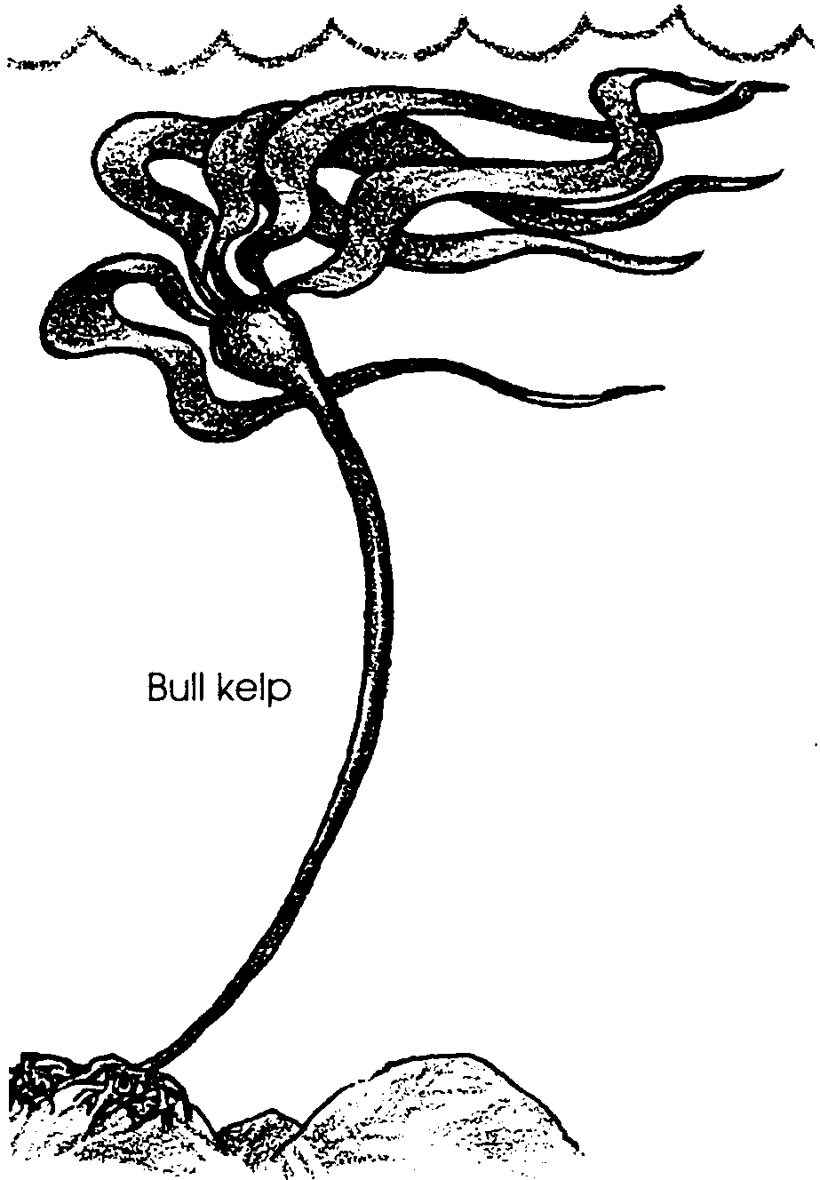
Sea otters eat sea urchins, mussels, crabs, turban snails, and a variety of other foods. They commonly are seen floating on their backs, banging open mussels and other shellfish against rocks held on their chests.
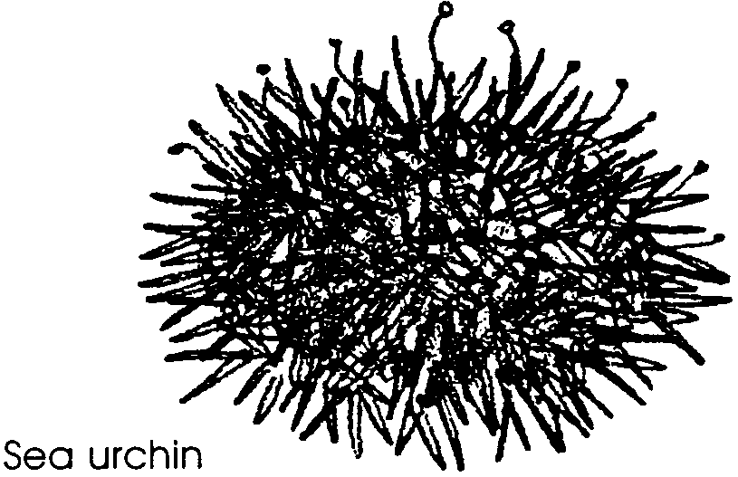

Since sea otters lack a layer of blubber, they depend on their fur and on food to maintain body heat. Indeed, an adult male easily can eat 15 pounds of food a day, nearly one-fourth of its body weight.

13. If the sea otter populations were reduced in number by hunting, what would probably happen to sea urchin populations?

14. Sea urchins eat kelp. What would likely happen to kelp beds if sea otters were reduced in number by hunting?

15. If you were a kelp harvester (remember all of those things we use algae for?), would you want to encourage or discourage sea otter population growth? Why?

Sleeping at night and feeding during the day, sea otters live in kelp beds, gathering in rafts (groups) of four or more animals. They stay close to the shore. Sea otters once ranged along the California coast where ever there were kelp beds. Because of their beautiful soft, dense, reddish-brown fur, sea otters were once the world’s most valuable furbearer. At one time, the fur trade was the most important industry on the California coast. The total California sea otter kill from 1786 to 1868 was estimated at more than 200,000. By 1900, sea otters were generally regarded as extinct along the California coast, although a small group was known to exist near Point Sur. In 1911, the Fur Seal Treaty, protecting both fur seals and sea otters, was ratified by the United States, Russia, Japan, and Great Britain. This treaty, supplemented by rigid federal and state laws, has stopped harvesters of sea otters, except for an occasional poacher or vandal. Stiff penalties exist for taking or possessing a sea otter or its skin. In recent years, populations have been increasing and otters have been expanding into new territories.

16. In the last few decades, scientists have noticed an increase in the number of purple urchins and widespread destruction of the kelp beds. Think about your answers to questions 13 - 15 and what you know of life in the sea. What do you think are some factors which might influence the health of kelp forests?

Much to the distress of abalone fishers, sea otters also eat abalone. In some areas off the coast of California, the California Department of Fish and Game has captured offending sea otters and moved them to reduce the abalone industry’s loss. This plan has met with mixed success. Some otters transplanted distances of 45 miles have returned to the point of capture within two months.
Sea otters breed and give birth throughout the year. Birth apparently takes place in the water. Since pregnancy lasts 8 or 9 months and a female has only one pup year or so, population increase is slow. Even so, the sea otter population has been expanding. As expansion occurs, increased confrontations with abalone fishers are likely.

17. Recent threats to sea otters have come from drift nets. Sea otters have become entangled in these fishing nets and have drown. What would you propose to eliminate or reduce this threat to sea otters?

