How Old Are You?
Lesson by Jerry Mohar, Lyle High School, Lyle, Washington.
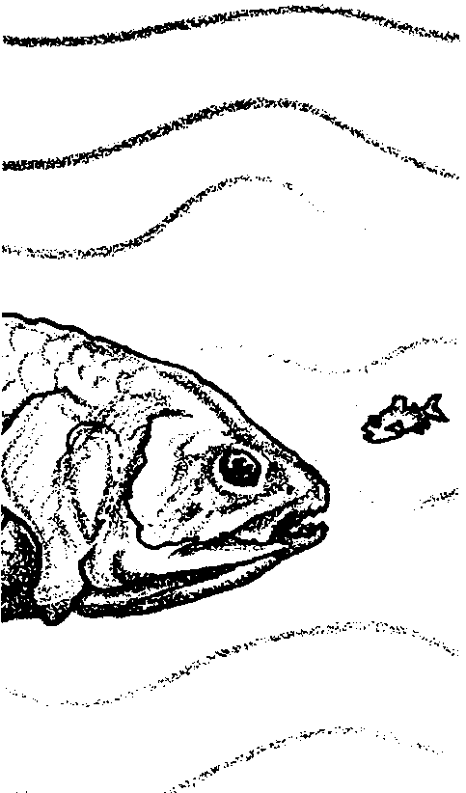

Key Concepts
1. The age of a fish can be determined by counting growth rings on its scales.
2. Studies of age distributions in a population of fish help fisheries scientists set size and number catch limits.

Background
One can discover the age of fish by extracting scales and counting growth rings. With that information, one can infer the longevity and age distribution in a population. Determining the age of fish by counting annual marks (annuli) is a standard technique used by biologists and fisheries personnel. It takes a fair amount of practice and training to do correctly, so this lab focuses more on interpreting data than on getting the right age figures.
A healthy population of fish includes individuals of all ages. If a population is not experiencing heavy fishing pressure, it will retain that wide age distribution. If a population has few very young fish and is dominated instead by older fish, researchers suspect an environmental problem, either natural or human caused, may be threatening the young fish. For example, a toxic spill or a temporary increase in the population of a predator may result in higher mortality rates in juveniles than in adults. A population dominated by young fish often indicates overharvesting. Fisheries managers may choose to regulate a fishery more tightly, especially if overall harvest numbers begin to drop.

Materials
For class of 32:
• compound microscope (1 per each pair of students)
• forceps 16
• cover slip and slides many
• balsam mounting medium (optional)
• alizarin stain 10 ml.
• fish (a series of different sized fish of the same species is ideal)
• fish heads of a variety of fish (eg. perch, bass, sunfish, etc.) (these materials may be picked up at the local supermarket or from a local fisher person
Teaching Hints

In “How Old Are You?”, students estimate the age of fish by counting scale growth rings.
You will find that there is wide variation in the ease with which fish of different species can be aged. Your students will tend to become frustrated if you select a fish that is difficult to age. For this reason a list of suitable fish follows. You can easily determine if other fish are suitable by removing a few scales and observing them yourself.
Easily Aged Fish
members of the perch family (Percidae)
members of the bass family (Serranidae)
members of the sunfish family (Centrarchidae)
anchovy
striped bass
flounder

It is often difficult to distinguish between true annuli and other markings on a fish scale. These difficulties tend to be reduced by practice. Encourage your students to look at several different scales. True annuli parallel the scale margin and reflect the crowding of the circuli that occurs just prior to the resumption of growth.
As you perform this activity, remind your students that they are obtaining “best guess” information. Be aware of the potential frustration brought on by this type of “real-life” investigation. You may be able to find biologists who are practiced at doing this kind of work on salmon and other regulated fish or on the shells of shellfish. The biologists will be able to share the expertise they have developed through long practice.
If the fish scales are large and thick, your students may find it easier to mount them between two slides rather than using a slide and coverslip. Alternate methods of examining the scales do exist. For a nice demonstration, place the scales between two thin layers of clear plastic. Mount sandwiched scales in a 35 mm photographic slide frame. The scale can then be projected on a screen so that the entire class can view the scale and count the annuli. Other fisheries biologists prefer to examine the impressions of fish scales left in plastic sheets rather than the fish scales themselves. This method requires a fish scale press.
The annual rings found in other hard structures in fish may be used to age fish. The otoliths or ear stones are widely used as are vertebrae. As an aside, many molluscs also reveal annual growth rings on their shells. Mussels, oysters and clams provide suitable subjects. Mollusks, however, are more likely to show the effects of environmental changes. In addition, the shells are sometimes quickly eroded away which makes counting very difficult.
As you perform the activity, emphasize that the technique is a tool used to obtain information helpful in the management of fisheries resource. Age data is important in making resource decisions. If such were not the case, fish scale annuli would be little more than an interesting curiosity.
Consider demonstrating the technique to your class prior to their performing it. You may wish to project a scale slide as detailed above. Circulate through the lab as the activity occurs. Since some scales are more readily aged than others, encourage your students to observe many different slides. Upon completion, plan to allow some time for a discussion of the techniques and to provide correct answers to the text and “Analysis and Interpretation” questions.

Key Words
age-length graph - graphic representation of data which is plotted to show the relationship of age to size
annulus - annual growth ring found on a fish scale
anterior - of, pertaining to, or toward the forward or head end of the body
circulus - fine line of annual growth on a fish scale
ctenoid - scales with spines
cycloid - spineless scales
dorsal - of, pertaining to, or toward the back
focus - the area where growth begins for a scale
lateral line - line of sensory structures on the side of a fish which sense pressure and /or vibrations
posterior - of, pertaining to, or toward the rear or tail end of the body
sustainable yield - the number or biomass of organisms that can be harvested each year, leaving enough for reproductive purposes to maintain a stable population

Answer Key
Text Questions

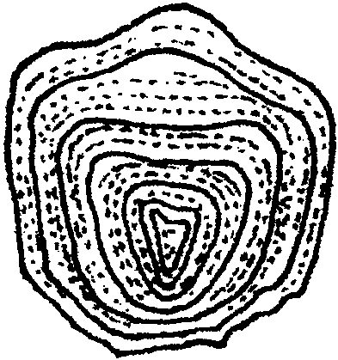1. Each annulus represents the end of the growth for a given year. The relationship of one annulus per one year allows biologists to determine a fish’s age by simply counting the annuli.
2.

Since there are 7 annuli, the best estimate for the fish’s age is 7 years.
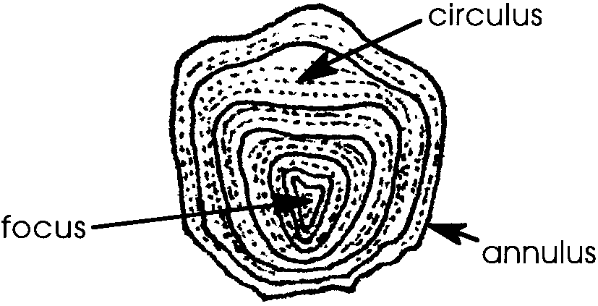
3.

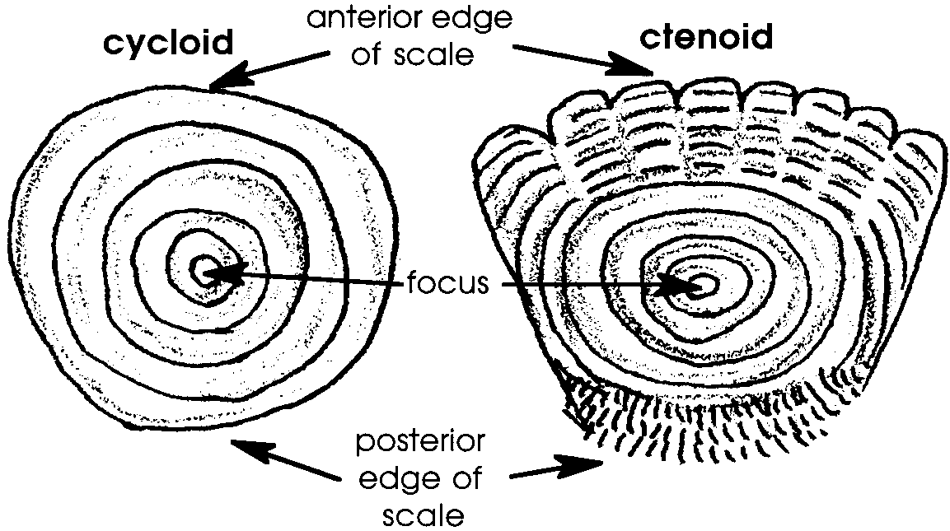
4.

5. The fish from which the cycloid scale was obtained was in its sixth year (see the labeled drawing in number 4).

Analysis and Interpretation
1 - 6. Answer depends upon experimental observations.
7. It is important to age more than one fish scale for several reasons. The primary reason is that a larger sample size allows us to put more faith in our results. Fish also lose scales. As the scale regrows, all of the annuli are not replaced. Damaged scales are also difficult to read and likely to give erroneous results. Sampling several scales can reduce the chance of error from these sources.
8 a. False annuli would cause the researcher to over-estimate the age of the fish. The fish would actually be younger than the age in years inferred by counting the number of annuli.
b. Sampling several fish of the same size and species can help reduce errors due to false annuli by providing a relationship between the length and age. If a sampled fish differs radically from what is expected, one is alerted to suspect false annuli, replaced scales or some similar anomaly.
9 a. While the results depend upon the experimental observations, in general, the relationship exists that the longer the fish, the greater the number of annuli.
b. The graph will depend upon experimental results. Regardless of specific data plotted, certain things should be present on the graph: a title, labels for vertical and horizontal axes, a curve connecting data points.
c. An age-length graph lets a field biologist estimate the age of the fish by reading on the graph the typical age associated with a given length of fish.
d. Age information gathered from scales can be used to establish an age length graph. The size of fish at an immature age can be used to establish regulations limiting the size of the herring captured.
10 a. Students may propose a variety of explanations for the decline in numbers of young fish. The favored habitat of the young fish may be disrupted, a vital food source may be scarce, a toxin may have killed juveniles, a predator may be more prevalent, a natural fluctuation in water chemistry or temperature may have harmed newly hatched fish, or a disease may be passing through a generation of fish.
b. If the decline in numbers of juvenile fish continues, there will be fewer fish maturing and fewer fish to catch.
c. Again, students may offer a variety of ideas for studying and regulating the fishery. Biologists often try to study water chemistry and other factors to try to determine what might be causing the population change. They may regulate the fishery by closing fishing during seasons when the juvenile fish hatch or during critical feeding times. They may reduce the number of reproductive fish that may be caught.
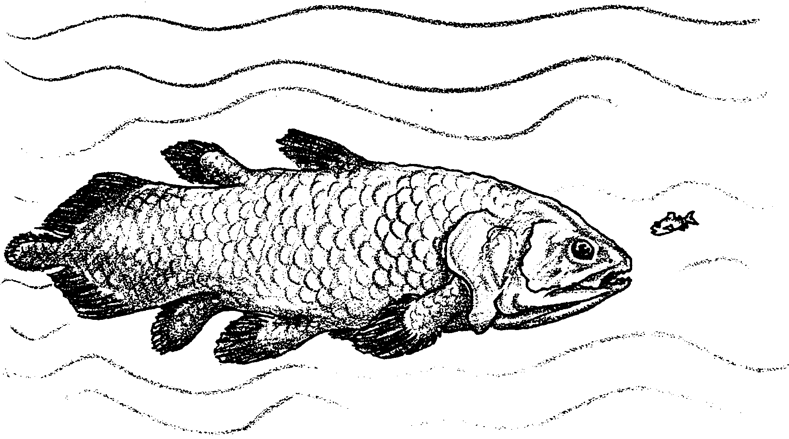
How Old Are You?

“How old are you?” That is a strange question to ask a fish. Why would you care? Age and growth rate information is of vital importance for the proper management of fishery resources. For example, if biologists sample a population of fish and find that there is a sudden decrease in the number of mature fish, they may reduce the number of fish people may catch in order to give young fish a chance to mature and reproduce and bring the population back up. The evaluation and conservation of fisheries depends on the ability of biologists to determine the age of fish.

How can you tell the age of a fish? One method is to count rings of growth on fish scales. Most fish are born without scales. As the fish matures, it develops scales. While the fish and its scales may grow in size, the number of scales remains the same. Growth begins at the focus, a point near the center of the scale. As growth proceeds, fine ridges called circuli are laid down in a circular pattern around the focus. Many circuli are added each year.

The circuli are widely spaced in warm seasons when growth is rapid and closely spaced in cold seasons when growth is slow. Thus, one year’s growth is revealed as a series of widely spaced spring and summer circuli followed by a series of closely spaced fall and winter circuli. This pattern is repeated each year. The outer edge of a series of closely spaced circuli represents the end of the growth that year. This closely spaced end region is called the annulus. The age of the fish is determined by counting the number of annuli (plural for annulus) or year marks.
Here are the materials you will need to make your own study of the age of fish:
• compound microscope
• forceps
• cover slip and slides
• balsam mounting medium (optional)
• alizarin stain
• fish (a series of different sized fish of the same species is ideal)
• fish heads of a variety of fish (eg. perch, bass, sunfish, etc.)

1. As a review, describe here how one can determine a fish’s age.

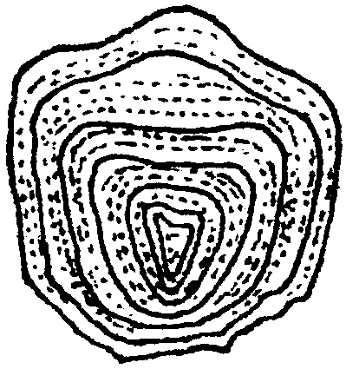
Sounds easy, right? Try your hand on the picture of the scale to the right. (Hint: the outer edges of the circuli are so close together they form dark lines.)

2. How old was the fish from which this scale was taken?

3. Label the focus, one circulus, and one annulus.

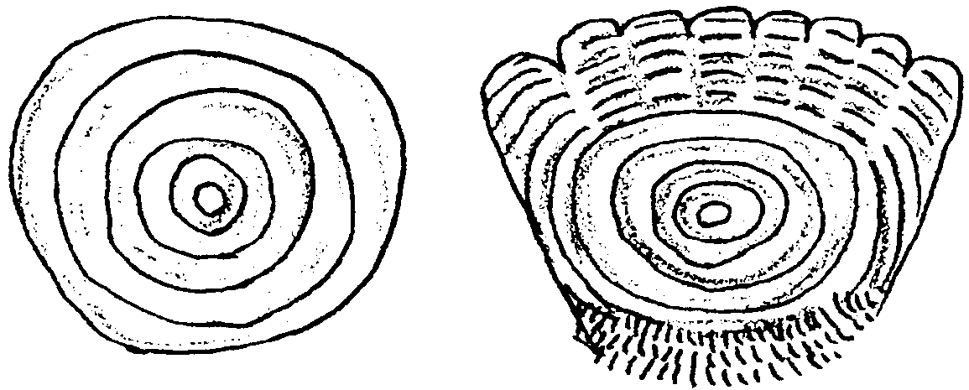
Among the bony fish there are two major types of scales. The scales on perch, salmon, and many other fish have tiny spines on the exposed posterior portion. (The posterior portion is the portion away from the head.) These spined scales are called ctenoid scales. Some soft rayed fish have scales with no spines. These “spineless” scales are called cycloid scales. The pictures below show these two types of scales.

4. Label the cycloid scale and the ctenoid scale; label the posterior and anterior edges of the ctenoid scale; and label the focus on each scale.
5. How old was the fish from which the cycloid scale came?

Are you ready? Use the procedure below to determine the age of your fish....

Procedure:

1. Obtain a fish or fish head. Record the common and scientific names:

2. If the entire fish is available, remove the scale from the middle of the body under the anterior part of the dorsal fin and above the lateral line. If only a fish head is available, use scales from the dorsal and ventral surface. Use forceps to gently remove at least five scales.

3. Rinse the scales thoroughly with tap water.

4. Prepare a wet mount by placing each scale on a glass slide, adding a drop of tap water and covering with a coverslip. If you prefer, you may make permanent slides by carefully blotting the scales dry and placing each scale in a drop of balsam mounting medium on a slide and covering with a coverslip.

5. Examine the slides under the low power of your microscope. Adjust your light source to get the maximum contrast between the growth rings and the background. If you find the growth rings difficult to distinguish, place a drop of alizarin stain on the edge of the coverslip and allow capillary action to draw the stain beneath the slip.

6. In the space below, diagram a scale as you see it through the microscope. Label those features which you can identify.

Analysis and Interpretation

1. Is the scale cycloid or ctenoid? .

2. If you removed scales from the dorsal and ventral portions of the head, were both scales of the same type, cycloid or ctenoid? .

3. How many annuli are present? scale 1:

scale 2: scale 3:

scale 4: scale 5:

4. Describe any difficulties you had determining the numbers of annuli.

5. For the fish you sampled, what is the average number of annuli you observed?

6 How old is your fish?

Give or take how many years?

7. Why is it important to age more than one scale?

8. Changes in oxygen, temperature, and food supply as well as rough handling by people can result in rings that look like annuli.

a. How would these false annuli affect age estimates?

b. How could sampling several fish of the same size and species help reduce errors due to false annuli?

9. If your class is using different sized specimens of a single species, record your fish length and the number of annuli on the board for class analysis.

a. What is the relationship between length of fish and number of annuli?

b. Use the grid below to plot age (number of annuli) vs. length.


c. How could an age-length graph be used by field biologists to quickly estimate the age of a fish?

d. The herring is locally in danger of being overfished. Fisheries biologists want to prohibit fishers from netting immature fish before they can reproduce. How might information gathered from fish scales be useful in establishing a regulation to protect the herring?

10. Fisheries biologists have conducted a test fishery before the start of fishing season. Their trial catches show an abnormally low population of young fish but a typical number of mature fish.

a. What might be causing the decline in young fish?
b. If this trend continues, how might it affect the fishery?

c. If you were in charge of studying and regulating this species of fish, what would you do to make sure the fish population survives and that people who fish continue to have fish to catch?

