Fish
Edited by Jerry Mohar, Lyle High School, Lyle, Washington and
Karen Mattick, Marine Science Center, Poulsbo, Washington.
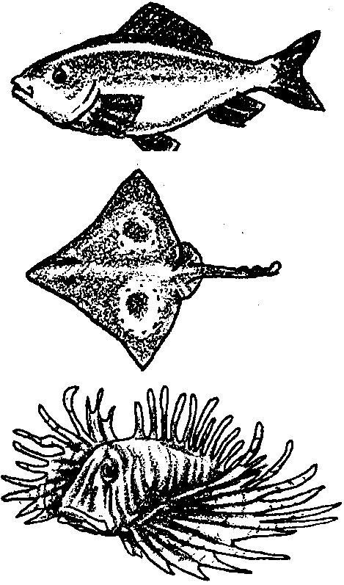

Key Concepts
1. Bony fish share several basic physical features including a bony skeleton, fins, gills, scales, mucus and chromatophores.
2. Fish have structures and behaviors which fit them to their environments, allowing them to successfully capture prey and protect themselves.

Background
The plankton, jellyfish and sharks that inhabit the open oceans share that realm with legions of fish. Some are familiar while others seem so bizarre that one would think they would appear only in science fiction.
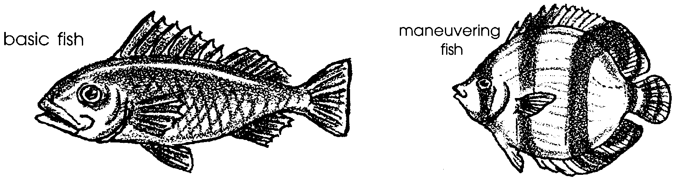
The familiar fish form, exemplified by fish such as perch or rockfish, enables those fish to maneuver fairly well, to swim steadily for short distances and to dart forward quickly when needed. Changes in that basic form will tend to improve a fish’s ability to do one of those three movements but sacrifice its ability to do the other two. For example, some fish, such as butterfly fish and other coral reef fish, have broader, rounder fins and bodies that somewhat resemble sideways frisbees or dinner plates. These fish are particularly adept at making the tight turns necessary in the crowded environment of the coral reef or rocky habitat. However, these reef fish could never cruise as far as a salmon or lunge after prey with the swiftness of a barracuda.

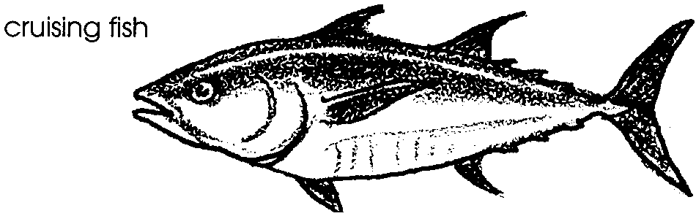
Salmon, marlin, tuna, herring and other fish that swim great distances typically have streamlined bodies, fairly small fins, and, to reduce drag, a thin caudal peduncle, the connection between the tail fin and the body. Though they are beautiful, graceful fish, they do not maneuver as well as reef fish. They do not need to wedge their bodies into crevices or to hover over coral heads probing for small bits of food. They need to be able to cover great distances with a minimum expenditure of energy.

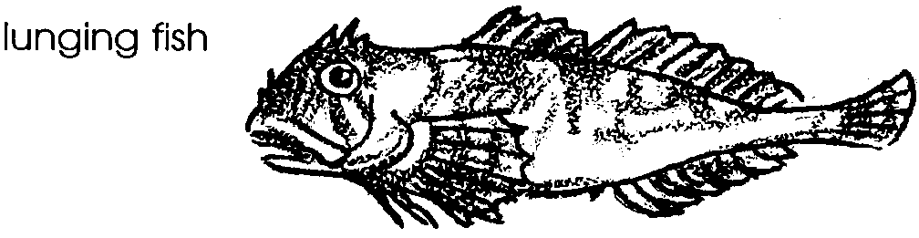
Sculpins, barracuda and flounder are examples of fish that neither dart in and out of rocks and coral heads nor travel the open ocean. Instead they wait for prey to approach and then, with startling speed, engulf their prey. These fish often have large mouths that reduce their aerodynamic efficiency but enable them to swallow large prey easily. They typically have a lot of muscle mass in their body to power their sudden attacks.

Materials
For class of 32:

• copies of “Fish” student pages

• video sequence of basic fish such as perch, or 8-16 containers of water, each with goldfish, perch or other basic fish

Teaching Hints
“Fish” is a two part introduction to boney fish. Part 1, “Roll Them Bones”, introduces basic fish anatomy and the functions of body parts in a fish with a familiar or basic fish form. Part 2, “Fitting”, focuses on fish whose coloring and body parts vary from the basic form and fit them into particular niches in their environments.

Key Words
adaptation - hereditary characteristic of an organism in a population that improves its chances for survival
anal - having to do with the outlet of the digestive tube
cartilage - tough, elastic connective tissue that makes up the skeleton of cartilaginous fishes such as sharks and rays
caudal fin - tail fin
chromatophores - sac-like cells which aid the fish in changing color
coelacanth - a true fish thought to be extinct but found alive in 1938 off the coast of Africa
countershade - dorsal dark colored and ventral side light colored.
lateral line - line of sensory structures on the side of a fish which sense pressure and /or vibrations
mucus - in this case, the outer slime layer of a bony fish which acts as a lubricant, protects from fungus and bacteria; helps the fish glide through the water
Osteichthyes - a group of animals (class) comprising the bony fishes
pectoral fin - fin located laterally near the gill slits
pelvic fin - fin located ventrally near the gill slits

Extensions
1. Many fish are far more bizarre and unexpected than the fish depicted in these readings. Students may enjoy using supplementary resources to research strange fish that intrigue them. Many not only look strange, but have unique behaviors that fit them to their environments as well.

Answer Key
Roll Them Bones
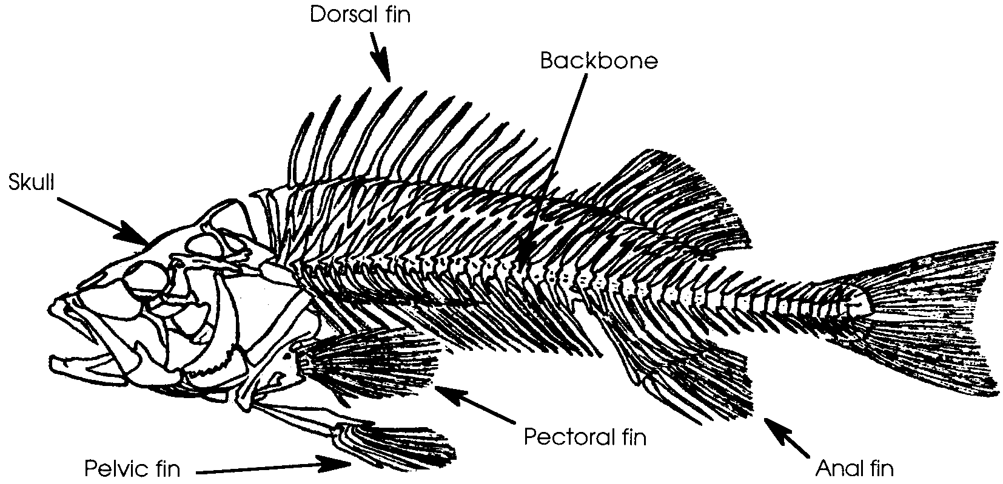
1.

2.
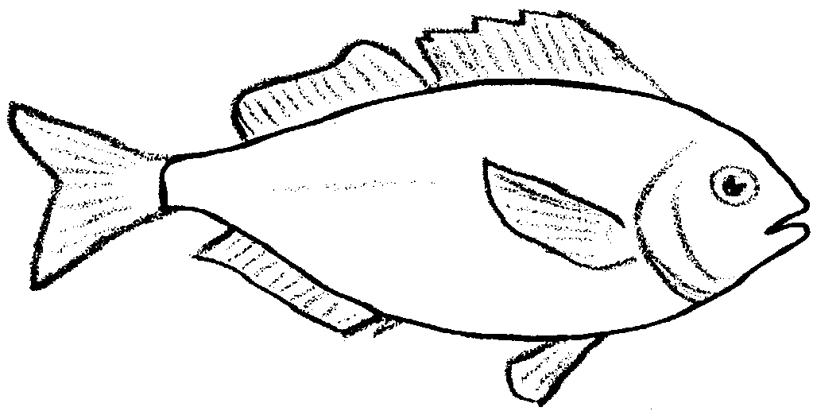

3 a., b.
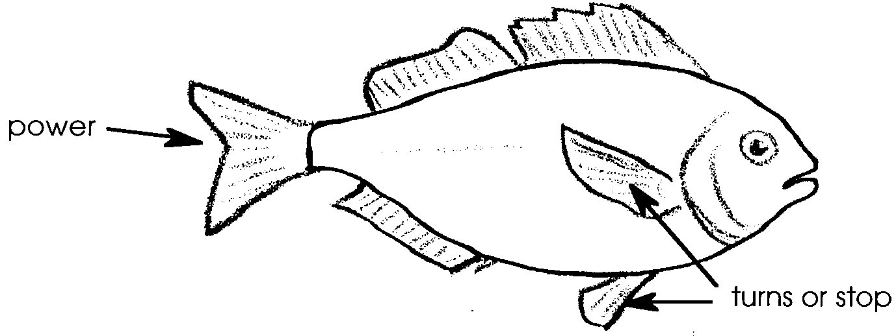
4. Answers will vary

5. The fish from which the scale was removed was in its seventh year.

6. The fish’s mucus layer acts as a lubricant, protects the fish from attack by fungus, bacteria and parasitic protozoa, and protects the fish from injury from abrasions, etc.

7. The ability to change color allows the fish to resemble its background. The survival value of this camouflage lies in the fact that the fish becomes much more difficult for predators to detect.

8. Experiments will vary depending upon the experiences and creativity of your students. In general, they should involve directing light to the light underside to see if the light causes the underside to darken. Of passing interest are the observations of one experimenter who put flounders in a glass tank and directed constant streams of light onto the underside of the fish. The flounders did eventually produce colored pigment on the light underside. The fact that it took the poor fish over a year to do it leaves one uncertain whether the scientist proved his theory or merely showed what changes can be made in nature’s arrangements when they are forcibly submitted to unnatural conditions.

Fitting

1. The dorsal, anal, pectoral and pelvic fins on the tuna are smaller than on the perch. The body is more streamlined. The caudal fin is quite tall and skinny. The connection with the tail is very thin.

2. The butterfly fish is round, instead of oval or bullet shaped. Its fins are rounded and are larger compared to the size of the fish.

3. The sculpin has a larger mouth than the perch. Its fins are large. Its body is more elongated.

4 a. Yellowtail jack are open ocean cruising fish. They have small fins, a thin connection between tail and body, small fins, and a tall, thin caudal fin. They also are countershaded.

b. Students probably will offer a variety of answers. This is a difficult fish to analyze. Sand sole are lunging fish. They are not streamlined for cruising. Instead they are camouflaged to match sand and have a lot of muscle mass. Flatfish, like the sand sole, bury themselves in the bottom sediment. Their body shape is advantageous for this behavior. Sometimes all that can be seen of the fish is its eyes because the rest of the body is covered by sediment.

c. Plainfin midshipman are lunging fish. They have large mouths, a large head and a lot of muscle mass.

d. Rockfish are maneuvering fish, though they do not maneuver quite as well as butterfly fish. They have wider fins than a perch. They are not streamlined like a tuna.

e. Sergeant majors are maneuvering fish. Their bodies are rounded and they have large fins.

5 a. The pipefish looks a lot like grass or seaweed, so it likely lives in a vegetated habitat. In fact, bay pipefish live in eelgrass beds.

b. The pipefish has a small mouth, so it must feed on small prey. Pipefish actually very quickly open their mouths to create a suction that sucks in small crustaceans and other plankton.

6 a. The anglerfish’ dark color and light producing organ suggest it may live where it is very dark, perhaps in a cave or in the deep sea. In fact, anglerfish are deep sea dwellers.

b. Scientists believe that the light producing organ attracts prey, serving as a fishing lure.
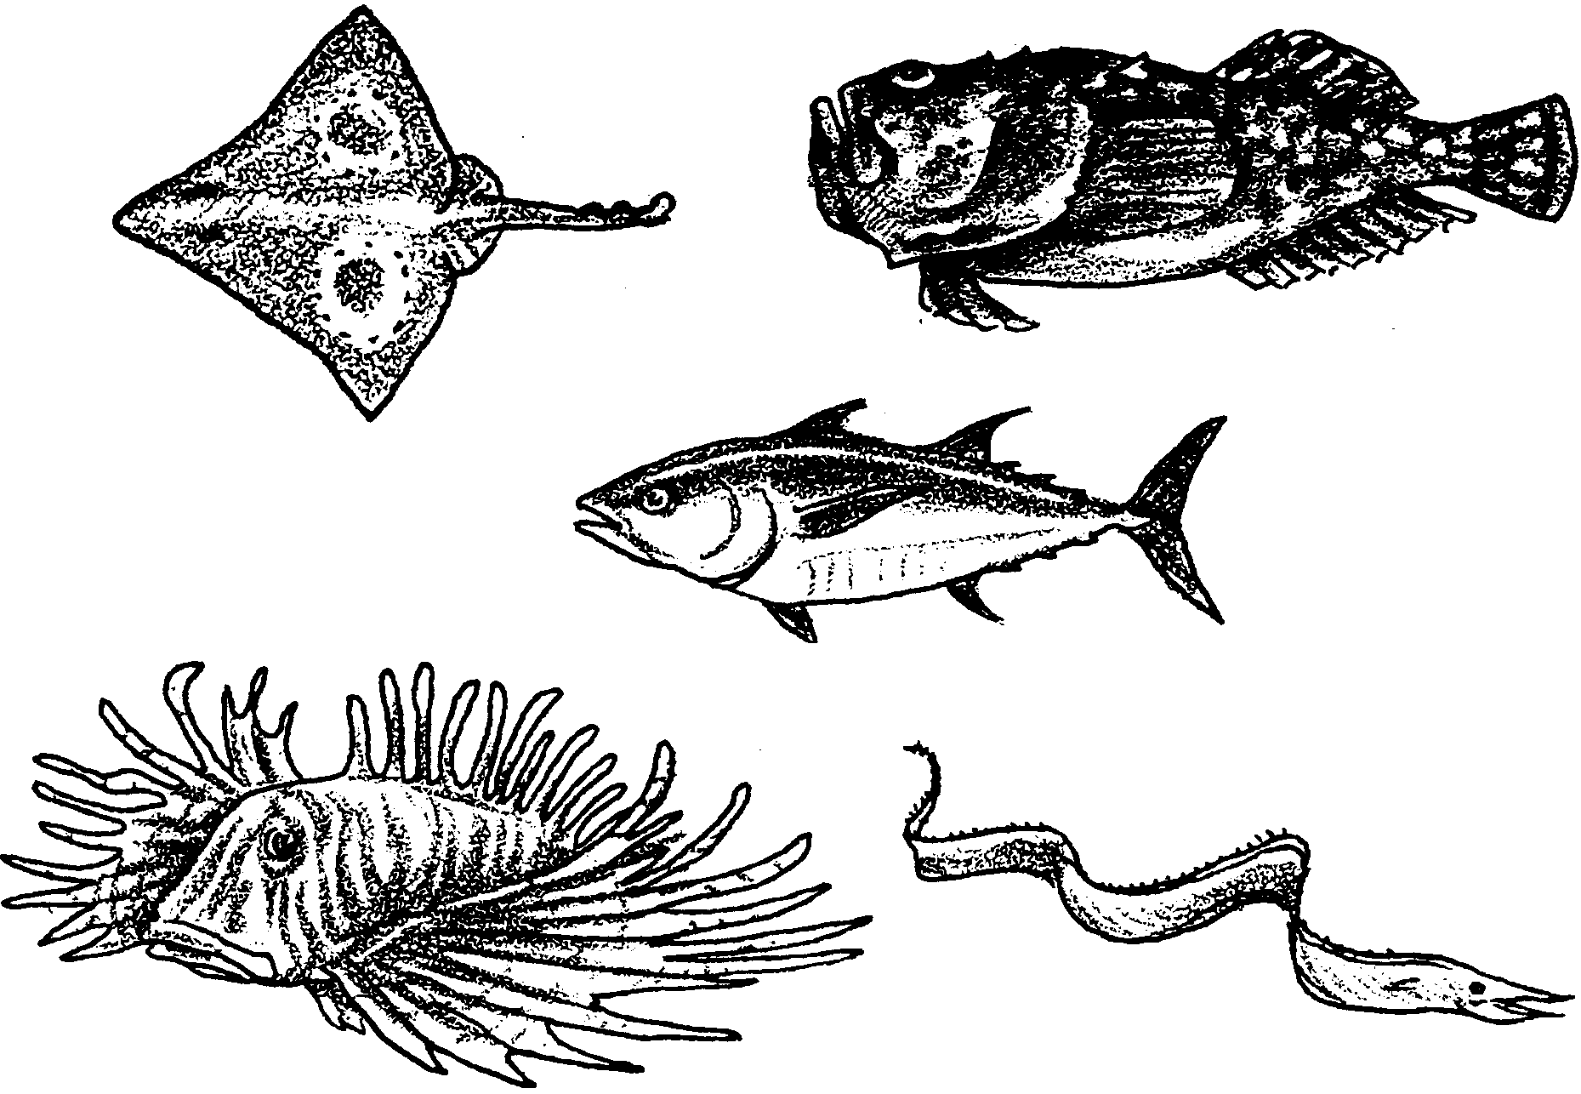
Fish

Part I: Roll Them Bones
As the ancient Polynesians traversed the Pacific Ocean in search of new lands, as the Europeans sailed in search of new trade routes, and as oceanographers explore the vast expanses of the open ocean, they find in that watery world legions of fish.
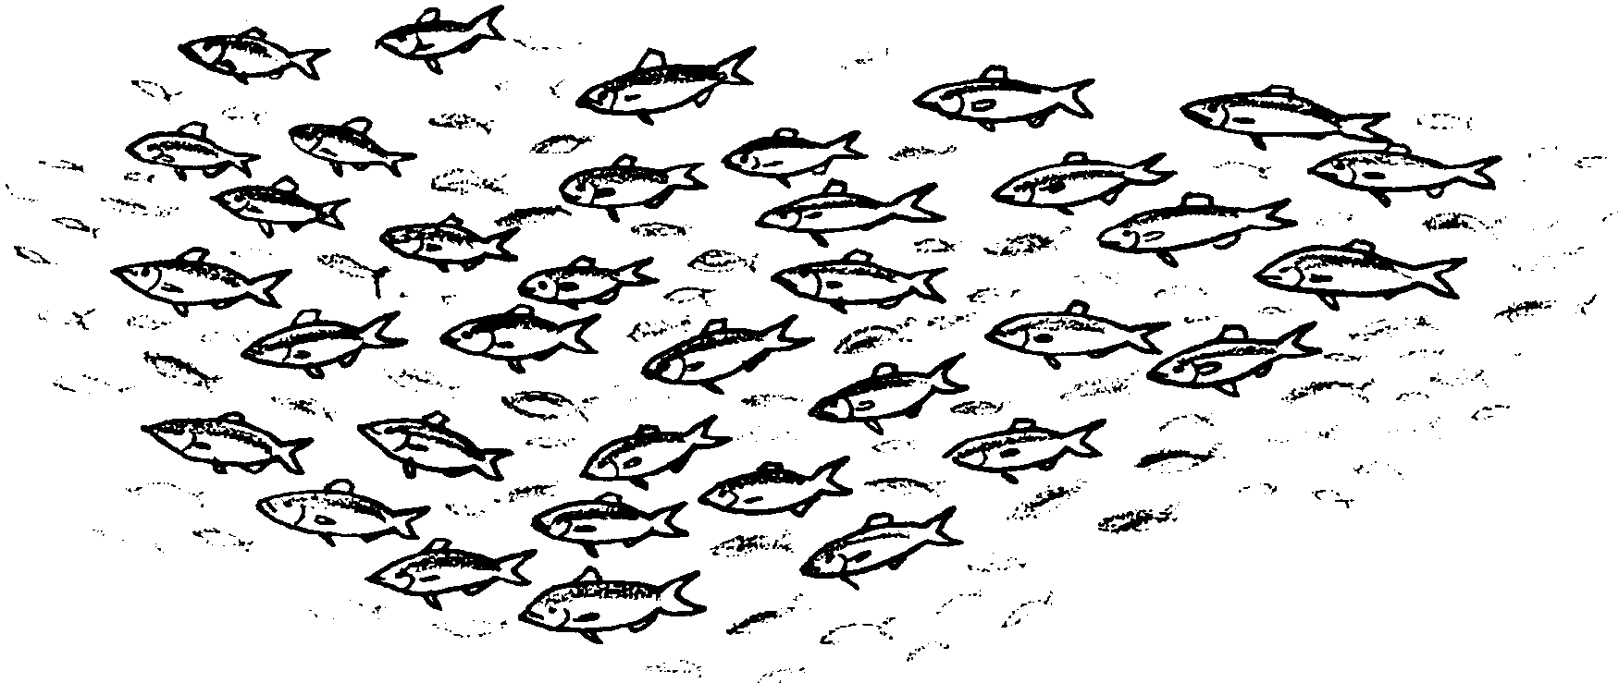
Some fish amass in huge numbers. The herring, for example, form schools of millions of fish.
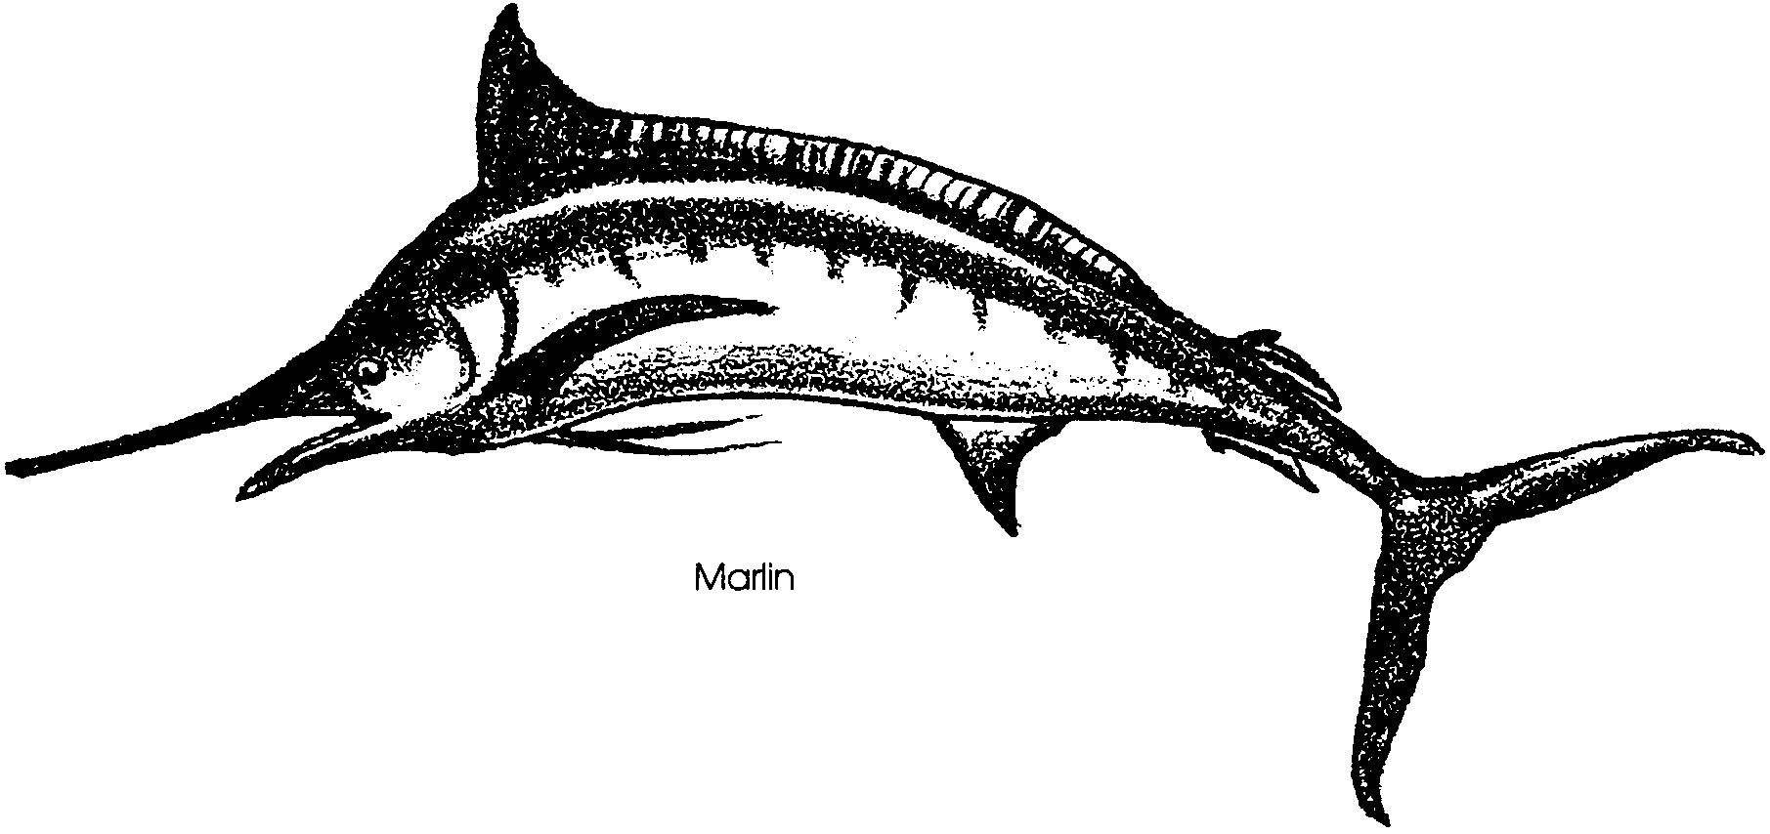
Some fish are giants. The marlin reach lengths of 15 feet and can cruise at 30 miles per hour.

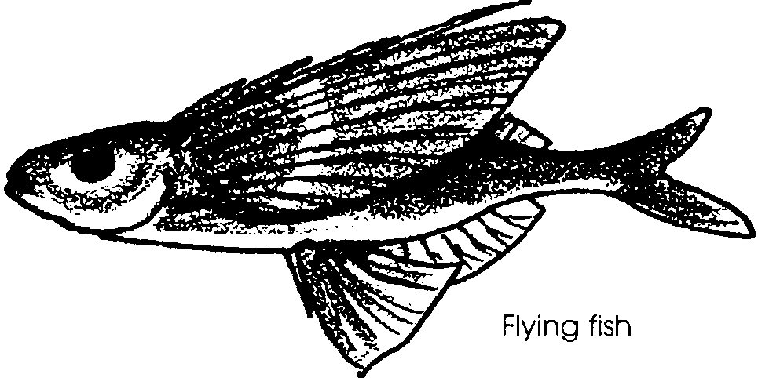
Some fish are amazing. Flying fish can burst from the water at 40 miles per hour, glide through the air, fall back down to the water, propel themselves upward again, and, in this fashion, fly as much as 1/4 mile over the ocean.

These are all true fishes. Scientists classify true fishes in the class Osteichthyes. Osteichthyes comes from the Greek words for “bony fishes”. Unlike the sharks and rays and their relatives, which have cartilaginous skeletons, true fishes have bony skeletons.
Today, fish are the most abundant vertebrates in both freshwater and marine environments. Some live in depths over 20,000 feet and others in shallows not deep enough to cover their dorsal fins. In nearly every habitat of the sea, fish abound. They are extremely important in the open ocean. What adaptations, what body structures and behaviors, make bony fishes successful?

The Basic Fish

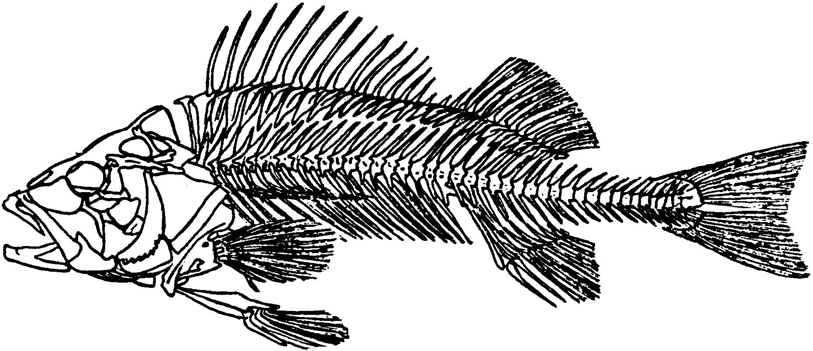
The essential elements of the fish framework include a skull, a backbone made up of a series of vertebrae, and two pairs of fins - the pectorals and the pelvics. The fish framework also has one or more dorsal fins on the back, and one or more anal fins on the underside. These fins are made of bone or cartilage and are attached to the rest of the skeleton. A caudal or tail fin is firmly attached to the end of the backbone. The bony skeleton provides a rigid framework that allows great variety in movement and provides protection for the internal organs.

1. Label the skull, backbone, dorsal, anal, pectoral fins and pelvic fins on the drawing above.

In fish with the familiar fish form, such as perch, each type of fin plays a particular and typical role in helping the fish move.

2. Obtain from your instructor either a video sequence of a familiar fish or a live fish in a container of water. Add to the fish outline at right all missing fins and other body structures you observe on the fish.

3. Now watch the fish’s behavior closely.
a. Label on the drawing which fin or fins power the fish, pushing it forward and giving it speed.

b. Label on the drawing the fins the fish uses to make turns or to stop swimming.

In fish with a “basic” fish form, the caudal or tail fin provides power. The pectoral and pelvic fins are used to steer and brake. The anal and dorsal fins stabilize the fish. A fish with a missing dorsal fin will be unable to stay upright and will tend to rotate or spin.

4. Did the fins on the fish you observed provide these functions? If not, what were some differences?

In addition to the bony skeleton that all of the true fish have, the bony fish share some other common features. They breathe through gills. Most fish have an outer covering of scales.

Unlike your skin, which is covered by several layers of dead and hardened cells, the fish’s skin is alive to the very outermost covering. Because the outer cells of the fish are constantly exposed to water, they do not need the protection from drying that our dead cell layers provide.


The scales grow from pockets in the skin. They overlap like shingles on a roof. It is interesting to note that when the fish first comes out of its egg, it has no scales. A few fish, like the catfish, remain “naked” throughout life. Once the scales begin to form, they grow with the fish. As the fish grows bigger, the scales grow bigger. The number of scales, though, always stays the same. A young fish has the same number of scales as it will have when it is older. As the scales grow, concentric rings form on them. These rings grow closer together in the winter than they do in the summer. This observation is of more than casual interest since by looking at the scale rings, one can determine the age of a fish.

5. How old was the fish from which this scale was removed?

Fish skin contains cells that secrete mucus, or slime. The cells are scattered between the skin cells and release mucus as a layer over the surface of the skin. This is what makes a fish slippery. The slime serves several purposes. In the first place, the slime acts as a lubricant that helps the body of the fish slide through the water. The fish can increase its speed while reducing the energy required to move through the water. Secondly, the slime protects the fish from attack by fungus, bacteria, and parasitic protozoa. Damage to the slime layer by handling exposes living fish to parasites. The slime layer also plays an important role in protecting the fish from injury from abrasions.

6. What are three roles the fish’s mucus layer plays?

a.

b.

c.


Fish have a variety and brilliance of color unequaled by any other group in the animal world. Many fish also have the ability to change color. To accomplish these color changes, fish have specialized skin cells called chromatophores (Greek, chromato (color) + phore (bearer) = color bearer). Chromatophores are little sac-like cells, shaped like many armed stars, which are scattered through the skin in great numbers. Each contains colored pigments. Fish can make the pigment practically invisible by withdrawing the coloring into the center of the cell, or it can expose its color in varying degrees by spreading the color into the arms of the star.

7. How would the ability to change colors be of survival value to a fish?

Many fish are countershaded. Countershading is a pattern of coloration in which the dorsal or back side of the fish is darker in color than the ventral or underside. It appears that the shading is a good example of protective coloration. The dark back is almost invisible to an enemy like a fish-hunting bird looking down from above into the dark water. To an enemy looking up from below, the light ventral or underside would be inconspicuous against the light coming from the surface.
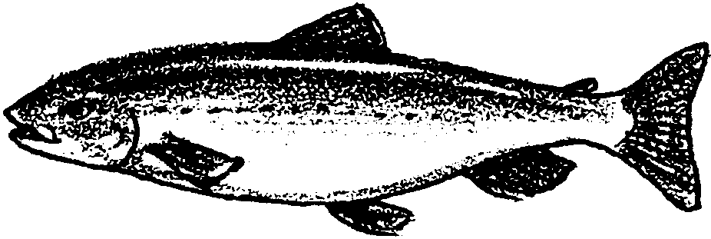
8. Some ichthyologists (scientists who study fish) think that the countershading we see in fish is due to the effect of light on the fish’s skin. In other words, the top of the fish “gets tan” while the bottom doesn’t. Design and briefly describe an experiment that would provide evidence to support or refute this hypothesis.

Fish have evolved into an enormous variety of shapes and body styles. This variety has enabled fish to live successfully in almost all aquatic habitats. Dietary habits of fish also vary greatly. Some fish eat plants, others eat fish, and others eat a great variety of animal life.
The following activity will give you an opportunity to examine some of the ways fish have adapted to their environment.

Part 2: Fitting
A lot can be learned about a fish’s way of life by simply looking at the fish. In this activity you will have a chance to “read a fish”. As you look at the drawings, keep in mind these three concepts:

1. The shape of the body is an adaptation that helps the fish survive. The body shape often tells us where and how a fish lives.

2. The shape and location of the mouth are adaptations for survival and can give us an insight into the way a fish lives.

3. The color of a fish helps the fish to survive. The color we observe can tell us something about the fish’s way of life.

Let’s take a look at how different body shapes help fish live in different environments.

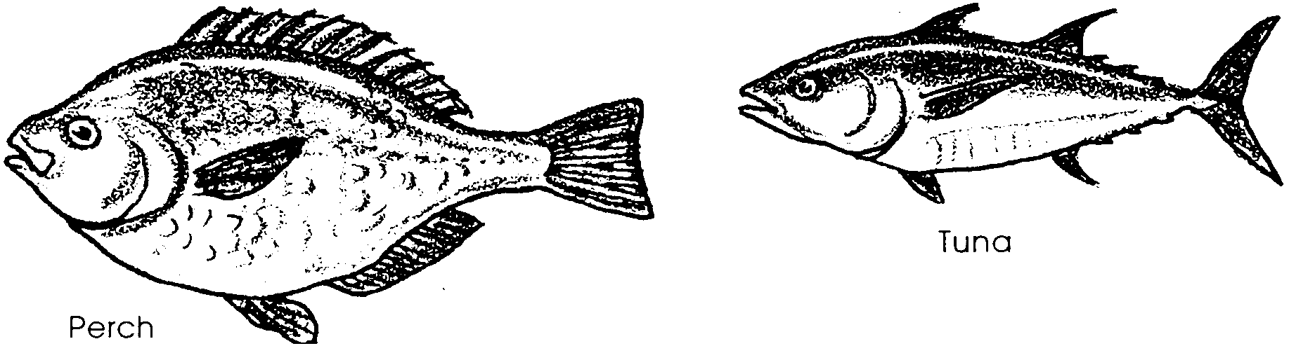
1. Compare the perch, a basic fish, drawn below, with the tuna, a fish that cruises in the open ocean. How are the fins and body of the tuna different from the fins and body of the perch?

Fish that are able to swim steadily over long distances tend to have a body plan much like the tuna. Note also that the tuna and other open ocean fish tend to be countershaded.
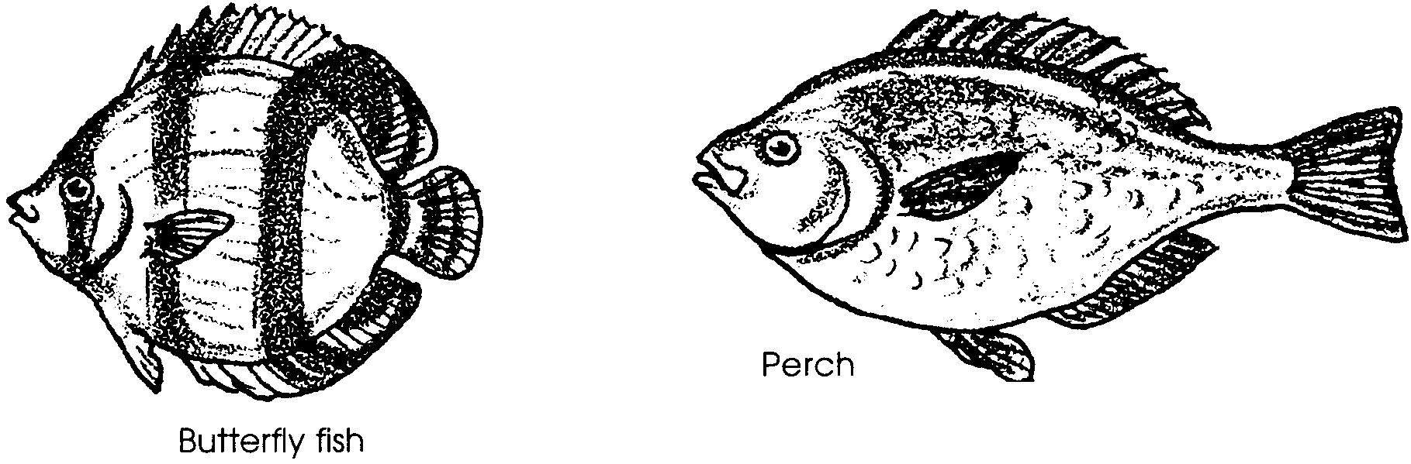
2. This time, compare the perch with the butterfly fish. How are the butterfly fish’s fins and body different from the perch?

Fish shaped like the butterfly fish tend to live around coral reefs or in rocky habitats. They lack the muscle mass and streamlined body of the tuna, so they are not able to cruise the open ocean. Instead, they maneuver very well among the nooks and crannies of reefs. Reef fish tend to have ornate camouflage coloration or vivid colors and patterns that attract mates. Countershading is not very common in these fish.
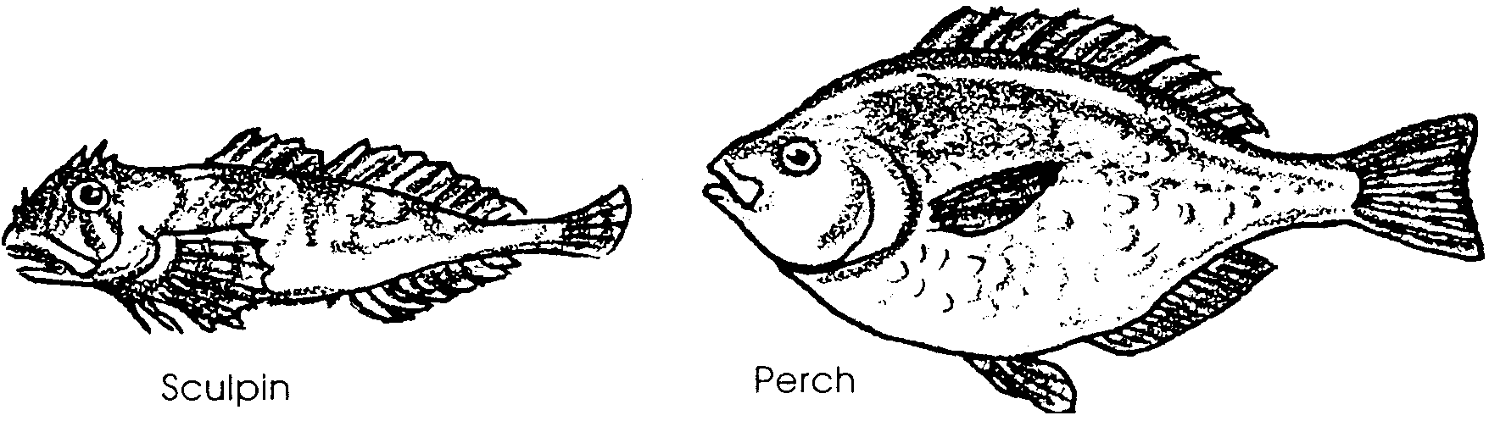
3. Finally, compare this sculpin with the perch. How do its fins, body and mouth compare with those of the perch?

The sculpin is an example of fish that sit or hover with very little movement and then ambush their prey, lunging with startling swiftness. Since they do not cruise great distances, as tuna do, they do not need to be streamlined. Instead, they benefit from a large mouth and considerable muscle mass to power their sudden acceleration. These fish tend to have camouflage coloration so that they blend in with the sand, rocks or vegetation around them.

4. Examine the following drawings and note your observations about how the fish’s fins and body compare with the basic fish form. Try your hand at inferring whether the fish cruises the open ocean, maneuvers around reefs, or lunges after its prey.

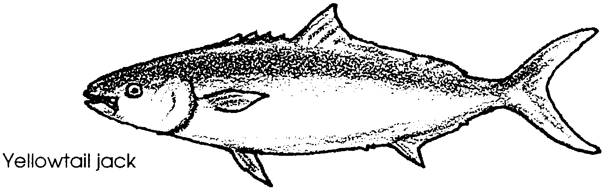
a. Yellowtail jack- Where do you think the jack lives? Is it a cruising, lunging or maneuvering fish? What evidence supports your inferences?

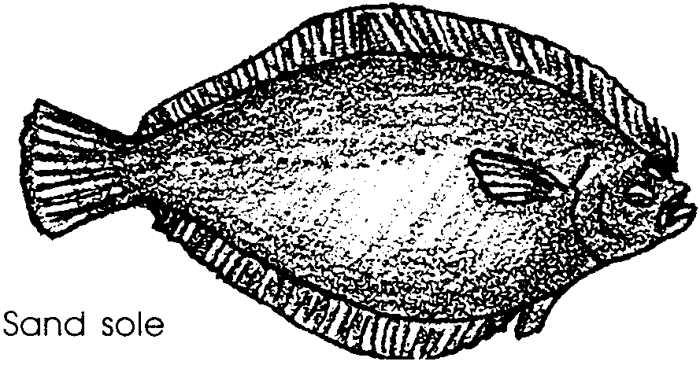
b. Sand sole- Where do you think the sole lives? Is it a cruising, lunging or maneuvering fish? What evidence supports your inferences?


c. Plainfin midshipman- Where do you think the midshipman lives? Is it a cruising, lunging or maneuvering fish? What evidence supports your inferences?

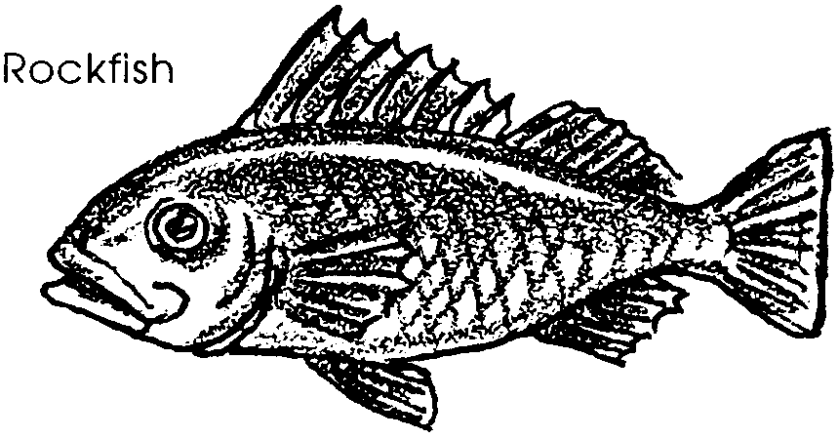
d. Rockfish- Where do you think the rockfish lives? Is it a cruising, lunging or maneuvering fish? What evidence supports your inferences?

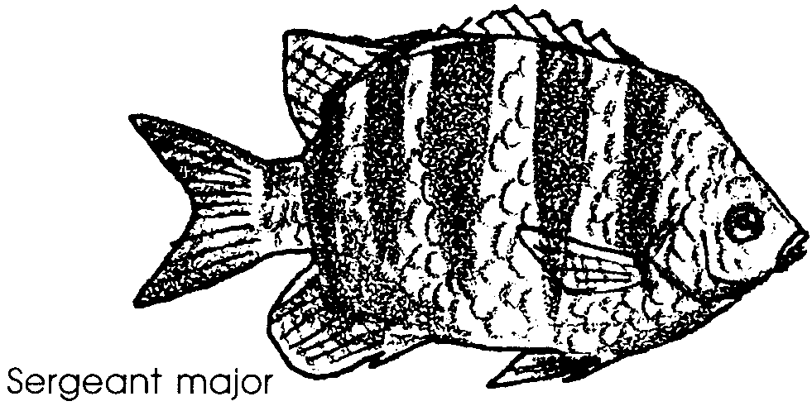
e. Sergeant major- Where do you think the sergeant major lives? Is it a cruising, lunging or maneuvering fish? What evidence supports your inferences?

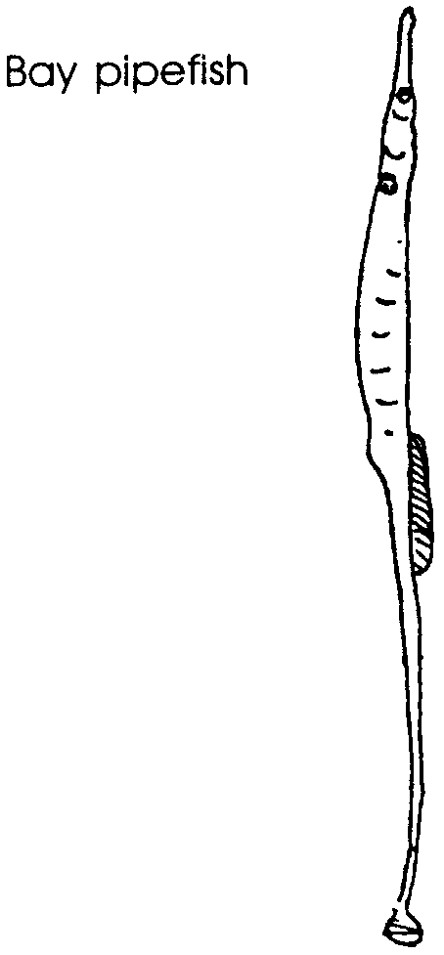
Some fish have bodies and coloration that are so unusual, it is hard to believe they are real. Consider the Bay Pipefish. The pipefish is a pale olive green with narrow horizontal gray lines. It is shown in its most common orientation to the bottom.

5 a. What do the color and shape tell us about the habitat in which we would most likely find the bay pipefish?

b. What does the size of the mouth tell us about what the pipefish eats?

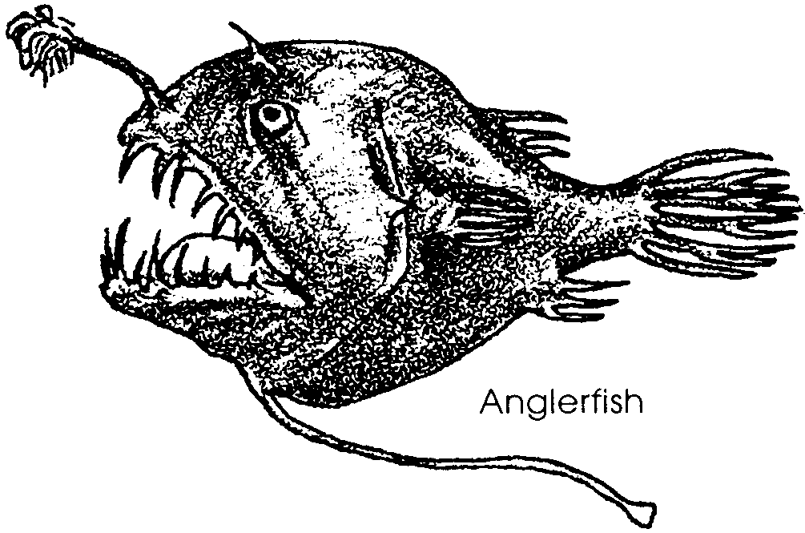
The anglerfish is dark maroon or black. The projection from the fish’s head produces light.

6 a. What does the color of the anglerfish and the presence of the light producing organ tell us about where the anglerfish lives?

b. What do you think the light producing projection might be for?

