A Shark Study

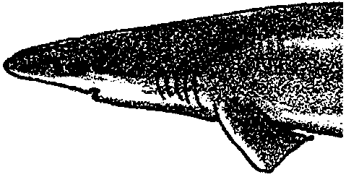
Key Concept
1. The shape and structure of the dogfish shark adapt it to its open water environment, enabling it to swim long distances, hunt prey, sense its environment, and reproduce.

Background
Background information for “A Shark Study” is found in the preceding activities “Sharks!” and “A Shark Reading”.

Materials
For each team of students:

• one dogfish, preserved, frozen or fresh

• dissecting tools

• ruler

• copies of “A Shark Study” student pages

Teaching Hints
Background information for “A Shark Study-Dissection” is found in the preceding activities “Sharks!” and “A Shark Reading”. Of all marine creatures, sharks may evoke the strongest reactions from students. Of all laboratory exercises, dissection will elicit the greatest emotions as well. “A Shark Study” is included here as an extension you may choose to do if you feel it will aid your students’ understanding of sharks and shark anatomy.
It is particularly important in “A Shark Study” to dispel the “Jaws” mentality that many of your students will have. Reinforce that sharks play an important role in the sea. We can be fairly certain that if all the sharks were removed, the disruption caused in the seas would result in a major collapse in the marine food web. Emphasize the role of the shark and the fact that shark attacks on humans, while horrible, are exceedingly uncommon. Strive to replace unfounded fears with fact.
As an alternative to dissection, have students design a layered cut-away model of a shark. This activity is not as easy as it seems as students need to make organs in proportion and in correct relationship to each other. The whole project requires some engineering skills. A book called “Animals Inside Out,” by Ruth Gold West has samples of cut-outs. This can be purchased at the National Science Teachers Association bookstore at any regional or national conference or write directly to Ruth Gold West, 142 Gable Rd., Padlt, PA 19301.
“A Shark Study” lends itself to completion in two class periods. One period is devoted to external anatomy, one period to internal anatomy. If time allows, it is possible to expand this activity by increasing the depth of study of the circulatory system and incorporating a dissection of the brain and central nervous system.
Preserved sharks may be obtained from the biological supply houses listed at the end of this section. If you live near the coast or have contact with sport or commercial fishermen, you can arrange to have them provide you with small sharks or with shark embryos from larger sharks. Donated sharks are best preserved via freezing but they can be preserved in ordinary fixative if no freezer facilities are available.
Duplicate the activity pages. One set is recommended per student. If your class is unaccustomed to dissection, review general techniques and safety instructions before you begin. Demand a respect for the specimens to be dissected and tolerate no mutilation. Ideally, students should work in pairs. Practically, four students per shark is a reasonable group size. Provide any dissection guides you may have, especially those with good drawings or photographs of the internal organization of the dogfish shark. Circulate through the laboratory area while your students perform the activity. Be available for aid and to set the proper tone. Plan to allow class time for a discussion of the techniques and to provide answers to the questions found within the instructions and in the “Analysis and Interpretation” section. With a small amount of advance planning, this activity can prove to be one of the most exciting of the year.
Shark sources:

Carolina Biological Supply Company Ward's of California
Powell Laboratories Division 316 Cannery Row - Box 1749
Gladstone, Oregon 97027 Monterey, CA 93940
(503) 656-1641 (831)375-7294

Main Office
Burlington, N. Carolina 27215
(336) 584-0381

Key Words
anterior - of, pertaining to, or toward the forward or head end of the body
buoyancy - the power of a fluid to push upward or keep afloat a body immersed in it
Chondrichthyes - a group of animals (class) comprising the cartilaginous fishes
dorsal - of, pertaining to, or toward the back
median - toward the middle plane which divides an animal into right and left halves
posterior - of, pertaining to, or toward the rear or tail end of the body
ventral - of, pertaining to, or toward the belly
Vertebrata - a group of animals (subphylum) comprising the vertebrate animals

Answer Key
Part I - External Anatomy

1. Answer depends upon experimental observations.

2 a. The caudal fin provides the power for swimming. While sharks are active swimmers, in general they are not very powerful swimmers.
b. Most dogfish possess two dorsal spines, one at the base of each dorsal fin. Since the dogfish is a bottom dweller, the fins may provide protection from being eaten (or “stepped” on) from above.

3. Answer depends upon experimental observations.

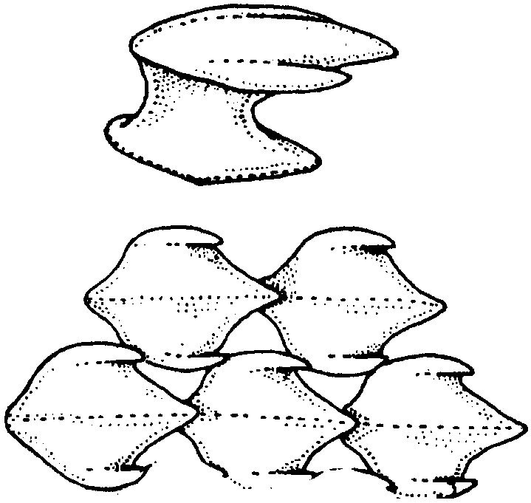
4 a. While the answer depends upon the experimental observations, the drawing should be similar to the following:

b. The dermal denticles are “toothed” and overlap in such a manner that movement from the anterior toward the posterior encounters much less resistance.

c. Answer depends upon experimental observations. Countershading (dark dorsal side, lighter ventral side) is a common phenomenon in the dogfish.

5. Teeth are present on both the upper and lower jaw.
a. and b. Answer depends upon experimental observations. While the teeth are arranged in rows, the number of rows varies between individuals. The teeth “unfold” from the back as the rows move forward so that a single shark may have teeth that point backwards in the posterior rows of teeth and teeth that point forwards in the anterior rows.

6. The water circulation in the nostril serves to bring food molecules in contact with sensitive neural receptors. The shark has been described as a “swimming nose”. The sacs increase the receptor covered surface area. When a shark takes water into its mouth to aerate its gills, suction causes some water to flow in and out of each olfactory sac. In addition, the forward motion of the shark brings water through the nostrils into the sacs. All of these mechanisms increase the shark’s ability to sense its environment.

7. Unlike most mammalian eyes, shark’s eyes have vertical pupils.

8 a. and b. Answer depends upon experimental observations.

Part II - Internal Anatomy

2 a. The liver is the largest visceral organ.

2 b., 3 a. and b., 4 a. and b., 5 a. Answer depends upon experimental results.

5 b. The pancreas is usually tan in preserved specimens while the spleen is gray. Variation is possible and the final answer must depend upon observation.6 a. and b. Answer depends upon experimental observations.

7 a. Yes, the heart is separated from the other organs by a thin transverse septum just anterior to the liver.
b. The pericardial sac functions to cushion the heart and provide lubrication which keeps the heart muscle from abrading (or being abraded by) surrounding tissue. Your students may have other suggestions.

8 a., b., c. Answer depends upon experimental observations.

9 a. The sinus venosus enters the atrium.

Analysis and Interpretation

1 a., b., c., d. Answer depends upon experimental observations.

e. The long time it takes for a dogfish to reach maturity (coupled with a relatively small litter size) means that dogfish have a poor recruitment ability and hence cannot quickly recover from overfishing.

2. Shark coloration seems to serve the general role of camouflage which allows sharks to approach their prey undetected.

3. The several rows of teeth, each with a slightly different orientation, provide an effective barb system that helps prevent the prey from escaping. The teeth which face posteriorly are particularly effective in preventing escape.

4. Because of the dramatic biting and head shaking feeding pattern (coupled with frequent attacks on tough materials) sharks often lose teeth. The ability to replace lost teeth guarantees that the shark will continue to have teeth to use in preying upon other animals. If the teeth were not replaced, each tooth loss would mean a reduction in the effectiveness of the shark’s predatory abilities.

5 a. Answer depends upon experimental observations.
b. Scientists are not in total agreement concerning how the lateral line functions and its role in the life of the shark. Evidence seems to indicate that the sensing of vibrations is important in locating prey, locating enemies, locating mates, and in navigating. Your students may have additional suggestions.

6 a. The shark adjusts its buoyancy by varying the oil content in the liver. Buoyancy is also related to the cartilaginous skeleton.

b. Having a swim bladder could indeed be a disadvantage to the shark. The shark needs to be able to rapidly change its depth in the pursuit of prey fish. Rapid changes in depth cause rapid changes in pressure which cause rapid changes in the size of the air bladder. The changes can be so extreme as to kill bony fish. Since sharks do not possess swim bladders, they are able to avoid this danger.

7. The ridged inner lining of the stomach aids in kneading the stomach contents in preparation for later absorption.

8. The spiral valve increases the effective length of the digestive tract without having to increase the actual length. The spiral valve greatly increases the absorptive area.

9. This question is designed to provide an opportunity for discussion about shark population dynamics and the role of sharks in the marine ecosystem. Overfishing of immature sharks may indeed change the population structure. When the present older sharks die, there may be fewer immature sharks to replace them causing a net reduction in the population.
It is important for your students to realize that sharks play an important and beneficial role in the sea. They are not likely to destroy other fish populations. We need to remember that these other populations have coexisted and benefited from the presence of sharks for millions of years. It appears that humans are a greater danger to fish (and shark) populations than sharks could ever be.
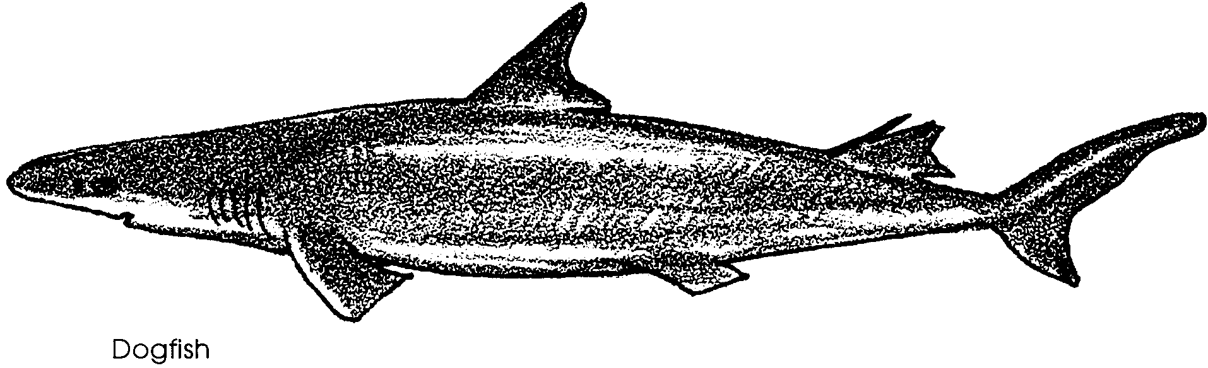
A Shark Study

Dogfish sharks are found along both the Pacific and Atlantic coasts. These sharks reach a maximum size of about 5 feet in length. As with most sharks, the females reach a greater size than the males. While they are active swimmers, dogfish usually remain in a limited area. Dogfish are active feeders, dining on herring, juvenile salmon, pilchard sardines, anchovies, smelts, sandlances and other small fishes, squid and crustaceans. They have also been known to feed on cannery wastes and other refuse dumped into the sea.

Sharks belong to the class Chondrichthyes of the subphylum Vertebrata. Sharks and other members of this class possess a skeleton made of cartilage. The dogfish most likely to be encountered on the Pacific coast is the spiny dogfish, Squalus acanthias.

Reproduction in the dogfish involves internal fertilization of three to fourteen large eggs. The eggs develop within the body of the female shark inside the enlarged oviduct. The gestation (development) period is nearly two years. The fact that any one female can therefore only breed once every two years is important in considering the likelihood of overfishing. The developing dogfish use stored yolk material for energy. When development is complete, the young sharks emerge as miniature adults.

Dogfish have sporadically been of commercial value. During World War I, dogfish meat was canned under the trade name “Gray Fish”. “Gray Fish” never became a big seller, most likely because improper handling causes canned dogfish to produce ammonia which isn’t exactly the aroma most chefs are looking for when they prepare dinner! During World War II, dogfish were extensively fished for their livers. The livers are rich in Vitamin A and pilots were given extra doses in hopes of improving their vision. The shark liver business boomed for a few years, only to collapse again when a synthetic vitamin A was developed. Since the middle 1970’s a small commercial fishery for dogfish has processed the fish for shipment to England and other European countries where the flesh becomes the “fish” of “fish and chips”.

In the following activity you will see part of another use of the dogfish shark - dissection. Many of our physicians and surgeons received their first anatomical training using the dogfish as a subject. While the absolute number of sharks used in anatomy classes is small, the role they play is great. Careful technique will enable you to learn much about the structure and workings of the vertebrate body.

Materials
• shark or late term shark embryo
• dissecting pan
• paper towels
• dissecting kit (scalpel, forceps, probes, scissors)
• scales or balance
• ruler and calipers (if available)
• anatomical charts
• dissecting microscope

Procedure:

I. External anatomy

Use the following diagram to help you identify the structures mentioned:
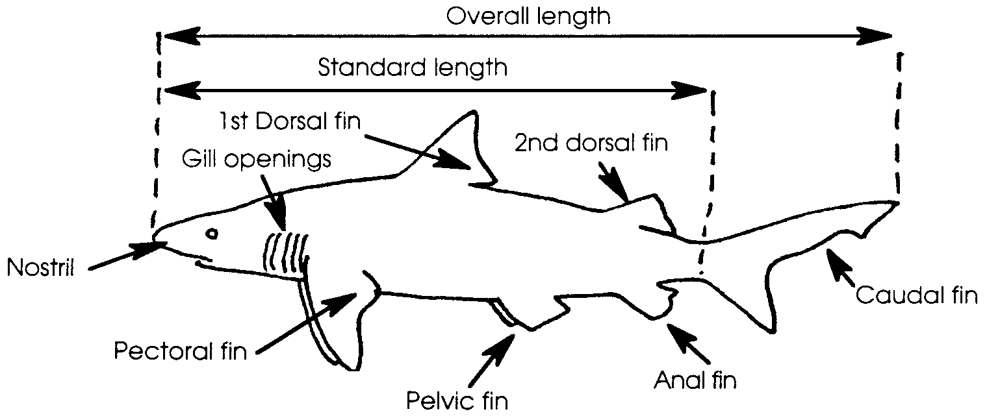
1. Obtain a dogfish shark and record the following data:

Common name: Scientific name:

Length overall:

Standard length:

Width at head:

Width at posterior (side away from head) to pectoral fins

Width at beginning of caudal fin:

How would the streamlining you’ve just measured be helpful to the shark as predator?

In the space below sketch the shape of the fins listed:
1st dorsal fin pectoral fin

pelvic fin caudal fin

2nd dorsal fin anal fin

2 a. Which fin provides the power for swimming?
b. Are any of the fins equipped with spines?

If so, which one(s)?

3. Examine the pelvic fins on your shark and those on other sharks available. In male sharks, the median edge (edge toward the midline of the fish) is modified to serve as a reproductive organ. This reproductive organ is called the clasper.

a. Is your shark a male or a female?

b. Record the sex of your shark in the space on the blackboard designated by your teacher.

4. Use your scalpel to cut a 1 cm. square below the dorsal fin. Cut just deep enough to pass through the skin. With the aid of your forceps remove the square of skin from the underlying tissue. Use a dissecting microscope to examine the shark skin.

a. The “scales” you see are called dermal denticles (literally “skin teeth”). In the space below draw an example of the dermal denticles:

b. Gently pass your hand along the surface of the shark’s skin in an anterior to posterior (head to tail) direction. Then, pass your hand gently from the posterior to the anterior. Which direction provides the least resistance?

How might the dermal denticles you observed under the microscope provide an explanation of any differences you noticed in the ease with which you could move your hand across the skin’s surface?
c. What color is the dorsal (“top”) surface of the shark?

Is the ventral surface (“bottom”) the same color?

If not, what color is the ventral surface?

5. Open the mouth of the animal. Do you see any teeth?

With the mouth held open, feel for the presence of teeth with a finger tip. Are teeth present on both the upper and lower jaws?

a. In the space below, draw a detailed series of shark’s teeth:

b. Are the teeth arranged in rows?

If so, how many?

Do the teeth point toward the opening of the mouth, away from the opening of the mouth? Or both ways?

6. Locate the paired nostrils. Gently insert a blunt probe into one of the nostrils. Water circulates through the small sac that you can feel within the nostril. How might the water circulation help the shark in locating food?

7. Examine the eyes. How do they differ from mammalian eyes like ours?

8 a. Locate the lateral line, a series of sensory receptors, on each side of the shark. The lateral line senses vibrations in the water. What is the overall length of the lateral line in your specimen?

b. Use the overall length of your shark (from number l) to determine the percentage of the total length occupied by the lateral line.

(Hint: % of body length occupied = length of lateral line x 100)
by lateral line overall body length

II. Internal Anatomy

1. Pin your shark, ventral side up, firmly in a dissecting tray. Use your scalpel and scissors to make an incision through the skin along the midline. Start at the cloaca (the opening between the pelvic fins) and proceed anteriorly up to the pectoral girdle (a cartilage structure at the level of the pectoral fins). Be careful not to cut deeply below the skin. Expose the viscera (internal organs) by holding back the lateral flaps of belly skin and making incisions from the ventral side to the dorsal side. Pin back the flaps of belly.

2. Use the diagram on the next page to find the liver. The liver stores food and oil high in vitamin A. Sharks can change the oil content of their livers to adjust their buoyancy (how they float).

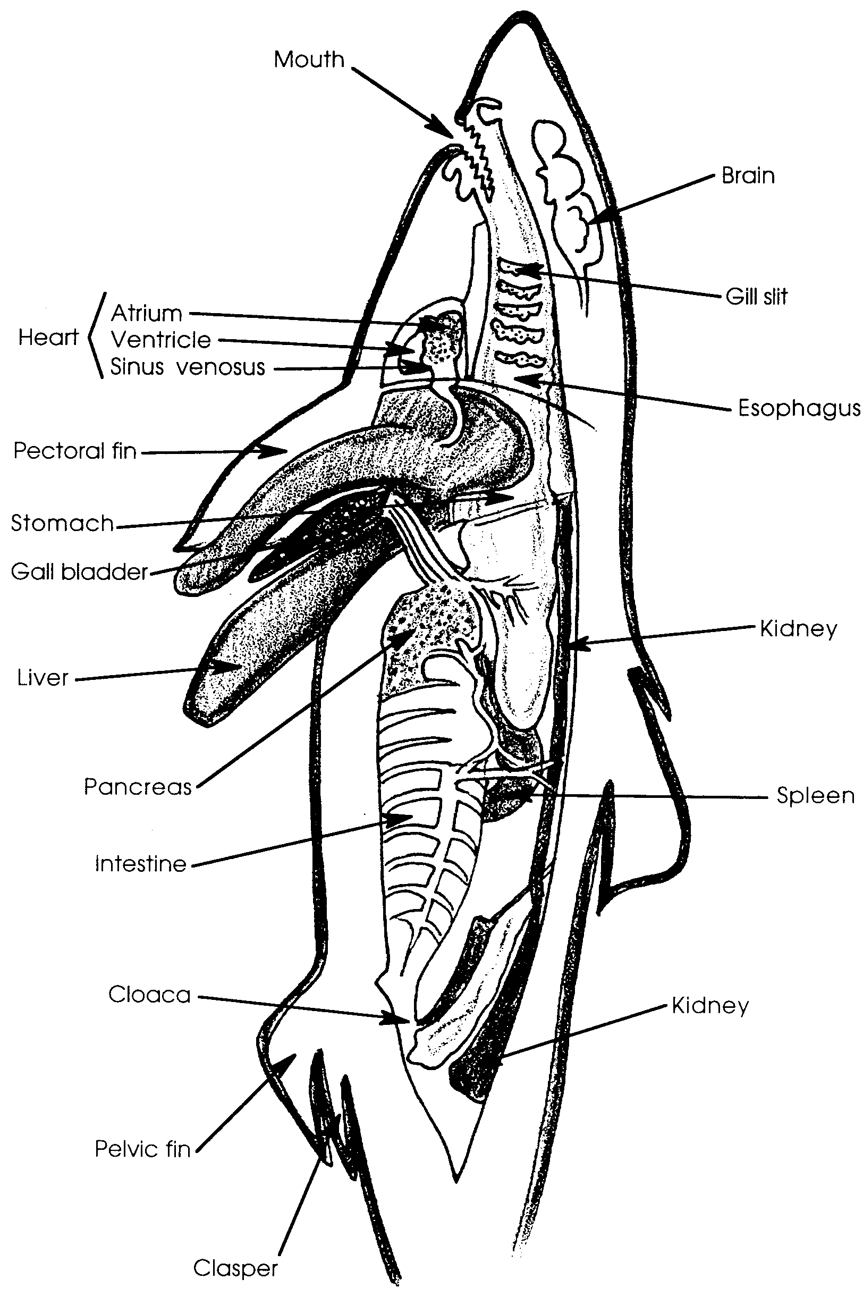

a. How does the size of the liver compare with the sizes of the other visceral organs?

b. How many lobes are present?

c. What color is the liver?

3. Remove the liver by carefully cutting the attachments to the body wall and to other organs.

a. Use a scale or balance to determine how much the liver weighs. Record the weight:

b. What percentage of total body weight consists of liver alone?
(Hint: you can find the percentage using the same technique you used in number 8, part I.)

4. The stomach is located immediately posterior to the liver. Locate the stomach and open it with a longitudinal incision.

a. Does the stomach contain food?

If so, what is present?

b. Describe the internal appearance of the stomach:

The intestine begins at the posterior end of the stomach where there is a muscular valve (sphincter) and extends to the anus inside the cloaca. The intestine forms an S-shape and then suddenly enlarges. The spleen and the pancreas are attached at the bends of the S. Inside the enlarged portion there is a spiral membrane which greatly increases the absorptive surface without increasing the length of the intestine. This membrane is called the spiral valve and is not found in bony fishes.

a. How long is the intestine?

b. The spleen which is an important site of blood formation is usually gray.

What color is the pancreas?

The pancreas produces important digestive enzymes.

6 a. Most of the sharks will be too small to be sexually mature. If the reproductive organs are present, you will find them filling the dorsal part of the body cavity. Are the gonads (testes in the male; ovaries in the female) present in your specimen?

If so, what sex is your shark?

b. Does this answer agree with your answer in 3 a.?

7. Use your sturdy scissors to cut through the cartilage of the pectoral girdle. Fold back the skin flaps. Locate the heart within the pericardial cavity.

a. Is there a partition separating the heart from the other organs?

b. The sac around the heart is called the pericardial sac. In life, it is filled with fluid. What is the likely function of the pericardial sac?

8. Remove the pericardial sac.

a. What is the length overall of the heart?

b. What is the width overall of the heart?

c. Find the sinus venosus which carries blood to the heart. Does it enter the heart on the anterior or posterior end?

9. Carefully open the heart. The atrium of the heart is the receiving chamber for the blood. While the ventricle of the heart pumps blood to the body.

a. Locate the atrium. Which blood vessel enters this chamber?

b. In the space below, draw and label a shark heart.

10. Return your shark and thoroughly clean your equipment and work area.

Analysis and Interpretation

1. Use the male/female information on the black board to answer the following questions:

a. What is the ratio of males to females?

males: females:

b. How many males were present per female? (Hint: Divide the number of males by the number of females)

males present per female.
c. Sex ratios are usually expressed in terms of number of males per hundred females. Express your results in these terms by multiplying your answer in number 2 by 100:
males: 100 females.

d. These sharks were probably caught with baited hooks. From your answers above would you say that the fishing gear selects one sex over the other?

If so, which sex is taken more frequently?

e. Male dogfish become sexually mature at about 11 years of age. Females mature at a later age, between 18 and 21 years old. How does the long time it takes for a dogfish shark to reach maturity make it a susceptible to overfishing?

2. Sharks come in all varieties of colors and patterns. How might the coloration of your shark help it to survive and be successful in its mode of life?

3. How does the positioning of the shark's teeth reduce the chance that the bitten prey will escape?

4. Sharks are active feeders and will attack and eat all types of sea life as well as some non-living items. Is the shark’s ability to replace lost teeth of value to the shark? How?

5. The lateral line extended over what percentage of your shark’s body?

%

The length may give us a clue to the importance of this sensory mechanism. What are two ways in which sensing vibrations in the water contribute to the shark's survival?

a.

b.

6. Most bony fish possess a swim bladder to help them adjust their buoyancy. Rapid changes in depth can cause the bladder to swell even to the point of killing the fish.

a. What is one way in which the shark adjusts its buoyancy?

b. Consider the way sharks feed and what they feed upon. How could having a swim bladder be a disadvantage for the shark?

7. The stomach begins the chemical breakdown and mechanical churning of the food. How might the internal structure of the stomach aid in this process?
8. What is the role of the spiral valve?

9. Most sharks used for dissection are sexually immature.

a. If most of the sharks taken by fishermen are also immature, is there a danger that fishermen are creating a population with few young sharks and more older sharks?

b. If all or most of the young sharks are captured, what will happen to the shark population when the older members die?

