A Shark Reading
“Shark-Hunt” is adapted from “Shark Facts”, a Florida 4-H Marine Science Special Interest Series publication by Mrs. Carolee Parmer.

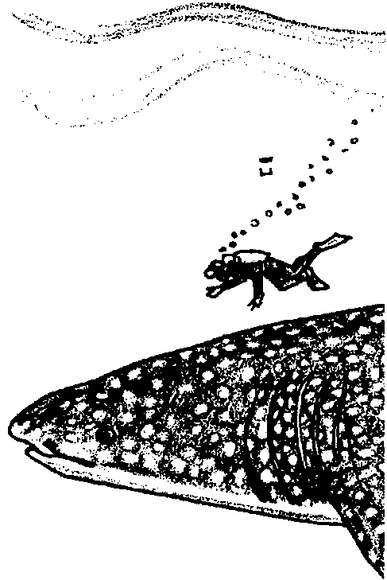
Key Concepts
1. Sharks come in a wide variety of forms.
2. Sharks re superbly adapted to their ocean environment with their unique teeth, skin, cartilage skeleton and their unique senses.
3. Sharks reproduce slowly and thus are highly vulnerable to overfishing.

Background
The number of papers, books, notes, letters, and articles on sharks is legion. The enormous number attests to the fascination that these creatures have held for humans since we first noticed them thousands of years ago. Your students, as you will have already noticed, are not immune to this fascination. Popular works on the shark tend to exaggerate and distort the facts while technical and scientific works shroud the facts in complex and precise vocabulary unintelligible to the lay reader. For additional background information, see preceding the activity “Sharks!”.

Materials
For each student:

• copy of “Shark Reading” student pages

Teaching Hints
The following reading strives to present the facts, without fantasy, in terms comprehensible to your students. With sharks, the facts can be fantastic enough. The article cited at the end of the student text serves as a good jumping off point for further exploration by you or by your students. The challenge for you will be to channel your students’ natural enthusiasm into constructive avenues and out of paths which lead to the destruction of sharks. A comprehensive work which can supply you with ample ammunition for your battle is:
The Book of Sharks by Richard Ellis (1975). Published by Grosset and Dunlap. New York. 320 pages.
The “Shark Hunt” is a simple word search designed to reinforce the vocabulary introduced in the text. You may elect to have your students create word searches or crossword puzzles of their own. These activities have proven effective in increasing retention of new vocabulary and concepts.
Duplicate the text pages. One set is recommended per student. This activity is best accomplished by individual students and may be assigned as a homework assignment. The subject matter lends itself to further research by your students and you might consider assigning research papers on various aspects of shark behavior and biology. Plan to allot some time for a discussion of the material and to provide answers to the questions contained in the text.

Key Words
buoyancy - the power of a fluid to push upward or keep afloat a body immersed in it
carrion - dead and putrefying flesh
cartilage - tough, elastic connective tissue that makes up the skeleton of cartilaginous fishes such as sharks and rays
caudal fin - tail fin
Chondrichthyes - a group of animals (class) comprising the cartilaginous fishes
Chordata - a group of animals (phylum) comprising the mammals, birds, reptiles, amphibians, and fishes
dorsal - of, pertaining to, or toward the back
lateral line - line of sensory structures on the side of a fish which sense pressure and /or vibrations
taxonomists - scientists who describe, identify, name, and classify organisms
Vertebrata - group of animals (subphylum) comprising animals with backbones

Answer Key
1. To many of your students, stripes will seem like an odd pattern for an animal that wants to hide. Stripes seem to provide an animal with camouflage by breaking up the outline of the animal - the zebra is a good example of this phenomena. Striped sharks would reasonably be expected to be found in habitats with vertical or horizontal barring perhaps due to vegetation.

3. The head shaking movement the shark uses in feeding turns the sharp teeth into miniature saws which can cut large chunks out of the prey.
4. The teeth in the second and third rows face posteriorly which may be of value to the shark in that these teeth act like barbs and hold the shark onto its prey. A secure bite and hold helps assure the shark of a successful hunt.

5. Cartilage provides several advantages to the shark: increased buoyancy, flexibility which allows the shark to change direction quickly and within a short space, and increased ability to change depths rapidly without risking fatal injury.

6. Since the majority of the shark’s life is devoted to food gathering, it is probably safe to assume that all of the senses are used in some degree in the food getting operation. In particular, the senses of smell, “hearing” or vibration sensing, and vision play important roles in locating food.

7. Stimulus Sense(s)
Splashing, yelling, or hitting lateral line
rocks together underwater

Swimming where blood, vomit, smell
bait or fish scraps are present.

Swimming alone rather than in lateral line, vision
groups.

Touching or bothering the shark vision, lateral line
while swimming in a black-wetsuit.

8. This is a question with no right or wrong answers since it asks for student opinion. Use the question to initiate a discussion of the issues involved in changing public opinion regarding the role of sharks in the marine ecosystem. The author’s bias is, of course, that education can change people’s attitudes. Hopefully, you share that bias.


Solution to “Shark Hunt”
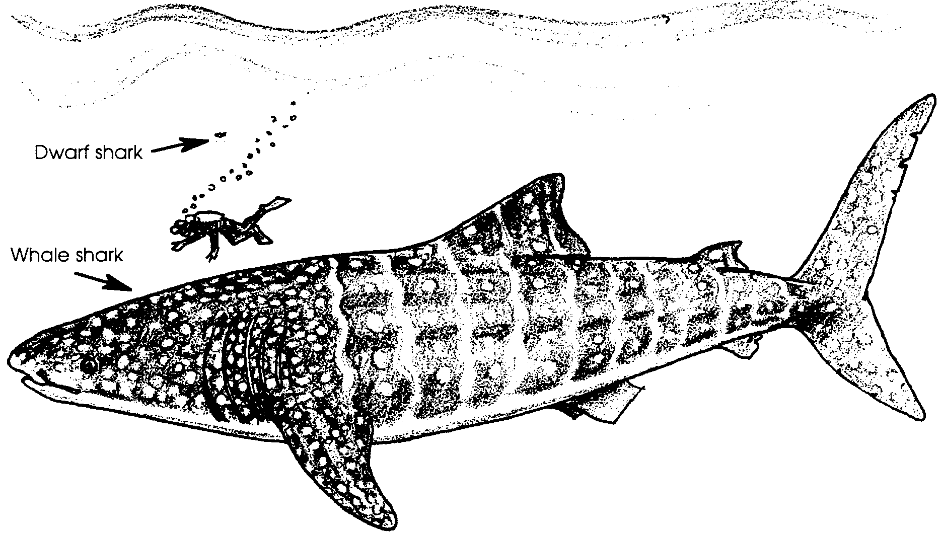
A Shark Reading

“Actually, sharks aren’t half bad once you get to know them.”.....Gary Soucie

SHARK! The word triggers the imagination - the big, streamlined torpedo-like body, gray above and white below, propelled silently through the water, the slack grin of its mouth opening to reveal rows of sharp, pointed teeth. What is the reality of our image? Aside from a few physiological facts, little can be said with confidence about sharks that applies to all species and individuals.
In size alone, sharks range from the dwarf shark, which is six to eight inches when full grown, to the whale shark, the biggest fish in the sea, whose length reaches at least 45 feet and probably 60 feet. In shape, sharks run the gamut from the eel-like to the lumpy.
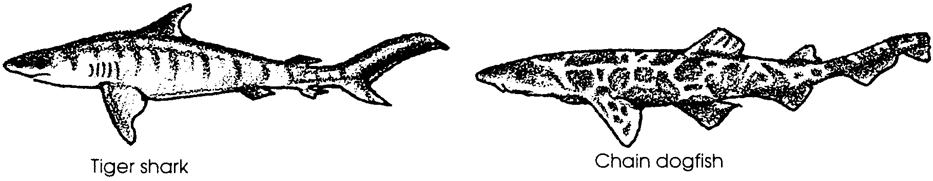
Shark colors range from midnight black through all sorts of grays, blues, browns and olive drabs to iridescent green. They may be of a solid color, dark above and light below, or marked with spots, speckles, bands, bars, reticulated (squares) patterns, zebra or tiger stripes. At least one shark has eyes that glow in the dark and a few others have luminous bodies.

1. Many sharks match the place in which they live. Where might you expect to find a striped shark?

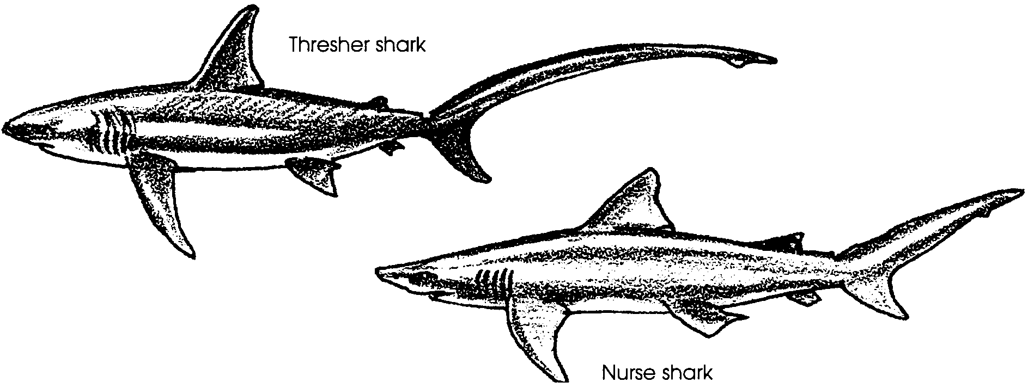
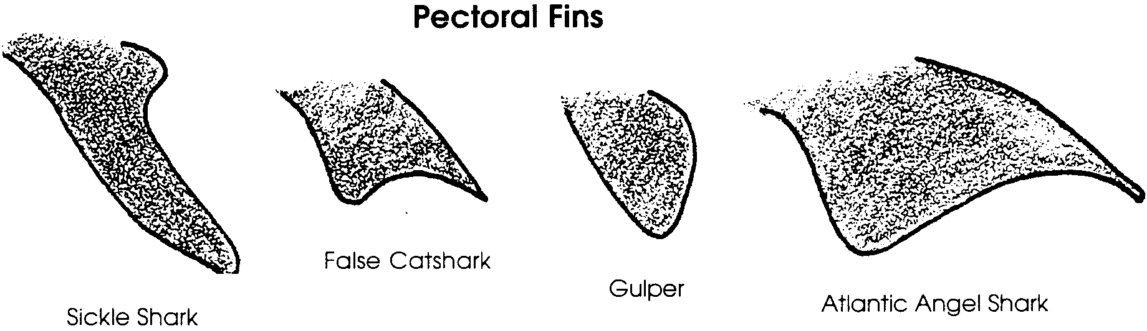
While all sharks have tails, or caudal fins, with upper lobes that are longer than the lower, there is great variety in the size and shape.

Similarly, the pectoral fins show a wide range of size and shape.

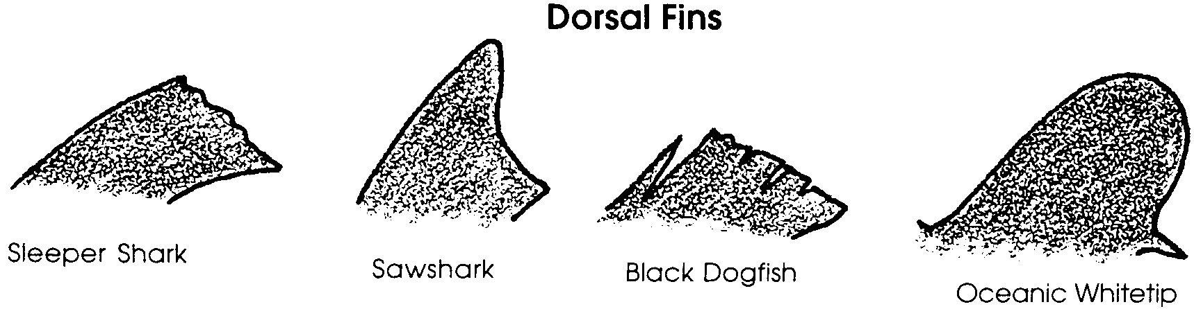
Sharks may have one or two dorsal fins and these, too, may be large or small, in several shapes other than triangular and, in the case of the sleeper sharks, floppy rather than stiffly erect.

2. The silhouette below shows a typical shark. Locate and label the eye, gill slits, first and second dorsal fins, caudal fin, pectoral fin, and the mouth and nostril. The remaining fins are labeled for you.

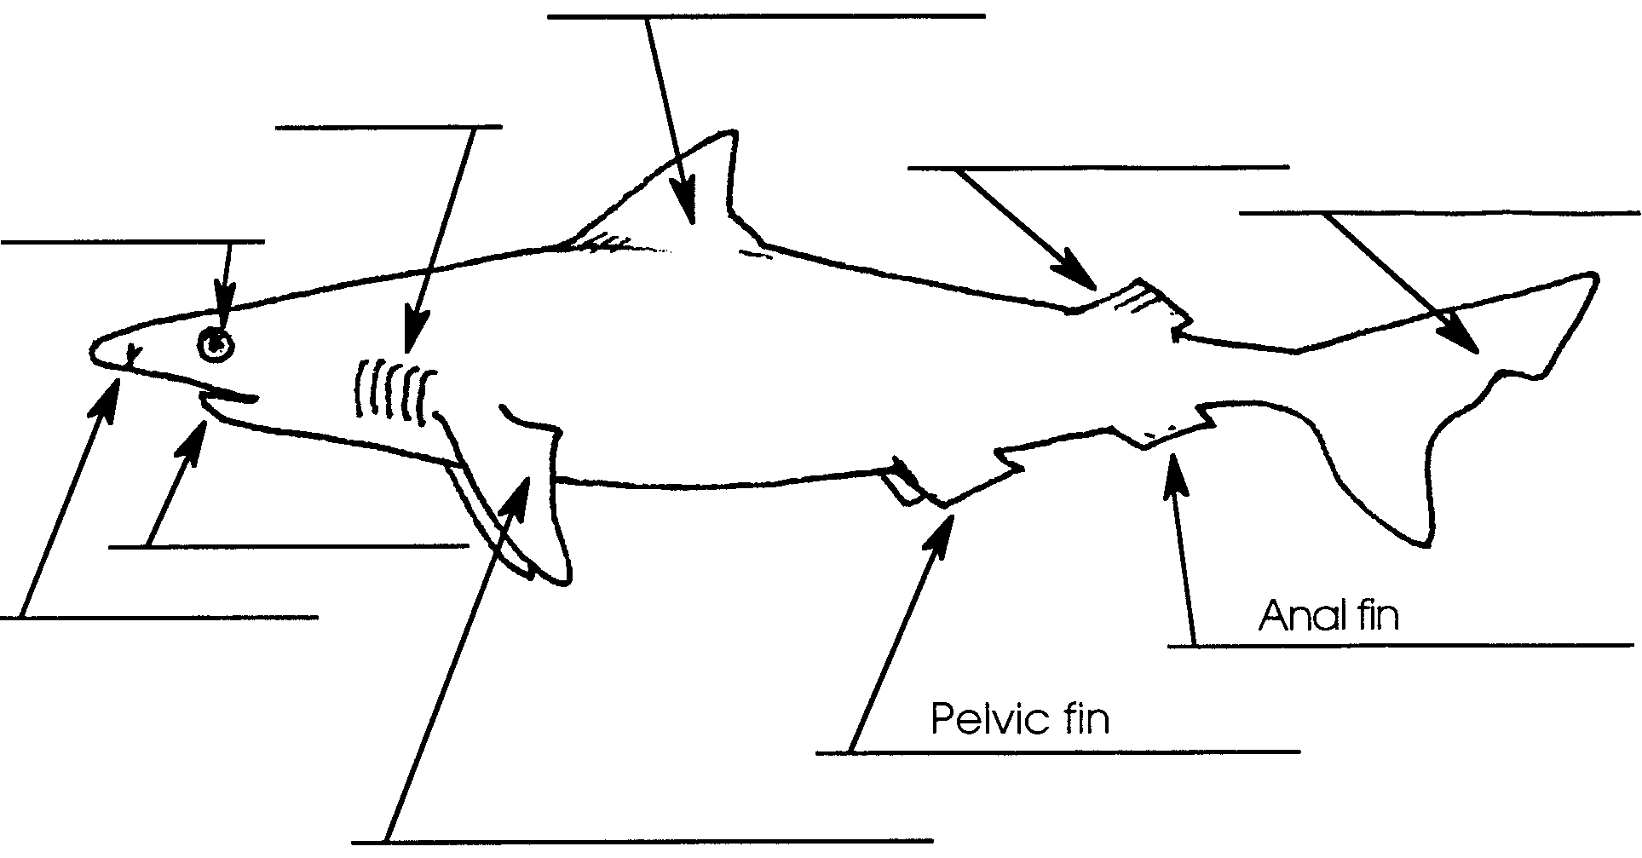
Sharks are famous for their teeth. The teeth may be large or small, triangular, crescent-shaped, awl-shaped or flattened. Some sharks have both cutting and crushing teeth. The teeth are, in reality, highly modified versions of the countless hard, sharp, pointed “scales” or dermal denticles which cover the shark’s skin. The teeth are not rooted in the jaws and in fact, the upper jaw is not fused to the skull (cranium). Because of these loose, but strong and flexible connections between the jaw and cranium, some sharks open their mouths until their snouts are virtually perpendicular. With the mouth wide open, the jaws protrude forward of the body and the teeth somewhat forward of the jaws. So, contrary to one of the oldest shark myths, sharks do not have to roll over to bite a big object. Attacking straight on, ten foot sharks have been observed taking bucket sized, twenty pound chunks out of huge whale carcasses, their shaking heads and convulsing bodies turning their teeth into miniature saws. The resultant bites are hemispherical and look as if they had been made by an enormous ice cream scoop.

3. What is the role of the head shaking movement in feeding?

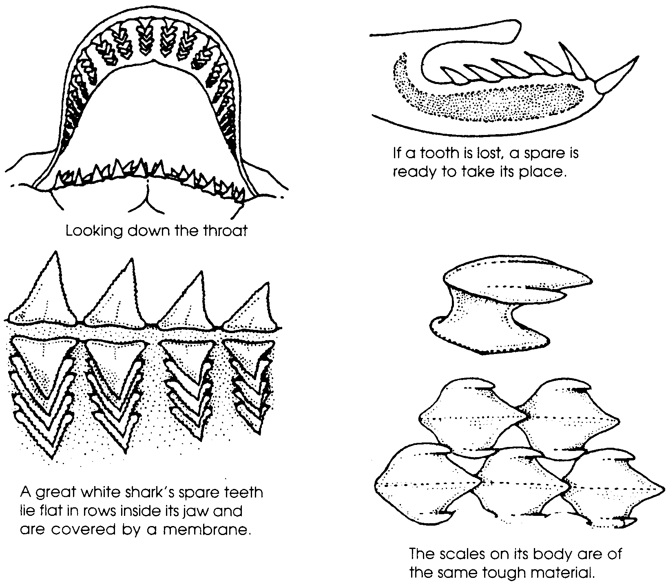
Sharks sometimes lose teeth in feeding. To compensate for these losses, sharks have six to fifteen rows of teeth but usually only the first row is erect and functional. The other rows lie in reserve, flattened beneath a thin membrane. The teeth in these new rows move forward to replace teeth that are lost. In some species, the teeth are replaced periodically so that the shark’s business teeth are always sharp and new. The triangular, serrated teeth so many sharks have are perhaps the most efficient cutting instruments known in nature.

4. The side view of the shark jaw shows the positioning of the rows of teeth. How might the way in which the second and third rows of teeth face be of survival value to the shark?

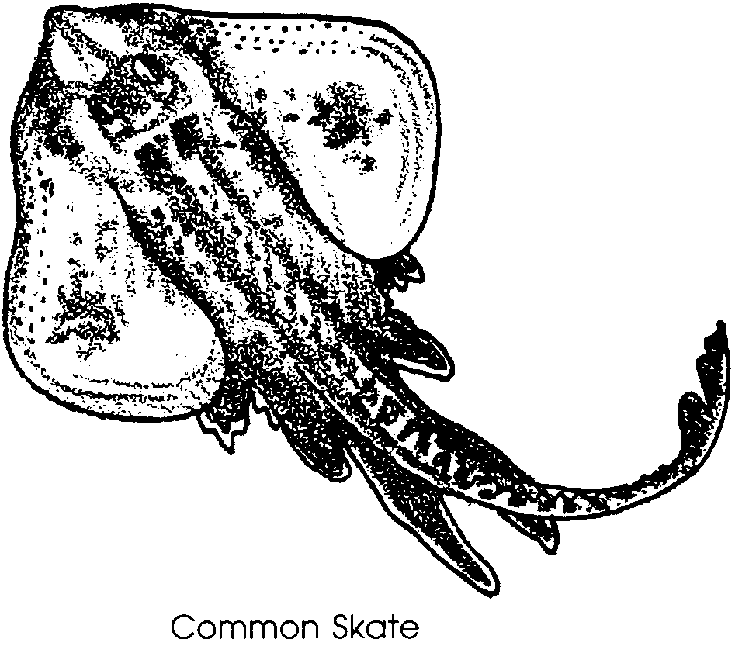Scientists presently recognize about 350 species of sharks and are working hard to increase our knowledge of sharks. Sharks fall within the subphylum Vertebrata of the phylum Chordata. They are grouped with the skates and rays in the class Chondrichthyes, a term that is comprised of the Greek words for “cartilage” (chondros) plus “fish” (ichthyes). The class name tells us something important about sharks. Their boneless skeletons are made of cartilage, a lighter and more flexible substance also found supporting our ears, making the end of our nose and cushioning our knee joints.
This bonelessness is the most important way in which sharks differ from other fish (those belonging to the Osteichthyes, “bony fish”). Cartilage is lighter and more buoyant than bone. Sharks lack the swim bladder that most fish have for buoyancy. The cartilage skeleton helps make up for this deficiency while enabling the shark to change depths rapidly without risking fatal injury due to expansion of the swim bladder. The ability to change depths rapidly is an obvious advantage to a predator on other fish. The cartilaginous shark is a supple fish, able to reverse direction quickly and within a short space. This maneuverability compensates for the shark’s inability to swim backward or stop quickly. Unfortunately, the flexible cartilage which forms the shark’s frame has trouble supporting the weight of the internal organs when the shark is out of the water. Even after a few minutes, the shark will suffer fatal injury and shock.
5. What are three ways in which the cartilaginous skeleton helps the shark survive?

a.

b.

c.
How does this steely eyed “eating machine” sense its surroundings? The complexity of the senses in sharks makes understanding difficult. We do know that sharks can smell quite well. The olfactory lobes of the brain which are the center of the sense of smell may make up two-thirds of the total brain weight in sharks. Because of this information we think that the sense of smell is very important to the shark in locating food.
“Hearing”, or at least vibration detection, is important for sensing changes in the surroundings. Vibrations such as those that an injured and struggling fish might produce are received in specialized sense organs located along the side of the shark in the lateral line.
We don’t know how well the shark can see or the role of vision in its life. We also don’t know whether the shark possesses a true sense of taste, even though it “tastes” a lot of things - finfish, squid, molluscs, crustaceans, echinoderms, jellyfish, seaworms, skates and rays, other sharks, sea turtles, seabirds, seals, the occasional land animal that wanders into the ocean at the wrong time and place, as well as a certain amount of garbage, carrion and indigestible junk.

6. What are three of the senses the shark uses to locate food?
a.

b.

c.

In the past, our lack of knowledge about the manner in which sharks behave made us say that sharks are unpredictable. As we learn about sharks, we’re beginning to think that their behavior is probably fairly predictable. We’d still like to know more because a very small amount of what seemed like unpredictable behavior is directed at humans. We can now identify behaviors and environmental conditions that induce shark attacks. We can also identify shark behaviors prior to attacks. From this information, we can predict, at least in general, shark attacks.
Shark attacks against humans are extremely rare events. The number of shark attacks around the world averages only about 26 per year. Only 29 percent of the attacks are fatal. About three-fourths of the victims are left bleeding and helpless, but uneaten, in the water after receiving a single bite. Twenty-six attacks out of some four billion humans worldwide is not a very high percentage. Still, when you’re swimming in the surf, it’s small comfort to know that four times as many people are struck by lightning in the United States alone than are bitten by sharks in all of the waters of the world each year. Shark attacks are unlikely and unwelcome.
No shark can be called a man-eater in the sense of customarily feeding on human flesh. Scientists think that usually when sharks bite people with supper in mind, it is a case of mistaken identity. Black-wetsuited divers look a lot like seals, a favorite prey of sharks. A person dangling arms and legs from an air mattress or surfboard may look like a sea turtle or a big, eviscerated fish. The erratic splashing of a frolicking surf-bather may seem to a shark like the frantic thrashing of a sick or wounded fish. We don’t know for sure. The Navy and Air Force have spent considerable sums of money in trying to find out.

7. Swimmers frequently encounter sharks. All of the actions listed below are things to avoid, if you see a shark. Next to the action, list the sense or senses (smell, lateral line, vision) the shark probably uses to react to the stimulus:

Stimulus Sense(s)

Splashing, yelling, or hitting
rocks together underwater

Swimming where blood, vomit,
bait or fish scraps are present.

Swimming alone rather than in
groups.

Touching or bothering the shark
while swimming in a black-wetsuit.

Prejudice against sharks is so strong that most of us overlook their positive contributions to humans. For centuries sharks have been used as food, fertilizers and hides; as a source of vitamins and medicines; and in cosmetics and costumes. The annual commercial catch of sharks exceeds 1.2 billion pounds. The shark provides much of the “fish” for fish and chips. It also is providing scientists with ammunition in the battle against cancer; most sharks seem to be virtually immune to the disease. Interest in shark exploitation is increasing.
Because of the relatively small litters, the long time it takes to grow to sexual maturity, the regular migration routes or easily fished habitats of so many species, and their relatively small population sizes, sharks are particularly susceptible to overfishing. So it appears that the shark has more to fear from humans than humans have to fear from the shark. In our ignorance of shark biology and behavior, we run the risk of destroying this magnificent balancing agent of the seas.

8. In your opinion, how can people’s attitudes toward sharks be changed?

Want to Learn More About Sharks?

Much of the information in the preceding section comes from the following article, used by permission, which you can read for yourself:

“Consider the Shark,” article by Gary Soucie with paintings by Gary Ellis. “Audubon Magazine”, September, 1976: Volume 78, number 5. Pages 2-35. Copyright 1976. The National Audubon Society.

This article is entertaining reading and beautifully illustrated.
SHARK HUNT
Here are clues to words that are hidden in the “Shark Hunt”. They may be written across, up and down, or sideways. Find as many as you can and draw a box around each word as shown. Some of the boxes may overlap. Happy shark hunting!

Clues

The smallest shark
What a shark’s skeleton is made of
The largest shark
A shark’s skin feels like this
The “teeth” on a shark’s skin
From the oil of shark’s livers
Made from sharkskin
Size of the largest shark
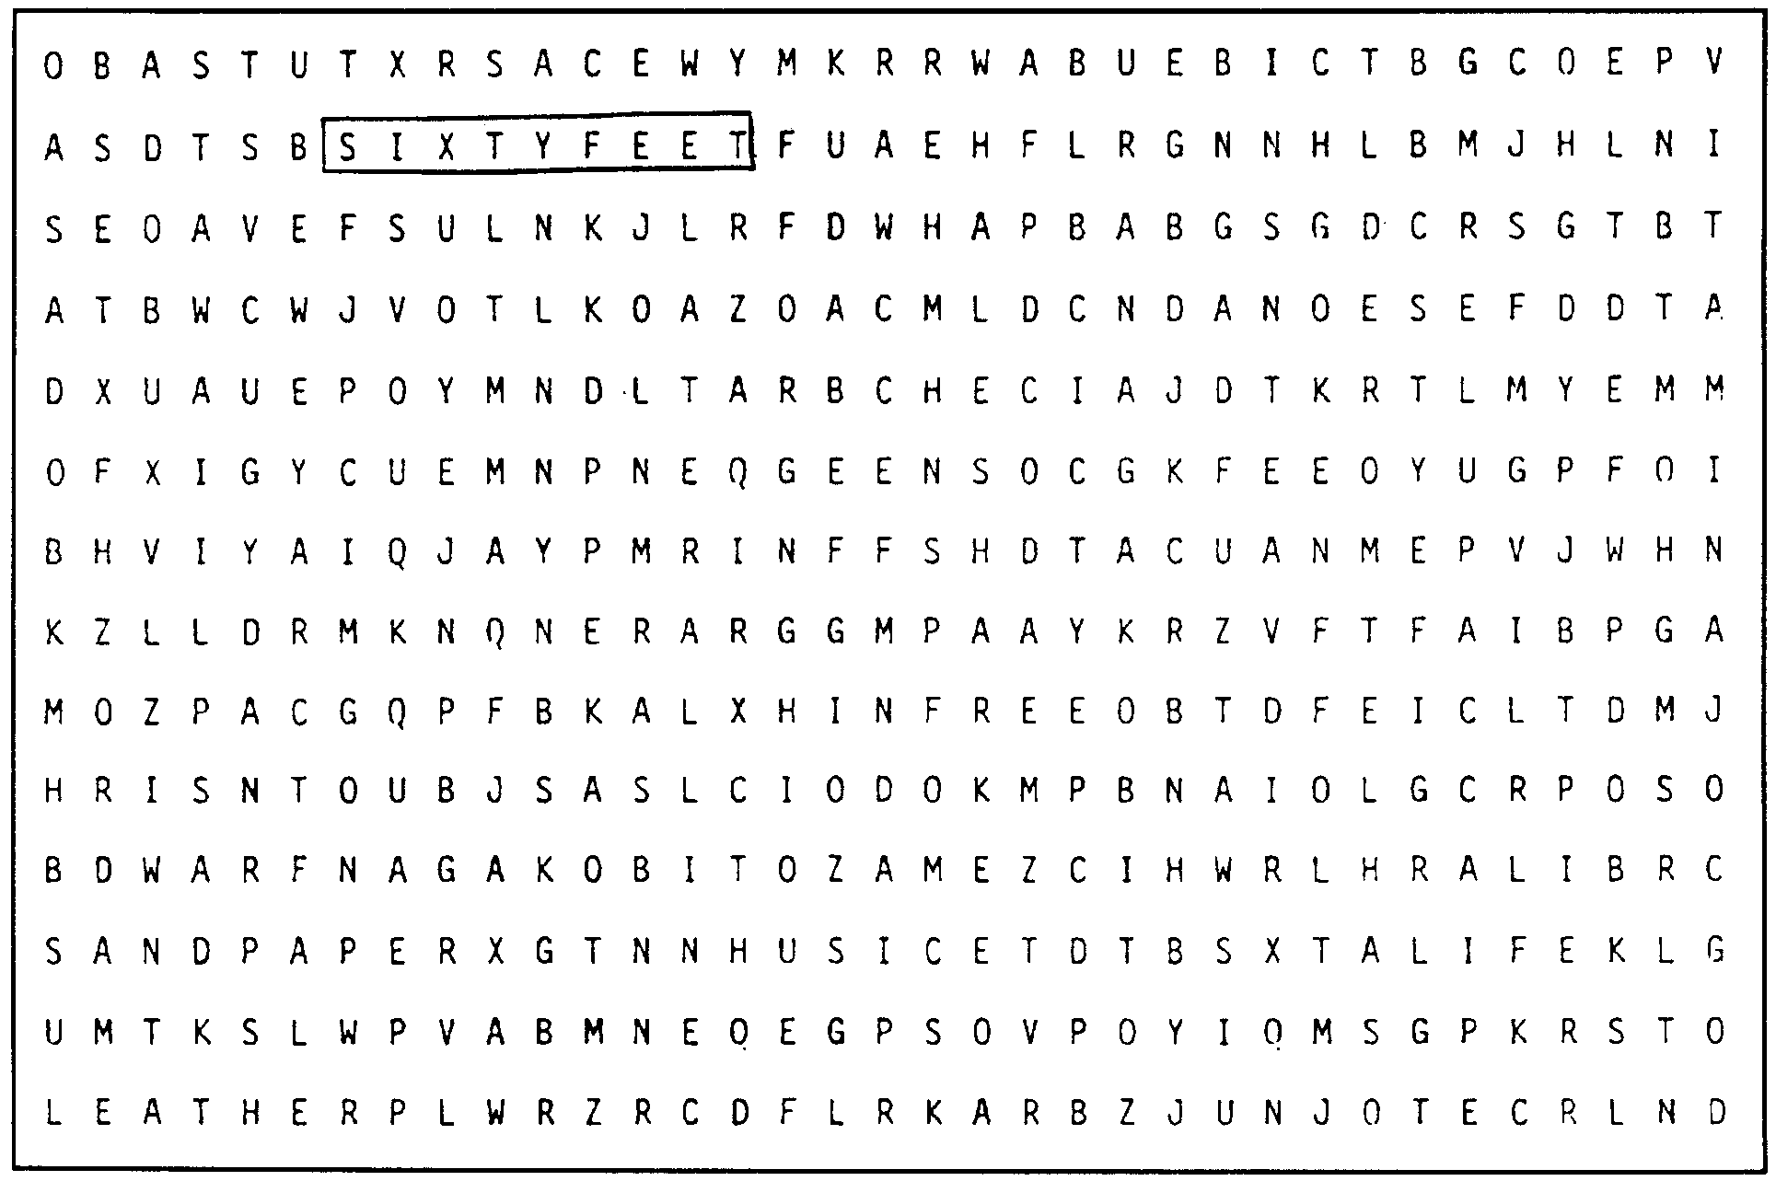
organs sense vibrations

