Sharks!
Written by Susan Wertz, North Thurston School District, Lacey, Washington including materials originally developed at The National Aquarium in Baltimore, Baltimore, MD; at the American Littoral Society, Highlands, N.J. 07732; and at the Center for Shark Research, Mote Marine Laboratory, Sarasota, FL 34236, and used herein with permission.


Key Concepts
1. Sharks elicit strong emotions and vivid images in most people.
2. Recent research is changing our image of the ocean's most maligned creature. They are superbly adapted to their ocean environment and are an important ecological component of the world's ocean.

Background
Sharks are a vital part of the ecological systems of the world’s oceans. As top predators, they keep smaller animals in check by eating them or enforcing a pecking order at kills. Sharks also provide food for other animals such as humans, elephant seals, and other sharks.
Humans tend to justify a creature’s worth by what it can do for us. Many people are unaware of the tremendous economic importance of sharks.
The fishery for sharks has exploded along the coasts of the United States, Europe and Asia. Sharks are fished commercially by hook and line, on long lines (lines hundreds or thousands of feet long with baited hooks at periodic intervals), or harpooned.
Shark meat is low in fat, high in protein and can be excellent eating. The meat can be barbecued, ground into fish meal, made into soup, dried, salted, smoked, marinated, minced, fried or baked. Some of the best eating sharks include the great white shark, lemon shark and black-tip. The belly, liver, and fins are especially prized. Shark fin soup is actually made out of the elastoidine fibers of the fins, NOT the muscle or the skin. A famous shark dish in Japan, Kamaboko, is prepared by steaming crushed shark meat with cornmeal. The only drawback to shark meat is that it has high concentrations of two nitrogenous compounds, trimethlyamine and urea (toxic metabolic by-products) in both the bloodstream and also in the muscle tissue. If the shark meat is not processed immediately after catching, bacterial action forms ammonia which causes the meat to be inedible with a strong, noxious odor.
Shark skin and shark stomach linings make good leather. A type of sandpaper can be made from shark skin. Jewelry is made from the teeth and parts of the eye. (The darker teeth seen in some jewelry are actually fossils). In addition, oil from shark livers is used in some cosmetics, as lubricants and as a source of vitamin A.
In medicine, a shark cartilage substance called chondroiten is being tested as a type of artificial skin for use in the treatment of severe burns. Extracts from cartilage are also being used in cancer research because sharks are virtually free of cancerous tumors. Shark corneas have even been used as implants for human corneas.
Sharks are so valuable now that they are being overharvested around the world. Many believe that, though sharks have been swimming the oceans for about 400 million years, many species may now be facing extinction. In addition to fisheries that focus on sharks, many other fisheries catch sharks incidentally and discard these sharks as undesired catch. Typically, about 80% of the 4,000,000 or so sharks caught in the Western North Atlantic each year are dumped back into the sea as incidental and undesired catch. According to Samuel Gruber, in 1989, more than 100,000,000 elasmobranchs (sharks and their relatives) were killed by the activities of humans. That works out to about one million sharks killed by humans for every one human bitten by a shark!
Though sharks have incredible value to humans, they are fascinating animals in their own rights. Sharks have incredible senses. They possess an excellent sense of smell and a fine sensitivity to low-frequency vibrations. It now seems they can find both their direction and their prey electromagnetically. Adrianus Kalmijn of the Woods Hole Oceanographic Institution showed that sharks can detect electric fields as low as a hundred-millionth of a volt per centimeter. All organisms in the sea produce small electrical fields, so sharks easily find fish, even if the prey is hidden under the sand.
Sharks also will attack live electrodes buried in the sand. Communication cables laid down by AT&T at depths greater than 4,500 feet have been damaged and found with shark teeth imbedded in them. It seems that the sharks are attracted to the electrical field given off by the cables and attack them. To prevent costly repairs, AT&T has wrapped the cables in steel.
A more incredible finding is that sharks also navigate using the earth’s magnetic field as their guide. By actively swimming through the ocean, a shark cuts the magnetic field lines of the earth, inducing an electric current around itself, which it detects by the same sensory organs it uses in detecting prey. The direction in which it swims affects the direction of the current induced. Thus, sharks have an internal compass that works electromagnetically.
For additional information, see the attached pages, “Sharks and Their Relatives”, from Mote Marine Laboratory and Sea World.
Teaching Hints

“Sharks!” is divided into a menu of activities. The first activity asks students to reveal their preconceptions and feelings about sharks. The next six options provide different ways to guide student research about sharks. The final five options utilize other learning styles and senses. Some are art projects, one focuses on the sense of touch, and one even involves tasting shark! Choose the activities that are most suited to the interests and skill levels of your students.

Introduction

Option 1: Pre-conceptions About Sharks

The constructionist approach to learning explores the constructs (ideas or described meanings) that learners have constructed in their own minds to explain phenomena. These constructs are identified and documented before new data is given. As you begin this unit, find out the conceptions and ideas students have about sharks as a result of their own prior knowledge and experiences. Have students answer the following questions. Emphasize that there are no RIGHT answers at this point and that all answers will be confidential. Have the students save what they have written. You may even consider having them seal their responses in an envelope.
After students have studied sharks, choose some of these same questions and find out if new information has indeed replaced some of the misconceptions and negative attitudes towards sharks that the students originally may have had. Students are really great at telling teachers what they think teachers want to hear. Listen carefully to assess whether or not incorrect “constructs” have been replaced with accurate concepts. Give the students an opportunity to open their envelopes and look at their original responses.
Here is a suggested list of questions:
a. What words come to mind when you think of shark? List 5 of these words.
b. What do most humans do when they see a shark?
c. What do most sharks do when they see a human?
d. What kind of an animal is a shark?
e. How many kinds of sharks can you name?
f. What are some relatives of the sharks?
g. What are shark teeth like?
h. How often do sharks have to eat?
i. Do all sharks eat the same things?
j. Would you want a shark for a pet?
k. Would you eat shark steaks?
l. Do you think sharks are mean?
m. If you saw a shark in your favorite swimming place, would you kill it if you could?
n. How do sharks reproduce?
o. What are sharks good for?

Student Research About Sharks

Option 2: Sharks!

Materials

For each class:

• lots of scraps of scratch paper

• fat marker pens

• masking tape

• resources about sharks

Meet the interest, awe, and fear associated with sharks head-on. Ask the students to brainstorm a list of things they would like to find out about sharks. Each time a student comes up with a question, he or she should write the question in large letters on a piece of scratch paper. You or a volunteer should collect ideas as they are written and hang the papers up on a board or wall.
When students seem to tire of brainstorming questions, ask them to start looking for questions that seem to be related. Students may have asked several questions about shark attacks, for example, or about how sharks feed, how sharks protect themselves, or how sharks reproduce. Move the papers into groups of related questions. You will have created a rough concept map about sharks.
Now have students research their questions. You may choose to have students or teams of students choose one group of related questions for their research topic. Allow students time in the library or provide a well-stocked classroom collection of journals, books and videos about sharks. As students collect information that address specific questions or that fit some of the groups of ideas, have them post their information and its source. It is likely that this process will generate more questions, but that is what learning is all about.
Option 3: Shark Scavenger Hunt

Materials

For each class:

• copies of “Shark Scavenger Hunt” questions

• access to information sources about sharks

The scavenger hunt questions are meant to spark the students’ interest. Brainstorm with the class a list of tools and resources they could use to conduct the scavenger hunt. Helpful instruments might include the phone, computers, laser discs, CD-ROM, and FAX communication. Resources might include experts from local resource agencies and aquarium staff as well as standard written materials. You might want to impose special rules on the scavenger hunt. For example, you could impose a time limit, require documentation of source and source reliability, or ask for publishing dates. One option that takes less class time is to cut the list of questions apart and have a shark lottery. Students choose just one or two questions to research.

Option 4: Shark Research Report

Materials

For each student:

• copy of “Shark Research Report” student pages

Each student locates an article about research about sharks and reports on the authors’ findings by using the research report worksheet.

Option 5: Shark Issue Report

Materials

For each student:

• copy of “Shark Issue Report” student pages

Each student locates an article about current issues surrounding human use of sharks and reports on the issue by using the issue report worksheet.

Option 6: Sharing Sharks

Have students create shark learning materials, learning centers, or multimedia presentations (skits, videos, newscasts, sitcoms, raps) for elementary classrooms.

Option 7: Student Shark Experiments

Have students design and carry out an experiment on sharks or participate in a tagging project. If possible have them work with a local fisheries resource agency or university.
Shark Activities

Option 8: Shark Cartoons are a Scream

Collect cartoons by Gary Larson and others. Have students explain why they are funny and what actual shark fact is alluded to in each cartoon.

Option 9: Parking Lot Shark Art

Have student teams choose a shark and collect information about that shark, including a picture or outline drawing. On one fine day, go out to your school parking lot (providing it is paved) or the local mall and have students draw their shark to scale. Then have a tour in which the students tell each other about their sharks.

Option 10: Shark Cut-Ups

Have students draw or copy an outline of a particular shark so that it fills an 8 1/2 x 11 piece of paper. Make a transparency from this paper and use the copier to make a mirror image. Have the students correctly color and shade the two sides, stuff with some recycled material, and glue or sew together. These can be used as mobiles, in dioramas or murals.

Option 11: Skin so Soft?

Obtain some shark skin and some fish skin. (Many high school zoology classes use dogfish sharks for dissection) Mount small pieces of the dried skin on 3x5 cards. Put the cards into a large envelope. Have students determine by feel only which is shark skin and which is fish skin.

Option 12: Succulent Shark

Research shark recipes. Order some shark from the local fish store or seafood department of a large grocery store. Have student teams be responsible for preparing different shark dishes.

Key Words
Batoidea - a group of animals including rays and their relatives
bioenergetics - the study of energy transfers in living things
Elasmobranchii - a group of animals (subclass) which includes sharks and batoids
endangered - a species in danger of becoming extinct
sustainable yield - the number or biomass of organisms that can be harvested each year, leaving enough for reproductive purposes to maintain a stable population
top predator - an animal without predators at the top of a food pyramid, only “preyed upon” by scavengers or bacteria when it dies

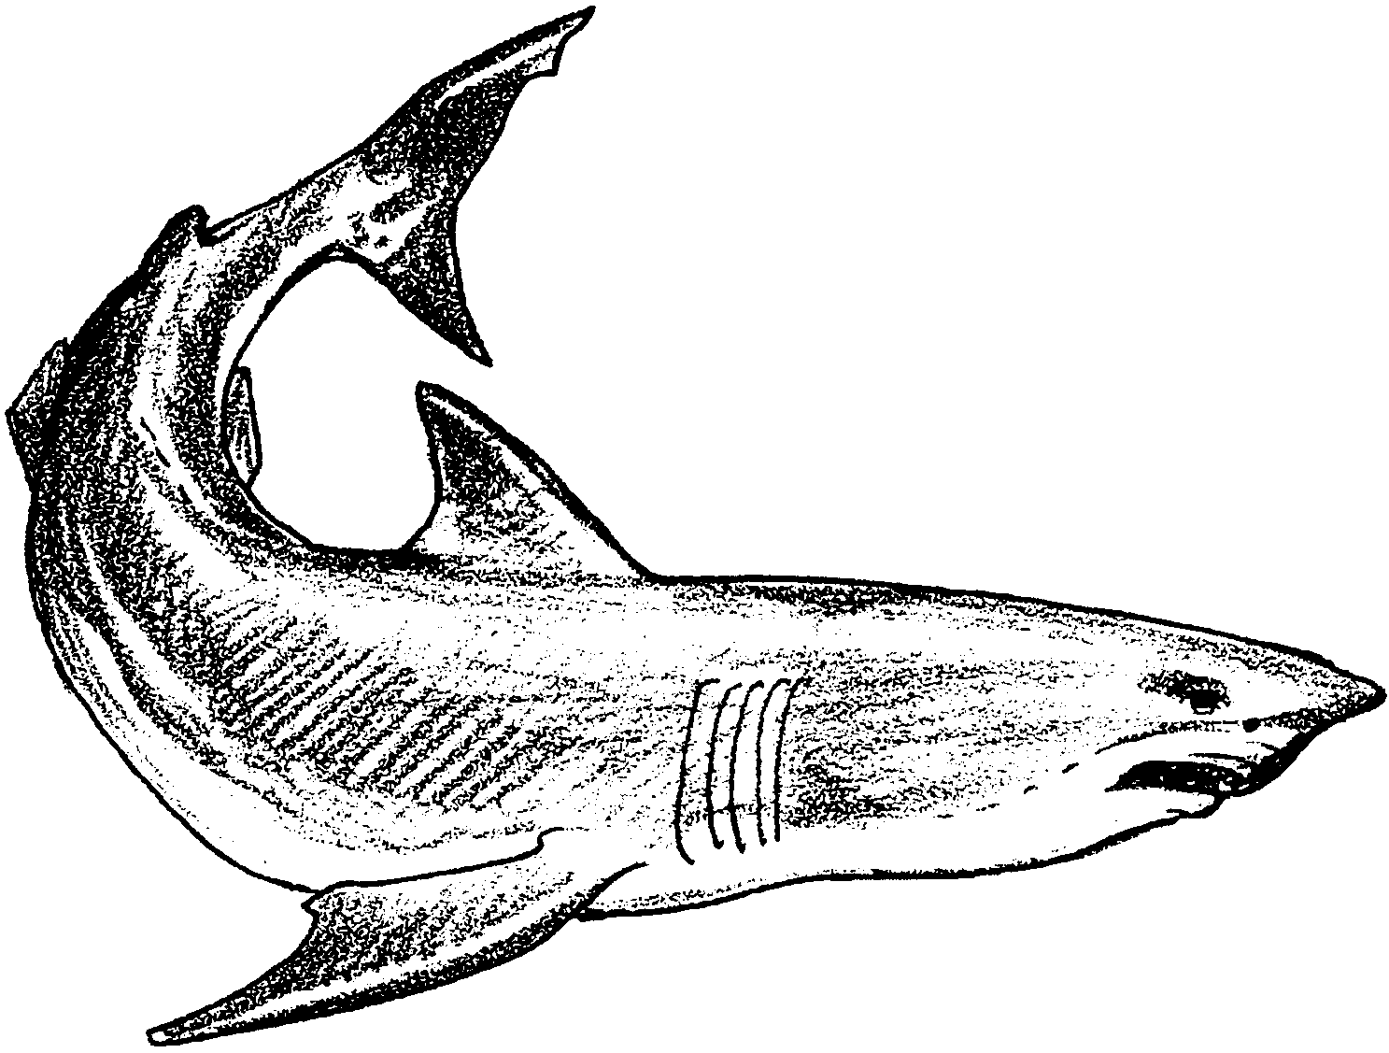
Sharks!

Shark Scavenger Hunt
Your teacher will give you the rules for this scavenger hunt. Please list the “rules” below.

Rules

1. Why do sharks discharge their internal organs while they are hanging either by their tails or mouths?

2. What causes the obnoxious odor that sharks exude soon after they die? Is it present in all dead sharks?

3. How fast can sharks swim and how does their speed compare with the speed of game fishes?

4. It’s obvious how the hammerhead shark got its name, but why did nature give it such a odd shaped head with eyeballs located on the ends?

5. Has science ever measured the pressure of a shark’s bite? If so, how great is it?

6. How does a shark “home in” on a thrashing hooked fish a quarter of a mile away? Can they actually hear this commotion at such great distances?

7. The external reproductive organs of a male shark suggests a complex type of sexual intercourse. How does copulation actually take place?

8. Is it true that cannibalism among the young takes place in a pregnant shark’s uterus before the pups are born? If so, how was this strange phenomenon discovered and what actually takes place?

9. How long do sharks live? Why do they often die when kept in captivity?

10. What is the “sleeping sharks” theory all about? Do they really sleep?

11. Which shark species is considered the most dangerous to humans and where is it found?

12. What are some of the other dangerous shark species, and how likely are they to attack swimmers?

13. How big was the largest human-earing shark ever caught?

14. Why were some of the aircraft used against the Japanese during World War II painted to represent shark jaws yet called the “Flying Tigers”?

15. From reading about the many fatal and non-fatal shark attacks upon people throughout the world, the investigating authorities can usually identify the exact species of shark that made the attack. How?

16. Is it true that sharks will deliberately attack a boat in order to get at its occupants?

17. What was the largest mass shark attack in history, and under what circumstances did it take place?

18. What does a “feeding frenzy” among sharks mean?

19. Is it true that authorities caution female bathers against entering the water if they are menstruating?

20. What is the most successful shark repellent presently used by the military?

21. Do sharks have enemies and what are they?

22. Do any of the large billfishes such as swordfishes and big black marlins ever attack sharks?

23. How large is the official world rod and reel record shark? How about the unofficial record?

24. Why are shark leather products so expensive?

25. According to some religious doctrines, eating fish that have smooth skins and not scales is strictly prohibited. Are sharks included?

Shark Research Report

Name of the article

Name(s) of the author(s)

Background information on one of the authors

I. Scientific problem(s)

II. Background research or information

III. Hypothesis (educated guess)

IV. Experimental design

a. materials

b. location

c. procedure

d. data collected

V. Analysis of Data

VI. Conclusion

Shark Current Issue Report

Name of Article

Publication and Date

Author(s)

Background or expertise of author

One paragraph review of the article:

Prioritize the ten most important facts from the article. Write these below in complete sentences.

What are the recommendations or conclusions of the author?

What is your recommendation?

What is your opinion about the subject or issue discussed?

What is your prediction for the year 2010 on this issue?

