Animals of the Open Ocean – Jellyfish and Nematocyst Firing
Lesson by Jerry Mohar, Lyle High School, Lyle, Washington and
Karen Mattick, Marine Science Center, Poulsbo, Washington.

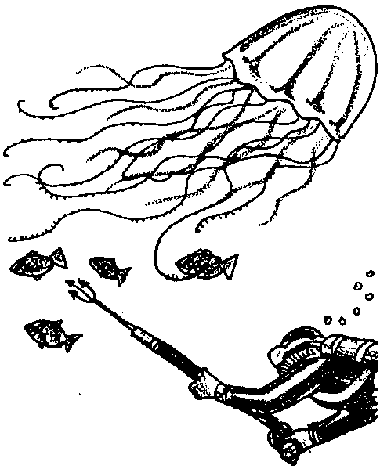
Key Concepts
1. Jellyfish, drifting in currents, use special stinging cells to defend themselves and to capture prey.
2. We can observe the stingers, called nematocysts, that these organisms use to defend themselves and gather food.
3. Some stimuli more strongly trigger nematocyst firing than others.

Background
Ocean currents create and connect marine habitats. They are the dominant force in the open ocean. In the open ocean environment there are no hard surfaces. Boundaries here are not made of rock or reef but of haloclines and thermoclines, divisions formed where ocean currents meet, mix and layer.
In this pelagic world, light and color are diffuse and so the creatures of the open ocean are patterned to blend with the silvery sea. They may be as clear as water or have backs as black as the abyss and bellies that sparkle like the sunlight on the water’s surface. Here, smell, touch and hearing are more vital than sight.
The pelagic organisms, including the drifting plankton, are ever moving. They follow the edges of currents and migrate from the deep to the shallows and back again, always seeking the right conditions and the right prey. They are the jellyfish, the sharks, the pelagic fish and the magnificent whales.
“Jellyfish and Nematocyst Firing” focuses on one of these open ocean animals, the jellyfish. Jellyfish are one of the few drifting, planktonic organisms that grows to be macroscopic. Cyanea jellyfish in Arctic and temperate waters may grow to be nearly two meters in diameter. A typical large jellyfish is 30 cm. or so across. (Some Siphonophores, a group of drifting, gelatinous organisms in a different phylum from jellyfish, grow to be as much as 20 meters in length.)
Jellyfish must capture prey as they float along in currents. They must be able to deter predators. Jellyfish accomplish both feats with amazing structures that sting. One of the most interesting and specialized cells found in the animal kingdom is the cnidoblast or stinging cell possessed by jellyfish and other members of the phylum Cnidaria. Nematocysts, discharged from the cnidoblast, are used for defense and to capture prey. In this lab, your students will have an opportunity to examine the discharge of nematocysts.

Materials
For class of 32:
• 1 or 2 jellyfish or sea anemones
• 10% acetic acid 20 ml.
• methylene blue dye (optional)
• alcohol 10 ml.
• clam juice 10 ml.
• materials the students want to test (of course, they should be legal and not dangerous)

For each pair of students:
• 1 compound microscope
• several slides and coverslips, or ready access to a sink to wash used slides for re-use
• 1 depression slide
• a pin or dissecting needle
• eye dropper

Teaching Hints
“Jellyfish and Nematocyst Firing” focuses on one of these open ocean animals, the jellyfish. The success of this lab is dependent on the availability of live specimens. One or two specimens of sea anemone or jellyfish will provide material for 75 or more students. Sea anemones will remain alive and healthy in a well aerated aquarium in spite of frequent removal of acontia, the threadlike structures used in the following activity. Jellyfish generally do not survive handling and do not do well in standard aquariums.

It is particularly easy to obtain acontia, thread-like structures which carry large numbers of stinging cells, from sea anemones of the genus Metridium. The acontia appear in great number when the sea anemone is removed from its substrate. If you have difficulty picking up an acontium, try sucking one end into a Pasteur pipette or medicine dropper and then cutting the other end away from the sea anemone with dissection scissors.
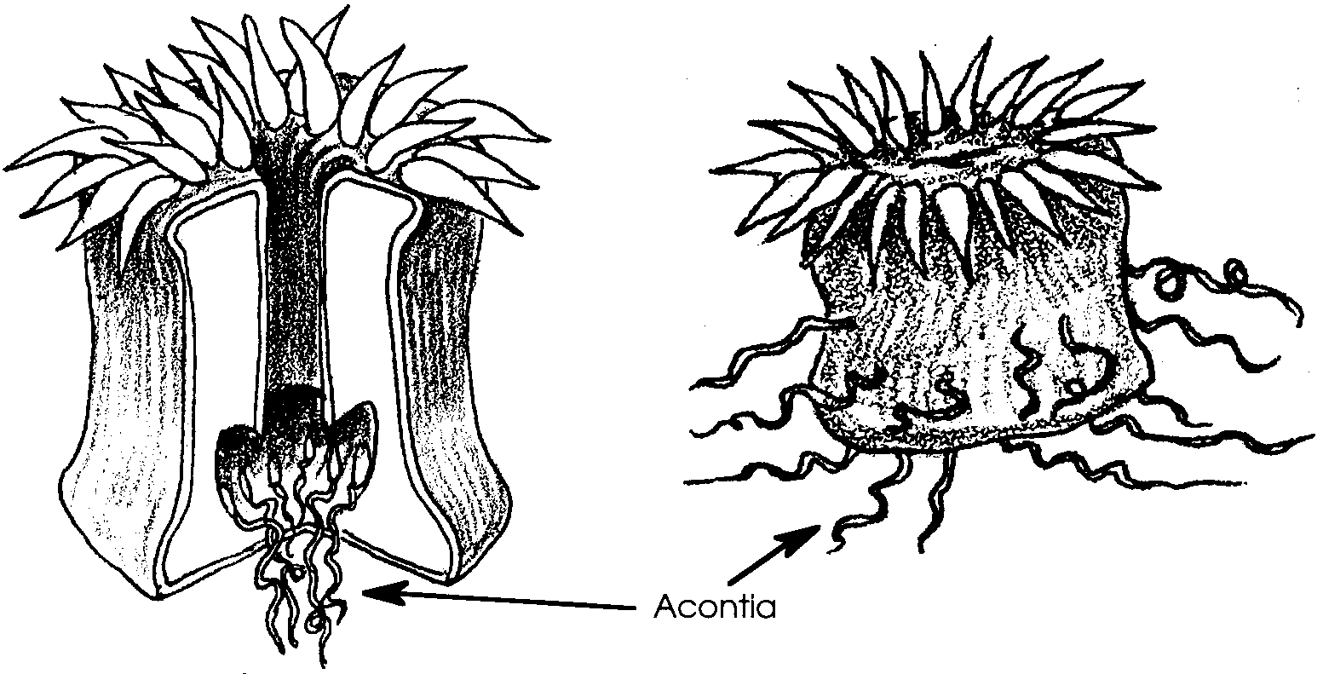
Review with your class the techniques used to obtain fluid movement under a coverslip. A small piece of paper toweling or blotter placed on the opposite side of the coverslip can help pull the fluid under the coverslip. Methylene blue may be added to the acetic acid to make the fluid movement more visible. During these observations, caution your students to use only low power and to be sure to wipe up any spills (both on and off the microscope) of salt water or chemicals. If necessary, review procedures for measuring objects within the field of vision. Plan to provide time for a discussion of the questions found in the body of the activity and in the analysis section.

Key Words
acontia - thread-like structures hanging inside the gastrovascular cavity of Cnidaria, equipped with stinging cells
Cnidaria - a phylum in which the organisms are characterized by stinging cells
cnidoblast - stinging cells containing nematocysts
gastrovascular cavity - a cavity which serves both digestive and circulatory functions
mechanical stimulation - in this case, the touching of an organism to cause it to move or respond
micron - 1/1000 of a millimeter
nematocyst - an organ in cnidarians, consisting of a minute capsule containing an ejectable thread, that causes a sting; “stinging cell”
pH - a symbol reflecting the hydrogen ion concentration of a solution; a measure of the acidity of a solution
sessile - referring to an organism what is permanently attached to a substrate, not freely moving
substrate - the base on which a sessile (nonmotile) organism lives or grows

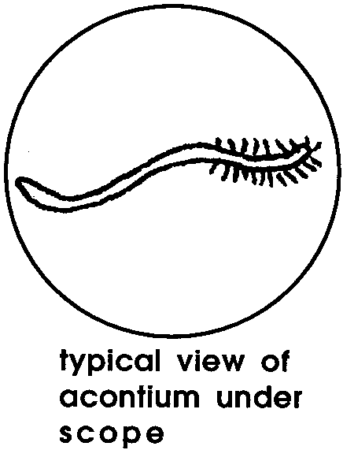
Answer Key
Experimental Procedure:
2. Answers will vary. In general, students will see a thread that may be moving some. Some of the nematocysts may have fired, in which case the students will see projections that make the acontium look like a fuzzy thread.
3. Students’ predictions will vary.
4. Answers depend upon experimental results. Some literature suggests using vinegar to neutralize nematocysts. Others claim acetic acid will increase firing. Your students likely will see some firing.
5. Answers depend upon experimental results. Mechanical stimulation increases the number of nematocysts firing.
6. Answers depend upon experimental results. Clam juice causes a reduction in the discharge rate but may not stop the firing completely since mechanical stimulation etc. may play a countervailing role.
7. Experimental results will vary, but, in general, alcohol stimulates firing.
8. Answers depend upon experimental results. The nematocysts can still fire. Each nematocyst acts independently of others and does not appear to be under the control of any central nervous system. This observation has led nematocysts to be called “independent effectors”.
9. Experimental results will vary.
10. The average width of a nematocyst Metridium sp. is about 250 microns. The range, however, is fairly large within a species and between species is tremendous.
11. The length of a discharged thread is about three times the width of the nematocyst or in the case of the acontia of Metridium sp., the length is about 750 microns.

Analysis and Interpretation
1. While the answer depends upon the experimental results, acetic acid and mechanical stimulation can cause an increase in nematocyst firing.
2. The students’ interpretations of the data will vary. Many may suggest clam juice or argue that none of the chemicals were very effective at slowing nematocyst firing. Nematocysts truly are effective defense tools!
3. The increase in firing due to mechanical stimulation has an obvious benefit for the sea anemone. If a small food item (fish, etc.) bumps into the anemone, it triggers nematocyst firing that can ensnare and/or impale and/or poison the prey.
4. Firing in response to chemical stimulation may be of survival value if either prey or predator of the sea anemone exudes the chemicals that cause the nematocysts to fire.
5. Since the pH of the solutions is different, it may be possible that nematocyst firing is triggered by certain pH solutions. These crude activities do not really allow us to make this statement with much confidence since the presence of other ions or compounds might be the triggering factor. The importance of these observations is that they provide a direction for further investigation. Interested students might want to experiment with food extracts, egg white, blood, etc., by poking acontia with a glass rod immersed in one of the solutions. Alternatively, they may wish to concoct test solutions using calcium or magnesium salts. They may wish to examine the effect of copper, poisons, other metals, drugs, alcohol or aspirin; can pH, or temperature changes cause a change in discharge? There are many opportunities for further investigation by your students.
6. Since the nematocysts fire even after the rest of the cellular organization is disrupted, it appears that nematocyst discharge is not under nervous control. As mentioned above, nematocysts are “independent effectors”.
7. Nematocysts play several roles in the life of members of the phylum Cnidaria. They are primarily concerned with defense or food getting behaviors and perform their functions by ensnaring, harpooning or poisoning the attacker or the prey.
ï
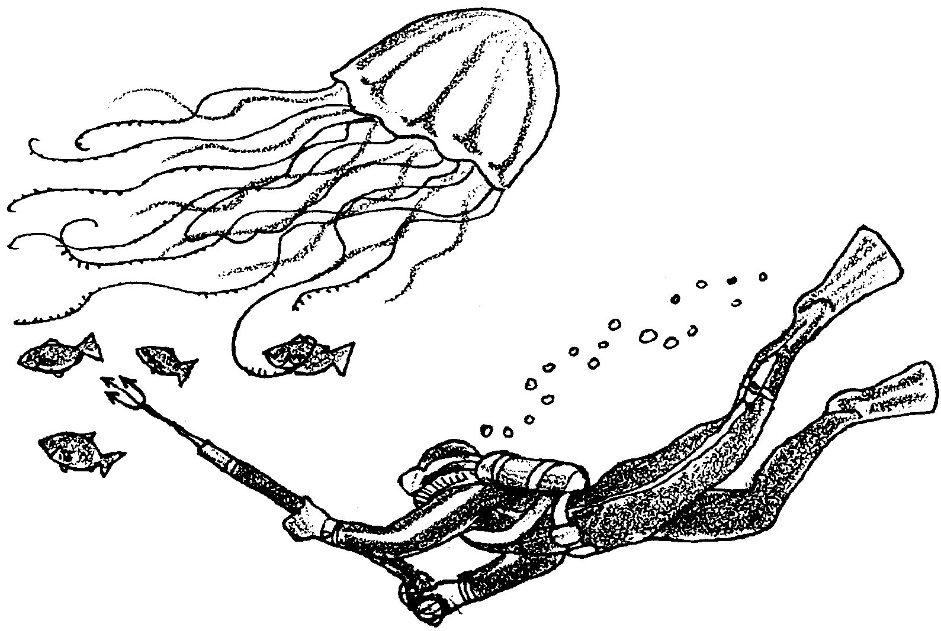
Animals of the Open Ocean – Jellyfish and Nematocyst Firing

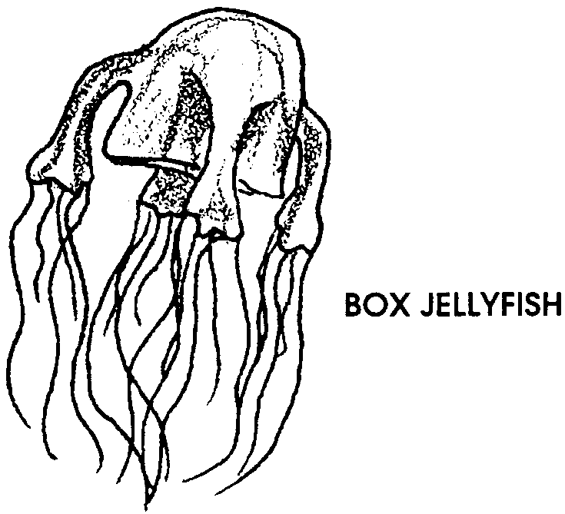
Picture a soft, gelatinous jellyfish drifting wherever ocean currents may carry it. How can this slow, delicate animal hope to catch any of the agile shrimp or fish that move around it in the sea? How can it protect itself from much stronger predators?

Consider the box jellyfish or sea wasp, a deadly jellyfish that lives in tropical waters around Australia. During a portion of each year, the box jellyfish drift in large numbers around swimming beaches. At best, a tangle with a box jellyfish leaves the swimmer with deep scars. At worst, the toxin in the jellyfish sting proves fatal.

Of all the zooplankton drifting in the great ocean currents, the best known and often most feared is the jellyfish. Jellyfish and their sedentary cousins, sea anemones, corals and hydroids, are armed with stinging cells. Few have stingers potent enough to fatally harm humans, but all make good use of their stinging cells for capturing their chosen prey and defending themselves.

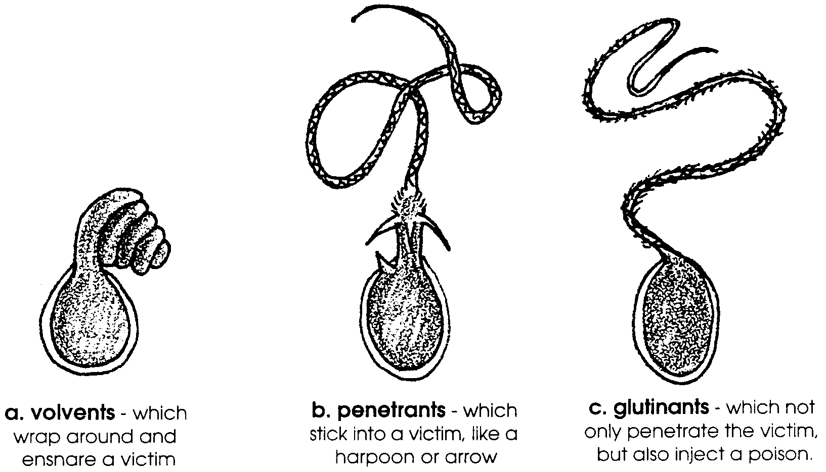
The stinging cells in jellyfish and their relatives are called cnidoblasts (nyd-o-blasts). Each cnidoblast cell has an organelle, or part, called a nematocyst. The nematocyst is the part that actually captures food. Nematocysts differ from species to species and perform their food-getting or defensive functions in one of three ways:

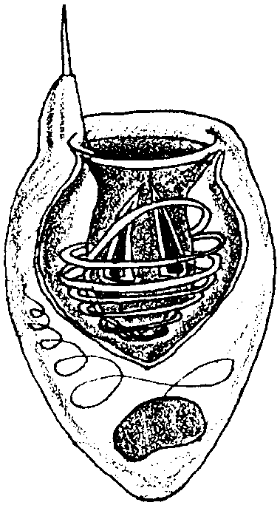
Cnidoblasts are rounded cells with the nucleus near the base. One end of the cell contains a short bristle called a cnidocil. The cnidocil acts like a trigger and is usually exposed at the surface. The interior of the cell is filled by a capsule containing a coiled tube. The end of the capsule, which is directed outward, is covered by a cap or lid.
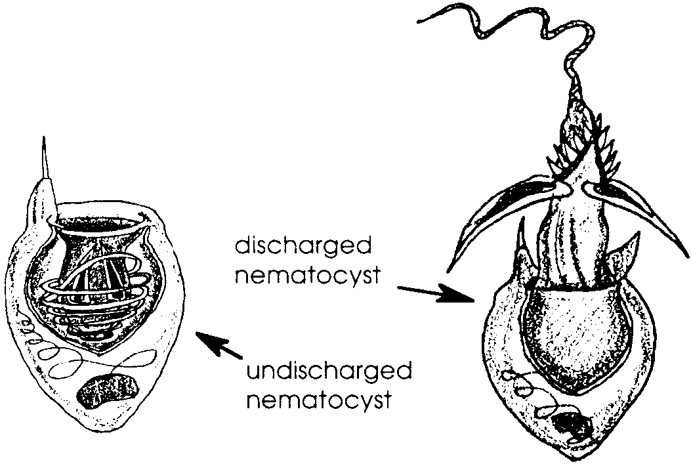
The firing mechanism is not well understood. It appears that chemical changes occur in the cell membrane that cause an inrush of water and greatly increased pressure. As a result, the lid is forced open, the tube turns inside out, and the entire nematocyst explodes to the outside.
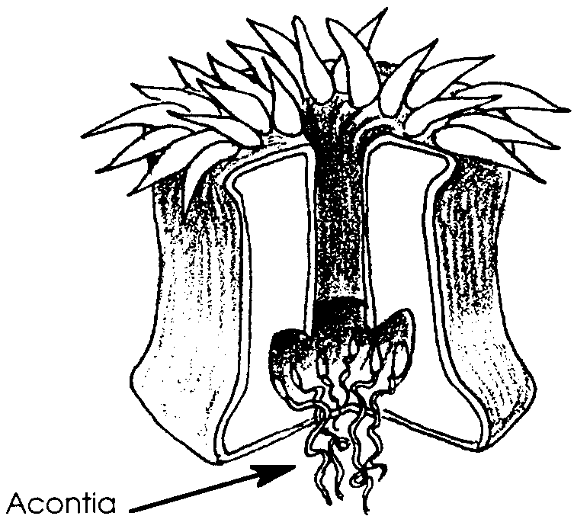
Lifeguards in Australia have tried alcohol, vinegar, meat tenderizer and a variety of other remedies in attempts to treat sting victims. In the activity that follows, you will have a chance to observe nematocyst firing and test various substances to see which might aggravate a jellyfish sting and which might reduce the firing of the stinging cells.
You will use a sea anemone as a source for stinging cells. The cnidoblast cells are far too small to extract by themselves, so you will need to collect acontia, thread-like structures that contain large numbers of cnidoblasts. The acontia threads hang inside the gastrovascular (stomach) cavity of most sea anemones.

These are the materials you will need to do this activity:
• sea anemone acontium
• compound microscope
• slide and coverslip
• depression slide
• 10% acetic acid
• methylene blue dye (optional)
• pin or dissecting needle
• eye dropper
• rubbing alcohol
• clam juice
• other substances available to test
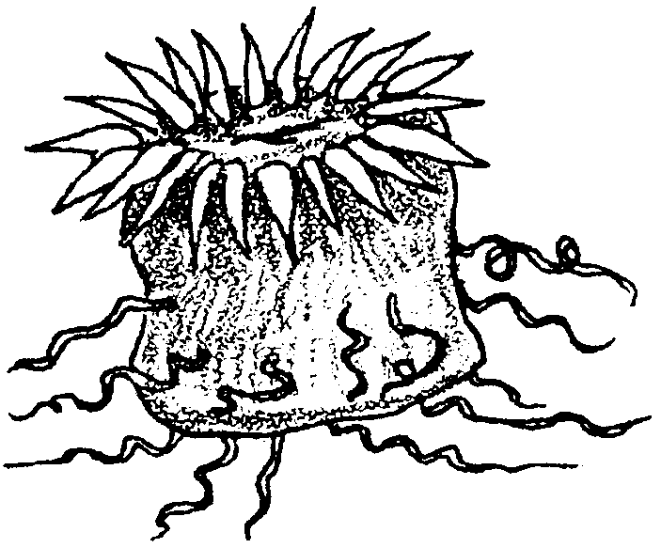
Getting Started: Observing an Acontium

1. Obtain an acontium from a sea anemone. The acontia will look like white threads. If the sea anemone has been recently removed from its substrate (the surface to which it was attached), you will find numerous acontia streaming from the animal. Otherwise, you can cause the sea anemone to eject acontia by gently squeezing it or poking it on the side with a pin or dissecting needle.
2. Mount the acontia in a drop of sea water on a depression slide. Cover with a coverslip and observe. Draw what you see in the space below:

Experimenting: What will trigger nematocyst firing?

3. Which of the following do you think will trigger nematocyst firing?

Stimulus Trigger firing? Why?
acetic acid (vinegar) yes or no?

touching the acontia yes or no?

clam juice yes or no?

rubbing alcohol yes or no?

what else would you like
to try? yes or no?

4. Place a drop of 10% acetic acid (with or without a pinch of methylene blue dye) along the side of the coverslip and watch for nematocyst firing. Draw what you see:

What is the effect of the acetic acid on the nematocyst firing?

5. Obtain a fresh acontia and place it in a drop of sea water on a slide. Do not cover with a coverslip. Using a pin or dissecting needle, touch the acontia as you watch through the microscope.

Does mechanical stimulation seem to have an effect on the nematocyst firing? If so, what is the effect? Draw or describe what you saw.

6. Repeat the procedure outlined in number 4 above. Introduce small amounts of clam juice. (Apply no mechanical stimulation as you observe through the low power lens of your microscope). Do the nematocysts discharge?

7. Repeat the procedure outlined in number 6 above, only substitute rubbing alcohol for the clam juice. Do the nematocysts discharge?

8. Obtain another acontia. Mount the acontia in a drop of sea water on a standard slide. Cover with a coverslip. Gently, but firmly, press down on the coverslip to squash the acontia.

Place a drop of 10% acetic acid along the side of the coverslip and watch for nematocyst firing.

Do nematocysts still discharge after the acontia has been squashed?

9. If you have the opportunity to test the effects of a substance of your choice on nematocyst firing, record in the space below what happened.

10. How wide is one of the nematocysts in microns? (Forget how to do this? Here are a couple of reminders: 1000 microns = 1 millimeter. How wide is the field of vision, or the circle of light you see through the microscope? Compare the size of the nematocyst to the field and estimate the nematocyst size).

11. How long is one of the nematocysts?
Analysis and Interpretation

1. Which of the factors you explored caused an increase in the number of nematocysts firing? List them below:

2. From your experimental observations, which, if any, of the stimuli would you use to slow or stop nematocyst firing in a person stung by jellyfish? Why?

3. How might nematocyst firing in response to mechanical stimulation help a sea anemone survive in the sea?

4. How might nematocyst firing in response to chemical stimulation help a sea anemone survive in the sea?

5. Look at the different solutions you used to cause nematocyst firing. Does there appear to be a relationship between the acidity of the solution and nematocyst firing? If so, what does the relationship appear to be?

6. Review how the nematocysts behaved after you squashed the acontium. Would you say that nematocyst discharge depends on a complex nervous system? Please explain.

7. What roles do nematocysts play in the life of jellyfish, sea anemones and their stinging relatives?

