The Shelled Animals—Mollusca
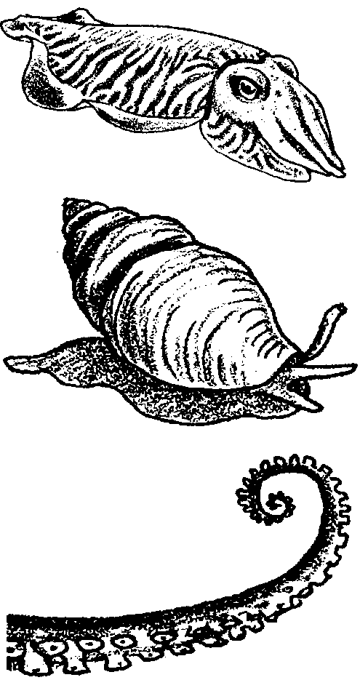

Key Concepts
1. The phylum Mollusca encompasses a diverse group of animals including snails, octopus, clams, sea slugs, limpets, mussels, oysters, scallops and pteropods.
2. Molluscs have a soft body and muscular foot, an advanced nervous system, and in most cases, a shell.
3. Scientists divide molluscs into five classes: Amphineura, Scaphopoda, Pelecypoda, Gastropoda, and Cephalopoda.

Background
The phylum Mollusca contains the clams, snails and octopods. The term “mollusca” comes from a Latin word meaning “soft”. As the name implies, molluscs are soft-bodied animals. They are bilaterally symmetrical with well-developed digestive, circulatory, respiratory and excretory systems. Many molluscs possess a calcareous shell. Most molluscs are slow-moving, crawling on their muscular foot. Notable exceptions are the swift cephalopods (octopus, squids, and the chambered nautilus). There is great variety in both form and function within the molluscs.
The molluscan body plan involves three main body regions: the head-foot, the visceral mass, and the mantle. The head-foot region is the locomotor and sensory portion of the body, upon which rides the visceral mass containing the excretory, circulatory, and digestive organs. The mantle, which secretes the shell, forms a fleshy cover over the visceral mass and a skirt around the foot. The gills are found in the mantle cavity. Note that, because the “gills” in bivalves and members of the Pelecypoda function in both respiration and feeding, they are often called “ctenidia” rather than “gills”.

Materials
For each student:

• One copy of “The Shelled Animals- Mollusca” student pages

Teaching Hints
For many students molluscs are the most familiar group of marine animals. You can use this familiarity to your advantage. Encourage your students to bring in their shell collections. Display these shells and pictures of the living molluscs that once inhabited them. Supplement the following material with appropriate audio- visual aids.
Later units in this curriculum include additional readings and laboratory activities about selected molluscs. In “Moving On” in Unit III: Tides and the Rocky Shore, students observe the structures and behaviors of a gastropod, such as a snail. “Burrowing and Burying” in Unit IV: Waves and Life in the Surf Zone examines the external and internal structures of clams. Paralytic Shellfish Poisoning is examined in the journal article “Shellfish and PSP” also in Unit IV.

Answer Key
1. The answers will vary depending upon the background experience of your students. Since the question is phrased “which ... do you think?”, any answer must be considered correct. This question is designed to make your students anticipate what is to follow and to look for a specific piece of information within the text. To answer the inevitable student inquiries, the class Gastropoda contains the greatest number of species.

2.
Common Name Class Univalve/Bivalve/Neither

Octopus Cephalopoda Neither

Oyster Pelecypoda Bivalve

Tusk shell Scaphopoda Univalve

Mussel Pelecypoda Bivalve

Periwinkle snail Gastropoda Univalve

Limpet Gastropoda Univalve

Giant gumboot chiton Amphineura Neither

3. An important observation used by taxonomists to place animals in the phylum Mollusca is the presence of a trochophore stage during larval development.

4. The similarities all molluscs share in larval development include a trochophore stage in which the mollusc possesses hair-like cilia which propel the larva and also sweep food into its mouth..

5. The mantle covers the visceral hump, secretes the shell, and forms the mantle cavity which contains the gills.

6. Other body parts one would find in most molluscs include: head, mouth, esophagus, stomach, intestine, gill, shell, and foot.

7. a. The incoming water carries oxygen which is important to all molluscs and food which is of importance to many molluscs (e.g., clams, oysters, mussels. Cephalopods, like the octopus, capture their own food).

b. The outflowing water carries away carbon dioxide and other wastes, the disposal of which is important to the mollusc.

8. Some of the structures which enable a chiton to live very successfully on wave-swept, rocky shores include: overlapping shell plates, a strong muscular foot, and the radula.

9. Since the scaphopods must move and extend tentacles to capture microscopic food organisms, you would expect to find more scaphopods in loose sand than in fine mud. The organism can move more readily in the sand. Tentacle operation is more difficult in mud.

10. Shells play many important roles. The most obvious role is protection from predators. They also function in camouflage, in protection from drying, in attachment for body parts and muscles, in food getting, in protection from wave pounding, etc.

11. In a pelecypod mollusc, water flows into the mantle cavity through the incurrent siphon. The water flows through the gills (ctenidia) within the mantle cavity and is then expelled through the excurrent siphon.

12. Many of the roles of shells mentioned above obtain. In particular, three ways shells help pelecypods survive include protection from predators, protection from crushing by the surrounding sand or other substrate, protection from drying, and as an attachment for body parts and muscles.

13. A scientist would place a newly discovered nudibranch in the class Gastropoda.

14. Torsion allows the head of a snail to be rapidly retracted into the shell. Torsion offers gastropods increased protection from attack, and has, thus, increased the survival chances of the gastropods.

15. A radula is a file-like, rasping mouthpart which is ribbon-like in structure and contains rows of serrations or teeth. A mollusc uses the radula like a scraper to file its food apart.

17. Structures and behaviors that make marine scientists think that cephalopods are the most highly developed molluscs include:
a. the possession of a large, differentiated brain
b. excellently coordinated movement
c. presence of well-developed eyes
d. rapid locomotor abilities.
e. sucker-bearing tentacles
Any two of the above will suffice.

18. a. The class Cephalopoda contains the most mobile molluscs.
b. Answers may vary. Cephalopods are predators.
c. Answers will vary.
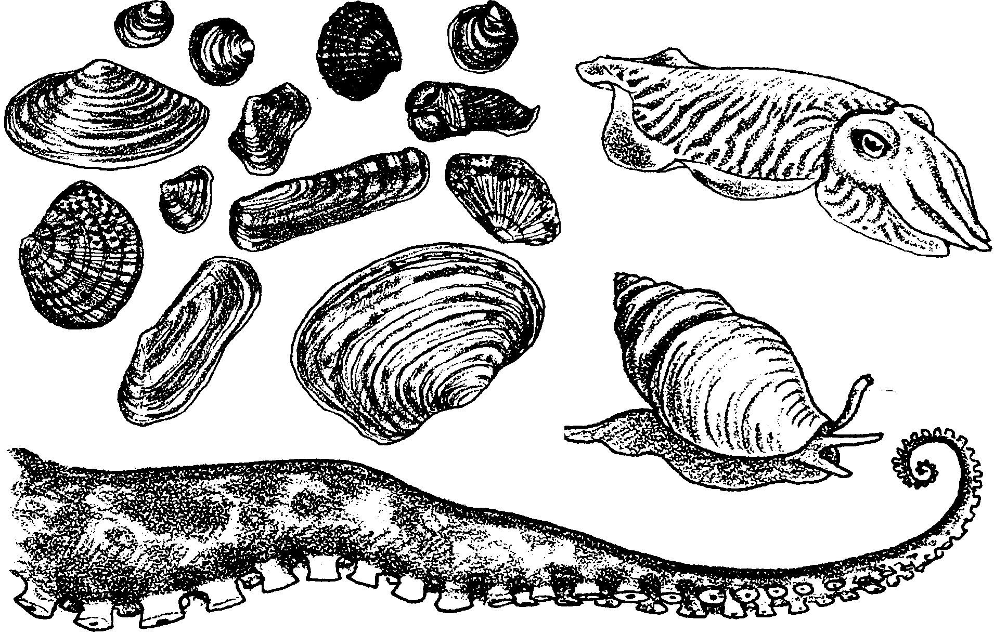
The Shelled Animals—Mollusca

Sea shell collections have made the phylum Mollusca the most familiar group of animals in the sea. Collectors travel to all parts of the world to find new molluscs. Over 80,000 living species of the phylum Mollusca have been described. Forty thousand of these are found in the sea, making this phylum the most abundant marine animal group.

There also is great diversity within the phylum. For example, both the clam and the octopus are classified as molluscs! This large group is subdivided into five classes:
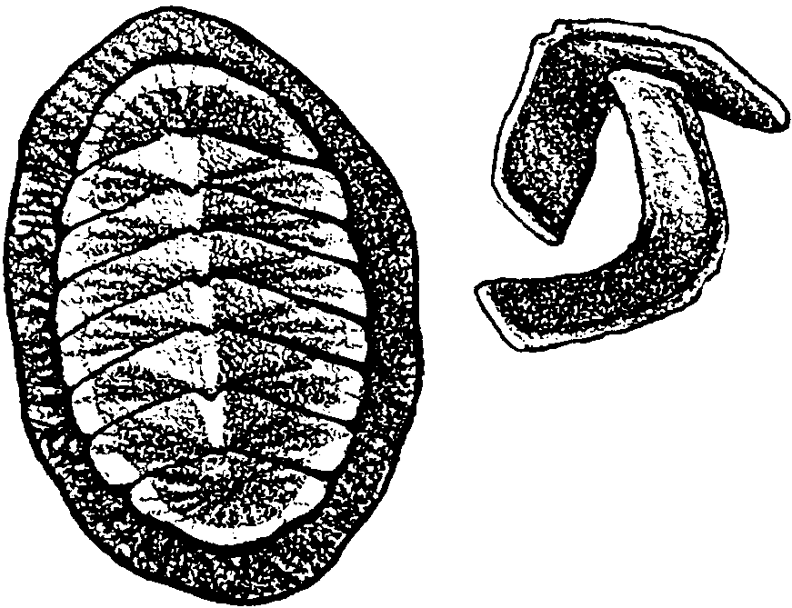
Amphineura - the chitons

Scaphopoda - the tusk shells

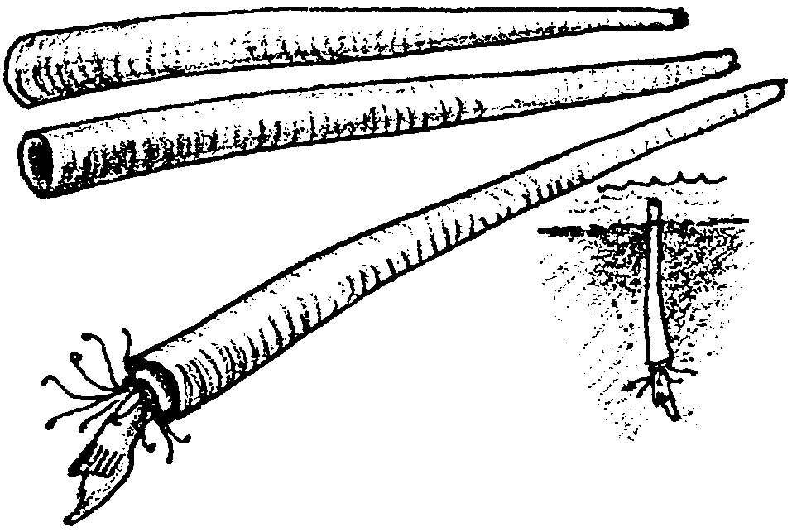
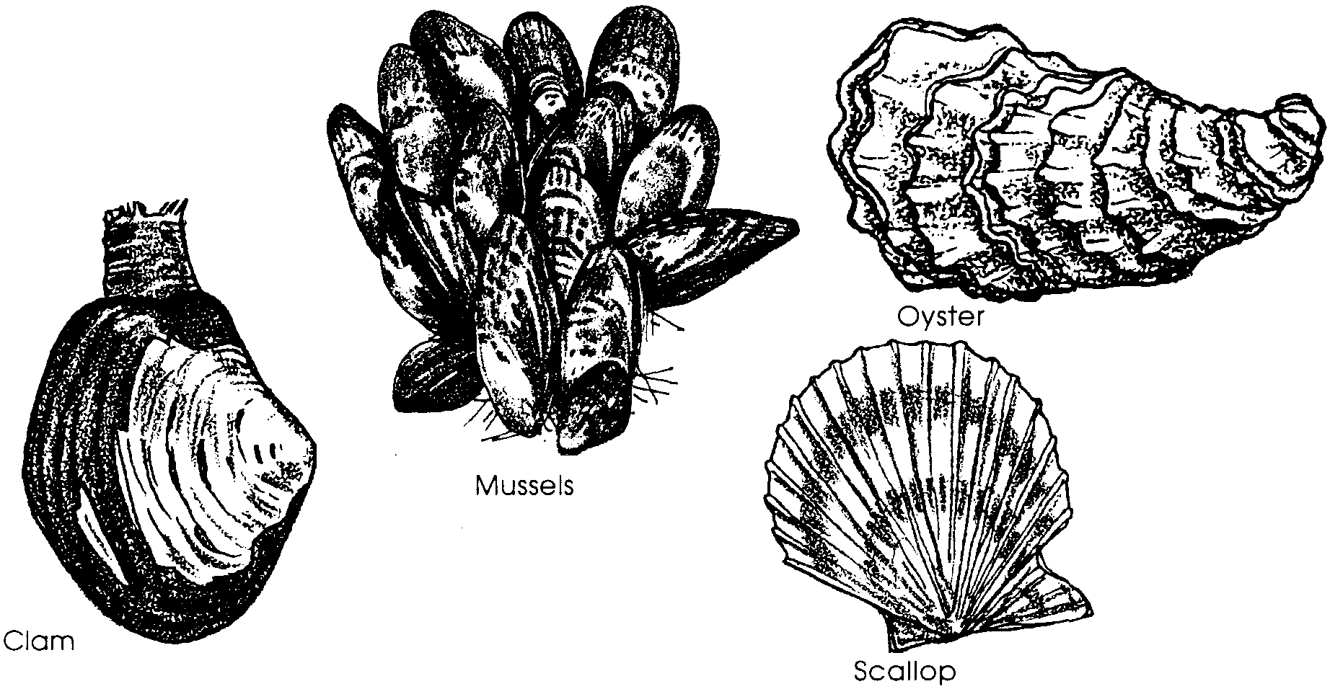
Pelecypoda - the clams, mussels, oysters and scallops

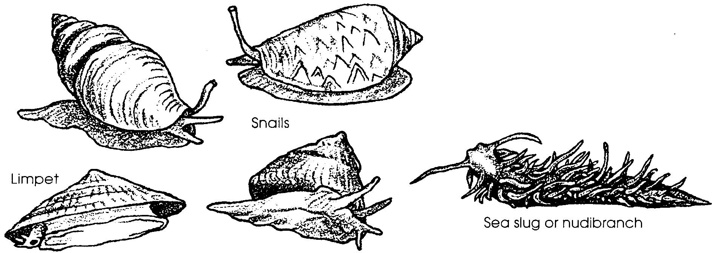
Gastropoda - snails, sea slugs or nudibranchs and limpets
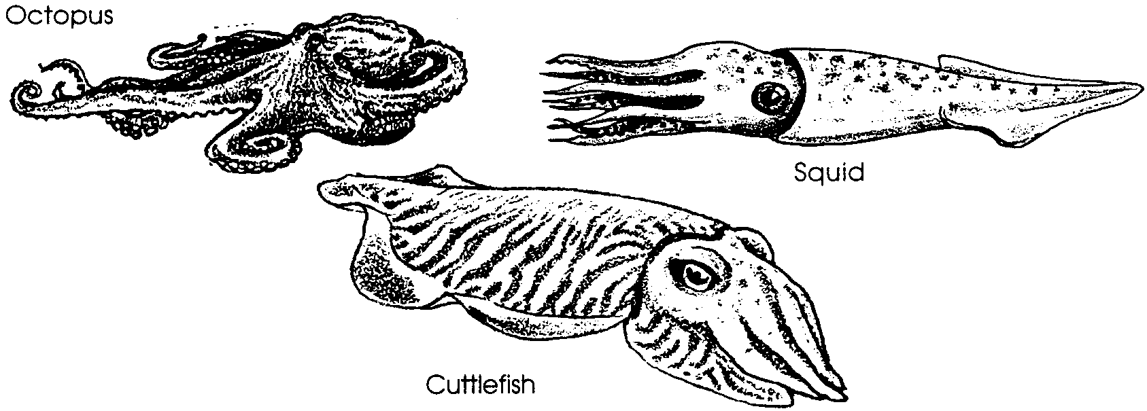
Cephalopoda - the octopuses and squids

1. Which one of the five classes mentioned above do you think has the greatest number of species?

2. Look at the drawings above and complete the following chart:

Common Name Class Univalve/Bivalve/Neither

Octopus

Oyster

Tusk shell

Mussel

Periwinkle snail

Limpet

Giant gumboot chiton

Octopus, clams, snails, and squids certainly do not look very much alike. Why have biologists placed these different animals in the same group? In placing animals into groups, taxonomists look for similarities in development as well as for similarities in appearance.
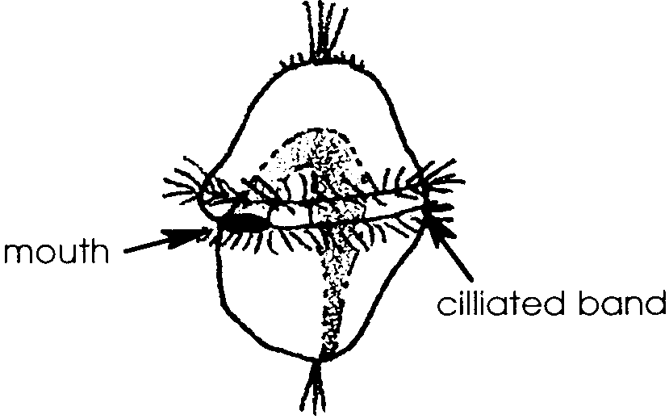
Animals classified as molluscs go through a stage of larval development in which they look the same. The larval forms of marine molluscs, called trochophores, are drifting zooplankton. The trochophore larva shown below is typical of marine molluscs. The hair-like cilia propel the larva and also sweep food into its mouth.

3. What is one observation taxonomists use to place animals in the phylum Mollusca?

4. Describe the similarities all molluscs share in larval development.

The body of an adult mollusc has a head, a foot, and a visceral (VISS-uh-rul) hump. Inside the visceral hump are the digestive organs, excretory organs, and the heart. The visceral hump is covered by a mantle. The mantle is a thin skin that in most species secretes the calcium carbonate shell. The mantle hangs down over the sides and back of the body, forming a space called the mantle cavity. Undigested materials go from the anus into the mantle cavity before passing out of the animal.
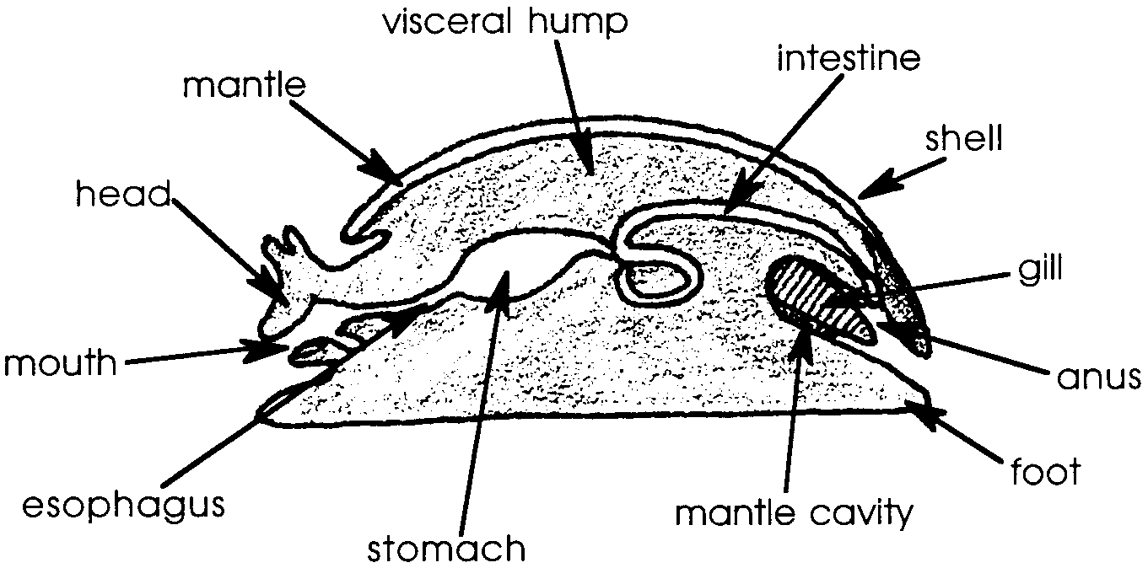
The gills are also in the mantle cavity. They are the respiratory organs of the aquatic molluscs.

5. What are two functions that the mantle performs?

6. The basic body plan of molluscs consists of:
• a muscular foot,
• a mantle containing the internal organs and,
• in most molluscs, one or more shells or a remant of a shell.

What other body parts would you find in most molluscs?

In most molluscs, a current of water flows through the mantle cavity. The water carries in oxygen and food, and carries away carbon dioxide and other wastes. Water flows into the cavity through an opening called the incurrent siphon. The water circulates over the gills and through the mantle cavity, where it picks up the carbon dioxide and wastes then exits through the excurrent siphon.

7 a. What substances does the incoming water carry that molluscs need?

7. b. What substance does the outgoing water carry?

The type of shell or shells or the absence of shells and the type of muscular foot are also characteristics used to divide the molluscs into the five classes.

Amphineura

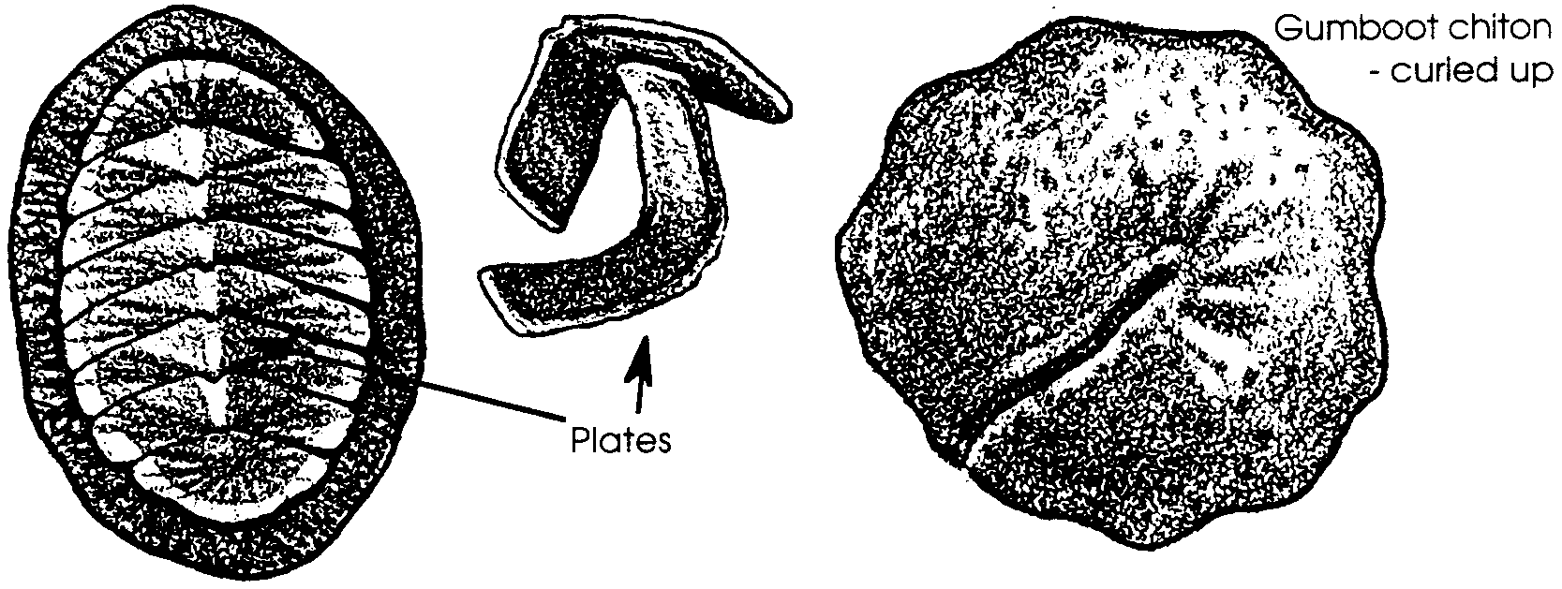
The class Amphineura includes chitons. They have eight partially overlapping plates lining the dorsal (back) surface of the body. The muscular foot of these molluscs is broad and well-adapted for clinging to rocks.
Chitons thrive in the clear waters of the rocky shores where currents are swift and wave action vigorous. Their shell plates can withstand the waves and their strong foot secures their hold in currents. The water movement also provides abundant oxygen and sweeps away particles that might clog the chiton’s gills.
Chitons eat by using a tongue-like belt called a radula to remove algae and detritus (dead and decaying material) encrusted on rocks. The radula is covered with tiny teeth made of calcium carbonate or other materials. (The giant gumboot chiton has radula teeth made of iron!) The chiton scrapes the rocks with the sharp and durable radula and swallows the bits of food the teeth loosen.
Adult chitons seldom reach a length longer than two inches. The gumboot chiton, found on the West Coast of the United States, is the largest of all chitons and can grow to a length of 12 inches.

8. What structures enable a chiton to live very successfully on wave-swept, rocky shores?

Scaphopoda

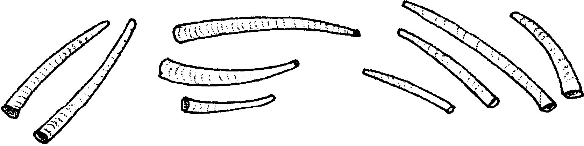
The class Scaphopoda contains about 200 species of burrowing marine molluscs. These are the tooth or tusk shells. The shell is an elongated cylinder shaped much like an elephant’s tusk. Northwest coast Indians used these shells as money because of the shell’s attractive appearance and its relative scarcity.
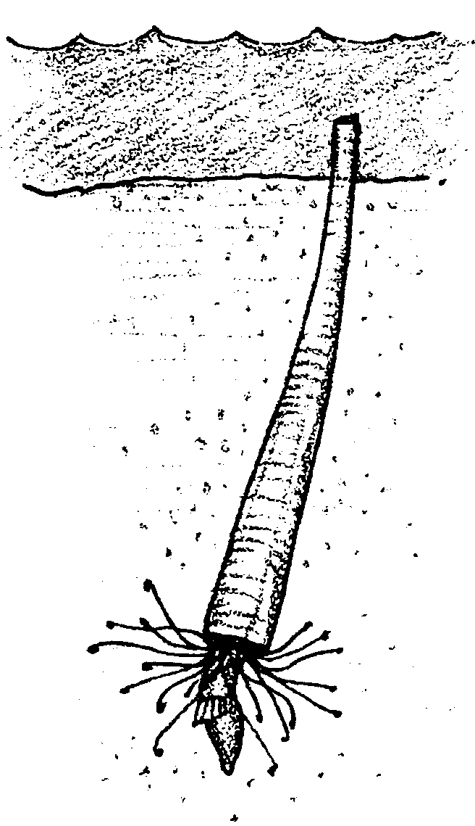
The shells, which are open at both ends, average 25 to 50 millimeters (1 to 2 inches) in length. The body is greatly elongated and the head and foot project from the larger opening of the shell. These animals burrow head down in sand or mud leaving only the posterior tip of the shell above the sand. Water is drawn in and expelled through the opening in the posterior tip of the shell. Oxygen and some food is drawn in with the water. Using thread-like tentacles, scaphopods capture microscopic food organisms from the sediment surrounding them. These tentacles must move through the spaces left between the grains of sediment. The looser the sediment, the easier the scaphopod can move to obtain its food.
The majority of scaphopods live burrowed in sediment under water ranging in depth from 6 to 1830 meters (about 20 to 5,500 feet). As a result, humans rarely encounter living animals. Judging from the number of shells washed up on beaches, however, scaphopods are not rare animals.

9. Considering the way that the scaphopods capture their food, do you think more scaphopod species would be found living in fine mud or in looser sand? Why?
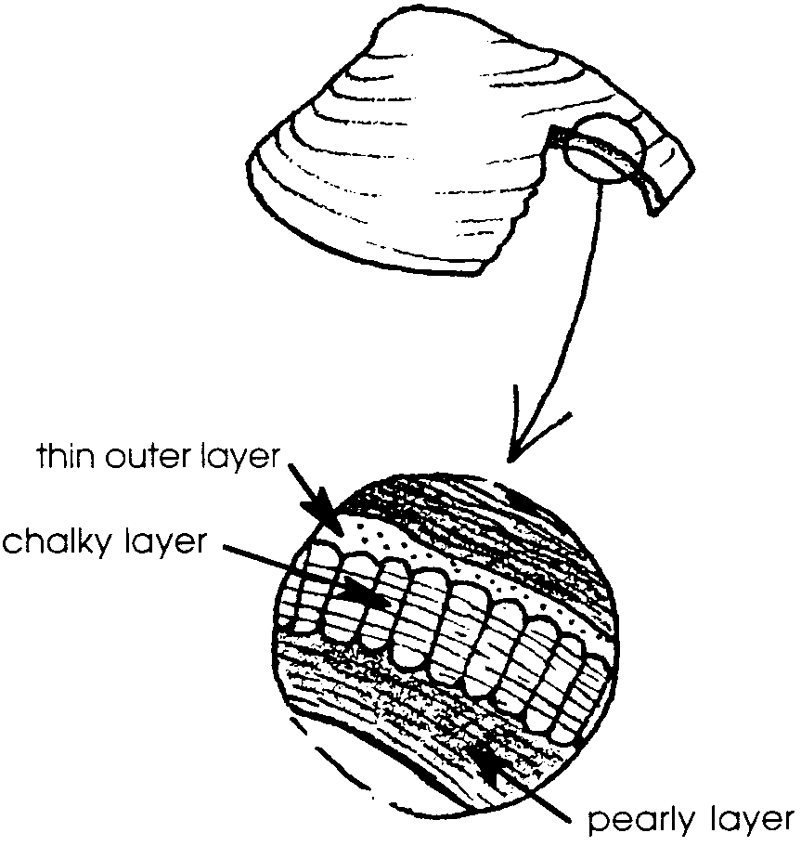
Pelecypoda

Molluscs like clams, oysters, scallops and mussels are called bivalves because their shells have two halves or valves. Bivalve molluscs belong to the class Pelecypoda. A hinge connects the two shells so they can be opened and closed by the animal. The shells are chalky structures made of calcium carbonate (lime) and other materials secreted by the mantle. There are three layers: an inner, pearly layer next to the mantle, a central chalky layer, and a thin outer layer (sometimes hard to identify) made of the same material as the hinge.

10. Shells play a number of different roles in the life of marine molluscs. What are two ways in which shells are used to help marine animals survive?

Pelecypoda means “hatchet footed”. The hatchet shaped, muscular foot helps the molluscs quickly dig into mud or sand. Many members of this class spend most of their lives partly buried. The valves are kept slightly apart and two siphons are extended into the water. Water flows into the mantle cavity through the incurrent siphon. The water flows through the gills before it is expelled through the excurrent siphon. The gills remove dissolved oxygen from the water and release carbon dioxide.
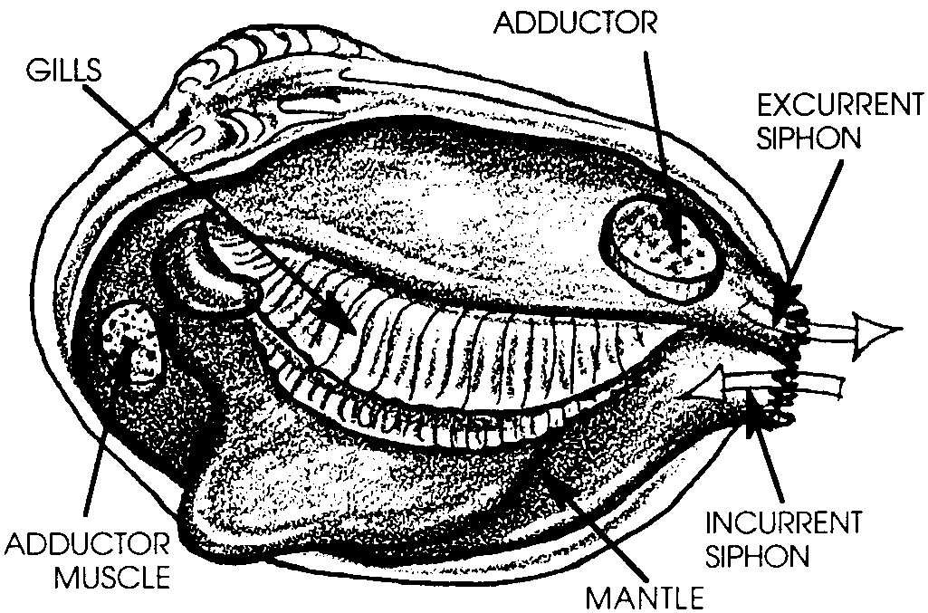
The gills also serve another important function. The gills are covered with a thin layer of mucus which traps small food particles. Cilia on the surface of the gills carry the food-bearing mucus to the mouth. These mucus-feeders feed on dead and decaying organic matter and the many microscopic plankton found in the siphoned water.
11. Describe the path of water flowing through a pelecypod mollusc.

12. Think about all of the dangers pelecypods might face. What are three ways shells help pelecypods survive?

a.

b.

c.

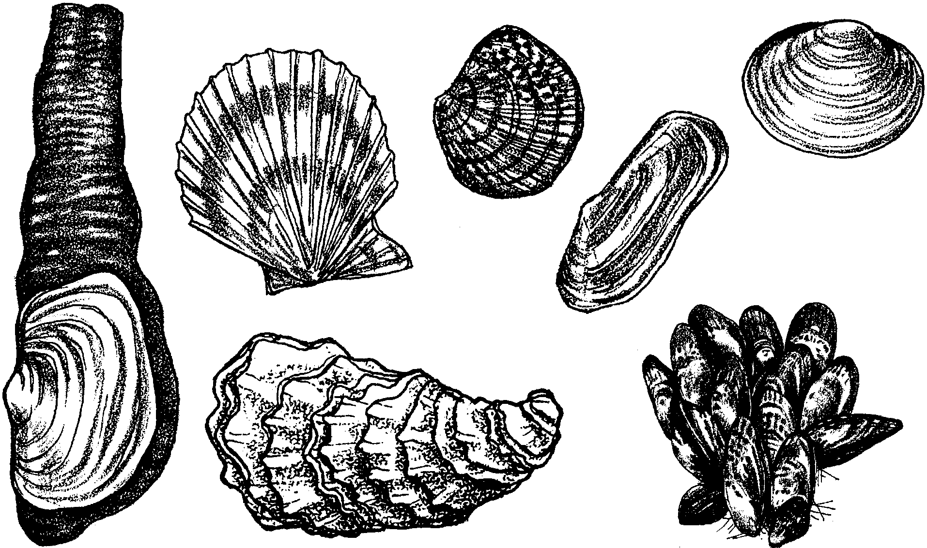
Many bivalve molluscs are important as food. Clams, oysters, scallops and mussels are all harvested in great numbers. Many of these species are cultivated by humans and serve as the basis for thriving industries.

Gastropoda
The most successful group of marine molluscs is the gastropods, the snails, sea slugs (or nudibranchs), limpets, and abalones. There are over 28,000 species of marine gastropods. Most of these animals have only one shell (univalves). Some have no shells.
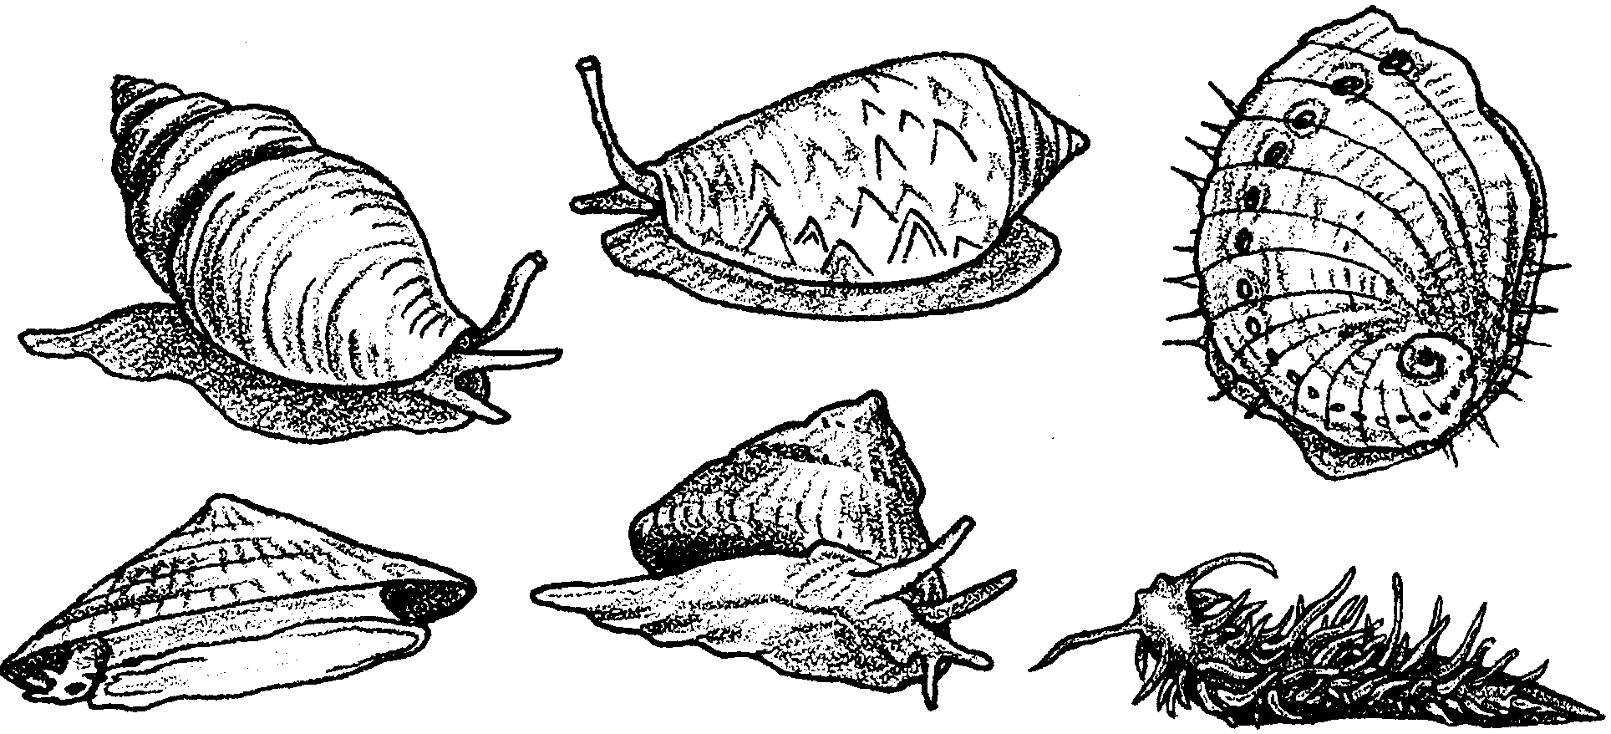

13. In which class would a scientist place a newly discovered nudibranch?

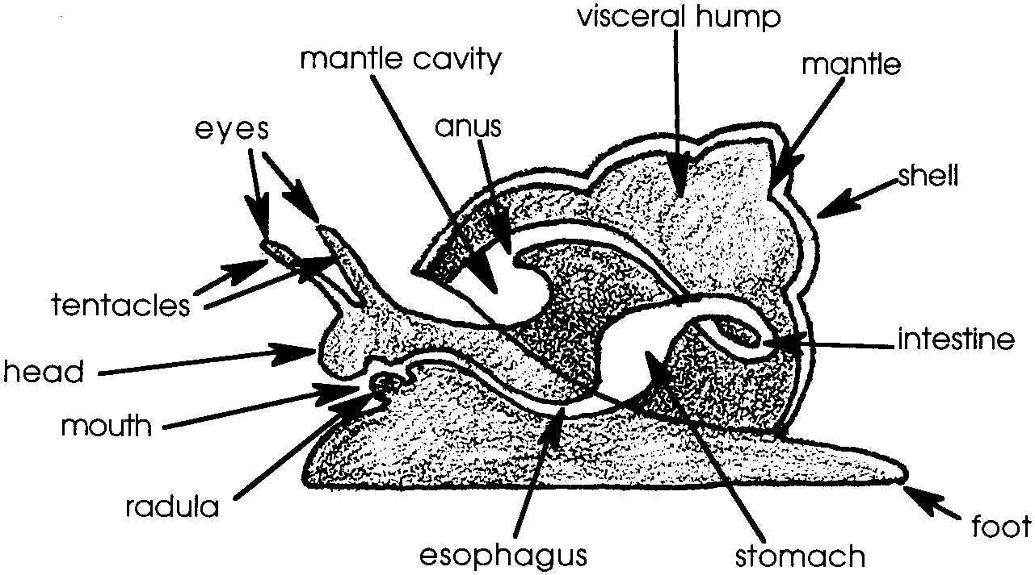
All gastropods possess a flat, muscular foot used for creeping. Most gastropods are slow travelers with a top speed of about three meters an hour. Gastropods also have a head, usually with tentacles and eyes.

This group of molluscs, like the chitons, possesses the rasping, tongue-like structure called the radula. The word "radula" comes from a Latin word meaning scraper. The ribbon-like oral structure contains rows of serrations or teeth which the gastropod uses to file its food apart. The teeth on the radula of gastropods, like the radula teeth of chitons, can be made of a variety of materials. Some limpets, for example, have a radula with teeth made of opal.
Sometime during the embryonic development of all gastropods torsion occurs. Torsion is a 180¡ rotation of the internal organs. This rotation results in the anus, the gills, and the mantle cavity (all originally at the rear) all being located immediately behind the head. The most widely accepted theory to explain the survival importance of torsion was advanced many years ago by the biologist Garstang. Garstang maintained that torsion allows the head to be rapidly retracted into the shell. This retraction of the head offers the gastropod protection from attack.

14. How has torsion increased the survival chances of gastropods?
Cephalopoda
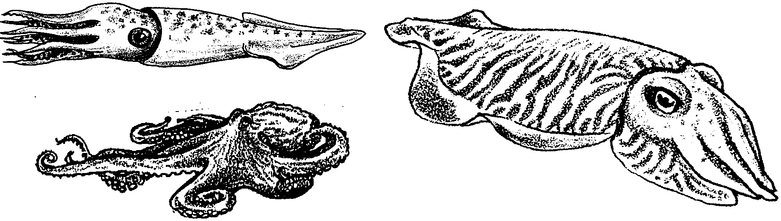
Octopus, squid, cuttlefish, and chambered nautilus belong to the Cephalopoda, or "head-footed" molluscs. Cephalopods are the most highly developed molluscs and may even be the most highly developed invertebrates.

The head of these molluscs is well developed and contains a large, differentiated brain. This complex nervous center allows the animals to be extremely active. Well-developed eyes, similar to the human eye, are present. With the notable exception of the chambered nautilus, most cephalopods have no external shell. Instead, they have an internal rod, or pen, which supports the body, or they have no support at all as in the octopus.
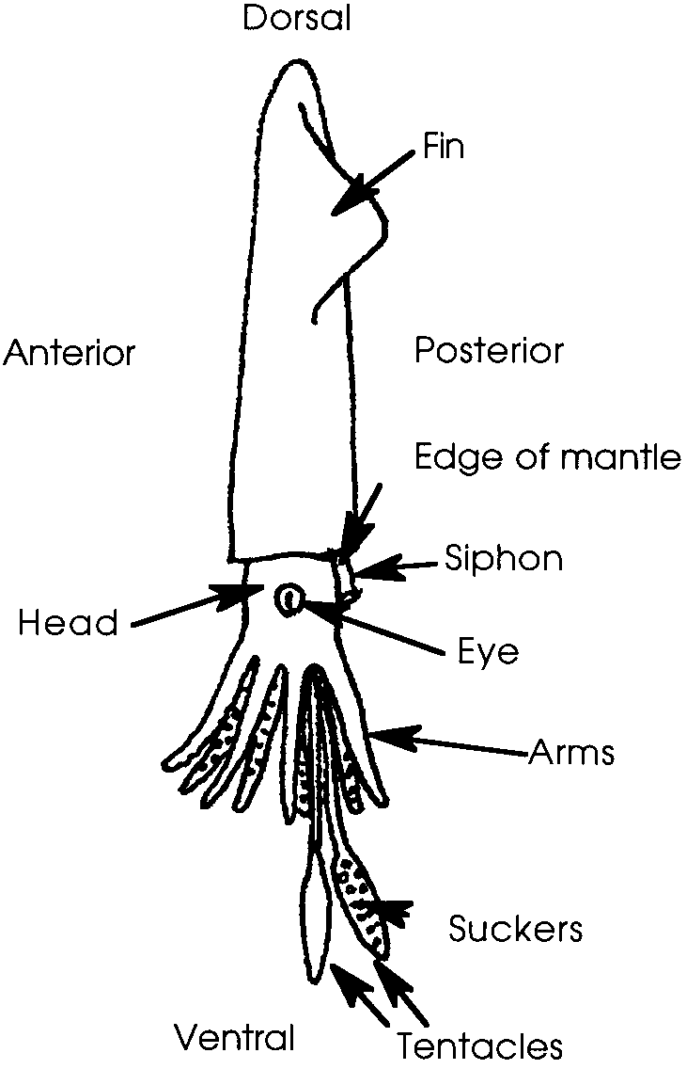
Cephalopods possess a siphon through which water can be expelled with great force. This stream of water propels the animal forward or backward in a jet-like manner. Some members of this group have fins, which enable the animal to swim in a fish-like fashion.
The mouth is surrounded by eight or ten sucker-bearing tentacles used for gathering food and for reproduction. A strong, parrot-like beak, frequently covered with a toxic mucus, is present in the mouth for grasping food. Immediately behind the beak is a file-like radula which is used to grind through shells.

15. What is a radula and how does a mollusc use it?

16. Which three classes of molluscs possess a radula?

a.

b.

c.

Cephalopods have an ink sack located inside their mantle. When threatened, they can discharge a cloud of black, inky fluid that hides their escape from enemies.
In spite of its reputation, the octopus is usually a timid animal. The largest octopus is found along the Pacific Coast. Its body can grow to a length of about 30 centimeters (about 12 inches). Its long slender arms, however, can give the octopus an overall length of five meters (about 18 feet)! Much larger, the giant squid is probably the largest invertebrate in the world. It may grow to be eighteen meters long (about 58 feet) and weigh 1,800 kilograms (about 3,960 pounds). Sucker marks from these giants are often seen on the skin of deep diving toothed whales.

17. List two structures or behaviors that make marine scientists think that cephalopods are the most highly developed molluscs:
a.

b.

Molluscs play a variety of ecological roles in the life of the sea, from scavenger to predator. Their diversity, abundance, and large range (where they are found) make the molluscs one of the most important groups of sea animals. Molluscs also play a large role in human interactions with the sea. Many of the animals we call shellfish are molluscs. For example, we harvest clams, oysters, mussels, abalone, squid, and octopus. Many of the animals classified as molluscs also provide the most realistic hopes for "sea farming" or mariculture. The many members of the phylum Mollusca are both ecologically and economically important.

18 a. Which class contains the most mobile molluscs?

b. This same class contains some of the most intelligent animals in the sea. They have well-developed eyes. Most have similar feeding styles. Would you guess that these molluscs are filter feeders, predators, or detritus feeders?
Why do you think so?

c. Think a bit more about these molluscs. How are mobility, intelligence, good eyesight, and feeding style linked together in the animals in this class?

