Meanwhile, In the Pacific...
Where Did the Polynesians Come From?
Lesson by Neil Glickstein, Waring School
Beverly, Massachusetts

Introduction written by Mike Vollmert, Hueneme High School
Oxnard, California

Key Concepts
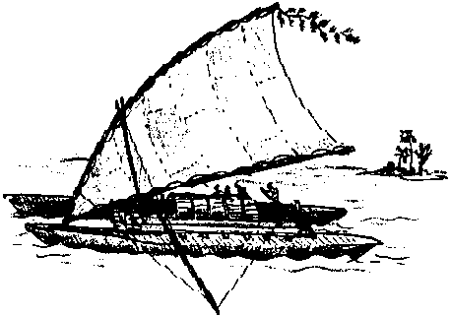
1. The ancestors of today's Polynesians embarked on a period of maritime colonization greater in scope and considerably earlier than any of the Western European voyages of discovery.
2. The migration of populations may be traced using a variety of forms of evidence.
3. Wind and ocean currents are logical starting places in the investigation of human migration patterns.
4. The presentation of information affects the degree to which it is believed. In a conflict of opinions, emotional appeal can overshadow compelling evidence.

Background
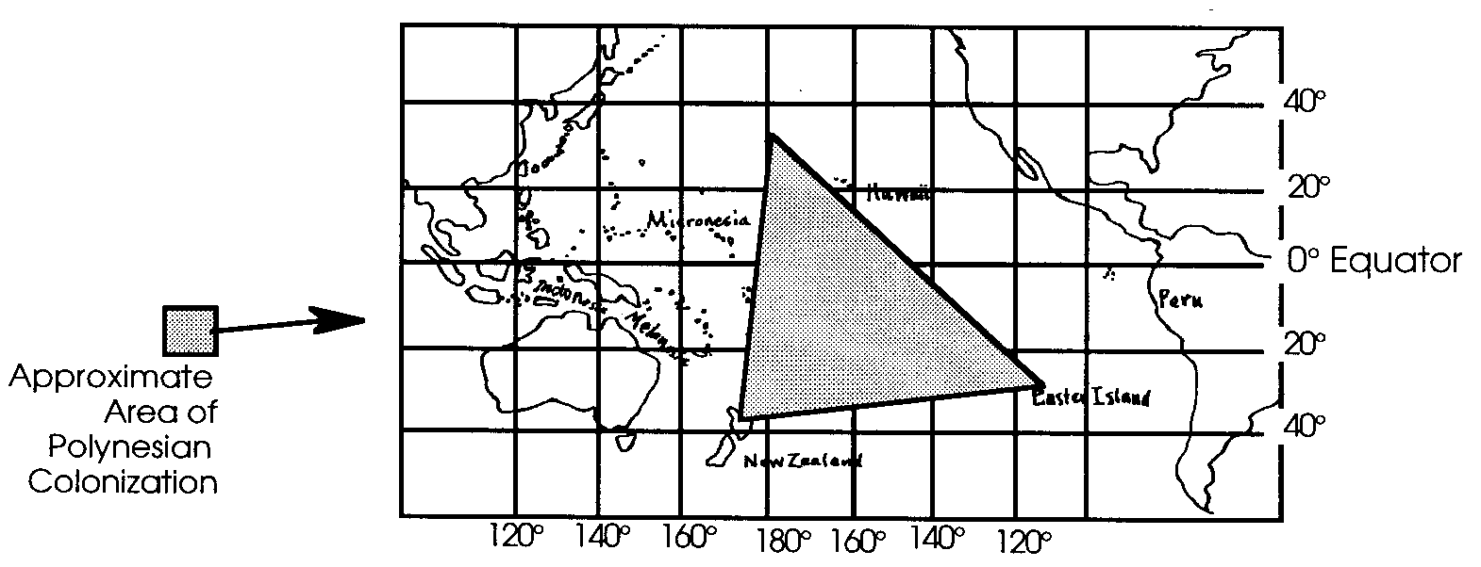
While the development of western civilization was progressing in Europe, the Mediterranean, and Atlantic, a different history, equally remarkable and arguably more intriguing, was developing in the South Pacific. That history was the populating of Pacific islands by the Polynesians. Theories vary as to exactly how the process took place, but it is known that Tonga was occupied by 1140 B.C., eastern Polynesia by 400 A.D., and western Polynesia by 1000 A.D.
Eventually, Poynesian explorers traveled as far east as Easter Island.
For this colonization to be possible, it was necessary for people to be able to voyage over very long distances, over open ocean out of the sight of land, with tremendous accuracy. Imagine trying to make landfall, with no instruments, when the landfall for which you are aiming is only a couple miles across, and you must travel 1000 miles to get there!
It is now clear that Polynesians were able to navigate skillfully at all points of sail; they didn’t just drift with currents. They were able to voyage long distances across the Pacific without the use of compass, chart, sextant, or chronometer. Europeans at this time didn’t sail out of the sight of land, because they, too, didn’t have very good instruments. But they, unlike the Polynesians, didn’t have the knowledge or skill to navigate without them.

Materials
For each student:
• Kon-Tiki, by Thor Heyerdahl
• ‘The Peopling of the Pacific’, “Scientific American”, (1988 vol 243 no.5 p174-185) by Peter Bellwood. “Scientific American” articles cannot be included in the CD ROM version of the FOR SEA Guide. Please check your local library.
• “Kon-Tiki” student pages
• “The Peopling of the Pacific” student pages
• “What Do You Think?” student pages

Teaching Hints
“Meanwhile in the Pacific” is an examination of efforts to determine where the original Polynesians came from and how they got to the islands. The lesson is divided into two parts. Part 1 is a comparison of theories about the origins of the Polynesians described in Kon-Tiki, by Thor Heyerdahl, and ‘The Peopling of the Pacific’, “Scientific American”, by Peter Bellwood. The voyagers in Heyerdahl’s explanation of the colonization of the Pacific left their fate to natural forces, floating to their destinations. By contrast, Bellwood argues that the ancestors of today’s Polynesians must have been skilled navigators and sailors with the knowledge necessary to travel east out of sight of land against prevailing wind and currents. Part 2 of “Meanwhile, in the Pacific...” includes two articles that describe modern voyages using Polynesian navigation. The first is “The Sons of Palulap: Navigating Without Instruments in Oceania,” by S.D. Thomas. The second is “Nainoa Thompson and the Lost Art of Polynesian Navigation,” Oceans, by Robert J. Hutchinson.

Part 1

In this lesson students analyze and compare two readings. Kon-Tiki by Thor Heyerdahl is a very readable sea adventure which is well within the reach of most secondary students. It documents a raft trip from the coast of Peru to eastern Polynesia by six young men to prove that such a trip was possible. It was undertaken to debunk the proposition that the islands were well out of range of early American sailors. Heyerdahl believed fervently that today’s Polynesians descended from American ancestors. His theory has never gained much favor among the international scientific community and today remains as discredited as it was before the voyage.
Peter Bellwood’s article, “The Peopling of the Pacific”, is written in the detached manner of “Scientific American”. Reading it typically presents students with a challenge. Though Bellwood’s review of the data on linguistic origins, agricultural necessities, similarities in social systems and development of stone tools, all of which is supported by a trail of distinctly stamped and incised Lapita pottery shards, is clearly presented, it is dry and requires an effort on the part of the reader.
The lesson allows for an analysis of each reading and encourages an ongoing discussion among class members concerning how one comes to believe an idea and how one sorts out conflicting evidence. Each student will make progress in assessing the importance of the presentation versus the substance of information when choosing what to believe.
The lesson also serves as an introduction to activities in the next unit, Unit 2- Ocean Currents. As students study Kon-Tiki and “The Peopling of the Pacific,” they will begin to learn about the patterns of ocean currents. They also will make their first acquaintance with ocean-going jellyfish, plankton, fish, sharks and whales.

Procedures:

Note: This interdisciplinary, ocean-oriented lesson integrates geography, oceanography and Pacific history, culture and archaeology. It is designed to accommodate a variety of approaches and should be personalized to meet the needs of individual classes and teachers.

The following is a suggested lesson plan.
1. Explain to the students the mystery they will be attempting to solve in this lesson: Where did the ancestors of the Polynesians come from?

2. Share with the students the key concepts for the lesson, rephrased here as questions, so that the students understand the goals of the activity and its place in the curriculum.

a. Western European voyages of discovery are well documented in books. What can we learn about the earlier and farther reaching voyages of the ancestors of the Polynesians?

b.What kinds of evidence could we use to trace past human migrations to new living places?

c. If you could observe the earth’s oceans from space, one pattern you might notice is great global wind and ocean currents. How might these currents have shaped where humans live?

d. How do we use evidence and the way evidence is presented to decide what we believe is the truth?

3. Provide students with copies of Kon-Tiki and copies of the student pages, “Kon-Tiki.” Have each student or student team develop a notebook with their notes and responses to the questions listed in the student pages.

4. Add variety to the students’ study with audio-visual materials. These will help provide images for the students of the places, people and marine life about which they are reading.

5. Pause for class or small group discussions. Find out what the students are thinking so far.

6. When students have completed Kon-Tiki, distribute copies of the article “The Peopling of the Pacific” and the student pages for “Peopling of the Pacific.” Have the students study this article and answer the study questions in their notebooks.

7. Now ask the student to decide what they think. The student pages, “What Do You Think?”, provide questions to focus students’ thinking. You may wish to have student teams debate the merits of the conflicting theories they have studied. Students may create notebooks, posters or other presentations to share their conclusions. You may choose to return to the key concepts presented at the beginning of the lesson and ask the students to write or discuss answers. In your discussions, be sure to focus on the question: What have they learned as they have done this activity?

Key Words
anthropologist - a person who studies cultures
archaeology - the study of artifacts and ancient cultures
chronometer - an accurate timepiece, used in navigation
ignominiously - less than glorious, shamefully
leeward - down wind, or down current
sextant - a device used to measure the angle of a star relative to the horizon, used in navigation
Southern Cross - a major constellation in the Southern Hemisphere, similar in significance to the Big Dipper in the Northern Hemisphere

Extensions
1. Have students write two simulated log entries as if they were part of the crew aboard the raft. Have them include weather and ocean descriptions, observations of crew members and personal feelings in the style of Heyerdahl. Encourage them to be creative while remaining within the constraints of the raft.

2. Have students make three drawings of significant events described in the text. This is an opportunity for students to show how they envision what they have read.

3. Consider having students write a book review article for their local newspaper. Ask them to include a description of the plot and style along with their opinion of Kon-Tiki as a piece of literature and as a work of science.
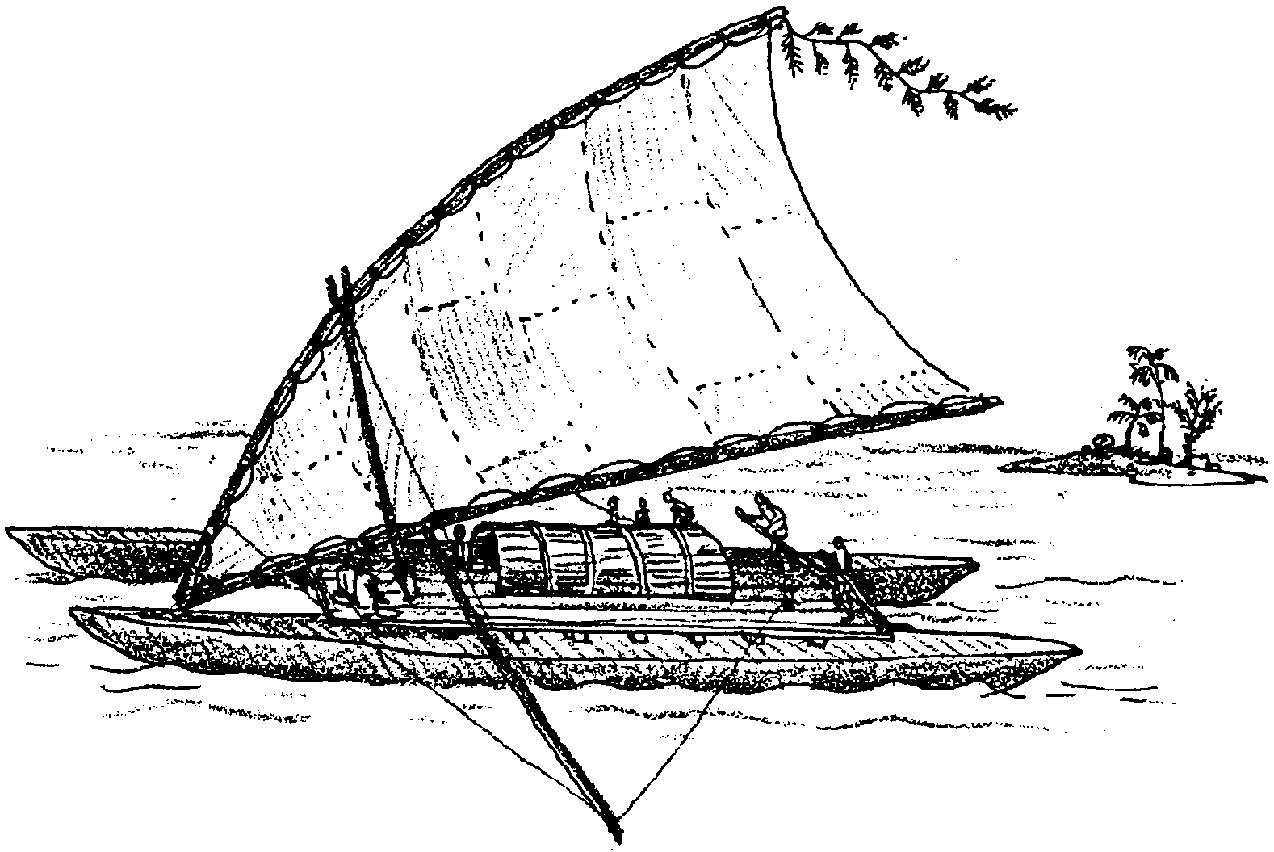
Meanwhile In the Pacific...
Where Did the Polynesians Come From?

While Europeans and Arabs were fighting wars and pioneering new trade routes, cultures halfway around the world in the Pacific Ocean were colonizing the islands that now make up Polynesia, Micronesia and Indonesia. In this activity, you will try to solve the mystery of the origins of these seafaring peoples.
There exist two theories about the origin of the Polynesians. Each is supported by evidence you will analyze. Your task will be to answer the question: Where did the ancestors of the Polynesians come from? Keep this important question in mind to focus your reading and discussions.

Theory 1: Kon-Tiki: A case for the migration from South America to Polynesia.

Thor Heyerdahl, a scientist from Norway, proposed the theory that the ancestors who settled the Pacific islands sailed from South America. In an attempt to prove that such voyages were possible, Heyerdahl and five other crew members sailed a raft from South America to Polynesia. They named their craft “Kon-Tiki”. Heyerdahl describes the expedition in his book Kon- Tiki. You will have an opportunity to read and study Heyerdahl’s adventures, his theory, and his evidence.
I. Point of View
As you read Kon-Tiki, answer the following questions.

A. What is Heyerdahl’s hypothesis?

B. What is his background and training?

C. Why is he taking the raft trip?

D. What was going on in the world in 1947?

E. What did people in Europe and the United States know about the Pacific in 1947?

F. Why did Heyerdahl write this book?

a. Is there a hidden agenda?

b. Who is he writing for?

c. Account for the sale of 20 million copies of this book.

G. Are Heyerdahl’s ideas revolutionary or evolutionary?

II. The Voyage

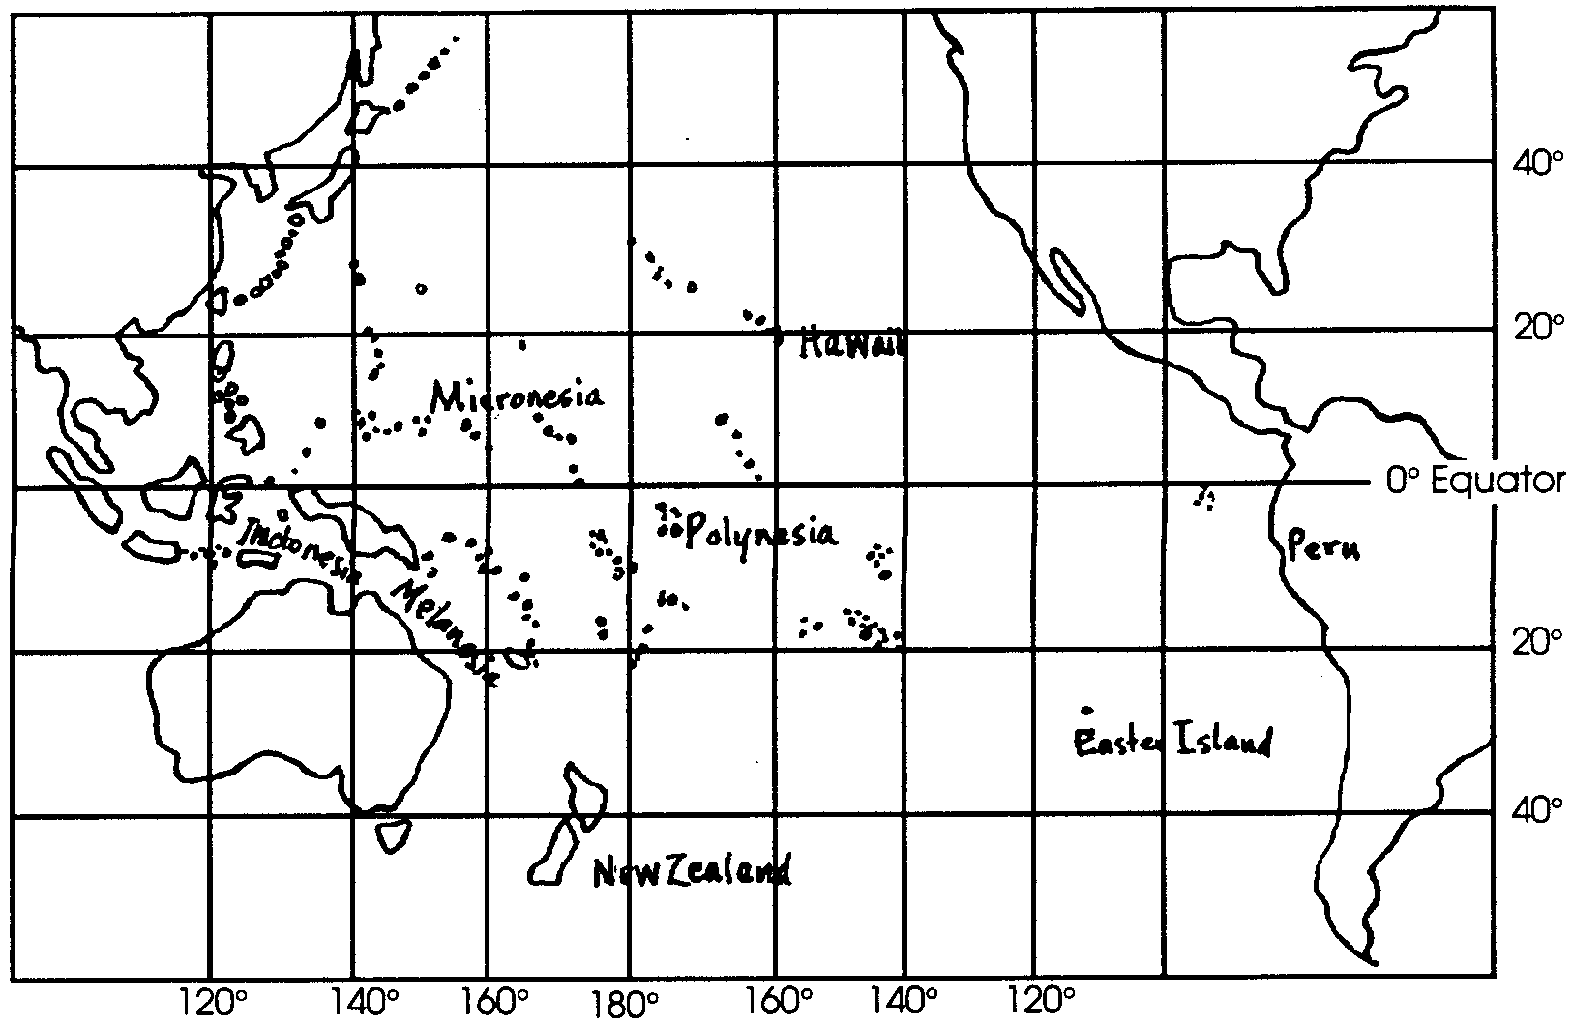
A. On the map of the Pacific Ocean circle Indonesia, Melanesia, Micronesia and Polynesia. Describe the geography of each in a few sentences.

B. Locate the places described in the book on this map and record the latitude and longitude of each.

C. Draw and label on the map the ocean currents discussed. What are the specific characteristics of each?

D. How did changes in the weather affect the voyage? Which way did the wind blow from? Where did the storms come from?

E. Marine Life

1. Make a list of all the marine organisms observed or caught.

2. Describe interesting and significant behaviors of these animals.

3. Construct a plausible food chain for these organisms.

4. Describe how the crew used these organisms as indicators.

F. Record how Thor Heyerdahl’s feelings about life on the raft changed during the trip.

G. List the data and evidence that Heyerdahl invokes to support his theory. Describe why each point is significant in his argument.

Theory 2: “The Peopling of the Pacific”: A case for the migration from Southeast Asia to Polynesia.

Another theory about the origins of the Polynesians argues that the ancestors sailed from Southeast Asia instead of from South America. This theory is summarized in the article, “The Peopling of the Pacific”.

I. Point of View
As you read this article by Peter Bellwood, answer the following questions:

A. What theory does Bellwood subscribe to?

B. What do you suppose his background and training is?

C. Why did he write this article?

1. Is there a hidden agenda?

2. Who is he writing for?

3. How widely read do you suppose this article is?

D. Does Bellwood present his ideas as a statement of fact or as part of an evolution of thought?

II. The Colonization Voyages
A. Locate the places described in the article on the map and record latitude and longitude.

B. Draw and label on the map the major ocean and wind currents which would have affected the migrations described. Would they be a help or a hindrance?

C. Draw lines on the map to indicate major colonization advances and approximate dates.

D. Construct a time line with the data presented by Bellwood. Begin 40,000 years ago and come up to the present. Note each important event for which evidence exists.

E. List the evidence that Bellwood uses to support this theory of migration from Indonesia. Describe the significance of each point in his argument.

F. List the reasons why a population might migrate. The challenges and dangers of moving over such great regions of ocean are daunting. What could possibly motivate groups of neolithic (stone age) people to take on such voyages? Which, if any, of these reasons does Bellwood suggest might have motivated the ancestors of the Polynesians?

G. Indicate how the diet of the people might have changed with the migration due to geographical and climate considerations. Did any part of their diet remain constant?

What do you think?

Now that you have had an opportunity to study both theories, record here your conclusions about the origins of the Polynesians.

1. Where do you suppose the ancestors of today’s Polynesians originated? Briefly describe why you have come to believe this.

2. How important were the prevailing winds and ocean currents to the overall pattern of human migration among Pacific islands?

3. Is it possible that the influences that helped to mold the island cultures came from more than one place? Describe how a synthesis might have taken place, include specific pieces of evidence.

4. Scientists test hypotheses by searching for evidence to support or refute specific questions. How should they treat conflicting evidence?

5. How should scientists communicate what they “know” to the general population?

6 a. While you were reading did you believe Heyerdahl or Bellwood more completely? Who did you want to believe? Why?

b. Who do you believe now? Why? How might what you have experienced here help you come to decisions in the future?

