“Starfish Threaten Pacific Reefs”
—Three Level Guide
Edited by Holly Anne Foley
Marine Science Center, poulsbo, Washington
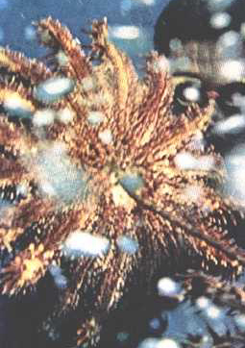

Key Concepts
1. The Acanthaster planet or crown-of-thorns sea star is a predator on living coral reefs.
2. The natural controls on this predator seem to be unable to control its devastating spread.
3. Studies by scientists looking for reasons for this outbreak are helping to gain some new understanding of coral reef ecology.

Background
The population explosion of Acanthaster planci, the crown-of-thorns starfish, has received much attention and caused widespread concern. The following article gives an overview of the problem and some possible causes . The article may be used to relate echinoderm biology to “real world” concerns.

Materials
For each student:
• “Starfish Threaten Pacific Reefs”, “National Geographic”, (March, 1970) by James A. Sugar.
• Starfish Threaten Pacific Reefs Three-level Guide

Teaching Hints
If your students have not used a Three-Level Guide, explain to them that the guide will take them through three levels of questioning, from a literal level, to inference, and then to analysis and synthesis. The idea is not to “get the answer right” per se, but more importantly, to use the questions as a guide to the major ideas in the article, and to try to incorporate those ideas into one’s own knowledge base. It is important to emphasize to the students that their reasoning is much more important than their answer. In fact, in levels two and three, there may be no “right” or “wrong” answer!
Traditionally, Three-Level Guides have been intended for individual work. Suggest that the students read the statements in the three-level guide before they read the article. (Some students may prefer to read the article first, then go back over it a second time with the three-level guide). The guide is intended to be a vehicle for helping students look for certain concepts in the article.
When students have finished, discuss the guide, referring to the article. You may wish to have students work in collaborative groups to compare their answers. The process of resolving differences of opinion can be very instructive.
It is sometimes helpful to have students note the page number and paragraph where they found evidence to support their answer. You may require the students to provide sound, complete explanations for the answers they chose!
For additional information about Three-Level Guides, see Teacher Background, Lesson 2, “Meanwhile, in the Pacific...”, Part 2.

Key Words
cause - the producer of an effect
crown-of-thorns - coral-eating sea star, Acanthaster planci, of the tropical Pacific an outbreak of which destroyed many of the living reefs that shelter coastlines from the continual pounding of the sea.
effect - result, something that is produced by an agency or cause

Answer Key
Level I
Directions: Read the statements carefully. Then as you read the selection, refer back to the statements in the guide and check those that you believe say what the author actually said or paraphrase what the author said in the selection. Indicate the page, paragraph and sentence on the statements checked for later reference. Also, be ready to explain what is inaccurate about the statements that you do not check.
x 1. In the tropical Pacific, coral-killing starfish are destroying living reefs that shelter coastlines from the continual pounding of the sea.
2. Acanthaster planci is not harmful to humans.
x 3. Scientists are following the spread of the crown-of-thorns starfish.
x 4. A major tactic in dealing with the crown-of-thorns starfish involves hunting and killing of the animals by humans.
5. Dead reefs pose few problems to the islands they surround.
x 6. The Pacific Triton is a natural predator on the crown of thorns.
x 7. Shell collectors took at least 100,000 tritons from the Great Barrier Reef between 1949 and 1959.
8. The Thorn-of-Crown uses sharp teeth to chew on the living coral.
x 9. Blasting for channels and channel dredging kills the coral animals.
10. Animal populations in nature tend to fluctuate.
x 11. Pollution may have an effect on coral reef growth.
Directions: Now compare your answers with those of others in your group. If there are any differences, find the page and paragraph that support your answer and write them next to the statement in question. When you finish your discussion, go on to the next level.

Level II
Directions: Science deals with causes and effects. Effects are the visible things brought about by a cause. They are the results. The cause produces the effect. Most of the statements you have checked in Level I are either cause statements or effect statements. Write the numbers of those statements which are cause statements in column A and the numbers of those statements which are effect statements in Column B. Be ready to justify your choices.

A. Causes B. Effects
6 1
7 3
8 4
10

Directions: Now compare your answers with those of others in your group. As before, where there are differences, try to resolve them by reference to the selection. When you finish your discussion, go on to the next level.

Level III
Directions: The causes you have listed in Level II should be testable using the scientific method. In other words, the proposed causes can be formulated as hypotheses. Several proposed experiments are listed below. Read each statement below, relating the details and author’s interpretations drawn from the selection to ideas and experiences you’ve had in reference to this topic. In the blank next to each experiment, write the number or numbers of the cause(s) (hypotheses) the experiment is designed to test. Be prepared to justify your choices.
6 1. Australian biologists are raising tritons for future release as adults along the Great Barrier Reef.
9 2. Marine Biologists in Guam and Rota weekly study the coral reefs adjacent to new yacht harbor channels.
11 3. Scientists in Tonga, an island which has not been affected by the crown-of-thorns outbreak, are studying the ecology of coral reefs.
Directions: Again, compare your answers with those of your group. Where there are differences, try to resolve them.
Starfish Threaten Pacific Reefs
Reprinted with permission from National Geographic Magazine, March 1970 (Vol. 137, No. 3, pages 340-353). Article and Photographs by James. A. Sugar
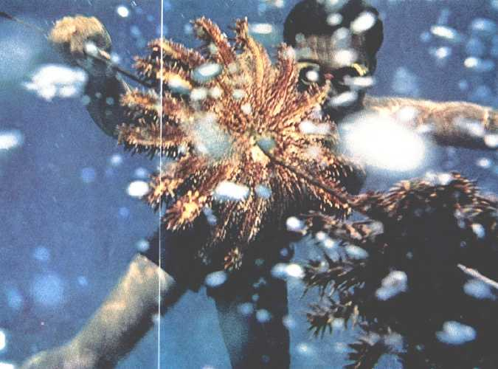

Spearing coral-killing marauders, a Truk Islander impales two crown-of-thorns starfish. The mysterious increase of the species threatens destruction of Pacific reefs that harbor fish life and protect islands against eroding waves. Because a starfish cut in two may become two starfish, the pests must either be poisoned or be speared, as here, and brought ashore for burial.

"Once they head down the windward side of the island, we'll lose them," the marine scientist shouted over the outboard's roar. "It's too rough out there for small boats."
Sounds like a sheriff leading his posse after a gang of outlaws, I thought, as we knifed along the northern coast of Guam. True, our quarry was "speeding" at only a few hundred feet a day, but otherwise the analogy fitted. For, in their way, the marauders we had come to kill were as dangerous as any human desperadoes. They were spine-covered, coral-killing starfish, and they were destroying the living reef that shelters Guam's coastline from the continual pounding of the sea.
Rare nocturnal predators only a decade ago, these spiny multipedes have undergone a mysterious population explosion and now, by day as well as by night, menace coral reefs in widely scattered areas of the Pacific.
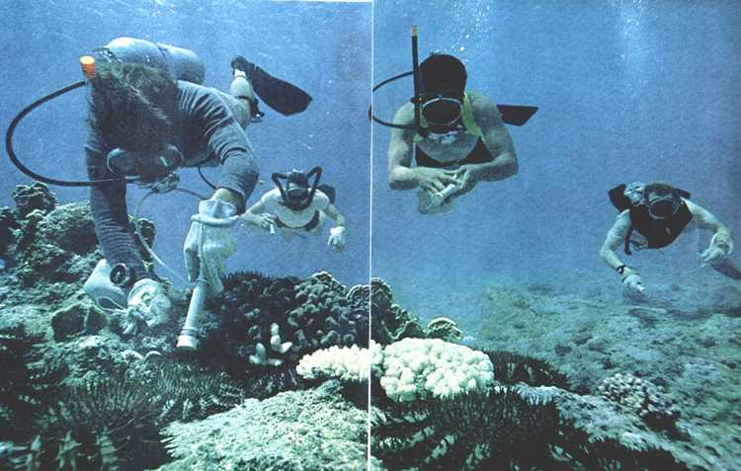
Hypodermic guns go into action off Guam, where herds of starfish have left bleached coral skeletons, center. Stripped of living polyps, the reefs lie prey to small sea animals that bore into and weaken these natural barriers against the sea's erosive action. Hands gloved against thorns that can poison, a diver with a hose-fed syringe injects a starfish with a lethal dose of form aldehyde solution (left). A team of four can kill as many as 2,500 in four hours. A rare nocturnal creature until it began reaching plague numbers seven years ago, the crown-of-thorns now feeds at all hours.
Casualty List Spans Half an Ocean
The prickly starfish, known commonly as the crown-of-thorns and scientifically as Acanthaster planci, eats the tiny coral polyps that create such reefs (page 348). In a single day it can graze an area twice the size of its 6- to 12-inch central disk.
Acanthaster has killed more than 90 percent of the coral along 24 miles of Guam's lOO-mile coastline in two and a half years. It has also invaded 300 miles of Australia's 1,250-mile-long Great Barrier Reef, the world's most extensive example of the creation of reefs and islands by the flower-like little polyps. The list of other coral areas under assault by starfish has doubled and trebled: Malaysia, New Guinea, Palau, Saipan, Truk, Fiji, Tahiti, the Tuamotus (maps, opposite).
At last our scientist skipper, Dr. Richard H. Chesher of the University of Guam (right), shut down the engines. "The starfish have killed most of the coral back to Piti Bay," he said. "They're now moving at more than 2,000 feet a week, looking for live reef."
We strapped on scuba gear and started down. Each of us carried a special hypodermic syringe with which to inject a fatal dose of formaldehyde solution into our prey.
I soon spotted the sea stars sixty feet below me. Their dark multi-armed bodies stood out clearly against the pale sea floor. I could see scores of them traveling in a herd about ten yards wide and perhaps a hundred yards long. Their orderly formation reminded me of a parade moving to the cadence of a band. But I was sure that these starfish marched only to the beat of their own private drum.
I dropped down for a close look at one and was again reminded of the aptness of the name "crown-of-thorns." Dozens of sharp spines jut out from each of the animal's arms (below), as well as from the central disk. Besides simple pricking power, these thorns can poison; injuries from them sometimes cause swelling, pain, and even nausea.
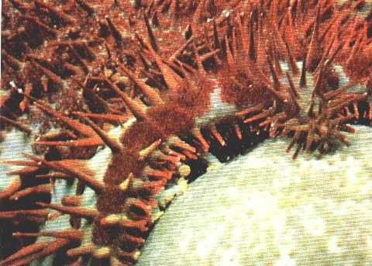

Menace on the march, a crown-of-thorns attacks a live coral head. Dozens of yellow-tipped feet flanked by blunt spines line the undersides of Acanthaster planci's 12 to 19 arms. Most often it has 16, each of which may grow as long as six inches.
Suction cups on the ends of the feet carry feeding starfish up vertical reef walls. The predators, moving in narrow, irregular columns parallel to the shoreline, may migrate nearly half a mile a week.

I drew my knife and flipped a two-foot-wide creature onto its back. Its underside was covered with tiny yellow tube feet which enabled it to move in any direction (page 350).
Those tube feet, I soon discovered, function like suction cups. I lifted the star with my knife and tried to balance it on my underwater camera. It immediately wrapped its arms around the camera, enveloping everything but the strap. I used that to tow my living pincushion to the boat, where I had to use my knife again to break the grip of its arms and tube feet on the camera.
Spears Are the Answer on Small Atolls
Diver Mick Church bobbed to the surface. His air tank was empty, but he was full of predatory pride. He had killed 150 starfish with his formaldehyde gun.
"Man, I've never seen so many in one place before," Mick gasped as he tried to catch his breath. "They were all over the place, moving as if they were playing follow-the-leader. It looked like a scene from a science-fiction movie–an invasion from inner space."
"We can control the invasion here in Guam," said Dr. Chesher as we stowed our gear. "Not long ago our killer team destroyed 2,549 starfish in four hours. The trouble is, people on most of the outlying islands don't have all this equipment. We'll have to teach them to collect the starfish on spears [pages 340-41] and bury them on land. Just stabbing them isn't enough. A pierced star may not die. If you chop one in two, both halves may regenerate and become complete individuals."
Driving home from the dock, Dr. Chesher told me that people living on low-lying Pacific islands face real danger as a result of the starfish's depredations.
"When live coral is killed, reefs may break down," he said. "Then storm waves might eventually eat away shorelines. But before this could happen, islanders might be forced to leave or starve. They get almost all their protein from the sea. Once the reefs die, food fish go too."
The possibility that such a disaster might strike the Pacific Islands Trust Territory, administered by the United States, prompted the U. S. Department of the Interior to send out an international team of more than 60 scientists and divers to study the problem last summer. The project, managed by the Westinghouse Ocean Research Laboratory of
San Diego, California, was set up to survey the damage caused by Acanthaster.
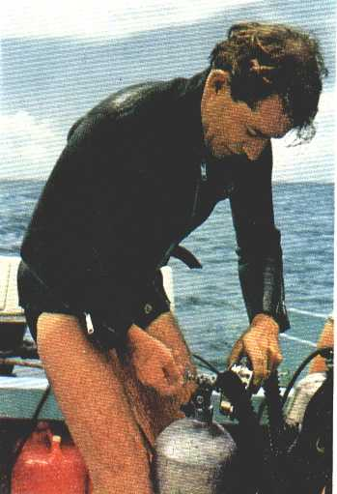
But the team also studied the animal's behavior, particularly its eating habits. Dr. Ralph W. Brauer, of the Wrightsville Marine Bio-Medical Laboratory in North Carolina, collected starfish which he kept in aquariums at the University of Guam, where he could observe them closely (page 350).
I accompanied Dr. Brauer and his two colleagues, David Barnes and Mike Jordan, on a collecting expedition to an infested reef along Guam's western coast. In an outboard-propelled rubber raft, loaded with diving equipment and large buckets for holding the starfish, we rode to a spot where I had seen starfish feeding a few days earlier. We located a cluster of the creatures, dropped anchor, and put on our gear.
"Be careful when you handle these critters," Dr. Brauer warned us. "I don't want you to damage the animals or yourselves. Watch out for their spines!"
We headed for the bottom. Here the sea floor was covered with coral heads of all shapes and sizes. Only a few Acanthaster were feeding on top of the heads. Most of them were well hidden under the coral, to which they held firmly with their arms and tube feet. To remove the starfish, I used my knife with the care of a surgeon, heeding Dr. Brauer's warning as I worked.

Gearing up for a look at the invader, Dr. Richard H. Chesher adjusts air tanks. Chief scientist of an intensive United States Department of the Interior study, he seeks causes and effects of starfish proliferation.
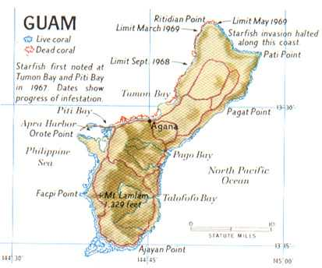

Crown-of-thorns depredation was first reported a decade ago on Australia's 1,250-mile Great Barrier Reef , world's most awesome coral formation. Starfish were ravaging reef areas between Cooktown and Townsville in Queensland. Plague reports multiplied, reading like a Pacific war map of the 1940's: Malaysia, Borneo, Guam, Saipan, Tinian, Truk.

Starfish-killer teams armed with formaldehyde syringes think they have contained the plague on Guam . But Acanthaster's appetite threatens many small atolls, where scientists hope to teach islanders simpler extermination methods.
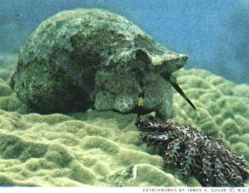
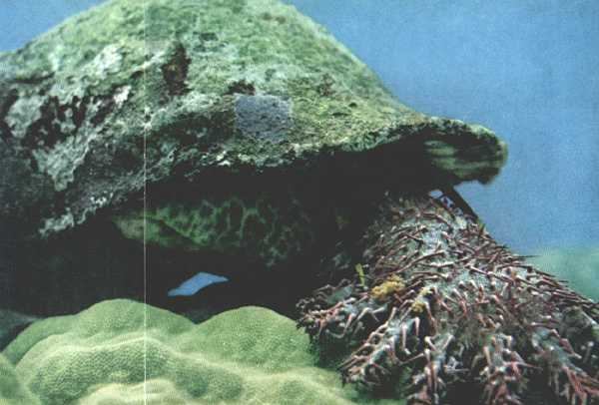
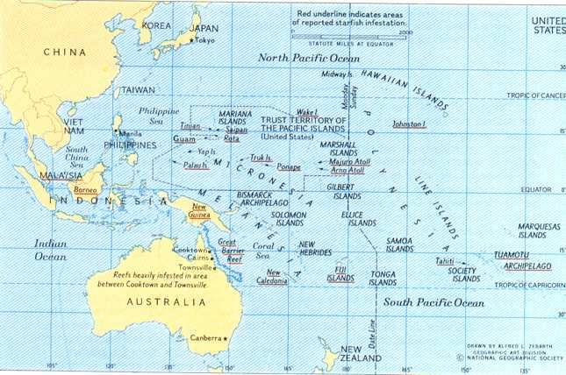

Triton's searching tentacles set off a low-speed chase.

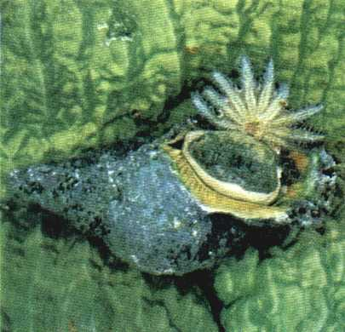
Probing for a meal which the author placed nearby, a Pacific triton (above) sends a crown-of-thorns fleeing over a coral head at 12 inches a minute. The race ends with the starfish locked between the attacker's foot and its algae-flecked shell (above, right).

Its prey immobilized, this triton rolls over, flipping the starfish on its back (right). Then the mollusk tears it to shreds with its file-like radula and digests it. Sometimes a half-eaten starfish skitters away at mid-meal; eventually its amputated portions may regenerate. Some scientists blame Acanthaster's increase on collectors who pay $35 or more for spiraled triton shells. Australia hopes to raise the giant mollusks for release on starfish-infested reefs.
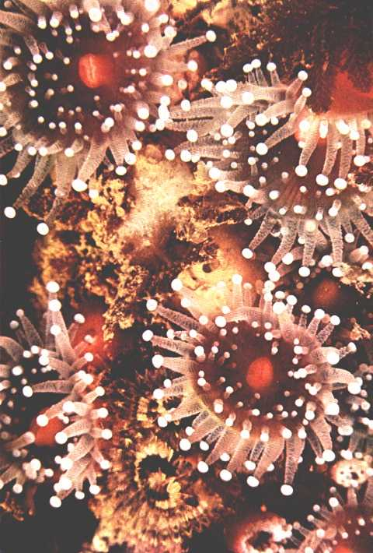
The quick and the dead: Flowerlike coral polyps (above), enlarged 7 1/2 times, were long mistaken for plants. Simple, stationary animals, they attach themselves to the skeletons of their ancestors and exude calcium carbonate to build a home around themselves. Withdrawn into their limey cups by day, polyps unfold tentacles at night to feed on microscopic sea life In one of nature's strangest vendettas, they devour millions of starfish in the larval stage. Thus man's destruction of coral reefs by blasting and dredging channels may contribute to the growth in starfish population. Desolation invades oceanic gardens of Guam in Acanthaster's wake. Thick fuzz of algae quickly covers dead coral, preventing new growth.

Spines Can Cause Painful Wounds
The four of us shuttled back and forth between the raft and the coral heads on the bottom. On each trip up we brought one starfish to the surface, put it in a bucket on the raft, and headed back down for another.
On Mike's last trip to the surface, he handed a starfish to David, who was in the raft. A spine brushed David's finger. Light as the touch was, it gashed his skin.
David yelped.
"Force the cut to bleed," Dr. Brauer told him. "Get the stuff out of the wound. If you do it right away, you'll have less pain later."
When we released our starfish in glass-walled tanks at the university, Dr. Brauer ran sea water over some living coral, filled a hypodermic syringe with the polyp-flavored water, and squirted it under a starfish creeping up the glass wall.
Mistaking the coral taste for live coral, the starfish opened its mouth (located in the center of its underside) and everted its stomach. The fleshy digestive sac covered an area larger than a man's palm.
Next Dr. Brauer placed a hungry starfish on a piece of living coral. Out came the stomach. It spread over the coral polyps, and its digestive juices began to dissolve them inside their limey shelters. After an hour, the polyps were reduced to semifluid shreds. Where colonies of colorful little animals had lived, there remained only a bleached white skeleton.
"In a single night," Dr. Brauer told me, "an adult starfish can clear off a coral head that might have taken fifty years to grow."
A stomach goes out to lunch
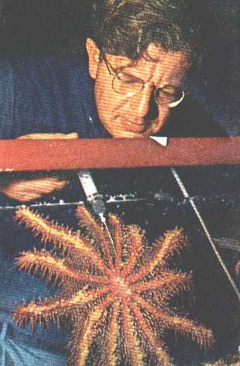

Wielding a syringe, Dr. Ralph Brauer squirts coral-flavored sea water along the underside of a captive starfish at the University of Guam. The stimulated Acanthaster hungrily opens its mouth in an experiment that demonstrates the creature's feeding behavior.

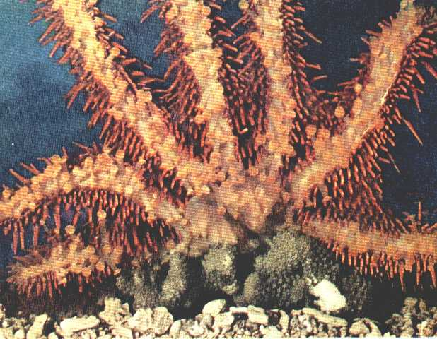

Live polyps placed on the tank bottom attract the predator. It moves its tube feet excitedly and begins to evert its gastric sac, a billowy membrane which, when fully extended, covers an area larger than its central disk. "It tumbled around the coral like a collapsed parachute," observed author Sugar.

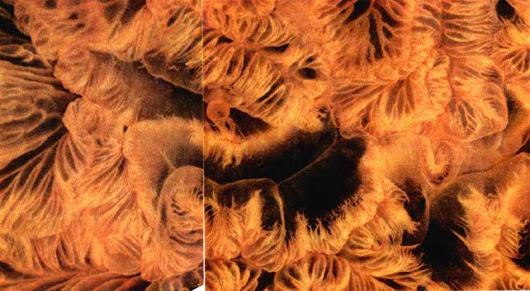

As the membrane –enlarged three times at left–drapes over the polyps, digestive juices pour from the body to dissolve the food into semifluid strands of tissue. The starfish then absorbs its meal, though scientists do not yet know exactly how. Within eight hours all coral covered by the stomach area will shine bone white–shorn of life.
Giant Tritons Prey on Stars
While such studies of the sea star's habits may lead eventually to a means of controlling the present plague, some scientists are seeking more immediate solutions. Australian biologists, concerned about the threat to the Great Barrier Reef, plan to attack the stars with armies of their natural enemies, giant tritons. They believe that man has upset the delicate ecological balance of the reef by collecting too many of these mollusks for their handsome spiral shells, permitting the stars to multiply abnormally.
"I have calculated that shell collectors took at least 100,000 tritons from the Great Barrier Reef between 1949 and 1959," says Dr. Robert Endean of the University of Queensland. "We are trying to find out whether it's possible to grow these animals on a special triton farm. If it is, we'll seed them as adults along the Great Barrier Reef."
Having once watched a giant triton devour an Acanthaster, I can vouch for its voraciousness. The triton first located the star with its two tentacles. The threatened starfish tried to creep away, but its pursuer chased it across a coral head and caught it. The mollusk first seized the starfish, holding it between shell and foot, then began to tear it to shreds and eat it. Several hours later, it ejected the spines.
If isolated or somehow contained within a given coral area, the crown-of-thorns soon curbs its own population explosion–at the cost of a totally dead reef. "Acanthaster become so numerous they eat themselves out of house and home," explained Richard Randall, an expert on the corals of the Marianas.
While I browsed through the dozens of coral-laden racks in his house on Guam, Mr. Randall pointed out that the devastation of a reef leads to starvation of the starfish–though only after it has led to the starvation of other reef creatures, and perhaps humans as well.
Man May Have Set 0ff the Plague
Can a reef recover from a starfish attack? Mr. Randall is trying to find out.
Coral regeneration is difficult because the porous skeleton of a ruined reef is soon covered with algae which prevent new growth. Within two or three days the white skeleton becomes a dismal gray, coated with fuzz (page 349) or festooned with long green strands.
No single theory offered to date has adequately explained the starfish plague and its wide distribution. Some scientists speculate that the population explosion has no unusual cause but is only a natural periodic phenomenon. Other theories seem valid for certain areas but not for others. Many Australian scientists are convinced that over-collection of giant tritons created the plague on the Great Barrier Reef. But lack of intensive shell collecting in remote island areas, now equally star-infested, indicates other causes as well as triton harvesting.
In his office at the University of Guam, Dr. Chesher told me that man may be responsible in another way for the invasion. "By killing coral in the process of blasting channels or dynamiting for fish," Dr. Chesher said, "he has perhaps altered the underwater environment in favor of the sea-star's survival."
Dr. Chesher explained that under normal conditions only a tiny percentage of the millions of eggs spawned by the female Acanthaster ever reach adulthood. Many of the floating starfish larvae are devoured by living coral polyps. But when an area of reef is killed by man, the vulnerable larvae can settle upon it and mature in safety.
Because there is usually living coral immediately adjacent to the dead reef, the young adults have a ready food source once they begin to eat polyps. As the adult starfish destroy even more of the reef, they enlarge the sanctuary for their young. The result of the chain reaction is a population explosion.
"Support for my hypothesis," Dr. Chesher pointed out, "comes from the fact that infestations in Guam, Rota, and Ponape were first discovered near blasting or dredging sites."
Others have wondered whether the imbalance in reef life might have been caused by the testing of nuclear weapons, or by pesticide residues washed into the oceans from the land. Whatever the cause may prove to be, all the theories advanced so far–except that of natural periodic population growth–point to the activities of man. Whether by dredging, or shell collecting, or pollution, this latest disturbance of the balance of nature seems to be a further example of man's disruption of his world.
THE END

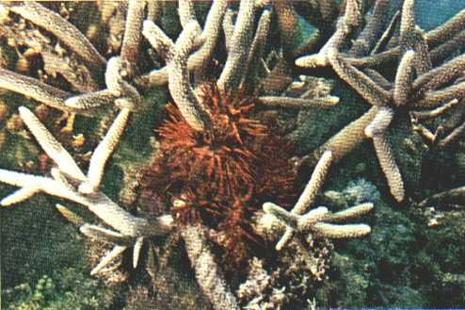

Deadly embrace dooms a prong of staghorn coral. Nearby, a whitened branch stands stripped of polyps like an ear of corn denuded of its kernels. Among the reef-building corals, few varieties enjoy immunity from the starfish.

Paradise in peril: Plagues seem far from mind as two islanders at Guam fish with dip net and bucket through a serene dusk. But scientists fear their way of life may vanish if the crown-of-thorns goes unchecked and the underwater ecology continues to change.
“Starfish Threaten
Pacific Reefs”
Three Level Guide

Level I
Directions: Read the statements carefully. Then as you read the selection, refer back to the statements in the guide and check those that you believe say what the author actually said or paraphrase what the author said in the selection. Indicate the page, paragraph and sentence on the statements checked for later reference. Also, be ready to explain what is inaccurate about the statements that you do not check.

1. In the tropical Pacific, coral-killing starfish are destroying living reefs that shelter coastlines from the continual pounding of the sea.

2. Acanthaster planci is not harmful to humans.

3. Scientists are following the spread of the crown-of-thorns starfish.

4. A major tactic in dealing with the crown-of-thorns starfish involves hunting and killing of the animals by humans.

5. Dead reefs pose few problems to the islands they surround.

6. The Pacific Triton is a natural predator on the crown-of-thorns.

7. Shell collectors took at least 100,000 tritons from the Great Barrier Reef between 1949 and 1959.

8. The crown-of-thorns uses sharp teeth to chew on living coral.

9. Blasting for channels and channel dredging kills the coral animals.

10. Animal populations in nature tend to fluctuate.

11. Pollution may have an effect on coral reef growth.

Directions: Now compare your answers with those of others in your group. If there are any differences, find the page and paragraph that support your answer and write them next to the statement in question. When you finish your discussion, go on to the next level.

Level II
Directions: Science deals with causes and effects. Effects are the visible things brought about by a cause. They are the results. The cause produces the effect. Most of the statements you have checked in Level I are either cause statements or effect statements. Write the numbers of those statements which are cause statements in column A and the numbers of those statements which are effect statements in Column B. Be ready to justify your choices.

A. Causes B. Effects

Directions: Now compare your answers with those of others in your group. As before, where there are differences, try to resolve them by reference to the selection. When you finish your discussion, go on to the next level.

Level III
Directions: The causes you have listed in Level II should be testable using the scientific method. In other words, the proposed causes can be formulated as hypotheses. Several proposed experiments are listed below. Read each statement below, relating the details and author’s interpretations drawn from the selection to ideas and experiences you’ve had in reference to this topic. In the blank next to each experiment, write the number or numbers of the cause(s)(hypotheses) the experiment is designed to test. Be prepared to justify your choices.

1. Australian biologists are raising tritons for future release as adults along the Great Barrier Reef.

2. Marine Biologists in Guam and Rota weekly study the coral reefs adjacent to new yacht harbor channels.

3. Scientists in Tonga, an island which has not been affected by the crown-of-thorns outbreak, are studying the ecology of coral reefs.

Directions: Again, compare your answers with those of your group. Where there are differences, try to resolve them.

