Hear-Sighted

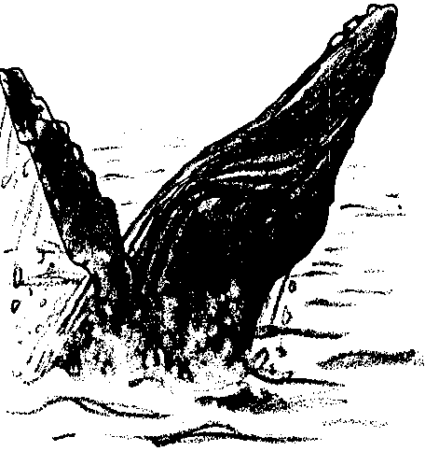
Key Concepts
1. Dolphins and many whales use echolocation as a primary tool to sense their environment.
2. In echolocation, the dolphins and whales emit sound waves, receive the reflected waves and determine from the changes in the sound waves locations and identities of objects.

Background

Only within the last three decades has improved technology allowed humans to investigate the complex system of underwater hearing used by cetaceans (whales and dolphins). Studies have shown that cetaceans, unlike sharks and rays, have virtually dispensed with the sense of smell as a method of gaining information about their environment. While the sense of vision is moderately well-developed in some species, vision can only play a limited role in information gathering. This is due to the finite penetration of light in sea water. For example, at a depth of thirty-five meters in the North Sea, 98 percent of the light is extinguished. In addition, at this depth light reflected off objects under water travels only a distance of seventeen meters. This distance is so short that a large blue whale cannot even see its own flukes. How, then, do these animals sense their environment. It now appears that the major information gathering system used by cetaceans centers on the emission of sound waves which create echoes.

The Basic Principle Of Echolocation
Cetaceans use sound pulses to sense their surroundings. Dolphins, toothed whales and some baleen whales generate short pulses of high frequency waves. The waves reflect off objects and return to the animal. With astounding accuracy and perception, the animal interprets the signals. In experiments with captive dolphins, the animals were able to use their echolocation to differentiate between spheres of the same size made of different materials.

How Sounds Are Produced
Many biologists think that the sounds are produced within the nasal cavity. The cavity, found inside the blowhole, has a complex structure. Extending from the main part into the head are several pouches, called nasal sacs, that may be filled with air. There is also a blowhole ligament and a nasal plug, both of which are very flexible.

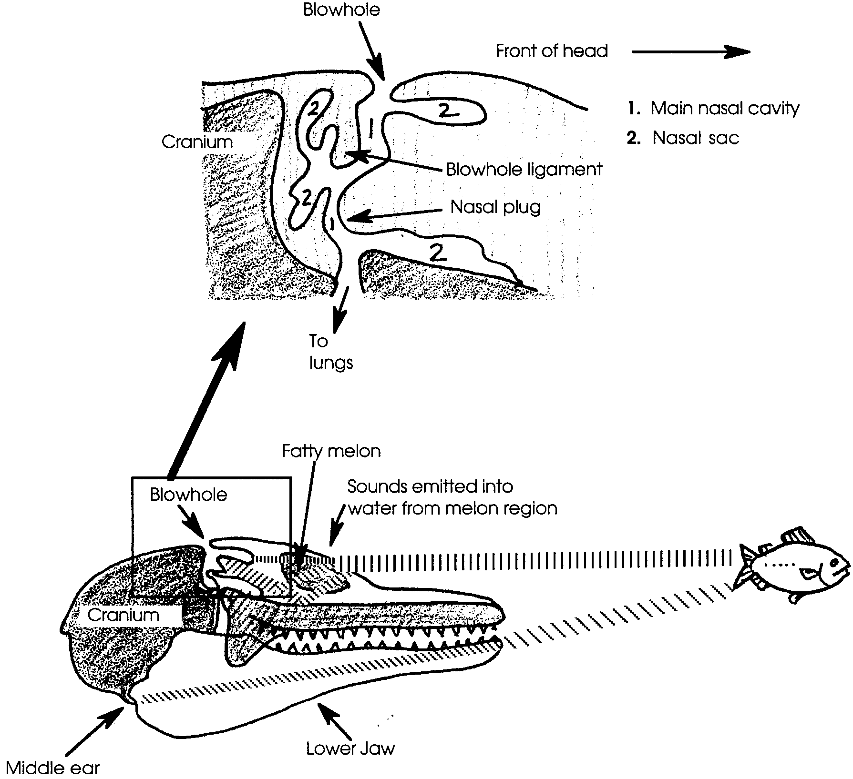
The sounds seem to be produced by the repeated coming together of the surfaces of the blowhole ligament and the nasal plug. This usually occurs when the blowhole is closed.

The physical structure of the dolphin head plays an important role in orienting the sound pulses before they leave the animal. The skull bones and nasal sacs reflect high-frequency sounds and direct the sounds to the “forehead” area which contains a peculiar fatty mass, called the melon. It is thought that the melon functions as an “acoustic lens” which focuses the sounds into a directional beam as they leave the head.

How The Returning Echo Is Received
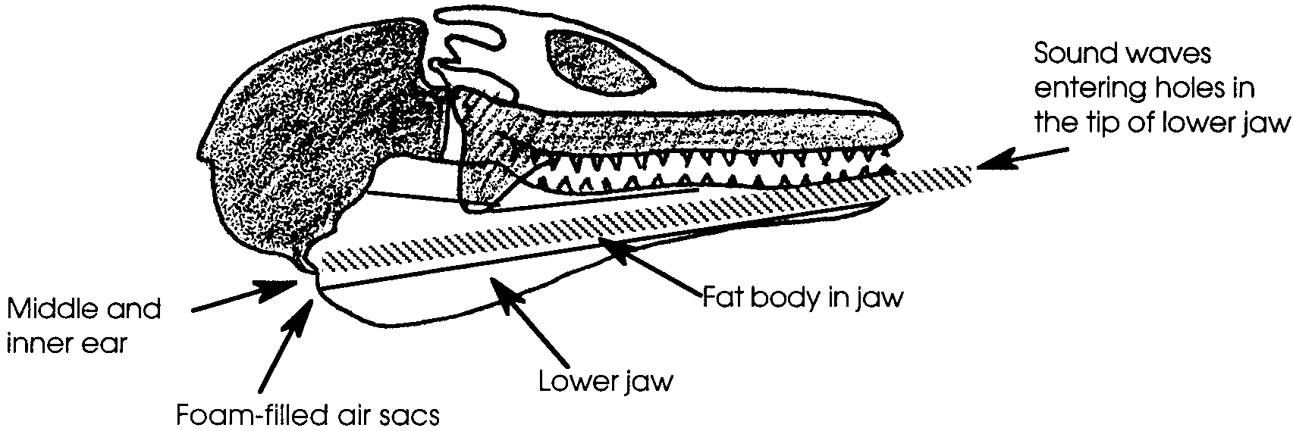
Just as the head has special adaptations for producing sound, it has ones for receiving the returning echo. Sound pulses from a returning echo are picked up by the lower jaw bone which is hollow, but not empty. The cavity contains a long fat body and a nerve that runs to the tip of the jaw where it exits through holes in the bone. It seems that the sound pulses enter the jaw through these holes and are then carried through the fat body which is capable of conducting sound pulses in one direction.

The sounds proceed via the fat body to the middle or inner ear which are located on each side of the head. The middle and inner ears are encased in a hard bony covering that is separated from the rest of the skull. This hearing unit is, in turn, surrounded by extensive air sacs, filled with foam. Since the foam is an effective sound barrier, the middle and inner ears are insulated from sounds in all directions.

The cetacean brain records the time between transmission and reception and combines this time with information about the speed of sound to give the distance to the target. The sophistication of this system allows the cetacean to determine the size, shape, quality and exact location of the object.

Whales use echolocation to locate food, avoid collisions, orient themselves to their surroundings, and to find and recognize others of their species for mating and protection. It appears that three broad groups of sound are used. For information about the topography, low frequency clicks, which have great penetrating power, are used. For communication between members of the same species, somewhat higher frequency whistles are used. The location of food depends on the highest frequency clicks.

Materials

For each student
• “Hear-Sighted” student background text
• blindfold

For each pair of students
• clock, non-electric
• long, clean table or counter
• meter stick

For the class
• large playing area outdoors or in gym (for simulation)

Teaching Hints

In “Hear-sighted”, students investigate their own sense of echolocation and experience a simulation game using echolocation to orient themselves and find food.

Part 1: Listen Closely...

The “Listen Closely” investigation is best accomplished in pairs. The background material may be read as a homework assignment prior to initiating the investigation or as a follow up. Any clock or watch with an audible click may be used for this investigation. Since the number of clocks is often the factor which determines group size, you may elect to encourage your students to bring in clocks from home.

Maintain the lowest noise level possible during the course of the investigation. If your students have trouble keeping their eyes closed, you may provide them with optional blindfolds to help assuage their curiosity. A preview reading makes the procedure much easier to follow. Circulate through the room as the investigation is being performed. Provide your students with any help necessary for successful completion. Plan to spend some time in a discussion of the procedure and the questions found in the “Analysis and Interpretation” section.

Part 2 - The Hear-Sighted Simulation Game

“The Hear-Sighted Simulation Game”, offers opportunities for a variety of experiences with echolocation. The object of the game is for students, while blindfolded, to use sound to: orient themselves, navigate, find others of their kind, locate food, and avoid predators. Students will enjoy playing it again at a later time to re-test or improve their skills and develop new strategies.
This activity is best done with a class of 25-30 students but can be done with a smaller group. It progresses sequentially from simple echolocation tasks to complex multi-tasks. Since players are blindfolded, stress that, for safety, players must walk, not run.

Procedure

1. Define the playing area before blindfolding students. It is helpful to ask 6-8 students to post themselves at the boundaries of the playing area. They are to tell blindfolded students when they are close to being out of bounds. These students will also act as “observers”, perhaps taking the role of cetologists, as they watch the play progress. You may choose to rotate roles so that everyone has an opportunity to participate as an “observer” and as a “whale”. After the games have been played several times, you may wish to have “observers” design studies, collect and analyze data from future games.

PLAY 1: Using echolocation to find others of your kind and navigate in darkness

1. Positions: Have the rest of the students spread out along the edges of the playing area. Have them blindfold themselves (encourage no peeking!) and tell them to stay in their place until you give the signal to begin play.

2. Assign roles: Whisper in each player’s ear the role they will play and the sound they will make in the first round:
Dolphins will whistle
Gray whales will grunt
Orca whales will click.

3. Action: At your signal, players will begin making their assigned sounds. They are to listen for others making similar sounds and then move to join with them while all the while avoiding bumping into anyone. When they are with others of their kind they are to join hands. The species that unites all member first, wins this round. The game continues until all members of the class have become united with their group.

4. Discussion: Discuss success and failure at achieving the goal. Ask students to describe the strategies they used. Ask “observers” to describe what they saw happening.

PLAY 2: Using echolocation to avoid collisions with underwater obstacles

1. Assign roles:

a. Obstacles: Assign 6-8 students to be underwater obstacles such as: shipwrecks, sea mounts, canyons, shallow continental shelves, etc. These students do not wear blind folds. They may not use speech. They echo back sounds produced by “whales” who are be blindfolded. The obstacles only produce echoes when they hear a sound produced by a whale. Obstacles do not move.

b. Migrating gray whales: The remaining students are gray whales migrating to the northern feeding grounds. Some obstacles stand in the way. Whales, which will be blindfolded, are to use echolocation to find their way without colliding with the obstacles. They produce a whale sound (choose clicks, groans, or moans!) without using speech. The obstacles echo back their sound to let them know where they are. If a whale collides with an obstacle it becomes an obstacle and echoes back sounds produced by nearby whales.

2. Positions: Have gray whales line up along one edge of the playing area. Show them the ending point (the “feeding grounds”) they are to reach safely without colliding with an obstacle. Depending on the size of the area, you may wish to move the ending point in from the opposite edge. Decreasing the size of the area, increases the density of the obstacles. Tell students that the boundaries still exist.

Blindfold the whales. After they are all blindfolded, have the “obstacles” move silently onto the playing area and position themselves to form an “obstacle course”. Position yourself at the safe destination, the feeding grounds. You will tell whales when they have safely reached the feeding grounds.

3. Action: Give the signal for play to begin. Play continues until all gray whales have safely reached the feeding grounds or have become obstacles. Repeat play so that each student has an opportunity to play a gray whale.

4. Discussion: Discuss success, failure, and strategies.

PLAY 3: Using echolocation to avoid collisions with underwater obstacles and to join others of your kind

1. Combine activities for PLAY 1 and PLAY 2. This time dolphins, gray whales, and orcas will be joining others of their kind, as in PLAY 1, while navigating through the obstacles, as in PLAY 2. They may join others (hold hands) on the route or in the feeding grounds. Play continues until all cetaceans have safely navigated the course (or have become obstacles) and have joined with others of their species. Repeat the game as often as you like, allowing students to change roles.

2. Discussion: Discuss strategies as before. Notice if some students are improving echolocation with practice.

PLAY 4: Using echolocation to locate food and avoid collisions with underwater obstacles

1. Assign roles:
obstacles as before
food (bottom dwellers like ghost shrimp and marine worms)
gray whales

Again the whales are blindfolded and may use only echolocation to avoid collisions and locate food. In this game the whales are challenged to devise a way to determine food from obstacles. Like obstacles, food will echo back only sounds produced by the whales.

2. Positions: Blindfold the gray whales at the starting line. Have the obstacles and food silently take positions on the playing area. If a “food” is behind an obstacle it might not be found by the whale until the whale is in position for sound signals to echo off the food. The obstacle might obstruct the sound wave. Food and obstacles do not move from their positions during play.

3. Action: The food will not be moving in this game. When a gray whale locates food it will “eat” it by holding onto the food. The food will stop returning echoes to searching whales because it will have been “eaten”. The whale continues to search for more food, while keeping its “eaten” food with it. Only one whale may “eat” each “food”. Play continues until all food has been eaten. If a whale collides with an obstacle it becomes an obstacle. If it is holding on to “food”, the food also becomes an obstacle. The whale with the most food at the end of the game wins. Repeat the game so that everyone has a chance to participate in different roles.

4. Discussion: Discuss the strategies as before.

PLAY 5: Using echolocation to avoid predators

1. Assign roles: All are blindfolded. All players echo back sounds made by the orca, as well as those made by the gray whale.

a. Gray whales - use echolocation to find safety zones and avoid dangerous predators. They echo back sounds made by orca whales.

b. Predators: orca whales, whale hunters, discourteous whale watchers, fishing nets - all echo sounds produced by gray whales. Also:

• When not returning echoes, whale watchers and hunters constantly make the sounds of engines running.

• Of all the predators, only orca whales may move in this game. Orca whales may also use echolocation and percussive behaviors (tail lobbing, flipper slapping, breaching) to locate gray whales, and each other, and for communication for cooperative group hunting strategies. They may not speak otherwise.

c. Safety zones: kelp beds and marine sanctuaries - echo sounds produced by gray whales and orca whales. Gray whales who find safety zones may stay there silently. Predators may not “take” gray whales in safety zones.

2. Positions: Move safety zones into a few places on the playing area and be sure everyone understands that gray whales cannot be harmed when they are in the safety zones. You may wish to limit the number of whales to permitted in a zone. Do not blindfold safety zones.

Blindfold gray whales and all predators. Carefully and as quietly as possible, position gray whales and predators on the playing area so that they are dispersed as in the ocean.

3. Action: At your signal play begins. Physical contact between a gray whale and any predator is a “take” (a harassment, capture, or kill). A “taken” gray whale stays in contact with the predator and no longer participates. Orca whales can also be “taken” by predators other than orcas. Orcas may not use “safety zones”. Play continues as long as there is at least one gray whale still free in the ocean.

4. Discussion: Discuss the difficulties of using echolocation in such a situation. Help the class list human actions that affect the habitat and behaviors of whales and the role of conservation in protecting whale species.

If you are using “Voyage of the Mimi” in conjunction with this unit, “Episode 6: Home Movies”, “Expedition 6: Songs of the Sea”, and “Expedition 7: Hands Full of Words” correlate with this lesson.

Key Words

auditory - pertaining to the sense of hearing

cetacean - a member of the order Cetacea, a group of aquatic, chiefly marine mammals, including the whales and dolphins

echolocation - in this case, the sonarlike system used by dolphins and some whales to detect and locate objects by emitting high pitched sounds that reflect off the object and return to a sensory receptor

melon - a fatty mass located in the “forehead” area of cetaceans thought to function as an “acoustic lens” which focuses sounds into a directional beam as they leave the head

Extensions

1. Have students use a carpenter’s estimator, available at hardware stores, to find distance. The tool finds distances by reflecting waves off walls.

2. Invite a guest speaker involved in the use of radar or sonar to talk about and demonstrate applications of radar or sonar.

3. Modify the games using various combinations of challenges.

4. Incorporate echolocation, as in these games, with the food chain games in “Who’s for Dinner” found later in this curriculum.

5. Show films and videos and play tapes of whale sounds. Then, tape individual students and groups of students whistling a well known tune. Play the tape and see if students can identify the whistlers or groups of whistlers. To challenge the students, make a revised tape of your original recording, mixing up the order so that students will not identify whistlers according to their memory of who comes next.

6. Have students compose or arrange music incorporating recorded whale sounds. Use sound effects or experiment with various objects, such as running your thumbnail along a comb, to make whale sounds. If you have access to a synthesizer, have students reproduce whale sounds and make their own recordings.
Answer Key

1. Answers may vary. Scientists are not in unanimous agreement regarding the benefits of “spy hopping” behavior. Since whale eyesight is useful only in relatively clear, well-lighted waters, pushing their eyes above the surface puts them into the clear, well-lighted (during the day, at least) atmosphere where viewing of shorelines, etc. may be better accomplished.

2., 3. A correctly labeled dolphin skull is shown below.
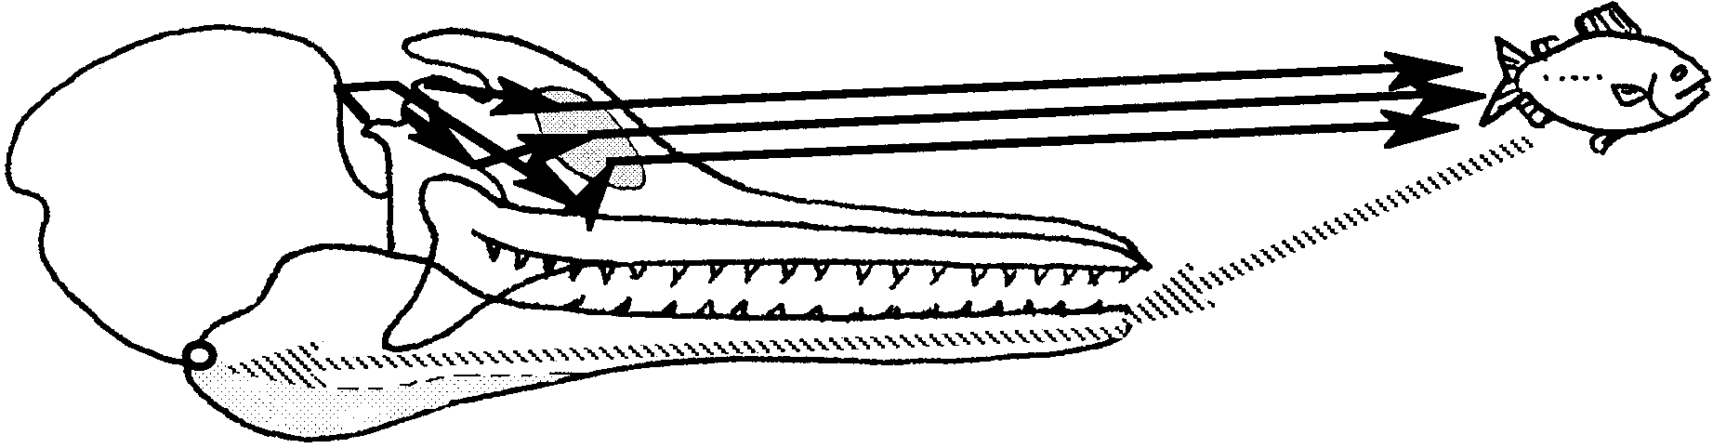

4. Drawings of a “whale’s eye view” of a SCUBA diver will vary. The purpose of the exercise is to reinforce that cetaceans “see” in a way truly different from the way in which humans “see”.

5. The underwater features could serve as a 3-dimensional road map which the whales could follow, much the way we use topographical clues in our travels.

Part 1 - Listen Closely...

Analysis and Interpretation

Part A.

1.a. While the answers depend upon the experimental results, it is unlikely that the right ear distances for Trials 1 and 2 are the same.

b. The answer depends upon the experimental results.

2. a. and b. See answers to 1 above.

3. a. Again, while the answer depends upon the experimental results, it is unlikely that the right ear and left ear distances or averages will be the same. Your students will be able to come up with many plausible reasons for the differences including injury to one ear, more noise during one of the trials, the improvement due to practice, etc. The differences also reflect the variation inherent in physiological systems.

b. Since this question asks for an opinion, there is no right answer. A reasonable case can be made that it is more important for whales to have equal hearing distances since they rely more heavily on hearing to sense their environment. However, it is not at all certain that equal hearing abilities are required to have echolocation work well. It is more likely that the brains of both humans and whales compensate for any slight differences in auditory acuity. This question is included to provide an opportunity for a discussion of the role of hearing in humans versus whales.

4. a. While the answers will vary in direct proportion to the vanity of your students, none of your students’ abilities will begin to compare with those of whales.

b. Practice will, in all likelihood, improve your students’ ability. Supporting data might include an increase in distance from the right ear Trial 1 to left ear Trial 2.

5. a., b., c. The answers depend upon the experimental observations.

d. This question asks for an opinion. As such, there is no right answer. Hopefully, your students will be able to generalize from the variability they saw in humans to the variability which exists in whales.

6. Factors that could affect echolocation ability include: sounds from boat engines; geographic features that may reflect, distort or muffle sounds; the presence of other whales also echolocating; turbidity of the water from sediment or plankton blooms; the massing together of objects such as krill in masses; and water density which affects the rate and distance sound travels.

Part B.

1. The answer depends upon the experimental results.

2. Data which supports the idea of an improvement with practice might include an increase in accuracy from position 1 to position 4.

3. Besides location, whales can tell the size, and quality of the object.

4. The whale’s well-developed sense of echolocation helps it to survive in several ways:

a. food location

b. collision avoidance

c. orientation (the whale can determine where she is in relation to other objects and organisms).

d. species and/or mate recognition.

Other suggestions are also possible. Two ways are required.

5. In the ocean environment, echolocation seems to be a more “important” sense than vision because of the limited penetration of light beneath the surface and the highly limited distance reflected light can travel beneath the surface. You are wise to point out that it is artificial to term one sense more important than another. All of the senses, in fact, apparently all of the things an animal does, have proven to have evolutionary significance - they help the animal survive. Humans alone rank the importance of the various adaptations. This may lead to a dangerous (even fatal) error in judgment on our part. Often, the things we term insignificant turn out to be highly significant for long term survival of the species in question, be it dolphins or humans.

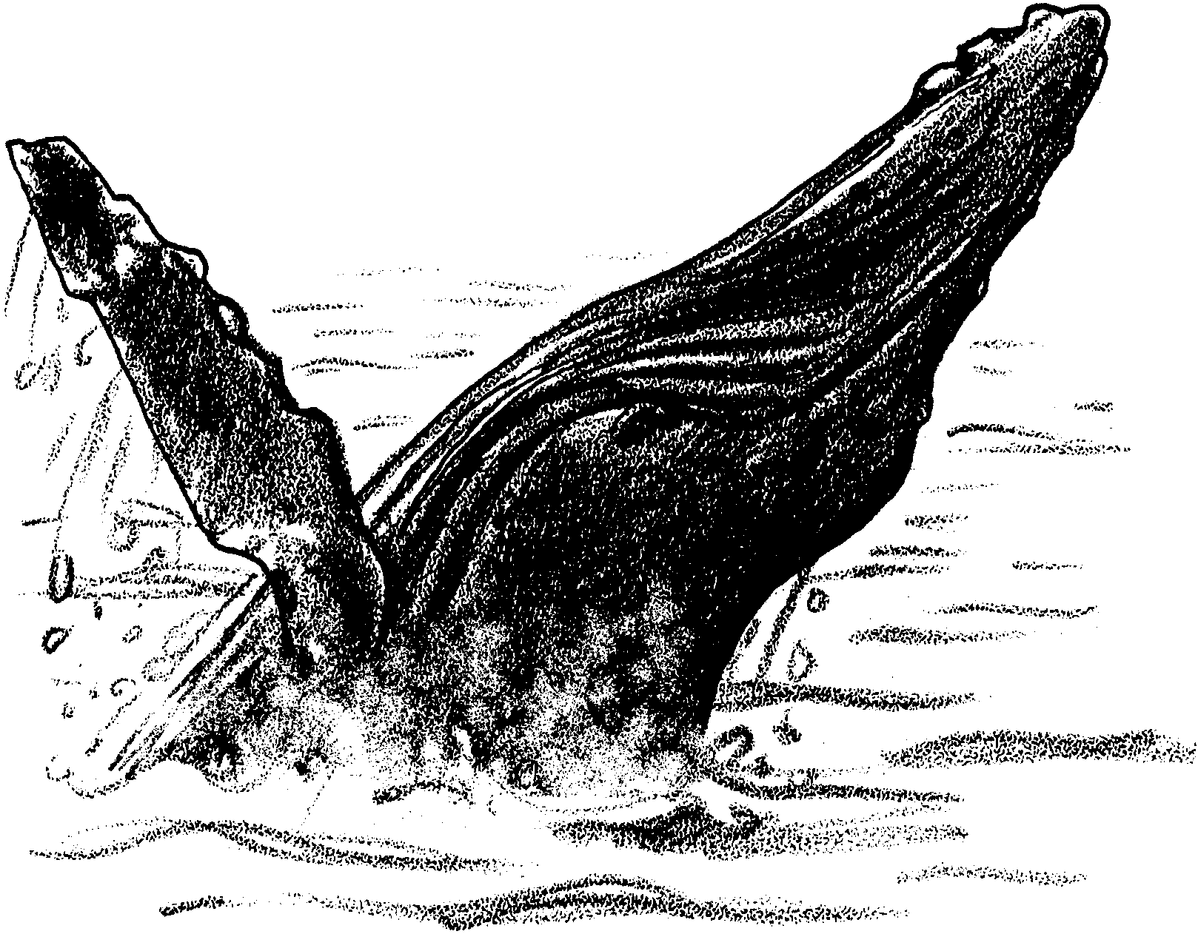
Hear-Sighted

In the moving, formless, often dark waters of the ocean, how do whales find their way? Maybe we can learn something from a whale that got “lost”.
In October, 1988, a humpback whale was spotted in San Francisco Bay. Humpback whales are usually found in the open ocean. His presence caused quite a stir. Soon known as Humphrey, he swam 67 miles upstream into the freshwater Sacramento Delta. He dodged boats that tried to herd him out of the river. He ignored recorded killer whale sounds played underwater. The sounds were supposed to scare him back downstream. They didn’t.
Upstream, the water got more shallow. Soon he trapped himself in a large drainage ditch. He lost body salts to the freshwater. His skin began to peel from exposure to air and sun. People tried most everything they could think of to get him to go back downstream. Nothing was working. Humphrey seemed doomed.
Then, in one last effort, rescuers on six small boats formed a “U” behind Humphrey. They slipped metal pipes into the water. They began banging on the pipes, making a curtain of sound. These “chimes” drove Humphrey downstream, back to San Francisco Bay. At the bay, Humphrey heard recorded Humpback feeding calls. The calls helped speed him back into the Pacific Ocean. His 25 day visit in freshwater was finally over. How were sounds able to save Humphrey?
The primitive ancestors of whales, dolphins, and porpoises lived on land. To survive, these primitive animals needed good eyesight. Modern cetaceans (whales, dolphins, and porpoises) also have fairly good eyesight. Unfortunately, most of the ocean’s waters are poorly lighted or totally dark. Only ten percent of the light hitting the ocean surface penetrates as far down as 30 feet. With limited light, vision (sight) is less effective. Seeing through dark or murky water is difficult. Cetaceans cannot depend upon vision to help them find others of their kind, navigate underwater, or guide them to their food. What senses do they use?

1. Often whales are seen “spy hopping”, pushing their heads up out of the water. How might this help them to get a better view of their surroundings?

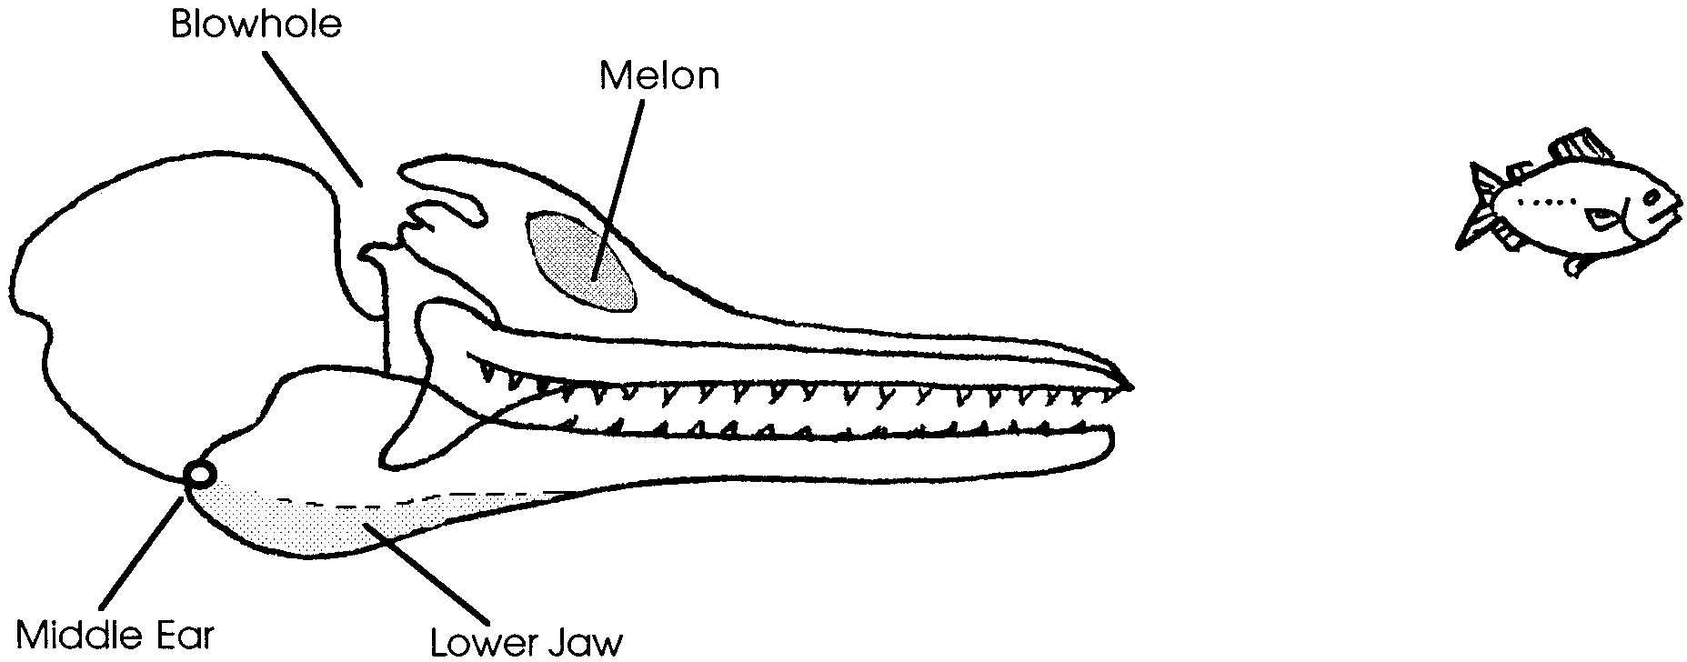
Whales, dolphins, and porpoises depend on their sense of hearing to guide them. Using this sense, they can “see” three dimensional objects in the water. How? These cetaceans have the ability to detect objects in the water using high frequency sounds. This ability is similar to that used by bats to catch flying insects. Sound waves are made and sent out. The sounds are produced inside the blowhole. A beam of sound waves passes forward out of the head through the melon. The melon is a mass of gelatin-like material in or “forehead”. The sound waves reflect off objects in the surrounding water as echoes. These echoes are received in the lower jaw, which then sends them to the middle ear.

The above diagram shows a cross section of a dolphin skull.

2. On the diagram use solid arrows to trace the path of sound waves from the blowhole to the melon and then to the fish.
3. Use dotted arrows to trace the path of sound waves from the fish to the tip of the lower jaw, then through the jaw to the middle ear.

Messages from the middle ears are sent to the brain. The well-developed auditory (hearing) areas of the cetacean brain receive the messages. From the nature of the echoes, the brain can determine the size, quality, shape and exact location of an object.

This whole process is called echolocation. Echolocation provides the cetacean with a three-dimensional view of its surroundings. Thus, whales, dolphins and porpoises “see” with their ears, as we do with our eyes.

4. The sound waves reflect off hard bony substances. They travel right through body tissue. A whale’s view of another animal is more like looking at an x-ray picture than a photo. In the space below, draw a “whale’s eye view” of a SCUBA diver.

Most echolocation studies have involved toothed whales. There is, however, evidence that at least some baleen whales also use echolocation. Gray whale sounds include clicks, grunts, moans and more. Scientists think that the clicks are probably used for locating food. They may also help the whale detect details in the environment. The grunts and moans may be used for finding others of their kind. They may also be used for scanning underwater features, like mountains and canyons. Migrating gray whales may remember these features. They may even use them to find their way from Mexican waters to the Arctic feeding grounds.

5. How could the memory of underwater features help whales to find their way from Mexican waters to the Arctic feeding grounds?

Humans, through the use of special amplifiers, continue to study echolocation by cetaceans. These amplifiers transform the high frequency sound into a series of clicks or pings. The following activity will help you determine your echolocation skills.

Part 1 - Listen Closely...

Materials

• clock, non-electric
• long, clean table or counter
• meter stick

Procedure

For this activity you will work in pairs. Read the procedure through before starting the activities to test your own echolocation ability.

Part A.

1. Obtain a clock and a meter stick.

2. Sit at one end of the table. Put your right ear flat against the table top. Place your hand flat over your other ear to reduce the sounds entering that ear.

3. Have your partner put the clock at the other end of the table.

4. Tell your partner you are ready to begin. Close your eyes and keep them closed until you are told to open them. Use your special creativity to imagine that you are a gray whale and the clock is a mass of shrimp, your favorite food.

5. When your eyes are closed, your partner will say “I am going to move the clock toward you. When you first hear the clock, raise your hand.”

6. After you raise your hand, open your eyes. Have your partner measure the distance from your ear to the clock. Record this distance:

Trial 1: Right ear distance centimeters.

7. Repeat steps 2 to 6 using your left ear. Record this distance:

Trial 1: Left ear distance centimeters.

8. Now repeat steps 2 through 7 to obtain a second set of data for your ears. Record these distances below:

Trial 2 Right Ear Distance: centimeters.

Trial 2 Left Ear Distance: centimeters.

9. Switch roles and help determine your partner’s “hearing vision”. Record your partner’s results in the spaces below:

Trial l Right Ear Distance: centimeters.

Trial 1 Left Ear Distance: centimeters.

Trial 2 Right Ear Distance: centimeters.

Trial 2 Left Ear Distance: centimeters.

Analysis and Interpretation

Part A

1. a. Are your right ear distances the same for Trial 1 and Trial 2? If they are, what was the distance?

b. If the distances are not the same, find the average distance for the right ear. (Hint: this is easy. To find the average add the two distances and divide the sum by 2.)

The average distance for the right ear is centimeters.

2. a. Are your left ear distances the same for Trial 1 and Trial 2? If they are, what was the distance?

b. If the distances are not the same, find the average distance for the left ear.

The average distance for the left ear is centimeters.

3. a. Are the right ear and left ear distances or averages the same? If not, what might explain the differences?

b. Do you think it is more important for whales or for humans to have equal hearing distances for right and left ear? Why?

4. a. With your present “shrimp hunting” ability, do you think you would make a good gray whale?

b. Do you think that you might be able to improve your ability with practice? Describe any of your data that supports your answer.

5. Compare your results with those of your partner.

a. Are your right ear distances the same? If not, what is the difference in centimeters?

b. Are your left ear distances the same? If not, what is the difference in centimeters?

c. Which of you could hear the shrimp at the greatest distance?

d. Do you think that all whales have equally good echolocation abilities? Upon what do you base your answer?

6. List three factors that could affect a whale’s echolocation ability.

a.

b.

c.

Part B.

Whales and other cetaceans use echolocation to do more than judge the distance to an object. They can tell the size, quality and exact location of the object. In Part B, you will see how well you can estimate the depth and position of your “shrimp”.

1. Again, sit at one end of the table. Put your right ear flat against the table top. Place your hand over your other ear to reduce the sounds entering that ear.

2. Tell your partner you are ready to begin. Close your eyes and keep them closed until you are told to open them.

3. When your eyes are closed, your partner will say “I am going to move the clock. When you first hear the clock, raise your hand. Tell me where the clock is on the table. Keep your eyes shut.” Your partner will move the clock to four different positions on the top, underneath the table, and on the table legs. (The clock must remain in contact with the table.)

4. Estimate the depth and position of the shrimp for all four positions. Your partner will record your answers (the apparent location) along with the actual location of the shrimp (clock).

Position Actual Location Apparent Location

1.

2.

3.

4.

5. Switch roles and help determine your partner’s “hearing vision”. Record your partner’s results in the space below:

Position Actual Location Apparent Location

1.

2.

3.

4.

6. Return the clock and meter stick. Answer the following questions.

Analysis and Interpretation

Part B.

1. I was able to correctly locate the shrimp in zero, one, two, three, four locations. (Circle the correct answer.)

2. Did your ability to locate the shrimp improve with practice? If so, what data supports your answer?

3. In this activity you tried to locate the position of the shrimp. Besides location, what can whales tell about an object by echolocation?

4. What are two ways in which the whale’s well-developed sense of echolocation helps it to survive?

a.

b.

5. Why does echolocation seem more important than vision in the ocean environment?

Part 2 - The Hear-Sighted Simulation Game

In “The Hear-Sighted Simulation Game”, while blindfolded, you will use sound to: orient yourselves and navigate without sight, find others of your kind, locate food, and avoid predators. Listen carefully and follow your teacher’s directions. Good luck!

