Gray Whale Photo I.D.
Written by Ardi Kveven, Snohomish High School,
Snohomish, Washington

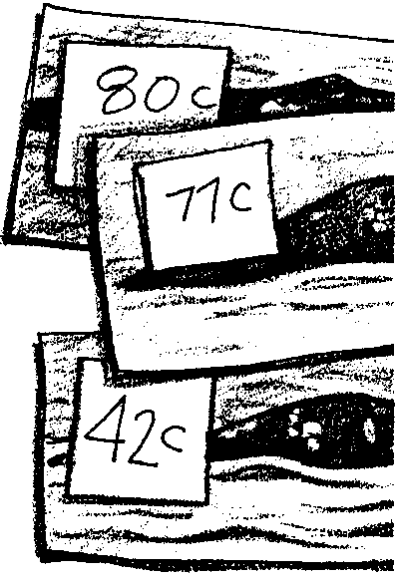
Key Concepts
1. Individual gray whales can be recognized by natural markings around the dorsal region of the whale.
2. Population information can be derived once individuals are identified.

Background

The fleeting time gray whales spend at the surface makes the identification and study of individual whales difficult. In the 1980’s, scientists in Washington State’s Puget Sound and off Vancouver Island, British Columbia began systematic programs of photo identification in an effort to learn more about gray whale life history. Utilizing information collected by scientists and members of the public, good identification photographs of many of the gray whales frequenting these areas have been assembled and cataloged.

Under ideal circumstances both the left and right sides of the whale’s back around the dorsal hump and the ventral side of the flukes are photographed. Since gray whales do not always raise their flukes out of the water and observers sometimes only see one side of a whale, the catalog listings are not always complete, a fact which complicates the task of identification.
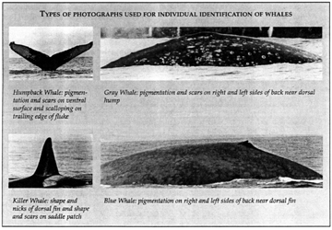

To establish individual identities, the natural markings around the dorsal region of the whales are compared in the photographs. Markings include skin pigmentation, mottling, scarring, and barnacles; all of which may vary between individuals. Some whale researchers combine this information with data from a computer program which matches the relative distances between the “knuckles” or bumps along the back of the whales to match individuals. Studies have shown that these markings and characteristics provide a reliable means of identifying gray whales over a long period of time.
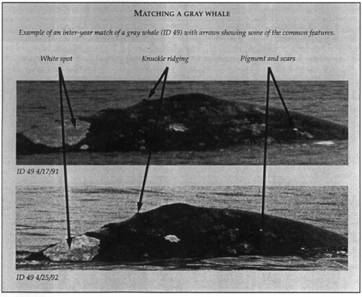

Researchers have established a catalogue of gray whales. Each entry provides the a number and date identification for each whale and photographs of the dorsal hump and, if possible, the ventral side of the flukes. Researchers compare new photos with the catalogue pictures to identify recently sighted whales.

Photo identification of whales was pioneered with the study of the orca whales in the Pacific Northwest and Vancouver Island in the early 1970’s when oceanariums were collecting live whales to display in captivity. After over 62 whales had been taken from local waters, residents started to worry about depletion of the population. Governments assumed there were thousands still roaming the waters, but commissioned a population study to be conducted by Dr. Michael Bigg. Dr. Bigg discovered that nicks, scratches and marks on the dorsal fins and saddle patches of the animals did not heal and were as indicative of individuals as human finger prints. To test his theory, Dr. Bigg marked two notches in the dorsal fin of one male whale with his jackknife after it was captured by an oceanarium. The whale was later released. Twenty-one years later, this male still can be seen in the San Juan Islands in the summer time and identified by his characteristic twin notches.

Materials

For each pair of students

• 1 set of 10 whale pictures

• gray whale catalogue

Teaching Hints

In “Gray Whale Photo I.D.”, your students compare 10 new gray whale photos taken in the field with catalogue pictures of gray whales. This activity is designed to simulate actual photo-identification research. It is most successful after the previous activity, “Field Studies of Whales”.

You may wish to make sets of whale photos and laminate them so you can use them year after year.

Students will need feedback on how accurately they are matching whale photos to the catalogue. Carry the key around with you to check student answers quickly. Remind students to use both the spacing between knuckles down the back and flukes to insure the correctness of their matches.

You may wish to introduce this activity by doing the following human finger print activity with your students: Have each student use a pencil to rub a shiny pencil-lead spot onto a piece of paper. Each student then rubs his or her right thumb on the lead to coat the right thumb print. Next, have each student carefully press the coated thumb onto a 3/4 to 1 inch wide strip of transparent tape. The print will be transferred to the tape. Then tape each print onto an index card and write the student’s name on the card. You now have a class catalogue of thumb prints. Have each child create another thumb print, but this time do not have students label the prints with their names. Let them use the catalogue of thumb prints to help them identify the prints of their classmates. Discuss successful searching strategies as you discuss overall success of the identification efforts.

Key Words

dorsal hump - in gray whales, a small hump on dorsal or top side useful in the identification of individual whales

fluke - either half of the triangular tail of a whale; tail flippers of the whale

Extensions

1. If you live near the Pacific coast, consider a gray whale watching trip. Contact the nearest aquarium or marine science center to locate whale watching charters.

Answer Key

Text questions

1. Answers may vary. Since the question calls for an opinion, accept any reasonable answer. The question is designed to get students thinking about the kinds of information needed and the difficulty in obtaining that information. Some students may suggest photography as an information gathering technique.

2. Answers may vary depending upon student experience. Some of the things which could be useful in identification include: skin pigmentation, mottling, scarring, and barnacles. The relative distances between the “knuckles” or bumps along the back of the whales also provides useful information.

Analysis and Interpretation

1. Answers will vary depending upon experimental results.

2. a., b. Answers will vary.

3. In addition to difficulty in locating the whales, bad weather, and sea sickness, photographers also have to have “camera angles” that allow the distinctive patterns to be visible in the photos.

4. From photos, researchers can gain information about familial relationships (who is the calf of whom), ages of animals first identified as a calf, and associations (which individuals or groups “hang out” together).

Gray Whale Photo I.D Answer Key
A-64
B-42
C-21
D-62
E-44
F-14
G-80
H-22
I-53
J-49

Acknowledgments:
Whale illustrations graciously donated by John Calambokidis
Whale catalogue pictures used with permission from Cascadia Research Collective, Olympia, Washington.

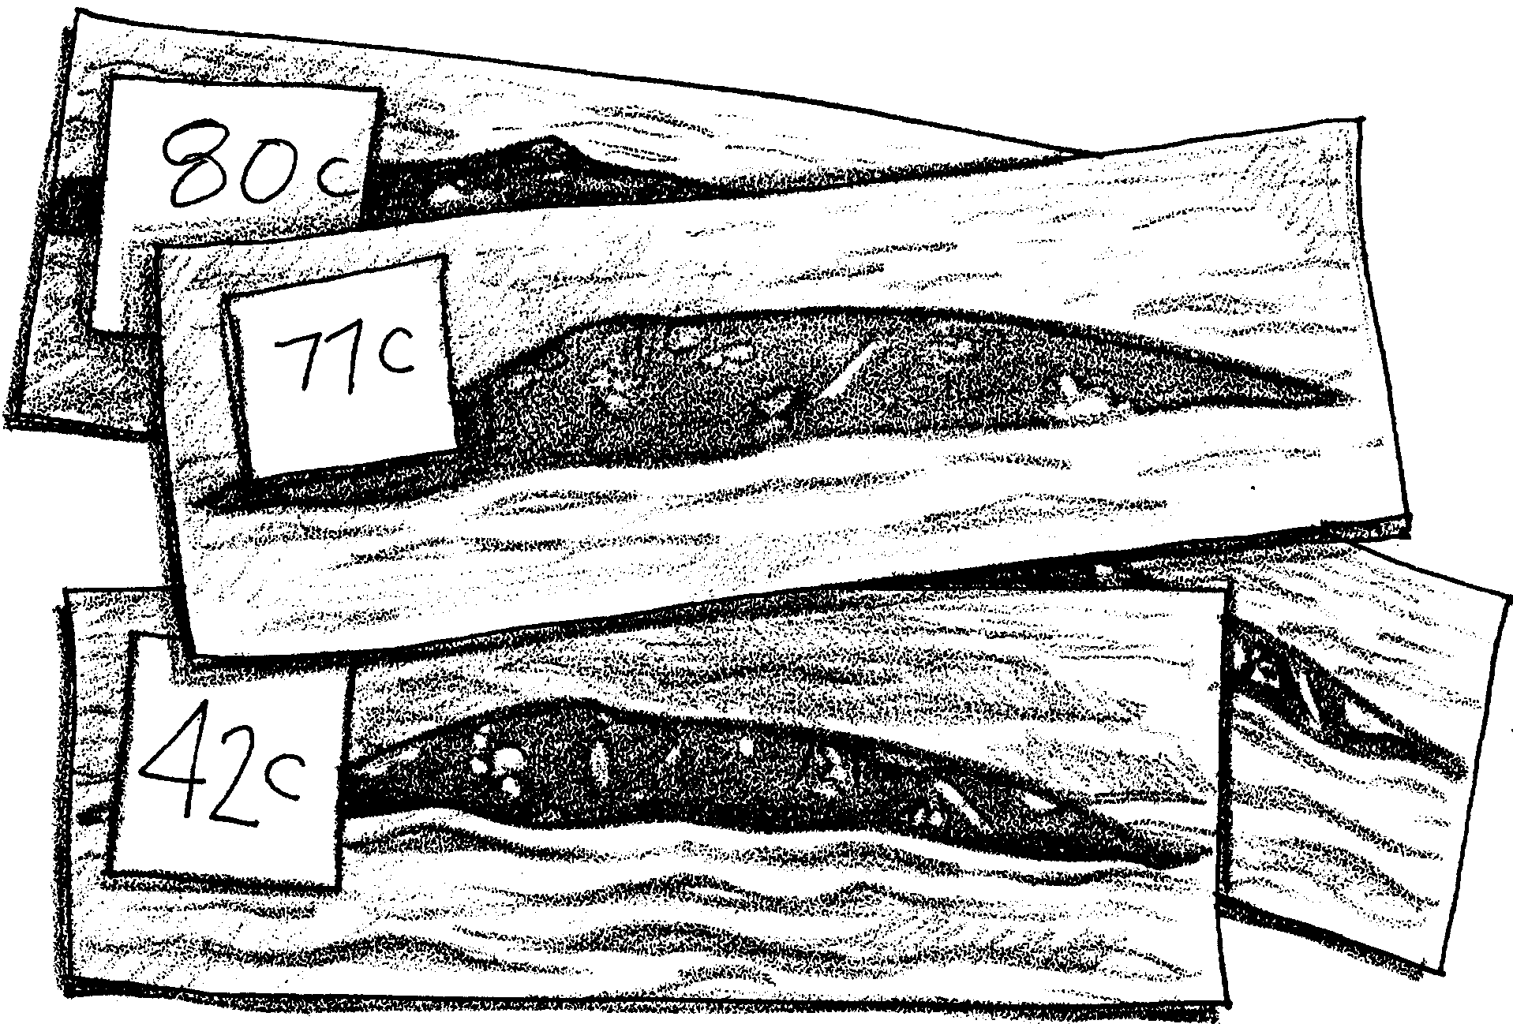
Gray Whale Photo I.D.

During their long migration, gray whales often swim near the shore. For centuries humans have watched these great whales. Today, scientists are watching these travels with renewed interest. As they watch, they wonder about lots of things. What course do the whales travel? Do they visit the same spots each year? How long do they stay in an area? How long do they live?

1. Think about some of the questions scientists are asking. How might you collect information to provide answers?

Answering these questions requires information about individual whales. Scientists have to be able to identify “who’s who”. This isn’t easy. Gray whales don’t spend much time at the surface. This makes the identification and study of individual whales difficult. Recently, photography has come to play an important role in whale identification. Now, good identification photographs of many gray whales have been assembled and cataloged. Some of the photos are taken by scientists. Others are taken by members of the public. Scientists identify each whale with a number. For example, the following picture shows whale “ID 21”
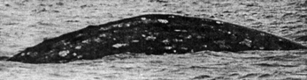
ID 21

Look at the photo of whale ID 21. It doesn’t look much like a whale. “Aha!”, you say, “it’s only part of a whale.” Right! But which part? The picture shows the left side of the dorsal hump. The dorsal hump and the flukes are most useful in identifying whales.

2. Look at the photo of whale ID 21 more closely. What are some of the things you see that could be useful in identification?

In the following activity, you will observe photographs of gray whales. Your task is to identify each whale. Just like the whale researchers, you will match pictures to identify individuals. Look for the shape and patterns. Look for scratches and nicks. Study both the dorsal hump and flukes in your picture. Compare these with the pictures in the catalog. Once you match your picture, identify the number of the whale in your picture.

Materials
• set of 12 whale pictures
• gray whale catalogue

Procedure

1. Work with a partner.

2. Spread out the whale photographs.

3. Try to match them to the catalogue pictures. Check with your teacher after you have matched the whales to see how many you have correct.

4. When you have identified all of the whales, answer the following questions.
Analysis and Interpretation

1. How many whales did you identify correctly the first time through?

2. a. Which whales were easier to identify? Why?

b. Which whales were more difficult? Why?

3. What problems might researchers face when trying to get photographs of the whales?

4. What other types of information about gray whales do you think researchers can gain from photos?

