Marine Mammal Adaptations:

Diving Buoyancy Part II

Microscale Cartesian Divers
Adapted with permission from John J. Mauch,
MicroMole Scientific
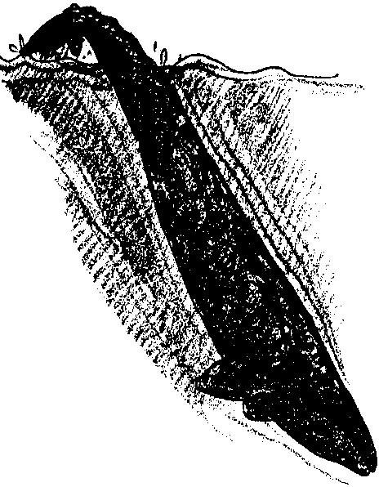

Key Concepts
1. Marine mammals maintain a near-neutral buoyancy in water.
2. Pressure tends to compress air spaces in marine mammals as they dive.
3. Air has weight and exerts pressure.

Background

The ability of whales to dive and surface is critical to their survival in the sea. What sorts of factors influence diving? Clearly, buoyancy influences diving. The blubber most marine mammals wear to keep warm is quite buoyant and would seem to prevent whales from diving. We know, however, that whales are extraordinary divers. Despite their buoyant blubber covering, their body composition makes them essentially neutrally buoyant. Through subtle control of their bodies, they can control their dives.

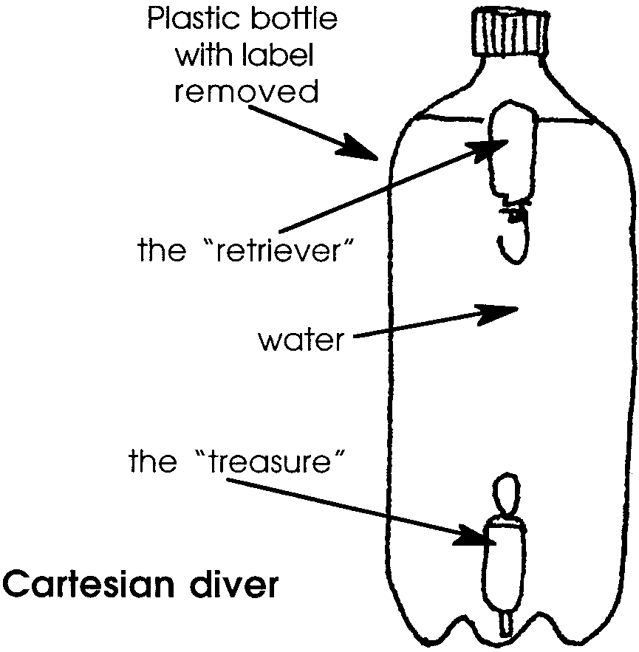
The concept of neutral buoyancy may be demonstrated with a device called a Cartesian diver. In its simplest form, a Cartesian diver is a glass vessel partially filled with water and covered with an airtight membrane, containing a hollow object that is open at the bottom and contains just enough air to allow it to float.

Like all air, the air in the hollow object has weight and so exerts pressure. (The air in a room can weigh as much as 100 kilograms, which is the weight of a large person.) That air can be squeezed, or compressed into a small space by pressing on the membrane. Compressing the air forces water into the hollow object and causes it to sink. Releasing the membrane causes the hollow object to rise.
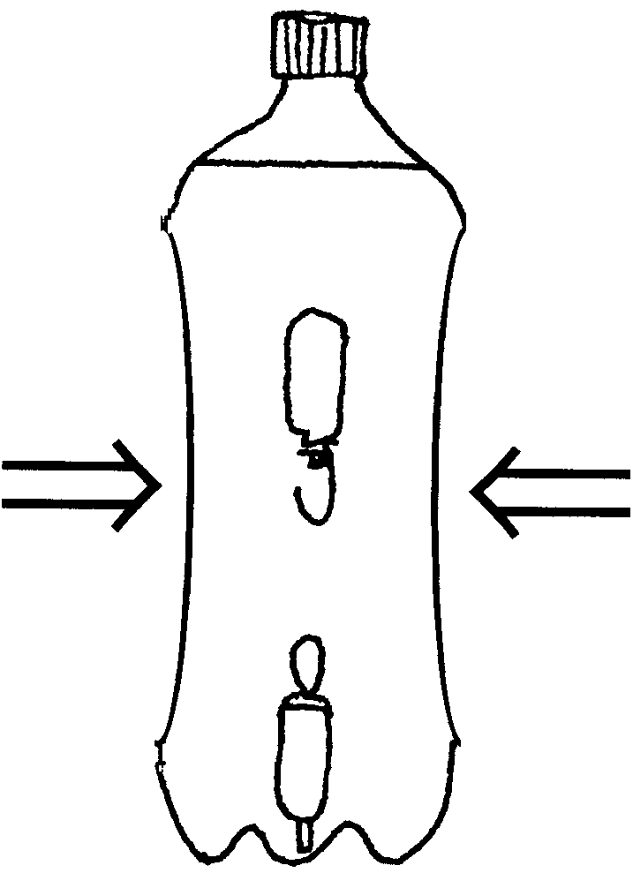
As an aside, the name “Cartesian diver” comes from the fact that the operating principle was first explained by Rene Descartes, a 16th century mathematician. Even today, diving machines that move by using air pressure are often described as “Cartesian”.

Materials

For each pair of students

• two graduated pipets with all but 1 cm of the stem cut off

• two stainless steel or brass hex nuts that can screw securely onto the stems of the pipets (If you take a pipet into a shop that specializes in nuts and bolts, they can usually find a size that fits. Usually, either 3/16" or 12/24 metric nuts fit and can self-thread on the stem of the pipet.)

• one 6-7 cm length of stiff nylon fishing line (30-50 lb. test)

• one 7-8 cm length of insulated copper wire (Speaker wire works really well because it can be bent without using any pliers; 22 gauge wire makes a stiffer hook but requires pliers to bend it into the proper shape.)

• one empty, clean, plastic, 2-liter soda bottle with cap

• water

For the class

• several containers with colored water

• one or more “testing tanks”, a 2-liter bottle with the top cut off at the point where the neck meets the side of the bottle

• hot-melt glue gun

• needle-nose pliers

• candle and matches
Teaching Hints

In “Diving Buoyancy Part II: Microscale Cartesian Divers”, students construct several toys called Cartesian divers. These toys will rise and fall exactly as a diving bell does. The exercise consists of two parts: “A Whale Retriever” and “Varying Buoyancies”.

In Part 1, “A Whale Retriever”, an easily adjustable Cartesian diver is made and then turned into a fun, challenging eye-hand coordination task. The directions are provided in the student activity pages. For safety, you may wish to have one or two candles for the class to use under your direct supervision. Position them near the “testing tanks” so that if the fishing line should catch on fire, the flame may be quickly extinguished by placing it in the testing tank.

After the divers are constructed, challenge the students to hook the treasure and bring it back safely to the surface by squeezing and tipping the bottle from side to side to can maneuver the retriever down. The degree of difficulty can easily be increased by decreasing the size of the loop and/or hook.

In Part 2, “Varying Buoyancies”, students create seven or more Cartesian divers each with a different degree of buoyancy. They then experiment with the effect of pressure changes on the divers.

The original idea of the Cartesian retriever was developed by Robert Becker of St. Louis, Missouri. The idea for “Varying Buoyancies” came from John Mauch’s observations of a first grader who wasn’t strong enough to get the diver to dive.

Durable, inexpensive, graduated pipets designed for these activities may be ordered from MicroMole Scientific, 1312 N. 15th, Pasco, WA 99301, (509) 545-4904.

Key Words

buoyancy - the power of an object to rise or float in a liquid

Cartesian diver - a glass vessel partially filled with water and covered with an airtight membrane, containing a hollow object that is open at the bottom and contains just enough air to allow it to float

epilogue - concluding part added to a literary work

neutral buoyancy - an object in a liquid which tends to remain vertically stationary, neither rising nor sinking

pipette - a slender graduated tube, in this case with a bulb at one end, used for transferring quantities of liquid from one container to another

retrieve - in this case, to recover from the bottom of a model sea

Extensions

1. Have students modify the diver set-up made in Part 1, “A Cartesian Retriever”, as follows:

a. Make a third pipet, with a loop on top and a hook on the bottom, so that it can serve as a “go-between”. The loops and hooks must be made smaller, thereby increasing the difficulty.

b. Increase the weight of the treasure to make it heavy enough so that when the first retriever hooks the treasure, it is not buoyant enough to lift the treasure.

c. Use the second retriever, working in tandem with the first, to lift the treasure.

2. Have students make a “Cartesian Helicopter” and hold a propeller design contest, trying to design a propeller that produces the most rotations as it sinks. Here’s what they’ll need:
• pipet
• a hex nut
• fifty cent piece
• wooden block
• paper punch
• utility or mat knife or similar sharp object
• scissors
• a small pinwheel propeller constructed from a sheet of plastic or vinyl (preferably bright colored material such as that found on some report covers)
• water
• one empty, clean, plastic, 2-liter soda bottle with cap

Here’s what they’ll do:

a. Using a fifty cent piece as a pattern, and a wooden block underneath the sheet of plastic, cut out a circle with an utility or mat knife or similar sharp object.

b. Punch a hole in the center of the circle with a paper punch.

c. Place the punched circle on the pipet and secure it with the hex nut.

d. Using a pair of scissors, cut the punched circle to the point on the hex nut where two sides meet. You will be making 6 cuts.

e. Adjust the density of the pipet with water, until it barely floats.

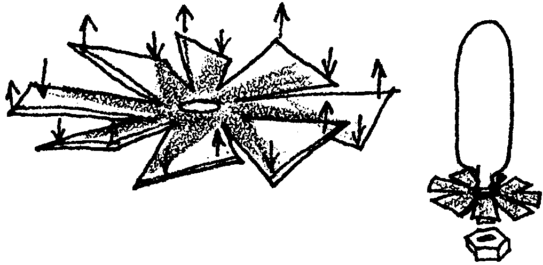
f. The ends of the propeller maybe bent so that when the pipet dives, it will rotate on the way down. (See figure 5). It will rotate in the opposite direction on the way back up.

g. Hold a propeller design contest, trying to design a propeller that produces the most rotations as it sinks. The propellers may be much larger than the mouth of the bottle, because the plastic will flex enough to permit the propellers to be inserted through the opening.

Note: A reference dot, placed on one of the propellers, makes it easier for students to determine the number of rotations. Have students consider the following parameters: the number of blades, the shape of each blade, pitch or angle of each blade, and size of the propellers.

3. Some of your students may be interested in playing “Cartesian Basketball”.

Here’s what they’ll need:
• pipet
• a hex nut
• fifty cent piece
• fishing line, about 10 cm
• aluminum foil
• candle and matches
• water
• one empty, clean, plastic, 2-liter soda bottle with cap

Here’s what they’ll do:

1. Wrap a piece of fishing line around a fifty cent piece and cut the line where it meets the end.

2. Heat the cut ends in the candle, make a loop, and join them together.

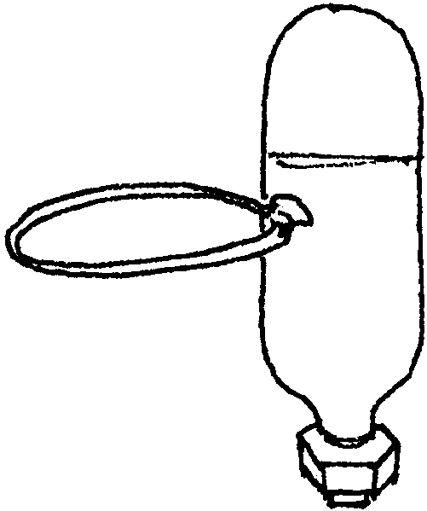
3. Select a pipet. Place the loop on the side of the pipet. At a right angle, glue the loop to the pipet. The pipette becomes the “standard or pole”, while the loop is the “basketball hoop”. Fill it with colored water and cut about one inch from the bottom. Attach the hex nut, and adjust the buoyancy until the basketball standard is on the bottom and floating upright. Seal the open end with hot glue.

4. A “basketball” can be made from a one inch square of aluminum foil that has been rolled into a ball. Some air is trapped in the foil so that it will float. As the ball descends, it will weave back and forth.

5. The rules of the game are quite simple. While maintaining a constant pressure, players try and maneuver the basketball through the loop of the basket.

Answer Key

Part 1: “A Retriever Whale”
1. The “whale” diver sinks when the bottle is squeezed.

2.a. Answers will vary. After a little practice, most students are able to suspend their whale retriever midway between the top and the bottom.

b. Answers will vary. Usually a particular constant pressure on the bottle is the key to suspending the whale retriever.

c. Since the question calls for an opinion, answers will vary. A real whale might want to suspend itself (i.e., be neutrally buoyant) when resting or sleeping to avoid predators or harassment. Accept any reasonable answer.

3. Answers will vary depending upon experimental results.

4. Answers will vary depending upon experimental results.

5. Answers will vary depending upon experimental results. Many students will find that the number of squeezes required to secure the treasure decreased with practice. The decrease could be interpreted as success in “training”.

Part 2: Varying Buoyancies
3. Answers will vary depending upon experimental results.

a. Whale number 7 usually floats the highest.

b. Whale number 1 usually floats the deepest.

c. From highest to deepest, the usual order for the numbers of the whales is:

7 6 5 4 3 2 1

4. Usually the divers descend in the following order:

1 2 3 4 5 6 7

Note: If students had other results and would like to see the divers descend in order, minor adjustments can be made to the buoyancy by either adding a little more water or squeezing some out.

5. The divers could be made to descend in some other order by varying their buoyancies through the addition or removal of water.

6. Answers will vary depending upon the knowledge and experience of students. Many students will note that increasing or decreasing the amount of air in its lungs will increase or decrease a whale’s buoyancy, at least temporarily.

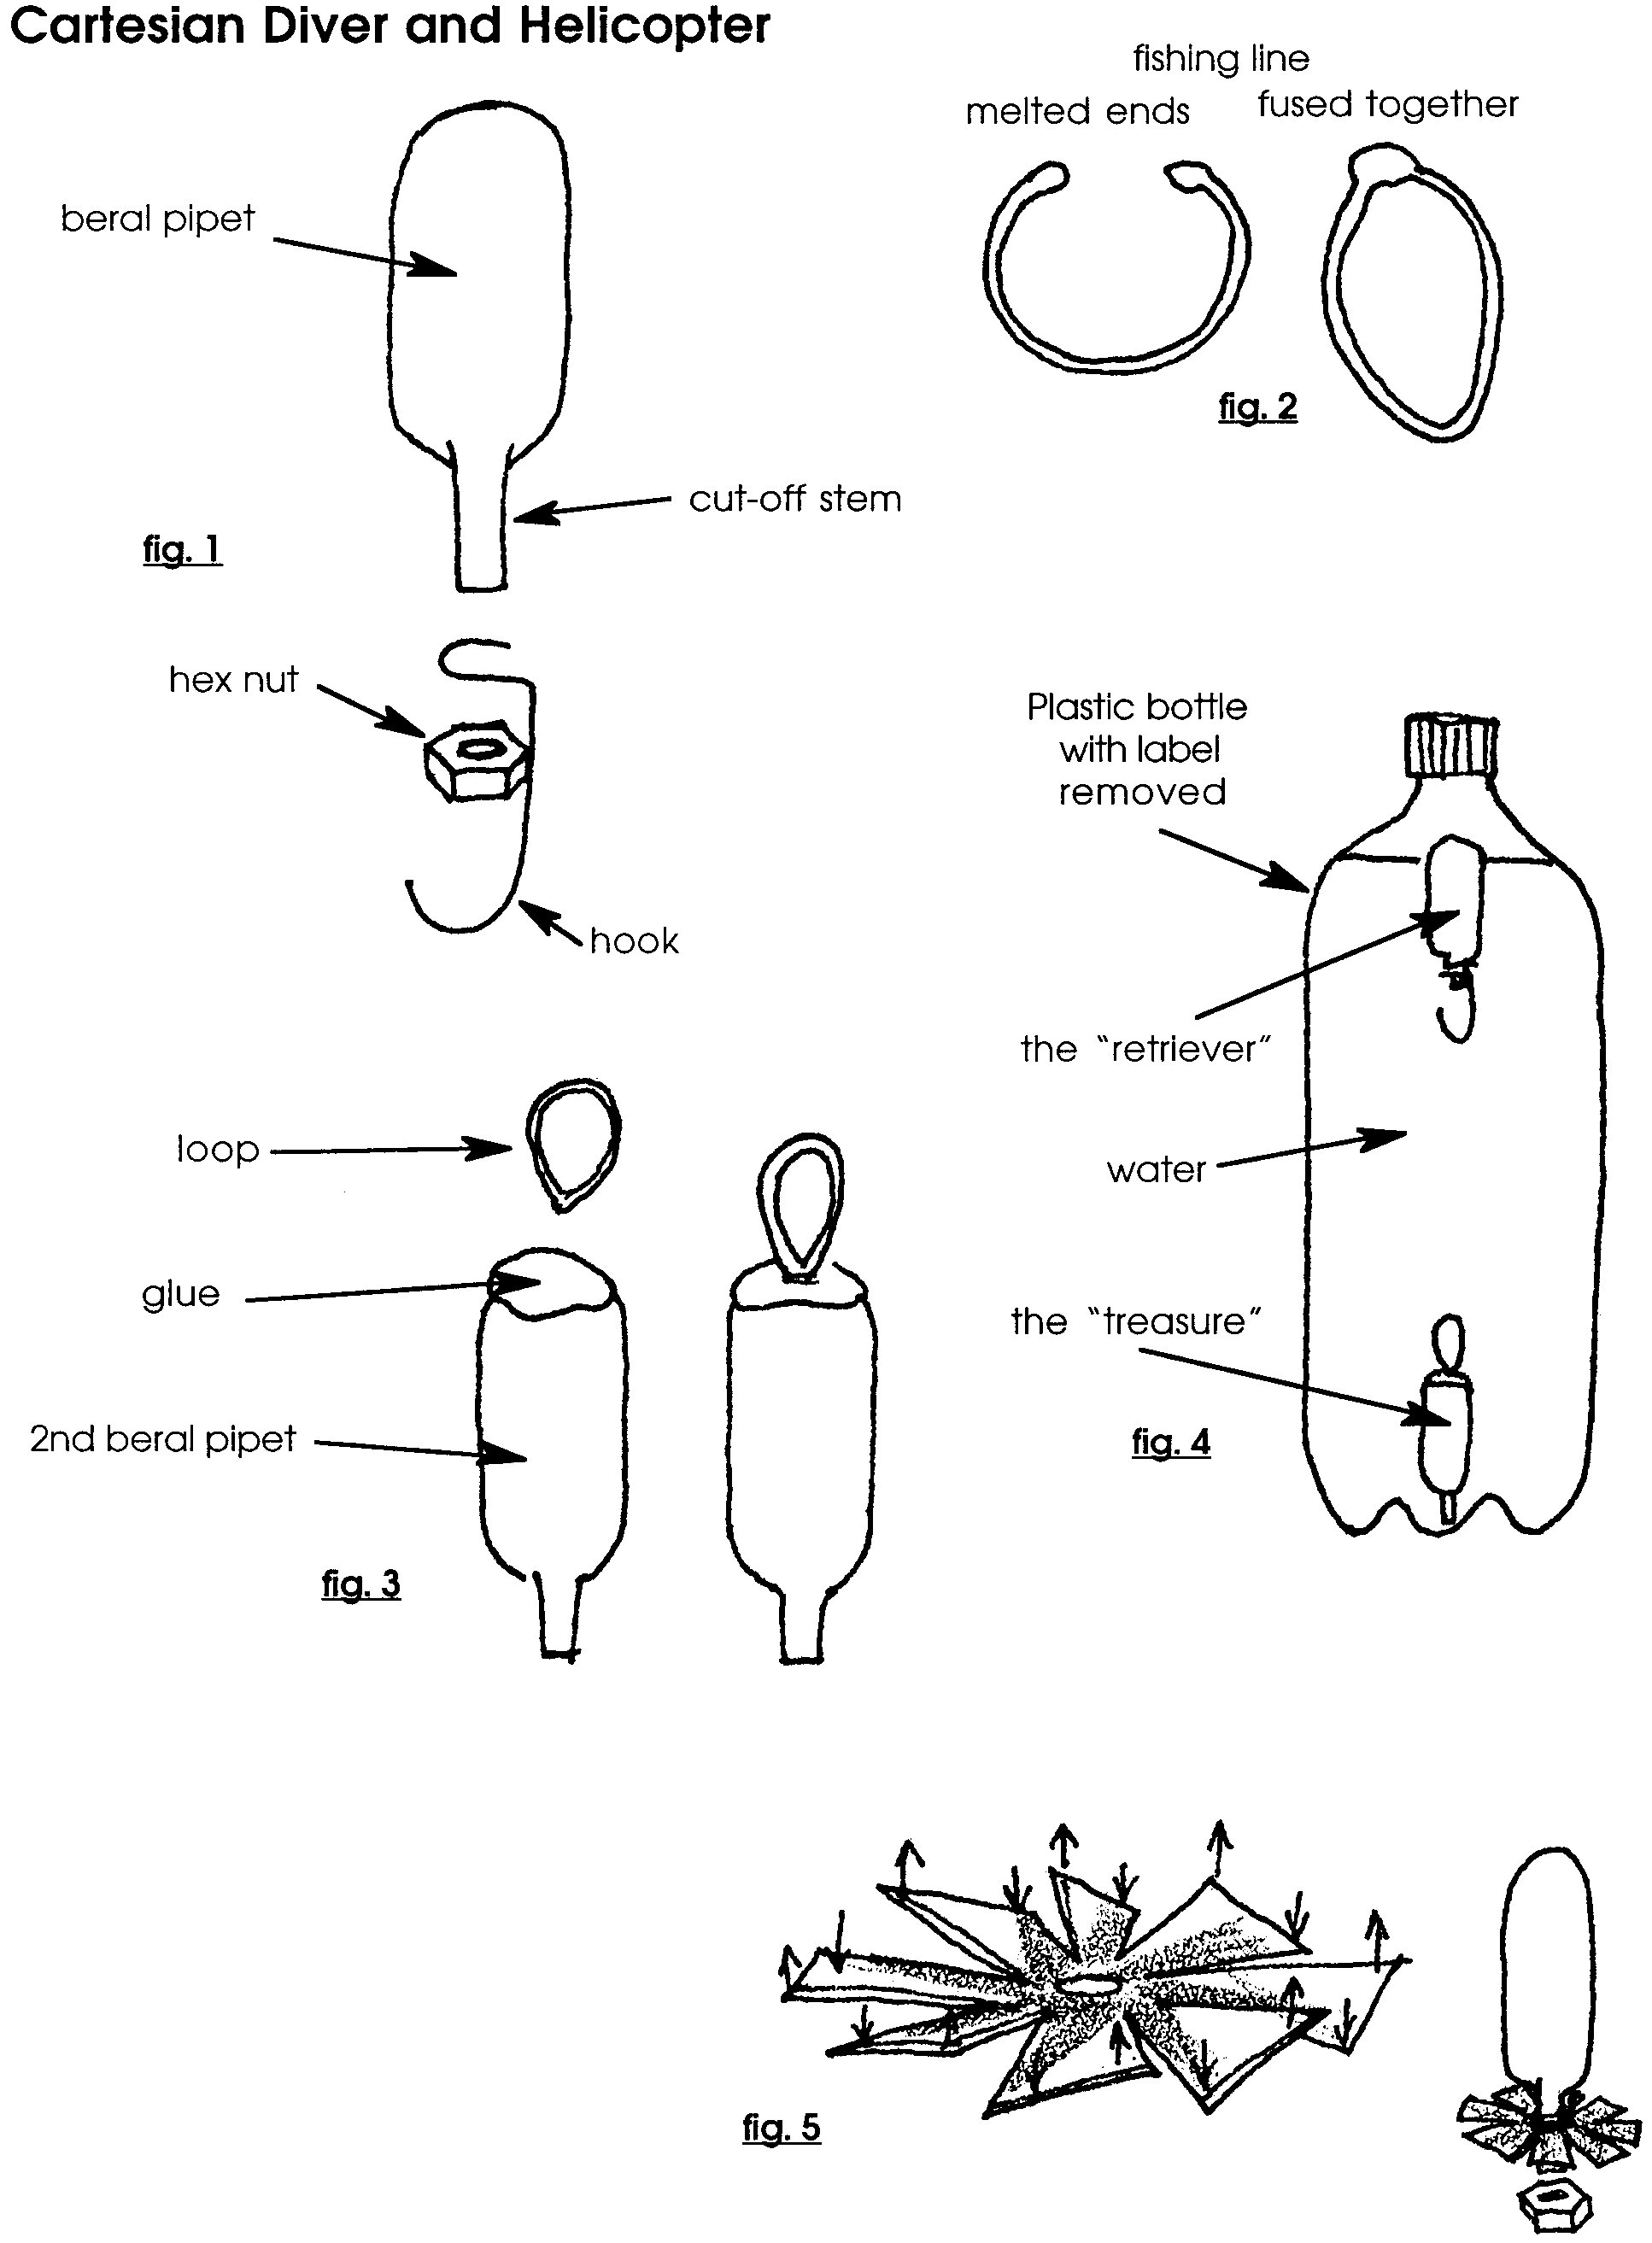

Marine Mammal Adaptations:

Diving Buoyancy Part II

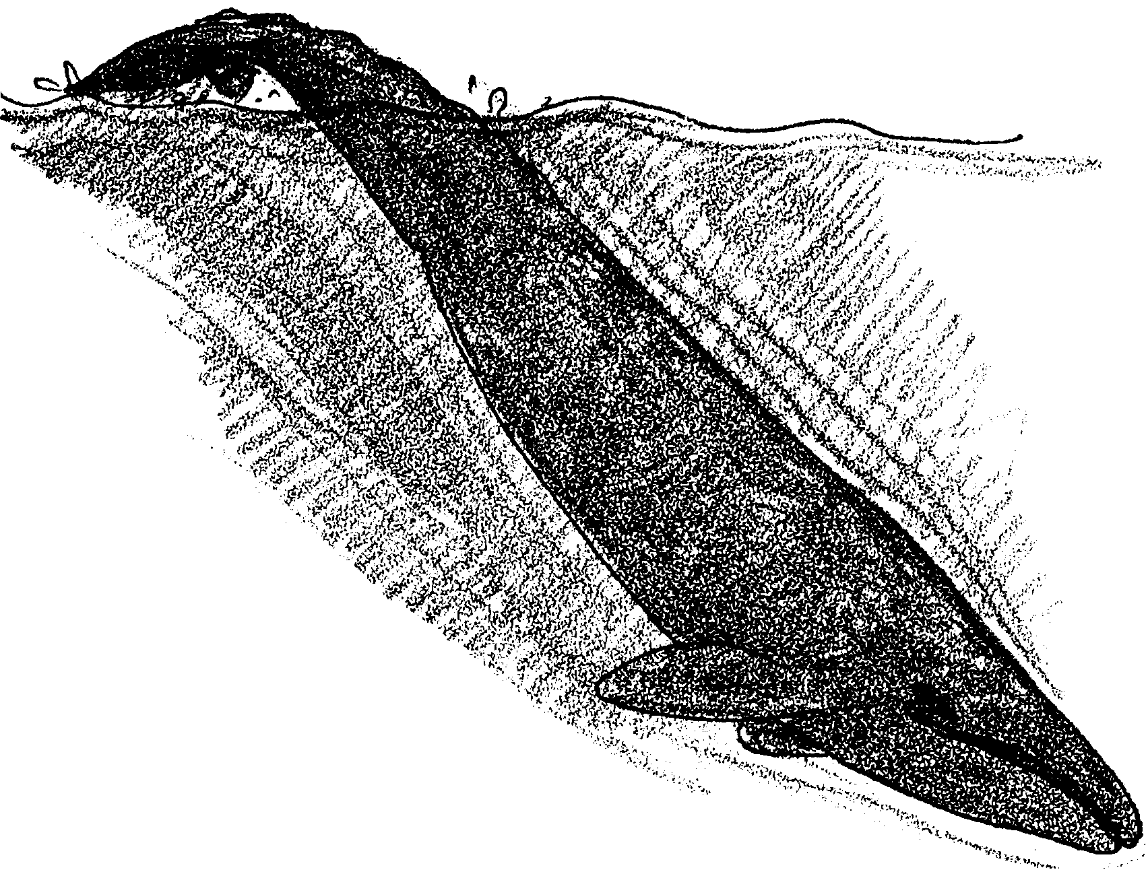
Microscale Cartesian Divers

Whales must dive and surface to survive in the sea. Their torpedo shaped bodies help them move through the water. What helps them float and sink?

The power to rise or float in a liquid is called buoyancy. A whale’s body composition makes it almost neutrally buoyant. This means that, at rest, a whale tends to stay put; neither rising or sinking. It also means that whales can control their dives by skillful control of their bodies.

In the following activities you’ll have a chance to test your skillful control of “whale divers”.

Part 1: “A Retriever Whale”

In Part 1, you’ll make an easily adjustable whale diver and then train it to retrieve a sunken treasure. Here’s what you’ll need:
• two plastic graduated pipets with all but 1 cm of the stem cut off
• two hex nuts that can screw securely onto the stems of the pipets
• one 6-7 cm length of stiff nylon fishing line
• one 7-8 cm length of insulated copper wire
• one clean, plastic, 2-liter soda bottle with cap
• water
• colored water
• hot-melt glue gun
• needle-nose pliers
• candle and matches

Construction of the Retriever Whale
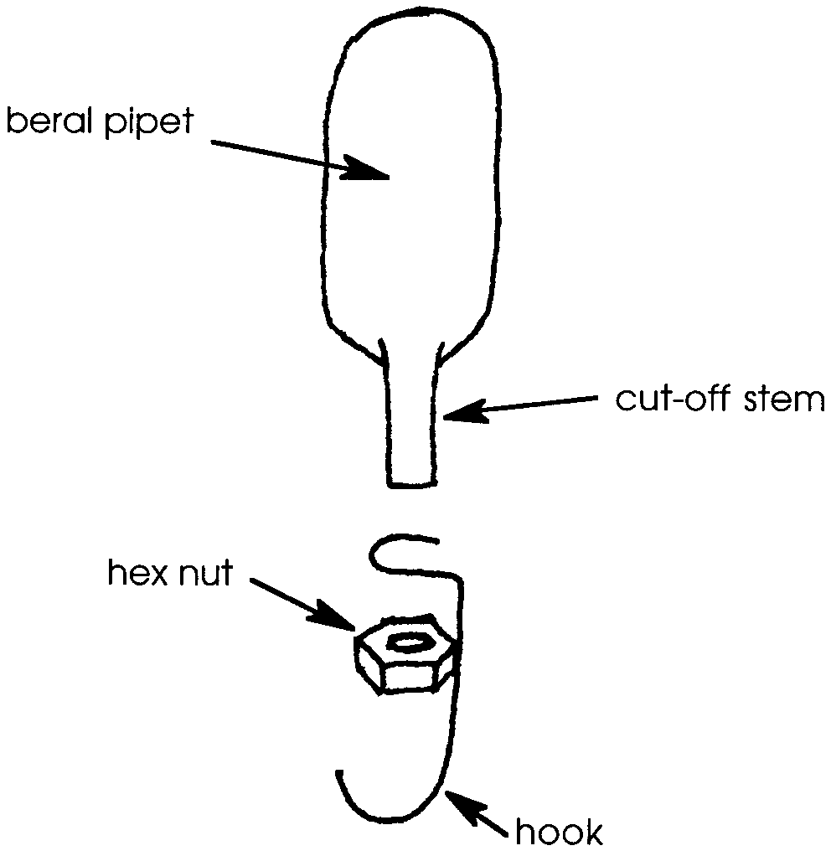
1. Using the pliers, make a hook from the wire.

2. Pass the cut stem of the pipet through the loop end of the hook. Thread one of the hex nuts over the end of the stem. Thread it on as far as it will go. The hook should now be held securely in place.

Construction of the Treasure

1. Attach the second hex nut to the second pipet.

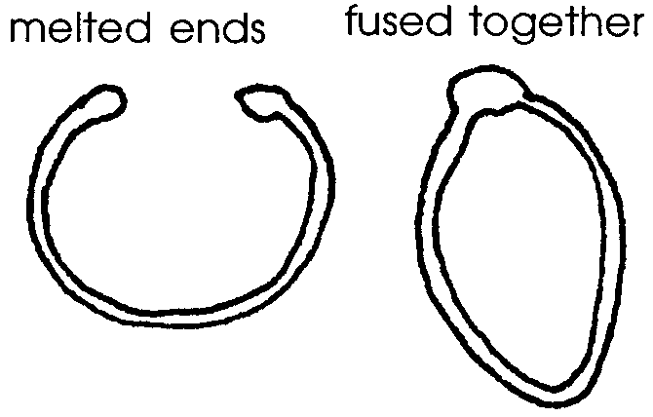
2. Light the candle. Bend the fishing line into a “U”. Hold the ends of the fishing line near the flame until the tips just start to melt. Push the two ends together so that they join to form a loop. Hold them together for at least 10 seconds to allow them to fuse securely. If the fishing line should catch on fire, extinguish the flame by placing it in the testing tank.

3. Place the loop on the end of the pipet away from the nut. Here’s how: Place a drop of glue on the end of the whale. Wait 3-4 seconds for the glue to begin to cool. Then push the joint of the loop down into the glue. Make sure that glue completely covers the joint. Wait one minute for the glue to set.
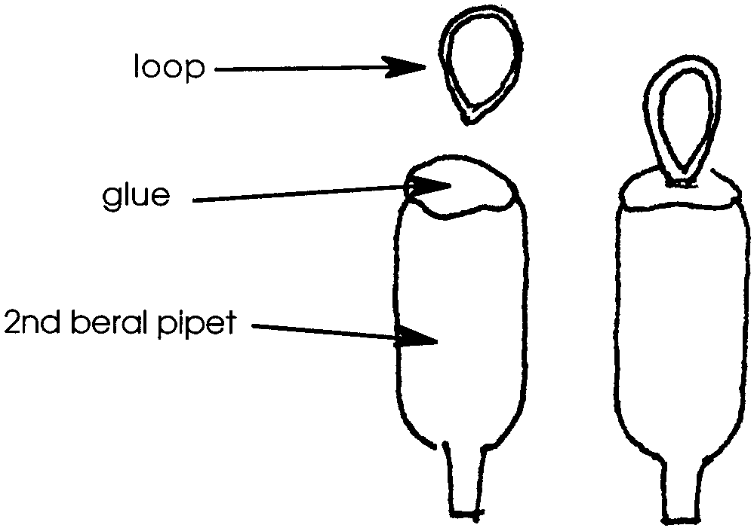

4. Fill the pipet about 1/2 full of colored water. As the treasure, this pipet needs to barely sink. Test it by placing it in the testing tank. If it readily sinks, squeeze a few drops of the colored water out of the pipet until it just barely sinks. If it floats, add a few drops of water until it just barely sinks.

5. Turn the pipet so that the end covered with the nut faces upward. Gently squeeze the pipet. Place a drop of glue into the opening to seal it. Place the “treasure” in the testing tank. Remove and gently squeeze the pipet to see if there are any leaks. The “treasure” is now finished.

Adjusting the Retriever

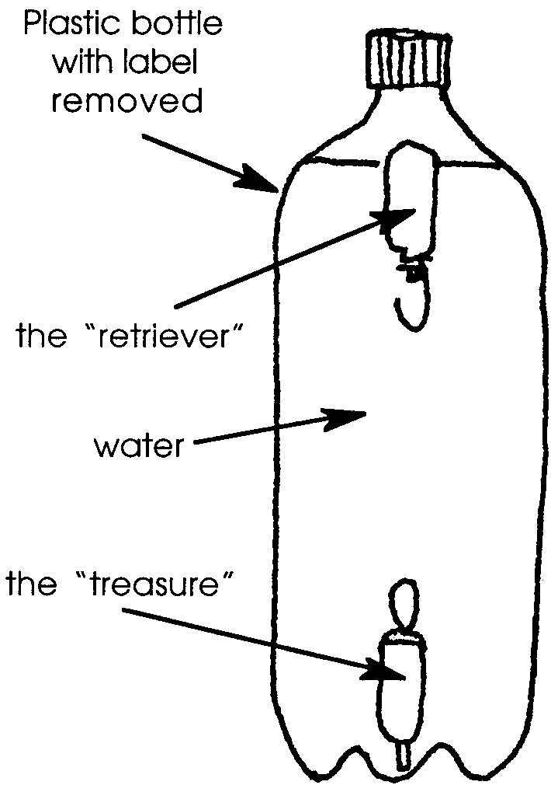
1. Place your treasure and whale retriever in the testing tank. Adjust the retriever so that when the treasure is attached, they will both float. If you leave too much air in the retriever, it will be almost impossible to squeeze the bottle hard enough to make it dive. The trick is to adjust the retriever so that it will be easy enough to dive, yet have enough buoyancy to lift the treasure, once it is captured.

2. Fill the plastic soda bottle with water to within about 5 cm of the top. Insert the “treasure”, then the “whale retriever”. Screw the cap on tightly. The treasure should be upright on the bottom, with the loop on top. The retriever should be on top, with the hook hanging down.
Your Challenge

Bring back the sunken treasure!

1. What happens when you squeeze the bottle?

2. Real whales can control their dives by skillful control of their bodies. Try to suspend your whale retriever midway between the top and the bottom.

a. Were you successful?

b. If so, how did you do it?

c. When might a real whale want to suspend itself in the water?

3. “Train” your retriever to hook the treasure and bring it back. Squeeze and tip the bottle from side to side. Count the number of squeezes until you bring your treasure back safely to the surface. Record the number below:

squeezes

4. Now that you’ve got the idea, try it two more times. Record the numbers below:

squeezes

squeezes

5. A trained “whale” will take fewer squeezes to hook the treasure. Have you been successful in “training” your whale? How can you tell?

Part 2: “Varying Buoyancies”

In Part 2, you’ll create seven whale divers each with a different degree of buoyancy. Then you’ll experiment with the effect of pressure changes on the divers. Here’s what you’ll need:
• seven plastic graduated pipets with all but 1 cm of the stem cut off
• seven hex nuts that can screw securely onto the stems of the pipets
• waterproof marker

1. Construct seven whale divers using the pipets and hex nuts.

2. Adjust the whales so that they all float with differing degrees of buoyancy. Here’s how: Number the pipets from 1 to 7. Leave #7 it full of air. Squeeze 2 bubbles of air from #6 while the diver is in the test tank. Squeeze 4 bubbles from #5. Squeeze 6 bubbles from #4. Squeeze 8 bubbles from #3. Squeeze 10 bubbles from #2. And, squeeze 12-13 bubbles from #1.

3. Place them all in the same 2-liter bottle.

a. Which whale floats the highest?

b. Which whale floats the deepest?

c. From highest to deepest, list the numbers of the whales below:

4. Screw on the cap, and squeeze the bottle. In what order do the divers descend? List the numbers from first to last:

5. How could you get the divers to descent in some other order?

6. How might whales change their buoyancy?

Epilogue

These “whales” are usually called “Cartesian divers”. They are named after Rene Descartes, a 16th century mathematician, who first played with them. So, how do they work? Like all air, the air in the diver has weight and so exerts pressure. (The air in a room can weigh as much as 100 kilograms. This is the weight of a large person.) That air is squeezed into a smaller space by pressing on the bottle. Compressing the air forces water into the diver and causes it to sink. Releasing the bottle causes the diver to rise.

