Marine Mammal Adaptations:

Diving Buoyancy
Lesson by Ardi Kveven, Snohomish, WA

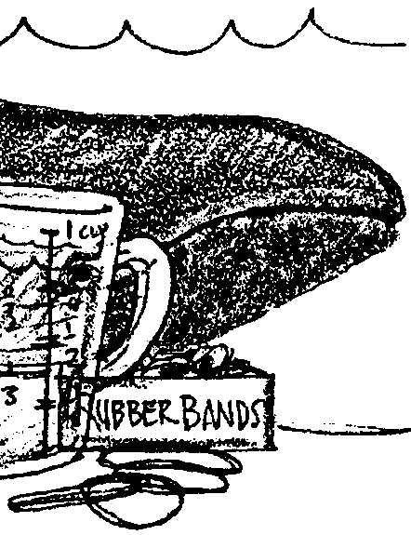
Key Concepts
1. Blubber insulation is one adaptation that enables marine mammals to maintain a near-neutral buoyancy in water.
2. Pressure tends to compress air spaces in marine mammals as they dive.

Background

The blubber most marine mammals wear to keep warm is quite buoyant and would seem to prevent seals and whales from diving. Seals and whales, however, are extraordinary divers. Despite their buoyant blubber covering, their body composition makes them essentially neutrally buoyant. Through subtle control of their bodies, they can control their dives.

Materials

For each pair of students

• resealable plastic sandwich bag

• a few ounces of vegetable shortening

• chicken leg bones (cook the chicken to kill any pathogens)

• gallon bucket with water

Teaching Hints

In this lab, students experiment with bone, air, fat, and water to find a combination that will be neutrally buoyant in a given tub of water. Then they submerge their model marine mammal and observe the compression of air spaces within the animal.

Key Words

blubber - the fat layer between the skin and muscle of whales, from which oil is made

buoyancy - the power to float or rise in a liquid

insulation - material that prevents or reduces the passage, transfer, or leakage of heat

neutral buoyancy - having a density similar to that of the surrounding fluid, in which case an object remains where it is placed, neither floating nor sinking

ratio - in this case, the proportional relations of the various materials used to simulate a whale body

Extensions

1. Have your students test and modify their plastic bag whales in a different type of water (colder, warmer or more or less salty).

2. Provide a balance and graduated cylinders and ask students to measure the mass and volume of each part of their model animals and then the mass and volume of their assembled plastic bag whale. What ratio of mass to volume is necessary to make a neutrally buoyant whale in the water they are testing? ( Fresh water has a density of 1 gram per milliliter, so any object that weighs more than 1 gram for each milliliter of space it takes up will sink in fresh water. Any object that weighs less than 1 gram for each milliliter of space it takes up will float in fresh water. Salt water has a higher density and so objects must be somewhat more dense, they must weigh more for their size, in order to sink in salt water.)

3. There are many standard physics lab activities that explore density and which could extend this lesson. For example, your students could make Cartesian divers.

4. Explore the role of blubber as an insulator. Use the activity “Marine Mammal Adaptations – Blubber Mitt Lab & Staying Warm” in the FOR SEA grades 9-12 curriculum as a place to begin.

Answer Key

1. Student lists of materials that make up a whale’s body will vary. They probably will include muscle, bone, nerves and skin. Students may mention blood, water and air. Accept reasonable lists.

2.a. Student predictions will vary.

b. The plastic bag filled with air will float.

3.a. Student predictions will vary.

b. The plastic bag filled with water will be neutrally buoyant and will neither float nor sink.
4.a. Student predictions will vary.

b. The plastic bag with a chicken bone will sink.

5.a. Student predictions will vary.

b. The plastic bag with shortening will float.

6. Ratios of materials will vary depending on the kind of water in which students are testing their whales.

7. Neutral buoyancy enables whales to dive or surface without expending a lot of energy to overcome buoyancy.

8. Answers depend upon experimental observations. It would be expected that the plastic bag whales would compress as the students submerge their plastic bags.

9. As whales dive, the air in their lungs would compress.

This lesson was written by Ardi Kveven, Snohomish High School, Snohomish, Washington and originated from an idea appearing in the 1993 JASON Project Curriculum published by the National Science Teachers Association.

Marine Mammal Adaptations:

Diving Buoyancy
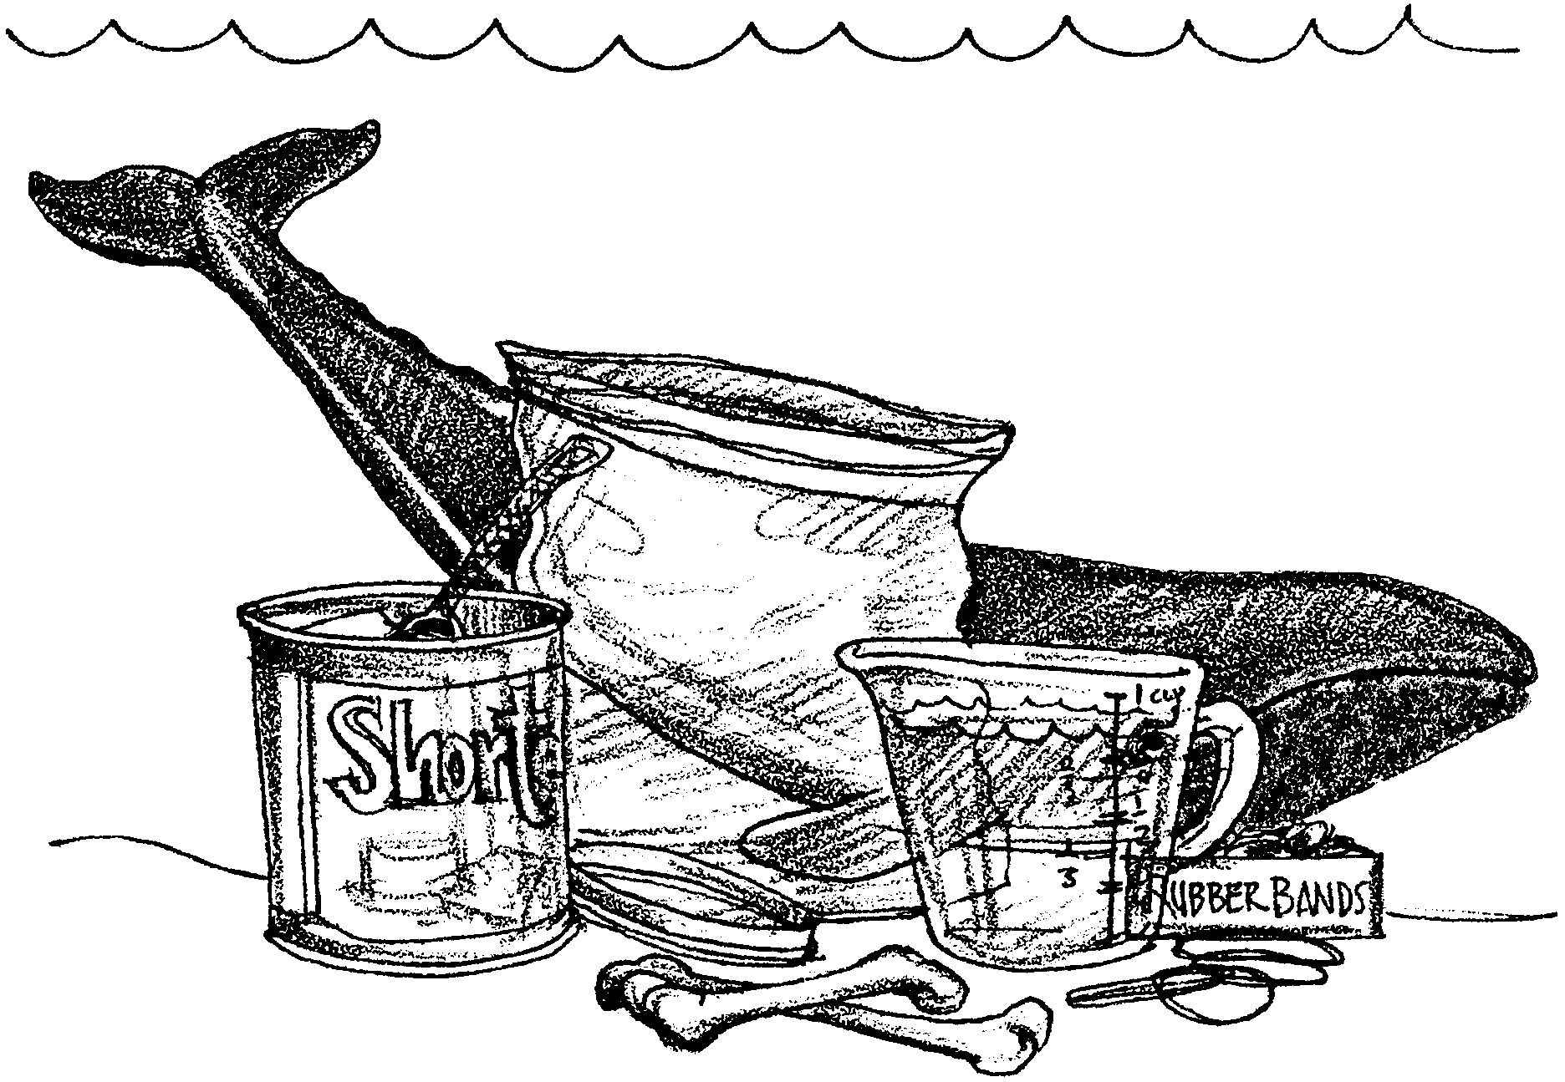
Whales have blubber to help them stay warm. This blubber not only insulates, but also floats very well. Whales do need to spend part of their time at the water’s surface to breathe, but they also depend on their ability to dive to evade predators, hunt food and travel. They are able to submerge despite their buoyant insulation.

1. What other materials, in addition to blubber, do you think make up a whale’s body?

In this activity, you will use models of the materials that make up a whale’s body and discover what ratio of materials enables your whale to rest in the water, neither floating too high nor sinking too deep. You also will get a chance to observe what happens inside your model whale’s body as it does dive deep.
A real whale is made of tissues including blubber, muscle, and skin. Its blood and its tissues are largely made of water. Its body also includes bone. Open cavities in the whale’s body are filled with air. We will use the following materials to model a whale’s body:

Blubber = shortening

Skin = plastic bag

Bone = chicken bones

Water = water, of course

Air = air, of course

Begin by testing the materials separately. Use a plastic bag as the skin to hold the other body parts of your whale.

2. a. Do you think a bag filled with air and sealed will sink or float?

I think the bag will .

b. Try it. What did the bag filled with air do?

3. a. What do you think a sealed bag filled with water will do in the bucket of water?

I think the bag will .

b. Try this, too. Did the bag sink or float?

4. a. Do you think a sealed bag with a chicken bone and no air will sink or float?

I think the bag will .

b. Try it. What did the bag with a chicken bone inside do?

5. a. Finally, do you think a bag with shortening and no air sealed inside will sink or float?

I think the bag will .

b. Try it. Place some shortening in a plastic bag. Push all the air out, and seal the bag. Place the bag in your bucket or tub of water. What did the bag with shortening do?

Now assemble some combination of these materials to create a plastic bag whale that is neutrally buoyant. This means that the whale will neither float at the surface of the water nor sink to the bottom.

6. How much of each material did you use to make a neutrally buoyant plastic bag whale?

Blubber

Skin

Bone

Water

Air

7. How might it be beneficial for a whale to be neutrally buoyant?

Make your plastic bag whale dive. Push it to the bottom of your bucket and watch how the bag and its ingredients change.

8. How did your model whale change as you made it dive?

9. Marine mammals can stay submerged a long time without coming up for air. For some time, scientists have wondered how. They once believed that it was because whales took in huge gulps of air before they dove. If this were true, what would happen to those lungfuls of air as the whale or seal dove? (Hint: What happened to your model whale as it “dove”?)

