Swimming Northward - March 7

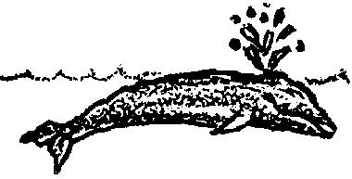
Key Concepts
1. Gray whales swim and dive continuously in a rhythmic pattern which allows them to migrate at 85-100 miles a day.
2. Gray whales have adaptations for swimming, breathing, and diving.

Background

During migration, gray whales have a rhythmic pattern of swimming, breathing and diving. A series of three to five short, shallow dives of less than a minute each, is followed by a long, deep dive of about five minutes in duration. This pattern appears to enable gray whales to store oxygen for an up-coming long dive and to get rid of carbon dioxide built up during the previous long dive.

A deep dive is usually signaled by the flukes rising out of the water. The approximate duration of a deep dive can be determined by counting the short dives, with one short dive for every minute spent in a deep dive.

The dives are identified by the blow or spout as the whale comes to the surface. Gray whales have a characteristic heart-shaped, double plume spout, a misty jet of vapor reaching up to 15 feet high and visible from quite a distance. The visibility of the spout against the horizon (i.e., “Thar she blows!”) and a migration route near to shore almost spelled doom for gray whales at the turn of the century.

The blow is not a fountain of water, but a mist which forms as the warm moist air from the whale's lungs, exhaled under high pressure, condenses in the cooler atmospheric air.

In migration whales generally swim 24 hours a day. Their rate of progress may vary due to disturbances by predators, feeding opportunities, resting times, currents, whales watchers, or hunters.

Materials

For the class:

• a clock with a second hand or a stop watch

For each student

• “Swimming Northward - March 7” activity pages
Teaching Hints

As our baby and mother gray whale continue their migration to Arctic waters, “Swimming Northward - March 7” examines the breathing and diving rhythm of the gray whale, calculates an average distance it travels per day on its migration, and illustrates the physical adaptations of the gray whale by relating its breathing technique to that of humans.

This brief look at the whale's swimming, breathing and diving adaptations may be expanded through the use of available media. As you embark on these activities, stress the relationship between the gray whale's physical world and its biological world. Bulletin boards, films, video, and tapes can help you tie these worlds together. Collect pictures of gray whales in various activities and perspectives and display them in the classroom.

If you haven't already done so, at this point you might consider posting a large scale map of North America on your bulletin board. On the map your students can show the route-to-date of the gray whale calf and mother. The route can be indicated by paper whales. Have your students indicate the calendar date on which the gray whales pass a given point. They can easily do this by writing the date on the paper whales as they place them in the appropriate spots on the map. Note that the dates are approximations; a mother and calf would likely migrate at a slower rate than adults without calves due to the extra time spent nursing, feeding, resting, and avoiding predators such as orca whales.

Procedure

1. Introduce a discussion of adaptations for traveling in water by asking students to describe how they breathe when they are swimming near the water's surface. They will probably say that people hold their breath when they swim under water and come up for air as they need it. Also, people swimming at the surface usually hold their breath for a certain period of time and exhale and inhale at regular intervals between strokes. Tell them this is similar to the way a whale breathes when it is swimming. Since the whale spends all its time in the water, breathing in this way is normal.

2. Have students propose strategies for “energy-efficient” swimming, breathing, and diving which could be used to travel great distances. Ask questions such as:
Would they swim mostly at the surface or under water?

How often would they need to breathe?

How could they breathe most efficiently?

What devices might they use to aid their swimming and breathing? (e.g., flippers, snorkel or scuba gear, etc.)
3. Brainstorm ways whales have adapted to swimming, breathing and diving in the ocean. How do these adaptations compare with the student proposals for “energy efficient” swimming?

4. Have students complete the student activity pages as individuals or partners in class. Allow for a discussion of the narrative questions and activities.

If you are using Voyage of the Mimi in conjunction with this unit, “Episode 4: Counting Whales” and “Episode 6: Home Movies” correlate well with the above lesson.

Key Words

adaptation - a change in structure, form, or habits to fit different conditions

cycle - a complete process of action that repeats itself in the same order

blow holes - a nostril or hole for breathing, in the top of the head of whales, porpoises, and dolphins

breathing reflex - the automatic, involuntary resumption of breathing governed, in part, by the level of carbon dioxide in the blood

esophagus - the tubular passage for food from the mouth to the stomach in vertebrates

evolution - the process by which all existing organisms have developed from earlier forms through modification of characteristics in successive generations

exertion - vigorous action, effort or exercise

spout - a mist which forms as the warm moist air from a whale's lungs, exhaled under high pressure, condenses in the cooler atmospheric air; also called a “blow”

Extensions

1. Follow up by exploring techniques for students to control their own breathing rate and the amount of air they can inhale. Record variations in individual ability to control breathing, have students speculate on causes for the observed differences, and design and conduct experiments to prove or disprove their hypotheses.

Answer Key

1. a. Our whale spent 8 minutes completing the breathing cycle described.

b. She swam 7.5 cycles in one hour. (i.e., 1 cycle = 8 minutes. 60 minutes divided by 8 minutes/cycle = 7.5 cycles in one hour.)

c. She swam one half mile in the cycle described.

d. At this rate, she would swim 3.75 miles in one hour. (i.e., 7.5 cycles x one half mile.)

e. At this rate, she would swim 90 miles per day. (i.e., 3.75 miles per hour x 24 hours.)

f. At this rate she would have traveled 1260 miles since February 21. (i.e., 90 miles/day x 14 days = 1260 miles.)

g. At 90 miles per day, our gray whale's rate falls within the observed averages for distance covered per day. Note that gray whales make the passage south from Unimak, Alaska to Baja California in an average of 55 days. They have been clocked at slightly slower speeds on their journey north.

2. a.-c. Adaptations that help the gray whale to be a great swimmer include: smooth body, torpedo shape (streamlining), density near that of salt water allowing it to be almost weightless, flippers, powerful tail fluke, and blubber for insulation and flotation.

3. A nostril location on the back of the head lets the whale continue to keep it “face” in the water while swimming. Unlike humans, whales don't have to lift their heads to breathe as they swim.

4. A spout is the mist which forms as the warm moist air from the whale's lungs, exhaled under high pressure, condenses in the cooler atmospheric air.

Answer Key continued on next page.
5.
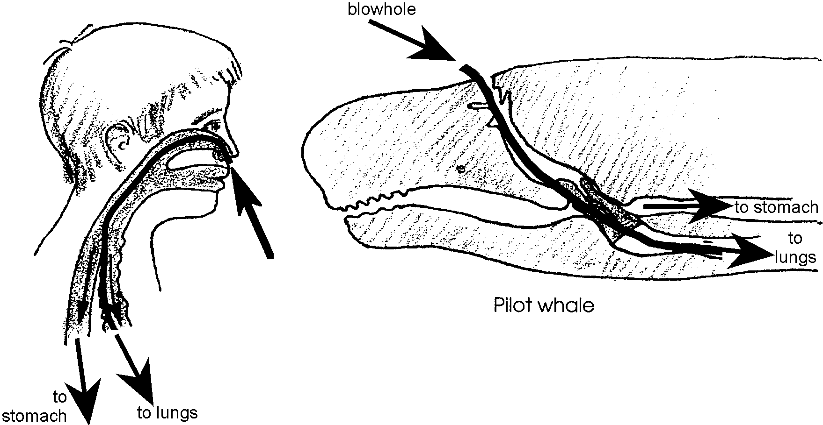

6. Students should find that they are unable to breathe and swallow at the same time. When humans try to swallow and breathe at the same time, the breathing is interrupted by the swallow and resumes after the swallow.

7. Recorded time will vary.

8. Your students' breath-holding capacity will be considerably less than that of a sperm whale or a gray whale. This exercise is designed to give your students a feel for the incredible diving ability of whales.

9. This question emphasizes the point that we breathe automatically when the carbon dioxide level in our blood increases. As a result, you would not have to worry about a child holding her breath until she dies. (You might have to worry about the threat but not about the possibility of asphyxiation.)

10. Your students will be able to exhale residual air after a regular exhalation. Since whales can almost completely exhale the used air, they retain less air than we do. The whale's lungs would contain little or no “dead” air.

11. While your students may have varied answers, a little discussion should help them arrive at the conclusion that the two body parts most likely to be affected by a lack of oxygen are the brain and the heart.

12. The period of shallow swimming probably provides the whale with an opportunity to recharge the oxygen levels in the blood and muscles.

13. Sketches will vary but each should show the following adaptations:

lungs - whale lungs use air efficiently; they can almost completely exhale the used air and replace it with fresh air.

blood - whales have proportionally more blood (which holds more oxygen) than land mammals of similar size.

muscles - whale muscles can store a large amount of oxygen in each cell for future use.

circulation - whales can shut off blood circulation to those parts of the body that can endure lack of oxygen for a period of time.

heartbeat - whales slow their rate of heartbeat during a dive.

Swimming Northward - March 7
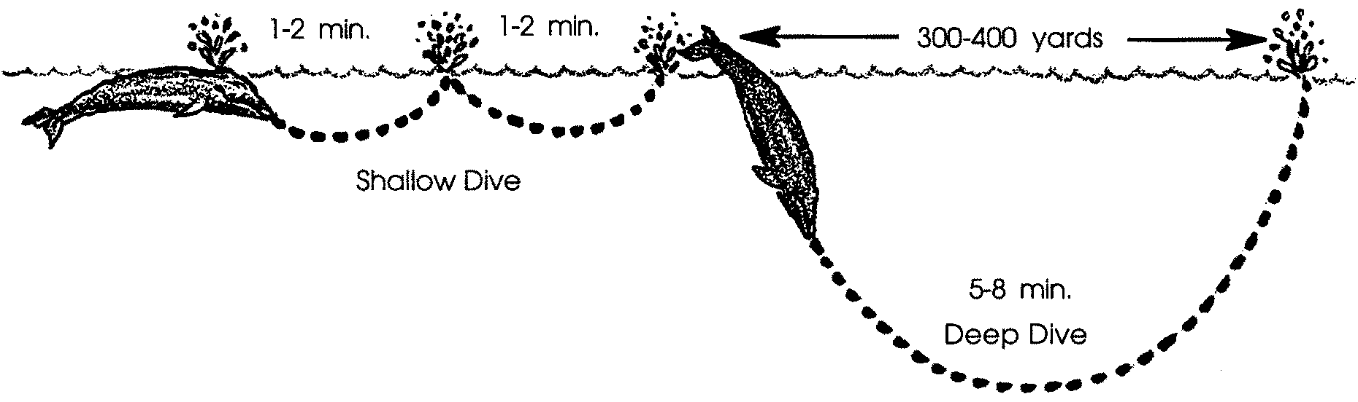

Swimming, breathing, swimming, breathing. Stroke after stroke her ten foot flukes push her 50 foot body through the sea. Without rest she swims northward.

The top of her head breaks the surface water. Her blow holes open and a sudden rush of warm air gushes from her lungs. The expanding air cools into a cloud of fog called a spout. She inhales and shallowly dives disappearing beneath the surface for one minute.

She resurfaces, exhales, inhales, and dives shallowly again. After another minute, she again resurfaces, exhales, and inhales.

She dives deeply, throwing her flukes out of the water to help propel her downward. She swims aggressively forward for six minutes before resurfacing and beginning the breathing cycle again. During this cycle of three breaths she has moved another half mile northward.

1. a. How much time did our whale spend in completing the breathing cycle described in the text? minutes

b. How many cycles did she swim in one hour (60 minutes)? cycles

c. How far did she swim during the cycle? miles

d. If she kept swimming at this rate how far would she swim in one hour (60 minutes)? miles

e. At this rate how far would she swim in one day (24 hours)? miles

f. At this rate how far has she traveled since she left the calving lagoon February 21? miles

g. Gray whales are known to swim 85-100 miles per day during the long migration. How is our whale doing compared to the average?

Swimming

With the grace of a dancer, our gray whale glides through the water. Her body is smooth and torpedo shaped. Supported by the salt water, she swims as if she is weightless. She turns, swirls and swims upside down. Moving her flippers like oars on the sides of a boat, she steers left or right. Powerfully swinging her tail fluke up and down she pushes herself through the water.

Again, she dives deeply. Her flukes plunge her to the ocean’s cold depths. A thick layer of fat, called blubber, helps her stay warm. The blubber also helps her stay afloat at the surface.

Swimming in this way can be very tiring. Our mother and calf doze lightly near the surface. Whales cannot sleep for very long below the surface since they must breathe air. They sometimes continue to swim as they doze.

2. What are three adaptations that help the gray whale to be a great swimmer?

(Hint: An adaptation is a structure or behavior that helps an animal survive.)

a.

b.

c.

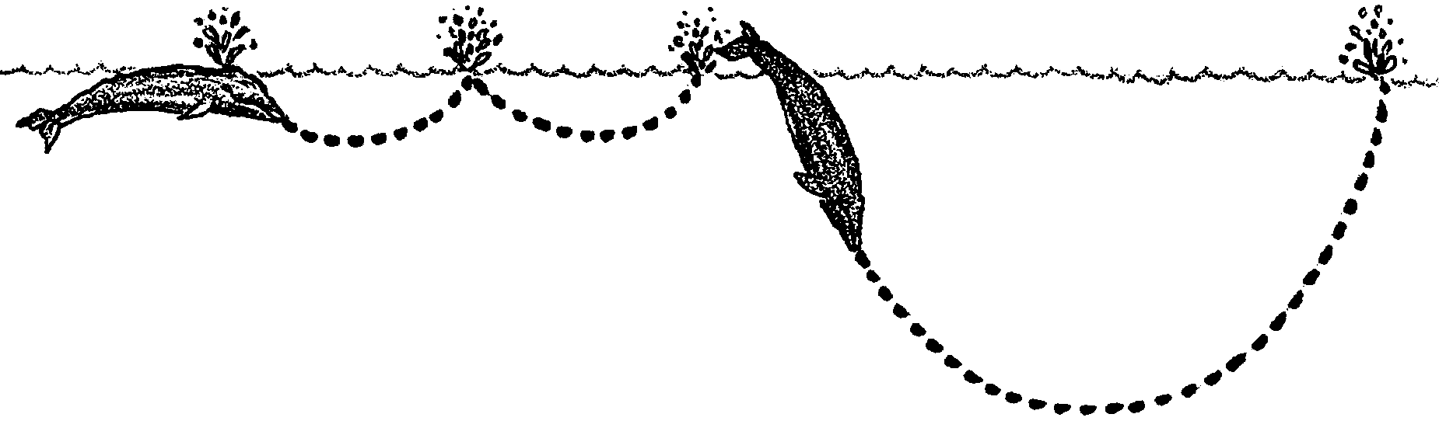
Breathing

Our whale breaks the surface. She blows a spray, or spout, into the air through her “ blow holes”. Just what are these “ blow holes”? The ancestors of gray whales were land mammals. They were built to live on land and to breathe air. Modern gray whales also breathe air. The nostrils of modern whales are no longer at the end of their snouts. Instead, they are located at the back of the head and are called “ blow holes”.

3. How might this different location help a whale swim more efficiently?

For a long time, people thought whales were spraying water into the air. The “spout” is really due to something else. When a whale exhales, it forces warm breath rapidly out of its blow hole. The breath is warmer than the air. As a result, it condenses into a misty fog, the spout. You may have seen something similar when you exhale on a cold, winter morning. Sometimes, surface water near the blow hole is shot into the air along with the breath exhaled. This water makes the spout more visible. A gray whale’s spout may be 15 feet high. Air is forced out of two blow holes making the spout appear heart shaped.
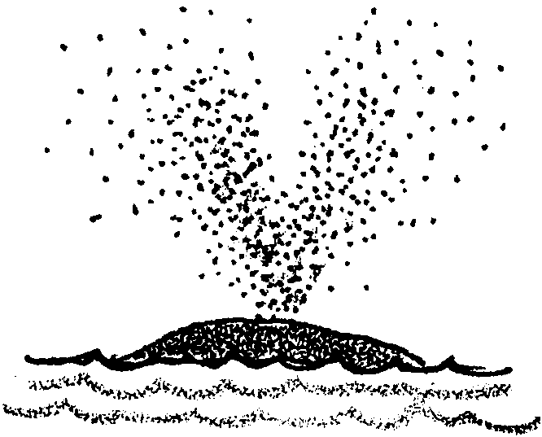

About 100 gallons of air, enough to fill two oil drums, are exhaled each time a gray whale spouts. In less than one second nearly 90 percent of the air is forced out. A spouting whale sounds like a giant swimmer blowing through a snorkel tube.

4. What causes a whale’s “spout”?

A gray whale inhales quickly after spouting. Then it closes its blowholes by relaxing a muscle. This way water cannot enter its nasal passage while it is under water. This is important because a whale’s lungs are directly connected to its nasal passage.

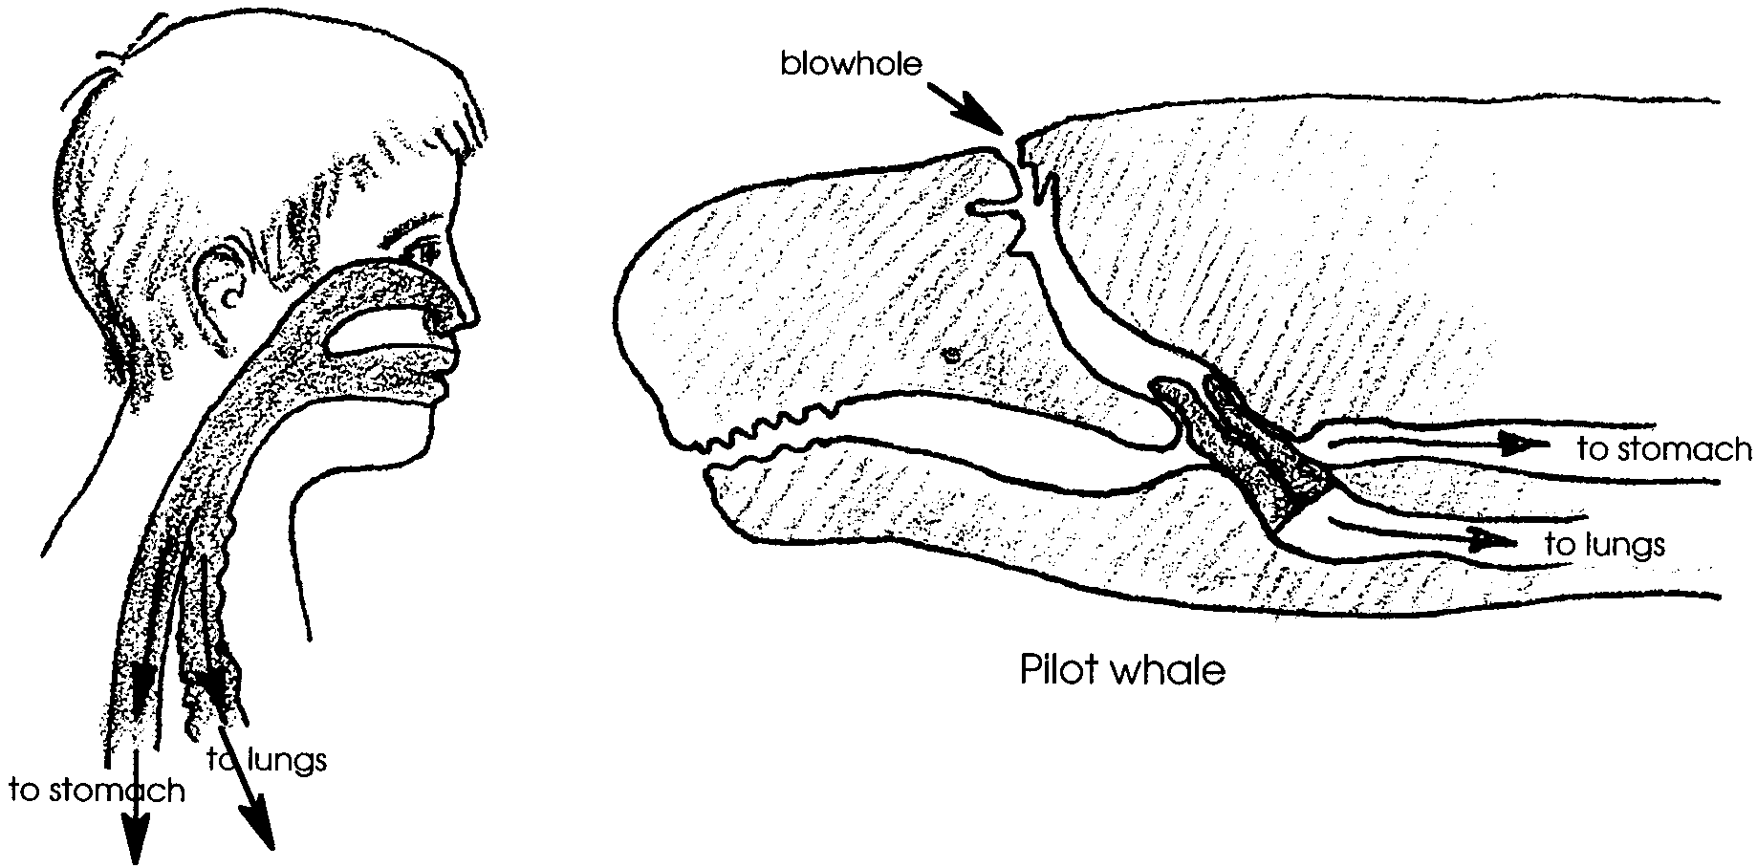
The toothed whales have muscles to close their blowholes too. They also have something else. The top of their windpipe is long and beak-shaped. This beak fits into the nasal passage. The close fit separates the breathing tube from the feeding tube. There is no direct connection between the mouth and lungs. This arrangement is different from that found in humans.

In humans there is a direct connection between the mouth and lungs. The nasal passage opens into the throat. In the throat the nasal passage connects with the mouth, esphagus and windpipe. If we breathe while swallowing, water or food can enter our lungs causing us to cough or choke. Whales, on the other hand, can swallow and breathe at the same time, without choking.

5. Use arrows to show on the drawings the path of the air from the outside to the lungs in a human and a whale.

6. Gray whales can breathe and swallow at the same time. Can you do the same? Try it and see. Record your results.

Diving

Holding their breath for a long time permits whales to swim great distances under water. It also lets them dive to great depths in search of food. Sperm whales have become tangled in underwater phone cables at a depth of 1000 meters (3240 feet). They can stay under water for over 90 minutes.
The shallow diving gray whale can stay under water for up to 20 minutes. A gray whale typically breathes 3 to 5 times in a row, 10 to 20 seconds apart. Then it dives for 3 to 7 minutes at depths up to about 200 feet. The average dive lasts 5 minutes.

7. Obtain a watch with a second hand. Take one (only one) deep breath and hold it. Record the time you can hold your breath. seconds.

8. How does your breath-holding ability compare with that of a sperm whale or gray whale?

Were you able to hold your breath for as long as you wanted? Probably not. We begin to breathe automatically when our carbon dioxide level rises. Unlike humans, whales can tolerate (stand) high carbon dioxide concentrations in their blood without triggering a breathing reflex.

9. Would you have to be concerned about a young child’s threat to “ hold its breath until it dies?

Evolution has drastically adapted (changed) the structure and function of the whale body. Several of these changes have improved its diving ability. Let’s look at some of these adaptations:

Adaptation I. Whale lungs use air more efficiently than do ours. They can almost completely exhale the used air and replace it with fresh air.

Adaptation II. Whale blood holds more oxygen than ours. Whales also have more blood in their bodies than do land mammals of similar size.

Adaptation III. Their muscles can store a large amount of oxygen in each cell for future use.

Adaptation IV. Whales can shut off blood circulation to those parts of the body that can endure lack of oxygen for a period of time.

Adaptation V. Whales slow their rate of heartbeat during a dive.

10. After your next regular exhalation, hold your breath for two seconds then forcefully exhale any additional air you can. Did your lungs retain some “dead” air after your regular exhalation? Would a whale’s?

11. Re-read Adaptation IV. Which two body parts are most likely to be affected by a lack of oxygen?

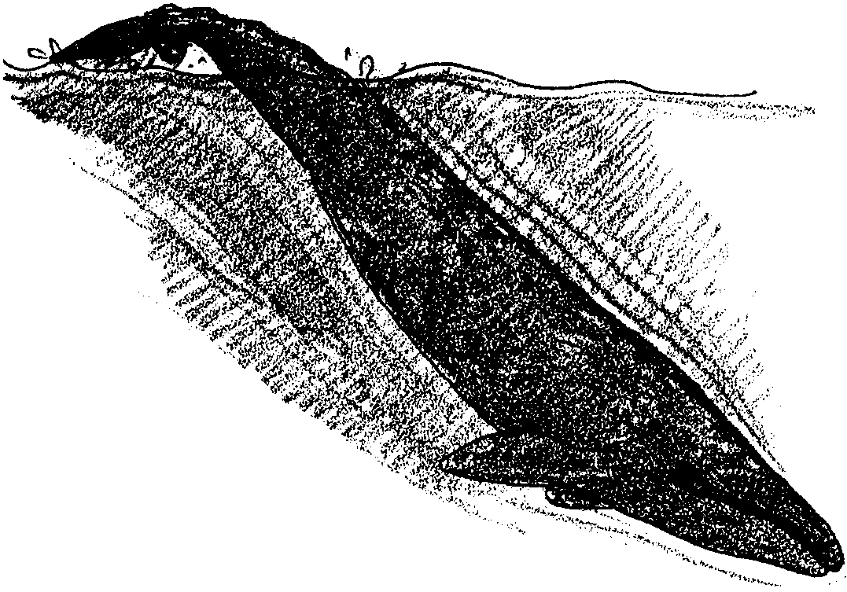

How do these five adaptations turn whales into super-divers? When a whale takes several breaths of air at the surface, great quantities of oxygen are taken up by the blood. The blood carries the oxygen to the muscles. Both the muscles and the blood then contain great amounts of oxygen and the lungs hold almost none. The whale dives.

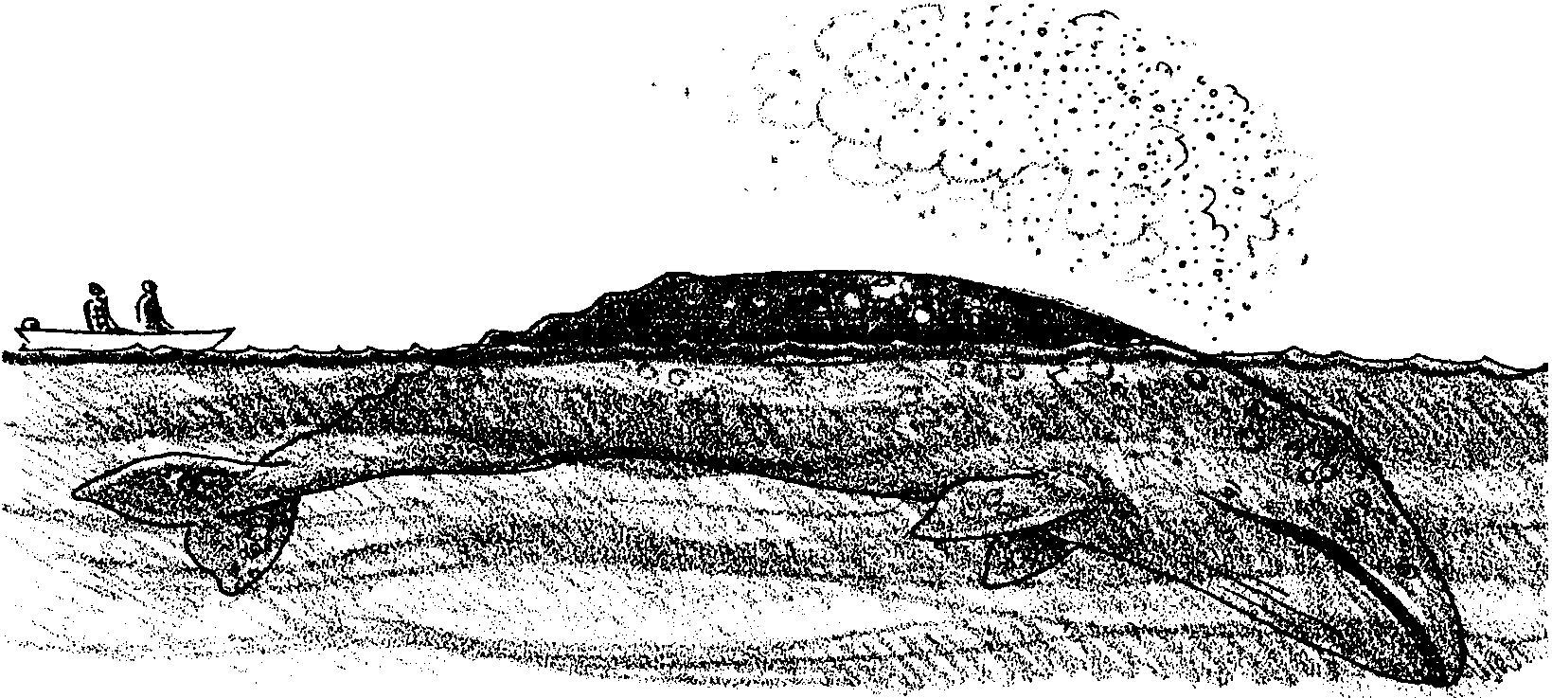
The swimming muscles use the oxygen stored within their own tissues. Most blood circulation in the body is shut off except for that serving the heart and brain. The oxygen in the blood continues to nourish these organs. The slow heart beat conserves energy and prevents the few organs receiving bloodfrom being overloaded. It also prevents overheating during the exertion of the dive.

The whale surfaces. The breathing rate increases. The heart rate increases. Excess carbon dioxide is rapidly exhaled. The blood and muscles are quickly recharged with oxygen.
12. Surfacing gray whales generally take several breaths before they again deep dive. What is probably happening to the oxygen levels in the blood and muscles during this period of shallow swimming?

13. In the space below, sketch the outline of a gray whale. Use arrows and words to show the five diving adaptations mentioned above.

