Field Study of Whales
Written by Ardi Kveven, Snohomish High School,
Snohomish, Washington

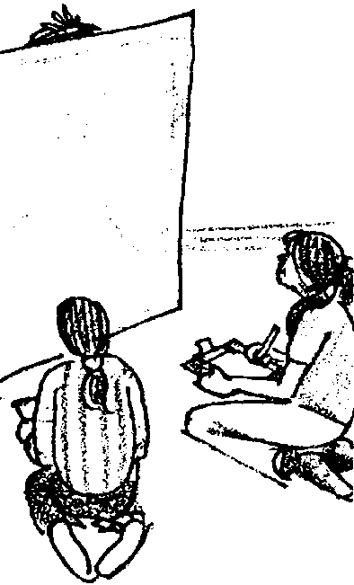
Key Concepts
1. Detailed observations are useful when identifying individuals within an animal population.
2. Researchers have overcome difficulties encountered when studying wild animals.

Background

Early information on whales and dolphins came primarily from whalers. In fact, not much was known about whales that were NOT hunted until dolphins were captured for oceanariums. At that point studies were conducted on captive whales and dolphins. It was not until the early 1970s that observations of wild populations began. Today, direct observation is now the most accepted scientific research technique for whales and dolphins.

There are a variety of problems with this method, however. The whales are not always around and do not always surface when the camera or equipment is ready. Everything from where to locate the whales to the weather affects the researchers and their work. In addition, researchers need to be able to recognize individuals within a population so they can conduct studies involving total number present, interactions, sex, and other important pieces of information.

Researchers have looked for characteristics that enable them to identify a whale every time it surfaces. Not all whale species are identified by the same characteristics. For example, orca whales have notches and nicks in their dorsal fins, as well as distinctive white markings called “saddle patches” that researchers use to identify individual whales. Humpback whales are identified by markings, patterns and scars on the underside of their tail flukes. Humpbacks often “fluke” (lift their tail out of the water) when they dive. Although gray whales also have unique markings on the underside of their tail flukes, they “fluke” much less frequently when they dive. Gray whales also lack the dorsal fin, a feature that is used to identify individuals in other species of whales. Researchers therefore use the spot patterns visible on the side of a gray whale when it surfaces.

Materials

For the class:

• roll of butcher paper

Teaching Hints

In “Field Study of Whales,” students try to determine the sex, total number of individuals and associations of a group of simulated gray whales. Students playing the role of gray whales periodically surface above a butcher paper water line as student researchers make observations.

Procedure
1. You will need an area large enough to separate a group of five “researchers” and a group of “whales” (comprised of the other students) by about 15 feet.

2. Have two helpers unroll the butcher paper as a screen between the researchers and the whales. The paper represents the water. Whales are only visible above the surface of the water (upper edge of the butcher paper).

Note: If your school has a stage with a curtain that can be drawn, leave the curtain open about 15 feet. Unroll the butcher paper across the opening and attach the paper to the curtain with tape or pins. The “whales” can move more freely behind the curtain, only visible when they “surface” above the butcher paper in the opening.

3. Gather the whale researchers in a “boat” at the end of the room away from the whales. (The whales will be behind the paper at the other end of the classroom.) If you are using a stage, the researchers should be seated in the audience.

4. Coach each group of students privately beforehand. Remind researchers that they are looking for: total number of whales, number of males and females, and associations with others.

Remind whales to show only the back of their heads for about 3-4 seconds at a time. They are to surface from behind the paper and are free to move about below the surface. Have each surface once a minute. Let students devise a surfacing sequence (or have them count off) so that whales are surfacing at different times. Have students use a five second interval between two whales surfacing (counting “one-one thousand, two-one thousand” is close enough for this activity). The whales should swim around and surface in different places at these different times.
5. Be sure everyone is in their proper positions and signal the start. Allow five or six minutes for the initial observation period. This amount of time permits each “whale” to surface at least three times. You may wish to ask if student researchers would like additional time.

6. When your researchers (or you) are satisfied, have students individually or in small groups answer the “Analysis and Interpretation” questions.

Key Words

fluke - either half of the triangular tail of a whale; tail flippers of the whale; sometimes used as a verb indicating a whale behavior in which the tail is lifted out of the water.

dorsal fin - the fin on top (along the backbone) of some fish and whales

saddle patch - white marking behind dorsal fin on orca whales

Extensions

1. Do this activity at the beginning of a new semester as an introductory activity.

2. Arrange some students in mother/calf family units that surface as a group near other family members. See if the researchers can recognize the family units.

Answer Key

Pre-activity questions
1-2. Answers will vary.

Post-activity questions
1-3. Answers will vary.

4. Answers will vary but researchers face difficulties in locating whales, in identifying individuals and in weather and sea conditions.

5. Knowing that gray whale calves live with their mothers, researchers can study relationships between mothers and calves and between these mother/calf groupings and other individuals or groups. Note that, unlike some animal populations, it is not possible to determine by visual observation the gender of most whale species in the wild. The gray whale mother/calf relationship provides valuable population information.

Field Study of Whales
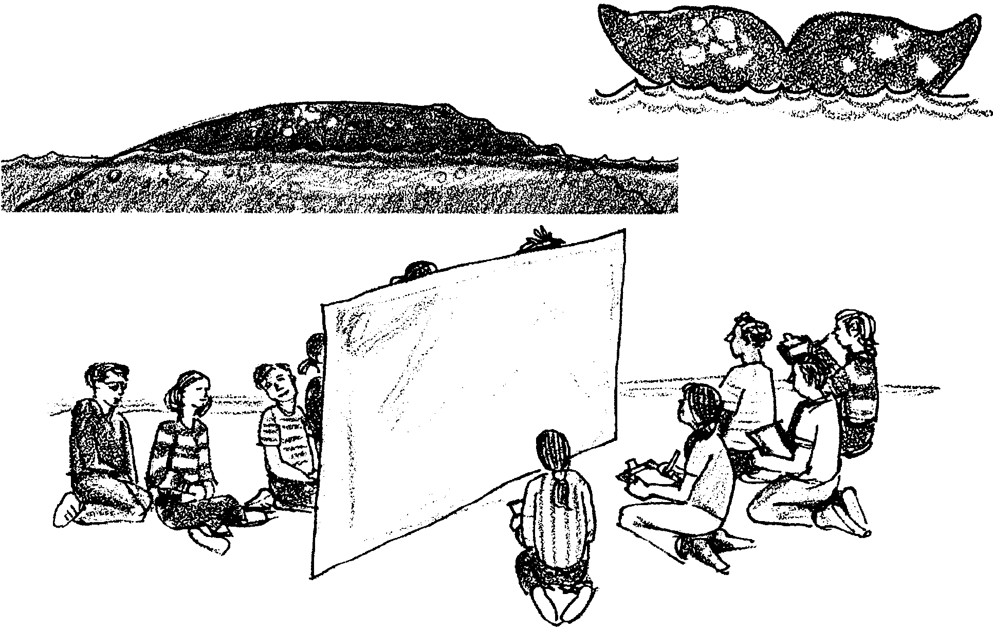
Early information on whales came from whale hunters. It is only within the last 20 years that work has been done on LIVE whales. Now most of what we know about the whales comes from looking at animals in the wild. Researchers have learned how to recognize individual whales. They look for patterns, nicks and marks on various parts of the whale. Unfortunately, researchers can only use the part of the body that shows every time the whale surfaces.

In this activity you will try to recognize your classmates while they are modeling whale behaviors. Your teacher will select you as either a researcher or a whale.

Answer these questions before you begin:

1. How do you recognize your friends?

2. How do you know that the person you see is your friend?

Answer these questions after the activity is completed:

Analysis and Interpretation

1. What characteristics helped the researchers recognize individual whales?

2. a. How many whales were there in total?

b. How many males and females?

3. a. Did the researchers count the total number correctly?

b. What made it difficult or easy?

4. What difficulties do you think actual researchers have when studying whales in the wild?

5. Researchers have found that gray whales stay and live with their mothers during their first migration. How might this fact be helpful in studying whale behaviors?

